MINISTRY OF EDUCATION AND TRAINING

**NAM CẦN THƠ UNIVERSITY**

**SCHOOL OF INFORMATION TECHNOLOGY**



**PRACTICAL SUBJECT REPORT**

**INFORMATION TECHNOLOGY**

**REAL AGENCY**

**TMA Solutions Limited Liability Company**

**FPT Software Co., Ltd.**

**Student: ĐOÀN TUẤN DŨNG**

**MSSV : 219519**

**Course: 9**

**Cần Thơ, 2/2025**

**MINISTRY OF EDUCATION AND TRAINING**

**NAM CẦN THƠ UNIVERSITY**

**SCHOOL OF INFORMATION TECHNOLOGY**

**PRACTICAL SUBJECT REPORT**

**INFORMATION TECHNOLOGY**

**REAL AGENCY**

**TMA Solutions Limited Liability Company**

**FPT Software Co., Ltd.**

**Student: ĐOÀN TUẤN DŨNG**

**MSSV : 219519**

**Course: 9**

**THANK YOU NOTE**

Dear teachers of the Faculty of Information Technology,

During the time of conducting the actual report at the enterprise, I received enthusiastic support and the best conditions from the esteemed Faculty. I sincerely thank you for these things.

Especially, I would like to express my deep gratitude to the esteemed Faculty for providing me the opportunity to intern at two leading companies in the field of information technology:

* **TMA Solutions Co., Ltd.**
* **FPT Software LLC**

Here, I have been exposed to a professional and modern working environment, where I have learned valuable practical knowledge, honed my skills, and gained work experience. This knowledge and experience will be invaluable assets for me on my future career path.

I would like to thank the esteemed Faculty for always accompanying, supporting, and creating the best conditions for me to successfully complete this practical period. I wish the esteemed Faculty continued development and even greater success in the career of training and scientific research.

Thank you very much!

Can Tho, the ... day of ... month, 2025.

**Students perform**

*( Sign and clearly write your full name )*

Full name

# COMMENTS FROM THE REFEREE INSTRUCTOR

Can Tho, the ... day of ... month, 2025

**Reviewer**

*( Sign and clearly write your full name )*

**TABLE OF CONTENTS**

COMMENTS FROM THE REFEREE INSTRUCTOR iii

IMAGE LIST vi

CHAPTER 1 1

GENERAL INTRODUCTION 1

1.1 Purpose of the field trip 1

1.2 Members of the visiting delegation 1

1.3 Visiting time 1

1.4 Tourist attractions 1

CHAPTER 2 2

UNDERSTANDING AN OVERVIEW OF THE COMPANY 2

2.1 TMA Solutions Company 2

**2.1.1 History of Formation** 2

**2.1.2 Area of activity** 7

**2.1.3 Scale of the corporation** 9

**2.1.4 Achievements** 9

**2.1.5 Recruitment Demand** 10

2.2 FPT Company … 11

2.2.1 History of Formation 11

2.2.2 Area of activity 17

2.2.3 Scale of the corporation 17

2.2.4 Achievements 19

2.2.5 Recruitment Demand 19

CHAPTER 3 21

RESULTS OF THE ACTUAL VISIT 21

3.1 TMA Solutions Co., Ltd. 21

3.2 FPT Software LLC ( FPT Software ) 23

CHAPTER 4 26

CONCLUSION 26

CHAPTER 5 27

SUGGESTIONS 27

# IMAGE LIST

Figure 2.1 Phase 1997 - 2000 2

Figure 2.2 Phase 2001 – 2005 3

Figure 2.3 Phase 2006 – 2010 4

Figure 2.4 Phase 2010 – 2015 5

Figure 2.5 Phase 2016 – 2020 6

Figure 2.6 Phase 2021 - 2024 6

Figure 2.7 FPT 1999 11

Figure 2.8 FPT 2005 12

Figure 2.9 FPT 2007 12

Figure 2.10 FPT 2008 13

Figure 2.11 FPT 2012 13

Figure 2.12 FPT 2014 14

Figure 2.13 FPT 2016 14

Figure 2.14 FPT 2017 15

Figure 2.15 FPT 2018 15

Figure 2.16 FPT 2021 16

Figure 2.17 FPT 2023 16

Figure 2.18 FPT 30,000 employees 17

Figure 2.19 FPT Revenue 18

Figure 2.20 TMA Company Welcome Gate 21

Figure 2.21 TMA Company Lobby 22

Figure 2.22 TMA Company Presentation 22

Figure 2.23 TMA Company Presentation (cont.) 22

# CHAPTER1

# GENERAL INTRODUCTION

## 1.1 Purpose of the field trip

The purpose of the visit is to learn about the production process, the technology used, and the business activities of TMA Solutions and FPT Software. I am particularly interested in the technologies as well as the working processes of the company. This visit is also an opportunity for me to meet industry experts, exchange experiences, and expand my network.

The practical tour at TMA Solutions and FPT Software provided me with incredibly valuable experiences. I not only learned specialized knowledge but also developed many essential soft skills for my future work, such as teamwork skills, communication skills, and problem-solving skills.

## 1.2 Tour group member

* Mr. Nguyễn Văn Linh (head of the delegation)
* Teacher Huỳnh Bá Lộc
* Teacher Nguyen Hoang Duy
* 24 students of class 21 TIN 02-TT

## 1.3 Visiting time

- Schedule:

09:30 : Welcome

09:45 : Introduction to TMA, working environment, Q & A

10:30 : Visit the working rooms at TMA

11:15 : Take photos during the tour and conclude the tour at TMA

13:30 : Visit FTown 3

14:15: Visit FTown 1,2

14:30 : Teabreak + Warm Up

14:45 : Fsoft Sharing , Q & A

## 1.4 Attraction location

First location: Independence Palace

Next location: TMA Solutions Co., Ltd.

Final location: FPT Software Co., Ltd.

# CHAPTER2

# UNDERSTANDING AN OVERVIEW OF THE COMPANY

## 2.1 TMA Solutions Company

**2.1.1 History of Formation**

Development stages

1997 – 2000 :

* Establishment of TMA Solutions with 6 engineers
* The first customers from Canada, the USA, and Japan.
* Achieve 100 engineers after 4 years
* Applying RUP (Rational Unified Process)
* Open an office in Phu Nhuan District

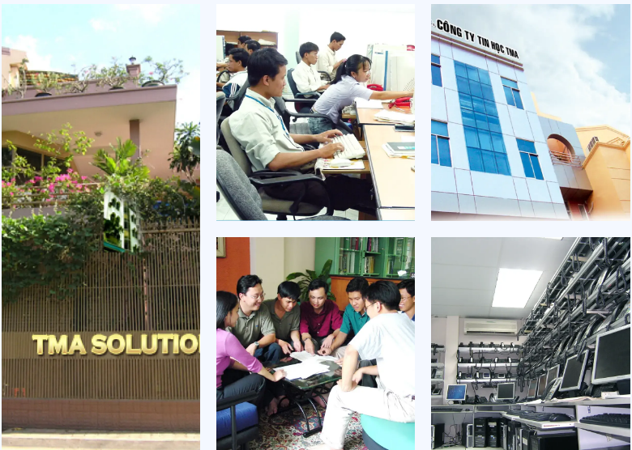

Figure 2.1 Phase 1997 - 2000

2001 – 2005 :

Reaching the milestone of 500 engineers

Establishing an office in Canada

Establishment of the R & D Center