MINISTRY OF EDUCATION AND TRAINING

**NAM CAN THO UNIVERSITY**

**SCHOOL OF INFORMATION TECHNOLOGY**



**REPORT ON PRACTICAL SUBJECT**

**INFORMATION TECHNOLOGY**

**REAL AGENCY**

**TMA Solutions Co., Ltd.**

**FPT Software Co., Ltd.**

**Student: DOAN TUAN DUNG**

**Student ID: 219519**

**Course: 9**

**Can Tho, 2/2025**

**MINISTRY OF EDUCATION AND TRAINING**

**NAM CAN THO UNIVERSITY**

**SCHOOL OF INFORMATION TECHNOLOGY**

**PRACTICAL SUBJECT REPORT**

**INFORMATION TECHNOLOGY**

**REAL AGENCY**

**TMA Solutions Co., Ltd.**

**FPT Software Co., Ltd.**

**Student: DOAN TUAN DUNG**

**Student ID: 219519**

**Course: 9**

**THANK YOU NOTE**

Dear teachers of the Faculty of Information Technology,

During the time of conducting the practical report at the company, I received enthusiastic support and the best possible conditions from the esteemed Faculty. I sincerely thank you for these things.

In particular, I would like to express my deep gratitude to the esteemed Faculty for providing me the opportunity to gain practical experience at two leading companies in the field of information technology:

* **TMA Solutions Co., Ltd.**
* **FPT Software Co., Ltd.**

Here, I have been exposed to a professional and modern working environment, where I have learned valuable practical knowledge, honed my skills, and gained work experience. This knowledge and experience will be invaluable assets for me on my future career path.

I would like to thank the esteemed Department for always accompanying, supporting, and providing the best conditions for me to successfully complete this practical period. I wish the esteemed Department continued growth and even more success in its training and scientific research endeavors.

Thank you very much!

Can Tho, the ... day of ... month, 2025.

**Students carry out**

*(Sign and write your full name)*

Full name

# COMMENTS FROM THE REFEREE INSTRUCTOR

Can Tho, the ... day of ... month, 2025

**Reviewer**

*(Sign and write your full name)*

**TABLE OF CONTENTS**

COMMENTS FROM THE REFEREE INSTRUCTOR iii

LIST OF IMAGES vi

CHAPTER 1 1

GENERAL INTRODUCTION 1

1.1 Purpose of the field trip 1

1.2 Tour group member 1

1.3 Visiting time 1

1.4 Tourist attractions 1

CHAPTER 2 2

LEARN ABOUT THE COMPANY OVERVIEW 2

2.1 TMA Solutions Company 2

**2.1.1 History of Formation** 2

**2.1.2 Field of activity** 7

**2.1.3 Corporation scale** 9

**2.1.4 Achievements attained** 9

**2.1.5 Recruitment needs** 10

2.2 FPT Corporation... 11

2.2.1 History of Formation 11

2.2.2 Field of activity 17

2.2.3 Corporation scale 17

2.2.4 Achievements attained 19

2.2.5 Recruitment needs 19

CHAPTER 3 21

RESULTS OF THE FIELD VISIT 21

3.1 TMA Solutions Co., Ltd. 21

3.2 FPT Software LLC 23

CHAPTER 4 26

CONCLUSION 26

CHAPTER 5 27

SUGGESTION 27

# LIST OF IMAGES

Image 2.1 Phase 1997 - 2000 2

Image 2.2 Stage 2001 – 2005 3

Image 2.3 Phase 2006 – 2010 4

Image 2.4 Phase 2010 – 2015 5

Image 2.5 Phase 2016 – 2020 6

Image 2.6 Phase 2021 - 2024 6

Image 2.7 FPT 1999 11

Image 2.8 FPT 2005 12

Image 2.9 FPT 2007 12

Image 2.10 FPT 2008 13

Image 2.11 FPT 2012 13

Image 2.12 FPT 2014 14

Image 2.13 FPT 2016 14

Image 2.14 FPT 2017 15

Image 2.15 FPT 2018 15

Image 2.16 FPT 2021 16

Image 2.17 FPT 2023 16

Image 2.18 FPT 30.000 employee 17

Image 2.19 FPT Revenue 18

Image 2.20 TMA Company Welcome Gate 21

Image 2.21 TMA Company Lobby 22

Image 2.22 TMA Company Presentation 22

Image 2.23 TMA Company Presentation (cont.) 22

# CHAPTER1

# GENERAL INTRODUCTION

## 1.1 The purpose of the field trip.

The purpose of the visit is to learn about the production process, the technology used, and the business activities of TMA Solutions Co., Ltd. and FPT Software Co., Ltd. I am particularly interested in the technologies as well as the working processes of the company. This visit is also an opportunity for me to meet industry experts, exchange experiences, and expand my network.

The practical tour at TMA Solutions Co., Ltd. and FPT Software Co., Ltd. provided me with incredibly valuable experiences. I not only gained specialized knowledge but also developed many essential soft skills for my future career, such as teamwork, communication, and problem-solving skills.

## 1.2 Tour group members

* Mr. Nguyen Van Linh (head of the delegation)
* Teacher Huỳnh Bá Lộc
* Teacher Nguyen Hoang Duy
* 24 students of class 21TIN02-TT

## 1.3 Visiting time

- Schedule:

09:30 : Welcome

09:45: Introduction to TMA, work environment, Q&A

10:30: Visit the working rooms at TMA

11:15: Take photos during the tour and conclude the visit at TMA.

13:30: Visit FTown 3

14:15: Visit FTown 1,2

14:30: Teabreak + Warm Up

14:45: Fsoft Sharing, Q&A

## 1.4 Tourist attractions

First location: Independence Palace

Next location: TMA Solutions Co., Ltd.

Final destination: FPT Software Co., Ltd.

# CHAPTER2

# LEARN ABOUT THE COMPANY OVERVIEW

## 2.1 TMA Solutions Company

**2.1.1 History of Formation**

Development stages

1997 – 2000:

* Establishing TMA Solutions with 6 engineers.
* The first customers from Canada, the USA, and Japan.
* Achieve 100 engineers after 4 years.
* Applying RUP (Rational Unified Process)
* Open an office in Phu Nhuan District

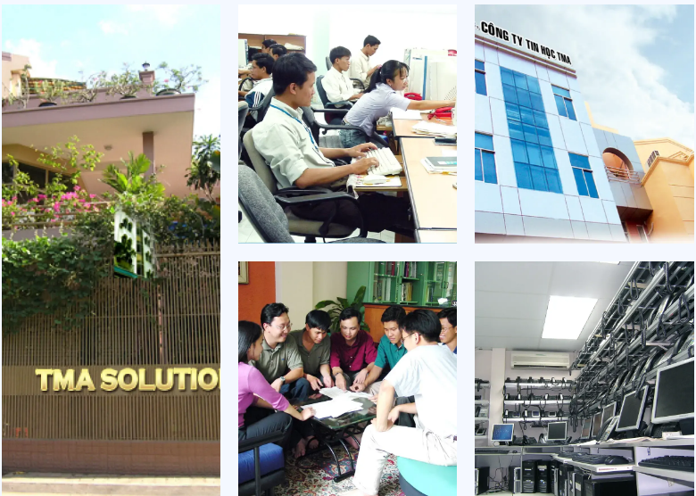

Image 2.1 Phase 1997 - 2000

2001 – 2005:

Reaching the milestone of 500 engineers

Establishing an office in Canada

Establishment of the R&D Center