Week 1 Report
Data Science Project Planning and Strategy Design
Hypothetical Project: Predicting Late Deliveries for an E-commerce Platform
Name: Anish Goyal
Internship: Virtual Data Science Explorer Intern (Yuva Intern)
Internship Period: 23 July 2026 – 20 August 2026
Task: Week 1 – Data Science Project Planning and Strategy Design
GitHub: github.com/anishgoyal0603/ecommerce-late-delivery-prediction

1. Introduction and Background
The aim of this first week was to plan a complete data science project before writing any real code. I have often seen (and done it myself in college projects) that people jump straight into a dataset, try a few models, and only later realise that the problem was never clearly defined. So in this report I have tried to think through the whole process in advance – what problem I am solving, why it matters, what data would be needed, how I would clean and explore it, which models I would try, how I would judge them, and how much time each part should take.
The project I have planned is a hypothetical one from the e-commerce domain: predicting whether an online order is likely to be delivered after the date promised to the customer. Online shopping has grown a lot in the last few years, and delivery experience has become one of the main reasons why customers either come back to a platform or leave it. Late deliveries are also a problem that almost everyone has faced as a customer, which made it easier for me to think about the business side of it and not just the technical side.

2. Project Motivation and Justification
When a customer places an order, the platform shows an estimated delivery date. If the parcel arrives after that date, the customer usually gets frustrated, contacts customer support, and in many cases leaves a low rating. For a marketplace, this directly affects repeat purchases and seller reputation.
At the moment, most platforms only find out that an order is late after the promised date has already passed, and by then the damage is done. If late orders could be identified early – at the time of purchase or when the order is handed over to the courier – the company could act in advance. It could inform the customer, prioritise the shipment with the logistics partner, or show a more realistic delivery date in the first place.
This problem is well suited for data science and Python because:
- Every order already creates a lot of data (timestamps, locations, product details, prices), so no extra data collection is needed.
- The target is easy to define and measure – the order is either late or not.
- Even a moderately accurate model gives business value, because acting early on some of the late orders is better than acting on none.
- The results can be explained in simple terms (for example, 'long-distance orders in festive months are more likely to be late'), which helps non-technical teams use them.

3. Problem Statement
Given the information available when an order is placed and shipped – product details, seller and customer location, freight cost, order date and the estimated delivery date – build a model that predicts whether the order will be delivered late.
This will be treated as a binary classification problem. The target variable will be is_late = 1 if the actual delivery date is after the estimated delivery date, otherwise is_late = 0.

4. Project Objectives and Scope

4.1 Objectives
- Combine the different raw tables into one clean dataset with one row per delivered order.
- Find out, through exploratory analysis, which factors are linked with late deliveries (distance, region, product category, season, freight cost, etc.).
- Create useful features from raw data, such as seller–customer distance and the number of days given in the delivery estimate.
- Build and compare at least three classification models and select the best one based on suitable metrics.
- Explain the most important factors behind delays and convert them into practical recommendations.
- Keep the work reproducible by documenting it and uploading the code to GitHub.

4.2 In Scope
- Delivered orders only, using historical order data.
- Data cleaning, EDA, feature engineering, model building and evaluation in Python.
- A final report with findings, charts and recommendations.
- An optional simple Streamlit demo, only if time allows.

4.3 Out of Scope
- Real-time prediction or deployment on a live e-commerce system.
- Predicting the exact number of days of delay (this is a classification project, not regression).
- Use of external data such as weather, traffic or courier partner data.
- Route optimisation or any changes to the actual logistics process.
- Analysis of cancelled or returned orders.

5. Proposed Data Source
Since this is a planning task, no dataset is being processed this week. However, to keep the plan realistic, I looked for a dataset that would fit the problem. The Brazilian E-Commerce Public Dataset by Olist (available on Kaggle) is a good fit. It contains around 100,000 anonymised orders from 2016 to 2018, split across several related CSV files:

File | What it contains
orders | Order status and timestamps – purchase, approval, handover to carrier, actual and estimated delivery
order_items | Products in each order, seller ID, price and freight value
customers | Customer city, state and zip code prefix
sellers | Seller city, state and zip code prefix
products | Product category, weight and dimensions
order_payments | Payment type, instalments and payment value
order_reviews | Review score (1–5) and customer comments
geolocation | Latitude and longitude for zip code prefixes

One important point I noted while planning: review scores are given after delivery, so using them as a model input would leak the answer into the model. Reviews will only be used in the analysis stage to show how late deliveries affect customer satisfaction.

6. Methodology and Strategy
I have based the methodology on CRISP-DM (Cross Industry Standard Process for Data Mining). I chose it because it splits the work into clear stages but also allows going back to an earlier stage when needed – for example, if the model performs poorly, I can return to feature engineering instead of only trying more models. Figure 1 shows the overall workflow.
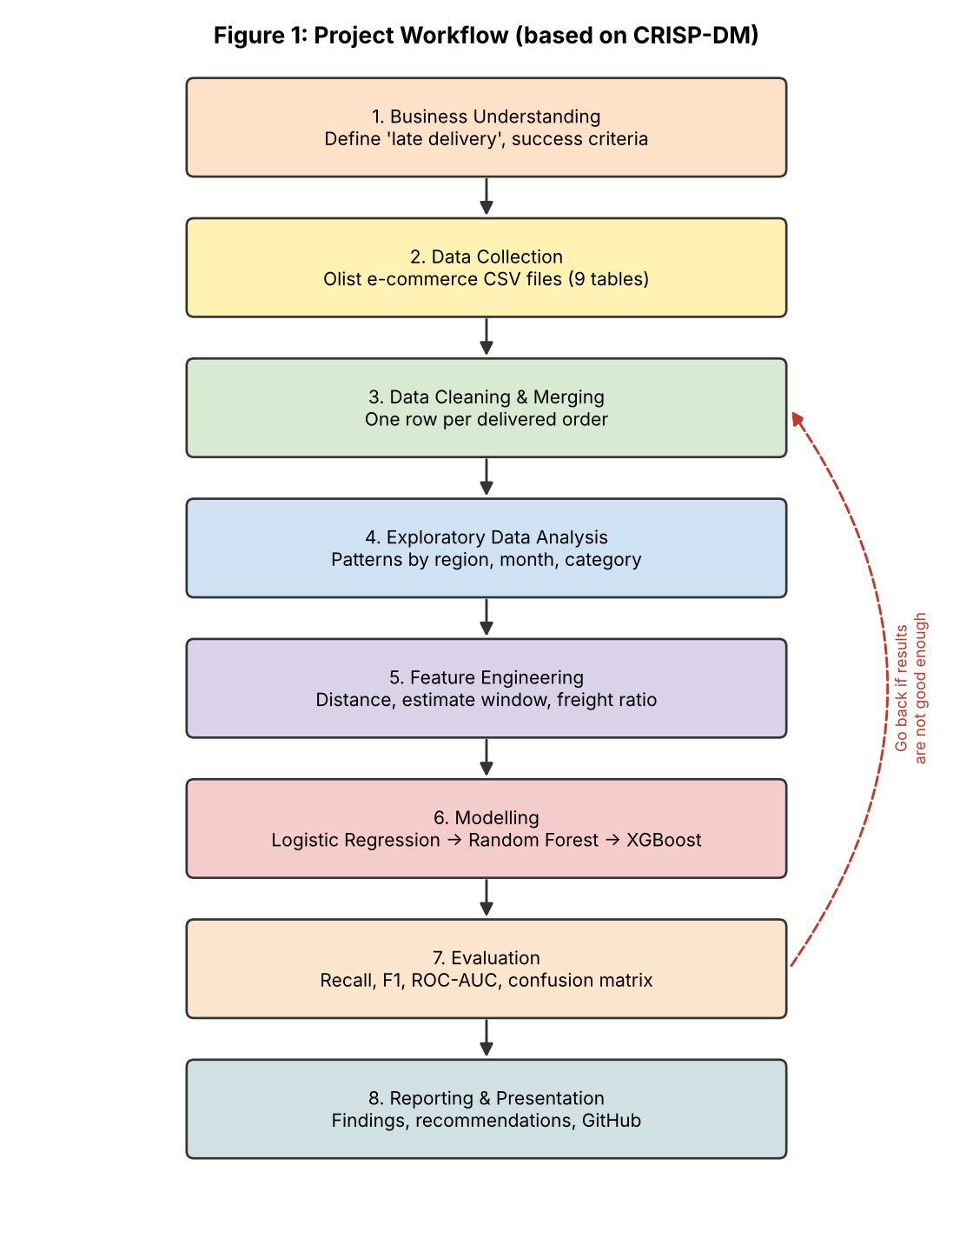

6.1 Data Collection
- Download the Olist dataset from Kaggle and load all CSV files using Pandas.
- Check the shape, data types, number of unique IDs and missing values in each file.
- Confirm how the tables connect to each other (order_id, customer_id, seller_id, product_id, zip code prefix).

6.2 Data Cleaning and Preparation
- Keep only orders with status 'delivered' and a valid delivery date.
- Convert all timestamp columns to datetime format.
- Fill missing product weight/dimensions with the median of the same category, and missing categories with 'unknown'.
- Aggregate orders with multiple items or sellers to order level (total weight, total freight, maximum distance, etc.).
- Remove clearly wrong records, such as delivery dates before the purchase date.
- Create the target column is_late.

6.3 Exploratory Data Analysis
- Check what share of orders are late, to understand the class imbalance.
- Compare late percentage by customer state, seller state, product category, month and day of the week.
- Plot delivery time distributions and the gap between estimated and actual delivery.
- Look at the relationship between late delivery and review score.

6.4 Feature Engineering
- Seller–customer distance in km using the haversine formula on latitude/longitude.
- Estimated delivery window – number of days between purchase and the promised date.
- Approval delay – time between purchase and payment approval.
- Purchase month, weekday, and a flag for major sale periods.
- Same-state flag, freight-to-price ratio, product weight and volume, number of items and sellers per order.
Figure 2 shows how the raw files will flow through these steps to the final model and report.
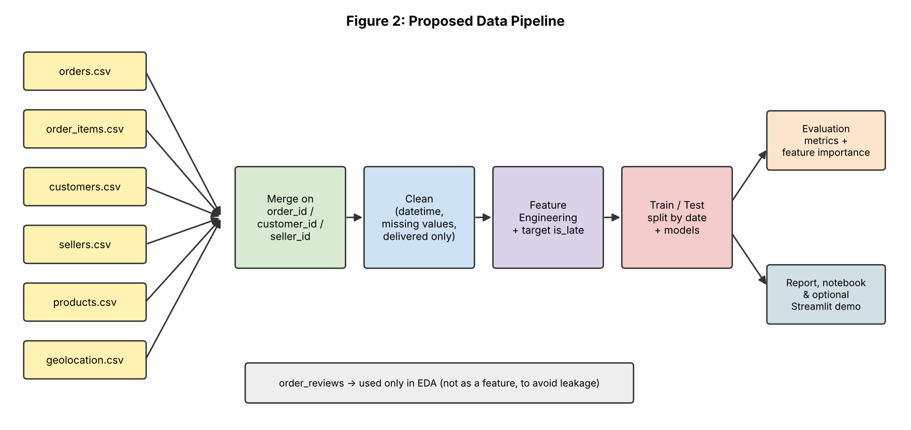

6.5 Modelling
- Split data by purchase date – train on older orders and test on newer ones – because in real use the model always predicts future orders. A random split could give over-optimistic results.
- Baseline model: Logistic Regression (simple and easy to explain).
- Advanced models: Random Forest and a gradient boosting model (XGBoost or LightGBM).
- Handle class imbalance using class weights first, and SMOTE only if needed.
- Tune the best model using RandomizedSearchCV with time-based cross-validation.

6.6 Evaluation
Because only a small share of orders are expected to be late, accuracy would be misleading – a model that predicts 'on time' for every order would still look accurate. Missing a late order is also more costly than wrongly flagging an on-time one. So the main metrics will be:
- Recall and Precision for the late class
- F1-score
- ROC-AUC and Precision-Recall AUC
- Confusion matrix, to see the actual number of late orders caught and missed
Feature importance (and SHAP values, if time permits) will be used to explain which factors drive the predictions.

7. Timeline
The project is planned for roughly 32 hours of work, spread across the four weeks of the internship so that every week ends with a clear output. Figure 3 shows the same plan as a Gantt chart.

Week | Activity | Hours | Output
Week 1 | Problem understanding and background research | 3 | Problem definition
Week 1 | Dataset study and writing the project plan | 3 | This planning report
Week 2 | Data cleaning and merging | 5 | Clean order-level dataset
Week 2 | Exploratory data analysis | 5 | EDA notebook with charts
Week 3 | Feature engineering | 4 | Final feature set
Week 3 | Model building and tuning | 6 | Trained models
Week 4 | Evaluation and interpretation | 3 | Model comparison, key drivers
Week 4 | Final report and GitHub upload | 3 | Report + repository
 | Total | 32
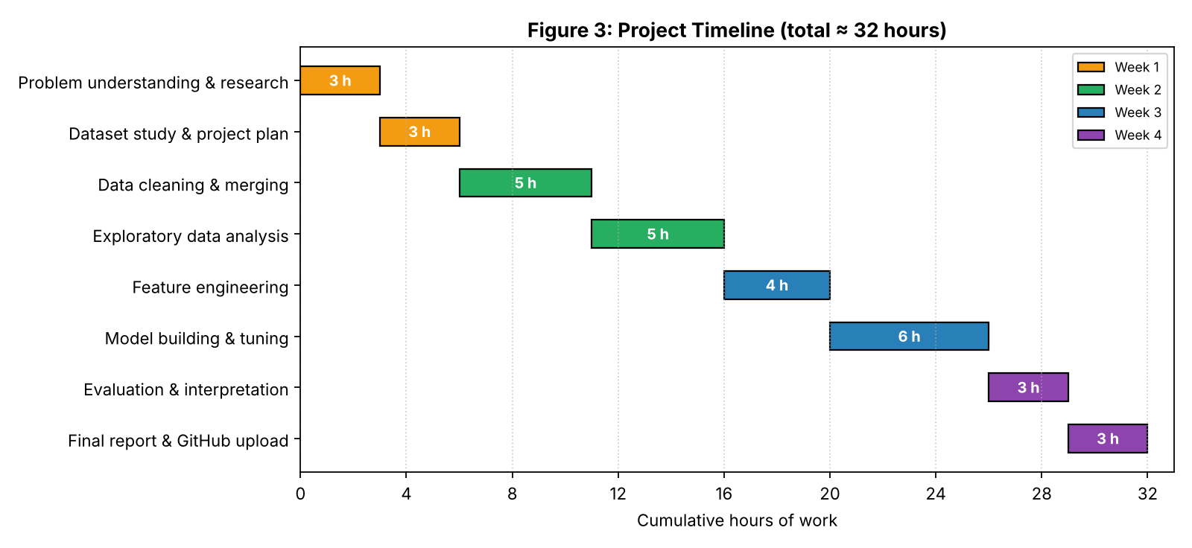

8. Tools and Python Libraries
Tool / Library | Purpose
Python 3 | Main programming language
Jupyter Notebook / Google Colab | Writing and running code step by step
Pandas, NumPy | Loading, merging, cleaning and transforming data
Matplotlib, Seaborn | Charts for EDA and results (also used for the diagrams in this report)
Scikit-learn | Preprocessing, Logistic Regression, Random Forest, metrics, tuning
XGBoost / LightGBM | Gradient boosting models
imbalanced-learn | SMOTE, if class weights are not enough
SHAP | Explaining model predictions (optional)
Streamlit | Simple demo app (optional)
Git and GitHub | Version control and sharing the project

9. Expected Outcomes and Benefits

9.1 Expected Outcomes
- A clean, documented order-level dataset ready for analysis.
- Clear insights into where and when late deliveries happen most.
- A classification model that catches a good share of late orders before they happen.
- A ranked list of the factors that contribute most to delays.
My expectation before seeing the data in detail is that distance between seller and customer, the customer's region and peak sale periods will be the biggest factors. This is only a hypothesis at this stage and will be tested during EDA in Week 2.

9.2 Benefits of this Approach
- Planning first avoids wasted time on data that is never used.
- The time-based split and leakage checks make the results more trustworthy.
- Starting with a simple baseline gives a fair reference point for complex models.
- Focusing on recall and F1 matches the actual business need better than accuracy.
- Explainable results make it easier for logistics and support teams to act on them.

10. Anticipated Challenges and Mitigation
Challenge | Mitigation strategy
Class imbalance (few late orders) | Use class weights, focus on recall/F1/PR-AUC, try SMOTE if needed
Data leakage from post-delivery columns | Use only information available before delivery; keep review data out of features
Missing values in product and location data | Category-wise median imputation; drop rows only if the share is very small
Orders with multiple items or sellers | Aggregate features at order level
Zip codes with multiple coordinates | Take the average latitude/longitude per zip prefix
Delays caused by factors not in the data (weather, strikes) | Accept as a limitation and state it clearly in the final report
Model may not generalise to newer periods | Time-based split and time-series cross-validation
Limited time (≈32 hours) | Follow the weekly plan; keep Streamlit and SHAP as optional extras

11. Conclusion
This week made me realise that planning is an actual part of a data science project and not just a formality. Writing down the problem, the target variable, the scope, the metrics and the risks in advance already made a few decisions easier – for example, splitting the data by date, and not using review scores as inputs. The diagrams helped me see the full flow of the project in one place. With this plan ready, the next step in Week 2 is to start working with the data – cleaning it, merging it and exploring it.

References
- Olist – Brazilian E-Commerce Public Dataset, Kaggle (kaggle.com/datasets/olistbr/brazilian-ecommerce)
- Chapman, P. et al. (2000). CRISP-DM 1.0: Step-by-step data mining guide.
- Scikit-learn documentation – scikit-learn.org
- Pandas documentation – pandas.pydata.org

