Week 4 – Final Report
Comprehensive Data Science Report and Insights Presentation Plan
Predicting and Reducing Late Deliveries for an E-commerce Platform
Name: Anish Goyal
Internship: Virtual Data Science Explorer Intern (Yuva Intern)
Internship Period: 23 July 2026 – 20 August 2026
Task: Week 4 – Final Report and Insights Presentation Plan
GitHub: github.com/anishgoyal0603/ecommerce-late-delivery-prediction

Note on the numbers in this report: this is a hypothetical project, as defined in the task. All figures, percentages and charts are illustrative mock-up values. They were chosen to be realistic for this kind of e-commerce data and to show how the final report and presentation would look. They are not results from real data, and would be replaced with actual results once the analysis is run.

1. Executive Summary
Late deliveries are one of the most common reasons for customer complaints and poor reviews on online marketplaces. This project looked at historical order data from a Brazilian e-commerce marketplace to answer three questions: how big the late delivery problem is, what causes it, and whether late orders can be identified early enough to do something about it.
Headline: about 1 in 12 orders arrives late, and those customers give ratings almost 2 stars lower. A machine learning model can flag around 6 out of 10 late orders right after payment is approved – days before the promised date.
Key findings:
- Size of the problem: around 8% of delivered orders arrive after the promised date.
- Customer impact: late orders receive an average rating of 2.6★ compared to 4.4★ for on-time orders. Late delivery is the single clearest driver of 1-star reviews.
- When: late deliveries more than double in November (Black Friday / holiday season) and in February–March.
- Where: customers in the North and Northeast regions face about twice the late rate of customers in the South and Southeast.
- Why: the biggest risk factors are long seller-to-customer distance combined with a short promised delivery time. Orders shipped over 1,500 km with less than 15 days promised are late about 31% of the time.
- Prediction: a gradient boosting model (XGBoost) catches about 62% of late orders in advance, and roughly 1 in 3 of its alerts is a truly late order. That is about four times better than random flagging.
Top recommendations:
- Make delivery estimates smarter – add buffer days for long-distance and remote-region orders, especially in peak months.
- Use the model's risk score to alert customers proactively and prioritise high-risk shipments with logistics partners.
- Run a 3-month pilot in one region to measure the real effect on ratings and complaints before rolling out fully.

2. Project Background and Objectives
Online marketplaces show every buyer an estimated delivery date at checkout. When this promise is missed, the customer is unhappy, support teams get more tickets, and the marketplace's reputation suffers – even when the delay was caused by a seller or courier. Today, the platform only finds out an order is late after the date has passed, when it is too late to prevent the bad experience.
The objectives of the project were:
- Measure how often orders are delivered late and how much this affects customer satisfaction.
- Identify the main factors – geographic, seasonal and order-related – that are linked with late delivery.
- Build and validate a model that predicts late delivery at the time of order approval.
- Turn the findings into practical recommendations for the business.
- Plan how to present the results clearly to both business and technical audiences.

3. Methodology Overview
The project followed the CRISP-DM process: business understanding, data understanding, data preparation, modelling, evaluation and deployment planning. The main steps are summarised below.

Stage | What was done
Data | Public Olist Brazilian E-Commerce dataset (~100,000 orders, 2016–2018) with separate tables for orders, items, customers, sellers, products, payments, reviews and geolocation.
Preparation | Tables merged to one row per delivered order. Dates converted, impossible records removed, missing product details imputed with category medians. Target defined as late = delivered after the estimated date.
Feature engineering | Seller–customer distance (haversine), days promised, approval delay, same-state flag, region, peak-season flag, freight-to-price ratio, product size, seller's past late rate.
Exploratory analysis | Univariate, bivariate and multivariate analysis with histograms, boxplots, bar charts, trend lines and heatmaps; statistical tests (Chi-square, Mann-Whitney U) to check whether differences are significant.
Modelling | Dummy baseline, Logistic Regression, Decision Tree, Random Forest and XGBoost, all inside a scikit-learn Pipeline to prevent data leakage.
Validation | Data split by date (older orders for training, newest 15% for final testing). Time-series cross-validation for model selection and tuning.
Evaluation | PR-AUC as the main metric (late orders are rare), plus recall, precision, F1, ROC-AUC and a confusion matrix. Alert threshold chosen from the recall vs precision trade-off.
Interpretation | SHAP values and permutation importance to explain which factors drive the predictions.
Tools | Python, pandas, NumPy, Matplotlib, Seaborn, Plotly, SciPy, scikit-learn, XGBoost, SHAP, Jupyter, Git/GitHub.

Two choices were important for making the results trustworthy. First, only information available at the moment of payment approval was used as model input – review scores and actual shipping dates were kept out to avoid 'cheating'. Second, the model was always tested on orders that came after the training period, which is how it would be used in real life.

4. Insights and Analysis
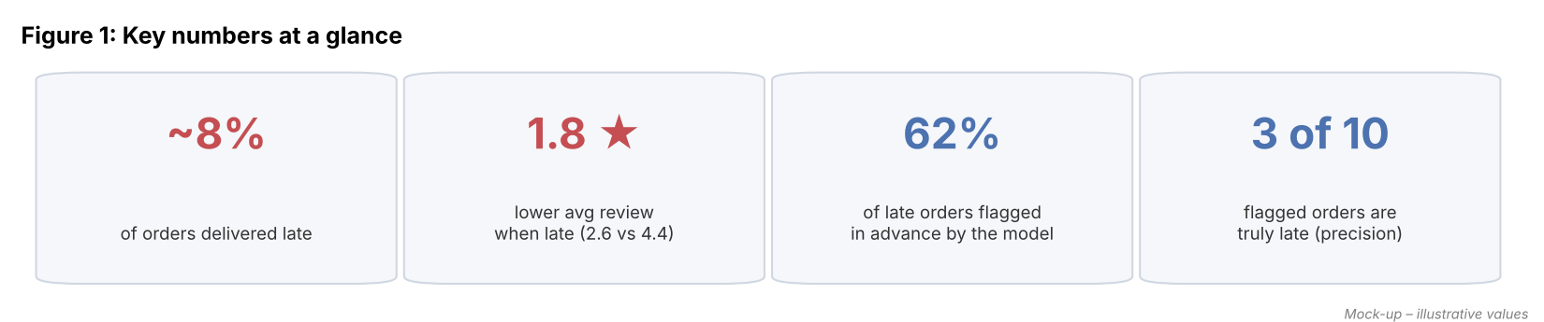
Figure 1: Key numbers at a glance (mock-up)

Insight 1 – Late delivery strongly damages customer ratings
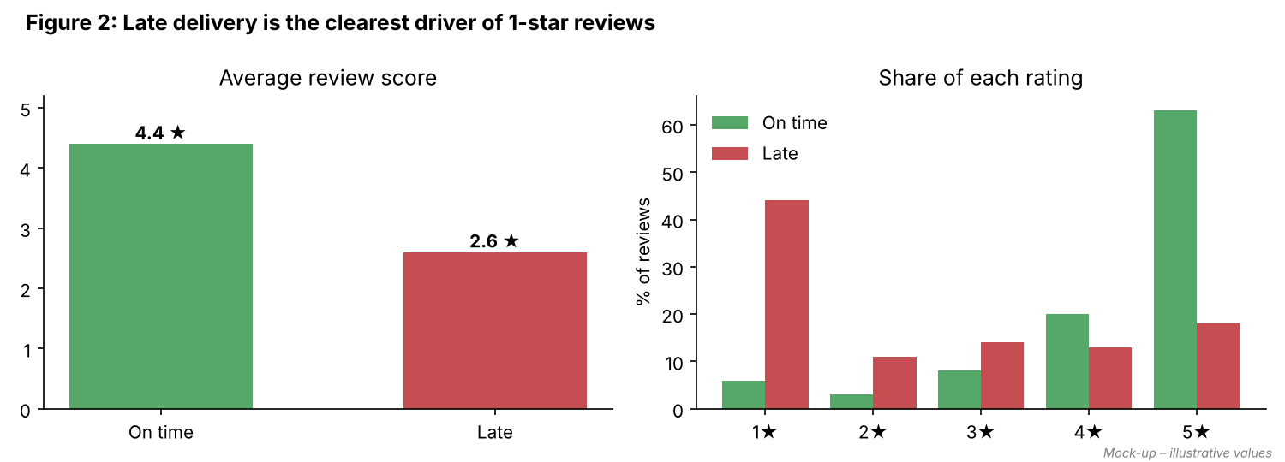
Figure 2: Review scores for late vs on-time orders (mock-up)
On-time orders receive an average of 4.4★, while late orders receive 2.6★. Almost half of late orders get a 1-star review, compared to only about 6% of on-time orders. A Mann-Whitney U test would confirm that this difference is statistically significant (p < 0.001).
So what? reducing late deliveries is one of the most direct ways to improve the marketplace's overall rating – even small improvements in on-time delivery should show up in reviews.

Insight 2 – Late deliveries spike in three specific months (trend and anomalies)
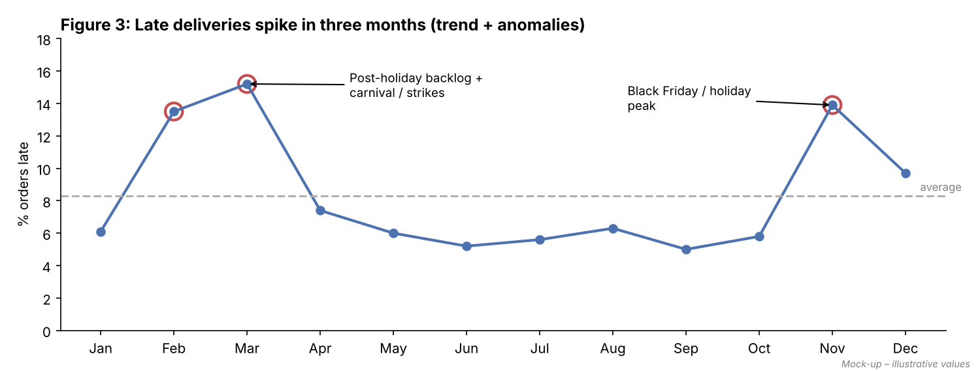
Figure 3: Monthly late-delivery rate with anomalies highlighted (mock-up)
For most of the year the late rate stays around 5–7%. November stands out (about 14%) because of Black Friday and holiday volumes. February and March are the biggest anomaly at 13–15%. These are likely linked to the backlog after the holidays, Carnival, and logistics disruptions such as truck driver strikes reported in Brazil during 2018.
So what? the current delivery estimate does not adjust for seasonal load. Delivery promises should be longer in these months, and logistics capacity should be planned ahead.

Insight 3 – Remote regions are served much worse
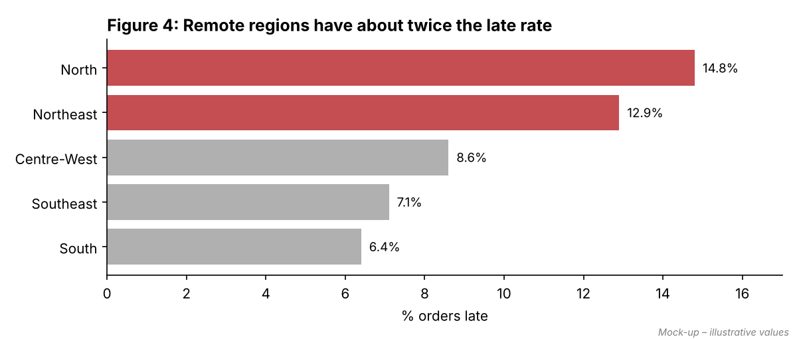
Figure 4: Late-delivery rate by customer region (mock-up)
Customers in the North (14.8%) and Northeast (12.9%) are about twice as likely to receive a late order as customers in the South and Southeast. Most sellers are based in the Southeast (especially São Paulo), so orders to these regions travel much longer distances, often through fewer courier routes. A Chi-square test would show that region and late delivery are clearly related.
So what? customers in these regions are getting a worse experience. Region-specific delivery estimates and partnerships with regional couriers or local sellers could close the gap.

Insight 4 – Long distance plus a tight promise is the real problem
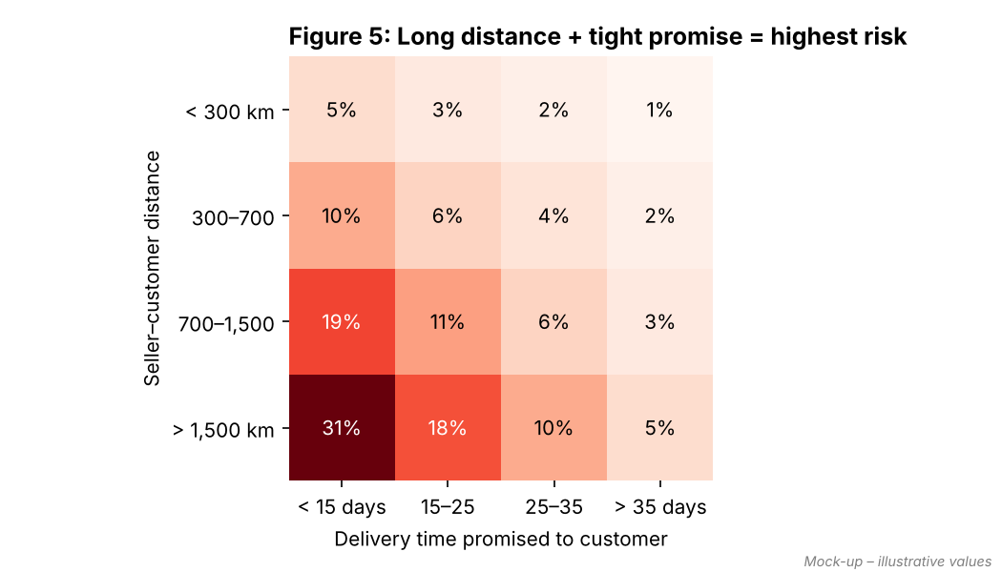
Figure 5: Late-delivery rate by distance and promised delivery time (mock-up)
Distance alone does not explain everything. When a long-distance order (over 1,500 km) is given a generous delivery estimate (over 35 days), only about 5% are late. But when the same distance is combined with a promise of less than 15 days, the late rate jumps to about 31%. This shows that the estimate is often unrealistic for long routes.
So what? the fastest fix is not only faster shipping. It is making the promised date match the actual route – a business decision that costs nothing to implement.

Insight 5 – Late orders can be predicted in advance
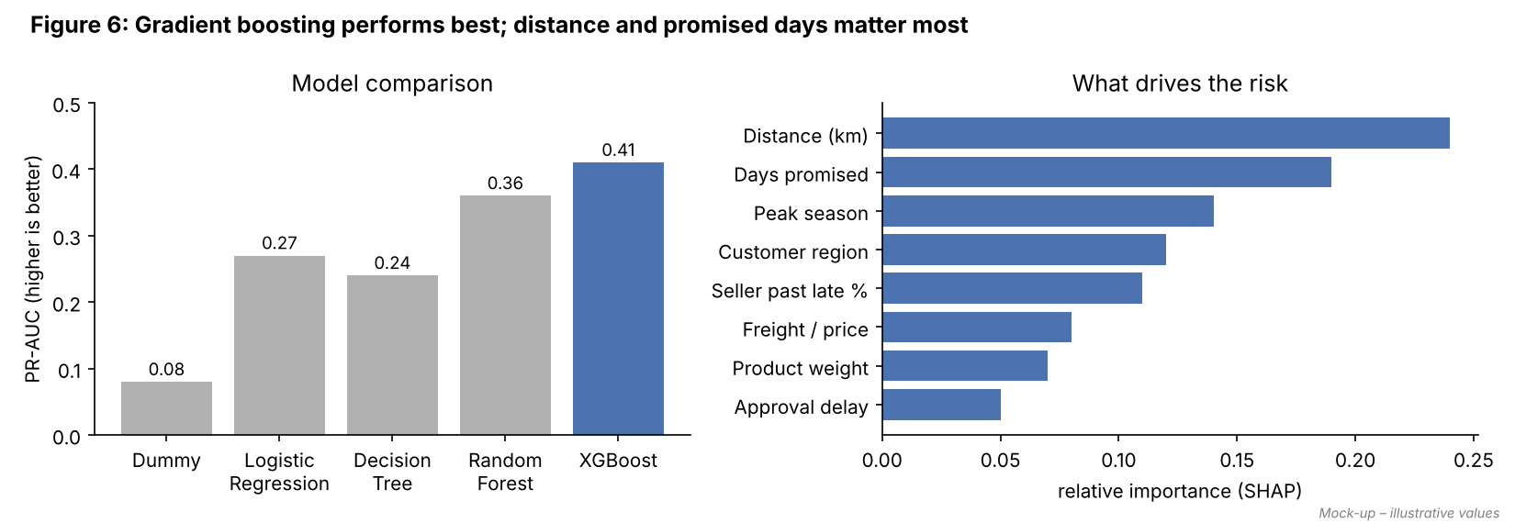
Figure 6: Model comparison and main risk drivers (mock-up)
Five models were compared using PR-AUC, which measures how well a model finds the rare late orders. XGBoost performed best (0.41), clearly ahead of Logistic Regression (0.27) and far above the random baseline (0.08, equal to the late rate). The most important factors were distance, days promised, peak season, customer region and the seller's past late rate – which matches the patterns found in the exploratory analysis.

Model | PR-AUC | ROC-AUC | Recall | Precision | F1
Dummy (baseline) | 0.08 | 0.50 | 0.08 | 0.08 | 0.08
Logistic Regression | 0.27 | 0.72 | 0.58 | 0.19 | 0.29
Decision Tree | 0.24 | 0.69 | 0.55 | 0.18 | 0.27
Random Forest | 0.36 | 0.78 | 0.60 | 0.29 | 0.39
XGBoost (chosen) | 0.41 | 0.80 | 0.62 | 0.33 | 0.43
Table: Test-set results on the newest 15% of orders, recall and precision at the chosen threshold (mock-up values)

Insight 6 – Choosing how many alerts to raise is a business decision
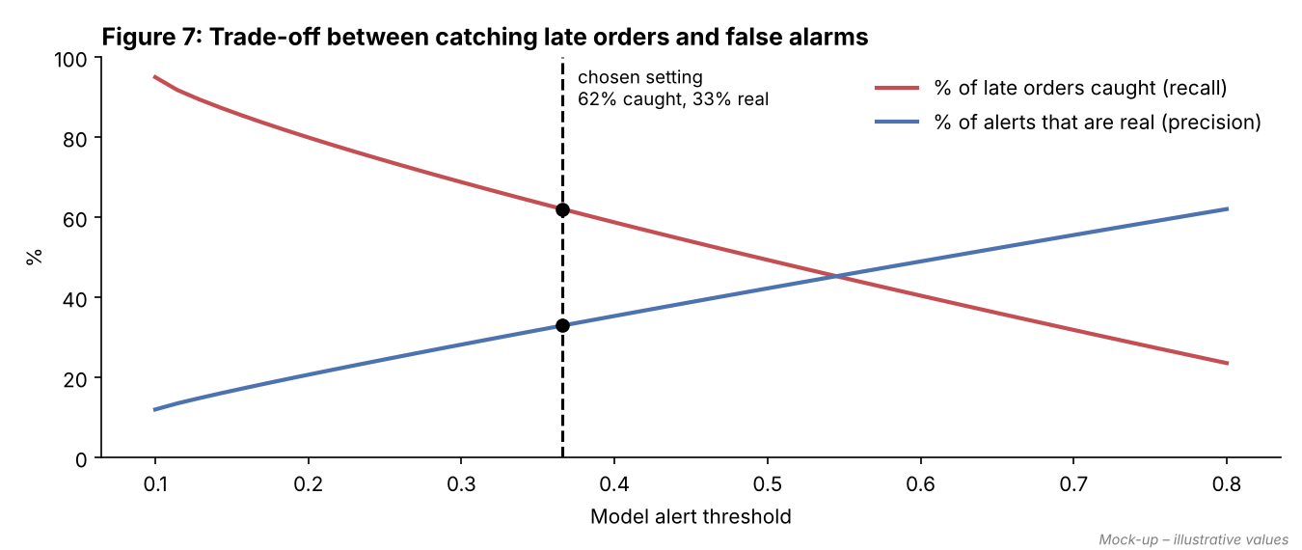
Figure 7: Trade-off between catching late orders and false alarms (mock-up)
The model gives each order a risk score. If the alert threshold is set low, more late orders are caught, but more on-time orders are wrongly flagged. The chosen setting catches 62% of late orders, with about 1 in 3 alerts being correct. In practical terms, for every 10,000 orders:
Outcome (per 10,000 orders) | Approximate count
Truly late orders | 800
Late orders flagged in advance | ≈ 500
Late orders missed | ≈ 300
Total alerts raised | ≈ 1,500
False alarms (flagged but arrived on time) | ≈ 1,000

A false alarm costs very little – at most a 'your order may take a little longer' message, or slightly faster handling of an order that would have been fine anyway. Missing a late order costs a likely 1-star review. So accepting more false alarms in exchange for higher recall is reasonable here.

5. Actionable Insights
Insight | Action | Owner | Expected impact
Tight promises on long routes cause most delays | Add buffer days to estimates based on distance band and region | Product / logistics | Fewer missed promises; quick win
Peak months double the late rate | Seasonal estimate adjustment; book extra courier capacity before Nov and Feb | Operations | Lower peak-season late rate
Remote regions get worse service | Regional courier partners; promote sellers located in those regions | Business development | Narrower regional gap
Late orders can be flagged early | Use risk score to send proactive delay messages and prioritise high-risk parcels | Customer support / logistics | Fewer complaints, softer rating impact
Some sellers are repeatedly late | Share seller-level late rates; set dispatch-time targets | Seller management | Better seller performance

6. Visualization Plan
Every visual in the final report and presentation answers one specific question. The table below lists the planned visuals, the type of insight each one shows, and why that chart type was chosen.

Visual | Chart type | Insight type | Rationale
Key numbers | KPI tiles | Summary | Busy executives see the main message in 5 seconds
Late % by month | Line chart with highlighted points | Trend + anomalies | Lines show change over time best; circles draw the eye to unusual months
Late % by region | Sorted horizontal bar, problem bars in red | Comparison | Sorted bars make ranking obvious; colour shows which ones need attention
Distance × promised days | Annotated heatmap | Interaction | Shows that two factors together matter more than each alone
Review score impact | Bar chart + grouped bars | Statistical / impact | Links the technical problem to something business cares about (ratings)
Model comparison | Bar chart, chosen model highlighted | Statistical | Justifies the model choice without technical tables on the slide
Risk drivers | Horizontal bar (SHAP importance) | Explanation | Explains 'why' the model flags an order, in plain feature names
Threshold trade-off | Two-line chart with chosen point | Decision support | Lets the business choose how many alerts it wants to handle
Per 10,000 orders table | Simple table | Business translation | Turns percentages into real counts people can picture
Interactive dashboard (optional) | Plotly / Streamlit with region and month filters | Exploration | Lets operations teams explore their own region

6.1 Design Rules for All Visuals
- Title states the finding (for example, 'Remote regions have about twice the late rate'), not just the topic.
- Red is used only for 'late / problem', green for 'on time'; everything else is grey, so attention goes where it should.
- Rates (%) are shown instead of raw counts when comparing groups of different sizes.
- Gridlines, 3D effects and unnecessary legends are removed; values are labelled directly on bars.
- A colour-blind safe palette is used, with labels so meaning never depends on colour alone.
- Each chart has a one-line 'so what' underneath.

7. Presentation Strategy

7.1 Know the Audience
Audience | What they care about | How to present
Senior management | Business impact, cost, decision needed | 10-minute deck, headline numbers, 3 recommendations, clear ask
Operations / logistics | Where and when problems happen; what to do daily | Regional and monthly breakdowns, dashboard, alert workflow
Customer support | Which customers to contact and what to say | Simple risk flag, message templates
Data / tech team | Method, validity, how to maintain | Technical appendix, notebook, GitHub repository

7.2 Storytelling Approach
The presentation follows a Situation → Complication → Resolution structure. A story with a clear problem and solution is much easier to remember than a list of charts. Each slide carries one message, and the slide title is that message.
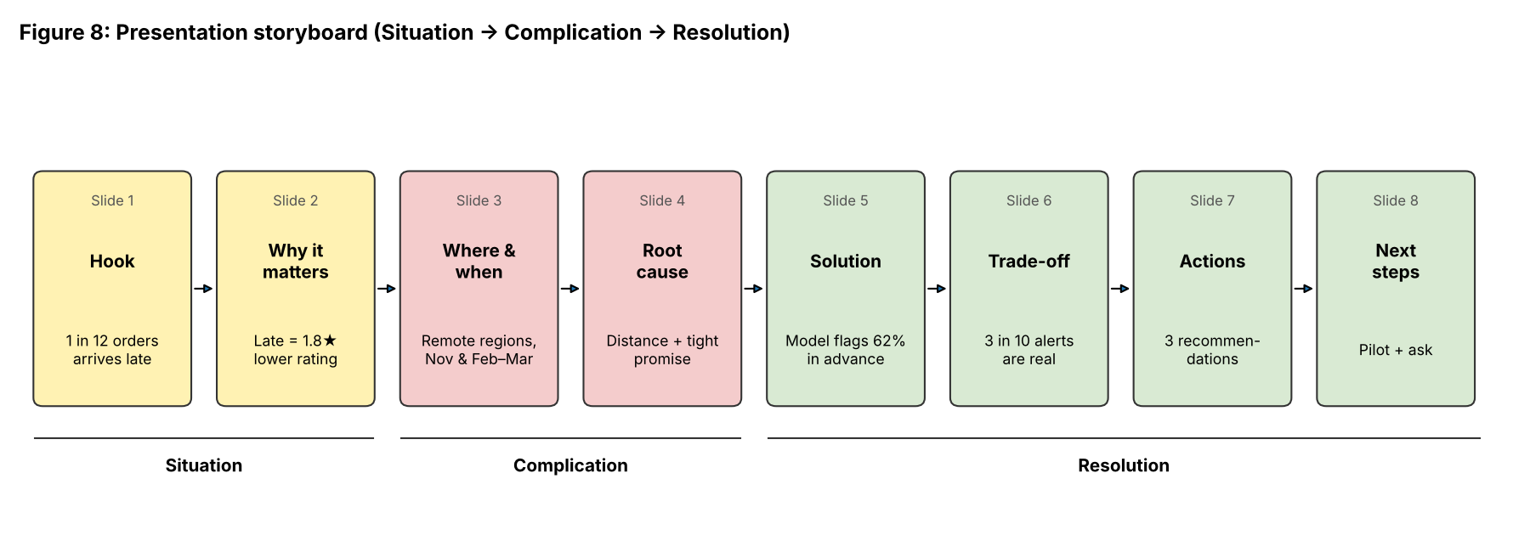
Figure 8: Presentation storyboard
Slide | Headline (the message) | Visual / content
1 | 1 in 12 orders arrives late – and customers notice | KPI tiles
2 | Late orders get ratings almost 2 stars lower | Review score bar chart
3 | The problem doubles in November and Feb–March | Monthly trend with anomalies
4 | Remote regions get twice the late rate | Sorted region bar chart
5 | Long distance + tight promise is the main cause | Heatmap
6 | We can flag 6 in 10 late orders in advance | Model comparison + top risk drivers
7 | We choose how many alerts we want to handle | Trade-off chart + per-10,000 table
8 | Three actions to reduce late deliveries | Action table
9 | Proposal: 3-month pilot in the Northeast | Timeline, success metrics, ask
Appendix | Method, validation, limitations | Technical details for questions

7.3 Communicating Technical Results to Non-technical People
- Avoid jargon on main slides: say '6 in 10 late orders caught' instead of 'recall = 0.62', and 'how often an alert is right' instead of 'precision'.
- Use counts people can picture ('per 10,000 orders') rather than only percentages or AUC values.
- Use analogies – the model is like a weather forecast: it gives a chance of delay, not a guarantee.
- Be honest about limitations: the model will miss some late orders and raise some false alarms, and it cannot see weather or strikes.
- End with a clear decision request, not just information.

7.4 Formats and Delivery
- Main deck: 9 slides, about 10 minutes, plus 5 minutes for questions.
- One-page summary (PDF) for people who cannot attend.
- Interactive dashboard for operations teams.
- Technical appendix and GitHub repository for the data team.
- Preparation: rehearse twice, keep each slide under a minute, and prepare backup slides for expected questions (for example, 'Why not just ship faster?', 'How much will this cost?', 'How often must the model be updated?').

8. Recommendations

8.1 Business Recommendations
- Smarter delivery estimates (quick win): adjust the promised date using distance, region and season. This needs no new infrastructure and directly addresses the biggest risk factor.
- Proactive alerts: use the risk score to send early 'your order may take a little longer' messages to high-risk orders. Honest early communication usually reduces complaints more than a silent delay.
- Prioritise high-risk shipments: share daily high-risk lists with courier partners for faster handling.
- Peak-season planning: increase courier capacity and extend estimates before Black Friday and in February–March.
- Seller accountability: track seller dispatch times and late rates; support or warn consistently late sellers.
- Pilot first: run a 3-month pilot in the Northeast. Measure late rate, average rating and complaint volume against a comparable control region before full rollout.

8.2 Recommendations for Future Work and Research
- Add external data – weather, public holidays, strikes and courier performance – which the current model cannot see.
- Predict how many days late an order will be (regression), not only whether it will be late.
- Update the risk score at each stage of the order (approval, dispatch, in transit) as new information arrives.
- Use causal methods or A/B tests to measure the real effect of proactive messages and changed estimates on ratings.
- Analyse review text (NLP) to see what late customers complain about most.
- Set up monitoring for data drift and schedule retraining so the model stays accurate as the business changes.

9. Limitations
- This is a hypothetical project; all numbers in this report are illustrative mock-ups.
- The underlying dataset covers 2016–2018 in Brazil. Patterns may differ for other countries or more recent years.
- Many causes of delay (weather, strikes, courier issues) are not in the data.
- The analysis shows associations, not proven causes. The pilot and A/B tests are needed to confirm the effect of the recommendations.
- Only delivered orders were analysed; cancelled orders may hide additional delivery problems.

10. Conclusion
Late delivery affects about 1 in 12 orders and has a clear, negative effect on customer ratings. The analysis shows that the problem is concentrated in specific regions and months, and mainly comes from long routes combined with delivery promises that are too optimistic. A gradient boosting model can flag a majority of late orders right after payment approval, giving the business time to act.
The most valuable outcome is not the model alone but the combination of three things: realistic delivery promises, early warnings for risky orders, and better planning for peak periods. Presented through a clear story with simple visuals and an honest view of the trade-offs, these results can help a non-technical team make a confident decision – starting with a small pilot.
Working on this project end to end – from defining the problem to planning how to communicate it – showed me that a data science project is only useful when its results are understood and acted upon. The communication plan matters as much as the model.

Appendix A – Plain-language Glossary
Term | Simple meaning
Recall | Out of all late orders, how many the model caught
Precision | Out of all orders the model flagged, how many were really late
F1-score | One number that balances recall and precision
ROC-AUC / PR-AUC | How well the model ranks risky orders above safe ones (higher is better)
Threshold | The risk level above which an order is flagged
Cross-validation | Testing the model on several different time periods to make sure results are stable
SHAP | A method that shows which factors pushed a particular order's risk up or down
Data leakage | Accidentally using information that would not be available at prediction time

Appendix B – Time Allocation for Week 4
Activity | Hours
Consolidating methodology and writing the executive summary | 5
Writing insights and analysis | 7
Designing mock-up visualizations (mockup_charts.py) | 6
Presentation strategy and storyboard | 5
Recommendations, limitations and conclusion | 4
Review, formatting and GitHub update | 5
Total | 32

References
- Olist – Brazilian E-Commerce Public Dataset, Kaggle
- Knaflic, C. N. (2015). Storytelling with Data. Wiley.
- Minto, B. (2009). The Pyramid Principle. Pearson.
- Chen, T. & Guestrin, C. (2016). XGBoost: A Scalable Tree Boosting System. KDD.
- Lundberg, S. & Lee, S. (2017). A Unified Approach to Interpreting Model Predictions. NeurIPS.

