Week 3 Report
Python-Based Machine Learning Model Development and Evaluation Plan
Project: Predicting Late Deliveries for an E-commerce Platform
Name: Anish Goyal
Internship: Virtual Data Science Explorer Intern (Yuva Intern)
Internship Period: 23 July 2026 – 20 August 2026
Task: Week 3 – ML Model Development and Evaluation Plan
GitHub: github.com/anishgoyal0603/ecommerce-late-delivery-prediction

1. Introduction
In the first two weeks I planned the late delivery prediction project (Week 1) and designed the EDA and visualization framework (Week 2). This week's task is the next step: planning how the actual machine learning model would be built, trained, tuned, evaluated and, optionally, deployed and maintained.
The task says that no code execution is needed. I have still written the plan in a way that can be implemented directly. Alongside this report, I added a scikit-learn pipeline template (ml_pipeline.py) to my GitHub repository that follows exactly the steps described here. It runs end to end on a simulated sample, which only confirms the code works. No results from it are reported here, because they would not mean anything on simulated data.

2. Problem Definition
An online marketplace shows every customer an estimated delivery date. Some orders arrive after this date, which leads to complaints, low ratings and fewer repeat orders. The goal is to predict, at the time an order is placed and approved, whether it is likely to be delivered late.

Item | Definition
ML task type | Supervised learning – binary classification
Unit of prediction | One delivered order
Target variable | is_late = 1 if actual delivery date > estimated delivery date, else 0
Prediction time | Right after payment approval, so only information known at that moment can be used
Model output | Probability of the order being late (0 to 1), converted to a yes/no flag using a chosen threshold
Data | Olist Brazilian E-Commerce dataset, cleaned and merged to one row per order (Weeks 1–2)
Who uses the output | Customer support and logistics teams

Fixing the prediction time is important. Columns such as the carrier delivery date or the review score only exist after the order has moved forward. If they are used as features, the model would look very accurate in testing but would be useless in real life. This is called data leakage, and the whole plan is designed to avoid it.

3. Justification of the Problem and Approach

3.1 Why this problem?
- Clear business value: catching even part of the late orders in advance lets the company inform customers or push those shipments, which protects ratings and repeat sales.
- Measurable target: late or not late can be calculated directly from the data, so no manual labelling is needed.
- Enough data: around 100,000 orders give enough examples to train and test a model properly.

3.2 Why machine learning and not simple rules?
A simple rule like 'flag all orders over 1,000 km' would catch some late orders, but delays depend on several factors together – distance, region, season, how many days were promised, product size and so on. Writing rules for all these combinations by hand is not practical, and they would quickly become outdated. A machine learning model can learn these combinations from historical data and give a probability, which is more flexible than a fixed yes/no rule.
Still, a simple rule-based or dummy model will be kept as a baseline. A complex model is only worth using if it clearly beats the simple approach.

4. Machine Learning Workflow
Figure 1 shows the complete workflow I plan to follow. The most important design choices are: the data is split by time before any preprocessing, all preprocessing is learned only from training data, and the test set is used only once at the very end.
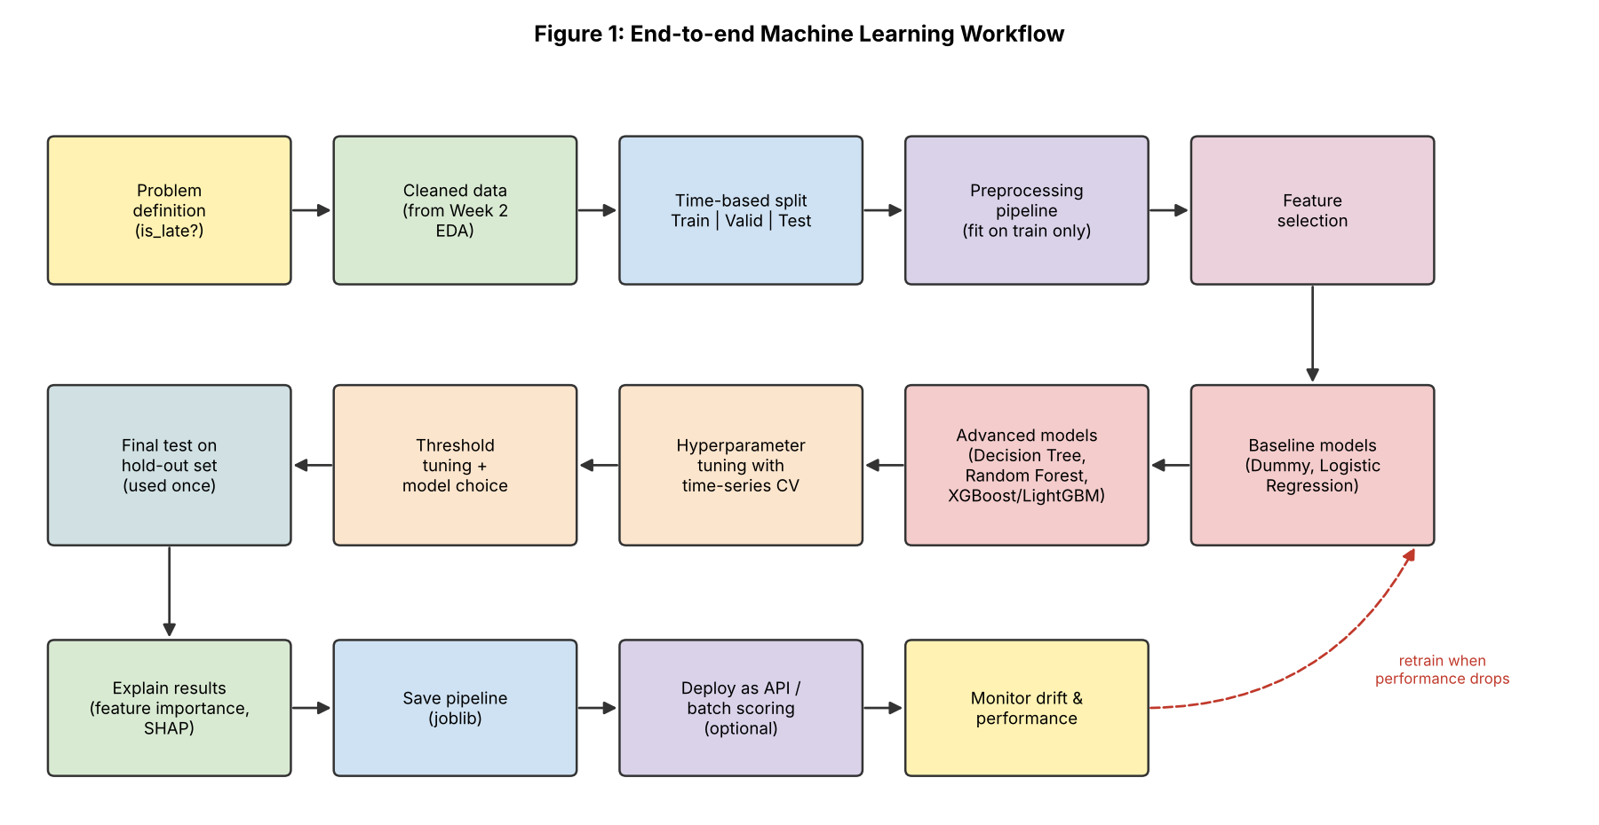
Figure 1: End-to-end machine learning workflow

5. Data Preprocessing

5.1 Data Cleaning
Most of the cleaning was planned in Week 2. The steps that matter directly for modelling are:
- Keep only orders with status 'delivered' and a valid actual delivery date.
- Remove impossible records – delivery before purchase, zero or negative price or weight.
- Remove duplicate order IDs created while merging tables.
- Aggregate orders with multiple items or sellers to one row (total weight, total freight, maximum distance, number of sellers).
- Drop all columns that are only known after the prediction time (carrier date, delivered date, review score and comment).

5.2 Train / Validation / Test Split – done first
The data will be sorted by purchase date and split into three parts: the oldest 70% for training, the next 15% for validation, and the newest 15% for final testing (Figure 3a). A random split is not used, because in real use the model will always predict future orders using past data. A time-based split gives a more honest estimate of real performance. The split is done before preprocessing, so that values like medians or encodings are learned only from the training data.

5.3 Handling Missing Values
- Numerical (e.g. product weight, dimensions): median imputation, since these columns are skewed.
- Categorical (e.g. product category): most frequent value, or a separate 'unknown' category.
- A missing-indicator flag will be tested for columns where missing values may themselves carry information.

5.4 Encoding Categorical Variables
Column type | Method | Reason
Few categories (payment type, region, weekday) | One-hot encoding | Simple; no false order between categories
Many categories (70+ product categories, 27 states) | Target encoding (with CV) or frequency encoding | Avoids hundreds of sparse columns
Binary (same_state, peak_season) | 0 / 1 | Already numeric
Cyclical (month) | One-hot, or sine/cosine encoding | December is close to January, not far from it

5.5 Normalization / Scaling
Not every model needs scaling. Tree-based models (Decision Tree, Random Forest, XGBoost) split on thresholds and are not affected by scale. Logistic Regression, which uses regularisation, does need features on a similar scale. So scaling will be part of the pipeline and will mainly matter for the linear model.
- Log transform (log1p) for right-skewed features: price, freight, weight, volume, distance.
- StandardScaler (mean 0, standard deviation 1) after the log transform.
- RobustScaler as an alternative if outliers still affect results.

5.6 Feature Engineering
Feature | How it is created | Why it may help
distance_km | Haversine distance between seller and customer coordinates | Longer distance → more chance of delay
estimated_days | Estimated delivery date − purchase date | A tight promise is easier to miss
approval_hours | Approval time − purchase time | Slow approval eats into delivery time
same_state | 1 if seller and customer are in the same state | Local deliveries are usually faster
customer_region | Map 27 states to 5 regions | Reduces categories; captures remote regions
freight_ratio | freight_value / price | High relative freight may mean bulky or remote orders
product_volume_cm3 | length × height × width | Bulky items may need special handling
n_items, n_sellers | Count per order | Multi-seller orders need more coordination
purchase_month, weekday | From purchase timestamp | Seasonality and weekend effects
is_peak_season | 1 for November–December (Black Friday, holidays) | Logistics load is highest then
seller_past_late_rate | Seller's late % on earlier orders only | Some sellers ship slowly (must use only past data)

5.7 Feature Selection
After feature engineering there may be features that are redundant or not useful. I plan to use three types of methods:
- Filter methods: remove features with near-zero variance, and drop one feature from pairs with correlation above about 0.9 (for example, freight value and distance may be strongly correlated). Mutual information scores will be used to rank features.
- Embedded methods: L1 (Lasso) regularised Logistic Regression and tree-based feature importance show which features the models actually use.
- Wrapper / permutation check: permutation importance on the validation set. Features whose removal does not reduce PR-AUC can be dropped.
The aim is a smaller, more stable feature set, which is also easier to explain.

5.8 Handling Class Imbalance
Late orders are expected to be a small share (well under 10%). If this is ignored, a model can simply predict 'on time' for everything and still look accurate. Options, in the order I will try them:
- Class weights (class_weight='balanced' in scikit-learn, scale_pos_weight in XGBoost) – the simplest option, with no change to the data.
- Adjusting the decision threshold instead of using the default 0.5 (Section 8.3).
- SMOTE oversampling, applied only inside training folds, if the first two are not enough.

5.9 Putting it Together – the Pipeline
All preprocessing steps are combined with the model in a single scikit-learn Pipeline (Figure 2). This guarantees that during cross-validation, imputation values, scaling and encodings are learned only from the training part of each fold. That prevents leakage and makes the final model easy to save and reuse.
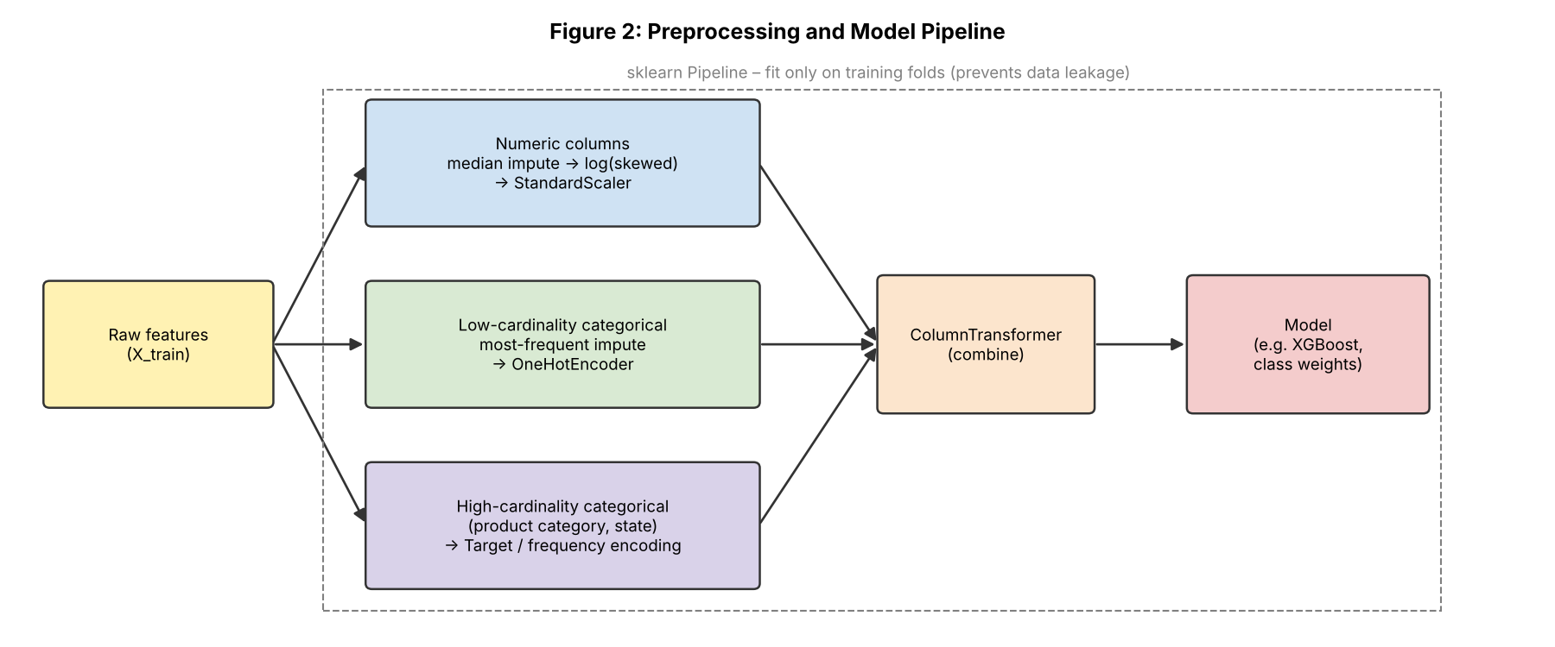
Figure 2: Preprocessing and model pipeline
preprocess = ColumnTransformer([
('skewed', Pipeline([('impute', SimpleImputer(strategy='median')),
('log', FunctionTransformer(np.log1p)),
('scale', StandardScaler())]), SKEWED_COLS),
('categorical', Pipeline([('impute', SimpleImputer(strategy='most_frequent')),
('onehot', OneHotEncoder(handle_unknown='ignore'))]), CAT_COLS),
])
model = Pipeline([('prep', preprocess), ('clf', XGBClassifier(scale_pos_weight=w))])

5.10 Preprocessing Challenges and Solutions
Challenge | Solution
Data leakage from future columns | Fix the prediction time; drop post-approval columns; split by time first
Leakage through target encoding | Compute encodings inside CV folds only
seller_past_late_rate uses future orders | Calculate it using only orders before the current order date
New categories in test data (new seller state, new category) | OneHotEncoder(handle_unknown='ignore'), group rare values as 'Other'
Skewed features and outliers | log1p transform; cap at the 99th percentile for the linear model
Class imbalance | Class weights, threshold tuning, SMOTE only inside folds
Multiple items / sellers per order | Aggregate to order level before modelling

6. Model Selection

6.1 Candidate Models
The task mentions linear regression, decision trees and ensemble methods. Since this is a classification problem (late or not late), plain linear regression is not suitable – it can predict values below 0 or above 1. Its classification counterpart, Logistic Regression, will be used instead. The candidates are:

Model | Strengths | Weaknesses
Dummy classifier | Shows the minimum score any model must beat | No real predictive power
Logistic Regression | Fast, easy to interpret (coefficients), gives well-calibrated probabilities | Only learns linear relationships unless features are engineered; needs scaling
Decision Tree | Very easy to explain as rules; handles non-linear patterns; no scaling needed | Overfits easily; unstable – small data changes can give a different tree
Random Forest | Many trees reduce overfitting; robust to outliers; good default results | Slower; larger model; less interpretable than one tree
XGBoost / LightGBM (gradient boosting) | Usually the best accuracy on tabular data; handles missing values; supports class weights and early stopping | More hyperparameters; can overfit if not tuned; needs SHAP to explain

Models like k-Nearest Neighbours and SVM were considered but are not planned. They are slow on around 100,000 rows, sensitive to scaling, and generally do not perform better than tree ensembles on this kind of tabular data.

6.2 Chosen Model and Argument
My planned final model is a gradient boosting model (XGBoost, or LightGBM if training speed becomes an issue), with Logistic Regression kept as the interpretable benchmark. The reasons are:
- The data is tabular with a mix of numerical and categorical features, which is where gradient boosting usually performs best.
- Delays most likely come from interactions (for example, long distance and peak season and a short estimate together). Trees capture these automatically, while Logistic Regression would need them created by hand.
- XGBoost handles missing values and class imbalance (scale_pos_weight) natively, and early stopping helps against overfitting.
- With SHAP values, its predictions can still be explained to the business team.
However, the choice will be confirmed by results and not assumed. If XGBoost is only marginally better than Logistic Regression (for example, less than 0.01–0.02 in PR-AUC), I would prefer the simpler and more interpretable Logistic Regression.

7. Training Process and Hyperparameter Tuning

7.1 Training Steps
- Step 1: Train the Dummy and Logistic Regression baselines with default settings and record scores.
- Step 2: Train Decision Tree, Random Forest and XGBoost with reasonable defaults and compare them using time-series cross-validation on the training period.
- Step 3: Shortlist the best one or two models and tune their hyperparameters.
- Step 4: Use the validation set to choose the decision threshold and check calibration.
- Step 5: Retrain the final model on training + validation data with the chosen settings.
- Step 6: Evaluate once on the untouched test set and report the results.

7.2 Hyperparameter Tuning Strategies
Strategy | How it works | When I would use it
Grid search | Tries every combination from a fixed list | Small search spaces, e.g. C for Logistic Regression
Random search | Tries a fixed number of random combinations | First pass for Random Forest / XGBoost – usually finds good settings much faster than grid search
Bayesian optimisation (Optuna) | Uses past trials to choose the next promising settings | Final fine-tuning of XGBoost if time permits
Early stopping | Stops adding trees when validation score stops improving | Always for boosting – sets n_estimators automatically

All tuning will use time-series cross-validation and optimise PR-AUC (average precision), since this metric focuses on the rare late class. Planned search ranges:
Model | Hyperparameter | Range to search
Logistic Regression | C (inverse regularisation) | 0.001 – 100 (log scale)
Logistic Regression | penalty | L1, L2
Random Forest | n_estimators | 200 – 800
Random Forest | max_depth / min_samples_leaf | 5 – 30 / 1 – 20
Random Forest | max_features | sqrt, log2, 0.5
XGBoost | learning_rate | 0.01 – 0.1
XGBoost | max_depth | 3 – 8
XGBoost | subsample, colsample_bytree | 0.6 – 1.0
XGBoost | min_child_weight, reg_lambda | 1 – 10, 0 – 10

7.3 Avoiding Overfitting
- Compare training and validation scores – a large gap means overfitting.
- Plot learning curves to see whether more data or a simpler model would help.
- Use regularisation (C for Logistic Regression; max_depth, min_child_weight and reg_lambda for XGBoost).
- Use early stopping in boosting.
- Never tune anything on the test set.

8. Evaluation Metrics

8.1 Why Accuracy Alone is Not Enough
Suppose 92 out of 100 orders are on time. A model that always says 'on time' gets 92% accuracy but catches zero late orders, which is the whole point of the project. So accuracy will be reported but not used to choose the model. The metrics below are used instead, and all of them are based on the confusion matrix (Figure 4).
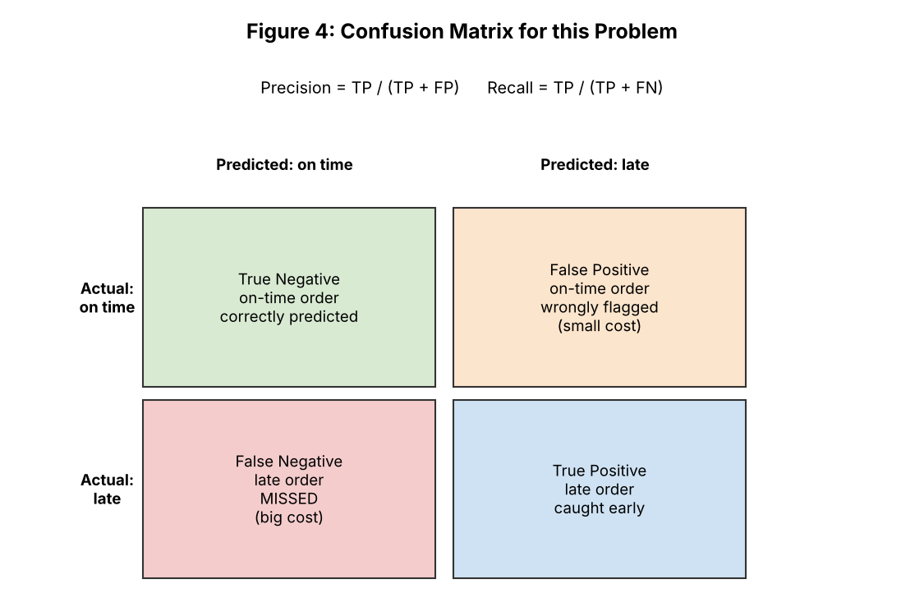
Figure 4: Confusion matrix explained for this problem
Metric | Formula | What it tells us here
Accuracy | (TP + TN) / total | Overall correct predictions. Misleading with imbalanced classes – reported only for reference.
Precision | TP / (TP + FP) | Of the orders we flag as late, how many really are late. Low precision means the team wastes effort on false alarms.
Recall | TP / (TP + FN) | Of all truly late orders, how many we catch. The most important metric here, since missed late orders are the costly mistake.
F1-score | 2 × P × R / (P + R) | Balance between precision and recall in one number; useful for comparing models at a fixed threshold.
ROC-AUC | Area under the TPR vs FPR curve | How well the model ranks late orders above on-time ones, across all thresholds. 0.5 = random, 1.0 = perfect.
PR-AUC (average precision) | Area under the precision–recall curve | Like ROC-AUC, but focused on the rare positive class. My main metric for model selection and tuning.
Brier score / calibration curve | Mean squared error of probabilities | Checks whether a predicted 30% risk really means about 30% of such orders are late.

8.2 Primary and Secondary Metrics
- Primary (model selection and tuning): PR-AUC.
- Business metric (final threshold): Recall on the late class, with a minimum acceptable precision.
- Reported alongside: ROC-AUC, F1-score, accuracy, the full confusion matrix, and the calibration curve.

8.3 Choosing the Decision Threshold
By default a model predicts 'late' when the probability is above 0.5. With imbalanced data, a lower threshold often works better. I will use the validation set to plot precision and recall for every threshold, and pick the one that gives the highest recall while keeping precision above an agreed minimum (for example 30%, meaning at least 3 of every 10 flagged orders are truly late). This turns the business trade-off into a clear, explainable rule.

9. Validation Strategy
Validation answers the question: will the model perform similarly on new orders it has never seen? A single train/test split can be lucky or unlucky, so cross-validation is used to get a more reliable estimate.
Method | How it works | Use in this project
Hold-out split | Keep part of data aside for testing | Final 15% newest orders = test set, used once
k-fold CV | Split into k parts, train on k−1, test on 1, repeat k times | Not used – it mixes future data into training
Stratified k-fold | k-fold that keeps the same class ratio in every fold | Only for a quick sanity check
Time-series CV (expanding window) | Each fold trains on older data and validates on the next period | Main method for model comparison and tuning
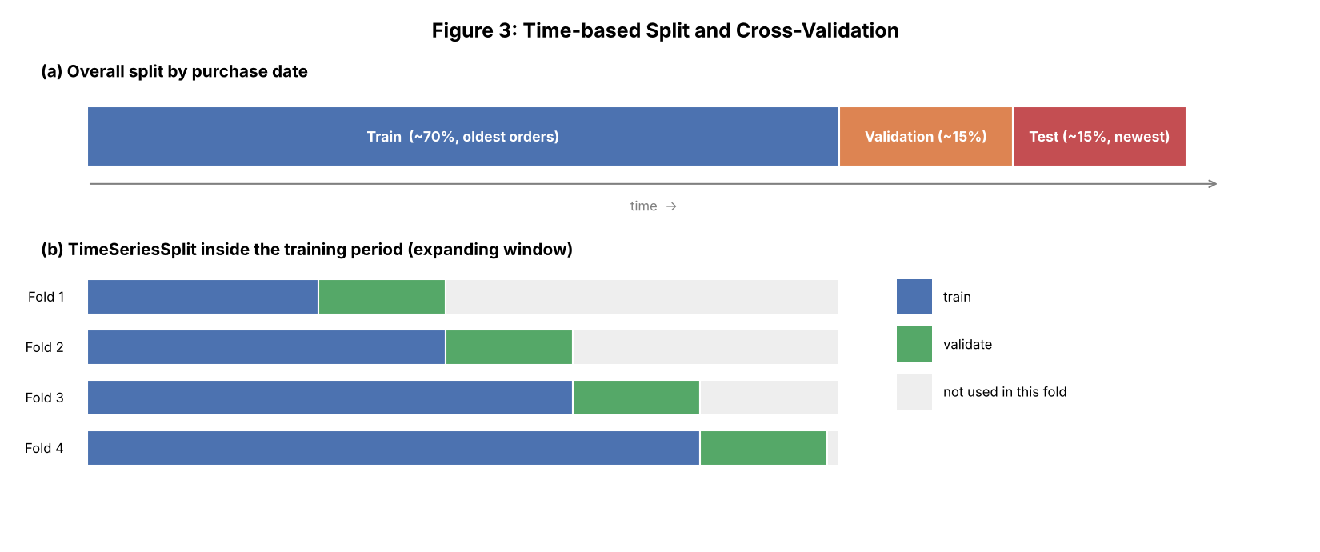
Figure 3: (a) Time-based train/validation/test split and (b) time-series cross-validation

9.1 How Cross-Validation Makes the Result Robust
- Every fold gives a score, so I can report the mean and standard deviation (for example, PR-AUC 0.42 ± 0.03). A small standard deviation means the model is stable.
- Hyperparameters are chosen based on the average across folds, not on one lucky split, which reduces overfitting to a particular period.
- The time-series folds also show whether performance drops in newer periods, which is an early warning of drift.
- Because preprocessing sits inside the Pipeline, it is re-fitted in each fold, so the validation part of each fold stays truly unseen.
- The test set is touched only once at the end, so the final reported number is an honest estimate.

10. Model Interpretation
Since the output will be used by people in operations, they should understand why an order is flagged. Planned methods:
- Logistic Regression coefficients – direction and strength of each feature.
- Feature importance from Random Forest / XGBoost.
- Permutation importance on the validation set – model-independent and more reliable than built-in importance.
- SHAP values – global summary plot of the top drivers, and a per-order explanation (for example: 'high risk because distance is 2,100 km and it was ordered in peak season').

11. Model Deployment and Maintenance (Optional)
Full deployment is outside the scope of this internship, but planning it helps show how the model would actually be used and kept useful over time (Figure 5).
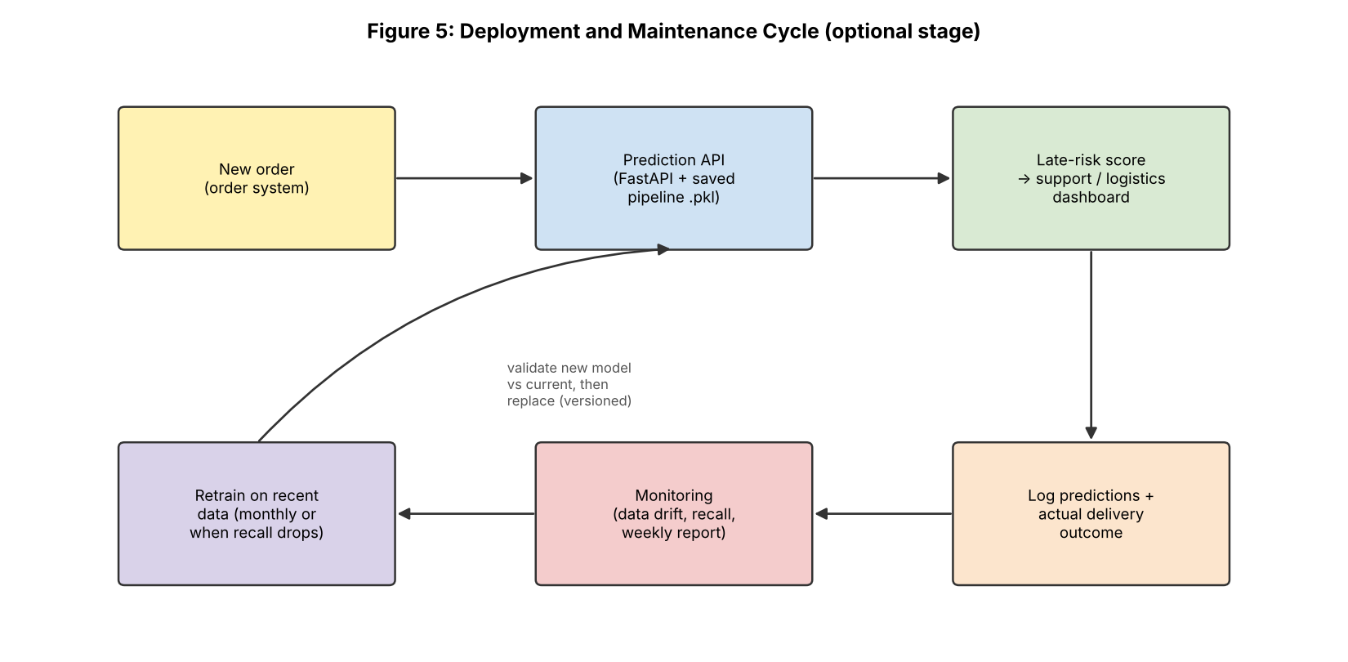
Figure 5: Deployment and maintenance cycle

11.1 Deployment
- Save the whole Pipeline (preprocessing + model + chosen threshold) as a single file using joblib, so the same transformations run at prediction time.
- Wrap it in a small FastAPI service: the order system sends order details and gets back a late-risk probability and flag.
- Package it with Docker so it runs the same everywhere.
- Alternatively, run batch scoring every few hours on newly approved orders and push the results to a dashboard.
- A simple Streamlit page can be used as a demo for non-technical users.

11.2 Monitoring and Maintenance
- Log every prediction with the actual delivery outcome once it is known.
- Data drift: compare the distribution of incoming features with the training data, for example with the Population Stability Index (PSI) on distance, region mix and freight.
- Performance drift: track weekly recall, precision and PR-AUC once actual outcomes arrive.
- Retraining: retrain on the most recent data on a schedule (for example monthly), and also whenever recall falls below an agreed level or a big change happens (new logistics partner, festive season).
- Versioning: track each model version, its data and its metrics (for example with MLflow). A new model replaces the old one only if it performs better on the same recent validation data, and the old version is kept for rollback.

12. Overall Challenges and Solutions
Challenge | Solution
Very imbalanced target | PR-AUC as main metric, class weights, threshold tuning
Data leakage | Fixed prediction time, time-based split, preprocessing inside the Pipeline
Overfitting with boosting | Early stopping, regularisation, CV-based tuning, learning curves
Patterns change over time (concept drift) | Time-series CV, monitoring, scheduled retraining
Causes outside the data (weather, strikes, carrier issues) | Accept as a limitation; consider adding external data later
Black-box model not trusted by business users | SHAP explanations, Logistic Regression benchmark
Long training / tuning time | Random search before Bayesian tuning; LightGBM for speed; sample data for quick tests

13. Time Allocation for Week 3
Activity | Hours
Defining the ML problem, prediction time and leakage risks | 4
Planning preprocessing, feature engineering and feature selection | 7
Comparing candidate models and choosing the approach | 5
Planning training, tuning, metrics and validation | 6
Writing the ml_pipeline.py template and diagrams | 5
Deployment plan, report writing and GitHub update | 6
Total | 33

14. Conclusion
This week I prepared a complete plan for building and evaluating the late delivery model. The problem is framed as binary classification at the time of order approval. Data is split by time, all preprocessing sits inside a scikit-learn Pipeline to avoid leakage, and several models are compared from a simple baseline up to gradient boosting. XGBoost is the planned final model, with Logistic Regression as the interpretable benchmark. Because late orders are rare, PR-AUC and recall are used instead of accuracy, the decision threshold is chosen based on a business trade-off, and time-series cross-validation gives a reliable estimate of performance. The optional deployment section explains how the model could be served, monitored and retrained over time.
The main lesson for me was that most of the work in a good ML project is in the decisions around the model – how the data is split, what counts as leakage, which metric reflects the real goal – and not only in picking the algorithm. In the final week, these plans will be brought together into the final report and recommendations.

References
- Scikit-learn User Guide – Pipelines, Cross-validation, Model evaluation (scikit-learn.org)
- Chen, T. & Guestrin, C. (2016). XGBoost: A Scalable Tree Boosting System. KDD.
- Lundberg, S. & Lee, S. (2017). A Unified Approach to Interpreting Model Predictions (SHAP). NeurIPS.
- Saito, T. & Rehmsmeier, M. (2015). The Precision-Recall Plot Is More Informative than the ROC Plot When Evaluating Binary Classifiers on Imbalanced Datasets. PLOS ONE.
- Olist – Brazilian E-Commerce Public Dataset, Kaggle

