Week 2 Report
Exploratory Data Analysis (EDA) and Visualization Framework Design
Project: Predicting Late Deliveries for an E-commerce Platform
Name: Anish Goyal
Internship: Virtual Data Science Explorer Intern (Yuva Intern)
Internship Period: 23 July 2026 – 20 August 2026
Task: Week 2 – EDA and Visualization Framework Design
GitHub: github.com/anishgoyal0603/ecommerce-late-delivery-prediction

1. Introduction
In Week 1, I planned a data science project to predict whether an e-commerce order will be delivered late. The next logical step in any such project is Exploratory Data Analysis (EDA). This week's task is to design how I would carry out EDA and which visualizations I would use – before actually running it on the full dataset.
I have written this framework around my Week 1 project, so that the examples are concrete. But I have tried to keep the steps general enough that the same process can be followed on any tabular dataset. I also wrote a small reusable Python module (eda_framework.py, available in my GitHub repository) that runs these steps on any pandas DataFrame.

1.1 What is EDA?
Exploratory Data Analysis is the process of studying a dataset using summary statistics and charts to understand what it contains before building any model. The term was made popular by the statistician John Tukey in the 1970s. He argued that we should first look at the data with an open mind, and only then decide which formal tests or models to use.
In simple words, EDA tries to answer questions like:
- What does each column contain, and is the data type correct?
- How much data is missing, duplicated or obviously wrong?
- How are the values distributed – normal, skewed, or with extreme outliers?
- Which features seem to be related to the target variable?
- Are some features strongly related to each other (and possibly redundant)?

1.2 Why EDA is Important
- Catches data problems early. Wrong data types, impossible values or missing data can silently ruin a model if they are not noticed.
- Guides feature engineering. Patterns found in EDA (for example, late deliveries rising in certain months) directly suggest new features.
- Helps choose the right model and metric. For example, finding that only a small percentage of orders are late tells us that accuracy is not a good metric.
- Builds hypotheses. EDA gives a list of ideas that can then be tested properly.
- Makes results explainable. Charts from EDA are often the easiest way to explain the problem to non-technical people.

2. Expected Dataset (from Week 1)
The proposed data source is the Olist Brazilian E-Commerce public dataset. After cleaning and merging the different tables (planned in Week 1), I expect one row per delivered order with roughly these columns:

Column | Type | Description
order_id | Identifier | Unique ID of each order
order_purchase_timestamp | Datetime | When the order was placed
estimated_delivery_date | Datetime | Date promised to the customer
delivered_customer_date | Datetime | Actual delivery date
customer_state / seller_state | Categorical (nominal) | Brazilian state codes like SP, RJ, MG
product_category | Categorical (nominal) | Category of the main product
price, freight_value | Numerical (continuous) | Item price and shipping charge
product_weight_g, volume | Numerical (continuous) | Physical size of the product
n_items, n_sellers | Numerical (discrete) | Count of items and sellers in the order
payment_type | Categorical (nominal) | credit_card, boleto, voucher, debit_card
review_score | Categorical (ordinal) | 1 to 5 (used only for analysis)
distance_km | Numerical (engineered) | Seller–customer distance
is_late | Binary (target) | 1 if delivered after the estimated date

3. Potential Data Types and How to Treat Them
Different types of data need different summaries and different charts. Using a histogram on a categorical column, or a mean on an ordinal rating, gives misleading results. So the first step of my framework is to classify every column into one of the types below.

Data type | Example | Summary statistics | Suitable charts
Numerical – continuous | price, distance_km, weight | mean, median, std, min/max, skewness | Histogram, KDE, boxplot
Numerical – discrete | n_items, installments | counts, median, mode | Bar chart, count plot
Categorical – nominal | state, category, payment type | frequency, % share, number of unique values | Bar chart (sorted), treemap
Categorical – ordinal | review_score (1–5) | median, mode, frequency | Ordered bar chart, stacked bar
Binary / target | is_late | class ratio | Bar chart, pie (only for 2 classes)
Datetime | purchase timestamp | range, counts per month / weekday | Line chart, calendar heatmap
Geographic | latitude, longitude, zip prefix | counts per region | Scatter map, choropleth
Text | review comments | word counts, frequent words | Word cloud, bar of top words

A practical point I noted: some columns look numeric but are actually categories – for example zip code prefixes or month numbers. These should be treated as categorical, otherwise the 'average zip code' would be calculated, which has no meaning.

4. The EDA Framework – Overview
I have arranged EDA into eight steps. They are listed in order, but in practice EDA is not completely linear – if a data problem is found in a later step, I would go back, fix it in the cleaning step, and repeat the checks.
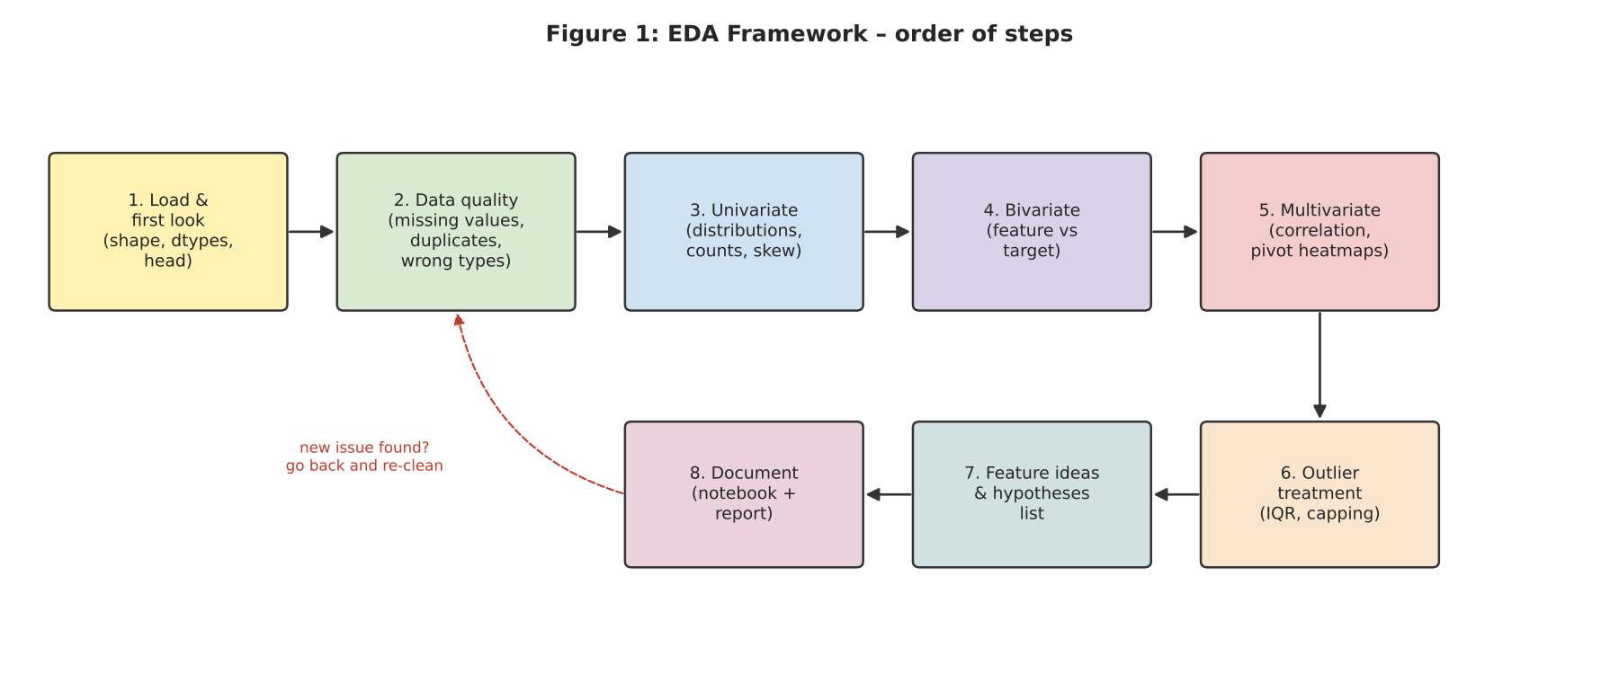
Figure 1: Proposed EDA framework
Step | Stage | Main question it answers
1 | Load and first look | What is in the data? Are the shapes and types as expected?
2 | Data quality check | What is missing, duplicated or clearly wrong?
3 | Univariate analysis | How is each variable distributed on its own?
4 | Bivariate analysis | How does each feature relate to the target (is_late)?
5 | Multivariate analysis | How do several features interact together?
6 | Outlier treatment | Which extreme values are errors and which are real?
7 | Feature ideas and hypotheses | What new features and assumptions does EDA suggest?
8 | Documentation | How are findings recorded for the report and next steps?

5. Data Exploration Techniques

5.1 Step 1 – Initial Inspection
The first look at the data is mostly done with pandas. The aim is to confirm that the data loaded correctly and to get a feel for its size and structure.
df = pd.read_csv('orders_clean.csv', parse_dates=['order_purchase_timestamp'])
df.shape # number of rows and columns
df.info() # data types and non-null counts
df.head() # first few rows
df.describe() # summary stats for numeric columns
df.nunique() # unique values per column
df.duplicated().sum()

5.2 Step 2 – Data Quality Checks
- Data types: convert dates stored as text to datetime; convert IDs and zip codes to string.
- Duplicates: check for fully duplicated rows and duplicated order_id after merging.
- Logical checks: delivery date should not be before purchase date; price and weight should not be negative or zero.
- Consistency: category names spelled in different ways, extra spaces, upper/lower case differences.
- Missing values: count and percentage per column (details in Section 5.6).

5.3 Step 3 – Univariate Analysis
Univariate analysis looks at one variable at a time. For numerical columns I would check the centre (mean, median), the spread (standard deviation, IQR), the shape (skewness) and extreme values. For categorical columns I would check how many categories exist and how the data is spread across them.
- Is the distribution skewed? Price and freight are usually right-skewed, so the median is more useful than the mean, and a log transform may help later.
- Are there very rare categories? Categories with very few orders can be grouped into 'Other'.
- What is the class balance of the target? This decides the evaluation metric and whether class weights are needed.
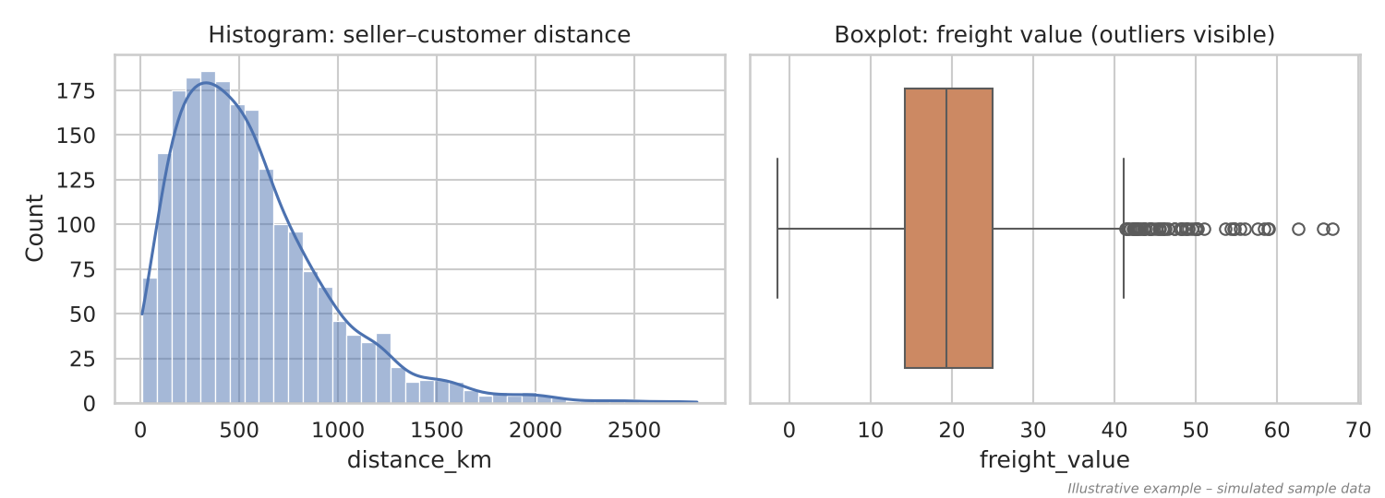
Figure 2: Univariate charts – histogram (left) and boxplot (right). Illustrative, simulated sample.
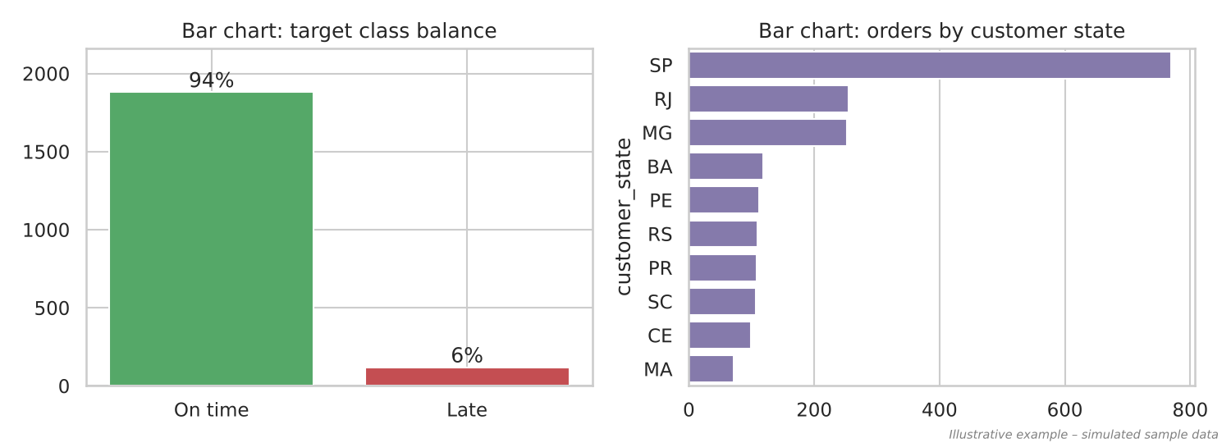
Figure 3: Bar charts for the target class balance and a categorical feature. Illustrative, simulated sample.

5.4 Step 4 – Bivariate Analysis
Bivariate analysis looks at two variables together. In this project the most useful pairs are 'each feature vs. is_late', because they show which features may help in prediction. The technique depends on the types of the two variables:

Variable pair | Technique | Chart
Numerical vs numerical | Pearson / Spearman correlation | Scatter plot (with trend line)
Numerical vs binary target | Compare medians; Mann-Whitney U test | Boxplot / violin plot by class
Categorical vs binary target | Late % per category; Chi-square test | Sorted bar chart of late %
Datetime vs target | Late % per month / weekday | Line chart

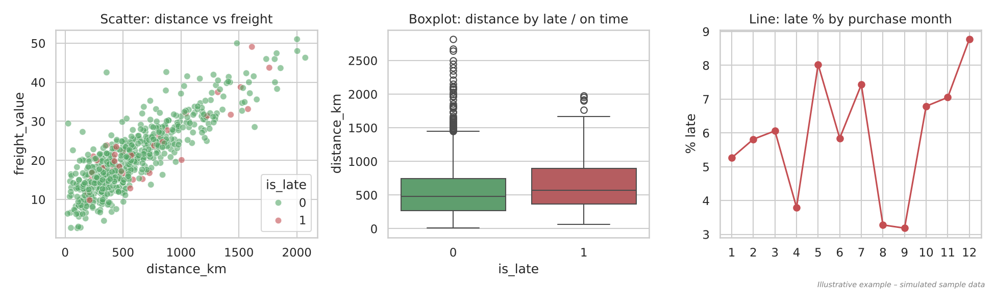
Figure 4: Bivariate charts – scatter, boxplot by class, and line chart over months. Illustrative, simulated sample.

5.5 Step 5 – Multivariate Analysis
Some patterns only appear when three or more variables are looked at together. For example, long distance on its own may not always lead to a late delivery, but long distance combined with a short delivery estimate probably does. Techniques I plan to use:
- Correlation heatmap of all numerical features, to spot strongly related (redundant) features. For example, freight value and distance are expected to be highly correlated.
- Pivot table heatmaps – late % across two grouped variables (distance band × estimate window, state × month).
- Pair plot of a few key numerical features, coloured by is_late.
- Grouped bar charts – for example, late % by month for the top five states.
- PCA (optional) – to check whether the classes separate in a reduced 2D space.
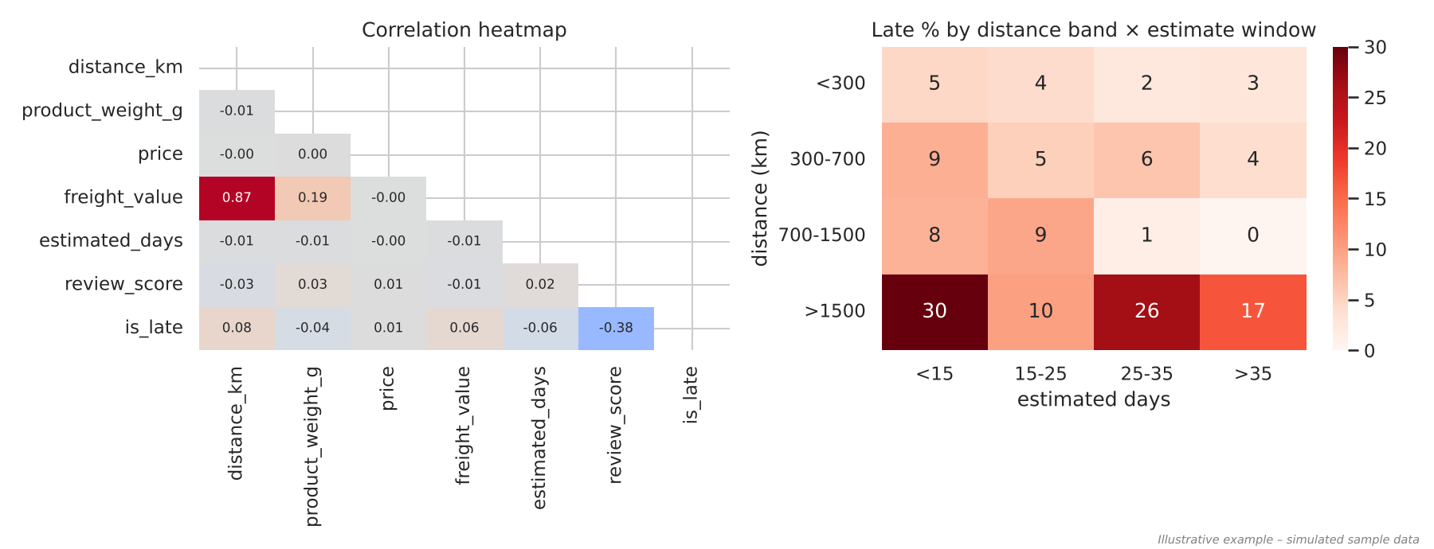
Figure 5: Multivariate charts – correlation heatmap and a pivot heatmap. Illustrative, simulated sample.

5.6 Handling Missing Data
Before deciding how to treat missing values, it is important to understand why they are missing. In the Olist data, for example, a missing delivery date usually means the order was never delivered. That is not random – those rows should simply be excluded from this analysis, not filled in.
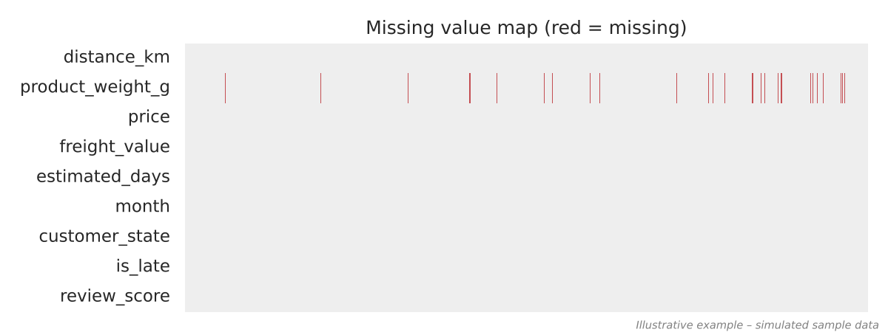
Figure 6: Missing value map – each red line is a missing value. Illustrative, simulated sample.
Situation | Method | Example in this project
Very few missing (< 5%) | Drop rows | Orders with missing approval date
Numerical, moderate missing | Median imputation (group-wise if possible) | Product weight – median of same category
Categorical missing | Fill with mode or a new 'unknown' category | Missing product category → 'unknown'
Missing has a meaning | Keep it as a flag column or filter rows | Missing delivery date = not delivered → exclude
Most of the column missing (> 40–50%) | Consider dropping the column | Review comment text (only for text analysis)

I will also add a simple 'was_missing' flag column where it makes sense, so that the model can still learn if missingness itself is related to late delivery.

5.7 Outlier Detection and Treatment
Outliers are values that are very far from the rest. They are not always errors – a very heavy furniture order is a genuine outlier. So the approach is to detect them first and then decide case by case.
- IQR method: values below Q1 − 1.5×IQR or above Q3 + 1.5×IQR are flagged. Works well for skewed data.
- Z-score method: values with |z| > 3. Only suitable when the data is roughly normal.
- Visual check: boxplots and scatter plots to see where outliers sit.
- Domain check: for example, a delivery time of 200 days or a weight of 0 g is clearly an error.
Treatment options:
Action | When I would use it
Remove | Clear data entry errors (negative price, delivery before purchase)
Cap (winsorize) | Genuine but extreme values that could dominate a linear model, e.g. cap freight at the 99th percentile
Log transform | Right-skewed features such as price, weight and freight
Keep as it is | Tree-based models (Random Forest, XGBoost) are not very sensitive to outliers

5.8 Step 7 – Turning EDA into Features and Hypotheses
The output of EDA is not just charts – it should be a list of findings that feed into the next stage. I plan to maintain a simple table while doing EDA:
Hypothesis to check | Possible feature if true
Longer distance → more late deliveries | distance_km, same_state flag
Shorter estimate window → more late deliveries | estimated_days
Late % is higher in peak sale months (Nov, Dec) | purchase_month, is_peak_season
Some customer states are harder to reach | customer_region, state-level late rate
Heavy / bulky products are delayed more | product_weight_g, volume_cm3
Late orders get much lower review scores | (used only to explain business impact)

6. Visualization Strategies
The purpose of a chart is to answer one question clearly. So for every chart I make, I want to be able to write the question it answers in one line. The table below lists the charts I plan to use and why.

Chart | Used for | Example question
Histogram + KDE | Shape of a numerical distribution | Is delivery time skewed?
Boxplot / violin | Spread, outliers, comparing groups | Are late orders shipped over longer distances?
Bar chart (sorted) | Categorical counts and rates | Which states have the highest late %?
Count plot | Class balance | How many orders are late vs on time?
Scatter plot | Relationship between two numbers | Does freight increase with distance?
Line chart | Trends over time | Does late % rise in certain months?
Correlation heatmap | Relationships among many numbers | Which features are redundant?
Pivot heatmap | Interaction of two grouped variables | Is long distance + short estimate the worst case?
Pair plot | Quick view of several numeric pairs | Do classes separate on any pair?
Map (choropleth / scatter map) | Geographic patterns | Are late deliveries concentrated in the north-east?
Stacked bar | Ordinal vs category | How do review scores differ for late vs on-time orders?

6.1 Design Principles I Will Follow
- Every chart gets a clear title, labelled axes and units (km, days, R$).
- Sort bar charts by value so the ranking is easy to read.
- Use the same colours for the same meaning everywhere – green for on time, red for late.
- Show rates (late %) instead of raw counts when comparing groups of very different sizes.
- Avoid pie charts with many slices and 3D charts, as they are hard to read accurately.
- Use colour-blind friendly palettes (seaborn 'Set2', 'colorblind').
- Write one or two lines of interpretation under each chart in the notebook.
- Static charts (Matplotlib / Seaborn) for the report; interactive charts (Plotly) for exploring and for the presentation.

7. Tools and Python Libraries
Library / tool | How it contributes to the analysis
pandas | Loading CSV files, merging tables, cleaning, groupby summaries, pivot tables, describe(), value_counts(). The backbone of the whole EDA.
NumPy | Fast numerical operations, conditions (np.where), log transforms, calculating IQR limits.
Matplotlib | Base plotting library. Full control over layout, subplots, labels and saving figures for the report.
Seaborn | Statistical charts in one line – histplot, boxplot, violinplot, heatmap, pairplot, countplot – with good default styling.
Plotly Express | Interactive charts (hover, zoom, filter) and map plots of Brazilian states; useful for exploring and for the final presentation.
SciPy (stats) | Statistical tests – Chi-square for categorical vs target, Mann-Whitney U for numerical vs target, skewness.
missingno | Quick visual of missing values (matrix and bar charts).
ydata-profiling | Generates an automatic HTML profile report as a first quick overview (I will still do manual EDA, since automatic reports miss context).
Jupyter Notebook / Google Colab | Running code step by step with charts and notes together.
Git and GitHub | Version control and sharing the notebook, scripts and charts.

A short example of how these come together, from my eda_framework.py module:
from eda_framework import overview, missing_report, outlier_report, run_full_eda

print(overview(df)) # dtypes, unique values, missing count
print(missing_report(df)) # % missing + suggested treatment
print(outlier_report(df)) # IQR outliers per numeric column
run_full_eda(df, target='is_late', out_dir='eda_output')

8. Making the Framework Work for Any Dataset
One of the goals of this task is to have a process that is not tied to a single dataset. The steps in Figure 1 do not depend on the e-commerce context – only the questions do. To make it reusable:
- The eda_framework.py module automatically splits columns into numerical, categorical and datetime, so it can be run on any DataFrame.
- Plots are chosen based on the data type (Section 3), not based on the column name.
- The target column is a parameter – it can be a binary label, a number (for regression), or left out completely for unsupervised problems.
- For a regression target, the boxplots by class would be replaced by scatter plots against the target, and late % by mean target value.
- For time-series data, an extra step would be added for trend, seasonality and lag plots.
- For text-heavy data, word counts and frequent words would be added to the univariate step.

9. Reporting and Documentation Plan

9.1 During EDA – the Notebook
The Jupyter notebook will follow the same order as the framework, with a markdown cell above every chart saying what I am checking, and a short note below it saying what I found. Planned notebook structure:
- 01_data_loading_and_cleaning.ipynb
- 02_eda_univariate.ipynb
- 03_eda_bivariate_multivariate.ipynb
- 04_feature_engineering.ipynb (Week 3)
All charts will be saved to an images/ folder with clear file names so that they can be reused in the report and README.

9.2 Final Report Structure
# | Section | Content
1 | Executive summary | 3–5 key findings in plain language, for non-technical readers
2 | Introduction | Problem, objective and dataset
3 | Data preparation | What was cleaned, removed or imputed, and why
4 | EDA findings | The most important charts, each with a one-line takeaway
5 | Hypotheses tested | Which assumptions were confirmed or rejected
6 | Modelling and results | Covered in Week 3–4
7 | Recommendations | Practical actions for the business
8 | Limitations and next steps | What the data could not tell us
9 | Appendix | Data dictionary, extra charts, link to code

9.3 Presentation (8–10 slides)
- Problem and why it matters → dataset overview → 3–4 key EDA charts (one finding per slide) → model results → recommendations → next steps.
- Each slide will have a title that states the finding, for example: 'Orders shipped over 1,500 km are much more likely to be late', instead of just 'Distance analysis'.

10. Time Allocation for Week 2
Activity | Hours
Reading about EDA techniques and best practices | 5
Studying dataset columns and classifying data types | 4
Designing the EDA steps and framework diagram | 5
Planning visualization strategy and chart choices | 5
Writing the reusable eda_framework.py and example charts | 7
Writing this report and updating GitHub | 6
Total | 32

11. Expected Challenges
Challenge | How I plan to handle it
Large number of categories (70+ product categories) | Show top 10–15 and group the rest into 'Other'
Imbalanced target hides patterns in raw counts | Always compare late % rather than counts
Too many charts, hard to see what matters | Write one takeaway per chart; keep only key charts in the report
Correlation does not mean causation | Present findings as associations; mention other possible reasons
Large dataset slows down plotting | Use a random sample for scatter and pair plots
Data leakage while exploring | Keep post-delivery columns (reviews) clearly separate from features

12. Conclusion
This week I designed a step-by-step EDA and visualization framework for the late delivery project. The main thing I learned is that EDA works best when it is driven by questions – each step and each chart should answer something specific, and the findings should directly lead to features and hypotheses for the modelling stage. Classifying data types first also makes chart selection much simpler and avoids common mistakes, like averaging zip codes.
Note: The charts in this report were made with a small simulated sample that has the same structure as the expected cleaned dataset. They only show what each type of chart will look like. In the next stage, the same framework and code will be applied to the real Olist data.

References
- Tukey, J. W. (1977). Exploratory Data Analysis. Addison-Wesley.
- Olist – Brazilian E-Commerce Public Dataset, Kaggle
- pandas documentation – pandas.pydata.org
- Seaborn documentation – seaborn.pydata.org
- Plotly Python documentation – plotly.com/python

