Week 3 Task Report
Statistical Analysis and Hypothesis Testing in Python
Testing what drives customer churn with t-tests, chi-square, ANOVA and logistic regression
Anish Goyal
Virtual Data Science with Python Apprentice Intern – Yuva Intern
Integrated M.Tech (IT), IIPS DAVV, Indore
GitHub: github.com/anishgoyal0603/telco-churn-eda

1. Introduction
In Week 1 I cleaned the IBM Telco Customer Churn dataset, and in Week 2 I used visualizations to tell a story about who leaves and why. Charts are good at showing patterns, but a pattern in a sample can sometimes appear just by chance. Before a company spends money on a retention plan, it should know which patterns are real.
The objective of this week is to test the main findings formally. For each idea I wrote a null and an alternative hypothesis, chose a statistical test whose assumptions fit the data, checked those assumptions, and then reported the p-value together with an effect size and a confidence interval. The p-value tells us whether an effect exists; the effect size and confidence interval tell us how big it is and how precisely we know it.

2. Hypotheses
I chose four hypotheses with direct business relevance, plus one control hypothesis where I expected no effect. Including a control is a good check that the methods do not simply find "significance" everywhere.
# | Business question | Null hypothesis (H0) | Alternative (H1)
H1 | Do churned customers pay more? | Mean monthly charge is equal for churned and retained customers | The means differ (two-sided)
H2 | Does contract type matter? | Contract type and churn are independent | Contract type and churn are associated
H3 | Do payment methods differ in price? | Mean monthly charge is equal for all 4 payment methods | At least one mean differs
H4 | Does Tech Support reduce churn? | Churn rate is equal with and without Tech Support | Churn is lower with Tech Support (one-sided)
H5 | Control: does gender matter? | Gender and churn are independent | Gender and churn are associated

3. Data and Methodology

3.1 Data
I used the cleaned file from Week 1 (data/processed/telco_churn_clean.csv): 7,043 customers, 23 columns, no missing values. The main variables are Churn (Yes/No) and its numeric copy ChurnFlag (1/0), MonthlyCharges (numeric, $18.25–$118.75), Contract (3 levels), PaymentMethod (4 levels), TechSupport (Yes/No), InternetService and gender. For H4 I used only the 5,517 customers who have internet service, because customers without internet cannot buy Tech Support at all.

3.2 Choosing the tests
Hypothesis | Data type | Main test | Robustness check / extra | Effect size
H1 | Numeric vs 2 groups | Welch's t-test | Mann–Whitney U | Cohen's d
H2 | Categorical vs categorical | Chi-square test of independence | Standardized residuals, Wilson CIs | Cramér's V
H3 | Numeric vs 4 groups | Welch's ANOVA | Classic ANOVA, Kruskal–Wallis, Holm and Tukey post-hoc | Eta squared (η²)
H4 | Two proportions | Two-proportion z-test | Logistic regression with controls | Relative risk, odds ratio
H5 | Categorical vs categorical | Chi-square test of independence | – | Cramér's V

3.3 Significance level and multiple testing
Testing five hypotheses at α = 0.05 each would give roughly a 23% chance of at least one false positive. To keep the overall error rate near 5%, I used a Bonferroni-corrected level of α = 0.05 / 5 = 0.01 for every decision. Inside H3, the six pairwise comparisons were additionally corrected with the Holm method.

3.4 Tools
Python with Pandas for data handling, SciPy (stats) for t-tests, chi-square, ANOVA, Levene and non-parametric tests, Statsmodels for Welch's ANOVA, proportion tests, Tukey HSD, multiple-testing correction and logistic regression, and Matplotlib/Seaborn for the visualizations. All code is in notebooks/week3_hypothesis_testing.ipynb.

4. Analysis and Results

4.1 H1 – Do churned customers pay higher monthly charges?
Descriptive statistics
Group | n | Mean | Median | Std. dev. | Skewness
Churned | 1,869 | $74.44 | $79.65 | $24.67 | −0.73
Stayed | 5,174 | $61.27 | $64.43 | $31.09 | −0.03

Assumption checks
- Equal variances: Levene's test W = 361.8, p ≈ 1.0 × 10⁻⁷⁸, so the variances are clearly unequal. The standard Student t-test is therefore not appropriate, and I used Welch's t-test, which does not assume equal variances.
- Normality: the charges are not normally distributed (the retained group has a large spike of cheap phone-only plans around $20). However, with samples of 1,869 and 5,174, the Central Limit Theorem makes the sampling distribution of the mean approximately normal, so the t-test remains valid. As an extra check I ran the Mann–Whitney U test, which makes no normality assumption.
churn = df.loc[df["Churn"] == "Yes", "MonthlyCharges"]
stay = df.loc[df["Churn"] == "No", "MonthlyCharges"]

stats.levene(churn, stay) # unequal variances -> Welch
t = stats.ttest_ind(churn, stay, equal_var=False)
ci = t.confidence_interval(confidence_level=0.95)
mw = stats.mannwhitneyu(churn, stay, alternative="two-sided")
Results
Measure | Value
Welch's t | t = 18.41, df = 4,136, p = 8.6 × 10⁻⁷³
Mean difference (churned − stayed) | $13.18 per month
95% confidence interval | $11.77 to $14.58
Cohen's d | 0.45 (small-to-medium)
Mann–Whitney U | U = 6,003,126, p = 3.3 × 10⁻⁵⁴, rank-biserial r = 0.24

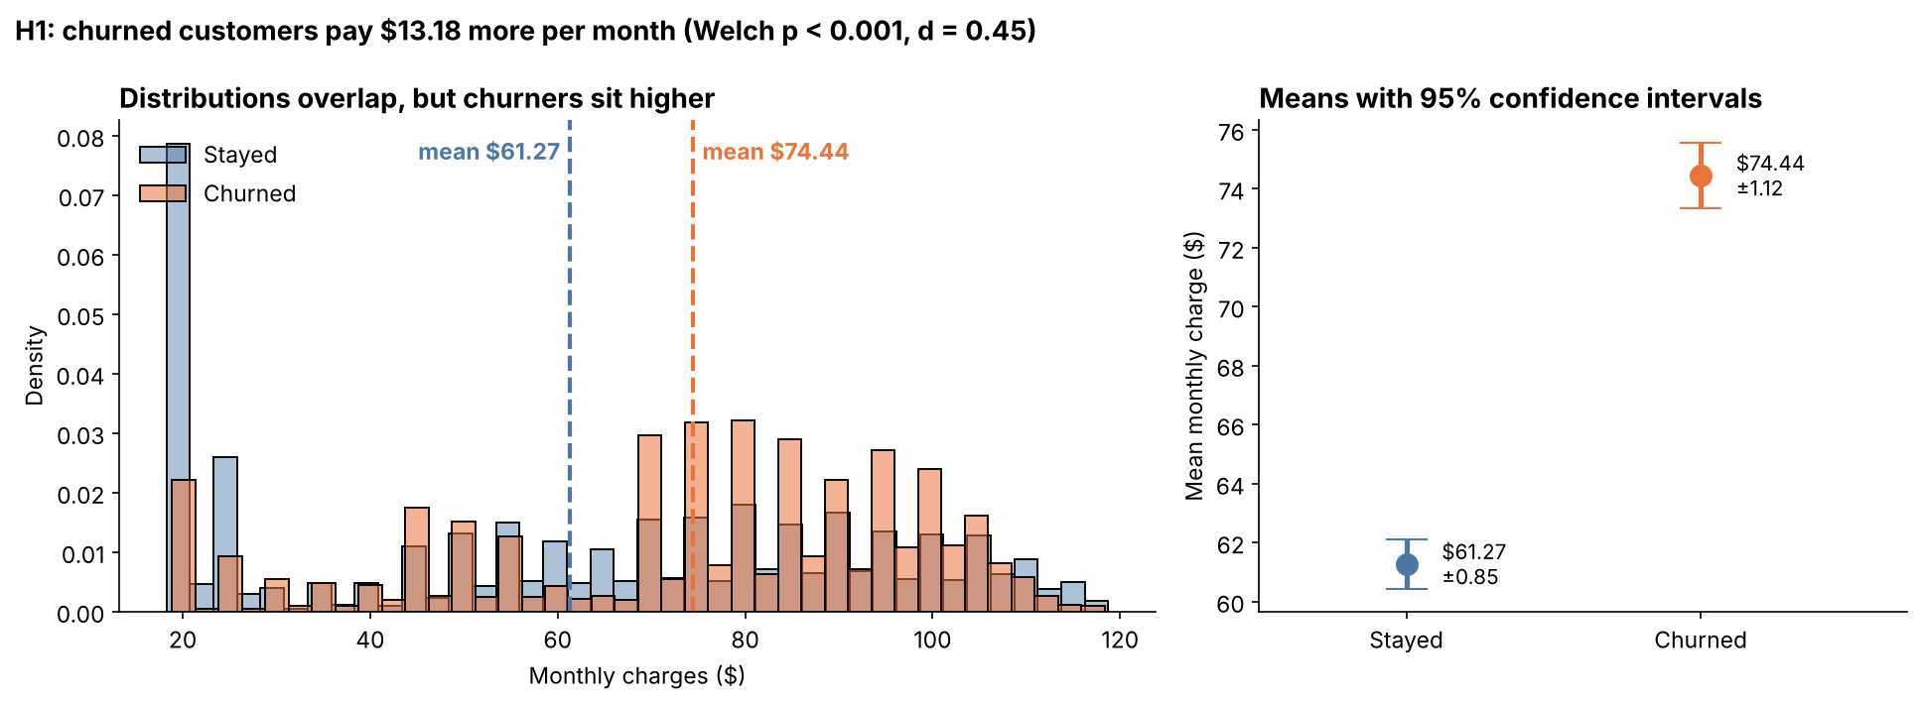
Figure 1: Distribution of monthly charges by churn status (left) and group means with 95% confidence intervals (right)
Interpretation
The p-value is far below 0.01, so I reject H0. Customers who churned paid on average $13.18 more per month than those who stayed. The 95% confidence interval ($11.77 to $14.58) does not include zero, which means we can be confident the true difference in the customer population is positive and somewhere in that range. The two confidence intervals in Figure 1 do not overlap at all.
The effect size gives important context: Cohen's d = 0.45 is a small-to-medium effect. The histograms overlap a lot, so many low-paying customers also churn and many high-paying customers stay. Price is a real factor, but it does not explain churn on its own. The non-parametric Mann–Whitney test reaches the same conclusion, so the result does not depend on the normality assumption.

4.2 H2 – Is contract type associated with churn?
Observed and expected counts
Contract | Stayed (observed) | Churned (observed) | Stayed (expected) | Churned (expected)
Month-to-month | 2,220 | 1,655 | 2,846.7 | 1,028.3
One year | 1,307 | 166 | 1,082.1 | 390.9
Two year | 1,647 | 48 | 1,245.2 | 449.8

Assumption check: the chi-square test needs every expected cell count to be at least 5. The smallest expected count here is 390.9, so the assumption is easily met. Observations are independent because each row is a different customer.
ct = pd.crosstab(df["Contract"], df["Churn"])
chi2, p, dof, expected = stats.chi2_contingency(ct)
cramers_v = np.sqrt(chi2 / (ct.values.sum() * (min(ct.shape) - 1)))
std_resid = (ct - expected) / np.sqrt(expected)
Results
χ² = 1,184.6, df = 2, p = 5.9 × 10⁻²⁵⁸, Cramér's V = 0.41.
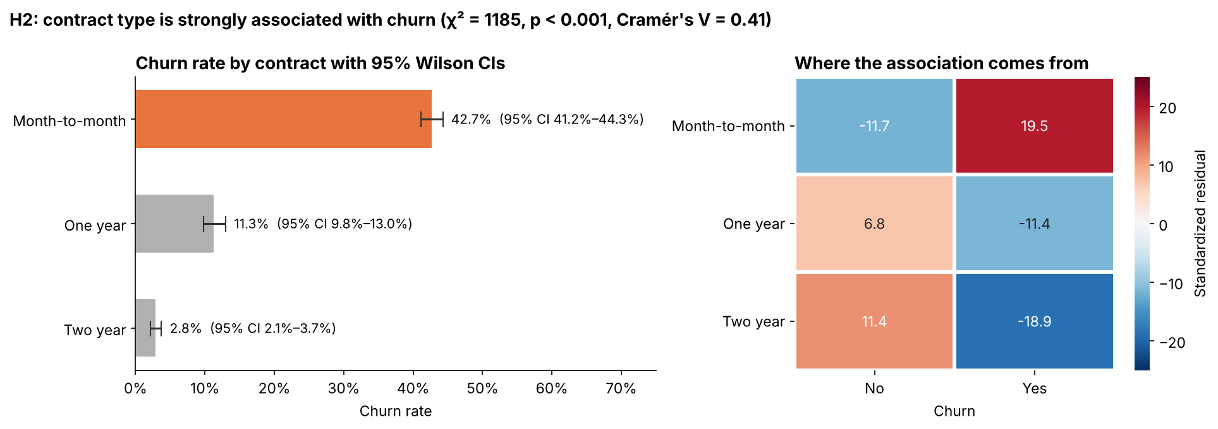
Figure 2: Churn rate by contract with 95% Wilson confidence intervals (left) and standardized residuals (right)
Interpretation
The p-value is effectively zero, so I reject H0: contract type and churn are strongly associated. Cramér's V = 0.41 indicates a strong association, the largest of all the factors tested.
The chi-square statistic only says that an association exists, so I used standardized residuals to see where it comes from. Month-to-month contracts have far more churners than expected under independence (+19.5), while two-year contracts have far fewer (−18.9). The churn rates with 95% Wilson confidence intervals are 42.7% (41.2–44.3%) for month-to-month, 11.3% (9.8–13.0%) for one-year and 2.8% (2.1–3.7%) for two-year contracts. None of the intervals overlap, so the differences between every pair of contract types are not due to sampling noise.

4.3 H3 – Do monthly charges differ across payment methods?
In Week 2, customers paying by electronic check had the highest churn rate (45.3%). Before concluding that the payment method itself is the problem, I tested whether these customers are simply on more expensive plans. This matters because a hidden price difference would be a confounding variable.
Payment method | n | Mean charge | Std. dev.
Electronic check | 2,365 | $76.26 | $24.05
Bank transfer (automatic) | 1,544 | $67.19 | $30.56
Credit card (automatic) | 1,522 | $66.51 | $30.61
Mailed check | 1,612 | $43.92 | $26.31

Assumption checks and test choice
One numeric outcome compared across four independent groups calls for a one-way ANOVA. Levene's test (W = 81.3, p ≈ 10⁻⁵¹) showed unequal variances, so I report Welch's ANOVA as the main result, with the classic ANOVA and the non-parametric Kruskal–Wallis test as robustness checks.
welch = anova_oneway(df["MonthlyCharges"], df["PaymentMethod"], use_var="unequal")
kw = stats.kruskal(*groups)
eta_sq = ss_between / ss_total
# post-hoc: pairwise Welch t-tests with Holm correction
pairs["p_holm"] = multipletests(pairs["p_raw"], method="holm")[1]
Results
Test | Statistic | p-value
Welch's ANOVA (main) | F = 520.9 | 9.6 × 10⁻²⁸¹
Classic one-way ANOVA | F = 450.3 | 1.2 × 10⁻²⁶⁷
Kruskal–Wallis | H = 1,103.3 | 7.0 × 10⁻²³⁹
Effect size | η² = 0.161 | –

ANOVA only says that at least one group differs, so I ran post-hoc comparisons for all six pairs:
Comparison | Mean difference | 95% CI | Holm-adjusted p | Significant?
Electronic check − Bank transfer | +$9.06 | $7.26 to $10.87 | < 0.001 | Yes
Electronic check − Credit card | +$9.74 | $7.92 to $11.56 | < 0.001 | Yes
Electronic check − Mailed check | +$32.34 | $30.73 to $33.95 | < 0.001 | Yes
Bank transfer − Credit card | +$0.68 | −$1.49 to $2.85 | 0.538 | No
Bank transfer − Mailed check | +$23.28 | $21.28 to $25.27 | < 0.001 | Yes
Credit card − Mailed check | +$22.60 | $20.59 to $24.60 | < 0.001 | Yes

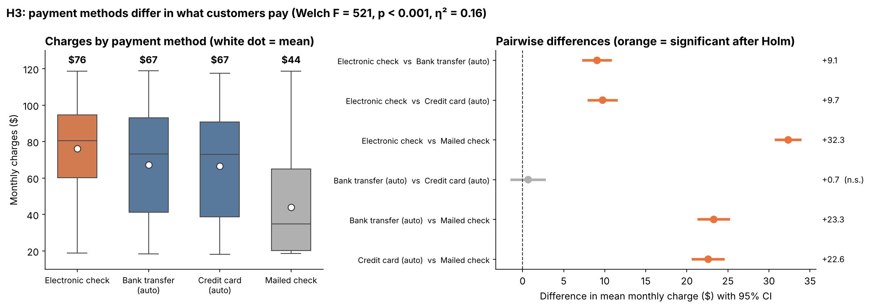
Figure 3: Monthly charges by payment method (left) and pairwise mean differences with 95% CIs (right)
Interpretation
All three tests agree and the p-values are essentially zero, so I reject H0. η² = 0.16 means payment method explains about 16% of the variation in monthly charges, a large effect. Five of the six pairs differ significantly. The only exception is bank transfer versus credit card (difference $0.68, p = 0.538), which makes sense because both are automatic payment methods used by similar customers. Tukey's HSD test gave exactly the same pattern of significant and non-significant pairs.
Electronic-check users pay about $9–10 more per month than automatic payers and $32 more than mailed-check users. This is an important finding: part of their high churn rate is likely a price effect rather than a payment-method effect. Any predictive model built later should include both variables so that one does not take credit for the other.

4.4 H4 – Do internet customers with Tech Support churn less?
Week 2 showed a large gap in churn between customers with and without Tech Support. I used a one-sided test because the business question has a direction: does Tech Support lower churn? The analysis uses only the 5,517 internet customers.
Group | Customers | Churned | Churn rate | 95% Wilson CI
No Tech Support | 3,473 | 1,446 | 41.6% | 40.0% – 43.3%
Has Tech Support | 2,044 | 310 | 15.2% | 13.7% – 16.8%

Assumption check: the two-proportion z-test needs at least 10 churners and 10 non-churners in each group and independent observations. Both conditions are met.
z, p_one = proportions_ztest(count=[310, 1446], nobs=[2044, 3473], alternative="smaller")
low, high = confint_proportions_2indep(1446, 3473, 310, 2044)

logit = smf.logit("ChurnFlag ~ C(TechSupport) + C(Contract) + tenure + MonthlyCharges",
data=net).fit()
np.exp(logit.params) # odds ratios
Results
Measure | Value
z statistic | −20.38
One-sided p-value | 1.2 × 10⁻⁹²
Difference in churn rate | 26.5 percentage points (95% CI 24.2 to 28.7)
Relative risk (with / without) | 0.36

Controlling for other factors
A simple comparison could be misleading. Customers who buy Tech Support might also be on longer contracts, and we already know longer contracts reduce churn. To separate the effects, I fitted a logistic regression that includes Tech Support, contract type, tenure and monthly charges at the same time.
Variable | Odds ratio | 95% CI | p-value
Has Tech Support (vs none) | 0.52 | 0.44 – 0.61 | < 0.001
One-year contract (vs month-to-month) | 0.43 | 0.35 – 0.53 | < 0.001
Two-year contract (vs month-to-month) | 0.20 | 0.14 – 0.28 | < 0.001
Tenure (per extra month) | 0.97 | 0.96 – 0.97 | < 0.001
Monthly charge (per extra $1) | 1.03 | 1.02 – 1.03 | < 0.001

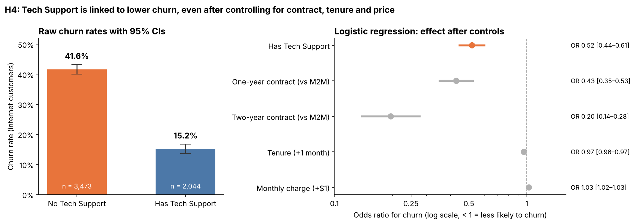
Figure 4: Raw churn rates with 95% CIs (left) and odds ratios from the logistic regression (right)
Interpretation
The z-test p-value is far below 0.01, so I reject H0. Internet customers with Tech Support churn at 15.2% against 41.6% without it, a difference of 26.5 percentage points with a 95% confidence interval of 24.2 to 28.7 points. Their risk of churning is about 0.36 times that of customers without Tech Support.
The logistic regression shows the effect survives after controlling for contract, tenure and price: the odds ratio is 0.52 (95% CI 0.44–0.61). Holding the other factors constant, customers with Tech Support have roughly half the odds of churning. The effect is smaller than the raw comparison suggests, because part of the raw gap was really the contract effect, but it remains strong and highly significant. The other coefficients also make sense: each extra month of tenure lowers the odds of churn by about 3%, and each extra dollar per month raises them by about 3%.
Because this is observational data, the result shows a robust association rather than proof that Tech Support causes customers to stay. Customers who choose Tech Support may differ in ways not captured in the data.

4.5 H5 (control) – Is gender associated with churn?
Gender | Stayed | Churned | Churn rate
Female | 2,549 | 939 | 26.9%
Male | 2,625 | 930 | 26.2%

Chi-square test: χ² = 0.48, df = 1, p = 0.487, Cramér's V = 0.008.
Interpretation
The p-value is far above 0.01 (and above 0.05), so I fail to reject H0. There is no evidence that churn differs between men and women, and Cramér's V ≈ 0.01 shows the association is practically zero. "Fail to reject" does not prove the two rates are exactly equal; it only means the data gives no evidence of a difference. This control result is useful in itself: it shows the methods do not find significance everywhere, and it tells the business that retention campaigns do not need to be targeted by gender.

5. Summary of Results
Hyp. | Test | Statistic | p-value | Effect size | Decision (α = 0.01)
H1 | Welch's t-test | t = 18.41 | < 0.001 | d = 0.45 | Reject H0
H2 | Chi-square | χ² = 1,184.6 | < 0.001 | V = 0.41 | Reject H0
H3 | Welch's ANOVA | F = 520.9 | < 0.001 | η² = 0.16 | Reject H0
H4 | Two-proportion z-test | z = −20.38 | < 0.001 | RR = 0.36, OR = 0.52 | Reject H0
H5 | Chi-square | χ² = 0.48 | 0.487 | V = 0.008 | Fail to reject H0

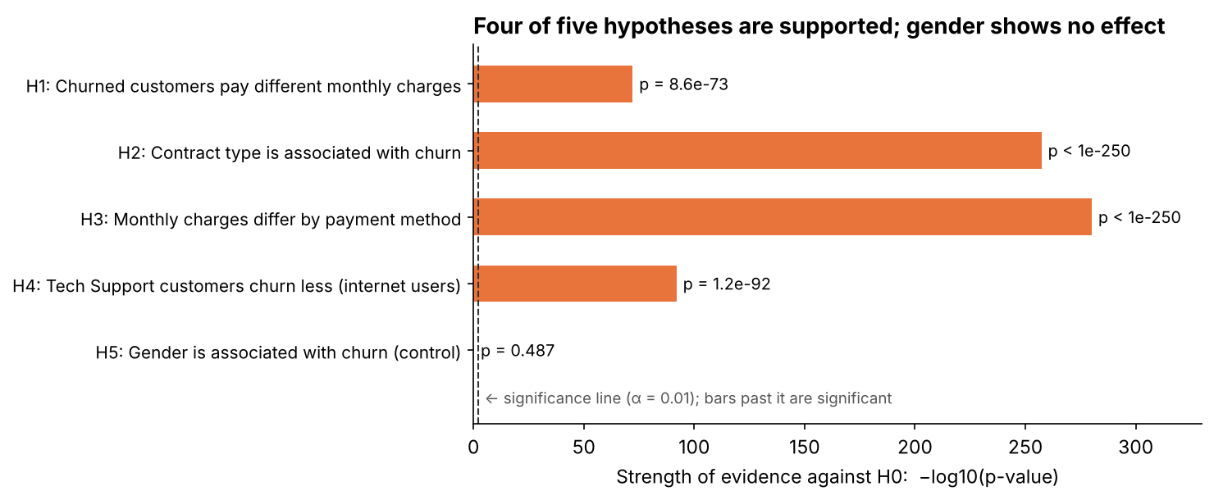
Figure 5: Strength of evidence for each hypothesis (−log10 p-value); the dashed line marks α = 0.01
Figure 5 puts all five tests on one scale. Because the p-values range from 0.487 down to about 10⁻²⁸¹, I plotted −log10(p): longer bars mean stronger evidence against the null hypothesis. Four bars are far past the significance line; the gender bar is too short to see.

6. Discussion: p-values, Confidence Intervals and Effect Sizes
With 7,043 customers, even very small differences can produce tiny p-values. A p-value only answers "is there an effect?", not "does the effect matter?". That is why every result in this report also includes an effect size and a confidence interval:
- p-value: the probability of seeing a difference at least this large if H0 were true. For example, p = 8.6 × 10⁻⁷³ for H1 means such a gap in monthly charges would be practically impossible if both groups really paid the same on average.
- Confidence interval: a range of plausible values for the true effect. The H1 interval of $11.77 to $14.58 means that if we repeated the sampling many times, about 95% of intervals built this way would contain the true difference.
- Effect size: how big the effect is in practical terms. H1 is significant but only small-to-medium (d = 0.45), while H2 is both significant and strong (V = 0.41). For a business deciding where to act first, this ranking is more useful than the p-values alone.

7. Conclusions and Implications
- Contract type is the strongest driver of churn (H2, V = 0.41). Moving customers from month-to-month to one- or two-year contracts should be the main retention strategy. Even after controlling for other factors, a two-year contract cuts the odds of churning by about 80%.
- Price matters, but moderately (H1, d = 0.45). Churners pay about $13 more per month. A pricing review for high-cost plans may help, but price alone will not solve churn.
- Payment method is tangled up with price (H3, η² = 0.16). Electronic-check customers pay significantly more, so part of their high churn is a price effect. Both variables must be included in the predictive model next week.
- Tech Support is linked to lower churn even after controls (H4, OR = 0.52). Bundling Tech Support into new fiber plans is a promising, low-cost idea that should be confirmed with an A/B test.
- Gender has no effect (H5). There is no need for gender-based targeting.
Overall, the statistical tests confirm the patterns seen in Weeks 1 and 2 and add something the charts could not: a measure of how certain each finding is and how large it is. These results directly inform which features to include in the machine learning model planned for Week 4.

8. Limitations
- The data is observational, so all results are associations, not proof of cause and effect.
- Large samples make small effects statistically significant, which is why decisions should be based on effect sizes as well as p-values.
- The dataset describes one fictional company at one point in time, so results may not generalise to other markets.
- Bonferroni correction is conservative; however, all significant results here have p-values so small that the conclusions would not change under any reasonable correction.

9. References
- IBM. Telco Customer Churn dataset. github.com/IBM/telco-customer-churn-on-icp4d
- Welch, B. L. (1947). The generalization of 'Student's' problem when several different population variances are involved. Biometrika, 34(1–2), 28–35.
- Cohen, J. (1988). Statistical Power Analysis for the Behavioral Sciences (2nd ed.). Lawrence Erlbaum.
- Virtanen, P. et al. (2020). SciPy 1.0: Fundamental algorithms for scientific computing in Python. Nature Methods, 17, 261–272.
- Seabold, S. and Perktold, J. (2010). Statsmodels: Econometric and statistical modeling with Python. Proceedings of the 9th Python in Science Conference.
- Project repository – github.com/anishgoyal0603/telco-churn-eda

