Week 2 Task Report
Advanced Data Visualization and Storytelling with Python
Who leaves, when, why, and what it costs: a data story on telecom customer churn
Anish Goyal
Virtual Data Science with Python Apprentice Intern – Yuva Intern
Integrated M.Tech (IT), IIPS DAVV, Indore
GitHub: github.com/anishgoyal0603/telco-churn-eda

1. Introduction
In Week 1 I cleaned the IBM Telco Customer Churn dataset and used exploratory analysis to find which features are linked to customers leaving. Those findings were correct, but they were written for someone who already understands data: correlation values, box plots and tables of percentages.
The objective of Week 2 is to communicate the same data to a non-technical audience, for example a manager in a telecom company who has to decide where to spend a retention budget. Instead of producing many separate charts, I built one connected story with six visualizations, where each chart answers the next natural question:
- When do customers leave? (retention curves)
- Who is leaving? (contract × tenure heatmap)
- What does it cost the company? (Pareto chart of lost revenue)
- Why might they be leaving? (add-on services dumbbell chart)
- Who should we target first? (risk-factor ladder)
- What is the big picture? (nested donut and interactive Plotly sunburst)

2. Dataset and Tools
I continued with the cleaned file from Week 1 (data/processed/telco_churn_clean.csv): 7,043 customers, 23 columns, no missing values. Using the same dataset keeps the project consistent and lets this week build on what was already found. The overall churn rate is 26.5%.
Tool | Used for
Pandas / NumPy | Aggregations, cross-tabs, Kaplan–Meier retention estimate, risk score
Matplotlib | Fully customised static charts (annotations, direct labels, twin axes)
Seaborn | Heatmap and colour palettes
Plotly Express | Interactive sunburst chart saved as HTML
Jupyter / GitHub | Notebook week2_visual_storytelling.ipynb and version control

3. Approach and Design Principles
Before making any chart I wrote down the questions the audience would ask and picked the chart type that answers each question most directly. I then applied the same design rules to every chart so the report feels like one piece of work:
- Action titles: every title states the conclusion (e.g. "Churn costs $139k a month – most of it from one segment") instead of describing the axes. A reader who only reads the titles still gets the full story.
- One accent colour: orange always means churn or risk; grey and blue are used for context. This draws the eye to what matters and keeps the meaning of colour consistent across charts.
- Direct labels instead of legends: values and series names are written on the chart so the reader does not have to look back and forth.
- Annotations: arrows and short notes point out the single most important detail in each chart.
- Less clutter: top and right borders removed, light gridlines, and customer counts shown wherever a percentage could be over-trusted.
ORANGE, BLUE, GREY, DARK = "#E8743B", "#4C78A8", "#B0B0B0", "#333333"
plt.rcParams.update({
"axes.spines.top": False, "axes.spines.right": False,
"axes.titleweight": "bold", "axes.titlelocation": "left",
})

4. Visual Analyses

4.1 When do customers leave? – Retention curves
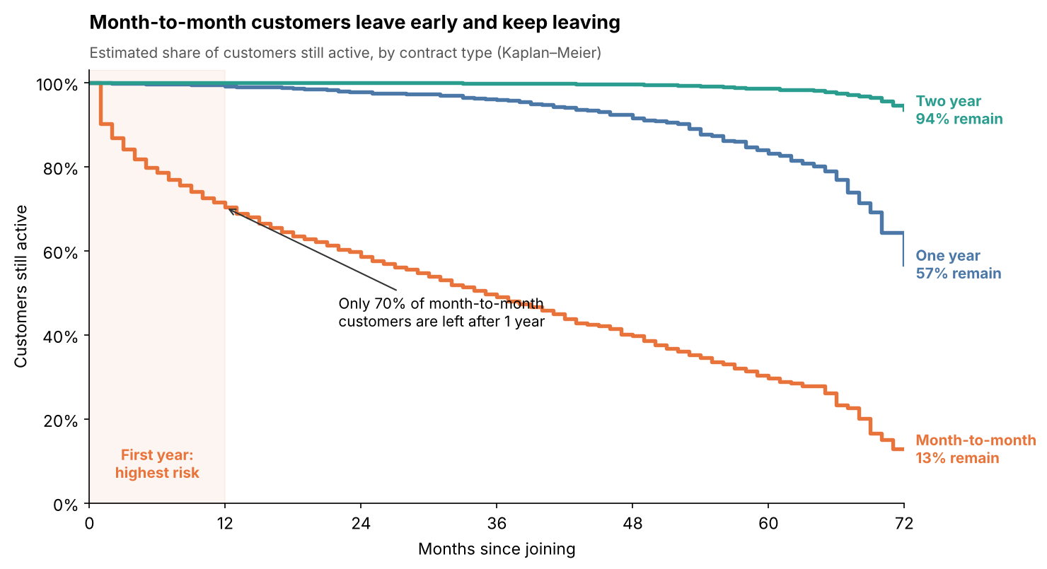
Figure 1: Estimated share of customers still active over time, by contract type (Kaplan–Meier)
Why this visualization
A bar chart of churn by tenure gives only a snapshot. A retention curve shows the full journey: out of every 100 customers who join, how many are still with the company after n months. I used the Kaplan–Meier method, which treats customers who have not left yet as "still active" instead of dropping them, so the estimate is not biased. I coded the estimator in plain pandas so every step is visible. Step lines are the standard way to draw retention data, and the end labels replace a legend.
def retention_curve(data, max_month=72):
survival, s = [], 1.0
for t in range(max_month + 1):
at_risk = (data["tenure"] >= t).sum()
churned = ((data["tenure"] == t) & (data["ChurnFlag"] == 1)).sum()
if at_risk > 0:
s *= 1 - churned / at_risk
survival.append(s)
return pd.Series(survival, index=range(max_month + 1))
What it shows
Contract | After 1 month | After 12 months | After 24 months | After 72 months
Month-to-month | 90.2% | 70.3% | 58.6% | 12.9%
One year | 100.0% | 99.1% | 97.8% | 56.8%
Two year | 100.0% | 100.0% | 100.0% | 93.6%

About 30% of month-to-month customers leave within their first year, and the line keeps falling steadily after that. One- and two-year customers stay almost flat for years. The shaded first-year zone sets up the rest of the story: the first year is where retention efforts matter most.

4.2 Who is leaving? – Contract × tenure heatmap
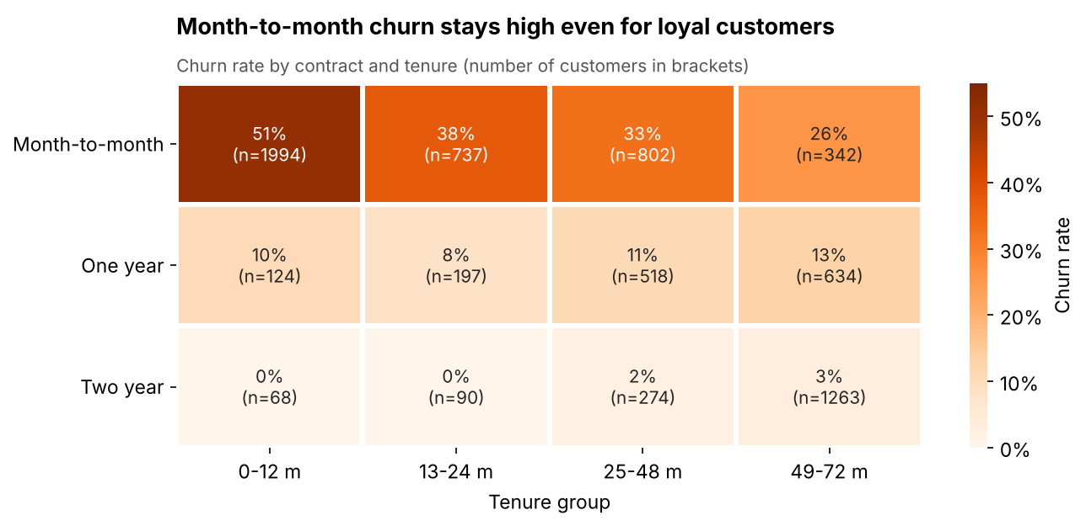
Figure 2: Churn rate by contract type and tenure group, with the number of customers in each cell
Why this visualization
Week 1 analysed contract and tenure separately. A heatmap shows both together and answers a follow-up question: do long-staying month-to-month customers become safe? Colour makes the pattern visible before reading any number, and the customer count in each cell warns the reader when a group is small.
What it shows
New month-to-month customers churn at 51%. Even after more than four years, month-to-month churn is still 26%, close to the company average. Two-year customers almost never leave (0–3%) in any tenure group. Tenure helps, but contract type is the stronger factor, which means converting customers to longer contracts is a better lever than simply waiting for them to become loyal.

4.3 What does it cost? – Pareto chart of lost revenue
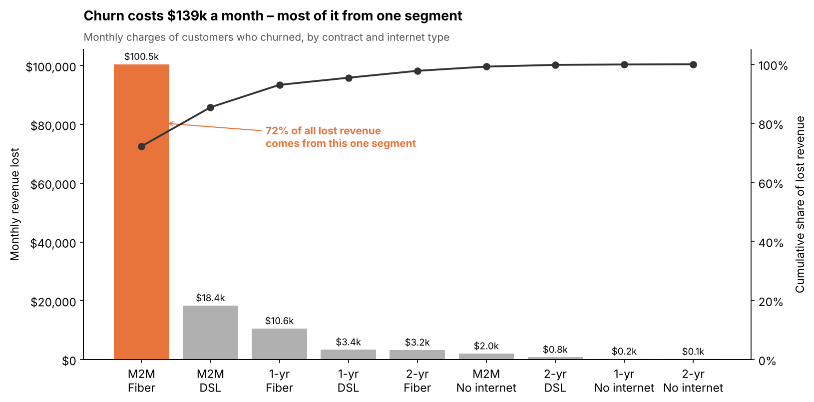
Figure 3: Monthly revenue lost from churned customers by segment, with cumulative share
Why this visualization
For a manager, "26.5% churn" is abstract; money is not. I added up the monthly charges of all customers who left and split the total by contract and internet type. A Pareto chart (sorted bars plus a cumulative line) answers "where should we focus?" in one glance. Only the biggest bar is coloured so it stands out.
lost = df[df["ChurnFlag"] == 1]
seg = (lost.groupby(["Contract", "InternetService"])["MonthlyCharges"].sum()
.sort_values(ascending=False).reset_index())
seg["cum_share"] = seg["MonthlyCharges"].cumsum() / lost["MonthlyCharges"].sum()
What it shows
Customers who churned were paying $139,131 per month, which is 30.5% of all monthly revenue ($456,117), even though they are only 26.5% of customers. Churners pay more than average. Month-to-month fiber customers alone account for $100,482, or 72% of the lost revenue. This turns a broad problem into a clear priority.

4.4 Why are they leaving? – Add-on services dumbbell chart
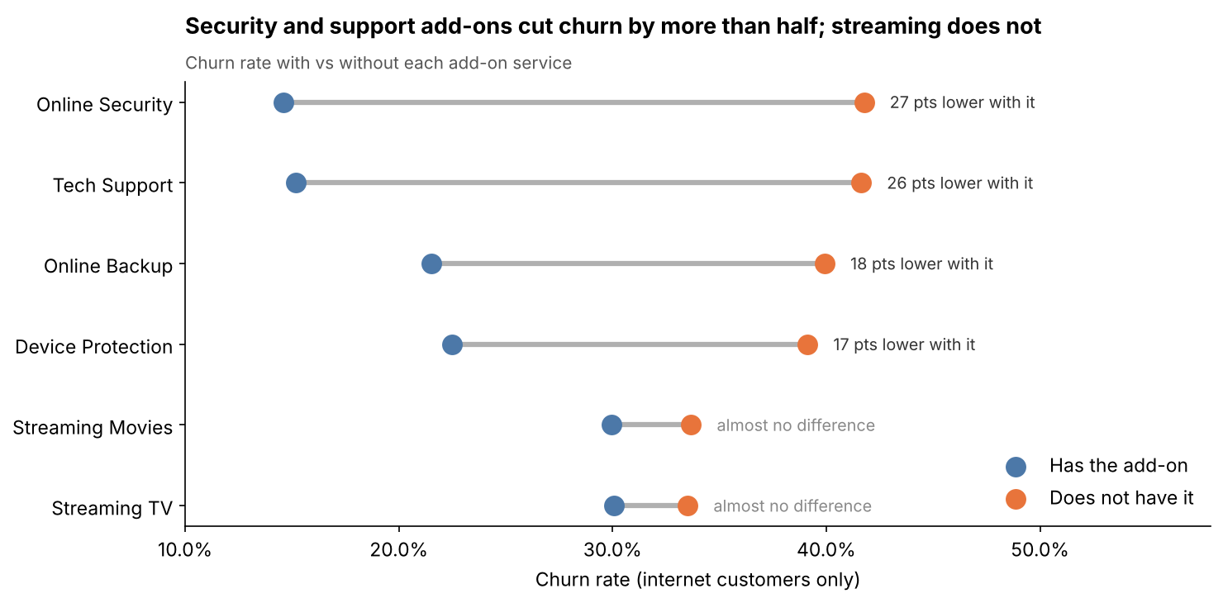
Figure 4: Churn rate with and without each add-on service (internet customers only)
Why this visualization
A dumbbell chart shows two values and the gap between them for many categories with very little ink. The length of the grey line is the size of the effect, so the reader can rank the add-ons instantly. I restricted the comparison to internet customers, because customers without internet cannot buy add-ons and would otherwise distort the "without" group.
What it shows
Add-on | Churn without | Churn with | Difference
Online Security | 41.8% | 14.6% | 27.2 pts
Tech Support | 41.6% | 15.2% | 26.5 pts
Online Backup | 39.9% | 21.5% | 18.4 pts
Device Protection | 39.1% | 22.5% | 16.6 pts
Streaming Movies | 33.7% | 29.9% | 3.7 pts
Streaming TV | 33.5% | 30.1% | 3.5 pts

Security and support services are linked to churn falling by more than half, while streaming services make almost no difference. This suggests that customers who feel supported and protected are more likely to stay. It is an association, not proof of cause, so it should be tested before a large rollout.

4.5 Who should we target? – Risk-factor ladder
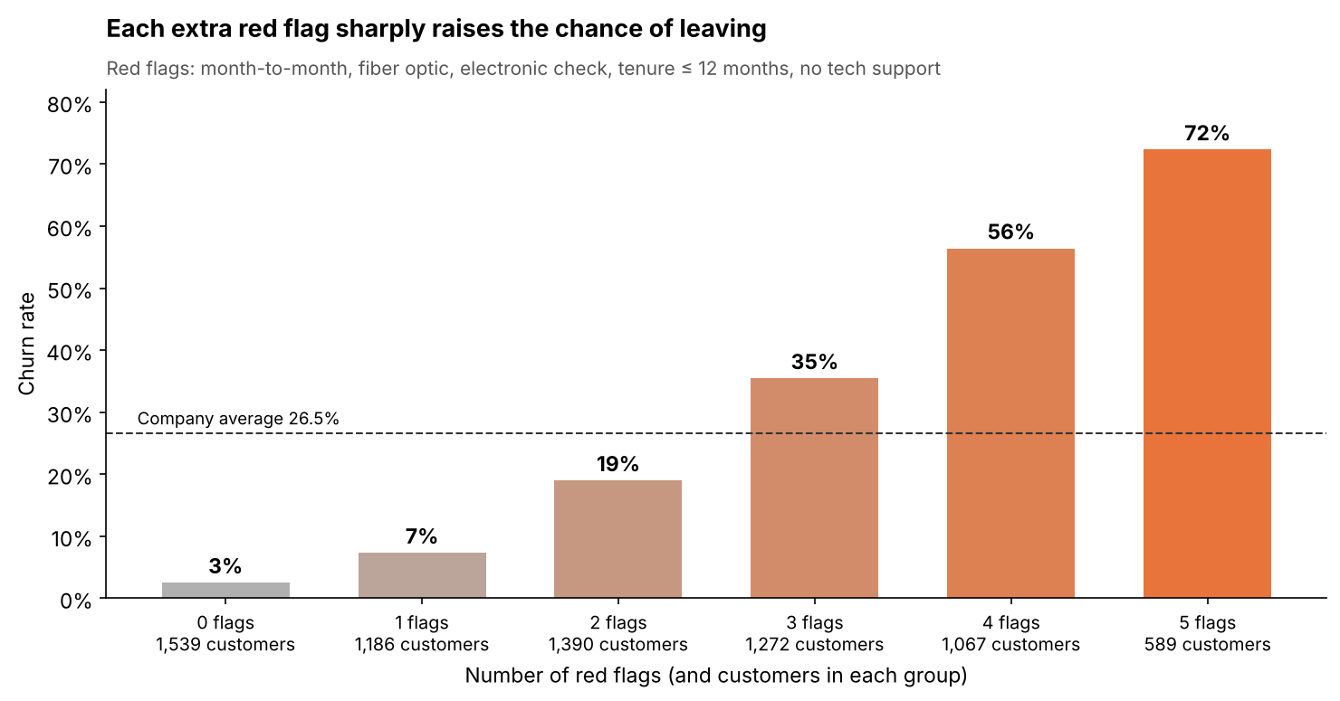
Figure 5: Churn rate by number of red flags, with the number of customers in each group
Why this visualization
The earlier charts each look at one factor, but in reality factors stack up. I counted how many of five red flags each customer has: month-to-month contract, fiber optic internet, electronic check payment, tenure of 12 months or less, and internet without tech support. A simple bar ladder turns this multi-factor idea into one number anyone can understand. The colour warms as risk rises, and the dashed line marks the company average.
flags = pd.DataFrame({
"Month-to-month": df["Contract"] == "Month-to-month",
"Fiber optic": df["InternetService"] == "Fiber optic",
"Electronic check": df["PaymentMethod"] == "Electronic check",
"Tenure <= 12 m": df["tenure"] <= 12,
"No tech support": (df["TechSupport"] == "No") & (df["InternetService"] != "No"),
})
df["RiskFlags"] = flags.sum(axis=1)
What it shows
Churn climbs from 2.5% with no flags to 7.3%, 19.0%, 35.5%, 56.4% and finally 72.3% with all five, nearly 30 times higher. The 1,656 customers with four or five flags form a ready-made priority list for a retention team, even before any machine learning model is built.

4.6 The big picture – Nested donut and interactive sunburst
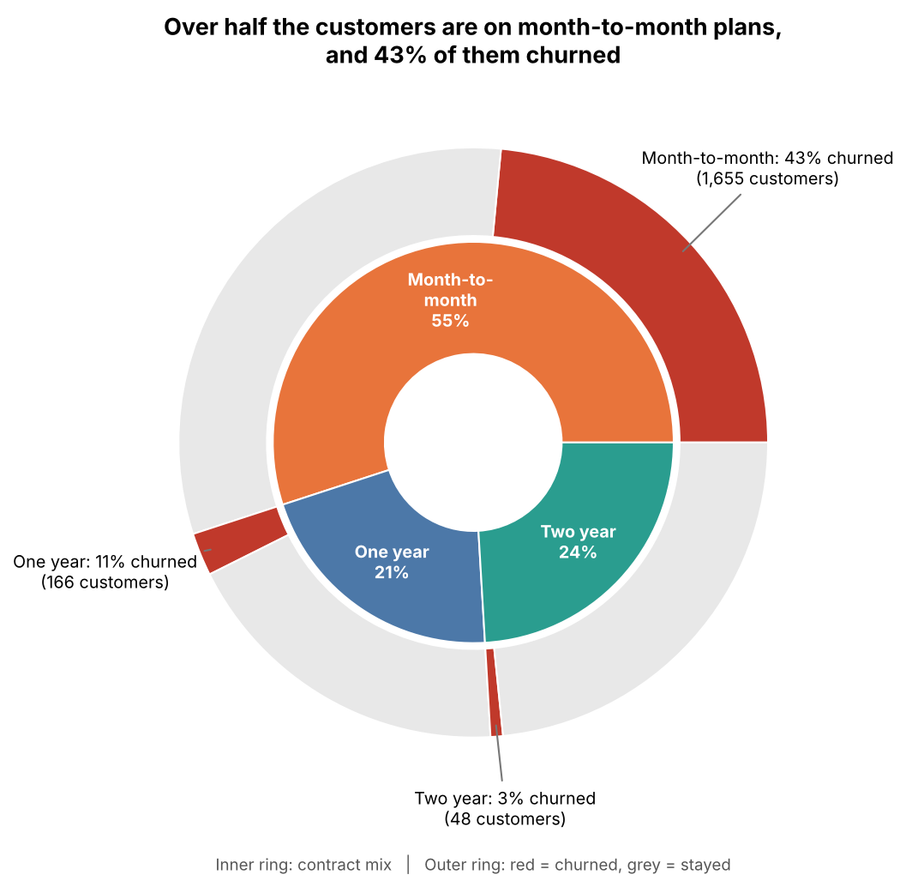
Figure 6: Contract mix (inner ring) and share of each contract that churned (outer ring)
Why this visualization
To close the story I wanted one overview that ties size and risk together. The inner ring shows how the customer base is split by contract; the outer ring shows how much of each slice was lost in red. Part-to-whole charts are usually weak for precise comparison, so here the exact numbers are written next to each red slice.
I also built an interactive Plotly sunburst (reports/interactive/churn_sunburst.html in the repository). It drills down Contract → Internet Service → Churn; clicking a slice zooms in, and hovering shows exact counts. This lets a curious reader explore the data without running any code.
What it shows
55% of customers are on month-to-month plans and 43% of them (1,655 customers) churned, compared with 11% of one-year and 3% of two-year customers. The biggest group of customers is also the riskiest one.

5. The Data Story in Summary
Question | Answer from the visuals
When do customers leave? | Mostly in the first year: about 30% of month-to-month customers leave within 12 months
Who leaves? | Month-to-month customers at every tenure level (26–51% churn)
What does it cost? | About $139k per month (30.5% of revenue); 72% of it from month-to-month fiber customers
Why might they leave? | Missing security and support add-ons is strongly linked to churn; streaming is not
Who to target first? | 1,656 customers with 4–5 red flags, who churn at 56–72%

6. Business Implications
- Move customers to longer contracts. Offer a discount or a free month for switching from month-to-month to a one-year plan, especially during the first year when risk is highest.
- Focus the retention budget on month-to-month fiber customers. This single segment drives 72% of lost revenue, so even a small improvement there has a large financial effect.
- Bundle Online Security and Tech Support for new fiber customers, then run an A/B test to confirm the add-ons actually reduce churn rather than just being correlated with it.
- Encourage automatic payments. Electronic check users are a high-risk group, and a small incentive to switch to auto-pay is cheap compared with losing the customer.
- Use the red-flag score as an early-warning list until a proper predictive model is built in the coming weeks.

7. Limitations
- The data is a single snapshot, so the retention curves are estimates and all relationships are associations, not proven causes.
- Lost revenue uses each churned customer's last monthly charge and ignores acquisition cost and lifetime value.
- The red-flag score gives every flag equal weight; a model in later weeks can learn better weights.

8. Conclusion
This week I turned the Week 1 analysis into a visual story for a non-technical audience. Six visualizations, built with Matplotlib, Seaborn and Plotly, each answer one question and lead to the next: customers leave early, month-to-month customers are the problem at every tenure level, the cost is about $139k per month concentrated in one segment, security and support add-ons are linked to much lower churn, and stacking risk factors identifies exactly who to contact first. Consistent design choices such as action titles, a single accent colour, direct labels and annotations keep the focus on the message rather than on the chart mechanics.

9. References
- IBM. Telco Customer Churn dataset. github.com/IBM/telco-customer-churn-on-icp4d
- Knaflic, C. N. (2015). Storytelling with Data. Wiley.
- Kaplan, E. L. and Meier, P. (1958). Nonparametric estimation from incomplete observations. Journal of the American Statistical Association, 53(282).
- Matplotlib, Seaborn and Plotly documentation
- Project repository – github.com/anishgoyal0603/telco-churn-eda

