Week 1 Task Report
Data Acquisition, Cleaning and Exploratory Data Analysis
Dataset: IBM Telco Customer Churn
Anish Goyal
Virtual Data Science with Python Apprentice Intern – Yuva Intern
Integrated M.Tech (IT), IIPS DAVV, Indore
GitHub: github.com/anishgoyal0603/telco-churn-eda

1. Introduction and Objective
Every data science project starts with data that is not ready to use. Columns are stored in the wrong type, some values are blank, and categories are written in inconsistent ways. The aim of this week was to go through that preparation stage on a real public dataset: download it, clean it with Python and Pandas, and then explore it to understand what the data is saying before any modelling is done.
I chose a customer churn dataset because churn is a common business problem. A telecom company wants to know which customers are likely to leave so that it can try to keep them. The guiding question for my analysis was: which customer characteristics are associated with a higher chance of churning?

2. Dataset Description

2.1 Source
The IBM Telco Customer Churn dataset is publicly available in IBM's GitHub repository (IBM/telco-customer-churn-on-icp4d). It describes a fictional telecom company with 7,043 customers and 21 columns. Each row is one customer and the target column Churn tells whether the customer left in the last month.
Reasons for choosing it: it is a realistic business dataset, it is large enough to show clear patterns, and it has genuine data quality problems (a numeric column stored as text, blank values and inconsistent category codes), which makes it a good fit for a cleaning exercise.

2.2 Columns
Group | Columns | Type
Identifier | customerID | Text
Demographics | gender, SeniorCitizen, Partner, Dependents | Categorical
Account | tenure, Contract, PaperlessBilling, PaymentMethod | Numeric / Categorical
Services | PhoneService, MultipleLines, InternetService, OnlineSecurity, OnlineBackup, DeviceProtection, TechSupport, StreamingTV, StreamingMovies | Categorical
Billing | MonthlyCharges, TotalCharges | Numeric
Target | Churn (Yes / No) | Categorical

2.3 Tools Used
- Python 3 with Jupyter Notebook
- Pandas and NumPy for loading and cleaning the data
- Matplotlib and Seaborn for visualisations
- Git and GitHub for version control and sharing the code

3. Methodology
I followed a simple pipeline: acquire → inspect → clean → validate → explore → document. All code is in the notebook notebooks/week1_data_cleaning_eda.ipynb in the GitHub repository.

3.1 Data Acquisition
The CSV was downloaded once into a data/raw/ folder so that the analysis does not depend on an internet connection every time. The raw file is never edited; the cleaned version is saved separately in data/processed/.
# download (run once)
curl -L -o data/raw/Telco-Customer-Churn.csv \
https://raw.githubusercontent.com/IBM/telco-customer-churn-on-icp4d/master/data/Telco-Customer-Churn.csv

import pandas as pd
df_raw = pd.read_csv("../data/raw/Telco-Customer-Churn.csv")
df_raw.shape # (7043, 21)

3.2 Initial Inspection
Using df.info() and a loop over the text columns to print their unique values, I found three issues:
- TotalCharges is a money column but was loaded as text, which means some rows contain non-numeric values.
- SeniorCitizen is coded as 0/1 while all other yes/no columns use "Yes"/"No".
- Six add-on service columns contain a third level "No internet service" and MultipleLines contains "No phone service".

4. Data Cleaning

4.1 Fixing the Data Type of TotalCharges
Converting the column to numbers revealed 11 blank strings (a single space, not a real NaN, which is why pandas did not report them as missing). When I looked at these rows, every one of them had tenure = 0.
blank_mask = df["TotalCharges"].astype(str).str.strip() == ""
blank_mask.sum() # 11
df.loc[blank_mask, ["tenure", "MonthlyCharges"]] # all have tenure = 0

df["TotalCharges"] = pd.to_numeric(
df["TotalCharges"].astype(str).str.strip().replace("", "0"))
Justification: a customer with zero months of tenure has not received a bill yet, so their total charges really are 0. Filling with 0 is the most accurate option. Dropping the rows would lose real customers, and filling with the mean or median (about 1,394) would give a brand-new customer a large bill they never paid.
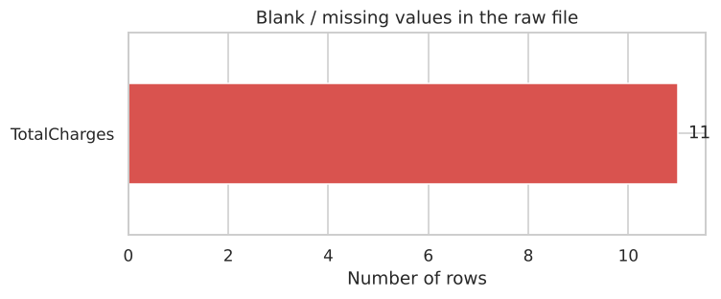
Figure 1: Blank values found in the raw file (only TotalCharges was affected)

4.2 Checking for Missing Values
After the fix, df.isna().sum() returned 0 for every column, so no further imputation was needed.

4.3 Handling Duplicates
df.duplicated().sum() # 0 exact duplicates
df["customerID"].duplicated().sum() # 0 repeated IDs
df.drop(columns="customerID").duplicated().sum() # 22
Decision: there are no exact duplicate rows and every customerID is unique. 22 rows match another row on all other columns, but when I checked them they were customers with around one month of tenure on the most basic plans (mostly no internet service). Identical profiles are expected in that group. Since the IDs are different, these are different people, so I kept all of them. Removing them would have deleted genuine records.

4.4 Making Categories Consistent
df["SeniorCitizen"] = df["SeniorCitizen"].map({0: "No", 1: "Yes"})

internet_cols = ["OnlineSecurity", "OnlineBackup", "DeviceProtection",
"TechSupport", "StreamingTV", "StreamingMovies"]
for col in internet_cols:
df[col] = df[col].replace("No internet service", "No")
df["MultipleLines"] = df["MultipleLines"].replace("No phone service", "No")

df[cat_cols] = df[cat_cols].astype("category")
df["ChurnFlag"] = (df["Churn"] == "Yes").astype(int)
Justification: "No internet service" is already captured by InternetService = "No", so repeating it in six columns only adds redundancy. Merging it into "No" keeps the meaning (the customer does not have that add-on) and turns each column into a clean binary feature. Text columns were converted to the category type, which uses less memory and makes grouping faster. A numeric ChurnFlag (1 = churned) was added so churn rates can be calculated as a simple mean.

4.5 Outlier Check
I used the 1.5 × IQR rule on tenure, MonthlyCharges and TotalCharges. No values fell outside the fences, so no outlier treatment was required. All values are also within sensible ranges (tenure 0–72 months, monthly charges 18.25–118.75).

4.6 New Feature: Tenure Group
To make the effect of customer age easier to see, tenure was grouped into four bands: 0–12, 13–24, 25–48 and 49–72 months.
df["TenureGroup"] = pd.cut(df["tenure"], bins=[-1, 12, 24, 48, 72],
labels=["0-12 m", "13-24 m", "25-48 m", "49-72 m"])
df.to_csv("../data/processed/telco_churn_clean.csv", index=False)

4.7 Cleaning Summary
Issue | Rows / columns affected | Action taken
TotalCharges stored as text | 1 column | Converted to float
Blank TotalCharges | 11 rows (tenure = 0) | Filled with 0
Exact duplicates | 0 rows | None needed
Same profile, different ID | 22 rows | Kept (distinct customers)
SeniorCitizen coded 0/1 | 1 column | Mapped to Yes/No
Redundant "No internet/phone service" | 7 columns | Merged into "No"
Outliers (1.5 × IQR) | 0 values | None needed
Final dataset | 7,043 rows × 23 columns | Saved to data/processed/

5. Exploratory Data Analysis

5.1 Summary Statistics
Statistic | tenure (months) | MonthlyCharges | TotalCharges
Mean | 32.37 | 64.76 | 2,279.73
Std. deviation | 24.56 | 30.09 | 2,266.79
Minimum | 0 | 18.25 | 0.00
Median | 29 | 70.35 | 1,394.55
Maximum | 72 | 118.75 | 8,684.80

Median values split by churn already show a strong difference:
Churn | Median tenure | Median MonthlyCharges | Median TotalCharges
No | 38 | 64.43 | 1,679.52
Yes | 10 | 79.65 | 703.55

The target is imbalanced: 26.5% of customers churned and 73.5% stayed.

5.2 Distributions of Numeric Columns
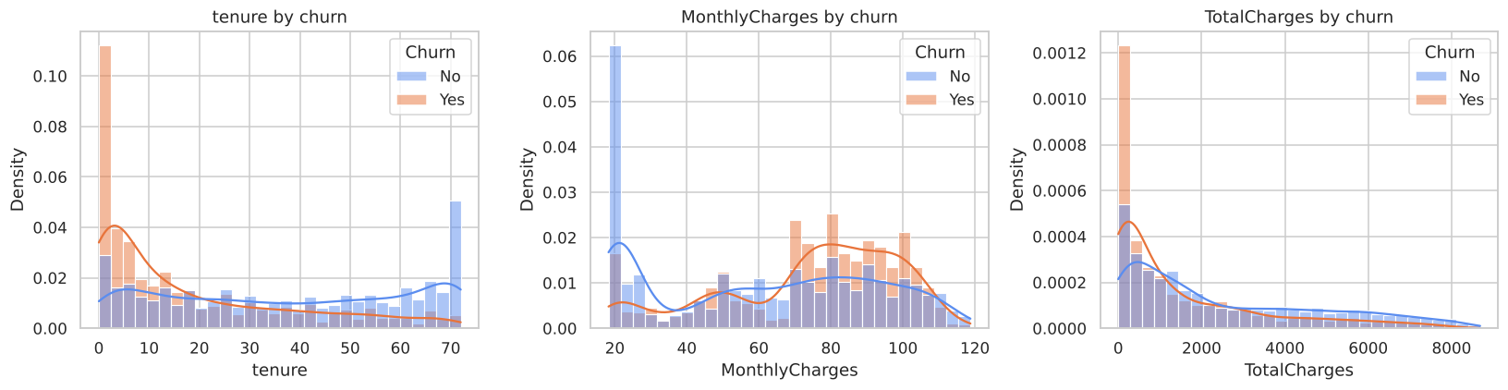
Figure 2: Histograms with KDE for tenure, MonthlyCharges and TotalCharges, split by churn
Churners are heavily concentrated at low tenure, while loyal customers spread across the whole range with a second peak near 72 months. Churners are also concentrated in the 70–105 monthly charge range, whereas the largest group of non-churners pays around 20 per month (customers with basic phone-only plans).

5.3 Box Plots
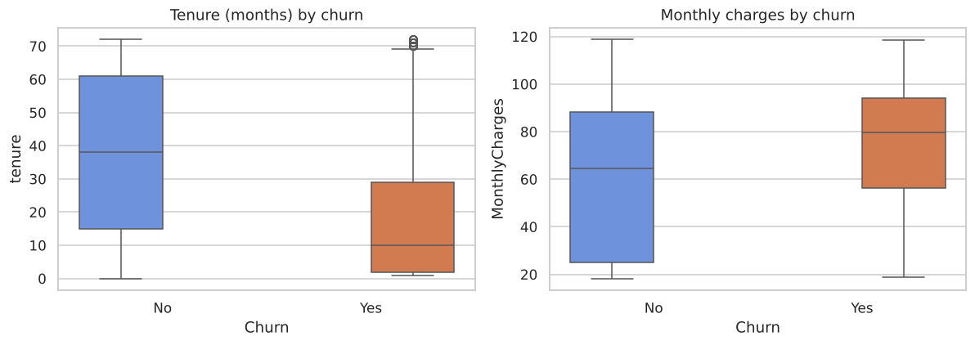
Figure 3: Box plots of tenure and monthly charges by churn
The box plots confirm the same pattern: customers who leave have much shorter tenure and higher monthly charges than customers who stay.

5.4 Churn Rate by Category
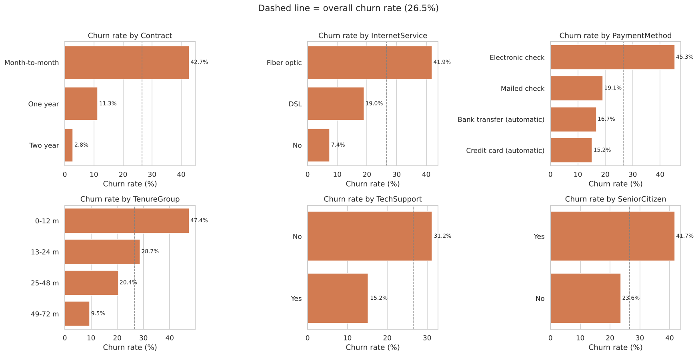
Figure 4: Churn rate for key categorical features (dashed line = overall rate of 26.5%)
Feature | Highest churn group | Lowest churn group
Contract | Month-to-month – 42.7% | Two year – 2.8%
Tenure group | 0–12 months – 47.4% | 49–72 months – 9.5%
Payment method | Electronic check – 45.3% | Credit card (automatic) – 15.2%
Internet service | Fiber optic – 41.9% | No internet – 7.4%
Senior citizen | Yes – 41.7% | No – 23.6%
Tech support | No – 31.2% | Yes – 15.2%
Online security | No – 31.3% | Yes – 14.6%
Paperless billing | Yes – 33.6% | No – 16.3%
Gender | Female – 26.9% | Male – 26.2%

5.5 Correlation Analysis
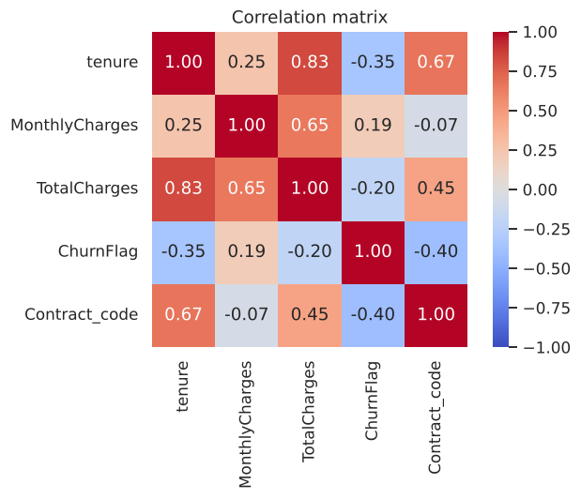
Figure 5: Correlation matrix of numeric features, churn flag and contract length
Contract length (−0.40) and tenure (−0.35) have the strongest negative correlation with churn, while MonthlyCharges has a weak positive correlation (0.19). Tenure and TotalCharges are highly correlated (0.83), which makes sense because total charges grow with every month a customer stays. This should be kept in mind to avoid multicollinearity when building a model.

5.6 Tenure vs Monthly Charges
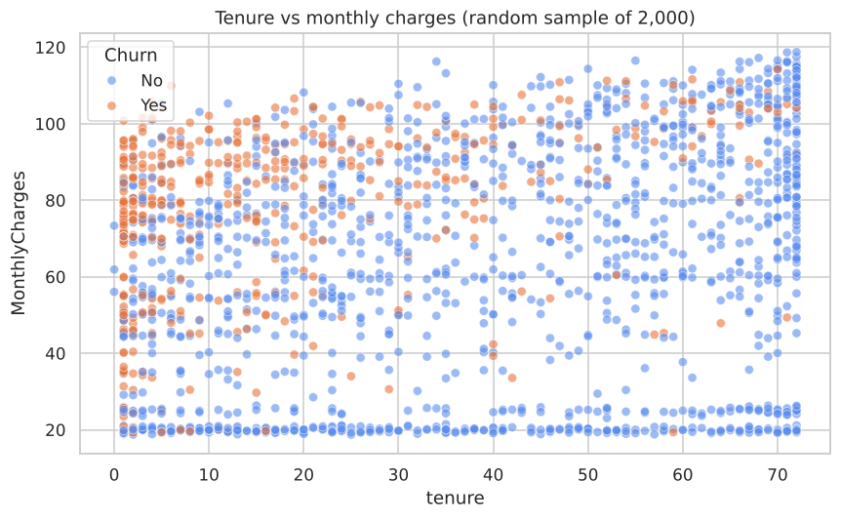
Figure 6: Scatter plot of tenure against monthly charges (random sample of 2,000 customers)
Churned customers cluster in the top-left of the plot: short tenure and high monthly charges. Customers who have stayed a long time rarely churn, even when they pay a lot.

6. Summary of Insights
- Churn is about 26.5%, so the classes are imbalanced (about 3:1). Future models should use stratified splits and be judged on recall and F1, not only accuracy.
- Contract type is the strongest signal. Month-to-month customers churn at 42.7%, compared with 11.3% for one-year and 2.8% for two-year contracts.
- The first year is the riskiest. Churn is 47.4% in the first 12 months and drops to 9.5% after four years. Median tenure of churners is just 10 months against 38 for customers who stay.
- Fiber optic customers churn at 41.9%, about double the DSL rate, even though it is the premium service. Together with higher charges among churners, this points to price or service quality issues worth investigating.
- Electronic check users churn at 45.3%, around three times the rate of customers on automatic payments (15–17%).
- Add-on services help retention. Customers without Tech Support or Online Security churn at roughly twice the rate of those who have them.
- Senior citizens churn more (41.7% vs 23.6%), while gender has almost no effect (26.9% vs 26.2%) and is unlikely to be useful for prediction.

7. Areas for Further Analysis
- Build classification models (logistic regression, random forest) on the cleaned data to predict churn.
- Check whether the fiber optic effect still holds after controlling for contract type and monthly charges.
- Study combinations of risk factors, for example month-to-month + electronic check + fiber optic.
- Estimate revenue at risk by combining predicted churn probability with each customer's monthly charges.
- Test statistical significance of the category differences using chi-square tests.

8. Conclusion
This week I took a raw public dataset through the full preparation process. The main cleaning work was fixing a numeric column stored as text, handling 11 hidden blank values in a way that matches their real meaning, checking for duplicates without deleting genuine customers, and standardising inconsistent category labels. The cleaned dataset has 7,043 rows, no missing values and correct data types, and is saved for the next weeks of the internship.
The exploratory analysis showed that churn is driven mainly by contract type, how long the customer has been with the company, payment method and internet service type. These findings give a clear direction for the modelling work that follows.

9. References
- IBM. Telco Customer Churn dataset. github.com/IBM/telco-customer-churn-on-icp4d
- Pandas documentation – pandas.pydata.org/docs
- Seaborn documentation – seaborn.pydata.org
- Project repository – github.com/anishgoyal0603/telco-churn-eda

