In the last few years I have worked in manufacturing and IT industry in many capacities like BA/ PM/trainer/auditor and in multiple domains like rail road, manufacturing and public sector. I believe I have become stronger in adapt to new roles, situations and work with variety of people. In all the projects where I have been a involved i have been appreciated my work on documentation, managing client and communications with stakeholders. I have also managed multiple projects at the same time, handled onsite-offshore teams which trained me well in time management and multi-tasking. I am disciplined, strong believer in work ethics and a keen learner. My exp as BA and PM provided the push I needed to move to take up Product Owner as the next role and look for an exciting opportunity where I can use my experience and skills but also learn new aspects of business.

**Strengths**

1. Quick in adapting n Willing to learn = started to learn to code Dynamics CRM, SQL stored procedures
2. Dedicated and hardworking which shows from the appreciation from every client I have worked with in the past
3. Know how to say NO – do not need to compromise on deliverables due to over commitment
4. Accepting my mistakes – Humans make mistakes and the best way to deal with them is to admit it than cover it - new to SQL and was updating the database for production issue, ran the update query without selecting the where clause. The whole table started showing a single value.
5. Good trainer – Conducted more than 1400 manhours of training

**Weakness**

1. Too particular with discipline – Delivery on time, excuses for delay,
2. Being upfront and vocal

**Success**

1. Client who never had any app to track/record information now are using mobile devices on the field and using the application provided. Reduced all the paper work and therefore long turn around time for that NYC agency

**Failure**

1. Quality of the product was compromised due the software they had selected as they had already purchased licenses but the expectation were no less. It was a lot of rework to try achieve the quality but there ofcourse was a a difference. They did not agree and we had to deliver at the best quality the tool offered by putting in a little extra effort.

**Best fit**

1. I believe I have it in me to be a good product owner as I posses most of the qualities expected. Some which I am not highly skilled, I can sure learn them.
2. With my experience and strong willingness to learn, I can assure you whatever the role demands I am up for it
3. Extensive experience of dealing with tech teams, UX teams, senior management will come in handy

**Challenges as a product owner**

1. The desired value from the sprint not achieved as the stories are not delivered
2. The stakeholders asking to add new requirements after confirming them
3. Team having the mentality of waterfall but feel trapped in agile

**Translate the vision to team**

Vision -> Product vision board -> Product roadmap -> Product backlog -> Sprint backlog

**Vision**

Clear and firm … Extensive and appealing …..Brief and concise

**User story**

**PBI**

**D –** Detailed

E – Emergent

E – Estimable

P – Prioritized

**Product owner**

Knowledgeable – multiple domain and platforms, client types

Efficient comm – awarded by client, appreciated by team

Conflict resolver – Storming phase -> roles/resp conflicts

Leader – lead 2 projects to delivery phase

Researcher – Being always in a new domain and the only BA or Pm,

I Independent

N Negotiable

V Value

E Estimable

S small

T testable

**Agile Scrum**

Lightweight framework of agile

Timeboxed

Collaborative

Iterative (same cycle repeats) and incremental (increments add to final release)

**Agile core values**

Individuals interaction / Process & tools

Working application / Documentation

Customer collaboration/ contract negotiation

Responding to change/ following plan

**Agile core values**

Individuals interaction / Process & tools

Working application / Documentation

Customer collaboration/ contract negotiation

Responding to change/ following plan

**Metrics**

Velocity chart

Sprint/release/ epicBurndown

Sprint Burnup

**Android phone**

1. AirWatch enabled phone to users, perform simple functions like capturing pictures and videos of inspection to be used as evidence when case if filed in court,
2. submit stop sheets to confirm the completion of a task and movement to another location
3. Track the next closest marked location for inspection using geo spatial tools

Mobile Android Vs iOS

1. Selection of app is critical – Native (Facebook), Hybrid (Gmail), mobile Web
2. Android Vs iOS –
   1. IOS – slow review process, but standard and advanced tools make development for iOS simpler and less costly
   2. Android - Fragmentation (Android OS version + device combination), less sophisticated tools, less cumbersome API’s, fewer exposed features
3. Mobile and web application are different – users are more distracted and focused on tasks at hand
4. Guidelines for development are different – requires specific design attributes and differ for android and iOS.
5. MVP model for mobile iteration
6. Train release schedule
7. Mobile app store – no certainty of user acceptance, slow review process
8. Feature flagging – no scope to revert to old version if something does not work
9. A step by step formulation for optimization
   1. Identify opportunities b. Define metrics
10. Hypo synthesize MVP d. Validate
11. Validate on App store f. Release to all users
    * 1. Methods for discovering optimization opportunities
12. Download -> Open -> Tutorial -> Login/ register -> Engage -> Retain
13. App discovery method
14. Maintaining multiple versions of the application simultaneously

**Prioritization**

Kano model -> MoSCoW-> Stacked ranking -> $100 test

Customer satisfaction -> Business Value -> Complexity -> Risk and Opportunity -> Cost -> Impacted users

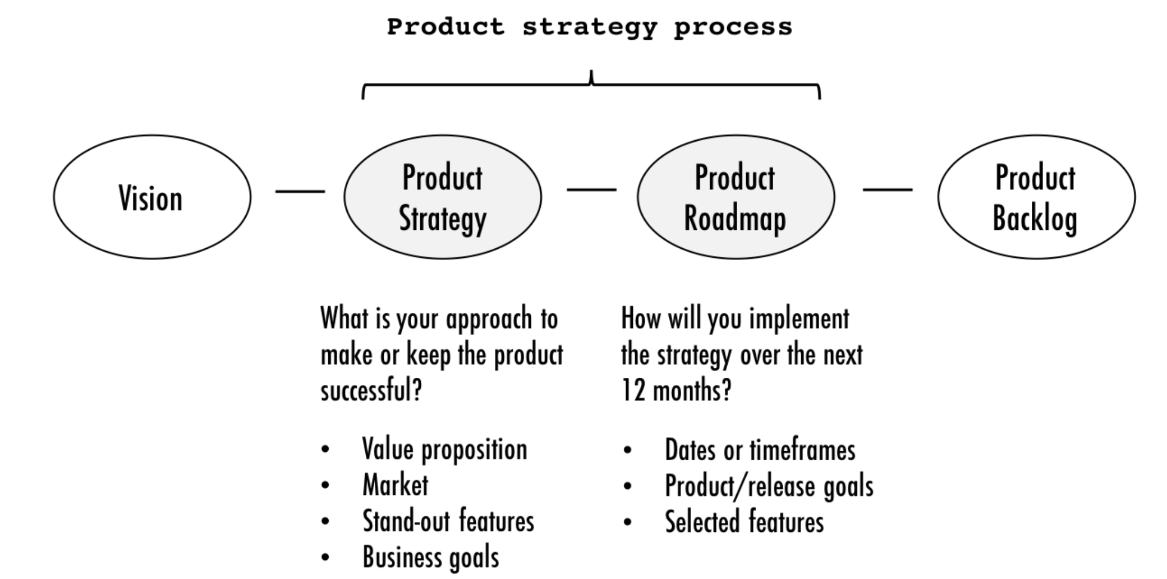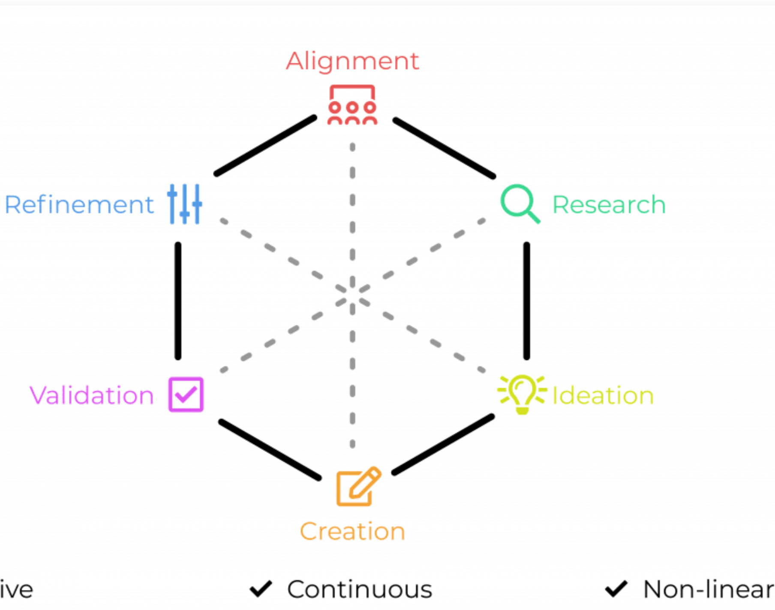

**Resolve conflict**

Don’t ignore

Regain composure/ Calm down

Gain perspective

Show some facts/skilful

Listen

**Product canvas**

1. Product vision board +
2. Cost
3. Revenue source
4. Risks
5. Competitors
6. Partners

**Skills of PO**

Communication

Commitment

Available

Focus on functionality

Vision

**Why agile**

1. Quick delivery instead of waiting
2. Value to product
3. Capture volatile market demands
4. Requirements not final

**Product vison board**

1. Vision
2. Target audience
3. Needs
4. Product features
5. Business goal (benefit to company)

**Is a PO successful?**

Healthy Product backlog

Smooth sprints

Constant delivery of value

Attaining release goals

Clarity over vision in team

Good product roadmap

Satisfied client