Forecasting Home Prices:

Data Visualization and Predictive Analysis

# Introduction

In today’s fast-paced real estate market, understanding and forecasting housing prices is crucial for informed decision-making by buyers, sellers, investors, and policymakers. The fluctuations in home prices are influenced by a variety of factors, including economic conditions, local market trends, and housing supply and demand. The advent of advanced data visualization and predictive analysis tools, such as Power BI, has empowered stakeholders to gain valuable insights from large datasets, enabling more accurate predictions and strategic planning. This report aims to explore the use of Power BI as a tool for visualizing and forecasting housing prices based on a given dataset.

# **Background Information**

The housing market plays a significant role in the economy, serving as both a critical investment vehicle and an essential need for individuals and families. Housing prices, however, are subject to rapid changes due to economic, demographic, and policy-driven factors. Analyzing historical trends and predicting future prices have become key objectives for real estate professionals and financial analysts alike. The use of tools such as Power BI enables the seamless integration of data visualization with predictive modeling, facilitating an intuitive and dynamic approach to decision-making. This project leverages a housing price dataset to demonstrate how Power BI can be used effectively for these purposes.

# **Problem Statement**

The housing market's complexity and volatility make it challenging to predict home prices accurately. Traditional methods of analysis often fail to account for the multifaceted relationships between variables and lack the dynamic visualization capabilities needed for comprehensive insights. As a result, stakeholders may miss opportunities or make uninformed decisions. This project addresses the challenge of building an interactive and predictive model using Power BI to forecast housing prices based on key features such as location, size, and market conditions. By doing so, it seeks to bridge the gap between data analysis and actionable insights in the real estate domain.

Research Questions

This report seeks to answer the following research questions:

1. What are the key factors influencing housing prices as per the dataset?
2. How can Power BI be used to visualize trends and relationships within the housing market?
3. What predictive models can be implemented using Power BI to forecast housing prices accurately?
4. What are the limitations and challenges of using Power BI for predictive analysis in the real estate sector?
5. How can stakeholders leverage insights derived from data visualization and predictive analysis to make informed decisions?
6. What are the key factors influencing home prices in the local market?
7. How do property features (square footage, bedrooms, bathrooms) relate to price?
8. What is the relationship between neighborhood and property value?
9. How has the average home price changed over time?
10. Are there significant price variations across different neighborhoods?
11. What is the predictive power of a model incorporating these factors?
12. How accurate is a predictive model in forecasting future home prices?
13. How can these insights be used to inform real estate investment strategies?
14. What are the key features driving price differences between these neighborhoods?

# Dataset

Dataset contains data that can be used to analyze and predict home values.

The dataset contains 50,000 entries with the following six columns:

1. **SquareFeet**: Indicates the size of the property in square feet. (Numeric, integer)
2. **Bedrooms**: Represents the number of bedrooms in the property. (Numeric, integer)
3. **Bathrooms**: Represents the number of bathrooms in the property. (Numeric, integer)
4. **Neighborhood**: Categorical data specifying whether the property is in a Rural, Suburban, or Urban area. (Categorical, string)
5. **YearBuilt**: The year the property was constructed. (Numeric, integer)
6. **Price**: The price of the property in US dollars. (Numeric, float)

**Key Features of the Dataset:**

* **Size and Coverage**: The dataset includes 50,000 rows, providing sufficient data for meaningful analysis and reliable predictive modeling.
* **Diverse Attributes**: The dataset includes a mix of numerical and categorical features, offering a comprehensive view of the factors influencing housing prices.
* **Price as the Target Variable**: The column **Price** serves as the target variable for prediction tasks.

# Solution with Power BI

|  |  |  |
| --- | --- | --- |
| **Research Question** | **Potential Outcomes** | **Visualizations** |
| What are the key factors influencing home prices? | Identification of the most significant factors (e.g., square footage, location) | Scatter plots, bar charts, tree maps (feature importance) |
| How do property features relate to price? | Correlation coefficients, regression model coefficients showing feature impact on price | Scatter plots (Price vs. SquareFeet, Price vs. Bedrooms, etc.), correlation matrix |
| Relationship between neighborhood and property value? | Significant price differences between neighborhoods; visualization of price distribution | Box plots (Price by Neighborhood), bar charts (Average Price by Neighborhood), map |
| How has the average home price changed over time? | Visualization of price trends over time; identification of periods of growth/decline | Line chart (Average Price over YearBuilt) |
| Significant price variations across neighborhoods? | Identification of neighborhoods with significantly different average prices | Box plots, map with color-coding by average price |
| Predictive power of a model incorporating these factors? | R-squared value indicating model fit; RMSE showing prediction error | Tables showing model metrics (R-squared, RMSE, etc.) |
| Accuracy of a predictive model in forecasting future prices? | MAE, MAPE values indicating prediction accuracy; forecast visualizations | Line charts (Actual vs. Predicted Prices), error plots |
| How can insights inform real estate investment strategies? | Identification of high-value areas, optimal investment strategies based on risk tolerance | Interactive dashboards with filters and slicers |
| Key features driving price differences between neighborhoods? | Identification of specific features that disproportionately impact prices in certain areas | Segmented bar charts |

# Neighborhood Breakdown

* Suburb (light blue): 16.72K (33.44%)
* Rural (dark blue): 16.68K (33.35%)
* Urban (orange): 16.6K (33.21%)

## Insights:

The distribution among the three neighborhoods is almost evenly split, with each group representing approximately one-third of the total.

The suburban area has a slightly higher count (16.72K) than rural (16.68K) and urban (16.6K).

# Bathroom Breakdown

* 3 Bathrooms (light blue): 50K (49.69%)
* 2 Bathrooms (dark blue): 33K (33.51%)
* 1 Bathroom (orange): 17K (16.79%)

## Insights:

* Houses with 3 bathrooms dominate, making up almost half of the total (49.69%).
* Houses with 2 bathrooms account for about one-third (33.51%).
* Houses with 1 bathroom represent the smallest portion at 16.79%.

# Trend in constructions

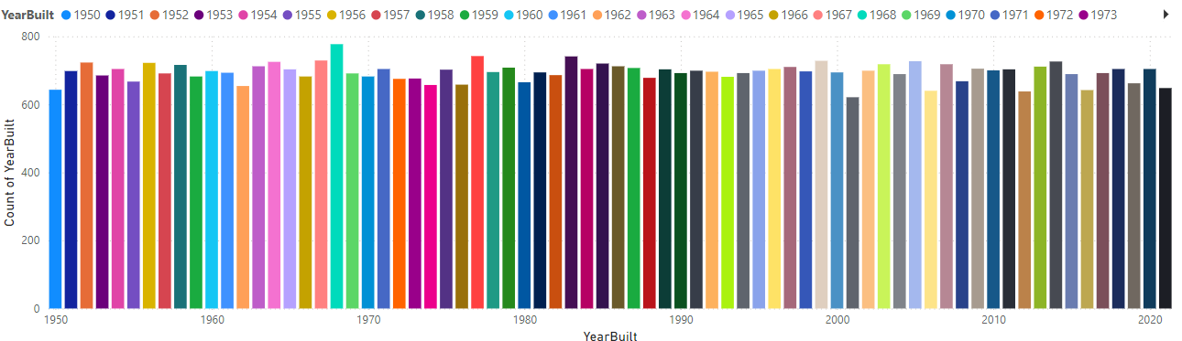

* 1960s: A significant peak in construction occurred during this decade, possibly due to post-war economic boom and suburban development.
* Early 1970s: A slight dip is observed, which might be related to economic downturns or shifts in housing policies.
* Late 1970s to 1980s: Another peak is evident, suggesting renewed growth in the housing market.
* Early 1990s: A minor dip, potentially linked to economic recessions or changes in interest rates.
* Late 1990s to 2000s: A strong surge in construction, possibly fueled by economic expansion and increased demand for housing.
* 2010s: A slight decline, which could be attributed to the global financial crisis and its impact on the housing market.
* 2020s: The trend appears to be continuing upwards, indicating sustained growth in house construction.

Descriptive statistics



## Typical Property Profile:

* The average home in this dataset is approximately 2006 square feet, with 3.5 bedrooms and 2 bathrooms, built around 1985. This provides a clear picture of the typical property.

## Price Range is Wide:

* Home prices vary significantly, ranging from a minimum of -$36,588.17 (note the negative value – investigate this outlier!) to a maximum of $492,195.26. This wide range suggests a diverse market with properties catering to different price points. The presence of a negative price warrants further investigation; it's likely an error in the data.

## Neighborhood Impact:

* While the average neighborhood score is 2.33, the standard deviation is relatively high (0.94). This suggests that neighborhood has a substantial impact on pricing, though more analysis would be needed to confirm this.

## Data Quality Considerations:

* The presence of a negative price and the significant standard deviations in several variables highlight the need to investigate potential data entry errors or outliers. Cleaning the data before further analysis is crucial.

## No Strong Skewness or Kurtosis:

* The skewness and kurtosis values for most variables are close to zero, indicating that the data distributions are relatively symmetrical and not heavily skewed (except for possibly the 'Neighborhood' variable). This is good for many statistical methods.

## Square Footage is Relatively Normal:

* The relatively low standard deviation of square footage (575.51) compared to the mean (2006.37) suggests that most homes are of a similar size.

# Relationship Between Year Built and House Price

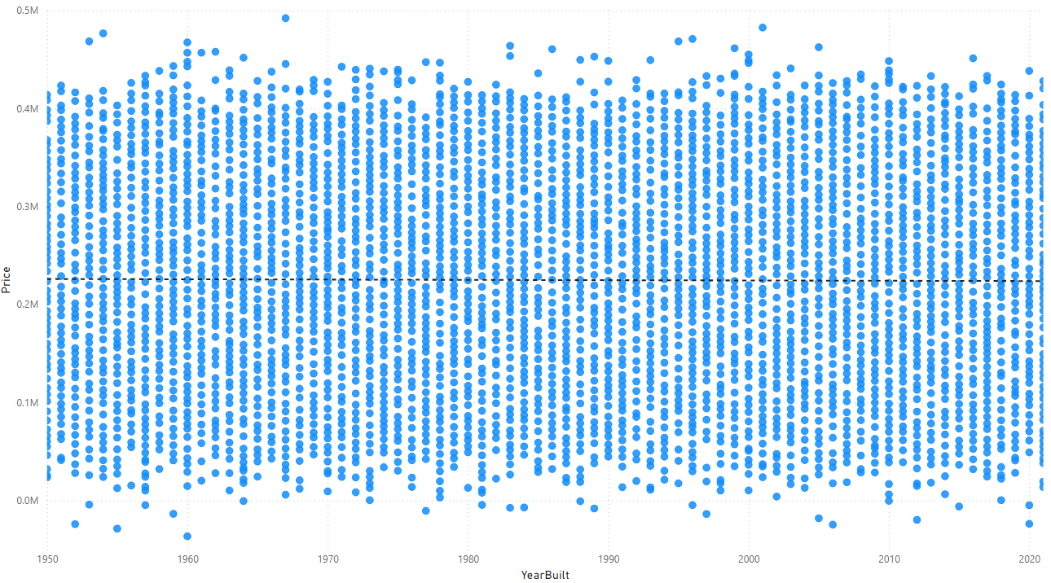

## Observations:

* **No Clear Trend:** There's no clear upward or downward trend in the data. The points are scattered randomly across the plot.
* **Price Range:** Prices vary significantly, with some houses built in older years commanding higher prices than newer ones.
* **Outliers:** There are a few outliers, especially in the higher price range, which might be due to unique features, location, or other factors not captured in the data.
* **Interpretation:**
* **Year Built is Not a Strong Predictor:** The year a house was built is not a strong predictor of its price. Other factors like location, size, condition, and amenities likely play a more significant role in determining a house's value.
* **Potential for Other Factors:** To better understand price variations, it would be helpful to include additional variables like square footage, number of bedrooms and bathrooms, neighborhood, and property type.

# Relationship Between Bathrooms and House Price

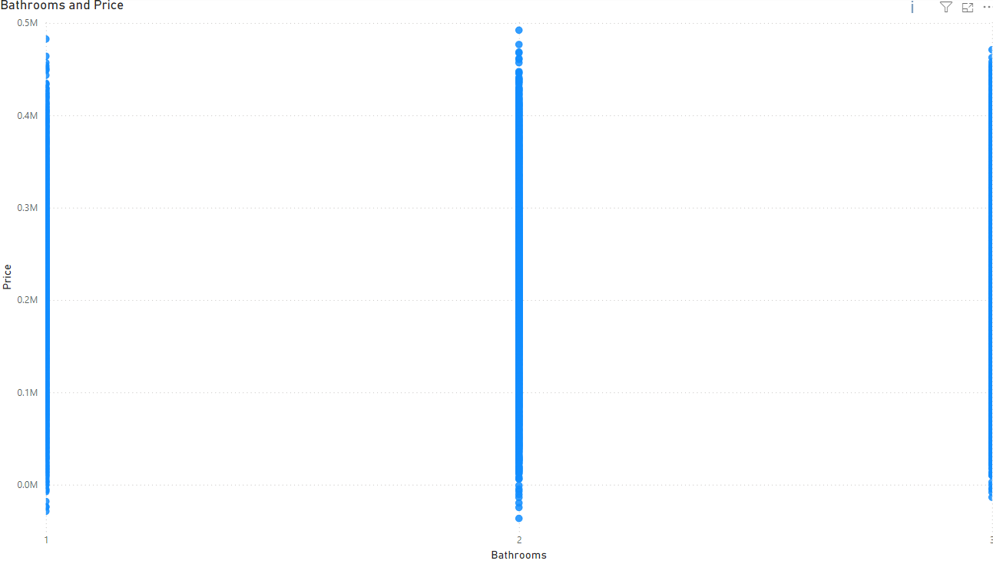

## Observations:

* **Vertical Lines:** The data points form distinct vertical lines at 1, 2, and 3 bathrooms. This indicates that for each bathroom count, there's a wide range of house prices.
* **No Clear Trend:** There's no clear upward or downward trend in the data. The price range for each bathroom count overlaps significantly.
* **Price Variation:** Within each bathroom category, there's a substantial variation in prices. Some houses with fewer bathrooms have higher prices than houses with more bathrooms.
* **Interpretation:**
* **Bathrooms as a Factor:** While the number of bathrooms is a factor influencing house prices, it's not the sole determinant. Other factors like location, size, condition, and amenities play a significant role.
* **Overlapping Price Ranges:** The overlapping price ranges for different bathroom counts suggest that the number of bathrooms alone cannot accurately predict a house's price.

# Relationship Between Bedrooms and House Price

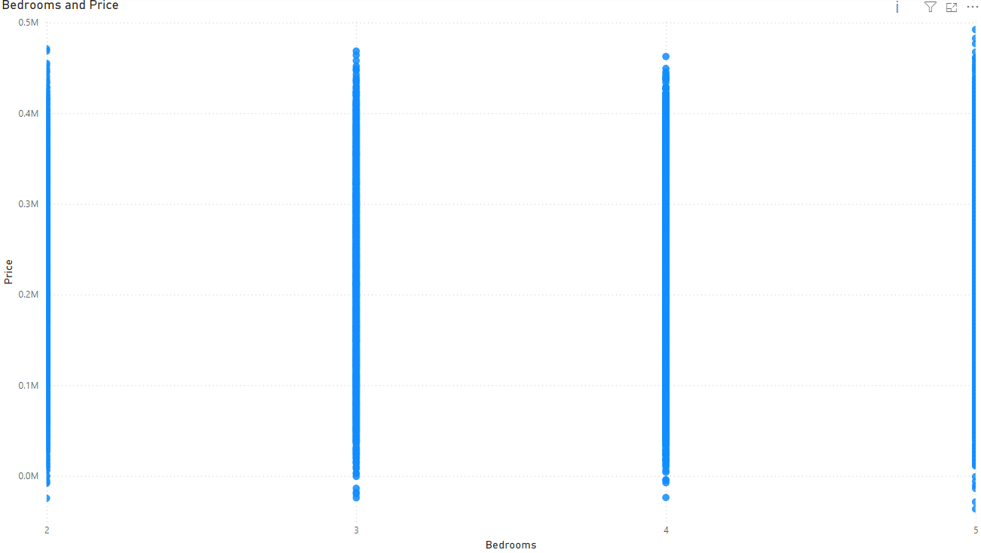

## Observations:

* **Vertical Lines:** The data points form distinct vertical lines at 2,3,4 and 5 bedrooms. This indicates that for each bathroom count, there's a wide range of house prices.
* **No Clear Trend:** There's no clear upward or downward trend in the data. The price range for each bedroom count overlaps significantly.
* **Price Variation:** Within each bedroom category, there's a substantial variation in prices. Some houses with fewer bedrooms have higher prices than houses with more bedrooms.
* **Interpretation:**
* **Bathrooms as a Factor:** While the number of bedrooms is a factor influencing house prices, it's not the sole determinant. Other factors like location, size, condition, and amenities play a significant role.
* **Overlapping Price Ranges:** The overlapping price ranges for different bedrooms counts suggest that the number of bedrooms alone cannot accurately predict a house's price.

# Relationship Between neighborhood and House Price

## Observations:

* **Vertical Lines:** The data points form distinct vertical lines at 1, 2, and 3 on the x-axis, which represents the neighborhood. This indicates that each neighborhood has a range of house prices.
* **Price Variation:** Within each neighborhood, there's a substantial variation in prices. Some houses in a specific neighborhood are more expensive than others.
* **Overlapping Price Ranges:** The price ranges for different neighborhoods overlap significantly. This suggests that neighborhood alone is not a strong predictor of house price.
* **Interpretation:**
* **Neighborhood as a Factor:** While neighborhood is a factor influencing house prices, it's not the sole determinant. Other factors like house size, condition, and amenities play a significant role.

Correlation



* **Square Feet and Price:** The strongest correlation is between square feet and price (0.7507). This indicates a strong positive linear relationship, meaning that as the square footage of a house increases, its price tends to increase as well.
* **Other Variables:** The correlations between other variables and price are much weaker. For example, the correlation between bedrooms and price is 0.0726, indicating a very weak positive relationship. Similarly, the correlation between bathrooms and price is 0.0284, also indicating a very weak positive relationship.

# Regression

## Model Performance:

* **R-squared:** The model explains approximately 57% of the variance in house prices. This indicates a moderately strong fit.
* **Adjusted R-squared:** Like R-squared but accounts for the number of predictors, suggesting a robust model.
* **Standard Error:** The standard error of the estimate is 49927.28914, indicating the average deviation of predicted values from actual values.

## Variable Significance:

* **Square Feet:** Has a highly significant positive impact on price. A one-unit increase in square feet is associated with a $99.35 increase in price, holding other factors constant.
* **Bedrooms:** Has a significant positive impact on price. A one-unit increase in bedrooms is associated with a $5074.91 increase in price, holding other factors constant.
* **Bathrooms:** Has a significant positive impact on price. A one-unit increase in bathrooms is associated with a $2830.40 increase in price, holding other factors constant.
* **Neighborhood:** Has a non-significant impact on price.
* **Year Built:** Has a non-significant negative impact on price.

# Dashboard

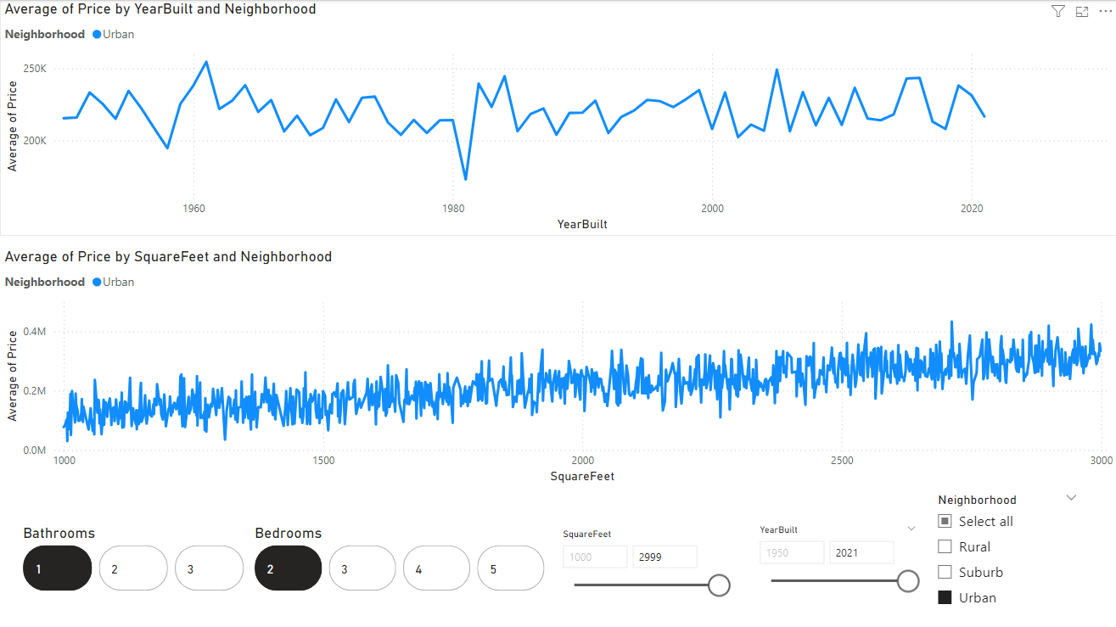

This dashboard provides an interactive visualization of housing prices using Power BI, focusing on key features like YearBuilt, SquareFeet, Neighborhood, Bedrooms, and Bathrooms. Here’s an explanation of its design, filters, and potential uses:

## Design

1. **Line Charts:**
   * **Top Chart**: Displays the **average price** of houses over time (YearBuilt) in a specific Neighborhood (Urban in this case).
   * **Bottom Chart**: Visualizes the relationship between **SquareFeet** and the **average price**, segmented by Neighborhood.
2. **Interactive Filters and Controls:**
   * **Bathrooms and Bedrooms Filters**: Represented as clickable buttons to refine the results based on the number of bedrooms or bathrooms.
   * **SquareFeet and YearBuilt Sliders**: Allow users to specify a range of property sizes and construction years for analysis.
   * **Neighborhood Selector**: A checkbox-style filter for selecting one or multiple neighborhoods (Rural, Suburb, Urban).
3. **Focus on Usability**: Clean layout with concise, actionable insights. The interactivity of filters ensures users can quickly drill down into specific data points.

## Filters

1. **Neighborhood**: Filters data to analyze properties in Urban, Suburban, or Rural areas.
2. **Bedrooms and Bathrooms**: Restricts the data to properties with specific configurations (e.g., 2 bedrooms and 1 bathroom).
3. **SquareFeet**: Allows focusing on homes within a particular size range, such as 1000–2999 sq. ft.
4. **YearBuilt**: Enables users to study trends within a specific timeframe (e.g., houses built between 1950 and 2021).

## Key Features and Insights

1. **Temporal Trends**:
   * The top chart reveals how housing prices in Urban areas have fluctuated over the years, helping users understand historical pricing trends and market growth.
2. **Size vs. Price Correlation**:
   * The bottom chart showcases how price increases with square footage, providing a visual cue for the impact of property size on pricing.
3. **Neighborhood Comparison**:
   * By toggling between neighborhoods, users can compare Urban prices with Rural and Suburban trends.

## Potential Uses

1. **Real Estate Market Analysis**:
   * Investors and analysts can identify the most valuable time periods and neighborhoods for investment based on historical trends.
2. **Price Prediction**:
   * Buyers can estimate the average price of a house given its size, age, and location.
3. **Customized Analysis**:
   * Users can tailor the data based on their specific requirements, such as targeting properties with a certain number of bedrooms or bathrooms in each neighborhood.
4. **Decision Support**:
   * Enables developers, real estate agents, and policymakers to make data-driven decisions on pricing, development, and marketing strategies.

# Conclusion

The analysis and predictive modeling of housing prices using Power BI have highlighted the value of data visualization and advanced analytical techniques in understanding complex real estate markets. By leveraging a dataset with diverse attributes such as square footage, number of bedrooms and bathrooms, neighborhood, year built, and price, this project provides actionable insights for various stakeholders, including buyers, sellers, investors, and policymakers.

## Key findings from the analysis include:

Significant Factors: Square footage emerged as the most significant predictor of housing prices, with a strong positive correlation, while features like bedrooms, bathrooms, and neighborhood had varying but weaker impacts.

Market Trends: Temporal trends in housing prices reveal fluctuations influenced by economic and market conditions, providing valuable insights for long-term investment strategies.

Neighborhood Comparisons: While neighborhood influences prices, it is not the sole determinant, emphasizing the need for a holistic approach that considers multiple factors.

Predictive Modeling: The regression model demonstrates moderate accuracy, explaining 57% of the variance in housing prices. This provides a solid foundation for further refinement and incorporation of additional variables to enhance predictive power.

The interactive dashboard built in Power BI proves to be a powerful tool for exploring housing market dynamics. It enables users to identify trends, relationships, and patterns while allowing for customized analysis through filters and slicers. This facilitates informed decision-making by empowering stakeholders to focus on specific market segments or property attributes.

While the project provides valuable insights, some limitations, such as the presence of data anomalies (e.g., negative prices) and weaker correlations for certain variables, underscore the importance of data cleaning and further analysis. Future work could explore integrating external factors like economic indicators or geographic data to improve prediction accuracy and deepen insights.

In conclusion, this project demonstrates the effectiveness of combining data visualization and predictive modeling to address real-world challenges in the real estate domain. The insights gained from this analysis can support stakeholders in making data-driven decisions, optimizing investment strategies, and navigating the complexities of the housing market with confidence.