
Preliminary Design Review
Lux Lunae (Team #14)
April 22, 2026

Table of Figures
Figure 1: Science Traceability Matrix
Figure 2: Landing Site
Figure 3: Distance from Landing Site to PSR Border
Figure 4: Water-Equivalent Hydrogen, Illumination, and Slope Values
Figure 5: Final Mission Location/Water Equivalent Hydrogen Readings
Figure 6: Mission Requirements Table
Figure 7: Concept of Operations Timeline
Figure 8: Labeled Cad Model of Rover
Figure 9: Team Introduction Table
Figure 10: Lux Lunae Organizational Chart
Figure 11: Mission Milestones and Estimated Dates
Figure 12: Mission Cost Breakdown
Figure 13: Chassis Drawing
Figure 14: Wheel Drawing
Figure 15: Solar Panel 1 drawing
Figure 16: CAD image of Rover
Figure 17: Constraints of Subsystem
Figure 18: Mechanical Subsystem Requirements Table
Figure 19: Mechanical Subassembly Data
Figure 20: Wheel Design Trade Study
Figure 21: Chassis Structure Material Trade Study
Figure 22: Chassis Material Parameters
Figure 23: Mechanical Verification Matrix
Figure 24: Rover Power vs Time Cycle
Figure 25: Power Subsystem Requirements Table
Figure 26: Power Overview
Figure 27: Power Subassembly Data
Figure 28: Power Verification Matrix
Figure 29: CDH Subsystem Requirements
Figure 30: CDH Subassembly I
Figure 31: CDH Subassembly II
Figure 32: Thermal Requirements
Figure 33: Subassembly Metrics
Figure 34: Subassembly Metrics II
Figure 35: Thermal Verification Matrix
Figure 36: Science Requirements
Figure 37: Payload Verification Matrix
Figure 38: Interface Control Key
Figure 39: N^2 Chart
Figure 40: FMEA
Figure 41: Mission Team Organizational Chart
Figure 42: Lux Lunae Mission Schedule
Figure 43: Gantt chart
Figure 44: Mission Phases
Figure 45: Personnel Budget
Figure 46: Travel Budget
Figure 47: Outreach Budget
Figure 48: Direct Costs

Acronym list
PDR: Preliminary Design Review
MDR: Mission Definition Review
CDR: Critical Design Review
SRB: Standing Review Board
PSR(s): Permanently Shadowed Regions
CRM: Continuous Risk Management
BoE: Basis of Estimate
ISR(s): Ice Stability Regions
ISRU: In-Situ Resource Utilization
SMD: Science Mission Directorate
ESDMD: Exploration Systems Development Mission Directorate
STM: Science Traceability Matrix
CDH: Command and Data Handling
FDIR: Fault Detection, Isolation, and Recovery
OBC: Onboard Computer
SSR: Solid State Recorder
MET: Mission Elapsed Time
ECC: Error-Correcting Code
PMU: Power Management Unit
UHF: Ultra High Frequency
BMS: Battery Management System
TRIDENT: The Regolith Ice Drill for Exploring New Terrain
MSolo: Mass Spectrometer Observing Lunar Operations
NIRVSS: Near-Infrared Volatiles Spectrometer System
NSS: Neutron Spectrometer System
AIM: Ames Imagining Module
MEDA: Mars Environmental Dynamics Analyzer

- Mission Overview

  - Mission Statement

The mission statement for Lux Lunae is to increase knowledge surrounding potential sites for future lunar exploration by conducting robotic surveys of the terrain and environment. This goal is achieved through the deployment of two 1.5m x 1.5m x 0.5m robotic rovers designed to navigate the difficult terrain, regolith, and severe temperatures of the lunar south pole’s Permanently Shadowed Regions (PSRs). One rover, Alpha, is dedicated to Science Mission Directorate (SMD) objectives, while the other, Gamma, focuses on Exploration Systems Development Mission Directorate (ESDMD) objectives.
The Alpha rover fulfills SMD objectives by characterizing the distribution and physical state of lunar polar water and other volatiles. This involves identifying the sources of these volatiles and the processes governing their transport, retention, and loss within PSRs, as well as assessing the potential for In-Situ Resource Utilization (ISRU) and interpreting the geologic history of these regions. To gather this data, Alpha utilizes instruments such as the TRIDENT drill for depth-resolved sampling, the MSolo Mass Spectrometer to analyze isotopic composition and volatile concentrations, and the Neutron Spectrometer System (NSS). This data is essential for understanding planetary formation and evaluating the feasibility of ISRU, which is helpful for future lunar exploration planning.
The Gamma rover supports ESDMD objectives by conducting robotic reconnaissance and in-situ measurements to characterize terrain, environmental conditions, and resource distribution, directly informing future human exploration. This work quantifies environmental hazards that astronauts may encounter and evaluates the type and distribution of in-situ resources to maximize safety and efficiency on the lunar surface. Data is gathered using the TRIDENT drill—including penetrometers to measure regolith mechanical properties—along with AIM cameras for mapping slope, boulder distribution, and illumination patterns, and MEDA-derived sensors for measuring dust and environmental conditions. These measurements are helpful for optimizing landing site selection, rover path planning, and astronaut EVA operations.

  - Science Traceability Matrix

Figure 1: Science Traceability Matrix
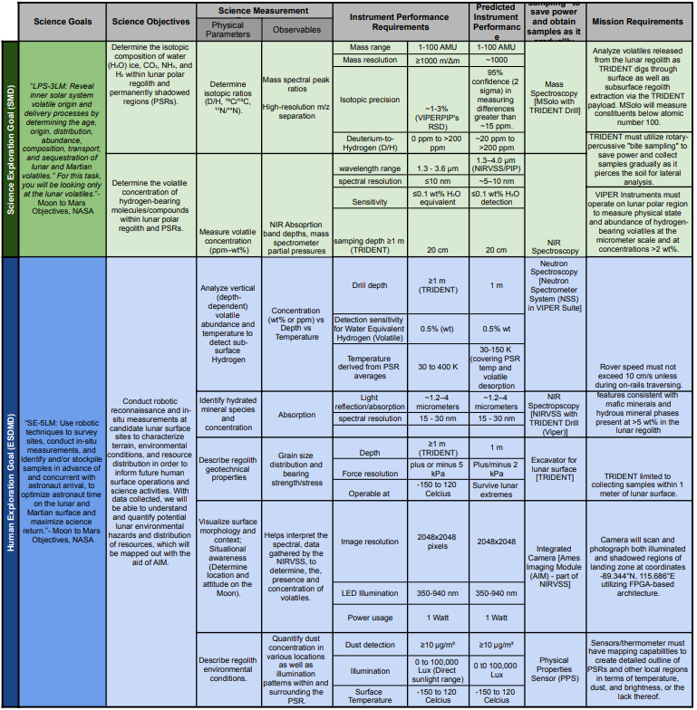

The primary purpose of the Lux Lunae robotic reconnaissance mission is to define key science objectives and measurement requirements that support future lunar surface exploration. It employs two distinct rovers: Alpha for the Science Mission Directorate (SMD) and Gamma for the Exploration Systems Development Mission Directorate (ESDMD). The mission aims to use data collected from these two to optimize astronaut time on-site. This is achieved by having these robotic systems characterize and identify candidate sites prior to human arrival. The mission focuses on three main subjects: subsurface volatiles, surface mineralogical/chemical composition, and terrain assessment for trafficability (for rovers and future reference).

- Rover Alpha: Science Mission Directorate (SMD) Objectives

Rover Alpha is dedicated to the SMD goal of revealing the origin and theological properties of lunar volatiles. Its primary focus is the lunar polar regolith and the Permanently Shadowed Regions (PSRs).
Isotopic Analysis and Volatile Origin: Alpha is tasked with determining the isotopic composition of water (H₂O) ice, CO₂, NH₃, and H₂. This includes measuring isotopic ratios such as D/H, ¹³C/¹²C, and ¹⁵N/¹⁴N to understand the age and transport of these volatiles.
Key Instrumentation: Alpha utilizes the MSolo (Mass Spectrometer) in conjunction with the TRIDENT Drill. The TRIDENT drill employs a rotary-percussive "bite sampling" technique, which saves power and allows for lateral soil analysis as it gradually pierces the surface.
Measurement Requirements: The MSolo instrument must provide high-resolution mass spectral peak ratios with a mass range of 1-100 AMU, covering a wide range of molecules both known to be or not to be on the lunar surface. It is required to have an isotopic precision of ~1-3% and a 95% confidence level in measuring differences greater than ~15 ppm.
Hydration Concentration: Alpha also uses NIR Spectroscopy (NIRVSS) to measure volatile concentration in the ppm to wt% range, specifically targeting 0 ppm to >200 ppm for Deuterium-to-Hydrogen.

- Rover Gamma: Human Exploration Goal (ESDMD) Objectives

Rover Gamma focuses on the ESDMD goal of conducting robotic reconnaissance to survey sites and identify resources in advance of astronaut arrival. Its mission is to characterize the terrain and environmental conditions to inform future human operations.
Subsurface Resource Mapping: Gamma analyzes vertical (depth-dependent) volatile abundance and temperature to detect subsurface hydrogen. It uses the Neutron Spectrometer System (NSS) to detect water-equivalent hydrogen with a sensitivity of 0.5% (wt) as outlined in the instrument’s qualifications.
Geotechnical & Mineralogical Assessment: To ensure rover trafficability for future missions possibly involving astronauts, Gamma describes regolith geotechnical properties, such as grain size distribution and bearing strength/stress. It also identifies mafic minerals and hydrous mineral phases present at >5 wt% in the regolith using NIR Spectroscopy. This standard was also set by the VIPER Proposal package which includes NIRVSS - an instrument package hosting an NIR spectrometer in addition to a Bracket Assembly, and Fiber Cables.
Environmental Monitoring/Tracking: Gamma is equipped with a Physical Properties Sensor (PPS) to quantify dust concentration (≥10 µg/m³) and monitor illumination patterns within and surrounding PSRs. It must also map surface temperatures ranging from -150 to 120 Celsius which includes the Moon’s average temperature range.
Triangulation: Gamma utilizes the Ames Imaging Module (AIM) as part of NIRVSS, which provides an image resolution of 2048x2048 pixels. This module helps interpret spectral data and provides the necessary situational awareness to determine the rover's location and attitude on the Moon.

Both rovers must operate under strict mission requirements to ensure data integrity and hardware survival:
Sampling Depth: The TRIDENT drill on both rovers is capable of reaching a depth of ≥1 meter, though it is limited to collecting samples within that range.
Rover Speed: Rover speed is restricted to 10 cm/s unless the rover is on-rails during a traverse. This speed is considered science acquisition speed by the VIPER proposal package aforementioned.
Lunar Conditions: The instrumentation is designed to survive lunar extremes, with the ability to operate in temperatures as low as -150 Celsius.
Imaging and Illumination: The AIM camera system utilizes LED illumination (350-940 nm) to photograph both illuminated and shadowed regions at specific landing zone coordinates.
By dividing these tasks between Alpha and Gamma, the Lux Lunae mission provides a comprehensive map of the lunar polar environment, ensuring that when astronauts arrive, the most viable and safe locations have already been identified and characterized.

  - Summary of Mission Location

LUX LUNAE targets PSR in the lunar southern pole because of the possibility of volatile water-ice inside of them. LUX LUNAE’s SMD contains the LPS-3LM, which states that the science goal is to “Reveal inner solar system volatile origin… by determining the age, origin, distribution, abundance, composition, transport, and sequestration of lunar volatiles.”
These PSR regions maintain extremely low cryogenic temperatures that are able to preserve volatile compounds indefinitely. Through the efforts from the Lunar Exploration Neutron Detector (LEND) from the Lunar Reconnaissance Orbiter (LRO), they used hydrogen mapping to detect abnormally high concentrations of hydrogen within several south pole craters, which gave scientists some evidence of the possibility of water-ice on the moon. The Lunar Crater Observation and Sensing Satellite (LCROSS) later confirmed this theory by crashing the upper stage of the rocket into a PSR to bring material under the surface into the air. Both of these sparked the interest of scientists to further their investigation into the possibility of water-ice on the moon.

Figure 2: Landing site with PSR highlighted in red and radial area displayed in bottom right

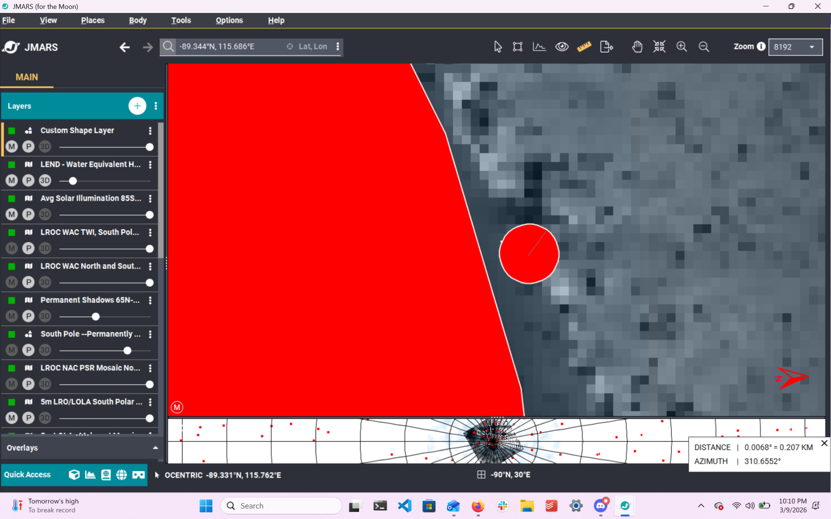

The mission location landing site chosen was at coordinates -89.344°N, 115.686°E. In order to account for uncertainty in the spacecraft’s landing process, the precision landing ellipse extends outward to a 0.2 km radial area. This location is on the right side of the outer rim of the Shackleton crater, which contains a circular PSR stretching about 17 km in diameter.⁶ This satisfies the customer requirements of the human exploration goal of mapping a contiguous PSR area of 150m². Other human exploration customer requirements, such as characterizing temperature conditions, surface slope, and the illumination at the boundary of the PSR, will be able to be met.
Although the crater itself is not the entire PSR according to the South Pole — Permanently Shadowed Craters overlay on JMARS, and there is some distance required to slope down into the crater to reach the PSR, the distance measurement of being 250 m away from the Exploration Zone (EZ), as dictated by customer constraints, was met when measured as starting from the rim of the crater to the radial landing area.

Figure 3: Distance from Landing Site to PSR Border

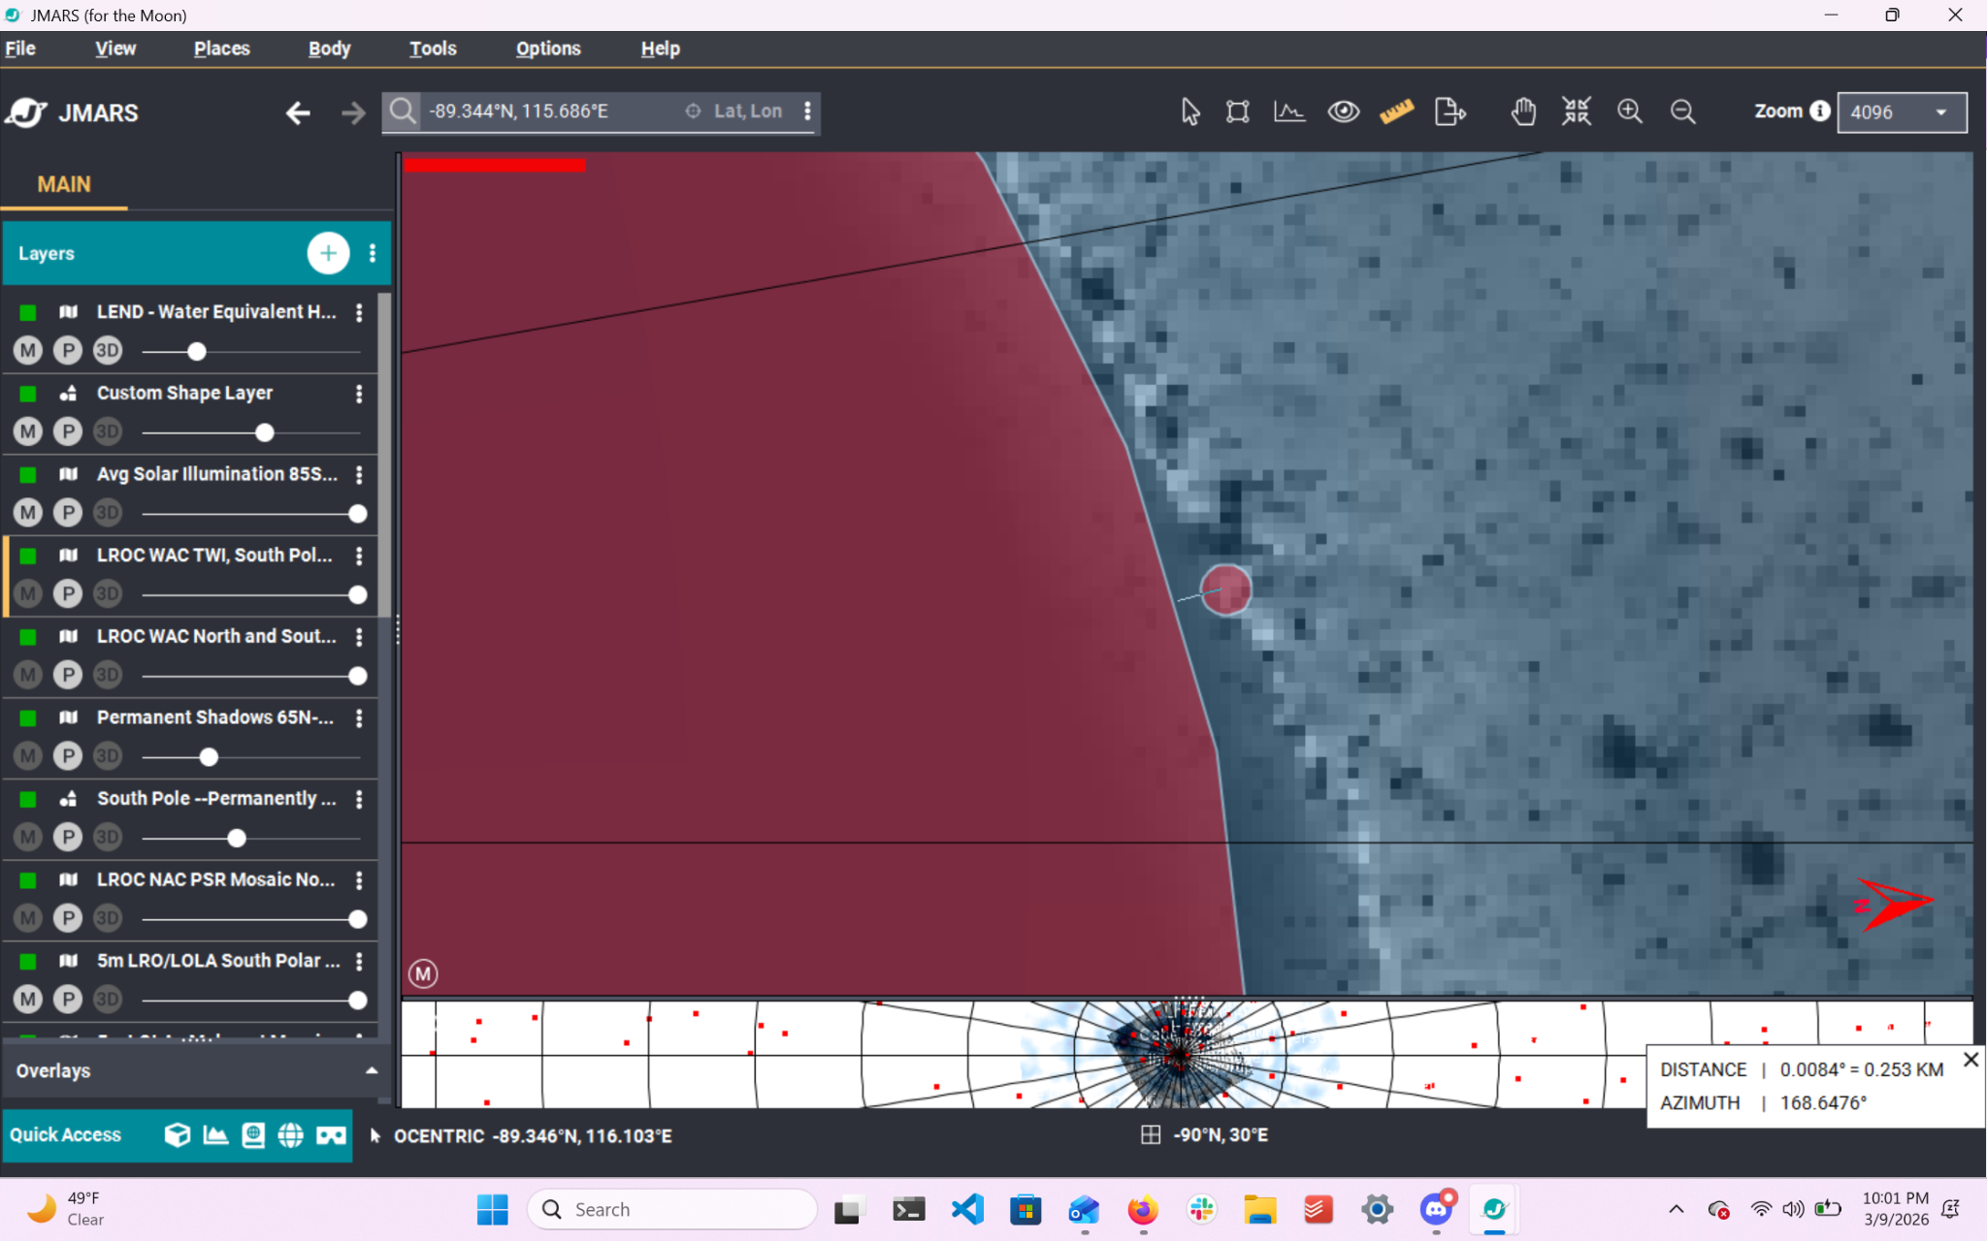

The 0.2 km radial area of the precision landing ellipse is marked inside the circle in the first figure. The majority of the slopes inside this radial area are all under 5°, as dictated by customer constraints and the terrain-relative navigation capabilities of the mission. The area is illuminated by the sun in a range of about 29 - 40% illumination according to the LROC WAC TWI sensor for the South Pole, as observed in the JMARS program. This illumination will allow for solar panel recharge for the rovers when rendezvousing with the base.

Figure 4: Water-Equivalent Hydrogen, Illumination, and Slope Values

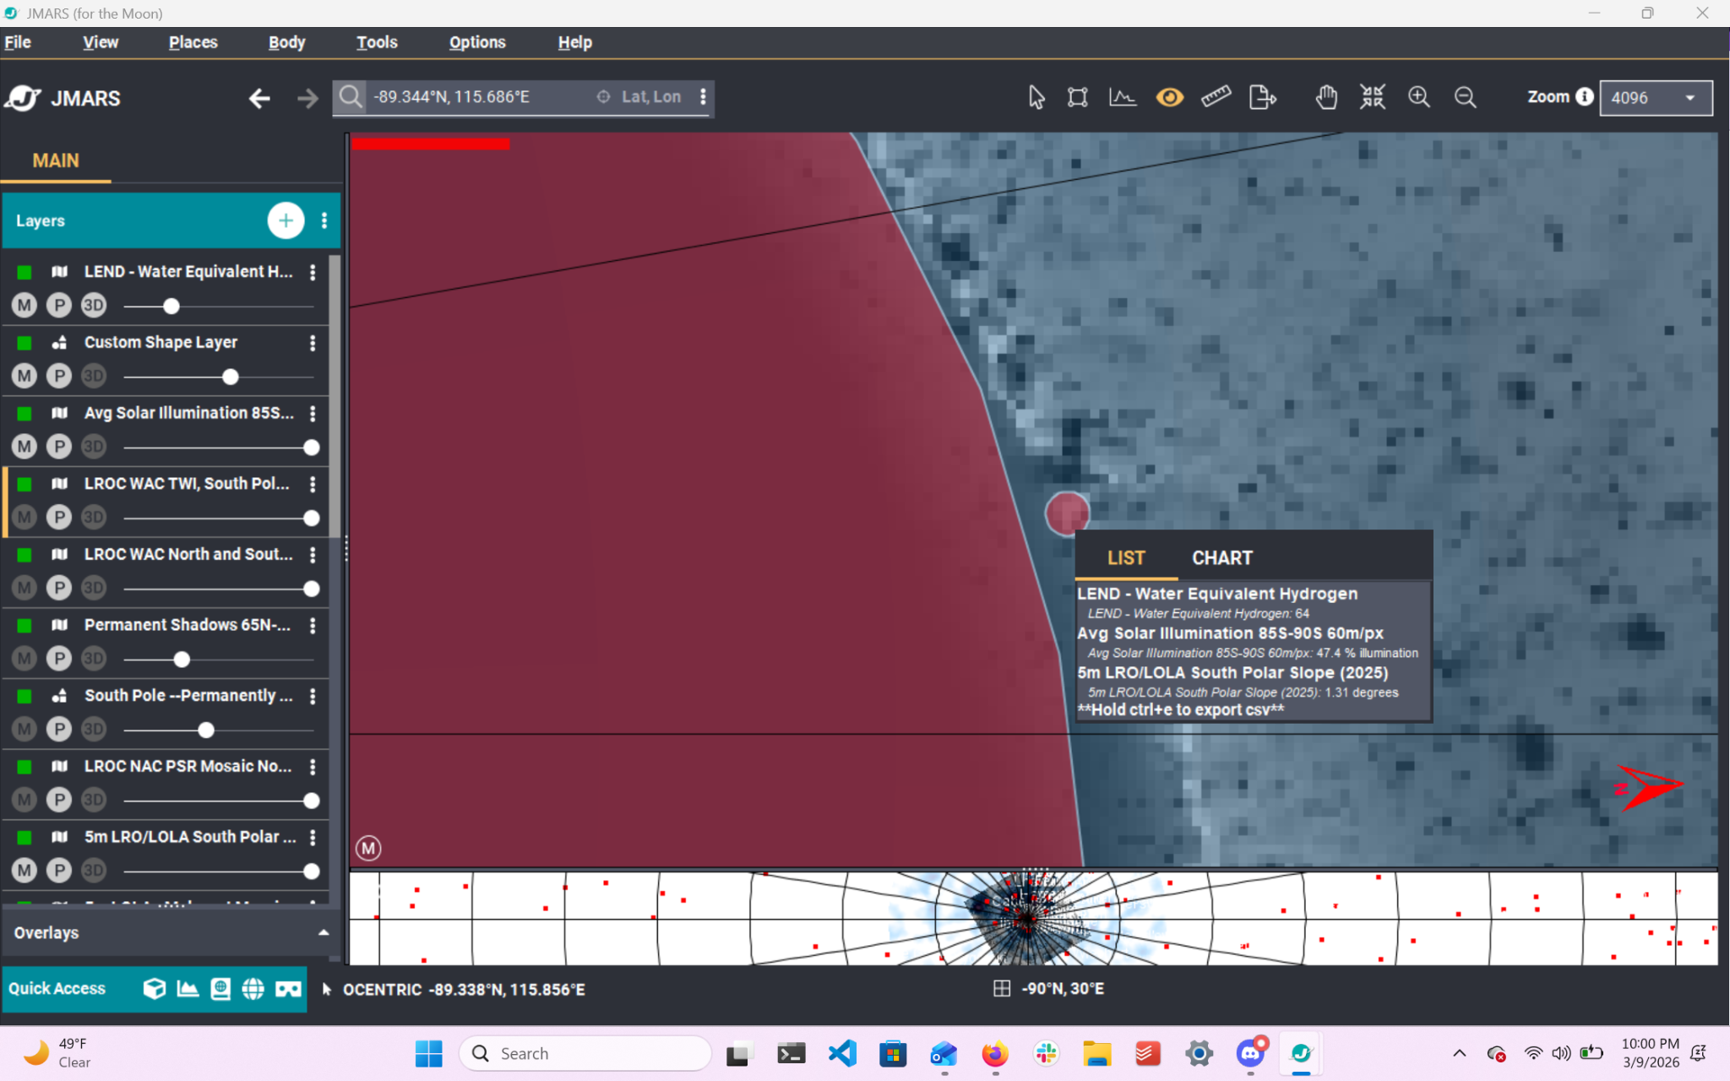

As discussed in the Mission Statement, two rovers will be deployed in order to map and characterize this PSR. Both of these rovers, by meeting landing constraints, will have a clear path to reach respective Science and Exploration mission areas inside the PSR.

Figure 5: Final Mission Location with Water Equivalent Hydrogen readings overlay

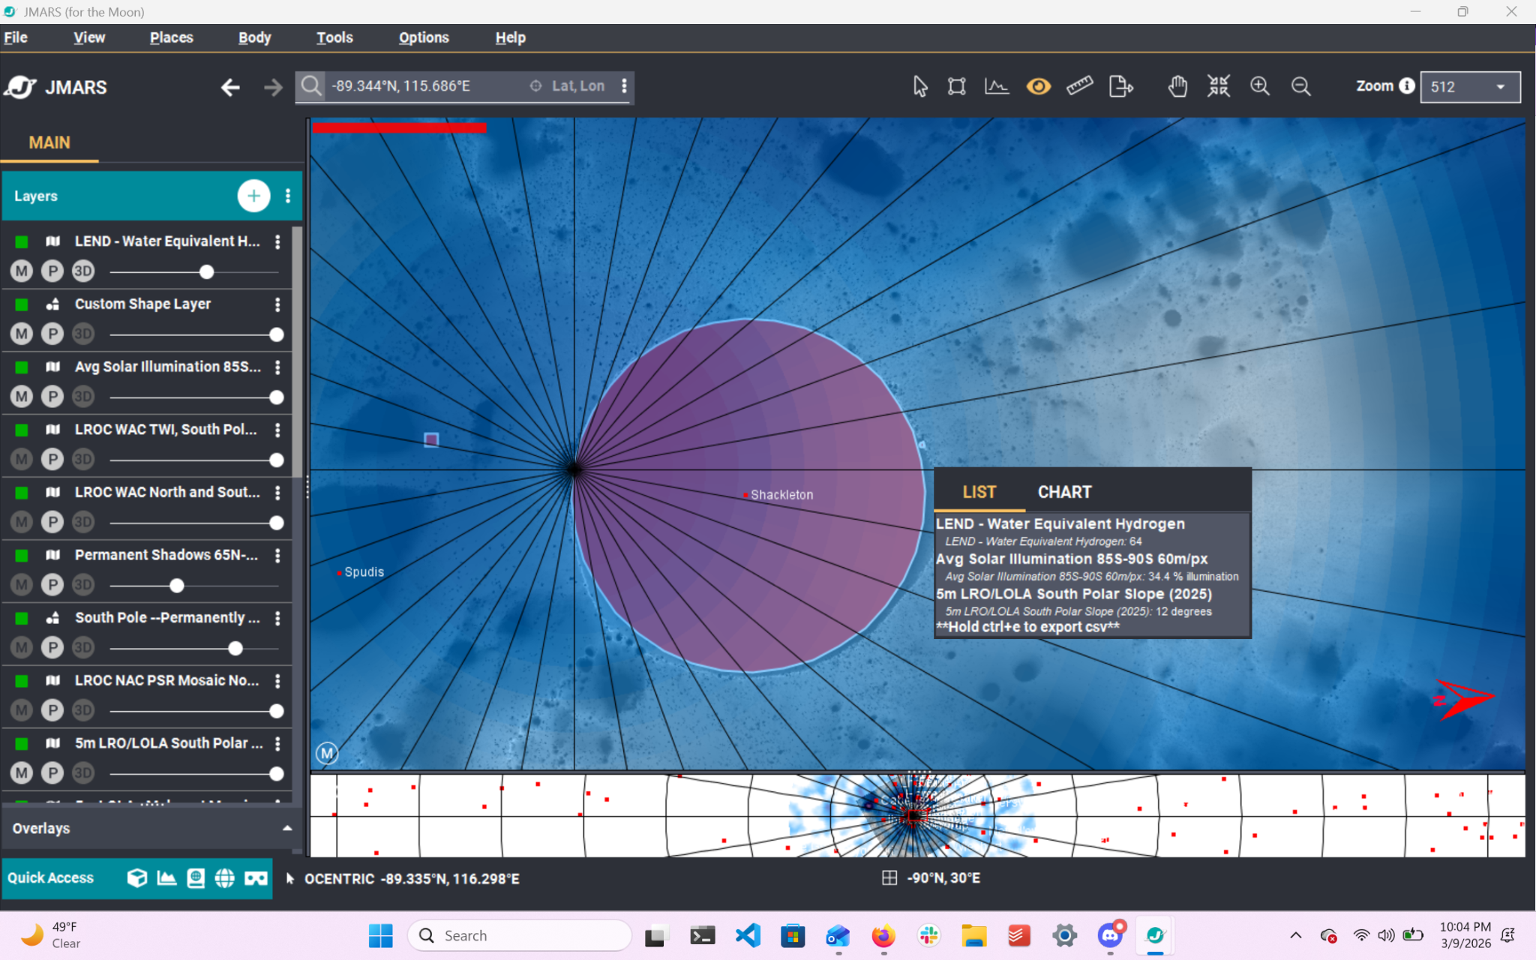

Originally, multiple locations were chosen based loosely off of proximity to multiple PSRs, when three rovers were being discussed to branch off in all different directions, and also based off of observed hydrogen readings inside the PSRs, which would give a higher chance for finding volatiles.
The current location was chosen based on high water-equivalent hydrogen readings taken from the LEND mission. These readings, as discussed in the STM’s ESDMD, are produced by potential hydrogen volatiles in the PSRs. These hydrogen readings, though a good indicator for water ice due to the fact that it is volatile, are not confirmation of water ice on the moon. Hydrogen can also be found in a multitude of other volatiles like methane (CH4), which are valuable for the SMD but perhaps less relevant to the ESDMD Human Exploration goals.

  - Mission Requirements

Mission requirements were derived based on the mission objective, and the SMD and ESDMD Goals and Objectives from the Science Traceability Matrix (STM). Many of the requirements were characterized based on their use for the Alpha or Gamma rovers.

Figure 6: Mission Requirements Table

Req # | Requirement | Rationale | Parent Req | Child Req | Verification method | Req met?
MAIN | LUX LUNAE is a lunar volatiles detection and measurement mission that shall be launched to the  lunar south polar region in a PSR area of 150 m^2 and fulfill the SMD and ESDMD objectives. | Main goal of mission. | Mission  Overview | SUB-1, SUB-2 | Demonstration | Met
SUB-1 | LUX LUNAE shall operate on the surface to identify and measure the depth-dependent physical  state and abundance of hydrogen-bearing volatiles. | Goal of mission per mission overview and  SMD and ESDMD objectives. | MAIN | SUB-1-1 | Demonstration | Met
SUB-1-1 | Volatiles shall be identified on the surface and subsurface up to a depth of 1 meter. | 1 meter is the maximum depth of the  TRIDENT drill. | SUB-1 | - | Demonstration | Met
SUB-2 | Two rovers, Alpha and Gamma, shall be utilized for mission goal fulfillment. | Two rovers will allow the SMD and ESDMD  requirements to be fulfilled concurrently. | MAIN | SUB-2-1, SUB-2-2 | Demonstration | Met
SUB-2-1 | LUX LUNAE shall build heavily on the instrumentation and mission plan of the VIPER rover mission. | VIPER shares a similar premise in  investigating lunar volatiles. | SUB-2 | - | Inspection | Met
SUB-2-2 | Rovers shall include a suite of rover-mounted instruments that will conduct scientific measurements on  volatiles and map their distribution across traversed areas. | Instruments will allow for the fulfillment of  the SMD and ESDMD requirements. | SUB-2 | - | Demonstration | Met
ALPHA | The instrumentation aboard the Alpha rover shall fulfill the SMD requirements. | Two rovers will allow the SMD and ESDMD  requirements to be fulfilled concurrently. | SUB-2-2 | ALPHA-1, ALPHA-2,  ALPHA-3, ALPHA-4,  ALPHA-5 | Inspection | Met
ALPHA-1 | The science payload shall identify the presence of hydrogen-bearing volatiles  including water ice present at concentrations of at least 0.5 wt% on the lunar surface and regolith. | Characterize distribution and physical state of  lunar polar water and other volatiles in lunar  regolith to understand their origin (from SMD). | ALPHA | - | Demonstration | Met
ALPHA-2 | The science payload shall investigate the origin of lunar water using Deuterium to Hydrogen  isotopic ratios with a protosolar value of ~20 ppm and cometary values of greater than 200 ppm. | The isotopic ratios required will put the volatiles  in a historical range valuable to  study the origin of our universe  through the information trapped within them,  essentially making them "time-capsules." | ALPHA | - | Demonstration | Met
ALPHA-3 | LUX LUNAE shall measure the subsurface context of hydrogen-bearing volatiles as  a function of depth at the centimeter scale to a depth of 100 cm with a Water Equivalent Hydrogen  concentration with a detection limit of 0.5 wt%. | These parameters allow us to optimize volatile  sequestration for the most likely depth and  concentration at which to identify volatiles. | ALPHA | - | Demonstration | Met
ALPHA-4 | LUX LUNAE shall determine variations in surface and subsurface temperatures. | Temperature variance will provide valuable on-site  data to pinpoint locations of potential volatiles. | ALPHA | - | Demonstration | Met
ALPHA-5 | LUX LUNAE shall characterize the geologic and temporal context of the PSR  and any ice stability region residing in and near by measuring surface and subsurface temperatures  and identifying key minerals and hydrous mineral phases at 0.5 wt% or higher. | Characterizing PSRs by temperature and  mineral phase allows for optimal identification  of volatiles. | ALPHA | - | Demonstration | Met
GAMMA | The instrumentation aboard the Gamma rover shall fulfill the ESDMD requirements. | Two rovers will allow the SMD and ESDMD  requirements to be fulfilled concurrently. | SUB-2-2 | GAMMA-1,  GAMMA-2 | Inspection | Met
GAMMA-1 | LUX LUNAE shall quantify and determine the physical states of hydrogen-bearing compounds  and minerals. | To support future human exploration and  evaluate the return on investment of In-Situ  Resource Utilization (ISRU) for lunar polar  regions (from ESDMD). | GAMMA | GAMMA-1-1,  GAMMA-1-2,  GAMMA-1-3 | Demonstration | Met
GAMMA-1-1 | LUX LUNAE shall identify and confirm the physical state of water on the lunar surface and regolith. | Confirming the physical state of water will allow  for protocols on how to analyze and retrieve water,  in states such as water-ice or hydroxyl.¹ | GAMMA-1 | - | Demonstration | Met
GAMMA-1-2 | LUX LUNAE shall determine the isotopic composition of water within the PSR, possible ISRs, and  lunar polar regolith with a precision of ~1-3% RSD (Relative Standard Deviation). | This precision on the isotopic composition of  water volatiles ensures that they could be  suitable for future ISRU. | GAMMA-1 | - | Demonstration | Met
GAMMA-1-3 | LUX LUNAE shall characterize the regolith geotechnical properties, including  grain size distribution and strength and stress of soil deposits. | Collecting data for future exploration and  instrumentation. | GAMMA-1 | - | Demonstration | Met
GAMMA-2 | The instrument data and imaging aboard the Gamma rover shall be used to create a map  of the characterization and quantification of volatiles at and around the landing zone. | This map of the volatiles will be used for analysis  as well as for planning for future missions. | GAMMA | GAMMA-2-1 | Demonstration | Met
GAMMA-2-1 | LUX LUNAE shall use imaging to interpret spectral data collected by Alpha and  Gamma. | Create a map or design informing future missions  of potential investment areas or zones to avoid. | GAMMA-2 | - | Demonstration | Met
Note: this tables contains the following reference:
[1] Clark, Roger N., Neil C. Pearson, Thomas B. McCord, Deborah L. Domingue, Keith Eric Livo, Joseph W. Boardman, Daniel P. Moriarty, Amanda R. Hendrix, Georgiana Kramer, and Maria E. Banks. “The Global Distribution of Water and Hydroxyl on the Moon as Seen by the Moon Mineralogy Mapper (M3).” ADS. Accessed April 23, 2026. https://ui.adsabs.harvard.edu/abs/2024PSJ.....5..198C.

  - Concept of Operations (ConOps)
The mission’s Concept of Operation starts from the landing of the rover on the lunar south pole where it will conduct its detection for water ice. The mission is designed to have a lifetime of 14-25 days.

Figure 7: Concept of Operations Timeline
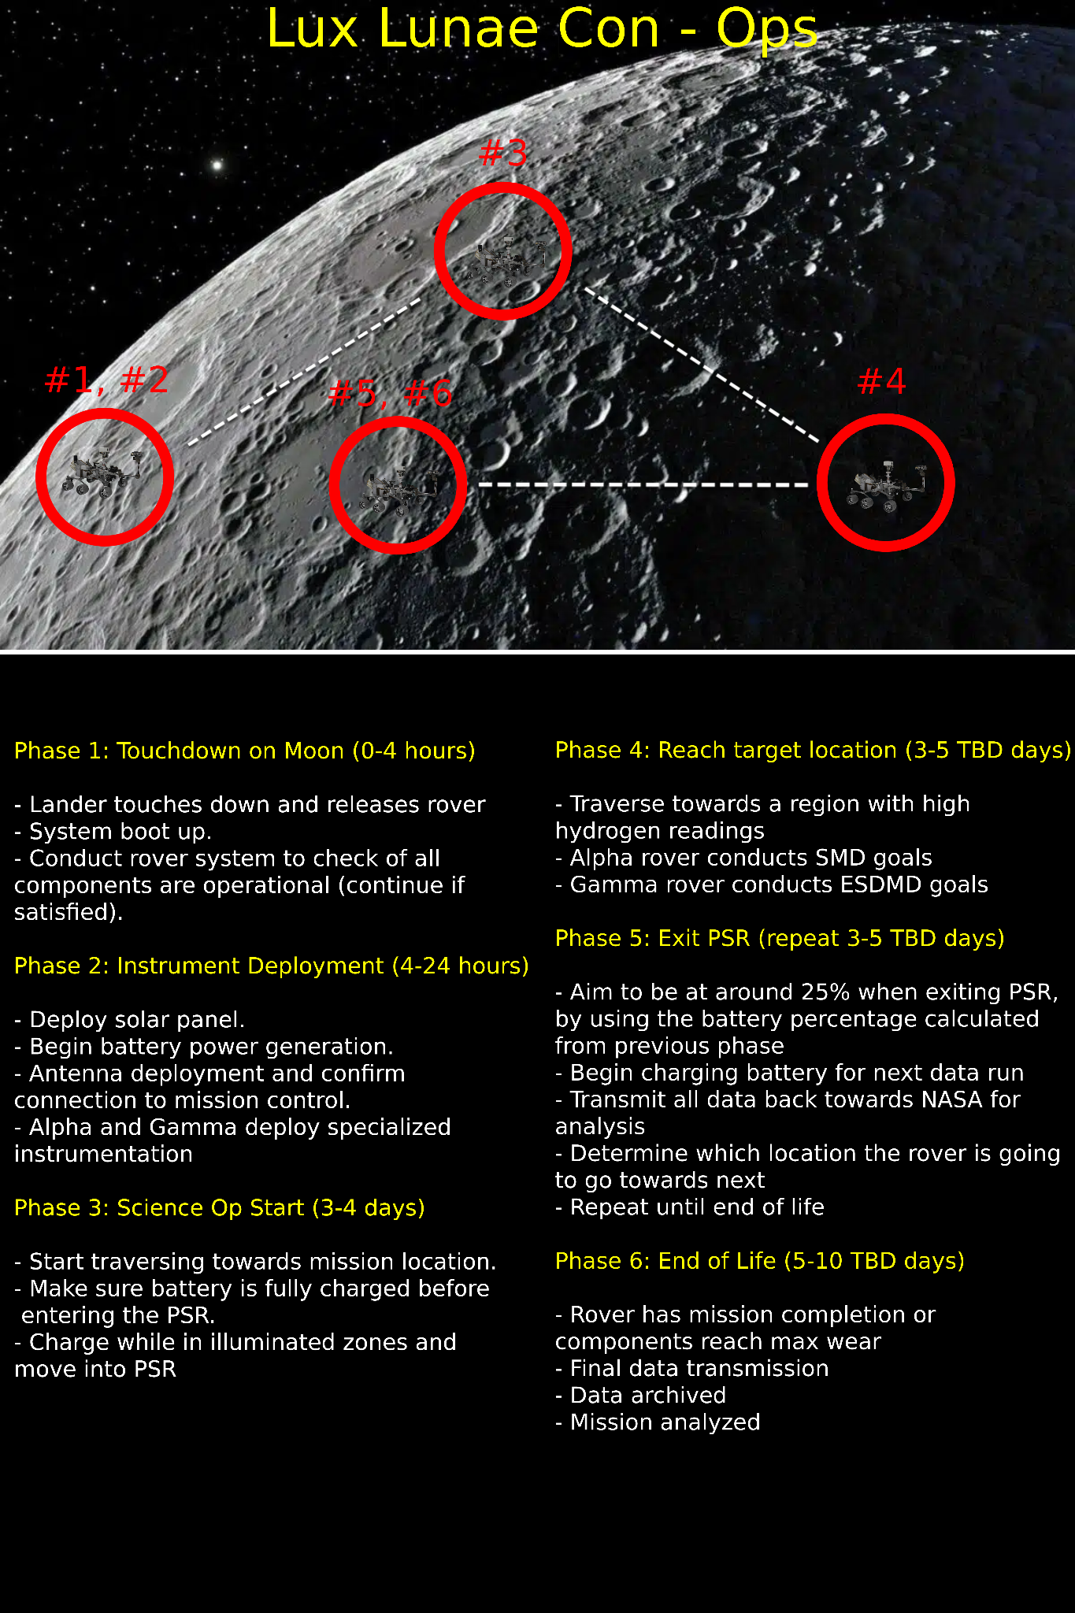
The Lux Lunae Mission starts after the rovers have landed at a selected site near a permanently shadowed region (PSR). The image in the Con-Ops figure is a representational lunar image and not the PSR landing site. After reaching the surface, the rovers complete a system check and setup. In this phase the rovers do health checks, set up communications, verify power source and distribution, and confirm the landing site is safe for exploration before starting. The mechanical subsystem verifies mobility hardware and structural condition, the power subsystem verifies battery state and solar deployment readiness, the thermal subsystem checks survival temperatures, the CDH subsystem checks onboard computation, storage, and communications links, and the payload subsystem checks instrument health and calibration status. If a component is not operational, the rover will enter a fault management or safe state procedure and either retry, isolate the failed component, continue with reduced capability, or wait for further commands from Earth through the lander. If one rover is unable to continue, the second rover will still continue partial mission goals, but both SMD and ESDMD goals may not be completed at full level if there is an operational issue.
The two rovers Alpha and Gamma deploy and start their different assigned operations and tasks. Both rovers deploy from the lander. They do initial mobility checks and calibrate their payload for operations. Both rovers will deploy their solar panels and antennas. The rovers are not tethered and must independently manage mobility, power, communications, and thermal survival throughout the mission. During this phase, CDH begins onboard data logging and confirms the rover-to-lander communications path before science operations begin.
The two rovers depart from their landing zones and start traveling towards their designated operational areas. Both rovers traverse over regolith and send back data about obstacles and movement in real time using antennas. While the rovers are also in illuminated areas they will start charging batteries using solar panels. The energy regeneration and levels will be verified before moving into PSR zones. The recharge duration for each cycle depends on solar access, battery condition, rover power draw, and how much energy was used during the previous traverse or science cycle. The timeline ranges in the ConOps are broad because traverse time can change depending on terrain difficulty, charging time, communications opportunities, obstacle avoidance, and the amount of science data collected at each site. A shorter mission case would include fewer science stops and quicker traverse between regions, while a longer mission case would include longer science operations, more charging cycles, and additional follow-on sites.
After reaching the science and exploration objective regions, both rovers begin their objectives. The Alpha rover is used to support the Science Mission Directorate objectives and studies hydrogen bearing volatiles, state of the water, and subsurface data. The Gamma rover is used to support the Exploration Systems Development Mission Directorate objectives and studies terrain, regolith, temperatures, and environmental conditions while mapping the PSR for future missions. More specifically, Alpha performs SMD focused science by using TRIDENT for subsurface access and sampling, MSolo for chemical and isotopic analysis, and NIRVSS for volatile and hydrated mineral observations. Gamma performs ESDMD focused exploration support by using NSS for hydrogen-related readings, AIM for terrain imaging and mapping, and MEDA for environmental characterization. This means the hydrogen readings mentioned in the graphic are measured during science operations by the payload instruments assigned to volatile detection and subsurface investigation, rather than being only a general observation. During this phase, CDH stores science and engineering data onboard, prioritizes important files, and schedules transmission back to the lander when communications windows are available.
When both rovers reach 25% battery health, they traverse regolith to exit the PSR. After entering sunlit zones, the rovers redeploy solar panels to recharge the battery. The rover also transmits all data back to the lander to send to Earth. After data analysis on Earth, the rover will undergo a short systems check, and receive instructions to move to the next target site. This will be repeated an estimated 4 times however is flexible to change depending on the on site data until the rover reaches maximum wear. This flexibility is necessary because strong hydrogen related readings, valuable subsurface sample results, terrain hazards, environmental anomalies, or unexpected engineering issues may cause spending more time at one site or changing the order of future sites. The CDH subsystem manages temporary onboard storage before downlink.
When the rover is unable to continue, the rover will begin its end of life phase. There will be a final data transmission to Earth containing all systems, research, and sensor data. The data will be analyzed and archived. There will be a mission evaluation for future missions. This end of life phase may occur because of maximum wear, power limitations, thermal limitations, mobility degradation, payload degradation, or a critical subsystem failure. If possible, the rover will first complete a final health report, a final engineering and science data dump, and a last communications pass to the lander before shutdown. Mission evaluation includes reviewing science return, subsystem performance, mobility performance, thermal behavior, power usage, communications performance, and lessons learned for future lunar PSR missions.

  - Vehicle Design Summary
For the Lux Lunae mission, there are two rovers: Alpha and Gamma, which share the same main rover design but have varying payloads depending on their mission objective. Alpha has a primary objective aligned with the SMD objectives, so its scientific payload will be more inclined towards volatiles and water studies. Meanwhile, Gamma has an objective aligned with the ESDMD objectives, focusing more on terrain mapping, environmental conditions, and assisting future human landings. Having two rovers with one common design allows for splitting of efforts without requiring two different rover designs.
Following the design change, the rover design had to be modified to accommodate the smaller vehicle constraints so the final rover design is based on the new compact design. Regardless, both rovers retain the same configuration for chassis, mobility, power, thermal, and CDH subsystems. The only major difference between the two rovers is in their payloads. The rover body is designed to be compact, robust, and reliable to maneuver over harsh lunar terrain, regolith, and PSR while still carrying the necessary hardware. One rover fits inside a 1.5 x 1.5 x 0.5 chassis with all components folded inside.
Five subsystems are the main ones used in the design of the rover Mechanical, Power, Thermal, CDH, and Payload. The Mechanical subsystem is the one that gives the rover body shape, wheels, and mounts on which other equipment can be placed. The Power subsystem allows charging in an illuminated area and operation in the PSR based on the energy stored in the batteries. The Thermal subsystem is responsible for protection of the rover from high and low temperatures on the Moon. The CDH subsystem allows handling of commands, data exchange, autonomy, and communications. The Payload subsystem differs for the two rovers, depending on their mission roles.
Thus, the resulting vehicle design includes two identical but slightly different rovers that will operate at the lunar South Pole to collect required scientific and exploratory information about the environment.
Figure 8: Labeled Cad Model of Rover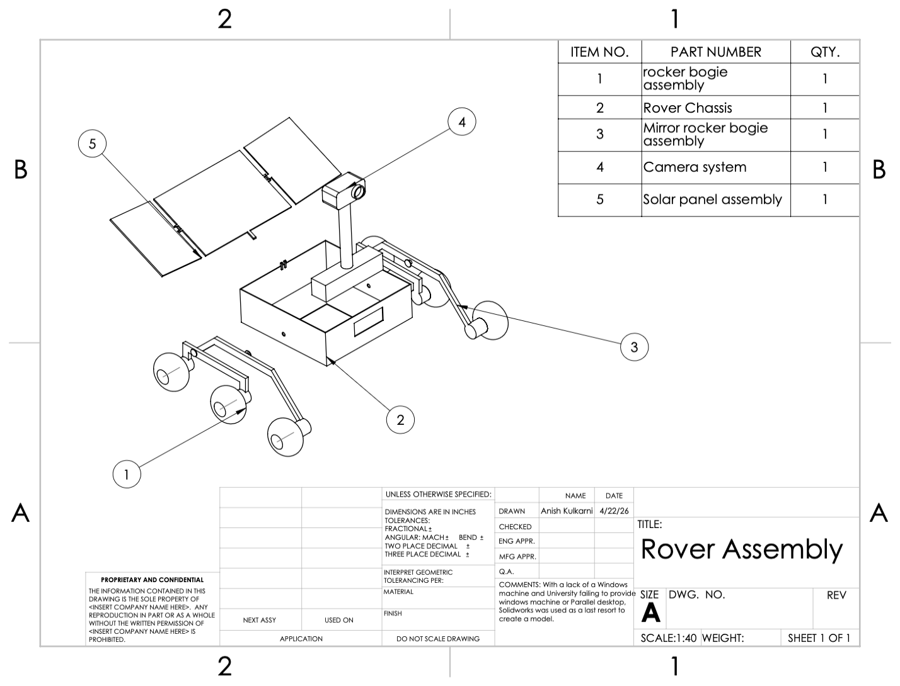e

  - Science Instrumentation Summary

The Lux Lunae mission - with its two specialized rovers, Alpha (SMD) and Gamma (ESDMD) - will conduct in-situ measurements and survey the candidate lunar sites. The mission’s primary objective is to optimize future human surface operations by identifying resources and characterizing environmental hazards prior to astronaut arrival. Any instruments involved or used on the mission will be aid towards that goal and nothing less.

- Rover Alpha: Science Mission Directorate (SMD) Suite

The Alpha rover focuses on the origin and delivery processes of solar system volatiles by determining the isotopic composition and abundance of materials in Permanently Shadowed Regions (PSRs).

- Mass Spectrometer (MSolo)
  - Measurement Objective: Determine isotopic ratios (D/H, 13 C/12C, 15N/14N) and identify volatiles (H2O, CO2, NH3, H2O).
  - Performance: Mass Range: 1-100 AMU. Mass Resolution: ≥1000 m/Δm. Precision: 1-3% RSD.
- TRIDENT Drill.
  - Measurement Objective: Extract subsurface regolith via rotary-percussive "bite sampling" for lateral soil analysis.
  - Performance: Depth: ≥1 m. Bite Interval: 10 cm to preserve stratigraphy and minimize power.
- Near-Infrared Spectrometer (NIRVSS).
  - Measurement: Measure volatile concentrations (ppm to wt%) and determine the physical state of hydration.
  - Performance: Spectral Range: 1.3 - 4.0 µm. Resolution: ≤10 nm. Sensitivity: ≤0.1 wt% H2O equivalent.

II. Rover Gamma: Exploration Systems Development (ESDMD) Suite

The Gamma rover is designed for robotic reconnaissance, resource mapping (ISRU), and terrain trafficability assessments to inform future human landing sites.

- Neutron Spectrometer (NSS).
  - Measurement: Prospect for hydrogen-rich materials and map vertical volatile abundance.
  - Performance: Detection Sensitivity: 0.5% (wt) Water Equivalent Hydrogen (WEH) at 3-sigma.
- Ames Imaging Module (AIM):
  - Measurement: Visualize surface morphology and provide situational awareness for rover attitude.
  - Performance: Resolution: 2048x2048 pixels. Illumination: LED-based (350-940 nm) for operation in PSRs.
- Physical Properties Sensor.
  - Measurement: Monitor environmental conditions including dust concentration and illumination patterns.
  - Performance: Dust Detection: ≥10 µg/m³; Illumination Range: 0 to 100,000 Lux.

III. Integrated Mission Requirements & Standards

To satisfy science requirements, the Lux Lunae rovers must adhere to the following operational parameters:
Subsurface Sampling: The TRIDENT drill must expose regolith samples from any depth between 0 and 100 cm, including a 30-minute pause at 100 cm to infer subsurface temperatures.
Trafficability: Rover speed must not exceed 10 cm/s during active science acquisition to ensure high-resolution data collection.
Thermal Survivability: Instruments must survive lunar extremes (-150 to 120 Celsius) and utilize "Safe Haven" operations during periods of no communication or shadow periods.
Resource Mapping: Data from both rovers will be integrated to create Resource Maps and Resource Models, predicting ice burial depths and mineralogy through geostatistical methods like Ordinary Kriging.
This information is derived from the referenced VIPER Proposal Package. However, it is important to note that Lux Lunae does not hope to achieve the same goal as VIPER was proposed to. While VIPER’s intended purpose is to integrate goals of lunar exploration studies and surface surveying into a single mission, Lux Lunae hopes to utilize a VIPER-like package as a stepping stone and go beyond simply characterizing the origin and physical state of volatiles and providing data to evaluate the potential return of ISRU. Lux Lunae includes specific measurement goals and a unique instrument not highlighted in the VIPER payload overview including a single mission site located, analyzing lunar trafficability of PSRs, and recording physical properties. It is a precursor to the goal of putting humans on the moon with studies also focused on the vertical distribution of resources and mapping environmental conditions to inform human surface operations.

  - Programmatic Summary

    - Team Introduction
Figure 9: Team Introduction Table

 | Name | Education | Location | Relevant Experience
 | Chowdhury, Farhan | Stony Brook University | Stony Brook, NY | Computer Engineering, interests embedded, robotics, gpu hardware, projects: automated email template bot
 | Cilluffo, Renee | Western Michigan University | Kalamazoo, Michigan | NASA NPWEE program; Low Energy Nuclear Reactions (LENR) researcher at WMU’s Particle Accelerator Laboratory; Payload sub team for Western Launch Aerospace Initiative; WSA Cabinet Member (student government)
 | Colak, Yaren | University of Central Florida | Orlando, Florida | Design of Aerospace Experiments Lab, Teaching Assistant; self-healing polymer sensor system intern, Embry-Riddle; Projects including: fluid dynamics using CFD analysis of rocket injectors and aerodynamic simulations.
 | Kulkarni, Anish | Georgia Institute of Technology | Atalanta, Georgia | NASA’s Proposal Writing and Evaluation Experience, selected for continued funding; Overnight cryogenic test operations at Georgia Tech’s High-Pressure Experimental Propulsion Laboratory;Ramblin’ Rocket Club’s GNC team: simulation, actuator modeling, and flight software validation.
 | Lazo, Yicel | North Shore Community College | Boston, Massachusetts | Computer Science, Cloud-computing/IT
 | Martinez, Sophia | University of South Florida | Tampa, Florida | Laboratory research in behavioral neuroscience; data collection and analysis. Interests include intersection of neuroscience and spaceflight, particularly human adaptation in extreme environments.
 | Mireles, Rodrigo | Western Michigan University | Kalamazoo, Michigan | Member of WMU AIAA Pegasus Chapter
 | Nickle, Anne-Claire | Worcester Polytechnic Institute | Worcester, Massachusetts | Previous research experience in optics at MIT Lincoln Laboratory; current research in sensing for plasma helicon;  Sigma Pi Sigma Physics and Astronomy Honor Society Member; Secretary, WPI Society of Physics Students chapter.
 | Pan, Jun | University of Florida | Gainesville, Florida | University of Florida Solar Car Racing team, electrical sub lead; experience with solar array, handling of battery pack, DC DC conversion, and implementing communication protocols.
 | Perez, Rolando | Georgia Institute of Technology | Atlanta, Georgia | Project Manager for a team CAD project, Community Learning Coordinator for  Sigma Phi Epsilon
 | Surve, Arushi | Georgia Institute of Technology | Atlanta, Georgia | Former NASA Intern; MMAARS Analog Astronaut; Aerospace Systems Design Laboratory student researcher; Mission Green Global founder; Chair of Member Engagement at UNA-USA Youth.
 | Thomas, Emily | Rensselaer Polytechnic Institute | Troy, New York | Outreach Director of RPI SWE; Calculus Tutor at Student Success Center; Worked on a project to filter microplastics from the ocean
 | Valentine, Hunter | Boston College | Boston, Massachusetts | Aerospace sector & mechanical sector, MechaEagles; Sigma Pi Sigma Physics and Astronomy Honor Society Member; Agentic AI development.

    - Team Management Overview
Figure 10: Lux Lunae Organizational Chart
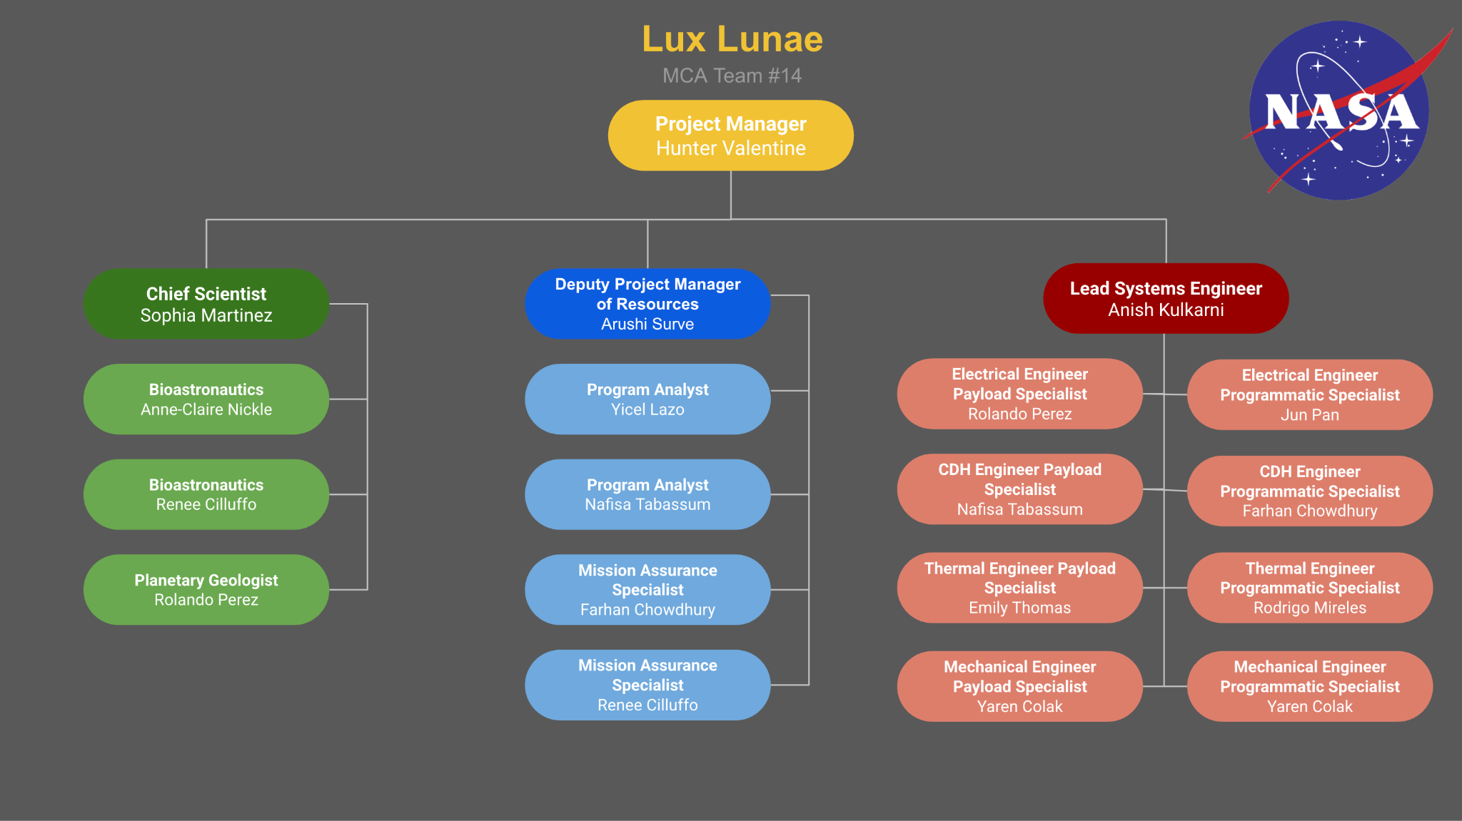

The team is organized into three subteams, with one project manager overseeing all three teams. Roles were assigned by democratic vote, with all leadership positions going through this process. All members of the team are capable of completing work according to the standard, and all subteam leads are strong leaders capable of leading their teams. Below are the tasks completed by each member for the Preliminary Design Review and the time they committed.

1.8.2.1 Workload Delegation
At the start of each deliverable, the project manager will create a task document, which will be sent out to the team. It is then the responsibility of the team leads to delegate tasks after discussing with their teams which roles apply to which tasks, and how many hours per week each member can contribute for the upcoming deliverable. If work is not getting completed, team leads will have the responsibility of re-delegating tasks and/or doing the tasks themselves. Team members will work on their tasks (some tasks will require more than one person) on their own time, managing timeline mini-deadlines (set by team leads) and then compile their completed drafts into a shared document. The project manager will then format and revise the document before submitting.

1.8.2.2 Decision Making:
There have been no changes to the decision making strategy. Decision making will be a mix of analytical, consultative, and democratic, depending on circumstance. If there is ample time to make a decision, the team will perform analysis to determine, objectively, what the best decision to make is, by creating a trade study of the situation. This analysis will be led by subteam leads, who will delegate this responsibility to the least occupied member of their team. Once completing the trade study, if there is an obvious solution, it will be selected. If there is not an obvious solution, the project manager will make the final decision using the evidence to back their choice.
Regarding time-sensitive decisions, a consultative decision making style will be adopted. The project manager will discuss the situation with the subteam leads, give the subteam leads a 24 hour window to discuss with their teams, and then reconnect. Team Leads should hear each member’s take on the situation, and take a democratic vote. Team leads should also take and report notes from their subteam discussion to the project manager. Once ideas have been shared, the project manager will make the final decision, taking into consideration the opinions of the team through the provided subteam lead’s notes.
Regarding any other form of decision making not planned for, the project manager will decide how to handle the situation.
1.8.2.3 Leadership Roles
Team leads are responsible for overseeing their teams. This responsibility includes: discussing task delegation to ensure team members are content with workload; ensuring tasks fit the role of the team member assigned; reporting weekly progress updates to the project manager; remaining in constant communication with team members, and the project manager; creating necessary documents for task completion; overseeing task progress from delegation to completion; completing their own assigned tasks; running weekly team meetings.
The project manager is responsible for overseeing the entire project. This responsibility includes: creation of documents related to task delegation; ensuring task delegation runs smoothly; ensuring progress is being made through weekly progress checks; leading weekly general team meetings; ensuring the wellbeing of the team members and team leads; holding team leads accountable for progress; reviewing and editing deliverables; formatting deliverables.
1.8.2.4 Challenges Encountered
One challenge faced is team members leaving the program. In this situation, the project manager has asked the remaining team members if anyone is willing to take on the extra role, and every time, a team member has taken the opportunity. If nobody is willing to take on the role, the project manager will reach out to member(s) whom they deem appropriate for the role. If this nominated person is still unwilling to accept the new role, this role will be adopted by the project manager. This will continue to be the strategy should more team members be removed from the program for whatever reason. A similar situation occurs when a team member becomes unable to do their role successfully. In this situation, the slack is expected to be picked up by other members of the subteam, and the project manager if necessary. If a subteam lead has to step down from their position, after discussing the situation with the member who is stepping down, the project manager nominates another member from the corresponding team to take over as subteam head. The former team lead who was removed from their role then gets moved into a less demanding role, usually switching roles with the team member who moved into their team lead position.

    - Schedule Overview
The Lux Lunae mission schedule spans Phase C through Phase F of the NASA project Life Cycle for robotic missions, as defined in NPR 7120.5E. All pre phase A, Phase A and Phase B activities are treated as sunk time completed during mission formulation thus excluded from this schedule. The primary schedule anchors established by the customer are the System Integration Date of December 1, 2030 at which the point the Lux Lunae rover must be ready for integration with the transit and EDL systems at Kennedy Space Center in Cape Canaveral, Florida and the Launch Readiness Date of February 1, 2031 from Cape Canaveral, Florida. All upstream milestones are back planned from these two firm dates.
The schedule is structured around the standard NASA robotic mission phase gate framework which requires a Key Decision Point (KDP) at each phase transition and an independent Standing Review Board (SRB) prior to each major Life Cycle Review. KDPs at C, D, and E require travel by key personnel to NASA HQ in Washington, D.C. as the SMD Mission Directorate Associate Administrator serves as the Decision Authority for missions of this class, with each meeting assumed to last five days. SRBs are scheduled approximately one week prior to each corresponding LCR gate, consistent with standard robotic mission SRB timelines observed in analogous missions including VIPER and CAPSTONE.
All milestone dates in Table 1.8.3.1 below that fall between KDP C start and KDP-E are derived by back planning from December 1, 2030 System Integration Date using phase durations analogous to the VIPER mission. The LRR SRB and LRR dates are derived directly from the February 1, 2031 LRD anchor with one week SRB lead time and a two week KDP decision window applied consistently throughout.

Figure 11: Mission Milestones and Estimated Dates
Milestone | Type | Phase | Anticipated Date
KDP-C | KDP | C | July 1, 2026
PDR SRB | SRB | C | May 14, 2026
PDR | LCR | C | May 21, 2026
KDP-D | KDP | C → D Transition | June 4, 2028
Critical Design Review (CDR) SRB | SRB | D | November 6, 2028
CDR Review | LCR | D | November 13, 2028
System Integration Review SRB | SRB | D | November 27, 2028
System Integration Review | LCR | D | June 4, 2030
KDP-E | KDP | D → E Transition | June 11, 2030
Manufacturing and Assembly Complete | Milestone | E | August 1, 2030
Environmental Testing Complete (TVAC, Vibration, EMI/EMC) | Milestone | E | October 15, 2030
System Integration Date | Hard Constraint | E | December 1, 2030
Launch Readiness Review (LRR) SRB | SRB | E | January 14, 2031
Launch Readiness Review | LCR | E | January 21, 2031
Launch Readiness Date | Hard Constraint | E | February 1, 2031
Mission Operations Begins | Milestone | E | March 23, 2031
Primary Science Mission Complete | Milestone | E | March 23, 2032
KDP-F  (End of Mission Declaration) | KDP | E → F Transition | April 6, 2032
Data Archiving and Final Reporting Complete | Milestone | F | October 1, 2032
Phase F close  (Disposal Complete) | Milestone | F | December 1, 2032

    - Cost Overview
The total budget cap for Lux Lunae is $150,000,000. Our final cost estimate is $130,517,877 which gives us around $19,482,123 (about 13%) left over as a reserve for anything unexpected that comes up during the mission.
The budget breaks down into four main areas. Personnel is the biggest one on the people side, coming out to around $28,390,457 total across all phases. That includes the Science subteam at $5,152,600, Engineering at $6,774,400, and Technicians at $3,992,373 who are doing the actual building and testing, plus administration and project management. Travel is estimated at about $471,500 which mainly covers the KDP review trips to NASA Headquarters and getting the team out to Kennedy Space Center for launching. Outreach comes out to around $1,393,920 across the whole mission for public engagement. Direct Costs are the largest piece at roughly $100,262,000. This covers everything hardware related including the TRIDENT drill, the MSolo mass spectrometer, and the rover chassis builds. The mechanical subsystem alone accounts for $50M, thermal control is $30M, and the power subsystem runs about $16M. A big chunk of this also goes toward integration and environmental testing at JPL.

Figure 12: Mission Cost Breakdown
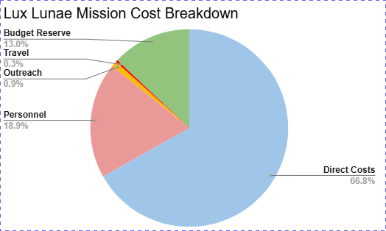
One of the bigger reasons we stayed under the cap was going with two rovers instead of three. Since Alpha and Gamma use the same design we can share tooling and vendor contracts and we get roughly a 10-15% cost reduction on Gamma just from having already built Alpha. The team is mindful on keeping track of costs by constantly revising through planned virtual meetings, in order to avoid going over the budget before it can become an issue.

- Overall Vehicle and System Design

  - Spacecraft Overview
The mission design is named Lux Lunae. It consists of a robotic lunar surface mission designed to investigate volatile rich regions at the moon’s lunar south pole in the permanently shadowed regions (PSRs). The Lux Lunae mission will use two rovers to target two separate goals of science and exploration. These two goals complement each other; however, they do not require identical hardware, and so two rovers can be a benefit. Alpha rover will be dedicated to the Science Mission Directorate (SMD) objectives while the Gamma rover will be focused on the Exploration Systems Development Mission Directorate (ESDMD) objective. Both rovers together can distribute their capabilities and also reduce operational risk.
The spacecraft system is designed to operate at PSRs defined by low illumination, extreme temperatures, abrasive regolith, and challenging terrain. The mission must support the study of hydrogen-bearing volatiles up to a meter depth, collect isotopic data, and study terrain and environment for future missions. The spacecraft must combine science access, thermal survival, power generation, autonomy, and strong communications into a single design to be used for two rovers. Rather than just the transportation of instruments, the system must cohesively combine all subsystems to tackle all requirements.
There will be one base rover model that can be configured for two goals. This means Alpha and Gamma use the same base chassis architecture, but they are configured with different payload sets for their different objectives. The rover mass distribution will be arranged for a center of mass closer to the bottom of the rover. This can improve the rover’s ability to climb slopes and uneven terrain without losing stability. With a total allowed geometry of 1.5 m × 1.5 m × 0.5 m, the height will be 0.5 m to give the rover a wider and longer stance. This also provides stability by lowering its center of mass. The geometry is appropriate for lunar surface missions to support difficult mobility. The chassis will provide a structural backbone, with every subassembly attached to the chassis. This will mount the wheels, electronics, power hardware, thermal elements, and payload instruments. The configuration of the rover will support drilling, imaging, environmental sensing, and communications relay. The chassis will have a cutout for drilling, sensors, and wheels; it will also have an aluminum body of 1 cm thickness as shown in the figure below.

Figure 13: Chassis Drawing
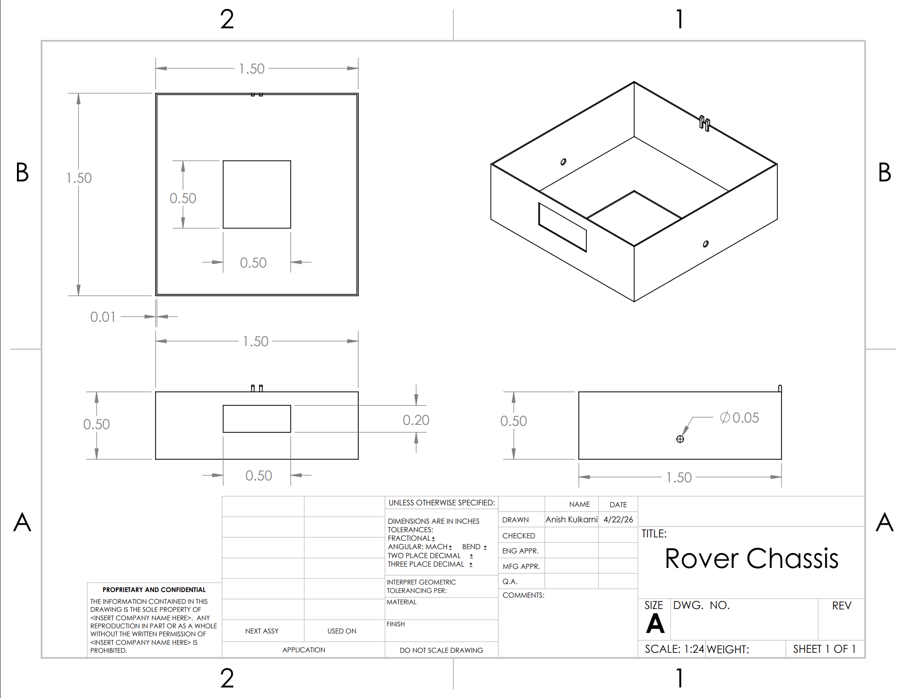

Figure 14: Wheel Drawing
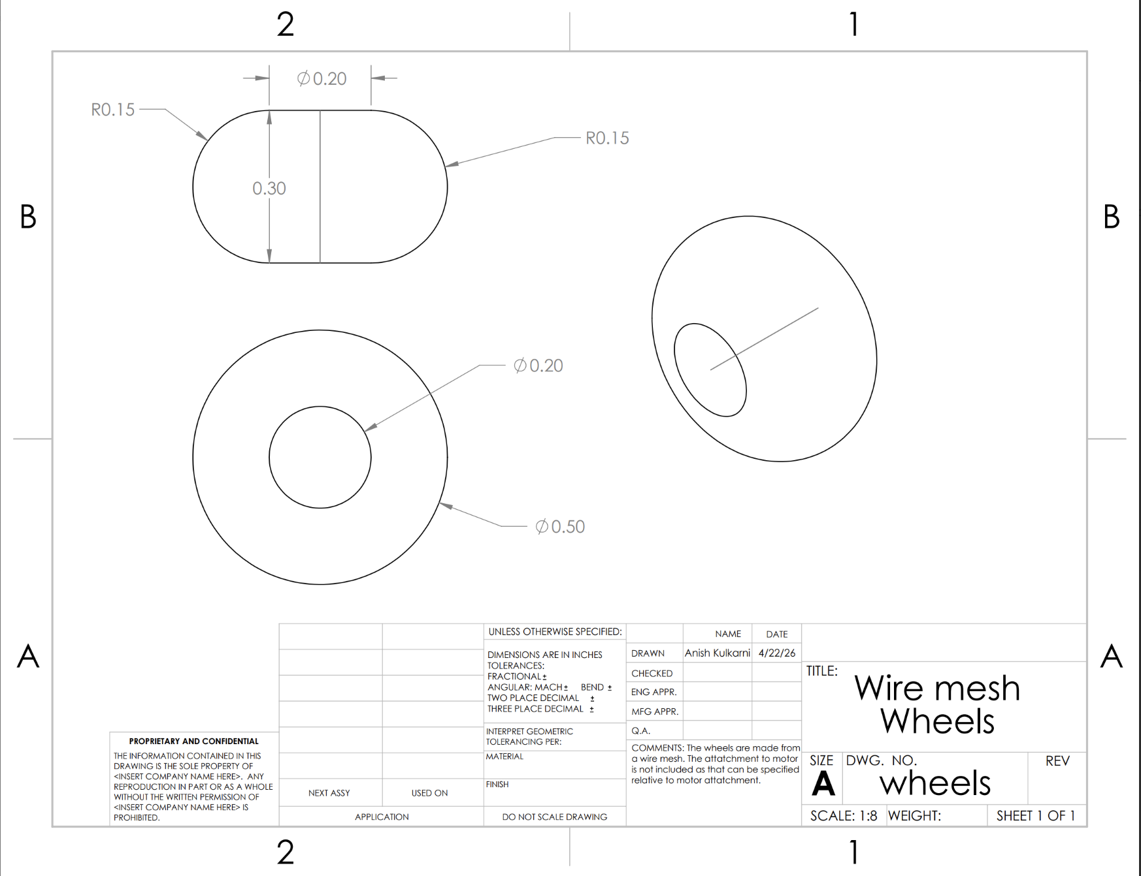

Figure 15: Solar Panel 1 drawing
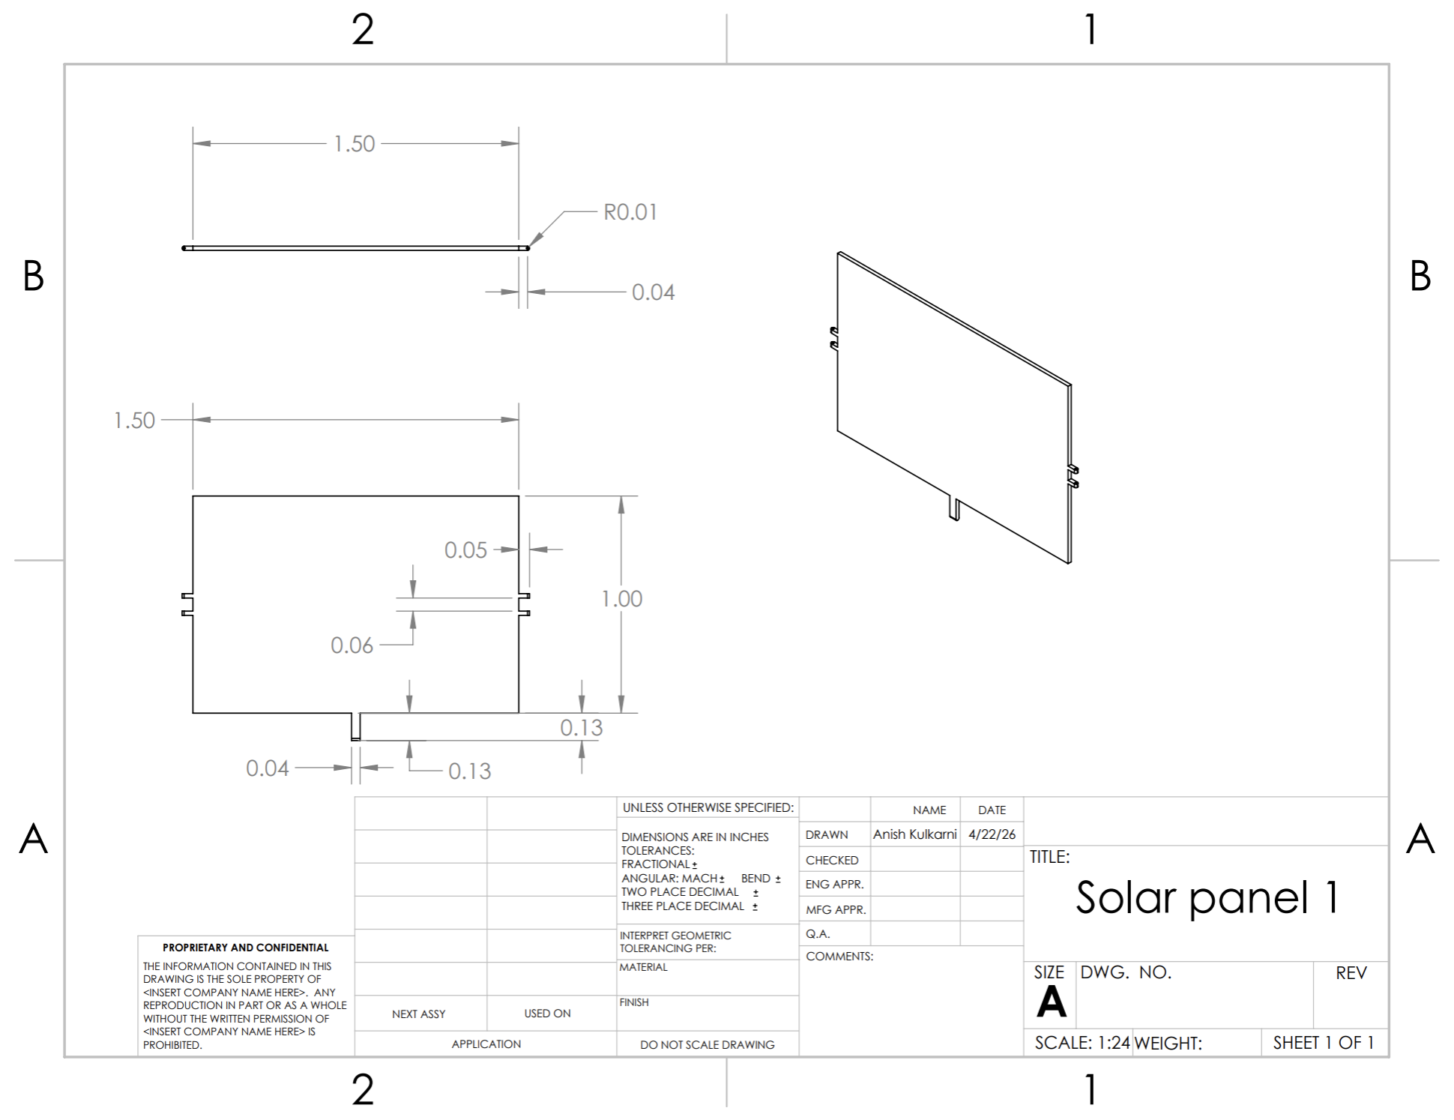

Figure 16: CAD image of Rover

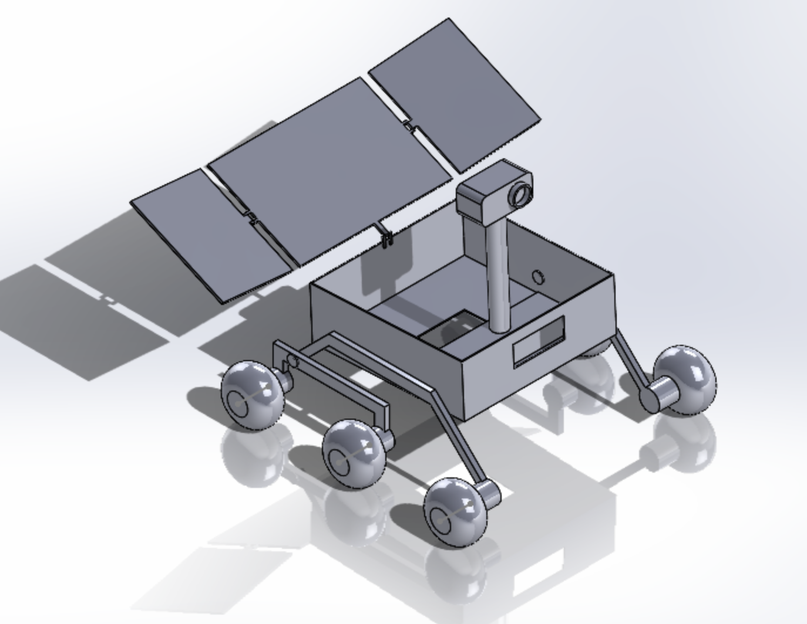The system of the rover is split into five different subsystems consisting of Mechanical subsystem, Power subsystem, Command and Data Handling (CDH) subsystem, Thermal subsystem, and Payload subsystem. These subsystems are coupled very tightly with each other. The mechanical subsystem will be providing the structural support for holding components of all subsystems, allowing mobility and transport. The power subsystem stores, allocates, and distributes energy for all the subsystems as required. The CDH subsystem provides command execution, data processing, and communications. The thermal subsystem will protect the hardware of all subsystems from the extreme low temperatures of the PSR, and possible high temperatures in illuminated regions. The payload subsystem will be able to perform the mission level requirements and can generate data for SMD and ESDMD goals. All subsystems have individual and independent goals which combine together for an integrated rover. At the top level, these subsystems must satisfy mobility, energy, thermal survival, autonomy, communications, and science performance requirements derived from the mission architecture.
Figure 17: Constraints of Subsystem

 | Mass (%) | Mass (kg) | Volume (%) | Volume (m³) | Power (%) | Power (W) | Cost (%) | Cost ($)
Thermal | 25 | 18.75 | 25 | 0.4209 | 29 | 6.525 | 25 | $18,750,000
Mechanical | 40 | 30 | 40 | 0.67344 | 50 | 11.25 | 40 | $30,000,000
Power | 16 | 12 | 16 | 0.269376 | 18 | 4.05 | 16 | $12,000,000
CDH | 10 | 7.5 | 10 | 0.16836 | 12 | 2.7 | 10 | $7,500,000
Payload | 9 | 6.75 | 9 | 0.151524 | -9 | -2.025 | 9 | $6,750,000
Total | 100 | 75 | 100 | 1.6836 | 100 | 22.5 | 100 | $75,000,000

The mechanical subsystem will provide the rover with structure, protection, and mobility. Structure wise, it will be able to support all subsystem hardware, maintain the alignment between them, and distribute the internal load during mobility, drilling, and static operations. Mobility wise, it will allow the rover to reach within the targeted regions by traveling through regolith, rocks, slopes, and crater terrain. The mechanical design is based on a one chassis design. By using an Apollo style wire mesh wheel system for mobility, the system can utilize the existing research done in the past. This wheel system was chosen to survive the dusty, cryogenic, and uneven lunar surface conditions. The top level requirements indicate that the rover must traverse obstacles at least 10 cm high, navigate slopes of 25 degrees, survive in cryogenic temperatures, remain functional for over 5000 m of total travel, remain stable during drilling processes, and avoid sinking in regolith. These top level requirements show that mobility is vital to enabling the mission and not a simple supporting convenience. The chassis must also provide a platform to integrate other subsystems. This is done by housing and mounting power elements, payload instruments, and using a center of mass to support drilling. Since both Alpha and Gamma rovers will be operating in such extreme environments, the mechanical subsystem will choose a design to maximize stiffness, mass efficiency, dust tolerance, and thermal resistance. In the trade study, 6061-T6 aluminum was chosen as the chassis material, and Apollo style wire wheels were chosen for mobility, as both have heritage in other lunar missions in order to reduce risk. Refer to the later trade studies.
The power subsystem allows both Alpha and Gamma rovers to operate all functions that require power through electrical energy. This will regulate the provided voltage and support steady-state and special operational electrical loads. Each of the rovers will use a design consisting of foldable solar arrays which will charge the lithium-ion battery pack to provide energy for operations. This will allow the rover to charge in solar regions and travel into the PSR to continue operations. This will provide a baseline power for operations plus an extra peak power for sampling and drilling activities. Power management hardware regulates and distributes energy to rover subsystems, allowing the rovers to balance their energy generation and storage in different situations and conditions.
The thermal subsystem must function across extreme surface thermal environments by supporting each other subsystem in maintaining a required temperature. This will be done by the use of both a passive system and an active system to regulate temperatures to an operating level. This will require a heating system, cooling system, and monitoring system since there are extreme cold and hot temperatures. Since the mission is not static, it must operate in both illuminated and shadowed regions, requiring a large range of temperatures. The thermal subsystem protects battery, electronics, mobility actuators, and payload instruments. While not only helping to prevent freezing, the system helps with overheating to maintain efficiency. The design will include insulation, heaters, conductive paths, and sensors to maintain rover survival.
The Command and Data Handling (CDH) subsystem is responsible for the computation and communications. This system will coordinate all subsystem activities by collecting sensor data, storing data, and making decisions to maintain operations. This system will also manage communications between the rover and the lander and the lander to Earth where science data can be processed for analysis. The system will also manage data from Earth to the lander and from the lander to the rover to enforce directions. The CDH requires 99% planned operational availability, radiation-resistant hardware, significant and operational data storage, a processor of the required speed, a rover to lander link, and a lander downlink. This shows the rover must have a significant amount of autonomy with limited intervention. Since the lunar environment is challenging, human error can be detrimental to the mission, and so autonomy is important to mission success. This must integrate the telemetry, data storage, coordination of subsystems, navigation, and recovery practices. This system is integral to survivability as it can maintain functionality of other integral subsystems. This helps the rover become a semiautonomous intelligent exploration platform.
The payload subsystem is the primary driver for the science objectives. This is divided across the Alpha and the Gamma rovers according to the objectives in the STM. The instruments will be divided into TRIDENT, MSolo, NIRVSS, NSS, AIM, and MEDA sensors to accomplish goals. The SMD rover (Alpha) will carry TRIDENT for subsurface sampling, MSolo for chemical and isotopic analysis, and NIRVSS for identifying hydrated minerals. The ESDMD rover (Gamma) will also provide instrumentation for volatile characterization while adding a NSS function for hydrogen detection, AIM for imaging and mapping terrain, and MEDA for environmental characterization. The payload distribution gives the mission a chance to investigate the resource and exploration in the same region. The instruments determine major features of the architecture of the rover. The payload interacts with each subsystem to ensure that the objectives are met and data is returned. Refer to Figure 1.
All subsystems are integrated together as one whole system, so it is useful to understand the subsystems in how they relate to each other. The mechanical subsystem provides a physical platform and mobility to reach and stabilize at science locations. The power subsystem can support PSR region operations. The CDH allows autonomy and communications. The thermal subsystem protects hardware in extreme temperature environments. The payload subsystem maintains the exploration goals and provides data for the mission goals. Together, the two-rover architecture allows a shared base design while still supporting mission-specific payload specialization.

    - Mechanical Subsystem Overview

The mechanical subsystem, consisting of the chassis structure and mobility system, provides the structural framework and traversal capability of the rover. The chassis structure supports and integrates all subsystems, including thermal, payload, command and data handling (CDH), and power subsystems, minimizing overall mass to lower the risk of deformation, improve mobility performance, and reduce power consumption. It also ensures stability by distributing loads evenly throughout the system. The mobility system enables the rover to navigate the challenging lunar terrain, including slopes, loose regolith, and obstacles to reach and operate in targeted mission regions under cryogenic temperatures and dust exposure.
The subsystem design is guided by defined requirements and supported through trade studies that evaluate key performance criteria, including material selection for the chassis and wheel design for the mobility system. Verification plans are constructed to ensure requirements are met through methods such as testing, analysis, and demonstration. Manufacturing and procurement plans are developed to define primary and back up suppliers and estimate process timelines, while Technology Readiness Levels (TRLs) are determined. Additionally, recovery and redundancy plans are considered to prevent mission failure and enhance system reliability.

      - Mechanical Subsystem Requirements

In Figure 8, the mechanical subsystem requirements define the performance capabilities necessary for the rover to traverse through the lunar surface under extreme environmental conditions. These requirements address key challenges such as slope traversal, wheel sinkage, obstacle negotiation, long-distance travel, resistance to lunar dust, and maintaining structural integrity under operational loads. Each criteria is defined qualitatively for clear verification and is structured hierarchically to ensure traceability in the system.

Figure 18: Mechanical Subsystem Requirements Table
Req ID # | Requirement | Rationale | Parent Req | Child  Req | Verification Method | Relevant Subsystems | Req Status
MS-1 | The rover shall be capable of traversing through challenging lunar terrain and reaching the targeted sampling locations under extreme environmental conditions. | Defines the ideal mechanical capability for the mission success. | - | MS-2, MS-4, MS-5,MS-6,  MS-7 | Demonstration | Mechanical | Met
MS-2 | The rover shall navigate slopes of at least 15° without significant slip or tip-over. | Required for traversing sloped and uneven lunar surface. | MS-1 | MS-3 | Test | Mechanical | Met
MS-3 | The rover shall limit wheels sinking into lunar regolith < 5 cm under loading conditions. | Prevents the rover from getting stuck on the terrain. | MS-2 | - | Test | Mechanical | Met
MS-4 | The rover shall overcome obstacles of at least 10 cm in height without compromising mobility. | Enables the rover to drive over rocks and irregular surface. | MS-1 | - | Test | Mechanical | Met
MS-5 | The rover shall traverse a cumulative distance of minimum 5000 meters on the lunar surface without losing mobility. | Ensures the rover can reach all the designated regions. | MS-1 | - | Analysis | Mechanical, Power | Met
MS-6 | The mobility system shall remain functioning after exposure to lunar dust with no more than a 10% decline in mobility performance. | Minimizes performance degradation due to lunar dust exposure. | MS-1 | - | Test, Analysis | Mechanical | Met
MS-7 | The chassis structure shall maintain structural integrity under traversal and operational loads without irreversible deformation. | Ensures all subsystems are supported during traversal and operational through terrain. | MS-1 | - | Analysis | Mechanical | Met

      - Mechanical Sub-Assembly Overview

The mechanical subsystem consists of two primary subassemblies: the chassis structure and the mobility system. A Technology Readiness Level (TRL) is assigned to each subassembly according to the maturity of the technologies used in the mission design and how these technologies are validated.
The chassis structure serves as the foundation for all subsystems within the rover by strategically integrating and positioning them. This subsystem placement ensures structural integrity through efficient load distribution during both traversal and sampling operations, while maintaining stability by optimizing the rover’s center of mass. The chassis structure is geometrically defined by its load-bearing frame, which serves as the primary structural skeleton, supporting all subsystems and resisting external forces. This load-bearing frame is composed of structural beams and panels supported by a base plate. While mounting interfaces provide the attachment points for subsystems to the chassis, internal support brackets are used to stabilize components within subsystems. The chassis also provides mounting interfaces for navigation and hazard cameras (navcams and hazcams), which are externally mounted on the front upper section of the chassis and at the lower front and rear corners near the wheel assemblies to enable terrain mapping and obstacle detection. Reinforcements such as cross-members, ribs, gussets are included as structural additions for improved rigidity, reduced deformation, and minimized stress concentrations under loading.
As shown in Figure 9, the chassis structure has dimensions of 1.0 x 1.0 m x 0.5 m, a mass of 25 kg, and does not generate power. Based on the trade study presented in Figure 11, 6061-T6 aluminum is selected as the primary chassis material due to its overall superior performance across structural strength, mass efficiency, thermal resistance, and cost. Structural strength ensures that the chassis can withstand the loads from all subsystems and external forces, preventing integrity failure. For structural strength, Titanium scored the highest because it has the highest modulus and strength of all three [Figure 12]. Aluminum and CFRP scored similarly high, right behind Titanium since they have similar modulus. Mass efficiency is crucial to reduce the overall mass of the system, minimizing cost and improving mobility performance. In terms of mass efficiency, CFRP scored the greatest mass efficiency since its density is much lower than Aluminum, which is lower than Titanium. Furthermore, thermal resistance allows the rover to function under cryogenic conditions, scored on both deformation and heat loss. While CFRP has the best Coefficient of Thermal Expansion (CTE), Titanium is frequently used in extreme temperatures due to its minimal heat loss so it scored the highest. Aluminum scored closely high as well, following CFRP and Titanium. Lastly, cost is considered to ensure the material selection remains economically viable. For cost, Aluminum scored exceptionally high compared to other designs. Titanium is the most difficult to source, having a high price, while CFRP requires extensive fabrication which can be expensive. Overall 6061-T6 Aluminum is selected as the best choice for chassis material.
The chassis structure is given a technology Readiness level (TRL) of 4 because aluminum-based rover structure is researched thoroughly and widely used in other planetary exploration missions such as Apollo Lunar Roving Vehicle (LRV), Curiosity Rover, and Perseverance Rover [1]. However, the specific aluminum chassis design for this rover has not yet been built or tested in a relevant environment. Thus, at this stage of the mission design, the chassis structure requires further prototyping and testing to advance its maturity.
The mobility system enables the rovers to traverse the lunar surface and reach designated sampling regions under varying terrain conditions. This system is primarily composed of wheels and a suspension system. The passive rocker-bogie suspension system connects the chassis to the wheel assemblies and distributes the loads from the chassis across all wheels, maintaining continuous contact with the ground. It also enables obstacle traversal while ensuring stability. Linkages within this suspension system connect all wheel assemblies through pivot joints, allowing controlled rotation and supporting independent wheel motion over the terrain. The wheels are designed to handle the uneven and rough terrain while minimizing sinkage and resisting dust accumulation. The wheels are connected to the suspension system through axles and wheel hubs, which facilitate load transfer between the chassis and the ground.
Additionally, as shown in Figure 9, the mobility system operates within defined power limits of 120 W, has a mass of 20 kg, and a wheel diameter of 0.4 m. Based on the trade study presented in Figure 10, Apollo-style wire mesh wheels are selected for the mobility system due to their overall superior performance across terrain mobility,
durability, thermal resistance, load capacity, mass and power efficiency, and cost.
Terrain mobility ensures that the rover can reach targeted locations without getting stuck or tipping over. In terrain mobility, the Apollo style wheels received the highest score as they were specifically designed for lunar terrain [2]. Superelastic Shape Memory Alloy (SMA) wheels also scored well due to their ability to conform to the surface, maximizing contact and traction. Cryo Rubber Composites also similarly conform to rocks, but still fail to match the grip of other designs. Lastly, Rigid Aluminum scored the lowest since it does not conform to irregular surfaces and therefore loses friction more easily. Durability allows the system to withstand repeated loads during long-distance travel. In terms of durability, the Apollo style wheels again scored the highest due to their proven reliability traversing long distances. SMA and Rigid Aluminum scored similarly, while Cryo Rubber Composites scored the lowest because they become unusable if punctured, reducing its effectiveness during long missions. Furthermore, thermal resistance is critical to prevent material deformation under extreme lunar temperatures. For thermal resistance, Apollo style wheels and Rigid Aluminum were least affected by extreme temperatures. NASA studies have shown that certain elastic metals do not function under lunar temperature ranges, and rubber materials become brittle at low temperatures [3]. Therefore, Cryo Rubber Composites scored the lowest. Load capacity ensures that the wheels and suspension system maintain structural integrity under operational loads. Regarding load capacity, the Apollo style mesh, Rigid Aluminum, and SMA demonstrate lower elastic deformation and higher tensile strength, enabling them to support larger loads. In contrast, Cryo Rubber Composite exhibits a lower elastic modulus, leading to increased deformation under stress. In addition, mass efficiency is crucial for the system to perform better, while reducing overall costs. For mass efficiency, all designs including Apollo Style Mesh wheels, had high scores due to their similar light mass. However, Rigid Aluminum performed the worst because of its higher weight. Rigid aluminum faces the most challenges with mass and power efficiency since it is the heaviest and will require more torque and power to operate. Lastly, cost is an important criteria to ensure the system remains practical within budget constraints. Rigid Aluminum will be the cheapest to design, manufacture, and test. Since the SMA and Apollo-Style Wire Mesh wheels are newer technologies, they will require a larger cost. Overall, Apollo-Style Wire Mesh wheels were selected as they were used the most in similar settings and purposes, with its existing technology that shows great capabilities.
Like the chassis structure, the mobility system is given a Technology Readiness Level (TRL) of 4 for similar reasons. The selected wheel design, Apollo-Style Wire Mesh, was studied to a great extent and was chosen to traverse across the rough and uneven surface in previous lunar exploration missions, including Apollo Lunar Roving Vehicle (LRV) [4]. However, this specific mobility design has not yet been built or tested in a relevant environment. Therefore, at this stage of the mission design, the mobility system also requires further prototyping and testing to advance its maturity.
Overall, the mechanical subsystem, consisting of the chassis structure and mobility system, provides the structural support and effective operation on the lunar surface. 6061-T6 aluminum and Apollo-Style Wire Mesh wheels along with a passive rocker-bogie suspension system, were selected carefully based on key performance criteria to ensure an efficient and reliable mission. The subsystem has a total mass of 45 kg, overall dimensions of 1.0 x 1.0 x 0.5 m, and a maximum power draw of 120 W.
Both the chassis structure and mobility system scored a Technology Readiness Level (TRL) score of 4. Since the overall subsystem Technology Readiness Level (TRL) drives Technology Readiness Level (TRL) of the entire subsystem, the mechanical subsystem is currently assigned a score of 4 at this stage of the mission design. As discussed, this is due to the specific design not being built or tested yet in relevant environments. Thus, further prototyping and testing will be conducted in the future for both subassemblies in order to meet higher TRL scores.

Figure 19: Mechanical Subassembly Data

Mechanical Subassembly | Mass (kg) | Dimensions | Maximum Power Draw (W)
Chassis Structure (6061-T6 Aluminum) | 25 kg | 1.0 x 1.0 m x 0.5 m | 0
Mobility System (Apollo-style Mesh Wheels + Passive Rocker-Bogie Suspension System) | 20 kg | Wheel diameter: 0.4 m | 120 W
Total | 45 kg | 1.0 x 1.0 m x 0.5 m | 120 W

Figure 20: Wheel Design Trade Study
Wheel Design
Criteria | Explanation | Grade | Weight | Ridgid Aluminum | Superelastic SMA | Cryo Rubber Composite | Apollo Style Wire Mesh
Terrain Mobility | MS-2 | 10 = Can traverse slopes > 25° with minimal slip  5 = Can traverse slopes 10-15° with moderate slip  1 = Can traverse slopes < 5° with significant slip  0 = Terrain mobility failure | 24% | 6 | 8 | 7 | 9
Durability | MS-5 | 10 = No measurable wear  5 = Moderate wear  1 = Severe wear  0 = Durability failure | 17% | 8 | 8 | 5 | 9
Thermal Resistance | General mission constraint | 10 = No thermal deformation  5 = Moderate thermal deformation  1 = Significant thermal deformation  0 = Thermal resistance failure | 14% | 10 | 7 | 5 | 9
Dust Resistance | MS-6 | 10 = No dust accumulation  5 = Moderate dust accumulation  1 = Severe dust accumulation  0 = Dust Resistance failure | 10% | 8 | 4 | 4 | 8
Load Capacity | MS-7, MS-3 | 10 = Supports all rover mass  5 = Supports rover mass with minimal safety margin  1 = Limited load support  0 = Load Capacity Failure | 10% | 9 | 8 | 6 | 7
Mass+Power Efficiency | MS-5 | 10 = Minimal mass and power consumption  5 = Moderate mass and power consumption  1= Significant mass and power consumption  0 = Mass+Power efficiency failure | 8% | 5 | 7 | 8 | 8
Cost | General mission constraint | 10 = Safely within budget  5 = Barely within budget  1 = Exceeds budget  0 = Cost Failure | 17% | 9 | 3 | 6 | 5
 |  | TOTALS: | 100% | 78.30% | 65.30% | 58.90% | 79.40%

Figure 21: Chassis Structure Material Trade Study

Chassis Material
Criteria | Explanation | Grade | Weight | 6061-T6 Aluminum | Ti-6Al-4V Titanium | CFRP Composite
Structural Performance | MS-7 | 10 = Highest strength  5 = Acceptable strength  1 = Weak structural capability  0 = Does not meet structural requirements | 35% | 8 | 9 | 8
Mass Efficiency | MS-5  MS-7 | 10 = Very lightweight  5 = Moderate weight  1 = Heavy for performance  0 = Too heavy for goals | 30% | 8 | 9 | 10
Thermal Resistance | General mission constraint | 10 = Minimal heat loss/deformation  5 = Acceptable heat loss/deformation  1 = Large heat loss/deformation  0 = Fails thermal requirements | 20% | 8 | 9 | 7
Cost | General mission constraint | 10 =Lowest cost  5 = Moderate cost  0 = Not practical budget | 15% | 9 | 3 | 4
 |  | TOTALS: | 100% | 81.50% | 81.00% | 78.00%

Figure 22: Chassis Material Parameters

Material | Young’s Modulus, E (GPa) | Yield Strength (MPa) | Ultimate Tensile Strength (MPa) | Density (g/cc) | CTE (×10⁻⁶ /K)
6061-T6 Aluminum | 68.9 | 276 | 310 | 2.7 | 23.6
Ti-6Al-4V Grade 5 | 114 | 830 | 895 | 4.43 | 9
CFRP | 70 | Varies | 600 | 1.6 | 2.1

      - Mechanical Subsystem Recovery and Redundancy Plans

Redundancy and recovery measures are incorporated into the rover design in order to ensure that the mission continues to operate on the lunar surface after experiencing challenges. Recovery includes the required actions taken by the system to return to normal operation after a component failure, while redundancy provides backup components to maintain system functionality. Therefore, these crucial measures support reducing the mission failure by managing potential subsystem faults.
The recovery plan for the mobility system focuses on overcoming traversal challenges on the lunar terrain, including high slopes, wheel sinkage, and obstacle negotiations. For the chassis structure, the recovery plan targets the prevention of excessive structural loading due to these challenges. When these conditions are encountered, the rover will reduce speed, avoid sudden acceleration, reverse to gain traction, and reapproach slopes or irregular terrain at different angles. If those actions are unsuccessful, the rover will reroute around the affected areas.
The redundancy plan for the chassis structure and mobility system within the mechanical subsystem is not feasible due to design constraints. As these two primary subassemblies are major components of the system, duplication is impractical and would significantly increase the overall weight and complexity of the rover. As a result, the mechanical subsystem relies on managing potential component failures through recovery optimization, adjusting rover operations when experiencing performance degradation. Additionally, the mechanical subsystem is designed carefully to minimize the likelihood of component failure through numerous performance criteria.

      - Mechanical Subsystem Manufacturing and Procurement Plans

The mechanical subsystem consists of two subassemblies: the chassis structure and the mobility system. The chassis structure is critical in strategically placing and holding all the components together and supporting the total system mass, while the mobility system is responsible for the rover to traverse through lunar terrain effectively.
The primary contractor for the 6061-T6 aluminum chassis structure is selected to be Lockheed Martin Space Systems because this company has an extensive background in designing and building spacecraft structures that are both durable and lightweight. Being one of NASA’s major long-term contractors, Lockheed Martin was involved in substantially relevant projects such as Orion Spacecraft, GOES- R series, and Mars InSight Lander, which successfully withstood extreme environmental conditions [1]. It was selected over Northrop Grumman due to the possibility of lower design and manufacturing risks, considering Lockheed Martin’s more direct involvement as a prime contractor in complex subsystem design and integration that have proven structural reliability. Even though Lockheed will have higher costs than Northrop Grumman due to extensive heritage, lowering these risks were prioritized over cost efficiency.
The chassis is designated to withstand loads while minimizing mass and securely supporting all subsystems. CNC (Computer Numerical Control) machining will be used to manufacture these rover components because it is a low-risk, reliable and repeatable method that ensures that the rover is precisely assembled to perform as expected under mechanical loads in extreme environments. After the part is designed in CAD, it is converted to machine instructions (G-code), and the machine automatically cuts the material with high accuracy. Therefore, this technique will ensure that the complex geometries are handled correctly, while structural integrity is maintained. It also allows for tight tolerances, meaning each part is made very close to the intended size and shape as the design, with only minimal allowable variations. The use of this method reduces human errors and increases manufacturing efficiency. The parts will be assembled with bolts to allow maintenance to be easier and faster. At the end, performance and reliability checks will be conducted to verify that the chassis meets all design and operational requirements.
The backup supplier will be Northrop Grumman as it is another company with similar experience that can satisfy the NASA requirements of the manufacturing process [2]. Northrop Grumman has contributed to major space programs such as the James Webb Space Telescope, Cygnus Spacecraft, B-2 Spirit, and Lunar Gateway HALO Module, demonstrating solid capabilities in large-scale systems, deployable structures, and habitat modules. However, Lockheed Martin is more aligned with compact, load-bearing structures that require tight subsystem integration, which is more suitable with the chassis structure.
The estimated fabrication time of roughly one year for the chassis structure accounts for design finalization, material selection, manufacturing process, final assembly, and structural testing for validation. Design finalization will take approximately 2-3 months, which will include CAD simulations and load assessments. Material selection will take around 1-2 months depending on the availability of the supplier and shipment dates. The manufacturing process, which includes CNC machining and fabrication, is estimated to take 3-4 months. Furthermore, final assembly will take approximately 1-2 months to carefully integrate all subsystems together. Finally, structural testing for validation will take an additional 2-3 months to verify performance and reliability.
The primary contractor for the mobility system is selected to be Honeybee Robotics as this company has expertise in building robotic rovers and other technologies that allow planetary exploration such as VIPER rover, Resource Prospector mission, and InSight Mars Lander, including contributions to NASA’s missions such as the Mars Curiosity rover and Mars Perseverance rover, where it developed sampling and drilling systems. [3]. It is also currently involved in developing a Firefly Aerospace mission to build a rover for lunar exploration. Compared to Astrobotic Technology, as Honeybee Robotics has involved more directly in mobility systems and regolith interaction, it was preferred as a first choice for this subassembly. Likewise, this decision was taken in order to minimize design and manufacturing risks despite having a higher cost than Astrobotic Technology.
The mobility system ensures efficient traversal while minimizing slip and sinkage. Apollo-style wire mesh wheel design will be utilized to reduce wheel sinkage into the lunar surface, reduce friction and dust accumulation, while maintaining traction on regolith. This wire mesh will be manufactured using wire forming techniques and welding processes to support the structural integrity and CNC machining to assemble the wheel to the rover. This open mesh structure will minimize material usage, which will reduce the overall mass of the system, while maintaining its structural strength. At the end, quality control will be performed to assess how well the mobility system meets the stability and operational requirements under simulated lunar conditions. As this design has shown success in the previous lunar experiences, it provides confidence in its effectiveness.
The backup supplier will be Astrobotic Technology since this company has experience in lunar landing systems and payload integration such as Peregrine Lunar Lander and the VIPER rover [4]. As it is considered less specialized in mobility systems, it may introduce higher technical and manufacturing risks compared to the primary contractor.
The estimated time to fabricate the mobility system is roughly one year, as well, following a similar timeline to chassis structure. The design phase is expected to take 2-3 months, focusing on wheel geometry and traction performance. Material selection will take 1-2 months depending on availability and supplier lead times. The manufacturing process, including wire forming, welding, and CNC machining, is estimated to take 3-4 months to ensure proper construction and overall durability. Final assembly will take approximately 1-2 months to integrate all the components. Lastly, structural testing for validation will take an additional 2-3 months to evaluate stability and performance.
When building the lead time schedule, an additional 3-4 months should be taken into consideration for both subassemblies in case of a contract change or unexpected challenges such as manufacturing delays, supply chain disruptions, and testing dependencies that may impact the process. Preparing the schedule this way allows for flexibility in accommodating uncertainties while preserving overall project timelines. Therefore, the overall timeline is approximately 15-16 months. All things considered, the selected contractors' choices prioritize reliability, performance, and risk reduction, while maintaining efficient and safe scheduling considerations.

      - Mechanical Subsystem Verification Plans

In Figure 13, the mechanical subsystem verification plan defines how each requirement will be validated through appropriate methods, including demonstration, test, and analysis. These methods were selected for the most practical and reliable way to validate each requirement. Testing is used for directly measurable requirements for terrain conditions, and analysis is chosen for requirements involving long-duration performance and structural behavior. Demonstration is used to validate overall system performance of the rover under expected operational conditions.
While slope traversal, wheel sinkage, and obstacle negotiation are verified through testing, long-distance travel and structural integrity assessment are evaluated through analysis. Dust-related performance degradation is verified using a combination of testing and analysis. Overall, this plan ensures all requirements are thoroughly validated and confirms readiness for mission operation. Any requirement not met during verification will require redesign and re-evaluation process until all requirements are satisfied.

Figure 23: Mechanical Verification Matrix
Req # | Requirement Summary | Verification Method | Rationale for Method | Preliminary Verification Plan
MS-1 | The rover shall traverse lunar terrain to reach designated regions | Demonstration | Overall system performance must be validated under operational conditions. | A mission simulation is conducted to replicate the rover and operational environment to observe whether objectives can be successfully achieved.
MS-2 | Traverse slopes > 15° | Test | Requires testing to evaluate rover stability and slip on inclined terrain. | The rover is tested on a prototype lunar terrain with adjustable inclines.
MS-3 | Wheel Sinkage < 5 cm | Test | Requires testing to measure wheel sinkage depth in loose terrain under loading. | The rover is tested on a prototype lunar terrain with loose regolith.
MS-4 | Overcome obstacles > 10 cm | Test | Requires testing to assess the rover's capability to traverse obstacles and irregular terrain. | The rover is tested on a prototype lunar terrain with obstacles with varying sizes and shapes.
MS-5 | Travel > 5000 m | Analysis | Long-duration traversal is impractical to test directly and is more efficient to evaluate through analysis. | The rover is analyzed to estimate the cumulative travel distance based on mobility performance and power consumption.
MS-6 | Performance degradation due to dust < 10% | Test, Analysis | Requires testing to measure mobility performance and analysis to quantify dust-related decline. | The rover is tested on a prototype lunar terrain with simulated dust and performance is evaluated before and after to quantify degradation.
MS-7 | The rover shall maintain structural integrity | Analysis | Structural integrity is evaluated the most efficiently under stress and deformation analysis under repeated loading . | The rover is analyzed through finite element analysis (FEA) to evaluate stress and deformation under repeated loading conditions.

    - Power Subsystem Overview
The power subsystem for the rovers has few major parts, the power generation, the power storage, and the power usage. The power generation comes from 2 deployable solar arrays that will recharge the battery in between missions within the PSR. Since there is 0 sunlight with the PSR with using solar array for power generation, there will not be continuous power generation for usage within PSR. There still needs to be a constant and consistent source for power, so this rover will be equipped with battery packs that can last the duration of time within PSR while performing payload tasks. PMU and BMS between solar array and battery, and Battery and downstream electronics help protect all components from damage from sudden changes in power. The BMS can also model and predict power usage for irregularities ensuring everything functions correctly and optimally during missions. The power from the battery pack after BMS gets fed into a central power converter to get useful power rails of common voltages across the downstream components from other subsystems.
The BMS constantly monitors the power usage of the whole system along with where power is being directed, this information is sent through most likely CAN to the onboard computer to manage model power usage for the operational phases. A mockup up power schedule is displayed below.

Figure 24: Rover Power vs Time Cycle

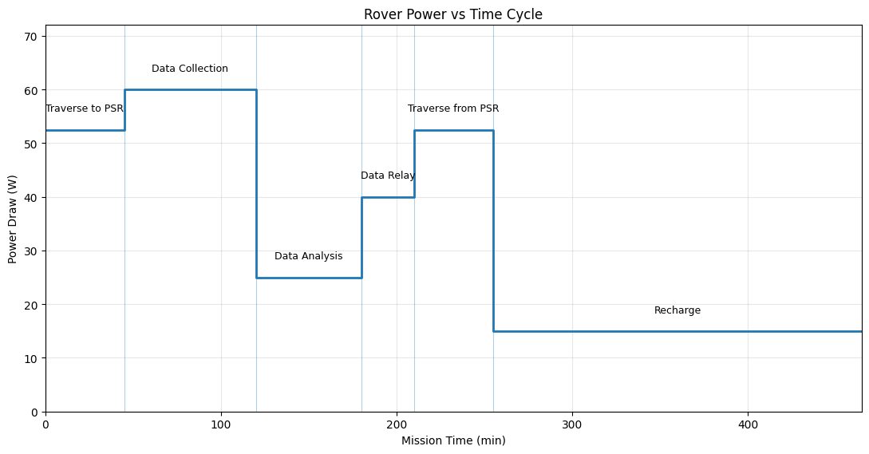

      - Power Subsystem Requirements

Figure 25: Power Subsystem Requirements Table
Req # | Requirement | Rationale | Parent  Req | Child Req | Verification  Method | Relevant  Subsystem
PWR -  001 | The  battery/batterie s shall store at least 1000 Wh and be ≤ 9kg. | Large energy capacity that can support  multiple  peaks and still be light  enough to  have enough weight for the other  components. | MIS-1 | PWR - 002 PWR - 003 PWR - 004 | Analysis | Power
PWR -  002 | The power  subsystem  shall provide ≥ 22.5 W  continuously  during PSR  operations  without relying on solar  energy. | There is no  reliable solar power  generation in PSRs. | MIS - 1 | PWR - 003 Test |  | Power,  Mechanical
PWR -  003 | The power  subsystem  battery shall  provide ≥ 225 W of peak  power for ≤ 10 minutes to  support drilling and sampling operations. | Drilling and  Sampling  require high  spikes of  power. Short duration only. | PWR -  001  PWR -  002 |  | Test | Power,  Mechanical
PWR -  004 | The high  power bus  shall regulate 32 V ± 5%  across the  rovers  components,  and low  voltage power  bus 5 V as required. | Consistent  voltage will  protect  electronics  from  long-term  damages. | PWR -  001 |  | Test,  Analysis | Power
PWR -  005 | The power  subsystem  shall maintain function  between  extreme  temperatures of 120°C to  -170°C. | The lunar  surface  experiences extreme  conditions,  especially  within PSR  being  extremely  cold. | MIS-1 | PWR - 006 Test |  | Power,  Thermal,  Mechanical
PWR -  006 | The power  subsystem will keep internal  electrical  components  between <  50°C ± 10°C. | Heat release from rover  use could  damage  electrical  components. | PWR -  005 |  | Test,  Analysis | Power,  Thermal
The power subsystem for Lux Lunae is required to provide a constant stream of power for the operation of the rover. Having operations at the lunar south pole with operations within PSR, the power subsystem is required to provide sufficient, reliable energy to every other subsystem. THe power subsystem has to be resilient to the environment and be functional during the extreme lunar climates. To provide a stable and sufficient power source within the PSRs, the battery onboard is required to store at least 1kWh. Power subsystem is required to have architecture to accommodate peak load during high intensity functions during operation. The subsystem has to properly and optimally distribute power across all other subsystems.

      - Power Sub-Assembly Overview

Figure 26: Power Overview
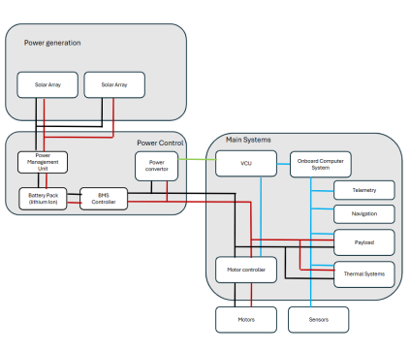
The power subsystem is responsible for power generation and power distribution for Lux Lunae. The subsystem needs to maintain constant power draw from all other subsystems and supply high loads during peak power draw procedures. For power generation, 2 solar arrays are used for each rover which charges battery packs between operations within the PSRs. Power gets split into different lines for different voltage requirements and is distributed with the BMS controller. Power use for each component on board is recorded and used to detect faults.

Power generation
Power generation for the rovers will be from 2 foldable solar arrays each that are deployed while outside of the PSR. With the solar array while in areas 90% illumination would be 70W which will charge the battery pack. The lunar south pole with a shallow tilt on solar rays causes there to be both regions of very limited illumination and very high direct illumination. The folded size for each array would be around 0.0035 m³ and would be .25 m^2 unfolded. The radioisotope system would not work with limited to 5g of nuclear material generating only 0.05W continuous power generation. Panels will have multilayer finish protecting from debris and radiation. Array having parallel and series wiring to optimize power generation in non idea light coverage. The solar array has diode integration to protect against reverse polarity and minimize impact from partial shading.

Power control / storage
Power Management Unit (PMU)
The Power Management Unit will be used as a controller for the power distribution between systems as well as storage. Power generated from the solar array will be inputted to the PMU where it will be distributed to high voltage, converter, or battery pack. The battery charging controller will be within the PMU. With variable power generation, the PMU regulates the load. Communication with microprocessors from VCU or onboard computer systems will give information on distribution of power. The Power Management Unit also serves a major fault protection location within the power subsystem. Built into our PMU would be fault detection logic to determine the state of the power subsystem. The PMU would adjust for overvoltage, undervoltage, over current, and reverse polarity protection. Sensors within the PMU can be provided data on voltage, power draw, temperature which can be sent along the main bus to VCU and telemetry.
Battery Pack (Li-ion)
A 2000Wh lithium ion battery pack will provide sufficient constant power throughout time within PSR. At baseline power draw 22.5W it will last for 96 hours supporting all systems. Higher power draw will be handled with a battery controller. Having the battery pack allows for higher peak power draw without needing a higher continuous power generation, which is ideal with the current design not being able to generate power while within the PSRs.
BMS Controller
The Battery Management System comes after the battery pack and controls load output to the rest of the rover. This hardware component serves as an inbetween buffer and safety net between the battery pack and other high power draw components. The BMS measures in real time on the whole pack and individual battery cells for voltage to detect faults within both the battery and other subsystems and can alert when there’s unusual activities with power consumption. This monitoring will be useful with modeling energy consumption and keeping the mission running smoothly. When detecting faults or possible failures through power readings on specific subsystems, it can pinpoint where issues might come from.
Power Converter
The power converter handles turning higher voltage into lower voltage for subsystems/control systems. The current design will use Buck converters for the main low voltage bus as it is more efficient and losses less energy, along with a linear regulator for a more stable output. The power convertor sets up different rails for voltages needed with smaller electronic components. This component helps provide more consistent voltage output for sensors and other sensitive components. With variable power draw with charging, discharging, and heavy load operations, this subassemble keeps a smooth clean power source for lower voltage components.

Communication/distribution
The electrical components within the rover will communicate through either CAN or/and I2C. The current setup would be ideal to bundle power and communication lines into a main bus between all the components using the main lower voltage for power.

The power flow can be broken down into 3 parts: generation, storage, and downstream usage. Power starts from generation, in this system that comes from the 2 foldable solar arrays. The power generated goes mainly into storage, while outside of PSR the generated power can be directly used by downstream components going through proper hardware to ensure electronic protection from unstable power supply. The power from generation goes mainly to storage in the lithium ion battery pack going through The PMU to ensure proper and optimal charging, preventing damage to battery packs or solar arrays. During operations within the PSR there will not be any power generation and all power will be supplied by the stored power within the battery pack. The power flows from battery pack through the BMS controller to monitor and ensure proper power output, as well as acting as an extra protection for the battery pack and downstream components. The power is then converted to common voltage rails for easy conversion/direct usage by other subsystems on board the rover.

Figure 27: Power Subassembly Data
Power  Subassembly | Component | Mass  (kg) | Dimensions | Peak  Power  Draw (W) | TRL
Solar Array | Photovoltaic cells Frame  Diodes  Finish | 1.2kg | 280 × 220 ×  40 mm | 0 | 6
Battery Pack | Lithium ion Cells | 8kg | 220 × 220 ×  150 mm | 0 | 6
BMS Controller | Cell voltage  Voltage and  Current sensor  Microcontroller  Communication(C AN or I2C)  Contactors | 0.2kg | 100 × 80× 30 mm | 2W | 5
Power  Management Unit | Electrical switches Voltage and  Current Sensors Microcontroller  Communication(C AN or I2C) | 0.2kg | 100 × 80 × 30 mm | 3W | 5
Power  Converter | DC to DC  convertor | 0.3kg | 120 × 100 ×  40 mm | 3W | 6

The photovoltaic cell solar array is given TRL 6 because of its proven reliability on rover missions like Spirit and Opportunity, which relied heavily on the use of solar panels. They were able to last extensive amounts of time under radiation exposure and harsh temperatures for 14+ years on the Opportunity rover. The lithium-ion battery pack is given TRL 6 based on its widespread usage across all forms of space missions. These missions have included a multitude of rover missions and have shown their consistency even in extreme conditions by still hitting their power demands. The BMS Controller and PMU are both given TRL 5 because similar systems like the monitoring logic and fault detection have been used in space systems and have performed well. The reason as to why they are TRL 5 instead of 6 is because the Lux Lunae rover's specific combination of components has not been tested for the specific environment. It would have needed to be tested in environments similar to lunar conditions to see if the system runs smoothly. The DC-DC power converter is given TRL 6 due to its extensive use in spacecraft electrical systems and proven reliability in missions.
The overall TRL of the power subsystem is given a TRL score of 5. Even though key components across the rovers, like the solar array, battery pack, and power converter, all received a TRL score of 6 because of their spaceflight heritage, the limiting factor is the TRL score of 5 that the BMS controller and PMU systems received. These components have been used and validated in other missions but have not been used on a rover system like these ones on a lunar mission. The overall TRL subsystem score must be determined by the lowest-rated component in the whole subsystem.

      - Power Subsystem Recovery and Redundancy Plans
Redundancy
Power generation from the solar array comes from 2 separate sets of panels, which reduces total failure of power generation. The individual arrays are set in parallel and series to allow for power generation when not being entirely lit. There are diodes that minimize power generation losses when the solar array is partially shaded, skipping cells that are affected. There are also diodes in place for reverse polarity protection, keeping the cells safe from frying in case of sudden negative voltage output.
The battery is laid out in serials and parallel in case of failure in individual cells the whole battery pack continues to function. The PMU and BMS provide protection from both the input and output sides of the battery pack. PMU controls power generated from solar arrays and can shut off input to the battery pack when detecting damaging loads. Additionally both PMU and BMS have reverse polarity protection built into the circuit.
Recovery
Unusual power draw will be picked up by BMS controller and specifically locating which electronic component is not behavioring as expected. After isolating and confirming malfunctioning load, the BMS controller can attempt to reset power distribution or mentarily shut off power to components. Data from BMS can be used to create predictive models on power consumption and if projected usage is no longer sustainable, it is possible to redirect operations to recover power and prevent stranding inside of PSRs.

      - Power Subsystem Manufacturing and Procurement Plans

The primary contractor that will be responsible for the solar array in this mission would be California Institute of Technology, specifically their Jet propulsion lab. Their lab has done work in the past for NASA in other rover missions. The alternative contractors are Aerospace Company and Northrop Grumman. The Aerospace Company has experience with solar panels in a lot of their space power systems and they have shown to be reliable. Northrop Grumman has experience with solar wings on satellites which could prove to be useful since they are already used to creating power systems suited for space missions. While these 2 alternative vendors are strong options, the JPL in CalTech has the addition of already understanding the NASA ecosystem and has experience with foldable deployable solar arrays. Their past expertise and familiarity would make integrating their system ideal and efficient with this mission.
For the battery pack for the rover system, going with Aerospace Company as the primary would be best. The assignment to Aerospace Company is due to their high reliability relating to space power systems. With the battery pack being the sole source of power while within the PSR, reliability is the top priority along with survivability which Aerospace Company all perform well in. LG Energy is identified as the alternative supplier due to their familiarity with lithium-ion battery technology which is what our battery packs will be composed of. The Aerospace Company was chosen as the primary in the end because of their successful work with space technology, while LG Energy does not traditionally focus on.
The battery management system is in charge of monitoring and ensuring the battery pack performs optimally and prevents damage to the power system. Northrop Grumman was selected to be the primary contractor for the BMS. They have a prolonged experience with power system design. They have flight heritage, use of components in previous space missions, in their battery systems and monitoring. The alternative being The University of Chicago is particularly strong with embedded systems which BMS would fall under so contracting. The reasoning of The University of Chicago was chosen as the alternative and not the primary because they are not hardware focused which would be important for the BMS. Northrop Grumman does not just have experience, but a strong portfolio of space-qualified electronics.
The power management system is another subassemble that is in place for the reliability and layer of protection within the power subsystem. Within the rovers it manages the charging of the batteries from the solar arrays preventing damage from occurring to either component, as well as maintaining controlled charging. The Aerospace Company is assigned the primary contractor for this component due to their experience and level of reliability when it comes to power systems for space applications. They would be able to design a robust system for the power distribution architecture. The alternative suppliers for the PMS are Lockheed Martin and California Institute of Technology. Both of these suppliers have experience with spacecraft power systems, while CalTech specifically has strong research on the subject. The reason for the Aerospace Company being chosen over the other 2 vendors is ultimately because they have proven to have a better streamlined approach to PMS development. This is great because it greatly reduces the technical risk of the system.
The primary vendor for the power converter will be assigned to the University of Colorado. They are suitable for the power electronics required for the power converter subassembly. They can design stable and regulated power draw systems for the downstream electronic applications on the rover. They will have the capability from their research labs to best optimize for efficiency as the battery is limited on each charge. The backup vendors that were chosen for the power converter are RECOM and Vicor. These companies are strong options due to their proven reliability with conversion components. While they are commercially available, they do lack in comparison to the University of Colorado the ability for flexibility for custom parts which is important for the subsystem it is a part of.
The primary vendor for power distribution will be contracted to the California Institute of Technology. They have always had a robust power distribution system that can be built for space missions that have been reliable for years. The alternative vendor will be CIT which is a great option for the power distribution implementation. CIT provides a reliable energy delivery across their systems as well as having capabilities in system design. CalTech was chosen over CIT as the primary for the simple reason of familiarity. They have worked in the past with NASA for similar rover power systems. They can easily fit into the NASA ecosystem and have the expertise to work on the power architecture and interfaces. Caltech can provide the most reliable and safest power distribution system for space rover applications.
The timeline for the primary preferred vendors and contractors lead time are as follows. For the deployable solar array contracted to Caltech it will be estimated to take 4-7 months, having done similar sub assembly in the past with NASA. Backup with Northrop Grumman is estimated to take 5-7 months with longer integration times. The battery pack through Aerospace Company is estimated to take 3-4 months. The back up with LG would take longer, around 4-6 months needing additional testing and validation for space applications. The BMS contracted to Northrop Grumman is estimated at 3-4 months with tuning and changes after receiving the battery back. The estimate for the back up with University of Chicago is 4-6 months. The PMU contracted to Aerospace Company will have an estimated lead time of 3-5 months, being streamlined with a battery pack. The backup with Lockheed Martin will be 4-6 months. The power converter contracted to the University of Chicago looks like 2-4 months with the custom design for power optimization. RECOM as backup would be faster taking between 1-3 months. Caltech for power distribution should take 3-5 months having done architecture work for other NASA rovers, primarily completed after the other subassemblies. The total assembly time for primary preferred is estimated to be around 6-9 months.

      - Power Subsystem Verification Plans

A verification matrix was created for the power subsystem to show how each of the requirements would be validated. There are 4 different types of verification methods that could be used on the subsystem. Analysis uses simulations and calculations to verify qualitative numbers. Testing sees how well the subsystem would perform in real lunar conditions. Inspection makes sure it is physically up to the expectations of the requirements. Lastly, demonstration to confirm successful power delivery occurs. Preliminary verification plans outline how exactly the verification will be conducted to satisfy the requirements. This matrix ensures the subsystem satisfies all requirements before the mission occurs to further push the percentage of mission success.

Figure 28: Power Verification Matrix
Req # | Requirement Summary | Verification Method | Rationale for Method | Preliminary Verification Plan
PWR-001 | The battery/batteries shall store at least 1000 Wh and be ≤ 9kg. | Analysis + Inspection | Energy capacity can be verified through calculations based on the battery specifications. Mass can be verified by physically measuring it. | The verification will consist of calculating the total energy capacity from the lithium-ion cells and weighing the masses after assembly. Must confirm energy is at least 1000 Wh and the mass be no more than 9kg.
PWR-002 | The power subsystem shall provide ≥ 22.5 W continuously during PSR operations without relying on solar energy. | Analysis | The power capability is determined through energy balance analysis. | The requirement will be verified by analysis of the battery discharge and power budget to verify the continuous ideal consumption is ≥ 22.5 W.
PWR-003 | The power subsystem battery shall provide ≥ 225 W of peak power for ≤ 10 minutes to support drilling and sampling operations. | Test | The subsystem must be tested under high loads to ensure the system can handle the spikes. | The power system will be applied with an induced peak load of 225 W to the power system for 10 continuous minutes. The system will be monitored to verify the system remains stable throughout with no damage to components.
PWR-004 | The high-power bus shall regulate 32 V ± 5% across the rover's components and the low-voltage power bus 5 V as required. | Test | The voltage regulation must be measured under varying conditions to ensure it is good for any condition | The plan will have the power system being applied with different loads and measuring the output of the voltage to confirm it remains within 32 V ± 5%.
PWR-005 | The power subsystem shall maintain function between extreme temperatures of 120°C to -170°C. | Test | The electrical components must be tested against extreme temperatures to validate survivability in lunar-like environments. | The subsystem will be placed into a thermal vacuum chamber and will have to endure temperature swings from 120°C to -170°C. System health will be monitored during the entire process to ensure there is no damage to the components.
PWR-006 | The power subsystem will keep internal electrical components at 50°C ± 10°C. | Analysis + Test | Thermal regulation can be predicted using analysis but should still be validated with testing. | The verification will first model the thermals to predict the internal temperatures. It must then validate the components with temperature sensors to get readings on the internals when inside of a thermal chamber.

    - CDH Subsystem Overview
The CDH subsystem is the central nervous system for both rovers, integrating four main components: Argotec FERMI OBC (LEON3FT dual-core), BAE Systems NAND Flash SSR, NanoAvionics UHF Transceiver, and NASA GSFC SpaceWire harness. These systems are integrated into a unified data and command architecture. All subsystems, including science instruments aboard Alpha (TRIDENT, MSolo, NIRVSS) and Gamma (NIRVSS, TRIDENT, NSS, AIM, MEDA sensors), connect to the OBC via the SpaceWire bus at around 100 Mbps. The OBC handles command execution, MET synchronization, and FDIR dispatch. The SSR uses ECC memory to correct bit mistakes caused by radiation for storing science and telemetry data. The UHF transceiver controls proximity links to the lander for Earth relay. At the same time, the FDIR engine continually checks subsystem health and applies a graded response (soft reset -> isolation -> safe mode at ≤5 W) within 30 seconds of fault detection.
Data flow corresponds to the ConOps phases: the FDIR engine starts monitoring during system check, and the OBC uses SpaceWire to initialize all subsystems. Real-time information, including power status, thermal readings, and navigation data, is transmitted to the lander via UHF during traverse. During PSR data collection, all instrument outputs are timestamped, buffered in the SSR, and protected by FDIR. Compressed science data and health summaries are transmitted via the lander to NASA mission control during data relay (post-PSR egress). NASA mission control then transmits command uplinks for the next target. If UHF communication is lost at any point, the rover stops, continues recording locally, attempts to reconnect several times, and then resumes autonomous traverse.

      - CDH Subsystem Requirements

The CDH subsystem requirements determine the lowest level of performance that’ll be expected of each element on the rover’s on board computer, data storage, communication and failure monitoring. Each requirement was built based on the mission level requirements in section 1.4 and was structured following the parent child hierarchy as described in the NASA Systems Engineering Handbook. The CDH subsystem requirements have been written using SMART, and contain the mandatory term “shall” as directed. The final PDR design included all elements required by this document and had no TBDs or TBRs left open for future definition.
Verification methods were chosen so that Test wasn’t picked as often when the other verification methods could meet compliance as per the handbook. Test is chosen for CDH-2, CDH-2.1, and CDH-7 because data obtained from specialized testing facilities is needed to confirm physical performance under simulated radiation and thermal environments.

Figure 29: CDH Subsystem Requirements
Req # | Requirement | Rationale | Parent Req | Child Req | Verification Method | Req Met?
CDH-1 | The CDH subsystem shall maintain command and control over all rover subsystems with a minimum system availability of 99% during the planned surface operations. | Continuous command and control over all rover subsystems is critical during planned surface operations. 99% availability refers to the CDH subsystem being in an operational state and does not imply continuous ground contact. DTE architecture requires scheduled communication windows. CDH must remain operational and ready independent of ground line of sight availability. | MIS-1 | CDH-8 | Demonstration | Met
CDH-2 | The OBC shall be radiation hardened to withstand a total ionizing dose of at least 20 krad over the mission lifetime. | The lunar radiation environment requires the OBC to tolerate accumulated radiation exposure without degradation. | MIS-3 | CDH-2.1 | Test | Met
CDH-2.1 | The CDH subsystem shall provide a minimum onboard data storage capacity of 32GB using a radiation hardened solid state recorder | Science instrument data streams require onboard storage before downlink, 32 GB is derived from Perseverance flash storage and combined instrument data output estimates. | CDH-2 | CDH-2.2 | Test | Met
CDH-2.2 | The SSR shall implement error correcting code memory capable of correcting single bit errors and detecting multi bit errors without needing physical storage redundancy. | A high radiation environment increases bit flip probability in stored data. Error correcting code maintains data integrity without mass penalty of a physically redundant storage system. | CDH-2.1 | - | Inspection | Met
CDH-3 | The OBC shall provide a minimum clock speed of 200 MHz to support autonomous navigation and science processing | Required by mission ConOps for real-time data processing and autonomous operations. | MIS-1, MIS-3 | CDH-3.1,  CDH-3.2,  CDH-3.3 | Inspection | Met
CDH-3.1 | The CDH subsystem shall support rover-rover proximity communication links operating in the UHF frequency band at a minimum data range of 256 kbps at a maximum range of 250 meters | Rovers must coordinate and share data within the surface network. 250m is the maximum expected traverse separation distance. 256 kbps is sufficient for compressed science data within available communication windows. | CDH-3 | - | Analysis | Met
CDH-3.2 | The CDH subsystem shall support a DTE (direct-to-Earth) communication link operating in the X band frequency at a minimum downlink data rate of 128 kbps during available DSN contact windows. | DTE architecture is required for this mission. No lander relay is used. 128 kbps accounts for the worst-case Earth-Moon distance and rover antenna size. | CDH-3 | - | Analysis | Met
CDH-3.3 | The OBC shall process and transfer science payload data at a minimum rate of 100 Mbps via the SpaceWire internal bus to prevent pipeline bottlenecking during peak operations. | Science payload instruments generate continuous data streams requiring real-time transfer to the SSR. 100 Mbps is derived from the SpaceWire ECSS-E-ST-50-12C standard minimum link speed as defined in CDH-9, ensuring the OBC processing pipeline is not bottlenecked during peak data collection. | CDH-3 | - | Inspection | Met
CDH-4 | The CDH subsystem shall implement an autonomous FDIR system capable of detecting and responding to critical subsystem faults without ground intervention within 30 seconds | Earth-Moon communication latency prevents real time ground response. 30 seconds accounts for 1.3 second one way latency and onboard fault processing time. | MIS-1 | - | Demonstration | Met
CDH-5 | The CDH subsystem total mass shall not exceed 9.2 kg, inclusive of the OBC, solid state recorder, transceivers, antennas, cabling harness and associated electronics. | The combined confirmed mass of the primary CDH components is approximately 4.77 kg. The 9.2 kg limit provides a nearly 100% mass margin to account for the SpaceWire harness, connectors, and mounting hardware, ensuring CDH remains well within the system-level mass budget. | MIS-1 | - | Inspection | Met
CDH-6 | The CDH subsystem shall consume no more than 13W in peak operational mode and no more than 5W in safe mode | Power availability in PSR is limited. 13W peak and 5W safe mode derived from the CDH power allocation. Safe mode ensures power preservation during contingency operations. | MIS-1 | - | Analysis, Demonstration | Met
CDH-7 | The CDH subsystem shall operate within a temperature range of -153° C to 121°C without performance degradation | All CDH components must survive the lunar south pole thermal environment, where PSR regions reach -153°C and PLR charging zones reach 121°C. | MIS-1,  TCS 1.2 | - | Test | Met
CDH-8 | The CDH subsystem OBC shall implement redundant processing capability to ensure continued operation upon a single-point processor failure. | Single point OBC failure would result in total mission loss. Redundant processing is required to maintain 99% system availability as defined in CDH-1. | CDH-1 | - | Demonstration | Met
CDH-9 | The CDH subsystem shall utilize a SpaceWire data bus to interconnect all onboard subsystems at a minimum link of 100 Mbps. | Required for real time science data transfer between payload and storage. Consistent with VIPER heritage architecture and ECSS-E-ST-50-12C standard. | MIS-3 | - | Inspection,  Analysis | Met
CDH-10 | The CDH subsystem total envelope shall not exceed 400 x 300 x 150 mm, inclusive of the OBC, SSR, transceivers, antennas, cabling harness and associated electronics. | The total length of the rover's external casing will be 1.5 meters x 1.5 meters x 0.5 meters. Less than two percent of the rover's interior chassis volume is utilized by a CDH centralized envelope measuring 400mm x 300mm x 150mm that has sufficient room to accommodate the payload, batteries and heat exchanger subsystems and encloses the CDH core components. | MIS-1 | - | Inspection | Met

2.1.3.2 CDH Sub-Assembly Overview
The CDH subsystem consists of 8 sub-assemblies that provide the onboard computer, data storage, communication, and fault management capabilities for the Lux Lunae rover. The selection of each sub-assembly was made using a trade study that compared mass, power, TRL, radiation hardness, and compatibility with mission requirements. These sub-assemblies include: On-Board Computer (OBC), Solid-State Recorder (SSR), UHF Transceiver, UHF Antenna, X-band Antenna, SpaceWire Data Bus, Cabling Harness, and Power Conditioning Module.
The Argotec FERMI (LEON3FT) is the primary processor for the rover and performs the function of the onboard computer. It is capable of operating at a minimum clock speed of 200 MHz as per CDH-3, which requires real-time autonomous navigation and data handling of the payloads. The LEON3FT has been specifically designed for radiation-tolerant space applications with TID ratings exceeding 20 krad as per CDH-2.
The Rad-Hard NAND Flash SSR provides a minimum of 32 GB of onboard memory as per CDH-2.1 for storing science data and telemetry data before transmitting it off-board. In addition to storing data in flash memory, the NAND Flash architecture includes error-correcting code (ECC) to prevent loss of data in the high levels of ionizing radiation present on the moon. Full hardware redundancy for the SSR could have been provided, but would have added too much mass and volume, so error-correcting codes and fault detection, isolation, and recovery (FDIR) were used for software-level redundancy for the storage of data (see Section 2.1.3.3).
The SpaceWire Data Bus provides the internal communication path among the various sub-assemblies, including the onboard computer, solid state recorder, science payload instruments, and others. SpaceWire can transfer payload data at a minimum rate of 100 Mbps, providing deterministic and low-latency data exchange according to the ECSS-E-ST-50-12C standards to meet CDH-9 and CDH-3.3. SpaceWire was chosen because of previous experience in deep space missions, native compatibility with the onboard computer’s interface, and its radiation-hardened design.
The NanoAvionics 1x2U UHF Antenna and UHF Proximity Radio provide surface-level communication for the rover at a minimum data rate of 256 kbps for distances of up to 250 m in order to satisfy CDH-3.1. UHF was selected above S-band and ZigBee due to its proven record in planetary surface missions and the availability of radiation-hardened implementations at TRL 9.
IQ Spacecom’s X-Band High Gain Patch Antenna allows for a downlink directly to Earth via satellite at a minimum data rate of 128 kbps in the 8025–8400 MHz frequency band with an effective gain of 10 dBi as per CDH-3.2. Downlink via Direct-to-Earth (DTE) removes dependence on a lander relay, eliminating single-point failure risks along the communications chain.
The SpaceWire Cabling Harness connects all sub-assemblies together and routes them throughout the rover body. The Power Conditioning Module regulates voltages, provides connectors, and conditions signals in order to deliver clean, reliable power to all parts of the CDH subsystem while operating within the maximum 13 W during peak power and 5 W during Safe Mode as specified in CDH-6.

Figure 30: CDH Subassembly I
CDH Sub-assembly | Component | Mass (kg) | Dimensions (mm) | Peak Power Draw (W) | TRL
OBC | Argotec FERMI (LEON3FT) | 0.8 | 102 × 100 × 45 | 5 | 7
Solid State Recorder | Rad-Hard NAND Flash SSR | 0.5 | 95 × 75 × 20 | 1 | 7
SpaceWire Data Bus | SpaceWire Interface | Integrated | Integrated | Included in OBC | 8
UHF Transceiver | NanoAvionics UHF Proximity Radio | 0.4 | 100 × 60 × 25 | 5 | 9
UHF Antenna | NanoAvionics CubeSat UHF 1x2U | 0.05 | 200 × 100 × 7 | N/A | 9
X-band Antenna | IQ Spacecom X-Band HGA Patch | 0.02 | 40 × 60 × 1.8 | N/A | 9
Cabling Harness | SpaceWire Wiring Harness | 2 | Distributed | N/A | 8
Power Conditioning Module | Voltage Regulators, Connectors | 1 | Distributed | 2 | 7
Totals |  | ~4.77 kg |  | ≤13 W peak / ≤5 W safe | 7

The entire CDH system was given a TRL of 7 because it had the lowest rated components. Both the Argotech FERMI OBC and BAE Systems SSR were rated as TRL 7. They had been tested for their performance under high levels of radiation that would be encountered during operation in space but they had not yet been used to support a mission to the lunar surface. Conversely, the UHF and X-band antenna systems are rated TRL 9 due to documented flight history from similar surface planetary missions, as well as small satellite missions that are part of the CubeSat community.

Figure 31: CDH Subassembly II
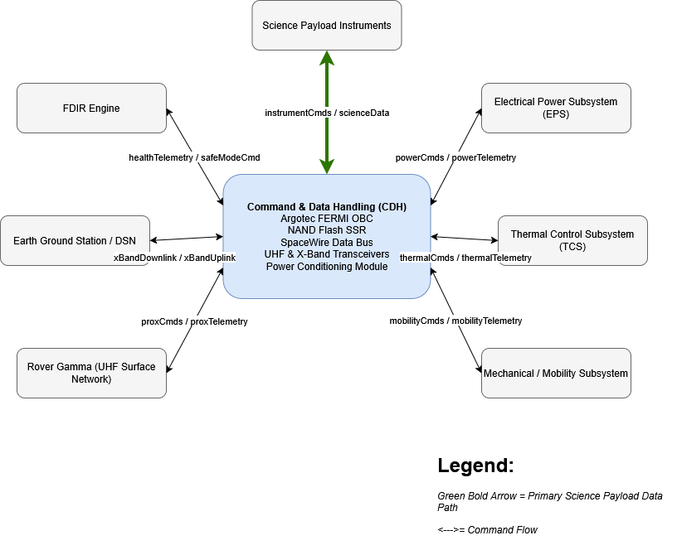
The Software Architecture Flow Diagram shows how data and commands flow between the CDH (Command and Data Handling Subsystem) and all of the rover's other hardware subsystems. The CDH is the center of computing where most functions are located. It includes the Argotech FERMI Onboard Computer (OBC), a NAND flash based Solid State Recorder (SSR), the SpaceWire Data Bus, transceivers, and a Power Conditioning Module. Data collected by each science instrument is sent to the CDH via the SpaceWire internal bus (scienceData). That data is then stored in the SSR until it can be directly transmitted to an Earth Ground Station using an X-band downlink (xBandDownlink). The FDIR engine continually receives health telemetry information from the CDH (healthTelemetry). If faults are detected, the FDIR engine sends fault messages back to the CDH which will send appropriate recovery messages to put the spacecraft into safe mode (safeModeCmd). All hardware subsystems have two-way communication with the CDH. They report their status back to the CDH and receive operation messages.

2.1.3.3 CDH Subsystem Recovery and Redundancy Plans
Overview
The CDH Subsystem is the operational core of each rover and coordinates all command execution, data gathering, fault management, and communication relay between the Earth and surface network. Lux Lunae cannot rely on real-time human intervention when abnormalities occur, as it operates in the deep interior of permanently shadowed regions where communication delays are measured in seconds to minutes. As a result, the recovery and redundancy architecture is designed on the graded autonomy principle. The rover attempts to self-heal at the lowest level of disruption possible, escalating only when prior responses have been ineffective in restoring the nominal state.
Fault Detection, Isolation, and Recovery (FDIR) Architecture
The FDIR system runs continuously on the Argotec FERMI OBC, leveraging its dual-core LEON3FT processor architecture. Each core independently monitors subsystem health, allowing the second core to continue vital functions if the primary experiences a fault. This is a form of processor-level hardware redundancy integrated into the component itself.
Local threshold monitoring across all subsystem interfaces is the first step in identifying an anomaly. At every CDH cycle, sensor data from the power management unit, thermal sensors, navigation systems, science instruments, and UHF transceiver are compared to predetermined operational bounds. Before any recovery response is initiated, all anomalies must go through a temporal validation filter. This avoids overreacting to events such as brief voltage spikes or temperature excursions during a PSR entry. Before a defect is escalated, it must persist across several consecutive samples or for a certain period of time. This method complies with NASA fault management handbook rules and directly avoids the "false positive" problem, which could otherwise lead to needless safe mode entrance and interfere with science operations.
Recovery has three graded levels: 1. soft reset and config restore; 2. safe mode: power reduced to ≤5 W, mobility parked, telemetry held locally; 3. deep power-saving: critical telemetry only, awaiting the next comms window. A watchdog supervision mechanism, based on Deep Space 1's rollback architecture, continuously re-evaluates whether the system state improves after each action, escalating or reverting accordingly.
For communication blackouts, the rover halts in place, logs locally, and retries UHF reconnection; it does not travel aimlessly. The NanoAvionics UHF transceiver was selected with enough link margin to absorb antenna pointing variation and dust accumulation, with Tethers Unlimited Cadet-U as the qualified backup. The main risk to the Phase D integration plan is the supply schedule for the SpaceWire harness, which is made internally at GSFC with VIPER heritage. Before rover-level integration at JPL, all FDIR logic is put through fault injection testing in both expected and unexpected scenarios.

2.1.3.4 CDH Subsystem Manufacturing and Procurement Plans
The procurement approach will focus on space qualified components with high Technical Readiness Level (TRL). All components have been identified through both commercial-off-the-shelf (COTS) sources and primary/backup suppliers as indicated below.
Argotec is the prime contractor for the OBC component and will supply the FERMI LEON3FT processor. Cobham Advanced Electronic Solutions (CAES), who was previously engaged to provide the RAD750 processor for previous NASA Mars missions due to its demonstrated heritage in Mars missions, has been identified as the backup source. Although Cobham's RAD750 offers considerable heritage in the area of power consumption, it does require slightly higher power levels than Argote's proposed FERMI LEON3FT processor.
BAE Systems has been contracted to supply the NAND Flash SSR. Microsemi has also been contacted and has offered to supply radiation tolerant FPGA-based storage alternatives. The two companies were chosen based on their demonstration of successful implementation of similar technology in other small satellite programs.
NanoAvionics has been selected as the primary contractor for the UHF proximity link transceiver based on its proven track record of implementing compact systems that consume very little power. The Tethers Unlimited company has designed a radio called Cadet-U that can be used as a backup. Both radios offer similar capabilities in terms of UHF communications.
IQ Spacecom is being contracted to provide the X-Band High Gain Patch Antenna. Syrlinks has been identified as the secondary provider for this antenna. This will allow us to select either the provided patch or select one of our own designs based on the design requirements we determine after reviewing the CAD models of each option.
The SpaceWire Cabling Harness is a component that will need to be custom routed according to the design of the rover chassis. Therefore, the harness will need to be manufactured at the NASA Goddard Space Flight Center Harness Fabrication Facility. If there is an issue with scheduling at GSFC, then we may need to use Axon' Cable as our secondary manufacturer. We expect to receive the SpaceWire Cabling Harness no later than when we begin assembling the rover mechanically at JPL. Procurement activities should begin immediately after we obtain KDP-C approval. The estimated lead time for obtaining radiation hardened flight hardware (the OBC and SSR) is 12 to 16 months. Estimated lead times for acquiring UHF and X-band transceivers are 8 to 10 months. Manufacturing of the SpaceWire Cabling Harness takes approximately 8 to 12 months. As a result, in order to meet the System Integration Date of December 1st, 2030, all OBC and SSR Purchase Orders will need to be placed no later than June 2026, which is consistent with the Phase C procurement timeline outlined in section 1.9.

2.1.3.5 CDH System Verification Plans
The CDH subsystem verification strategy ensures that every primary flight component meets all its subsystem requirements prior to being integrated into the rover. Verification progresses from component-level verification to subsystem-level verification, and then it moves on to total system environmental qualification in Phase D.
Each component goes through stand-alone verification before it can be integrated with other components. The Argotec FERMI OBC is verified through an inspection of manufacturer-supplied datasheets to determine if the clock speeds meet CDH-3, and through demonstrating dual-core fail-over behavior to verify CDH-8. The BAE Systems NAND Flash SSR is verified by inspecting the ECC architecture specification to verify that CDH-2.2 is implemented, and through testing the unit under simulated radiation levels to verify that CDH-2 & CDH-2.1 are met. The NanoAvionics UHF transceiver and the IQ Spacecom X-band antenna are verified by evaluating the link budget calculation against the minimum data rates specified in CDH-3.1 & CDH-3.2. Mass budgets (CDH-5), volumetric envelopes (CDH-10), and SpaceWire interface compliance (CDH-9) are also verified via an inspection of the as-built hardware and manufacturer specifications, so that no additional physical testing is necessary.
After verifying each individual component, the assembled CDH subsystem is verified by performing functional end-to-end testing using a ground support equipment testbed. This verifies that commands execute properly across the entire OBC-SSR-transceiver chain. FDIR functionality is also verified through fault injection, verifying that each fault level will trigger the proper graduated response and that Safe Mode will reduce power consumption to 5 W or less as specified by CDH-6.
In Phase D, the CDH subsystem will go through environmental qualification at JPL. During thermal vacuum testing, all components of the CDH subsystem will be exposed to both the worst-case PSR cold soak (-153°C) and PLR charge peak (121°C) to verify that CDH-7 has been satisfied. Radiation testing will verify that TID tolerance meets CDH-2. Vibration and acoustic testing will also verify that the mechanical integrity of harness connectors and board-level components survive simulated launch loads. Although component and subsystem-level functional verification must be completed by the end of Phase C, the final environmental qualification testing is done in Phase D. If any unresolved anomalies enter into the Critical Design Review, they will shorten the Phase D integration schedule and increase the risk of missing the February 1, 2031, Launch Readiness Date.
    - Thermal Control Subsystem Overview
In order to meet the operational and survival requirements of the mission, each rover on the mission will be equipped with a thermal system. This system is significant, as many of the components installed in the rover can only function in a certain temperature range before they fail. To maintain a balance between cost, efficiency, mass and size, the thermal system will utilize a combination of active and passive thermal controls. For reference, active thermal controls use power to maintain rover temperatures, meaning they are more efficient at doing their job, but also more costly. On the other hand, passive thermal controls do not use power to maintain rover temperature, but tend to have a higher mass and size. In total, the thermal subsystem will consist of four subassemblies: passive thermal control, active heat acquisition & transport, active heat rejection & cooling and thermal monitoring.

      - Thermal Control Subsystem Requirements

Figure 32: Thermal Requirements
Req ID # | Requirement | Rationale | Parent Req | Child  Req | Verification Method | Relevant Subsystems
TCS-1.1 | Thermal subsystem shall maintain operation temperatures for critical components under environmental temperatures of -253°C to +121°C | Rover is required for operation in PSRs and sunlit regions(for charging). |  | TCS 1.2, | Analysis | All
TCS-1.2 | Thermal subsystem shall use a combination of passive and active thermal control systems to autonomously maintain operational temperatures of -40°C to +85°C for critical internal components. | Rover temperature will primarily need to be managed autonomously in order to protect critical components from changing temperatures in the environment. | TCS-1.1 | TCS-1.3, TCS-1.4, TCS-1.5 | Analysis | Thermal, Power Payload, CDH
TCS-1.3 | The thermal subsystem shall provide active heating capability of ≥30 W to maintain component survival temperatures during worst-case PSR conditions. | Temperatures in the PSR will drop to cryogenic temperatures, which will cause many components within the rover to fail. | TCS-1.2 |  | Test | Thermal
TCS-1.4 | The thermal subsystem shall provide at least 90 W of heat rejection capability to prevent overheating during worst-case sunlit conditions. | Temperatures in the sunlit regions will reach scorching temperatures, which will cause many components within the rover to fail. | TCS-1.2 |  | Test | Thermal
TCS-1.5 | Thermal subsystem shall include a thermal monitoring system to track the temperature of the rover and its components. | Rover temperature must be tracked to ensure all components can function properly. | TCS-1.2 |  | Test | Thermal

2.1.4.2 Thermal Control Sub-Assembly Overview

i. Passive Thermal Control Subassembly
To passively reduce thermal fluctuations, multiple technologies will be used, one being sprayable thermal coatings. A white coating, such as AZ-93 White Thermal Control Coating will be sprayed on surfaces of the rover to prevent overheating when charging. Another passive technology that will be put in place is multilayer insulation(MLI), which is a type of thermal insulation made of multiple thin layers. It prevents radiative heat loss in cryogenic temperatures when wrapped around important components, such as batteries, electronics, coolant loops etc. To properly insulate each component, each MLI will consist of an outer cover to resist degradation, reflector layers to reduce radiative heat transfer, separator layers to keep the reflective layers from touching and an inner cover to directly protect each component. Certain electrical components are fragile and have an intricate shape that may not be properly covered by an MLI–in these cases, the aerogel will be used as a replacement. This is because it is extremely lightweight, flexible and has the lowest thermal conductivity of any solid materials. Finally, thermal straps, heat pipes and heat sinks will be installed to reuse excess heat produced by major electronics and computer hardware components. Copper thermal straps are conductive links that can transfer heat between a heat source and heat sink. Their flexibility allows them to be installed on heaters and within tiny slits in the MLI to connect with heat sinks. Heat sinks are passive devices that dissipate heat into the surrounding area–this works due to heat’s tendency to move from hot to cold areas to achieve thermal equilibrium. They would be placed in parts of the rover most susceptible to the cold temperatures, such as areas with less heater capabilities or with temperature sensitive components. This would help the rover maintain an operable temperature and reduce the workload of the heaters installed. All of the technology listed above have been used multiple times successfully in previous NASA missions, such as the Apollo Mission. For instance, the Solar-Wind Spectrometer used multi-layer insulation of aluminized Mylar and silk organza around an electronic package, while the Suprathermal-Ion-Detector Experiment used white paint on its exterior surfaces to reduce heat absorption. The VIPER rover’s thermal management system had similar technology as well as thermal straps, heat pipes and heat sinks for heat transportation purposes. Due to all of the technologies having a long heritage, the passive thermal control subassembly will have a TRL of 9.

ii. Active Heat Acquisition & Transport Subassembly
This assembly will primarily operate when the rover is in a PSR. In order to conserve and produce heat, a heat acquisition subassembly will be put in place. The purpose of this subassembly will be to collect as much excess heat as possible from what the rover produces through power dissipation. This will be done in tangent with the passive control subassembly, using thermal straps, heat pipes and heat sinks to collect and transfer heat directly to areas in need. Since the majority of electrical energy is converted to heat when used, the main focus of this subassembly will be centered around collecting energy from electrical components. The assumption is that ≥80% of the heat from the electrical and computer hardware components will be collected for use. The rovers will primarily be operating in the PSR, meaning using the excess heat from electronics will not be enough to keep the rover at an operable temperature. Electrical Kapton heaters will be installed to make up for the amount of heat that is missing. These heaters are made of polyamide, a conductive, thin and flexible material that is able to be installed in tight and irregularly shaped spaces. They also are highly resistant to corrosive agents, meaning they will be able to survive the lunar regolith’s corrosive nature. Kapton heaters have been used successfully in many previous missions, such as the Mars Curiosity rover where it helped protect the rover’s wiring from freezing. They were also used in the Mars Spirit and Opportunity rovers and were able to heat up gas generators from -33°C to 0°C in 1 hour. Overall, the active heat acquisition & transport subassembly will have a TRL of 9.

iii. Active Heat Rejection & Cooling Subassembly
This assembly will primarily operate when the rover is in a sunlit region for charging, since the temperatures can reach up to 121°C, meaning there is a much higher risk of overheating. Whether the heating or cooling subassembly is operating will be dependent on the thermal monitoring subassembly. This subassembly will also work with the passive control system–however, this time the heat will be redirected to radiators that emit heat outside the rover, rather than to other parts of the rover. In case this is not enough to cool the rover to an operable temperature, thermoelectric coolers (TEC) will be incorporated as a backup option–these are small heat pumps that are able to cool down the surrounding area. They work due to the Peltier effect, meaning that if electricity is powering the device, heat will be transferred from one side of the device to the other side. The remaining heat would be released through radiators. Since the TECs are small, they would be able to be installed near electrical and computer hardware components, as well as any crevices in the rover susceptible to the outside heat. However, TECs are sensitive to the stresses caused by thermal expansion, so in order to mitigate this, thermal straps must be added to the cold side. Nearly all NASA spacecraft rovers have radiators to dispose of excess heat, such as Voyager 1, the International Space Station, the Curiosity Rover and the Perseverance rover. TECs are used less often in NASA missions because they have a lower efficiency compared to radiators or fluid loops. Fluid loops were also considered, but they would add too much mass and require more power than the rover could supply for its thermal control system.
Due to the TECs being a backup cooling option as well as the rover having strict mass and power constraints, it was determined that they would be suitable for the rover. They have also been used in the Mars Curiosity Rover and Space Shuttle Program. Overall, the active heat acquisition & transport subassembly will have a TRL of 7. This is because most of the listed technology has been proven reliable and been tested successfully in multiple NASA missions in the past.

iv. Thermal Monitoring Subassembly
In order to monitor and maintain a sustainable operating temperature for the rover autonomously, multiple temperature sensors will need to be installed throughout the rover. They will primarily be placed at electrical, computer hardware and payload components, as these tools are fragile and have strict operating temperatures. The specific sensors used will be thermocouples and heat flux sensors, which measure temperature and the flow of heat respectively. These sensors will measure the component temperatures and continuously send this data to the rover’s CDH subsystem. From then, the CDH subsystem will autonomously regulate each component’s temperature by utilizing the other three subassemblies. For instance, if a battery is starting to fall within 10°C of its minimum operating temperature, the CDH subsystem can utilize the active heat acquisition & transport subassembly to send heat to that component. Once the component is safely within -40°C to 85°C, the CDH subsystem will stop the heating subassembly from sending additional heat. The same applies to a component that is getting too hot–in that case, the CDH subsystem will activate the active heat rejection & cooling subassembly. Overall, the thermal monitoring system will have a TRL of 8. This is because thermal monitoring systems are used in nearly all of NASA spacecraft, specifically temperature sensors. For instance, the Perseverance Rover as well as the Apollo mission’s Solar Wind Spectrometer and Heat Flow Experiment all used temperature sensors to activate electrical heaters if the temperature dropped below a set limit.
Figure 33: Subassembly Metrics I
Thermal Subassembly Metrics Per Rover
Note: Each rover will have the same metrics
Name | Classification | Mass(kg) | Volume  (m³) | Max Power Draw(W) | TRL
Passive Thermal  Control Subassembly | Passive | 8.5 | 0.22 | 0 | 9
Active Heat  Acquisition & Transport Subassembly | Active | 4 | 0.07 | 3.5 | 9
Active Heat Rejection & Cooling Subassembly | Active | 5 | 0.1 | 2.5 | 7
Thermal Monitoring Subassembly | Active | 1.25 | 0.0309 | 0.525 | 8
Total: |  | 18.75 | 0.4209 | 6.525 | 7

Figure 34: Subassembly Metrics II
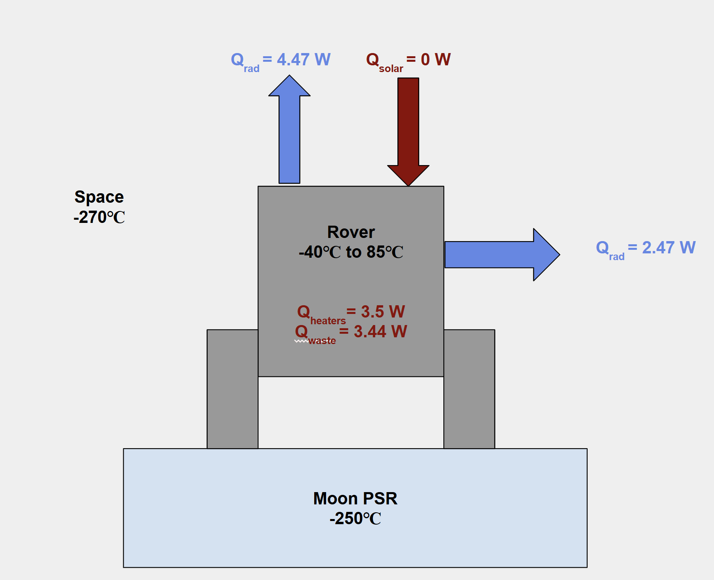
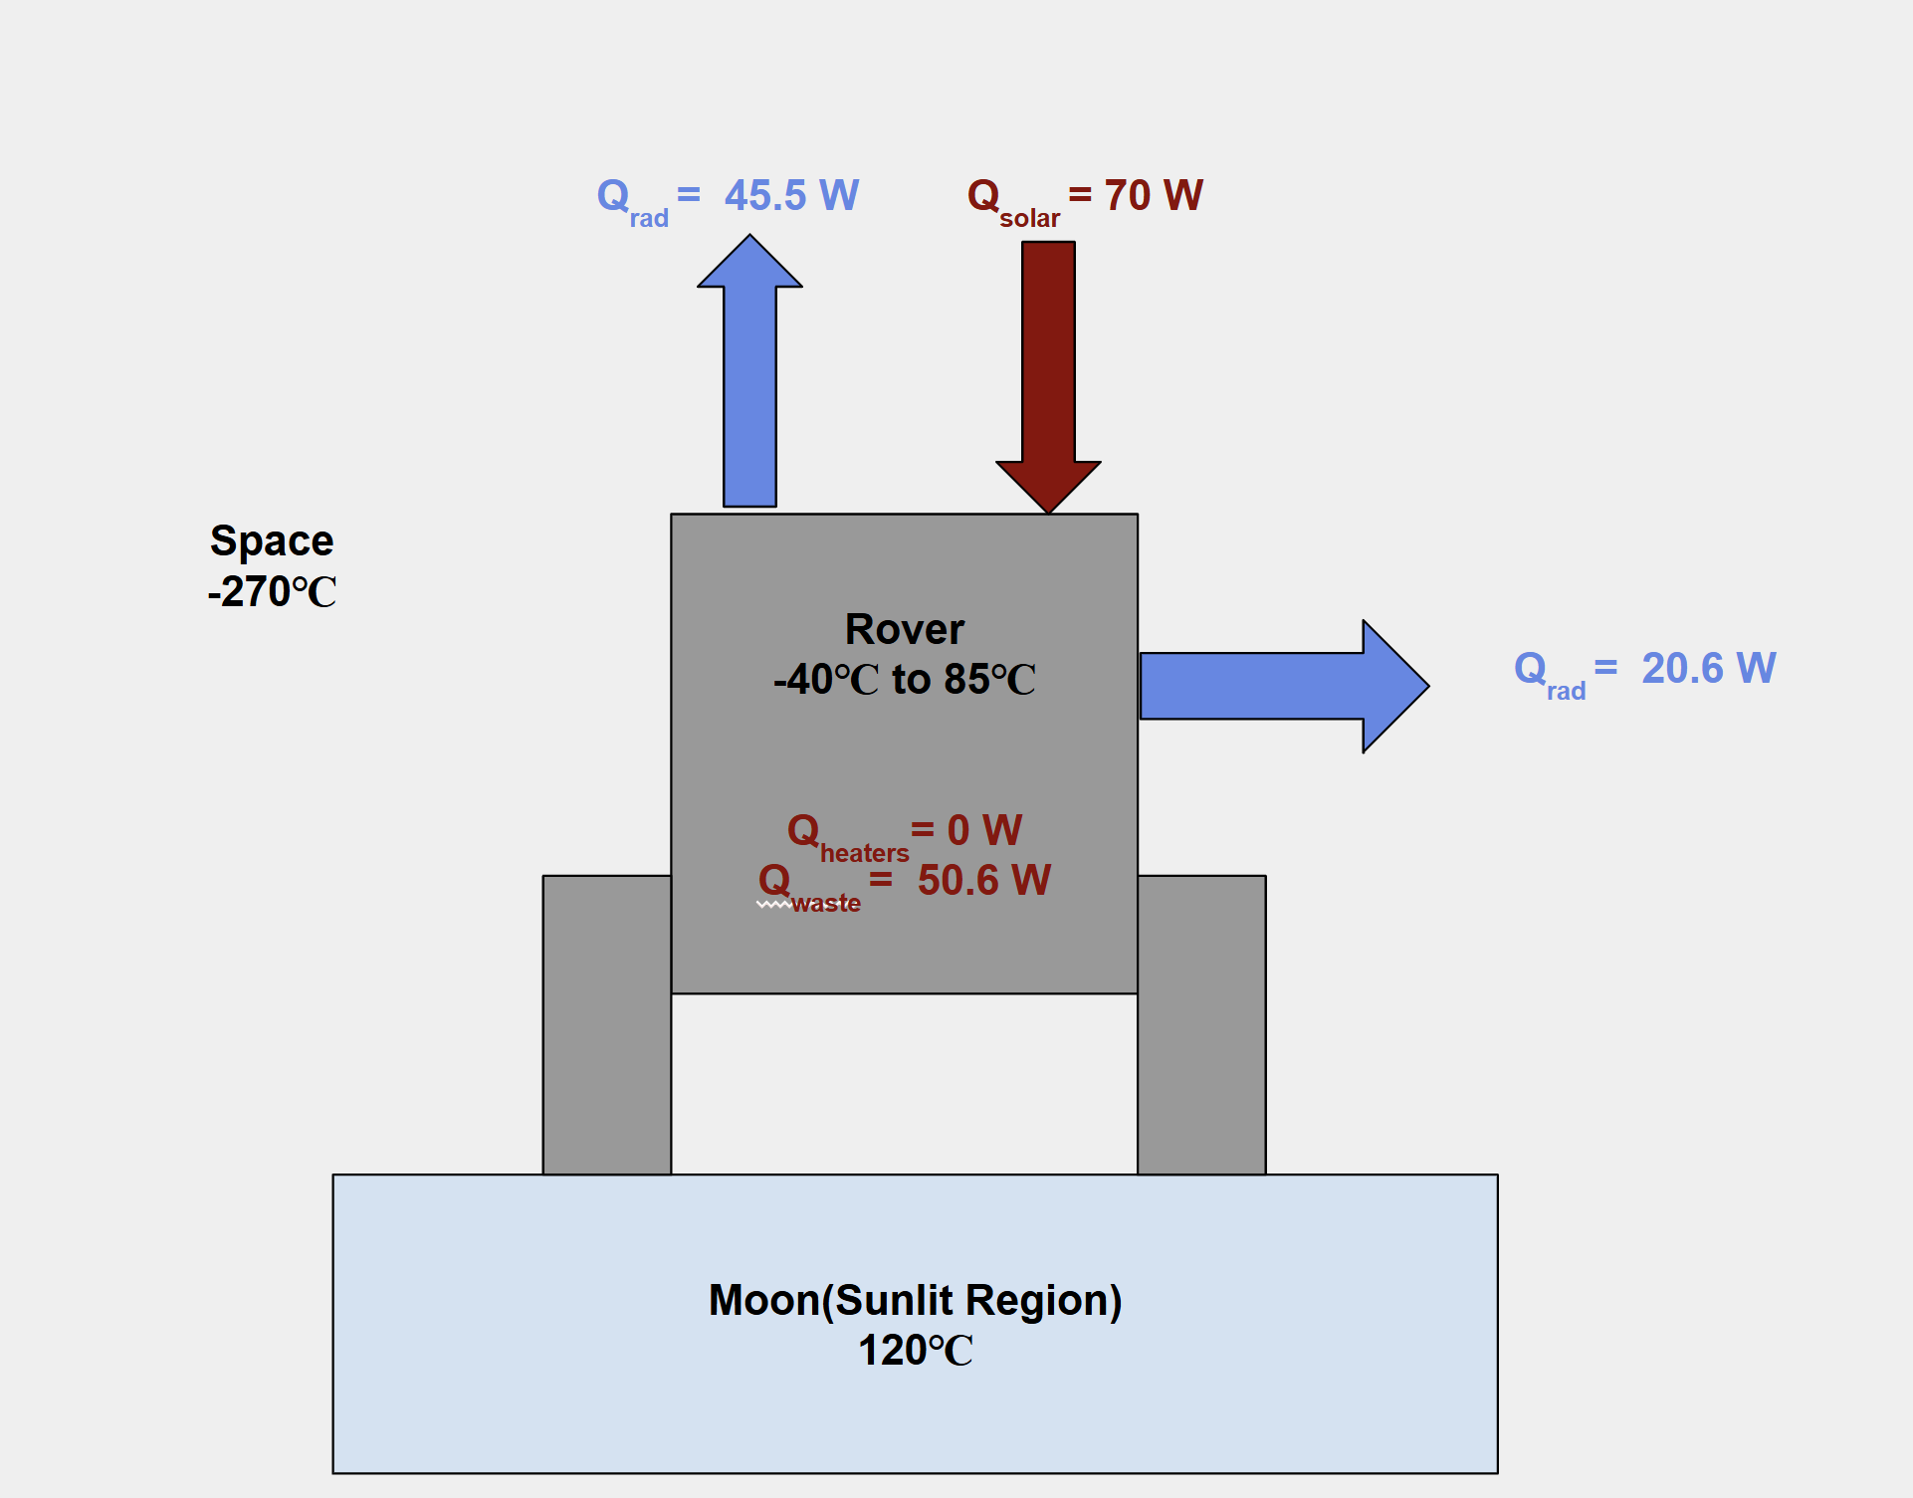

2.1.4.3 Thermal Control Subsystem Recovery and Redundancy Plans

Redundancy for the thermal system is obtained with the dispersed temperature sensors and multiple resistive heater elements that are located near major components (batteries, payload electronics), which have been identified as critical. Each critical component will have at minimum 2 temperature sensors in close proximity in case one sensor fails. The heating system has multiple heater elements, with the total heater power being equal or greater than 30 Watts. Therefore, if a single heater element fails, thermal control will not be lost. Multi-layer insulation (MLI) also provides a passive thermal protection method for the thermal subsystem by limiting the amount of heat that will be lost in permanently shaded areas and the quantity of heat that can be gained from the sun.
The thermal subsystem maintains component temperatures within an operational temperature range of -40 °C to +85 °C with the ability to survive temperatures above or below the operational minimum and maximum temperature limits. If temperatures are ever less than the minimum operational limits, then battery-associated electronic component performance will be degraded to the point of reduced capacity, and in some circumstances, permanent damage will occur. If a component is exposed to a temperature below -120 °C, it could fail due to freezing. Conversely, if a component operates at a temperature above 85 °C, overheating may reach a level that results in the electronic component failing due to heat damage, accelerated degradation of material properties, or complete failure.

2.1.4.4 Thermal Control Subsystem Manufacturing and Procurement Plans

The primary purpose of the thermal subsystem is to keep each rover at an operable temperature during the cryogenic temperatures in the moon’s PSRs. It will also be responsible for preventing the rover from overheating when it is charging outside of the PSR. The subsystem consists of four main subassemblies: a passive thermal control subassembly, a heat acquisition & distribution subassembly, a heat rejection & cooling subassembly and a thermal monitoring subassembly.
The passive thermal control subassembly will consist of multilayer insulation(MLIs), aerogel, thermal coating, thermal straps and heat sinks. The primary contractor for this subassembly will be 3M Company. They have provided thermal components for the Artemis I & II missions as well as the Perseverance Rover, meaning their products have been thoroughly tested in past missions. The main backup contractor will be Textron, as they also have extensive experience designing thermal subsystems for NASA missions. In total, the passive control subassembly lead time will take approximately 3-4 months due to material, customization and thermal requirements–analysis and testing will also contribute lead time. The MLIs especially must be custom designed to match the layout of the rover components and will have different layering depending on the operable temperature requirements. If Textron is used for this subassembly, there will be an estimated lead time of 4-6 months due to more extensive testing.
The heat acquisition & distribution subassembly will consist of multiple Kapton Heaters. This subassembly is designed to work with the passive thermal control subassembly to distribute heat to parts of the rover that need to be kept warm. The primary contractor will be Honeywell due to their specialization in Kapton heaters as well as extensive experience in thermal control systems and hardware. They have supplied thermal system parts for the Artemis I & II missions as well as for the International Space Station. In total, the lead time will take approximately 4-5 months due to material procurement, integration with rover components and testing to ensure the heaters will function to keep component temperatures at operable levels. The backup contractor will be Minco due to their specialization in Kapton heaters. If used, Minco will have a lead time of approximately 5-6 months.
The active heat rejection and cooling subassembly will consist of fluid loops, thermoelectric coolers and radiators. It will primarily be used when the rover is charging in direct sunlight and is at a high risk of overheating. The main contractor will be L3Harris due to their experience in developing thermal control systems for spacecraft–specifically, they have worked on the Curiosity and Perseverance rovers. In total, the lead time will be 6-7 months. This is because creating a comprehensive cooling system with fluid loops, coolers and radiators will require extensive planning, design and testing. The backup contractor will be Northrop Grumman, since they also have experience in creating cooling technology for spacecraft. If used, Northrop Grumman will have a lead time of approximately 7-8 months.
The thermal monitoring subassembly will consist of multiple temperature sensors placed at electrical, computer hardware and payload components that measure
temperatures and autonomously maintain each component’s temperature. The primary contractor will be L3Harris as they have previously worked on the instrumentation and thermal monitoring for the thermal subsystem of the Curiosity and Perseverance rovers. In total, the lead time will take approximately 4-6 months due to sensor customization as well as integration with the rover’s command and data handling system. Extensive testing will also need to be performed in order to ensure the system can perform accurately. The backup contractor will be Honeywell, since they also specialize in temperature sensors and other thermal components. If selected, Honeywell will most likely have a lead time of 5-7 months.

2.1.4.5 Thermal Control Subsystem Verification Plans
The verification matrix is a reference that indicates how each thermal subsystem requirement will be verified in the preliminary design stage. Each requirement will have a verification technique specified, and an explanation for how the verification will be accomplished will be included. The Verification Matrix's purpose is to ensure that all requirements can be measured and confirmed.

Figure 35: Thermal Verification Matrix

Req # | Requirement Summary | Verification Method | Rationale for Method | Preliminary Verification Plan
TCS 1.1 | Thermal subsystem shall maintain operation temperatures for critical components under environmental temperatures of -253°C to +121°C | Analysis | Full lunar environmental conditions (PSR and sunlit extremes) cannot be completely replicated in testing. Thermal analysis allows evaluation of system performance across all mission scenarios. | A thermal model will simulate PSR and sunlit conditions to verify all components remain within operational temperature limits.
TCS 1.2 | Thermal subsystem shall use a combination of passive and active thermal control systems to autonomously maintain operational temperatures of -40°C to +85°C for critical internal components. | Analysis | System-level behavior and interaction between passive and active elements are best evaluated through thermal modeling. | A system-level thermal model will simulate passive and active control to verify internal temperatures remain within -40°C to +85°C.
TCS 1.3 | The thermal subsystem shall provide active heating capability of ≥30 W to maintain component survival temperatures during worst-case PSR conditions. | Test | Heating capability must be physically measured to confirm performance meets required output. | The heating system will be tested to confirm it provides at least 30 W and maintains component survival temperatures in cold conditions.
TCS 1.4 | The thermal subsystem shall provide at least 90 W of heat rejection capability to prevent overheating during worst-case sunlit conditions. | Test | Cooling performance must be validated through controlled testing to confirm the system can reject required heat loads. | The cooling system will be tested with simulated heat loads to verify it can reject at least 90 W and prevent overheating.
TCS 1.5 | Thermal subsystem shall include a thermal monitoring system to track the temperature of the rover and its components. | Test | Sensor performance and data acquisition must be validated through functional testing. | The monitoring system will be tested to verify sensor accuracy, response time, and proper temperature data transmission to CDH.

    - Payload Subsystem Overview

- Executive Summary

The Lux Lunae mission is a dual-rover robotic reconnaissance mission designed to address planetary science objectives and human exploration goals at the lunar south pole. The mission utilizes two distinct rover suites: Rover Alpha, managing the SMD directives, and Rover Gamma, managing the ESDMD goals. The primary scientific objective of the payload suite is to determine the origin and delivery processes of lunar volatiles and inner solar system volatiles while also characterizing the lunar PSR environment and resources to optimize future human surface operations.
The integrated payload suite includes the Mass Spectrometer Observing Lunar Observations (MSolo), the Near-Infrared Volatiles Spectrometer System (NIRVSS), the Neutron Spectrometer System (NSS), the Regolith and Ice Drill Exploration of New Terrain (TRIDENT), and the Physical Properties Sensor (PPS). Collectively, these instruments provide a comprehensive capability for isotopic analysis, mineralogical identification, vertical resource mapping, and geotechnical assessment.
Resource requirements for the mission are optimized for solar-powered rover platforms. The payload is supported by a power system capable of generating approximately 410 Watts of total power, with specific instruments like the Ames Imaging Module (AIM) requiring as little as 1 Watt during active sensing. Data handling is designed for flexibility, with instrument scan rates capable of being throttled to 7 kbps to ensure reliable DTE communication during active surface operations.

- Payload Overview & Architecture

The Lux Lunae payload architecture is distributed across the Alpha and Gamma rovers to satisfy distinct mission pillars. Rover Alpha serves as the primary scientific assay platform, hosting the MSolo and a TRIDENT drill to prioritize the determination of isotopic ratios in PSRs. Rover Gamma functions as the reconnaissance and environmental surveying platform, equipped with the NSS for hydrogen prospecting - the analysis of natural hydrogen trapped in underground geological formation, the PPS for dust and illumination monitoring, and a TRIDENT system optimized for geotechnical property description.
Each rover’s internal architecture facilitates high-fidelity data collection through standardized interfaces. The NSS includes a dedicated Data Processing Module that interfaces with the rover for command and data handling. The MSolo utilizes an Instrument Interface Unit to bridge its modified commercial-off-the-shelf electronics with the spacecraft’s power and communication systems. Mechanical integration is strategically managed to ensure scientific integrity; for instance, the NSS sensor module is mounted on the front of the rover to maintain an unobstructed view of the lunar surface, while the NIRVSS bracket assembly is positioned to observe the cuttings pile delivered by the TRIDENT drill.

- Instrument Descriptions

Mass Spectrometer Observing Lunar Operations (MSolo) – Rover Alpha

The MSolo instrument is a modified quadrupole mass spectrometer designed to identify the isotopic composition of volatiles including H2O,CO2, NH3, and H2. It operates across a mass range of 1-100 AMU with a mass resolution of ≥ 1000 m/Δm . Its primary objective is to measure Deuterium-to-Hydrogen (D/H) and other isotopic ratios with an isotopic precision of 1-3%, providing the 95% confidence necessary to distinguish between protosolar and cometary volatile origins.

Neutron Spectrometer System (NSS) – Rover Gamma

The NSS is the mission's primary tool for prospecting for hydrogen-rich materials while roving. Its source relies on spallation, or the production of neutrons due to cosmic rays interacting with lunar surface atoms. It consists of helium-3 filled tubes; one tube is sensitive to epithermal neutrons, while the other detects both thermal and epithermal neutrons. The flux calculated reveals the presence of Hydrogen, specifically that which is indicative of low-energy neutrons. The system is designed to achieve a detection sensitivity of 0.5 wt% Water Equivalent Hydrogen (WEH) at a 3-sigma confidence level while the rover maintains a speed of 10 cm/s. It will be able to detect Hydrogen up to 1 meter below the surface.

The Regolith and Ice Drill Exploration of New Terrain (TRIDENT) – Alpha & Gamma

The TRIDENT system provides the capability to physically excavate regolith to a depth of ≥ 1 meter using a rotary-percussive "bite sampling" technique. On Rover Alpha, TRIDENT delivers subsurface samples to the MSolo for lateral analysis, while on Rover Gamma, it is instrumented to measure forces and displacements to determine regolith bearing strength with a force resolution of ±5 kPa.

Near-Infrared Volatiles Spectrometer System (NIRVSS) – Alpha & Gamma

NIRVSS is a dual-channel spectrometer operating in the 1.3-4.0 μm range to measure volatile concentrations and identify mineralogical features. It includes the Ames Imaging Module (AIM), a 4-megapixel CMOS camera equipped with 7 sets of LEDs (350-940 nm) to provide surface morphology context and situational awareness even in total darkness within PSRs.

Physical Properties Sensor (PPS) – Rover Gamma

The PPS describes the environmental conditions of the lunar south pole by quantifying dust concentrations (≥10μg/m3) and mapping illumination patterns (0 to 100,000 Lux). This instrument is essential for creating detailed outlines of PSRs in terms of temperature and brightness to inform future human trafficability.

- Payload Integration and Data Handling

Instruments on both Lux Lunae rovers are integrated via standardized mechanical and electrical interfaces to ensure reliability. Mechanical mounting is specialized to this mission. In other words, the NIRVSS bracket assembly utilizes fiber cables to connect the spectrometer to its strategic viewing aperture, or lens opening. The electrical power system distributes power to the payload via 1 m^2 solar arrays and an integrated battery system.
Data handling follows a time-stamped protocol to facilitate precise geospatial mapping. Raw data from instruments such as the MSolo and NSS are captured in continuous scans, allowing ion currents and neutron counts to be plotted against time and rover position. This architecture supports the generation of advanced data products, including WEH maps and Digital Elevation Models (DEMs), which are eventually archived in the Planetary Data System (PDS) for long-term scientific use.

- Environmental and Operational Requirements

The Lux Lunae payload is engineered to survive and operate in the extreme environment of the lunar south pole, characterized by temperatures ranging from -150 to 120 Celsius. Thermal control is managed through a combination of heat-rejection radiators and survival heaters, which are activated during Safe Haven operations when the rovers hibernate during loss of sunlight and direct-to-Earth communication.
Operational safety and contamination control are paramount to the Lux Lunae Mission. During the lunar transit phase, the MSolo and NIRVSS undergo bakeouts to minimize outgassing and contamination from the rover itself. Additionally, the MSolo is equipped with a dust cover mechanism that protects the sensitive instrument until after the landing and initial checkout phases are completed. Pointing requirements are satisfied by the AIM and navigation cameras mounted on pan/tilt gimbals, ensuring 360-degree situational awareness and to support the continuous scans they have.

- Expected Science Performance

The integrated payload of the Lux Lunae mission is uniquely positioned to fulfill NASA’s Science Mission Directorate and Human Exploration goals. By achieving an isotopic precision of 1-3% and a WEH detection sensitivity of 0.5 wt%, the instruments will provide the high-fidelity data necessary to resolve longstanding questions regarding the delivery of volatiles to the inner solar system. Furthermore, the characterization of regolith geotechnical properties and environmental hazards will ensure that future human explorers have the necessary reconnaissance to operate safely and efficiently on the lunar surface for future missions such as Artemis.

      - Science Instrumentation Requirements

The payload subsystem requirements table involves the TRIDENT, MSolo, and VIPER systems, as well as general requirements for sensors, cameras, and data acquisition instruments, traced back to the SMD and ESDMD Science Objectives and Goals (LPS-3LM, SE-5LM).

MR = Mission Requirement
PAY = Payload
Figure 36: Science Requirements

Req # | Requirement | Rationale | Parent Req | Child Req(s) | Verification method | Req met?
MR-1 | MSolo will measure constituents  below atomic number 100. | Analyze volatiles released from the lunar regolith as TRIDENT  digs through surface, as well as resulting  extracted subsurface regolith. | SMD Science Objectives1 and 2 | PAY-1 | Analysis | Met
PAY-1 | MSolo shall analyze gas released  from constituents in regolith samples. | Based on parent requirement to focus on constituents with  relevant values with an atomic number below 100 for regolith  analysis. | MR-1 | - | Analysis | Met
MR-2 | TRIDENT shall utilize a rotary-percussive "bite-sampling" method  to collect and deposit regolith and volatile samples to minimize  contamination and loss of volatile material, as well as save power. | Drill takes samples in cm-level bites, which minimizes the chance of material getting  stuck in the flutes and reduces the risk of volatile contamination or loss by being  accidentally disposed of. Bite samples save power as well as preventing  heat buildup from melting volatile samples. | SMD Science Goal: "LPS-3LM:... [determine the] transport,  and sequestration of lunar and Martian volatiles.”  ESDMD Science Goal: "SE-5LM: Use robotic techniques to  survey sites, conduct in-situ measurements...  maximize science return." | PAY-2-1, PAY 2-2 | Test | Met
PAY-2-1 | TRIDENT shall utilize a brush system to periodically  clean its flutes. | Buildup can occur over time in the flutes that must be cleaned out. | MR-2 | - | Demonstration | Met
PAY-2-2 | TRIDENT shall collect samples in bit carousel adapted to  specific rover constraints. | The bit carousel will store samples and rotate out to present  new containers for further samples. | MR-2 | - | Test | Met
MR-3 | VIPER Instruments must measure  physical state and abundance of hydrogen-bearing volatiles  at the micrometer scale and at concentrations >2 wt%. | The micrometer scale and concentration levels specified  are vital in order to make proper measurement of the properties  of the volatiles; higher weight percent ensures more accurate analysis. | SMD Science Objective 2 | PAY-3 | Analysis | Met
PAY-3 | Rover systems shall calibrate screw thread of micrometer in  VIPER instruments every month. | This ensures accuracy of micrometer measurements by  keeping screw thread calibrated to ensure rotational precision. | MR-3 | - | Inspection | Met
MR-4 | Rover speed must not exceed 10 cm/s  unless during on-rails traversing. | Too much speed for the rover may cause collisions with the  environment or interactions with other hazards, such as ditches. | ESDMD Science Goal: "SE-5LM: Use robotic techniques to  survey sites, conduct in-situ measurements...  maximize science return." | PAY-4 | Demonstration | Met
PAY-4 | Rover shall not travel on inclines over 30 degrees. | Safety measure due to the fact that traveling at inclines over 30 degrees  may cause the rover to slide or tip over. | MR-4 | - | Demonstration | Met
MR-5 | Identify mineralogical features consistent with mafic minerals and  hydrous mineral phases present at >5 wt% in the lunar regolith. | Mafic minerals and hydrous mineral phases at >5 wt%  increases likelihood that volatiles are present in the sample. | SMD Science Goal: “LPS-3LM: Reveal inner solar system volatile  origin and delivery processes by determining the age, origin,  distribution, abundance, composition, transport, and sequestration  of lunar ... volatiles.”  SMD Science Objective 2 | PAY-5 | Analysis | Met
PAY-5 | Scanning Electron Microscopy shall be used to  analyze the composition of samples. | Scanning electron microscopy will help to determine  elemental composition and material spatial distribution. | MR-5 | - | Analysis | Met
MR-6 | Integrated AIM Camera will scan and photograph both  illuminated and shadowed regions of landing zone at  coordinates -89.344°N, 115.686°E utilizing FPGA-based architecture. | Images will allow for further analysis of landing zone, such as  identifying possible exploration sites and dangerous terrain. | ESDMD Science Objective: “...characterize terrain, environmental  conditions ... in order to inform future human surface operations and  science activities. With data collected, we will be able to understand  and quantify potential lunar environmental hazards and distribution  of resources, which will be mapped out with the aid of AIM.“ | PAY-6 | Test | Met
PAY-6 | Camera shall transmit images back to Earth using  High-Gain Antenna. | High-gain antenna allows for direct Moon-to-Earth  transmission of images at a rate of up to 500  megabits per second. | MR-6 | - | Test | Met
MR-7 | Sensors/thermometer must have Scanning Electron  Microscope mapping capabilities to create detailed outline of landing  zone at coordinates -89.344°N, 115.686°E, PSRs and other local  regions in terms of temperature, dust, and brightness, or the lack thereof. | Sensing data will allow for further analysis of landing zone, such as  identifying possible exploration sites and dangerous terrain, to ensure safety for  possible future human exploration. | ESDMD Science Objective: “...characterize terrain, environmental  conditions... in order to inform future human surface operations and  science activities. With data collected, we will be able to understand  and quantify potential lunar environmental hazards and distribution  of resources, which will be mapped out with the aid of AIM.“ | PAY-7 | Demonstration | Met
PAY-7 | Maps shall be able to be separated in layers, in terms of the parameters  being measured. | Data must be isolated and able to be combined in order  to use the specific parameters that are needed in the situation. | MR-7 | - | Test | Met

      - Payload Subsystem Recovery and Redundancy Plans
The Lux Lunae mission architecture incorporates a multi-layered approach to redundancy and recovery, ensuring that scientific objectives and human reconnaissance goals are met even in the presence of errors, anomalies, or the extreme environmental conditions of the lunar south pole. This strategy is built on the dual-rover configuration, which provides inherent redundancy. By separating Science Mission Directorate (SMD) goals onto Rover Alpha and Exploration Systems Development Mission Directorate (ESDMD) goals onto Rover Gamma, the mission minimizes the impact of a failure at a single point. If one rover experiences a terminal mechanical or electrical fault, the other can continue its independent investigation, preserving at least 50 percent of the total mission science return . Furthermore, the overlap in some instrumentation, such as both rovers carrying NIRVSS and TRIDENT systems, allows for limited cross-functional recovery if one platform's specific instrument suite is compromised.

- Subsystem-Level Redundancy and Resilience

At the instrument level, redundancy is integrated into the sensor design to ensure continuous data acquisition. The NSS on Rover Gamma utilizes two helium-3 filled tubes; one is sensitive to epithermal neutrons while the other detects both thermal and epithermal neutrons. This dual-tube configuration not only provides the data necessary to resolve vertical hydrogen distribution but also serves as a fail-safe; if one tube fails, the remaining sensor can still provide bulk hydrogen counts, albeit with reduced depth-modeling capabilities. Similarly, the NIRVSS instrument features a dual-channel design, consisting of Shortwave (SW) and Longwave (LW) channels fed by a single fiber optic bundle. This separation allows the instrument to continue identifying mineralogical features even if one spectral channel experiences degradation.
The TRIDENT drill system incorporates mechanical and thermal redundancies to mitigate the risks associated with subsurface excavation. Each drill string is equipped with two embedded temperature sensors with one at the drill bit tip and another approximately 20 cm above the tip. This ensures that subsurface thermal gradients can still be measured if a single sensor fails. Additionally, the drill is capable of varying key parameters such as auger speed, percussive frequency, and weight on bit (WOB) in real-time, allowing mission operators to recover from scenarios or unexpected regolith resistance that would cause the drill to be stuck by adjusting the mechanical approach to suit the localized geotechnical properties.

- Environmental Recovery and Safe Haven Operations

The survival of the payload subsystems during the extreme lunar night and periods of shadow is managed through Safe Haven operations. When the sun sets below the horizon or the rovers enter an extended shadow period (less than 70 hours), the rovers are positioned in areas of persistent sunlight to maintain battery charge. During these periods of lost signal, all non-essential subsystems, including the primary science payload, are shut down to conserve power. The recovery of these systems is facilitated by survival heaters that maintain critical avionics and instrument electronics above their survival temperatures, which range from -150 to 120 Celsius. Once direct-to-Earth (DTE) communication is re-established and the rovers return to a positive power state, a controlled power-on sequence is initiated to verify the health and status of each instrument before resuming science operations.

- Situational Awareness Recovery

To recover from navigational or operational anomalies, the mission utilizes an extensive imaging and localization suite. Redundancy in the mission’s situational awareness is shown by the Ames Imaging Module (AIM) as well as the NavCams, HazCams, and AftCams. The hazard cameras, located in each of the four wheel wells, provide a 360-degree view of the near-field environment, allowing ground operators to identify wheel sinkage or terrain obstacles that might impede the rover. If a primary navigation camera pair fails, the hazard and rear-facing cameras provide sufficient coverage to continue operation at reduced speeds. This imaging suite is essential for interpreting spectral data and providing the context needed to recover the rover's attitude and location after an unexpected move or slide on the lunar regolith.

- Data Recovery and Integrity Protocols

Data integrity and recovery are supported by the use of FPGA-based architecture and standardized data handling protocols. Each instrument's data set is tagged with a time stamp, allowing the mission’s Science team to reconstruct measurement sequences even if there is a gap in the telemetry downlink, or wireless transmission of data from remote station to ground station. For instruments like MSolo, which captures data through continuous scans, the scan rate is variable and can be throttled down to 7 kbps if downlink rates are compromised, ensuring that at least a minimum set of mass spectral data reaches the ground. In the event of a total communication dropout, the rovers are programmed to enter a low-power "wait" state until the lander or DTE link is restored, at which point stored health and status data can be downlinked to diagnose the cause of the signal loss. These comprehensive redundancy and recovery plans ensure that the Lux Lunae mission remains resilient against the mechanical and environmental challenges of the lunar south pole.

      - Payload Subsystem Manufacturing and Procurement Plans
The manufacturing and procurement strategy for the Lux Lunae mission involves an approach based on heritage instruments to leverage established NASA invention, expertise and strategic partnerships. To ensure the successful delivery of the Alpha and Gamma rover payloads, the mission employs a procurement model that combines modified Commercial Off-The-Shelf (COTS) hardware with spaceflight instrumentation that will be customized for this mission specifically. This strategy is designed to balance technical maturity with the specialized requirements of the lunar south polar environment, ensuring that all subsystems meet the performance specifications defined in the Science Traceability Matrix.
The procurement of the Mass Spectrometer Observing Lunar Operations (MSolo) for Rover Alpha follows a specialized "COTS-to-Flight" model. The core of the instrument is a 100 AMU quadrupole mass spectrometer sourced from INFICON, specifically the Transpector MPH model. To adapt this industrial hardware for the lunar surface, the manufacturing plan includes significant modifications to the electronics and structural chassis to ensure survivability under vacuum and extreme thermal conditions. A critical component of this procurement is the development of the Instrument Interface Unit, which is manufactured to provide the standard spacecraft interfaces required to bridge the COTS instrument with the rover’s power and communication systems. Additionally, the plan includes the fabrication of a custom Dust Cover mechanism and a calibration gas system containing a known gas mixture to facilitate periodic in-situ calibration during the mission.
The NIRVSS and NSS instrument suites represent a collaborative manufacturing effort between NASA Ames Research Center (ARC) and the Applied Physics Laboratory (APL). The NSS consists of a sensor module and a data processing module, with procurement focused on specialized helium-3 filled tubes. These tubes must be sized and coated with precision to achieve the required detection sensitivity of 0.5 weight percent Water Equivalent Hydrogen while the rover is in motion. The NIRVSS manufacturing plan involves the assembly of the Spectrometer, Bracket Assembly, and specialized Fiber Cables. The Bracket Assembly is a complex opto-mechanical component that integrates the spectrometer aperture, a tungsten filament lamp, the Longwave Calibration Sensor (LCS), and the AIM. The LCS itself requires the procurement of four thermopiles with specific filters at 10, 14, 18, and 6–25 microns to support high-fidelity thermal radiometry.

The procurement of the TRIDENT drill systems for both rovers is managed through a contract with Honeybee Robotics, which specializes in sampling and excavation hardware. The manufacturing plan for TRIDENT focuses on a rotary-percussive design capable of "bite sampling" in 10-cm increments to a total depth of at least 1 meter. Because the drill is a primary tool for describing regolith geotechnical properties, the manufacturing specifications require high-precision instrumentation to measure rotation speed, torque, and weight on bit, ensuring a force resolution of plus or minus 5 kPa.
The AIM and the PPS are manufactured to provide the environmental and situational awareness necessary for pre-human reconnaissance. The AIM is a 4-megapixel CMOS imager that requires the procurement of seven distinct sets of LEDs, ranging from 350 to 940 nm, to allow for multispectral imaging in PSRs. The manufacturing of the PPS involves the integration of high-sensitivity dust detection sensors and thermometers capable of operating between -150 and 120 Celsius. These sensors are procured to meet the specific mapping capabilities required to create a detailed outline of candidate landing sites in terms of brightness and environmental hazards.
Final integration of the payload subsystems onto the Alpha and Gamma rover platforms would be a coordinated effort between NASA Johnson Space Center (JSC) and NASA ARC. The procurement plan for the rover suites includes the fabrication of three approximately 1-square-meter solar arrays and high-capacity battery systems to support the 410 Watts of total power required for surface operations. All manufactured components must adhere to strict quality assurance standards and undergo environmental testing to verify they can survive the launch, transit, and landing phases.

      - Payload Subsystem Verification Plans

Figure 37: Payload Verification Matrix
Req # | Requirement Summary | Verification Method | Rationale for Method | Preliminary Verification Plan
SVP 1.1 | Science subsystem shall maintain operation temperatures for critical components under environmental temperatures of -253°C to +121°C | Analysis | Full lunar environmental conditions (PSR and sunlit extremes) cannot be completely replicated in testing. Scientific analysis allows evaluation of system performance across all mission scenarios. | Thermal analysis simulating Safe Haven operations and survival heater performance during extended shadow periods
SVP 1.2 | TRIDENT must excavate to the depth of up to one meter in 10-cm increments. | Test | Function of mechanical depth and bite sampling technique must be demonstrated to ensure stratigraphy preservation | Pre-flight ground testing in lunar regolith-like qualities followed by post-landing functional checkout where drill footpad is deployed to verify its mechanical alignment.
SVP 1.3 | The mission shall characterize the vertical and lateral distribution of volatiles at the decimeter scale to evaluate ISRU potential | Analysis | Evaluating ore body as economically viable resource requires geostatistical interpolation of point-source data | Simulations will analyze spatial continuity of hydrogen-bearing volatiles and report probability of the presence of them
SVP 1.4 | The mission shall address Strategic Knowledge Gaps (SKGs) regarding lunar surface trafficability and regolith adhesion | Analysis | Quantifying operational risks to future human operations requires correlating collected geotechnical data with surface imagery. | Geotechnical data is collected from TRIDENT while imagery is collected by AIM. Both will be used to produce hazard maps for future rover endeavors.

  - Interface Control
Figure 38: Interface Control Key
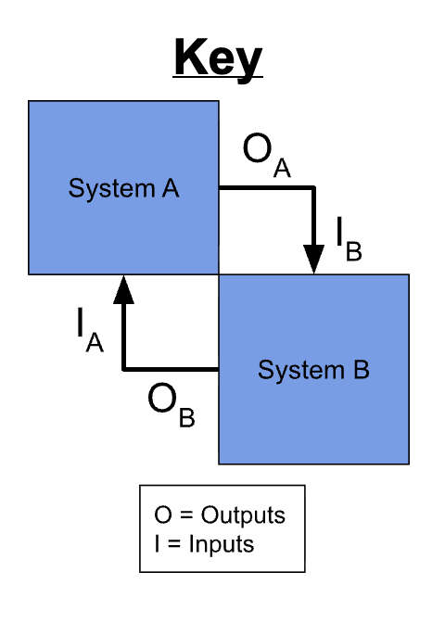
Figure 39: N^2 Chart

Inputs from External | Deployment from lander | Regolith and photon input for science observations | Command uplink from Earth via lander | PSR and illuminated thermal environment | Solar photon input for battery charging
 | ↓ | ↓ | ↓ | ↓ | ↓
[System Name] Interfaces
Internal Interfaces | Mechanical | Payload mounting, drill reaction support, alignment constraints | Wheel and actuator status, encoder feedback, mobility health | Conductive paths, chassis and motor temperatures | Motor and actuator power demand
Internal Interfaces | Payload mounting loads, sampling and drilling reaction loads | Payload | Science data packets, payload health status | Payload temperature limits, heat dissipation loads | Payload power demand and duty cycle
Internal Interfaces | Mobility, deployment, and drill commands | Instrument commands, timing, data handling | Command & Data Handling (CDH) | Heater commands, thermal monitoring logic, fault response | Power mode, switching, and load shed commands
Internal Interfaces | Survival heating, chassis and motor temperature control | Payload heater control and survival temperature maintenance | Temperature telemetry, overtemperature and fault flags | Thermal | Battery thermal conditioning and heater demand
Internal Interfaces | Motor and actuator bus power | Instrument and payload bus power | Avionics and radio bus power | Heater bus power and thermal controller power | Power
 | ↓ | ↓ | ↓ | ↓ | ↓
Outputs to External | Mobility and deployment status | Science data and payload health status | Command acknowledgement and rover telemetry | Temperature telemetry and thermal fault flags | Battery state of charge and power status

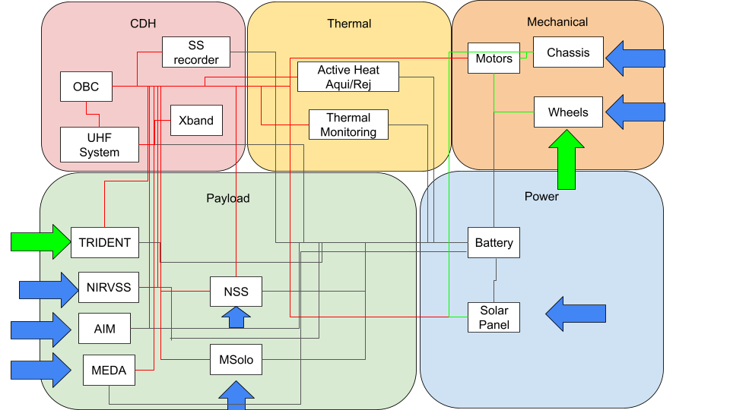
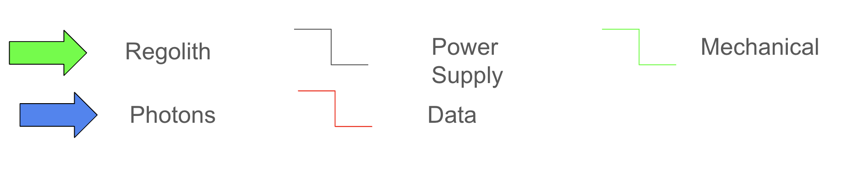
The Power subsystem delivers regulated electrical power to the Thermal, CDH, Payload, and Mechanical subsystems, and receives power demand and operational load requests from each subsystem relative to their needs. The Thermal subsystem also receives commands from CDH and provides thermal control to every other subsystem, including heater control, temperature regulation, and thermal status feedback. The CDH receives data from each subsystem sensor and provides control and directives to operate all other subsystems. It also manages command routing, data handling, storage, and rover-to-lander communications. The Payload subsystem provides drill loads to Mechanical, science data to CDH, temperature data to Thermal, and power demand to Power. It also returns payload health and instrument status data. The Mechanical subsystem provides structure for housing all subsystems, while also supporting mobility, wheel and actuator interfaces, payload mounting, and drill reaction support. External interfaces include deployment from the lander, commands from the lander, environmental interaction with regolith and photons, and science and health data sent to the lander for relay to Earth.

- Science Mission Plan

  - Science Objectives

The Lux Lunae mission provides a unique dual-benefit to NASA by addressing both high-level planetary science questions and the practical necessities of human expansion into the solar system.
- Lunar Volatile Acquisition and Studies
The mission addresses the Science Mission Directorate (SMD) goal of revealing the origin and delivery processes of inner solar system volatiles. By determining the isotopic composition (D/H, 13C/12C,15N/14N) of water ice and other volatiles, Lux Lunae acts as a stepping stone for the history of volatile collection in the solar system.
Future research will benefit from Alpha’s ability to distinguish between protosolar delivery (~20 ppm) and cometary delivery (>200 ppm). This provides data to model the conditions and processes of volatile emplacement, which is a key objective for understanding the evolution of terrestrial planets.
- Economic Evaluation of In-Situ Resource Utilization (ISRU)
While previous missions like LCROSS and LRO proved that water exists, Lux Lunae moves the objective toward understanding the "ore body" on a deeper level. NASA requires data at the decimeter scale to evaluate if water ice is localized in “economically viable” concentrations (ideally >2 wt% for water and >5 wt% for other volatiles). By providing vertical distribution data (depth-dependent abundance) via the Gamma rover, NASA can develop economic mining models and identify where ground material removal is most efficient. All in all, this will support a tight budget in numerous future missions.
- Direct Risk Mitigation for Human Surface Operations
A primary goal for the ESDMD is to use robotic reconnaissance to identify and potentially stockpile samples in advance of astronaut arrival. This ensures that when humans land, their time is spent on scientific activities rather than basic site prospecting. Lux Lunae also addresses specific Strategic Knowledge Gaps (SKGs) by quantifying dust concentration (≥10μg/m^3) and describing regolith geotechnical properties like bearing strength and stress. This is vital for assessing trafficability, ensuring that future human-driven rovers can safely navigate the polar terrain without mechanical degradation from regolith adhesion or soil failure.
- Moon to Mars: How NASA Can Move Forward
The mission aligns with NASA’s "Moon to Mars" objectives by validating technologies and operational capabilities, such as dual-rover coordination and subsurface "bite sampling", that have direct extensibility to harvesting resources on Mars, asteroids, or other planetary bodies.

  - Experimental Logic, Approach, and Method of Investigation

The Lux Lunae mission investigation is structured as a systematic, phased exploration of the lunar south pole, utilizing the complementary capabilities of the Alpha (SMD) and Gamma (ESDMD) rovers. The experimental logic follows a pipeline designed to identify and characterize lunar volatiles and terrain trafficability.
The mission is conceptualized into two science-driven phases. Phase I focuses on meeting STM-outlined science requirements and minimum success criteria, while Phase II utilizes developed Resource Maps to test specific theories of volatile emplacement and retention.
Operations are divided into three primary functional modes:
"On-Rails" Traversing: Used for efficient movement between high-priority Science Stations, defined as areas of collection within the PSR of 150 m^2. During these segments, rover speeds may not exceed 10 cm/s, and while instruments may remain active for safety and situational awareness, they are not required to meet measurement requirements.
Prospecting (Mapping): Conducted at a maximum speed of 10 cm/s. This mode allows for near-continuous data collection by the NSS, NIRVSS, and MSolo to map lateral volatile distribution and characterize the local environment (temperature, morphology, and mineralogy).
Subsurface Assay (SA): Stationary activities where the TRIDENT drill is deployed to perform vertical profiling of the regolith.

- Subsurface Assay

The primary method for ground-truthing orbital data is the Subsurface Assay (SA). This is achieved by rotary-percussive "Bite Sampling" in which TRIDENT utilizes 10-cm intervals to extract regolith. After each "bite," the drill is retracted to deposit a cuttings pile on the surface.
By sampling in 10-cm increments, the mission preserves layer stratigraphy, allowing Alpha’s MSolo to measure isotopic composition and Gamma’s NIRVSS to identify mineralogical features at specific depths.
To infer subsurface temperatures, the drill string pauses for 30 minutes at a depth of 100 cm. This allows the integrated temperature sensors to interface with the borehole floor, providing data to update thermal models of volatile retention.
Regarding PSR constraints, due to extreme power and thermal constraints, only one 1-meter subsurface assay is required within a Permanently Shadowed Region (PSR), though multiple shallow assays (down to 40-60 cm) may be conducted if resources allow.

- Environmental and Trafficability Assessment Approach

Unique to the Lux Lunae mission is the integration of human exploration reconnaissance via Rover Gamma.
Geotechnical properties are described by measuring grain size distribution and bearing strength/stress through TRIDENT force-displacement sensors during drilling. The Physical Properties Sensor (PPS) performs continuous quantification of dust concentration (≥10μg/m3) and illumination patterns. Finally, the Ames Imaging Module (AIM) utilizes FPGA-based architecture and LED illumination (350–940 nm) to provide high-resolution (2048x2048 pixels) visual context in total darkness, aiding in the interpretation of spectral data and rover attitude.

- Geostatistical Modeling

The investigation employs a tactical geostatistical modeling approach to optimize the traverse path in real-time. NSS data is converted into Water Equivalent Hydrogen (WEH) maps, while NIRVSS provides real-time water ice band depths.
For predictive models, methods such as Ordinary Kriging and Sequential Gaussian Simulation (SGS) are used to predict ice burial depths and temperatures between data collection points.
Additionally while the first two drill sites in a Science Station will be pre-planned, the third drill site is selected based on the prospecting data gathered during the traverse to maximize scientific return during the mission.

- Safe Haven Operations

The investigation accounts for the harsh lunar environment through “Safe Haven” operations, taken from the proposal of VIPER. Essentially during periods of no communication or extended shadow, the rovers hibernate in areas of persistent sunlight to maintain survival temperatures. Science activities only resume once direct-to-Earth (DTE) communication and solar power are restored due to needing to be controlled in near-real time.

  - Payload Success Criteria

The determination of mission success for Lux Lunae is dependent on the ability of the Alpha and Gamma rover payloads to meet the specific technical thresholds defined in the Science Traceability Matrix. For the SMD objectives assigned to Rover Alpha, success is primarily defined by the characterization of the isotopic composition of volatiles within the lunar polar regolith and PSRs. This requires the MSolo instrument to achieve a mass range of 1 to 100 AMU with an isotopic precision of approximately 1 to 3 percent. To successfully resolve the origin of solar system volatiles, the payload must maintain a 95 percent confidence level in measuring isotopic differences greater than approximately 15 ppm, particularly for Deuterium-to-Hydrogen ratios across the range of 20 ppm to 200 ppm. Furthermore, the Alpha payload must demonstrate the capability to detect hydration at the micrometer scale via NIR Spectroscopy with a sensitivity of at least 0.1 weight percent water equivalent.
The success criteria for the ESDMD objectives, managed by Rover Gamma, focus on robotic reconnaissance and the characterization of environmental hazards to inform future human surface operations. A success involves the NSS, which must achieve a detection sensitivity for Water Equivalent Hydrogen of 0.5 weight percent at a 3-sigma confidence level while the rover maintains a speed of 10 cm/s. Additionally, the Gamma payload must successfully describe regolith geotechnical properties, including grain size distribution and bearing strength, with a force resolution of plus or minus 5 kPa. To ensure future trafficability and astronaut safety, the Physical Properties Sensor (PPS) must accurately quantify dust concentrations of at least 10 μg/m3 and map illumination patterns across a range of 0 to 100,000 Lux.
Lastly, a success for both rovers involves the TRIDENT system, where success is defined by the ability to utilize rotary-percussive bite sampling to reach a subsurface depth of at least 1 meter and deliver representative samples for lateral soil analysis. The Ames Imaging Module integrated into the Gamma suite must provide situational awareness and surface morphology visualization with a minimum image resolution of 2048 by 2048 pixels. Full mission success is achieved when these quantitative performance requirements are satisfied across the designated landing zone (150 m^2) at coordinates -89.344°N, 115.686°E, providing the high-resolution data necessary to identify and potentially stockpile resources in advance of human arrival.

  - Testing and Calibration Measurements

The testing and calibration strategy for the Lux Lunae mission is designed to ensure the integrity of scientific data across all mission phases, from lunar transit to active surface operations. During the lunar transfer and orbit phase, the NSS will be activated while the rovers are at a distance of at least one Moon-radius from the lunar surface to acquire critical background calibration data.
Simultaneously, the MSolo and NIRVSS instruments on both the Alpha and Gamma rovers will undergo a series of checkouts and bakeouts intended to minimize potential contamination and facilitate the outgassing, or release of volatiles, of any materials that could interfere with high-sensitivity measurements.
Upon successful touchdown at the designated landing zone, a suite of post-landing checkout and calibration activities will be initiated before the rovers egress from the landing system. NIRVSS will perform a critical radiometric calibration of its spectrometer by utilizing a specialized reflectance target that is permanently affixed to the rover-lander interface assembly. This is done via Longwave Calibration Sensor (LCS) as part of the Bracket Assembly. The target provides a known baseline for radiance units, ensuring that subsequent spectral data gathered from the lunar surface can be accurately converted into reflectance values. Following this, MSolo will utilize its internal Calibration Gas System, which contains a known gas mixture, to verify spectral sensitivity and ensure the instrument is correctly identifying mass spectral peaks within the 1 to 100 AMU range.
The geotechnical and mechanical systems will also undergo verification to ensure operational readiness for subsurface investigations. Once the rovers have egressed and moved onto the lunar surface, the TRIDENT system will initiate a calibration sequence by deploying its drill footpad and applying sufficient force against the regolith to verify sensor alignment and mechanical integrity. While no active drilling is performed during this initial calibration, this step is needed so that force and displacement measurements used to determine regolith bearing strength and geotechnical properties are precise and reliable.
Further technical refinements involve the optimization of instrument performance based on initial characterization measurements conducted during the mission. For instance, MSolo peak widths are deliberately decreased to improve peak separation and minimize abundance sensitivity, supporting the mission's requirement for a relative standard deviation (RSD) of 1 to 3 percent. Additionally, the NIRVSS radiometer will continuously report a temperature derived from radiometer counts which will allow the science team to correlate localized surface temperatures with topography at scales of less than 5 meters. These overlapping calibration routines across the Alpha and Gamma payloads ensure that the Lux Lunae mission provides high-quality data that meets all defined science and exploration requirements while surviving the extreme temperature variations of the lunar polar region.

  - Precision and Accuracy of Instrumentation

The Lux Lunae mission utilizes a suite of high-precision instruments distributed across the Alpha and Gamma rovers to ensure that all scientific and exploration measurements meet the rigorous standards required by the Science Traceability Matrix. For the SMD objectives assigned to Rover Alpha, the MSolo mass spectrometer is engineered to operate across a mass range of 1 to 100 AMU with a mass resolution of at least 1000 m/Δm,. This instrument provides an isotopic precision of approximately 1 to 3 percent, which is critical for maintaining a 95 percent confidence level when measuring isotopic differences greater than 15 ppm. Such precision enables the mission to accurately characterize the Deuterium-to-Hydrogen (D/H) ratios within the 20 ppm to 200 ppm range, thereby distinguishing between protosolar and cometary volatile origins. Complementing this, the NIRVSS instrument on Rover Alpha features a spectral resolution of 10 nm or less and a detection sensitivity of 0.1 weight percent water equivalent, allowing for the precise measurement of volatile concentrations at the micrometer scale.
Rover Gamma, tasked with human exploration reconnaissance, relies on the NSS to prospect for hydrogen-rich materials with high accuracy. The NSS tubes are specifically sized to achieve a detection sensitivity for Water Equivalent Hydrogen of 0.5 weight percent at a 3-sigma confidence level while the rover traverses the surface at a speed of 10 cm/s,. To support future trafficability assessments, the TRIDENT system on Gamma is designed with a force resolution of plus or minus 5 kPa, which is necessary to accurately describe the regolith bearing strength and grain size distribution. Environmental monitoring is further refined by the proposed Physical Properties Sensors (PPS), which provides a dust detection limit of 10 μg/m3 and an illumination measurement range spanning 0 to 100,000 Lux, covering the full spectrum from total darkness in permanently shadowed regions to direct solar illumination.
The situational awareness and morphological characterization required for both science and navigation are supported by the Ames Imaging Module (AIM), which provides a high-fidelity image resolution of 2048 by 2048 pixels,. The integrated LED illumination system for the AIM operates across wavelengths from 350 to 940 nm, ensuring that visual data remains accurate and clear even within the absolute darkness of lunar craters. AIM’s TRL of 7-9 have proven its capability as well.
Temperature measurements across the mission are similarly robust, with Gamma's sensors capable of mapping surface and subsurface temperatures between -150 and 120 Celsius, which is essential for documenting the Moon’s extreme thermal environments. These strict performance specifications ensure that Lux Lunae’s collected data possesses the accuracy required to build reliable Resource Maps and Models for future lunar exploration.

  - Expected Data & Analysis

The Lux Lunae mission is designed to generate a multidimensional dataset that characterizes the lunar south pole across chemical, physical, and environmental domains. The scientific analysis will follow a rigorous pipeline which will transform raw telemetry into calibrated data products and predictive models for archival in the Planetary Data System (PDS). This data will be critical for achieving the mission’s goal of optimizing astronaut time and ensuring the safety of future human surface operations.
Data acquisition begins with the continuous collection of prospecting data by both Rover Alpha and Rover Gamma. The Neutron Spectrometer System (NSS) on Rover Gamma will provide time-stamped counts per channel, which are converted into neutron flux and then into Water Equivalent Hydrogen (WEH) maps. Neutron flux is calculated from the difference in thermal and epithermal neutrons detected by the Cadmium-wrapped detector and bare Helium-3 detector. This analysis is particularly sensitive to the top meter of the regolith due to relying on cosmic-ray-induced neutrons, allowing the team to identify areas of significant hydration (Hydrogen-rich). Simultaneously, the Near-Infrared Volatiles Spectrometer System (NIRVSS) will produce time-stamped spectra in radiance units, facilitating the real-time computation of spectral band depths. This allows for the immediate identification of surface hydration and mineralogical features, such as mafic minerals or hydrous phases, which will be mapped to provide geological context for human exploration sites.
The isotopic analysis conducted by Rover Alpha’s MSolo instrument represents one of the most complex data processing tasks of the mission. Raw data consists of time-stamped ion current intensities for each mass-to-charge ratio within the 1 to 100 AMU range, chosen to encapsulate a wide range of elements beyond those in volatiles. Scientific analysis involves converting these intensities into quantitative abundance values for various species, including water, methane, and carbon dioxide. To determine the origin of these volatiles, the team will analyze isotopic ratios, such as Deuterium-to-Hydrogen (D/H), with the precision necessary to differentiate between protosolar and cometary sources. Because initial measurements may be influenced by spacecraft outgassing, the analysis will utilize high-resolution scans that oversample the mass spectrum to calibrate spectral positions and ensure that the final derived products represent true lunar conditions.
Geotechnical and subsurface analysis will rely on integrated data from the TRIDENT drill and associated sensors. As the drill executes its bite sampling routine, it provides raw counts that are processed into physical parameters including rotation speed (rpm), rate of penetration (m/s), and torque (Nm). These measurements are used to derive the unconfined compressive strength (UCS) and general material strength of the regolith at 10-cm depth intervals. Furthermore, the analysis of subsurface temperatures via the sensors embedded in the drill string will provide thermal gradients.
Because the 30-minute thermal pause at 100 cm is insufficient for full thermal equilibrium, the science team will apply thermal modeling and correlation with laboratory results to infer the ambient regolith temperature, which is vital for understanding volatile retention and stability.
The synthesis of these datasets is achieved through advanced geostatistical modeling, which provides the predictive power required for human reconnaissance. The science team will first perform trend analysis to identify geospatial patterns across the NSS, NIRVSS, and MSolo datasets. Following this, simple linear regression analysis will be used to explore correlations between variables, such as the relationship between surface slope and subsurface ice concentration. To predict conditions in areas where the rovers have not traversed, the mission utilizes Ordinary Kriging and Empirical Bayesian Kriging (EBK). These methods examine the spatial relationship and redundancy of measurements to estimate values for ice burial depth and mineralogy across the candidate landing sites.
To quantify the uncertainty of these resource estimates, the team will employ Sequential Gaussian Simulation (SGS). This procedure generates 100 equiprobable realizations of the lunar surface, creating a probability distribution that captures the natural variability of the regolith. By aggregating these simulations, the Lux Lunae team is able to report the 10, 50, and 90 percent probability of resource presence, providing a more robust framework for strategic planning than simple interpolation. This geostatistical output will be combined with the Ames Imaging Module (AIM) data, which provides depth/disparity images and 3D panoramas, to create high-resolution Digital Elevation Models (DEMs) and hazard maps.
Finally, the mission’s environmental data, collected by the Physical Properties Sensor (PPS), will be analyzed to map dust concentrations and illumination patterns. This analysis will produce detailed outlines of the Permanently Shadowed Regions and surrounding areas in terms of brightness and surface temperature. All standard science data products, including calibrated spectra, mass traces, and geotechnical maps, will be prepared for archiving in the PDS within six months of mission completion. Higher-level products, such as the integrated Resource Maps and Resource Models, will be delivered subsequently to provide the scientific community and future mission planners with a comprehensive blueprint of the lunar south pole

- Mission Risk Management

  - Safety and Hazard Overview
Safety for Lux Lunae is centered on the survival and operation of the Alpha and Gamma rovers in the high-risk environment of the lunar south pole. The approach to risk identification involves a systematic review of environmental, mechanical, and operational hazards that could compromise mission success. The biggest environmental threats include extreme cold in the PSRs which can drop to -150°C, abrasive lunar regolith, and the lack of direct solar power. Not every risk gets the same attention, so the team will focus on any malfunctions that could affect the mission. To manage, the design focuses on advanced thermal insulation and robust power management systems. Mechanical risks are also considered, such as the potential for a rover to become stuck in soft regolith or suffer a mobility failure on steep, uneven terrain.
The team’s method for analyzing these risks involves prioritizing them based on the likelihood of occurrence and the severity of impact. Since resources are limited, the focus goes where the consequences of failure are highest. While lower-cost missions are often permitted to carry higher risks to demonstrate new technologies, critical systems (like the FERMI on-board computer), the communication link to Earth, and the power systems must maintain a level of reliability that can be defended during technical reviews. This information is used to establish safety margins, such as redundant sensors and extra battery capacity, so the rovers are not designed around “best-case” assumptions.
Planetary protection is a major safety and implementation concern, since the mission focuses on the study of lunar volatiles like water and hydrogen. Since the mission takes place in sensitive regions, strict protocols are to be followed to ensure that mission activities do not contaminate the lunar environment with Earth-based materials. These measures include utilizing low-outgassing materials and performing thorough cleaning of the TRIDENT drill and MSolo Mass Spectrometer prior to launch. Acknowledging these issues now during design is a lot cheaper than dealing with them on the lunar surface.

    - Risk Analysis

4.1.1.1 Automation Risks
Due to limited real time control and communication delays, the success of automated systems is critical to achieving the SMD and ESMD objectives. Thus, any calibration or synchronization failure in power distribution, data collection, navigation, FDIR, communication, or thermal protection could result in mission failure. R2, R4, R8, R19, and R20 identify these risks for different scenarios.
Given the low visibility and uncertain terrain of PSRs, the navigation and hazard avoidance systems are susceptible to faults, resulting in collisions, rover immobilization, or mission failure. To mitigate this risk (R4), an autonomous FDIR system will be installed on CDH-4, that includes a predetermined local recovery response within 30 seconds of fault detection, system reconfiguration to isolate the affected subsystem and maintain partial functionality, and safe mode. For example, if a communication blackout or signal degradation were to occur due obstructed line-of-sight communication from the topographical variation and limited Earth visibility from polar latitudes (R19), recovery actions would include transitioning to safe mode (reducing power to ≤5 W, park mobility, maintaining only required telemetry stored locally in non-volatile memory), executing a soft reset of the impacted subsystem, and sending a notification to the ground operator using the first available opportunity for communication. If a UHF connection to the lander is lost, the rover will halt in place and continue recording local data while repeatedly attempting to re-establish the connection, rather than blindly traversing without intention. These responses ensure power conservation, and reduce potential losses in telemetry, command capability, and mission effectiveness. Furthermore, the CDH will be programmed to continuously transmit health updates, including system status and location with timestamps, to the lander, providing the team with more information to troubleshoot in the case of a blackout. If an update is not reported within a predefined timeout period, the system will enter safe mode. If communication is not restored within a longer threshold, the system will enter a deep power-saving mode, only maintaining critical telemetry and operating conditions.
With a reliance on autonomous FDIR, there is also the risk (R20) of incorrect fault detection of certain anomalies, adversely impacting system health, and thereby resulting in escalation of failures or inability to recover from anomalies. Thus, a FDIR rollback and watch dog supervision mechanism similar to the methodology on Deep Space 1 will be implemented to continuously evaluate whether the system state improves after a recovery action and escalate or revert to the previous configuration accordingly. Moreover, a graded FDIR response will be implemented to prevent overreaction of benign anomalies rather than using a single-point decision-making structure. Each subsystem will have local health monitoring and threshold-based fault detection where sensor data is continuously evaluated against expected operational bounds and anomalies are validated across multiple independent data sources before a system wide recovery response is initiated. To prevent any false positives due to transient environmental effects, all fault detections must pass through a temporal validation filter, requiring persistence over a defined duration or multiple consecutive samples before escalation. This approach is consistent with the NASA fault management handbook. Additionally, the FDIR system will undergo extensive fault injection testing for both expected and unexpected fault scenarios to expose it to a wide range of anomalies and ensure it is capable of diagnosing and correcting faults beyond those explicitly anticipated during the initial design.
To mitigate the risk (R2) of on-board clocks and sensor calibration becoming out of sync due to extended operation in extreme thermal and radioactive environments, the mission will implement a centralized time synchronization protocol within the CDH system. All subsystems will operate on a shared mission elapsed time (MET) distributed from the onboard computer. Time synchronization will be maintained through periodic time broadcast messages from CDH to all subsystems, time stamped telemetry and command execution events with redundancy in key measurements, and clock drift monitoring and correction algorithms. If discrepancies in subsystem clocks exceed predefined tolerances, the CDH will automatically initiate time resynchronization procedures, ensuring that all operations remain coordinated. This is critical for sequencing commands, aligning sensor data, and ensuring correct execution of autonomous operations.
Given the moon's lack of atmosphere is susceptible to GCRs and UV radiation, there is a possibility for lunar dust to become temporarily charged and for photoionized particles to levitate up to 10 m from ground, penetrating electrical components critical to CDH and power systems, resulting in the loss of critical mission data and scientific integrity. Therefore, the mission will utilize radiation-hardened components, redundant memory storage, and electrical shielding paired with a component-level resilience plan to fully address this risk (R8). The FERMI OBC's dual-core LEON3FT processor architecture inherently includes processor-level hardware redundancy where if a fault occurred in one processor core, the second core can provide continuity of operation for the most critical functions of the OBC. In addition to providing inherent fault-tolerant capabilities, the NAND Flash SSR utilizes ECC (Error-Correcting Code) to identify and correct single-bit errors and to alert when multi-bit errors occur, thus preventing data loss due to radiation-caused bit flip failures without requiring a second physical storage unit. For communications, a UHF transceiver was selected with sufficient link margin so that small variations in antenna pointing or dust accumulation on the antenna surfaces will not result in a communication failure.
4.1.1.2 Thermal Control
With PSRs reaching cryogenic temperatures as low as 40 Kelvin, there is a risk (R3) of the thermal control system (resistive heaters, radiators, etc) failing to sustain operational temperatures, causing power losses within batteries, electronics and other temperature sensitive rover subsystems to not function properly, resulting in limited mission duration and data collection scope. Thus, a hybrid thermal control architecture with passive insulation and active heat acquisition/rejection will be implemented. The FDIR system will continually monitor and perform autonomous corrective actions to keep temperatures within operational constraints. Temperatures will be maintained through redundant temperature sensors, resistive heaters, and optimized MLI distributed around batteries, avionics, payload electronics, and critical instrument interfaces. Waste heat from avionics, for example, can be recycled through conductive routing to temperature-sensitive zones. Furthermore, thermal control will be run though a mode-based software where there will be temperature set points, allowable heater duty cycles, and power shed rules for solar charging, PSR survival and operations, and traversal between. During development, full-system thermal vacuum (TVAC) testing will be conducted across worst-case PSR and sunlit cycles, as well as operational temperature cycles representative to the mission.
4.1.1.3 Power Failure
Given that solar charging performance is sensitive to position, terrain obstructions, wind, and dust accumulation, the rover may be insufficiently charged for experiments into the PSRs and thus, unable to meet mission objectives or timelines. This risk (R17) can be reduced through dust-tolerant coated solar panels where panel current and battery charge trends will be continuously monitored against expected threshold charging rates. If the charge rate underperforms at a planned recharge site, the autonomous FDIR system will adjust the solar panels to an optimal angle before finding an alternate recharge waypoint. The rover will not attempt new science until a power threshold is met. Additionally, power generation will come from two separate sets of panels to reduce total failure of power generation. The individual arrays are set in parallel and series to allow for power generation when not being entirely lit. There are diodes that minimize power generation losses when the solar array is partially shaded, skipping cells that are affected. There are also diodes in place for reverse polarity protection, keeping the cells safe from frying in case of sudden negative voltage output. The battery is laid out in serials and parallel in case of failure in individual cells the whole battery pack continues to function. The PMU and BMS provide protection from both the input and output sides of the battery pack. PMU controls power generated from solar arrays and can shut off input to the battery pack when detecting damaging loads. Additionally, both PMU and BMS have reverse polarity protection built into the circuit. Unusual power draw will be picked up by BMS controller and specifically locate which electronic component is not behavioring as expected. After isolating and confirming malfunctioning load, the BMS controller can attempt to reset power distribution or temporarily shut off power to components. Data from BMS can be used to create predictive models on power consumption and if projected usage is no longer sustainable, it is possible to redirect operations to recover power and prevent stranding inside of PSRs.
This redundant power system will also help to mitigate the risk (R18) of depletion of onboard energy reserves before the rover reaches a charging location, and consequently, irreversible shutdown. Additionally, autonomous power monitoring with be implemented into the system where power distribution is limited by the battery reserve margin and the energy requirements for return as computed by the PMU/BMS; if the status of available power drops to the required return power, the rover will stop any operations and return to the charging station. Return paths will be optimized to the nearest charge capable area based on topography, shadows, and illumination angle. Each subsystem will have strict energy budgets for operation and return, as well as a safety margin. Considering R18 is a high risk, it will be especially critical for the mission to utilize energy efficient components.
4.1.1.4 Mechanical Failure
Given PSRs have more extreme terrain composed of loose, abrasive rocks and dust coupled with steep slopes and pits, there is a possibility for the rover to slip, sink, or be unable to traverse areas with extreme conditions, causing tire wear and mechanical strain on the rover, minimizing mission scope. To address this risk (R7), the rover will have hard limits for slope, sinkage, and tilt, with the ability to pause, back up, or reroute before those limits are exceeded. The FDIR system is responsible for detecting any difficulty passing an obstacle and identifying alternative ways to proceed through the lunar terrain safely and efficiently. Additionally, failure tolerance can be observed with a multi-wheel system, so that in case of a wheel malfunction, the remaining wheels can continue to support the rover’s weight and allow it to continue moving. This way, a minor mobility issue does not lead to a complete mission failure. Payload mass constraints and increased power input required will have to be factored into this decision.
Given the rover is subjected to thermal cycling (between PSRs and solar charging regions) and continuous mechanical loading (from uneven terrain and drilling operations), there is a possibility for cumulative material fatigue and microfracture formation, resulting in deformed mounting interfaces, degraded structural integrity of the rover chassis, and eventual mission-ending failure. This risk (R16) can be reduced through materials selection, interface design, and mission operations constraints. Only materials with compatible coefficients of thermal expansion at critical bolted and bonded joints will be used. Validation of individual components will be performed through stress analysis and fatigue life modeling, while the full assembly will undergo accelerated thermal cycling and vibration tests. Operations will minimize unnecessary PSR–sunlit transitions, forbid high-load operations such as drilling immediately after a major thermal transition, and require a thermal soak window before sampling begins.
Exploring unknown lunar composition where there may be compacted regolith may cause drill jams, stalls or failure to penetrate the required 1m depth, resulting in diminished sampling capability from TRIDENT, thus failing to collect critical samples to fulfill the SMD and potential instrumentation damage. Acceptance of this risk (R5) is justified because the scientific return is still achievable with partial sampling and TRIDENT has demonstrated effectiveness at penetrating compacted regolith. There is less likelihood of stalls given that TRIDENT utilizes axial percussion and rotational cutting to break up material and drill through the surface rather than relying solely on shear forces. Nevertheless, in the event that a stall is detected, the autonomous FIDR system can preserve instrument integrity by enabling adaptive drilling modes (e.g., incremental progression of depth), and if the stall still persists beyond the torque and penetration rate threshold, terminate the attempt, flag the site as partially sampled, and sample the next site. To reduce mission risk, volatile sites with the lowest resistance will be prioritized before sampling the higher value sites with more resistance next only if the first sample succeeds.
4.1.1.5 Contamination
Given the moon has loose surface terrain coupled with frequent dust storms, dust accumulation can coat the spacecraft, which can block, clog, and erode surfaces, gears, radiators, optics, and solar panels, reducing rover cooling capability, traversal, steering, power generation, and data collection. This risk (R6) can be managed through dust-resistant coatings, sealed joints, and shielding of critical surfaces (e.g., radiators, gears, etc). Cameras and sensors will be placed behind replaceable or cleanable covers and elevated on the rover, if possible, to minimize exposure to a dust plume. Dust tolerant components will be prioritized in development. Steering input, panel current, and image quality will be monitored so that degradation is tracked before it causes a failure. Residual risk is accepted because dust can be managed but not eliminated on the Moon.
Given volatile compounds are sensitive to temperature and changes in the environment; and drilling operations may introduce heat or foreign material to the volatiles; samples may sublimate or become contaminated, reducing data collection. To mitigate this risk (R1), the drill bit temperature will be monitored, and FDIR will pause operations when thermal equilibrium is not met, reduce energy when entering likely volatile-rich layers, and maintain short dwell times. Samples will be collected and transferred through a thermally insulated sampling path and into sealed containers within a fixed duration to minimize exposure time to ambient conditions. Every sample will carry metadata including a time stamp, thermal exposure history, and baseline conditions. Any risks (e.g., contamination, thermal instability) detected during data collection will also be recorded. Additionally, no external surfaces will be reused for sample handling, internal pathways will be regulated and cleared before a new sample is collected, and previously disturbed sites will not be revisited. This will also help to reduce the risk (R12) of contaminating lunar environments, ensuring COSPAR Planetary Protection Category II and NPR 8020.12D guidelines are met. Furthermore, the mission will use low-outgassing materials and avoid lubricants near sampling interfaces. Prior to launch, the spacecraft will undergo vacuum bake out; the drill, sample path, and storage chambers must meet defined cleanliness thresholds and be documented; and compliance reviews will be conducted.

4.1.1.6 Programmatics
Risks (R10, R11, R13-15) leading to potential cost growth, scope reduction, schedule delays, and even missed launch windows can be mitigated through robust project management and systems engineering. Cost risks (R14) will be managed through the use of margin allocation, periodic cost and schedule reviews, and defined trigger points that initiate descoping or reallocation strategies if thresholds are exceeded. Given the supply chains for specialized components such as radiation-hardened electronics, space-qualified batteries, and precision instruments are limited and subject to delays, there is a possibility of late delivery or unavailability of critical components. This risk (R15) will be watched carefully with long-lead items identified, ordered early, and contingency plans implemented (e.g., alternative vendors or acceptable substitutions) prior to a shortage. Any lower TRL payload will have explicit exit criteria in environmental, interface stability, and repeatable performance to reduce mission risk (R10) prior to launch. Additionally, redundancies will be implemented to safeguard these technologies. Furthermore, integration and test risks associated with limited facility availability (R13) will be mitigated through advanced scheduling, parallel test campaigns where feasible, and the use of high-fidelity simulations to supplement physical testing. While there are limitations in simulating lunar PSR conditions on Earth (R11), dominate physics (vacuum, thermal cycling, communications emulation, terrain mobility) can be tested separately to a higher extreme than is expected and safety factors can be applied to design targets and FDIR set points to err more on the side overperformance.

    - Failure Mode and Effect Analysis (FMEA)

Figure 40: FMEA

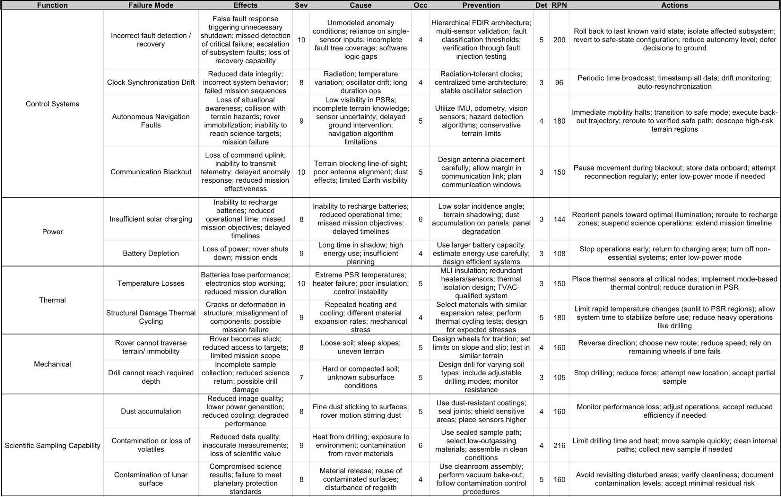

4.1.3 Personnel Hazards and Mitigations

4.1.3.1 Cutting Hazards
Cutting Hazards often occur during machining operations that involve CNC machine cleanup and the handling of sharp tools. The cleanups happen because of the loose metal chips that occur during the manufacturing phase when components are being formed and finished. Being exposed to flying debris without the proper precautions can lead to severe cuts and eye injuries. The main way of reducing this risk is for the personnel on the machine floor to be wearing long sleeves and pants along with protective equipment like safety glasses and steel-toe shoes constantly. Additionally when doing a cleanup, it is important to use brushes and also be wearing cut-resistant gloves to ensure the metal chips do not catch your skin.² Always using the machine guards during operation is also a must to ensure that there is no flying debris. Proper training will be a requirement to work on the machine floor to further reduce injury.
4.1.3.2 Entanglement Hazards
Entanglement Hazards happen with machinery, such as a CNC lathe, where loose clothing or hair is caught along the rotating components. These can cause life-long injuries and can even lead to death because it pulls a person's body into the machine. Strategies to mitigate this is a strict enforcement of prohibiting loose clothing and jewelry being worn on the machining floor, as well as, requiring long hair to be tied back to ensure the safety of the personnel. There will be training of the safety measures that will be required of every personnel to take. Along with all these safety measures there will also be required emergency stop mechanisms readily accessible to quickly shut down the machine if an incident does occur.
4.1.3.3 Thermal/Burning Hazards
Thermal and Burning Hazards occur from operations like welding or soldering in where it uses equipment that melts materials for use. They more rarely occur as well in potential equipment fires during manufacturing which can cause irreversible damage to people. Being exposed to these temperatures can result in varying levels of burns that can be life-threatening.³ It can even cause damage to the equipment which will drive up cost for the project. Personnel will be required to wear heat-resistant gloves and clothing that will not catch on fire when handling the equipment. Fire extinguishers will also be readily available in all work areas to ensure a quick response to a fire. Personnel will be trained on proper safety on fire prevention to protect the personnel as well as the equipment.
4.1.3.4 Electrical Hazards
Electrical Hazards such as high voltage electric arcing occur when electric current is sustained outside of its normal environments, such as conductive cables, and instead goes through something like ionized air. This “ionized air” is plasma, conductive and gas-like, and can form due to high voltage, moisture, damaged insulation, or other factors.⁴ The arc typically acts in this environment across a small physical gap in electrodes, which are common in electrical engineering. Electric arcs can create intense light, and heat up to three times that of the sun, or around 19,400℃; this is known as an arc flash.⁴ These arcs, when controlled, are used in furnaces and welding, but are extremely dangerous and could cause extreme third-degree burns, ignite clothes, and even vaporize and melt materials nearby if occurring uncontrolled.⁴ Arc shocks and flashes can be avoided by de-energizing high voltage equipment before working with it, using insulated tools, and following industry standards, such as NFPA 70E, for avoiding electrical hazards.⁴ In order to protect personnel, arc-rated Personal Protective Equipment (PPE) should be worn.
4.1.3.5 Heavy Equipment Hazards
Heavy Equipment Hazards are seen during the lifting of large objects during the assembly or manufacturing phase. These are seen with the use of a forklift or even physically lifting said components. Improper lifting form or loss of control during these transportations could result in damages to components or risk injury to the person doing the lifting. To reduce these risks, workers must follow the protocol of proper lifting like lifting in a group for large objects. For forklifts, it will be important that the workers using them are properly certified to be allowed to use it. Pathways will also be kept clean to make sure colliding with objects is kept to a minimum.
4.1.3.6 Trip and Slip Hazards
Trip and Slip hazards can be seen all across the workplace. The manufacturing floor can have oil spills and scrap materials that have not been cleaned, tools and materials may have not been returned, or simply just having a dirty work surface. These turn into hazards for everyone around them by causing falls and sprains to the personal walking over them. To reduce these risks there will be housekeeping rules that will need to be followed by the personnel in the area. These rules will include the cleaning of spills immediately, tools and materials put in their proper places when they are done being used, and having inspections done to make sure everything is up to code. Also requiring all personnel to use non-slip shoes along with non-slip flooring should make it even better for reducing the risk of falling. This will ensure that the safety of the personnel is being taken care of, as well as, making sure they are efficient.
4.1.3.7 Human Issue Hazards
Disagreements between team leads and/or subsections of the team could affect mission stability. Team leads and programmatics collaborate often in the office environment, and any disagreements, if not handled properly, could lead to conflict, resentment, and unnecessary delays.
A disagreement with a team leader, whether reasonable or not, could even lead to retaliation and being fired from the mission. If this person were an essential component of the mission, finding their replacement could very well negatively impact the mission schedule.
Members of the engineering, programmatics, and science subteams can also have disagreements on the directions in which they want to go with mission components, especially if said components are dependent on each other. These disagreements, if brought to entire subteam levels, could cause major delays in the mission, and, if not addressed immediately and fairly, can lead to poor performance from the interacting teams, people resigning from their jobs, and even major delays in the schedule.
Workplace harassment, often in the form of bullying based on race, gender, religion, or other personal traits, could have serious adverse effects on individuals and on team performance as a whole.
These disagreements and harassment can be avoided, or, if needed, resolved by ensuring constant and clear communication between teams and individuals about issues, addressing said issues promptly and seriously. When hiring supervisors and team leads, they should be screened to ensure they are capable of impartially addressing issues, implementing disciplinary action as necessary and appropriate, and establishing fair resolutions. If an issue escalates to a mission-compromising level, a board should be formed to hear both sides of the issue and come to any resolution(s) on how to move forward.
Excessive work hours can lead to fatigue for personnel, which in turn will cause poor performance and threaten the integrity of the mission and schedule. Work hours should be tracked clearly and team members should not be allowed or expected to work excessive overtime hours.
4.1.3.8 Chemical Hazards
Chemical Hazards occur from exposure to toxic fumes from hazardous materials. This can be seen from adhesives, epoxies, or any other dangerous chemical. Inhaling these chemicals can lead to respiratory issues that can damage your lungs permanently. Having it come into contact with your skin can lead to irritation or even chemical burns that can leave long-term health effects if not dealt with quickly. To prevent this, it will be assured that the personnel using these materials are wearing proper clothing with gloves and masks. Any material that releases dangerous fumes will be kept in an area with good ventilation along with a fume hood if possible. It will also be made sure that proper storage and disposal of these chemicals are being done currently to ensure safety.

- Activity Plan

  - Project Management Approach
An estimated 200 workers are needed for the entire Lux Lunae project, split among four main divisions: Engineering, Science, Programmatics, and operations. Each mission phase has a different level of staff. During active design, fabrication, and integration, Phases C and D have the highest amount, whereas Phase E surface activities see a shift toward Science and Mission activities workers.
Engineering is the largest division, comprising of approximately 100 engineers organized into dedicated subsystem teams. Each subsystem team operates semi-autonomously but must adhere to system-level requirements established at PDR. Subsystem teams include Thermal Management, Power & Electrical Systems, Command and Data Handling, Mechanical Systems, and Communications. Each team maintains its own internal lead responsible for day-to-day technical decisions. Cross-subsystem coordination is managed through recurring Systems Engineering Reviews and interface control working groups. During Phases C and D, engineering staffing is at max capacity. Engineering support is reduced during Phase E, with a smaller team supporting mission operations and anomaly resolution.
Compared to team 14's three-person science subteam, science now has 30–40 members. Each major payload element (MSolo, NIRVSS, TRIDENT, NSS, AIM) has a specialized instrument subteam, and scientists are arranged by discipline, planetary geology, astrobiology, and spectroscopy. Planning, data interpretation, and science return evaluation are the responsibilities of each instrument subteam. During Phase E, a different Rover Operations team chooses drilling and sampling locations, plans daily rover activities, and interprets incoming data in real time. Phases C and D see a decrease in science staffing, which achieves full capacity when surface activities begin.
About thirty personnel are needed for Project Management, Mission Assurance, and Procurement on the Programmatics team. Each subsystem team is given a budget reserve, subject to Programmatics approval, and this division has centralized budget responsibility for the whole mission. In order to track schedule, cost, and technical performance versus baselines, mission assurance specialists are integrated into every phase. During Phases C and D, procurement is in charge of overseeing long-lead item ordering, vendor relations, and contract compliance.
About fifty employees are needed for Mission Operations, which collaborates closely with the Science division. Flight operations, surface navigation, and raw science data processing are all included in this area. During Phase D for operations preparation training, Mission Operations manpower increases, and by the time of the lunar landing in 2031, it is fully staffed.
Each division lead has control over their allotted budget reserve according to the framework of budget authority, with Programmatics handling final approval and reallocation decisions. At each mission phase gate, formal System Engineering Reviews and Design Reviews are used to cooperatively make important technical and programmatic decisions.
The entire mission team structure at the subteam level is shown in the organizational chart below.

Figure 41: Mission Team Organizational Chart
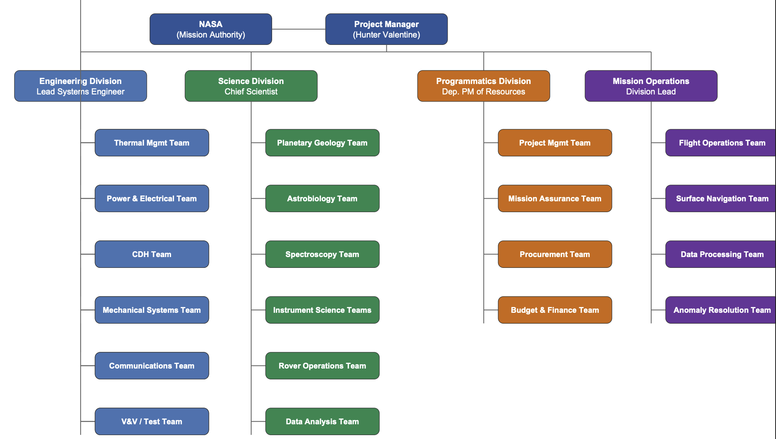

  - Mission Schedule
    - Schedule Basis of Estimate
The Schedule Basis of Estimate defines the ground rules, assumptions and drivers that underpin the Lux Lunae mission schedule. This Basis of Estimate provides stakeholders with full transparency into how the schedule was constructed, what constraints shaped it and what estimation strategies were applied. All Pre Phase A, Phase A and Phase B activities are treated as sunk time and are excluded from this estimate consistent with customer direction.

Ground Rules
The Lux Lunae Project schedule reflects Phases C through F of the NASA project lifecycle described within NPR 7120.5E. Customer direction excludes all Pre Phase A, Phase A and Phase B work. Those phases’ duration are excluded from cost estimation.
Both the System Integration Date (December 1, 2030) and the Launch Readiness Date (February 1, 2031) are fixed, customer-directed dates that serve as anchors for backward planning all upstream milestones. Duration estimates for each phase were derived using an analogous comparison to similar NASA robotic lunar missions (VIPER & CAPSTONE). Those estimates were then used to perform backward planning from the two anchored dates (System Integration and Launch Ready Dates).
A 10% schedule contingency has been added to each phase as recommended within the NASA Schedule Management Handbook for projects at this level of development. Approximately one week before each corresponding Life Cycle Review, a Standing Review Board will be convened consistent with typical NASA Robotic Mission SRB lead times.
Each KDP is given a two week window to make decisions on an SRB after the phase gate meeting associated with that SRB based on the Phase Gate Process of NPR 7120.5E. The decision authority for the decisions C, D and E for the Lux Lunae mission will be located at NASA Headquarters in Washington D.C. The SMD Mission Directorates' Associate Administrator serves as the decision authority for those types of missions. It is assumed, based on customer input, that each of the three meetings would take approximately 5 working days.
Budgeting for the Lunar Surface Vehicle System is limited to $150 million for Phases C-F. Launch vehicles, transit systems, and Entry Descent and Landing Systems are procured and managed by third party contractors and are therefore excluded from this plan.

Assumptions
Pre-Phase A, Phase A and Phase B have been successfully completed, and the PDR marks entry into Phase C. Its assumed funding will be available on an uninterrupted basis upon the commencement of each phase of this mission. Items subject to long lead procurements like the TRIDENT drill, the MSolo mass spectrometer, the Argotec FERMI On-Board computer, the Spectrolab solar panels and the EaglePicher battery pack shall be ordered within the first sixty days after initiating Phase C or no later than June 2026, so as to avoid integrating them during Phase D. The Launch Readiness Date is a firm customer imposed constraint independent of any orbital alignment requirements. Lunar transfer opportunities occur about once every two weeks. Therefore, based on customer direction, February 1, 2031 was chosen as a program level fixed date and not as a planetary window constraint. If this date were missed, it would be necessary to wait for the next viable launch opportunity and would result in mission cancellation.
Environmental Qualification Testing shall be performed at JPL in Pasadena CA, using the 25-foot Space Simulator for Thermal Vacuum Testing (TVT), Vibration Testing (VT) to qualification load levels, Electromagnetic Interference/Electromagnetic Compatibility (EMI/EMC) Testing, and Acoustic Testing.
The SRB Review Cycle for this Mission Class is estimated to be one week per session. This is similar to the level of scrutiny used for a Small Robotic Lunar Mission, but less than the full life-cycle SRB Review Cycles typically utilized for Crewed Missions.
Both Rovers shall use identical Hardware Architecture throughout Phases C & D. Utilizing identical Hardware Architecture for both Rovers reduces Schedule Risk since the same designs, Tooling, Test Methods, and vendor relationships can be applied to both Rovers. Describing a Three-Rover Mission to a Two-Rover Mission due to Falcon 9 Payload Volume Constraints did not introduce any Major Schedule Delays nor Unplanned Redesign Cycles nor any Organizational Changes as determined by the Mission Descope Assessment completed prior to completing the MDR. All relevant design inputs are assumed to be fixed with regards to mission surface location at the rim of Shackleton Crater prior to completion of the Critical Design Review.
Drivers
Beginning in Phase C, the development of science instruments (both the TRIDENT rotary-percussive drill and the MSolo miniaturized mass spectrometer) represent the main critical path drivers. Each instrument has reached Technology Readiness Level 6 and needs to undergo further qualification testing as well as lunar environmental acceptance tests at the instrument level prior to being integrated into the flight rover chassis. In terms of procurement and qualification timelines, the TRIDENT drill is expected to take approximately 18-24 months from when Phase C begins. Additionally, the MSolo instrument can be expected to take 20-24 months to develop within NASA's own facilities at the Kennedy Space Center. Either way, delays associated with qualifying one or both instruments will result in delayed Phase C and subsequently reduced Phase D integration schedules. Component-level verification and confirmation of functionality is required for each of the CDH subsystem components (Argotec FERMI On-Board Computer, BAE Systems NAND Flash Solid-State Recorder, and NanoAvionics UHF Transceiver) before rover-level integration can occur. An in-house developed SpaceWire cable harness, created by employees at the Goddard Space Flight Center Harness Fabrication Facility with a lead time estimate of 8-12 months, must also be delivered to the JPL integration facility before mechanical assembly can begin. Delays in delivery of either the CDH components or the SpaceWire cabling harness will ultimately affect the availability of time for Phase D integration. The Critical Design Review is the most important formal review because it verifies that all design work is completed for each subsystem, all manufacturing drawing releases are completed, and all TBDs/TBRs from the MDR/PDR are formally closed. If a major redesign action occurs at CDR, Phase C will likely be extended which reduces the amount of time allowed for Phase D integration. It is necessary to maintain the System Integration Date of December 1st, 2030 so that sufficient launch preparation time can be made available at Kennedy Space Center. Delaying this date increases the likelihood that the February 1st, 2031 LRD will not be met and therefore could cause a minimum of several month delays in conducting lunar surface operations due to lack of suitable subsequent launch opportunities; if not met, could be used as justification to cancel the mission.

    - Mission Schedule
This mission concept uses two identical rovers. They’ll be operating independently on the lunar surface. Each rover has a mass of 150 kg and uses the same design and payload configuration. Using identical rovers simplifies development because the same architecture can be built twice.
The mission also incorporates formal NASA lifecycle review gates, including Key Decision Points (KDPs), which serve as major internal milestones where the Decision Authority evaluates technical maturity, cost, and schedule readiness before authorizing progression into the next phase of development. These KDPs are placed at phase transitions throughout Phases C, D, E, and F to ensure mission control.
Additionally, independent Standing Review Boards (SRBs) are included at key lifecycle milestones. These SRBs consist of experts who provide assessments of mission readiness, risk posture, and technical performance. Their evaluations support decision-making at major reviews such as SRR, PDR, CDR, and TRR, ensuring that progression through each phase is validated technically.
The mission schedule laid out here begins after the Preliminary Design Review (PDR), which marks the end of Phase B of the NASA project life cycle. Earlier phases (Pre-Phase A through Phase B) were assumed to already be completed. Because of this, the schedule for this mission focuses only on Phases C through F of the NASA lifecycle (NASA Systems Engineering Handbook).
To improve alignment with mission standards, all tasks in the schedule are organized under phases (Phase C, Phase D, Phase E, and Phase F). This structure allows each activity to be associated with its corresponding stage, making reviews more transparent.
The entire schedule is built around a Launch Readiness Date (LRD) of February 1, 2031. Lunar missions depend on orbital alignment between Earth and the Moon. If the mission misses this launch date, it may have to wait for another launch opportunity, which could cause major delays. To prevent this, the schedule was created by working backwards from the launch date to make sure enough time was available for design, fabrication, integration, and testing. NASA schedule planning typically organizes missions around major milestones like this (NASA Schedule Management Handbook).
Similar robotic lunar missions were used as references to estimate a more realistic timeline. These include CAPSTONE, Lunar Trailblazer, and the VIPER rover. For example, NASA’s Lunar Trailblazer mission launched on February 26, 2025 and required a cruise phase of about four to seven months (Lunar Trailblazer Mission Overview).
In addition to KDPs, the schedule includes required Standing Review Boards (SRBs) that occur at major technical milestones. These SRBs are scheduled prior to or alongside key lifecycle reviews such as SRR, PDR, CDR, and TRR to ensure that systems are mature independently before approvals are made. Each SRB is treated as a formal schedule event with defined start and end dates and associated travel requirements to support review participation. All milestone dates are set, including both internal KDPs and independent SRBs, used to validate technical readiness.
The CAPSTONE mission also provided a useful comparison. CAPSTONE is a 12U CubeSat launched on June 28, 2022. Instead of taking a direct path, CAPSTONE used a ballistic lunar transfer trajectory that took about four months to reach the Moon. This shows how trajectory design can affect mission timeline (CAPSTONE: A Summary of a Highly Successful Mission in the Cislunar Environment).
Schedule risks are further mitigated by incorporating SRBs and KDPs as formal decision gates throughout the mission lifecycle.
After the Preliminary Design Review (PDR), the mission enters Phase C, where the final spacecraft design is completed. After a year into this phase, a Critical Design Review (CDR) confirms that the design meets all mission requirements. Then, we move to Phase D, where assembly and testing happen to ensure all components work together.
Environmental testing is important in Phase D because the spacecraft must survive the launch and then operate in space. Some common tests include vibration testing (to simulate launch forces), thermal vacuum (to simulate space conditions), and acoustic (to simulate launch sound levels) (VIPER Environmental Testing Documentation).

Figure 42: Lux Lunae Mission Schedule
Milestone | Estimated Date
Preliminary Design Review (PDR) | Apr 19, 2026
Critical Design Review (CDR) | Jun 1, 2028
Subsystem Fabrication Complete | Dec 31, 2029
System Integration Begins | Jan 1, 2030
Environmental Qualification Testing | Jun 1 – Oct 1, 2030
System Integration Readiness | Dec 1, 2030
Launch Readiness Date | Feb 1, 2031
Surface Operations Begin | Feb 2, 2031
The spacecraft has to reach System Integration Readiness by December 2030 to allow enough time for final launch preparation before the LRD. After launch, the mission enters Phase E (Operations), where rovers conduct scientific observations on the lunar surface. Finally, the mission enters Phase F (Closeout).
Schedule risks are much more likely during testing, because there may be issues identified that may require design changes. For example, the CAPSTONE mission experienced delays due to development challenges, extending the time to about 33 months (CAPSTONE: A Summary of a Highly Successful Mission in the Cislunar Environment).

Figure 43: Gantt Chart

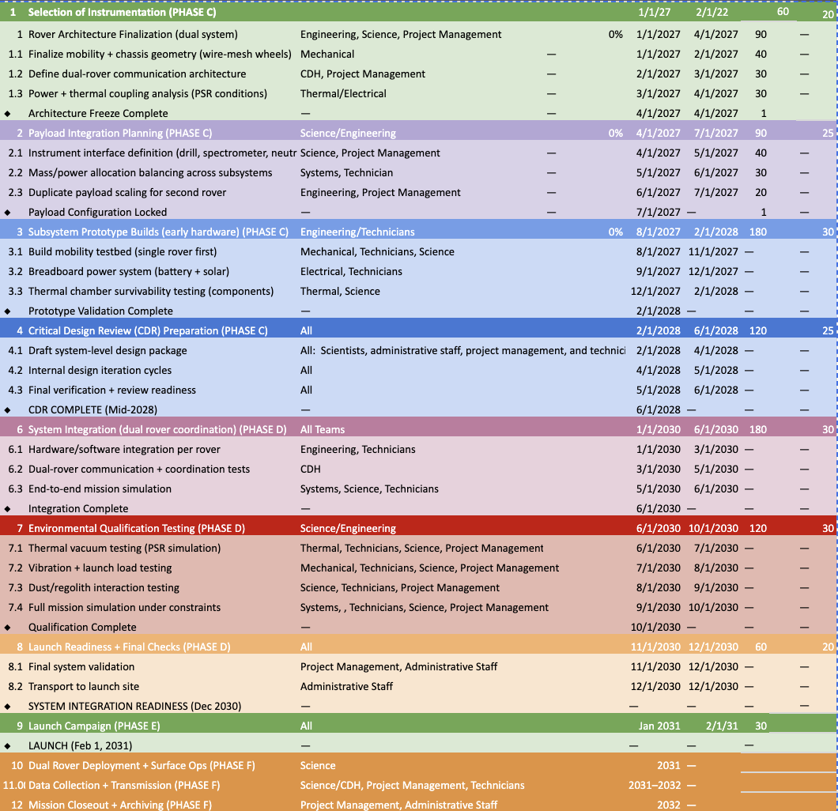

  - Budget

    - Budget Basis of Estimate

Ground Rules

The cost estimate for the lunar surface vehicle system (LSVS) includes all aspects of the LSVS for phases C-F of the NASA project lifecycle and represents only that portion of the mission costs to be covered by the customer. Costs associated with launch vehicles, transit systems and entry descent landing systems (EDL) will be separately managed by independent contractors. Therefore, these costs have been excluded from this cost estimate. The budget cap for the mission is established at $150 million in FY 2026 dollars per the Mission Task Document. All future-year expenditures will be increased using the NASA New Start Inflation Index to account for the effect of inflation over the entire duration of the mission. A contingency reserve of 15% to 20% has been added to each subsystem cost estimate and to each major category of programmatic costs to address the risks associated with technology development. Currently, this reserve is being kept as a flat percentage across all subsystems. However this margin will be allocated to specific identified risks at the CDR.The two-rover design will provide a reduced learning-curve cost advantage due to the fact that the second rover will benefit from experience gained while developing the first rover. This cost advantage may approximate 10% to 15%. Costs related to components that are currently at or below TRL six will need to include additional development funds during phase C (Science Payload). These costs will also be reflected in the Science Payload Direct Cost Estimate. All costs incurred prior to phase A, during phase A, and during phase B were considered "sunk" costs and therefore were excluded from this estimate.
Assumptions
A "bottom-up" estimating approach has been used to develop cost estimates. Costs were developed individually for each component, grouped into sub-systems, and then added together to produce the overall cost estimate for the entire mission. For those cases where there was insufficient detail regarding pricing for individual components, comparable mission information from previous missions (VIPER, CAPSTONE, Mars 2020, and Lunar Trailblazer) was compared to provide an analogous cost basis. Additionally, differences in component sizes, complexities, and operation environment related to the lunar PSR operational environment were accounted for. Estimates of labor hours required to accomplish the necessary work (design, fabricate, assemble, integrate and test) for each of the various sub-systems were developed and multiplied by the appropriate NASA labor rate(s). Rates are consistent with the guidelines established by NASA Systems Engineering. Contractual/vendor costs are based upon publicly available pricing information; however, since there were no actual vendor quotes provided during this initial development phase, contractual/vendor costs were based upon analogously priced contracts. Estimated costs for environmental testing facilities located at JPL were made utilizing historical use rates of these facilities for NASA sponsored spaceflight missions. Costs for mission operations were derived from staffing levels previously utilized for other small robotic lunar missions having a similar surface duration of approximately two-three lunar days. Salary amounts for personnel involved in the mission were derived from the L'SPACE Mission Task Document, and include; scientist/engineer salary = $80,000/year; technician/administrative staff salary = $60,000/year; and project manager salary = $120,000/year. Employee-Related Expenses were computed at 28% of employee salary. Future-year personnel costs are escalated annually based on the embedded inflation rates contained within the NASA budget template. Airfare travel costs are estimated using City-Pair Program airfares; GSA Per Diem expenses; and FedRooms Lodging rates that comply with Federal government travel standards as directed in the Mission Task Document. Eliminating the third rover reduced the recurring hardware costs associated with one full rover unit (one flight instrument package; one chassis assembly; one battery pack; one solar array; and one CDH system), reducing the total cost estimates of the direct costs of each of the affected sub-systems. These cost reductions are reflected in the current budget. The elimination of the third rover resulted in no unforeseen redesign cycles or organizational changes being required; therefore, none of the mission requirements were impacted. The two remaining rovers (Alpha and Gamma) continue to support unique scientific objectives. Alpha will be dedicated to supporting Science Mission Directorate (SMD) goals; while Gamma will be dedicated to supporting Earth Science Division Mission Directorate (ESDMD) goals. Each of the remaining rovers also retains its own 15 kg science instrumentation mass allowance due to the removal of the third rover. It is assumed that sufficient funding is available and continuous at the beginning of each mission phase. Primary Contractors are assumed to have secondary vendors who are qualified to meet their delivery schedules should their primary vendor become unavailable. Associated schedule and/or cost impacts resulting from any delays/cancellations are included in the contingency reserves incorporated into each phase of the mission. There will be 8 trips to Washington DC over the next three years for Key Decision Points (KDPs) C, D & E. Five day trips are anticipated to be taken by 5 people/trip. Approximately 20 people will make a single round-trip journey to Orlando FL for launch travel that will last about 5 days.
Drivers
The most expensive cost factor throughout the mission lifecycle will be Phase C. The reason for this is that it is where there are the largest amounts of people and space in activities like Final Design, Long Lead Procurement, Instruments Level Qualification Testing, and Subsystems Fabrication. Although the dual-rover fabrication method is likely cheaper than the three-rover method of construction, it still requires two sets of flight hardware which includes instruments, chassis assemblies, battery packs, solar arrays, and CDH systems. Therefore, the recurring hardware costs for all the above mentioned items will be one of the biggest cost drivers throughout Phases C and D. The Thermal System is also much more costly than typical planetary surface missions because a hybrid passive and active thermal control system is necessary to satisfy the requirements to operate in PSR environments as cold as 40 K. Examples of components included within this Hybrid Passive and Active Thermal Control Architecture include multi-layer insulation, Kapton heaters, fluid loops, thermoelectric coolers and radiators. However, each of these must be specifically custom designed and undergo extensive TVAC validation testing. Radiation-hardened CDH components (Argotec FERMI OBC and BAE Systems NAND Flash SSR) will have higher cost per item and longer lead times for manufacturing than their commercial-grade counterparts. The reason for this is that they are radiation-hardened so that they can withstand the ionizing radiation present at the lunar south pole. Estimates for Science Instrument costs were created using the NASA Instrument Cost Model as references. TRIDENT and MSolo will require additional Phase C funding in order to advance from TRL 6 to a state of readiness for flight. A major component of Phase D costs consist of the integration and test at JPL (thermal vacuum, vibration, acoustic, EMI/EMC). The cost associated with these was calculated by using published JPL Facility Use Rates for NASA-sponsored missions. As indicated earlier, while Mission Operation Costs are less expensive than Development Costs they are primarily driven by the number of staff members supporting both rovers for the duration of the surface stay of approximately two to three lunar days.

    - Total Mission Cost
The Lux Lunae Mission Cost Estimate encompasses all Lunar Surface Vehicle System costs from Phase C through Phase F of the NASA Mission Life Cycle, consistent with the $150 Million (USD) budget cap established in the Mission Ground Rules. Launch vehicle, transit, and entry-descent-landing systems are contracted to third-party vendors and are therefore excluded. The total estimated mission cost is $136,841,416, leaving approximately $13.2 million in remaining margin against the $150M cap, providing meaningful programmatic flexibility to absorb unforeseen technical challenges.
Cost estimates were developed using a bottom-up methodology. Individual component costs were aggregated to subsystem totals, then to mission totals. Analogous missions such as VIPER, CAPSTONE, Mars 2020, and Lunar Trailblazer informed higher-level programmatic estimates where component-level data was unavailable. A 15–20% reserve is applied to all subsystem and programmatic categories to address technical risk and uncertainty. Inflation is accounted for using the NASA New Start Inflation Index across all expenditure years. The decision to adopt a two-identical-rover architecture rather than the originally planned three-rover configuration produced significant cost savings. Shared designs, tooling, vendor relationships, and a 10–15% learning-curve reduction on the second unit, meaningfully reduced recurring hardware and integration costs. The largest cost drivers are spacecraft subsystem fabrication, integration, and testing at JPL, and personnel across all phases. The full budget breakdown by cost category and mission phase is provided in the table below. All TBD and TBR items from prior reviews have been resolved and are reflected in this complete estimate.

Figure 44: Mission Phases
Mission Phase | Phase C | Phase C | Phase C-D | Phase D | Phase E | Phase F
Year | Year 1 | Year 2 | Year 3 | Year 4 | Year 5 | Year 6 | Cumulative Total
Personnel
Science Personnel | $ 800,000 | $ 820,800 | $ 420,800 | $ 431,200 | $ 1,324,800 | $ 1,356,000 | $ 5,153,600
Engineering Personnel | $ 1,200,000 | $ 1,231,200 | $ 1,262,400 | $ 1,293,600 | $ 883,200 | $ 904,000 | $ 6,774,400
Technicians | $ 960,000 | $ 984,960 | $ 1,010,569 | $ 1,036,844 | $ - | $ - | $ 3,992,373
Administration Personnel | $ 300,000 | $ 307,800 | $ 315,600 | $ 323,400 | $ 331,200 | $ 339,000 | $ 1,917,000
Project Management | $ 480,000 | $ 492,480 | $ 504,960 | $ 517,440 | $ 529,920 | $ 542,400 | $ 3,067,200
Total Salaries | $3,740,000 | $3,837,240 | $3,514,329 | $3,602,484 | $3,069,120 | $3,141,400 | $20,904,573
Total ERE | $1,043,834 | $1,070,974 | $980,849 | $1,005,453 | $856,591 | $876,765 | $5,834,466
Personnel Margin |  |  |  |  |  |  | $ -
TOTAL PERSONNEL | $4,783,834 | $5,035,827 | $4,728,927 | $4,967,356 | $4,333,985 | $4,540,526 | $28,390,457
Travel
Total Flights Cost | $12,000 | $12,000 | $48,000 | $48,000 | $22,000 | $10,000 | $152,000
Total Hotel Cost | $9,500 | $9,500 | $36,000 | $36,000 | $21,000 | $10,000 | $122,000
Total Transportation Cost | $2,500 | $2,500 | $7,500 | $7,500 | $4,500 | $2,000 | $26,500
Total Per Diem Cost | $7,000 | $7,000 | $24,000 | $24,000 | $13,000 | $6,000 | $81,000
Travel Margin | $15,000 | $15,000 | $15,000 | $15,000 | $15,000 | $15,000 | $90,000
Total Travel Costs | $ 46,000 | $ 46,000 | $ 130,500 | $ 130,500 | $ 75,500 | $ 43,000 | $ 471,500
Outreach

Total Outreach Materials | $50,000 | $52,000 | $54,000 | $56,000 | $58,000 | $60,000 | $330,000
Total Outreach Venue Costs | $40,000 | $42,000 | $44,000 | $46,000 | $48,000 | $50,000 | $270,000
Total Outreach Travel Costs | $15,000 | $16,000 | $17,000 | $18,000 | $19,000 | $20,000 | $105,000
Total Outreach Services Costs | $30,000 | $32,000 | $34,000 | $36,000 | $38,000 | $40,000 | $210,000
Total Outreach Personnel Costs | $50,000 | $52,000 | $54,000 | $56,000 | $58,000 | $60,000 | $330,000
Outreach Margin | $10,000 | $10,000 | $10,000 | $10,000 | $10,000 | $10,000 | $60,000
Total Outreach Costs | $195,000 | $209,304 | $224,076 | $239,316 | $255,024 | $271,200 | $1,393,920
Direct Costs
Mechanical Subsystem | $12,500,000 | $12,500,000 | $12,500,000 | $12,500,000 | $ - | $ - | $50,000,000
Power Subsystem | $4,000,000 | $4,000,000 | $4,000,000 | $4,000,000 | $ - | $ - | $16,000,000
Thermal Control Subsystem | $7,500,000 | $7,500,000 | $7,500,000 | $7,500,000 | $ - | $ - | $30,000,000
Comms & Data Handling Subsystem | $2,500,000 | $2,500,000 | $2,500,000 | $2,500,000 | $ - | $ - | $10,000,000
Guidance, Nav, & Control Subsystem | $2,500,000 | $2,500,000 | $2,500,000 | $2,500,000 | $ - | $ - | $10,000,000
Science Instrumentation | $3,000,000 | $3,000,000 | $3,000,000 | $3,000,000 | $ - | $ - | $12,000,000
Spacecraft Cost Margin | $4,000,000 | $4,000,000 | $4,000,000 | $4,000,000 | $ - | $ - | $16,000,000
Total Spacecraft Direct Costs | $10,000,000 | $10,000,000 | $10,000,000 | $10,000,000 | $ - | $ - | $40,000,000
Manufacturing Facility Cost | $5,000,000 | $5,000,000 | $5,000,000 | $5,000,000 |  |  | $20,000,000
Test Facility Cost | $7,000,000 | $7,000,000 | $7,000,000 | $7,000,000 |  |  | $28,000,000
Facility Cost Margin | $2,500,000 | $2,500,000 | $2,500,000 | $2,500,000 |  |  | $10,000,000
Total Facilities Costs | $14,500,000 | $14,877,000 | $15,254,000 | $15,631,000 | $ - | $ - | $60,262,000
Total Direct Costs | $24,500,000 | $24,877,000 | $25,254,000 | $25,631,000 | $ - | $ - | $100,262,000
Total MTDC | $10,000,000 | $10,000,000 | $10,000,000 | $10,000,000 | $ - | $ - | $40,000,000
Final Costs Calculations
Total F&A | $600,000 | $600,000 | $600,000 | $600,000 | $ - | $ - | $2,400,000
Total Projected Cost | $30,124,834 | $30,769,327 | $30,944,289 | $31,578,351 | $4,672,361 | $4,860,316 | $132,949,480
Total Cost | $6,525,000 | $6,525,000 | $6,525,000 | $6,525,000 | $25,000 | $25,000 | $26,150,000
Margin | 21.70% | 21.20% | 21.10% | 20.70% | 0.50% | 0.50%
Total Project Cost | $30,124,834 | $30,769,327 | $30,944,289 | $31,578,351 | $4,672,361 | $4,860,316 | $132,949,480

    - Personnel Budget
The personnel costs for Lux Lunae are from the staffing distribution and salary assumptions outlined in the customer’s budget template, and they reflect how the team evolves across mission phases rather than staying fixed. The number of personnel in each category—science, engineering, technicians, administration, and management—comes from the “Additional Information” staffing table, while salary values are taken from the standard salary assumptions provided at the bottom of the template (e.g., $80,000 for science and engineering personnel, $60,000 for technicians and administration, and $120,000 for project management).
In the early mission phases (Phase C, Years 1 and 2), the team requires about 10 science personnel and 15 engineering personnel (from the “# People on Team” table), along with 16 technicians, 5 administrative staff, and 4 management personnel, for a total of 50 personnel. This results in science personnel costs of $800,000 in Year 1 and $820,800 in Year 2, and engineering personnel costs of $1,200,000 and $1,231,200 (from the “Personnel” cost table). Technician costs are $960,000 in Year 1 and $984,960 in Year 2. These increases are not because of staffing changes, but instead are because of the inflation rates listed in the template (2.6% in Year 2). During this stage, the emphasis is on design and analysis, which explains why the number of science and engineering personnel is the same while costs rise.
Technicians are a significant portion of personnel during the first four years of the mission, with 16 technicians assigned from Years 1 through 4 (from the staffing table). This leads to technician costs of $960,000 in Year 1 increasing to approximately $1,035,000 by Year 4, again based on the base salary of $60,000 along with accounting for inflation. This technician workforce supports fabrication, assembly, and testing activities during these years, which involve more hands-on work.
After Year 4 (transition into Phase E), the number of technicians drops from 16 to 0 (from the staffing table). This explains why technician costs go from approximately $1,035,000 in Year 4 to $0 in Years 5 and 6 (from the cost table). This reduction reflects the transition out of hardware development and into mission operations, where physical assembly is no longer the focus.
Science personnel show almost the opposite pattern. While there are 10 science personnel in Years 1 and 2, this drops to 5 in Years 3 and 4, before increasing to 15 in Years 5 and 6 (from the staffing table). This fluctuation is reflected in the cost values: approximately $420,800 and $431,200 in Years 3 and 4, followed by a significant increase to $1,324,800 and $1,356,000 in Years 5 and 6. This shift shows that scientific analysis becomes more important during mission operations, when data is being collected.
Engineering personnel numbers are stable compared to other roles, with 15 engineers from Years 1 through 4, decreasing to 10 in Years 5 and 6 (from the staffing table). Corresponding costs range from $1,200,000 in Year 1 to approximately $1,293,600 in Year 4, then decrease to $883,200 and $904,000 in Years 5 and 6 (from the cost table). The demand for larger engineering teams diminishes after a system's launch, despite the ongoing need for support.
Administrative and management staff are present across all mission phases. Each year, 5 administrative personnel and 4 management personnel are assigned. Their associated costs increase due to inflation. Administrative expenses go from $300,000 in Year 1 to approximately $339,000 by Year 6. Project management costs also rise, climbing from $480,000 to approximately $542,400 over the same period. This consistency shows the constant need for organizational support across all phases, which these roles provide.
The total cost across all six years is reduced from the original estimate due to the lower number of technicians but still includes both salaries and Employee Related Expenses (ERE), calculated at 28% of salaries, as specified in the budget template. These costs account for employee benefits such as healthcare and retirement contributions (non-salary compensation). Overall, the total ERE across the six years is $5,834,466.
Each numerical change in cost can be directly traced to either staffing adjustments from the “Additional Information” table or inflation and salary assumptions defined within the budget template, driven from resources such as NICM, MCCET, and GSA. See the Personnel Costs Table below, detailing the above in a table format.

Figure 45: Personnel Budget
Personnel
Science Personnel | $ 800,000 | $ 820,800 | $ 420,800 | $ 431,200 | $ 1,324,800 | $ 1,356,000 | $ 5,153,600
Engineering Personnel | $ 1,200,000 | $ 1,231,200 | $ 1,262,400 | $ 1,293,600 | $ 883,200 | $ 904,000 | $ 6,774,400
Technicians | $ 960,000 | $ 984,960 | $ 1,010,569 | $ 1,036,844 | $ - | $ - | $ 3,992,373
Administration Personnel | $ 300,000 | $ 307,800 | $ 315,600 | $ 323,400 | $ 331,200 | $ 339,000 | $ 1,917,000
Project Management | $ 480,000 | $ 492,480 | $ 504,960 | $ 517,440 | $ 529,920 | $ 542,400 | $ 3,067,200
Total Salaries | $3,740,000 | $3,837,240 | $3,514,329 | $3,602,484 | $3,069,120 | $3,141,400 | $20,904,573
Total ERE | $1,043,834 | $1,070,974 | $980,849 | $1,005,453 | $856,591 | $876,765 | $5,834,466
Personnel Margin |  |  |  |  |  |  | $ -
TOTAL PERSONNEL | $4,783,834 | $5,035,827 | $4,728,927 | $4,967,356 | $4,333,985 | $4,540,526 | $28,390,457

    - Travel Budget
Lux Lunae travel costs are developed with the customer’s requirements in mind. Key Decision Points (KDPs), system testing, and mission launch requirements are met through travel. All estimates are based on federal travel standards, including airfare through the City Pair Program (CPP), lodging rates from the U.S. General Services Administration (GSA), and accommodations through FedRooms partner hotels.
These costs are associated with travel dates from two days prior to the launch date and departing two days after for each member traveling to the launch, so January 30th-February 3rd, 2031, with the launch Readiness date being February 1st, 2031.
Flight costs were determined using CPP fares (YCA rates). For travel to Orlando, Florida, CPP data showed a one-way fare for about $495, resulting in an approximate round-trip cost of $500–$600 per person. Similar fare assumptions are applied for Washington, D.C. for KDPs travel. Having that higher estimate makes sure that flight costs reflect realistic government travel pricing that can exceed the average fare, so that the real cost stays under the budget and doesn't go over.
Lodging costs are based on GSA per diem rates. For Orlando, Florida (Brevard County/Cocoa Beach region), lodging rates are approximately $166 per night for Extended Stay America in Orlando, which is a Fedroom Hotel. For Washington, D.C., lodging is in the $150–$180 range for Melrose Georgetown Hotel, again a Fedroom. The average costs of other Fedrooms in these two places is almost the same (CPP, GSA, FedRooms website).
Per diem for meals is estimated to be $75–$80 per day as seen in GSA for the two locations (DC and Orlando). Ground transportation is estimated at $60–$80 per day per vehicle, and for larger groups, multiple vehicles would be needed (GSA).
Travel for Key Decision Points (KDP-C, KDP-D, and KDP-E) needs eight personnel per trip, each lasting five days in Washington, D.C. Using CPP airfare (~$600 round trip), GSA lodging (~$170/night), and per diem (~$80/day), so each KDP results in a cost of approximately $17,000, for a total of about $51,000 across all three KDPs (GSA).
System testing travel costs more because more people are involved. About 20 personnel travel is needed for testing, with at least two such testing trips (thermal and mobility testing). Each campaign would be about a week. Using the same federal travel rates, each campaign would then cost ~$50,000, resulting in a total testing travel cost of ~$100,000.
Mission launch travel is planned for Orlando, Florida over a five-day period, with approximately 25 personnel. Using CPP airfare (~$500 per person), GSA lodging (~$166/night), and per diem (~$75/day), the total cost for launch travel is ~$50,000 (GSA).
Coordination travel is also included for reviews and more activities that might be needed, particularly during years that have more staffing. This creates an estimate of ~$75,000 across the mission timeline.
System Requirements Reviews (SRRs), including major design reviews such as the System Requirements Review (SRR), Preliminary Design Review (PDR), and Critical Design Review (CDR), are also accounted for in travel planning. These reviews are essential for validating mission design and ensuring readiness to proceed between phases. Similar to KDP travel, each SRB requires approximately 8–10 personnel traveling to Washington, D.C. for a duration of about five days. Using the same federal travel assumptions from the CPP and GSA websites (CPP airfare, GSA lodging, and per diem), each SRB is estimated to cost approximately $17,000–$20,000. Across multiple review milestones, SRB travel contributes an additional ~$50,000–$60,000 to the total travel budget.
Overall, the travel cost is approximately $380,000, with a margin of $15,000 each year, so $90,000 total, for a total travel cost of $503,000 with higher costs associated with testing and integration phases. See the Travel Costs Table below, detailing the above in a table format.
Figure 46: Travel Budget
Travel
Total Flights Cost | $12,000 | $12,000 | $48,000 | $48,000 | $22,000 | $10,000 | $152,000
Total Hotel Cost | $9,500 | $9,500 | $36,000 | $36,000 | $21,000 | $10,000 | $122,000
Total Transportation Cost | $2,500 | $2,500 | $7,500 | $7,500 | $4,500 | $2,000 | $26,500
Total Per Diem Cost | $7,000 | $7,000 | $24,000 | $24,000 | $13,000 | $6,000 | $81,000
Travel Margin | $15,000 | $15,000 | $15,000 | $15,000 | $15,000 | $15,000 | $90,000
Total Travel Costs | $ 46,000 | $ 46,000 | $ 130,500 | $ 130,500 | $ 75,500 | $ 43,000 | $ 471,500

    - Outreach Budget
Lux Lunae's outreach costs were analyzed directly from the outreach plan, with each cost estimated with each part of the engagement plan. These estimates couldn't be modeled to other missions, so are just based on realistic assumptions.
For K–8 engagement (classroom-based projects that come with guided lectures and kits), the cost would be of the materials used in hands-on activities. These include rover simulation kits that are meant to reflect the mission’s focus on mobility on lunar surfaces. Each kit would be ~$25 (stem kits cost this range on Amazon), and assuming that 2,000 kids are engaged, the total cost would be ~$50,000 per year. This estimate is for outreach to multiple schools and can be expanded.
At the high school engagement level, outreach is delivered through workshops that merge engineering with mission decisions (mission planning through tradeoffs: solar power versus continuous energy generation, lightweight materials versus structural strength, autonomy versus control). These workshops would require datasets and teacher/mentor instructional materials. Each workshop would be ~$500 (with wood, small battery pack, and metal frames costing this range on Amazon), and with 40 workshops conducted annually, the yearly cost would be ~$20,000. Again, this can be expanded.
University engagement uses data and computational models and even though there's less physical materials, there's technical infrastructure, as students will be solving subsystem challenges within the mission such as improving thermal control strategies for extreme environments or optimizing battery performance in low-temperature conditions. ~$30,000 yearly would be needed to support outreach here, based on estimated costs for buying subscriptions to software platforms for analysis (coding, CAD, and CFD platforms like ANSYS and Solidworks cost in total $500 per year, per college, so a specialized software for Lux Lunae would be around this price).
Community outreach costs would be due to public installations like exhibits in public spaces, like community halls and libraries. These events would happen maybe ten times per year, with each event costing $250 (equipment and setup, including poster boards, materials for exhibition, and printed resources), and hosting at 40 places costing $10,000. With this happening ten times a year, rotating to new places, this is ~$50,000. While these events are higher investment, they have more accessibility and more returns.
Digital outreach is also included, and is estimated at about $35,000 per year. Outreach travel is estimated at $15,000 annually to support program delivery and coordination. This digital outreach includes interactive tools and online challenges that participants can engage in by simulating rover operations and mission planning in real time (through apps and websites), making complex space exploration concepts accessible to the general public.
In total, the outreach cost is approximately $200,000–$220,000 per year, resulting in a total cost of approximately $1,305,000 over the six-year mission timeline, with an added $10,000 margin each year ($60,000 margin across six years) in case material costs for exhibits, employment costs for people explaining exhibits, and tech costs for universities and online apps through digital outreach fluctuate, for a grand total of ~$1,365,000 in outreach costs over the mission.
Outreach activities are scaled over time to match mission development phases, with higher engagement and resource allocation occurring during later phases (Phases D–F) when mission visibility and public interest increase. See the Outreach Costs Table below, detailing the above in a table format.
Figure 47: Outreach Budget
Outreach

Total Outreach Materials | $50,000 | $52,000 | $54,000 | $56,000 | $58,000 | $60,000 | $330,000
Total Outreach Venue Costs | $40,000 | $42,000 | $44,000 | $46,000 | $48,000 | $50,000 | $270,000
Total Outreach Travel Costs | $15,000 | $16,000 | $17,000 | $18,000 | $19,000 | $20,000 | $105,000
Total Outreach Services Costs | $30,000 | $32,000 | $34,000 | $36,000 | $38,000 | $40,000 | $210,000
Total Outreach Personnel Costs | $50,000 | $52,000 | $54,000 | $56,000 | $58,000 | $60,000 | $330,000
Outreach Margin | $10,000 | $10,000 | $10,000 | $10,000 | $10,000 | $10,000 | $60,000
Total Outreach Costs | $195,000 | $209,304 | $224,076 | $239,316 | $255,024 | $271,200 | $1,393,920

    - Direct Costs
This section outlines the direct costs associated with the Lux Lunae mission by breaking them down at the subsystem level, including mechanical, power, thermal, command and data handling (CDH), guidance, navigation, and control (GNC), science instrumentation, and supporting facilities. Costs are allocated across development phases (primarily Phases C and D). Direct costs must be estimated using subsystem-level assumptions. These numbers are estimated using known mission analogs like VIPER and other rovers.
Mechanical Subsystem
The mechanical subsystem cost is about $50 million total, spread across development years (Years 1–4). This estimate is based on rover systems from similar NASA missions, but scaled down. It's important to note that a design with wire-mesh wheels and a reinforced chassis increases manufacturing and testing costs.
Power Subsystem
The power subsystem is estimated to be at around $20 million total, based on battery capacity and solar sizing. This number is derived using cost-per-watt estimates (~$200/W for space-grade solar systems) and battery scaling from previous missions. The need to operate in PSRs increases battery requirements, which increases the cost.
Thermal Subsystem
Thermal control is estimated at $30 million, and this estimation factors in insulation, heaters, and validation testing costs. This number is based on increased thermal demands due to PSR environments, where systems must survive extremely low temperatures. This need also drives up total costs.
CDH (Command & Data Handling)
CDH is at around $10 million total, based on communication systems that are required on the mission. This is one of the more predictable subsystems compared to others, because good estimate costs can be found with existing flight hardware pricing.
Guidance, Navigation, and Control (GNC)
GNC is estimated at $10 million (included within mechanical/CDH allocations), based on autonomy software development and navigation systems. This is high due to the rover's reliance on semi-autonomous operation.
Science Instrumentation
The payload is estimated at $12 million total, making it the most expensive subsystem. This number is found using the NASA Instrument Cost Model (NICM) while assuming multiple instruments (drill, spectrometer, neutron detector). Comparable payloads from missions like VIPER also fall within this range when scaled.
Manufacturing & Testing Facilities
Facility costs are estimated at a manufacturing cost of $5 million and testing costs of $7 million. These cost numbers are based on access to specialized environments (thermal vacuum chambers, regolith simulants, etc.), which are expensive but needed for the mission.
Summing all subsystems, the total direct costs is at about $144 million. All the costs are based on the MCCET tool and NICM, with the table of constraints below and are roughly based on the Lunar Trailblazer, VIPER, and CAPSTONE.,,
Subsystem | Mass % | Mass (kg) | Volume % | Volume (m³) | Power % | Power Drawn (W) | Cost % | Cost ($)
Thermal | 25 | 37.5 | 25 | 0.84375 | 29 | 22.5 | 25.42 | $30,000,000
Mechanical | 40 | 60 | 40 | 1.35 | 50 | 8.1 | 42.37 | $50,000,000
Electrical | 16 | 24 | 16 | 0.54 | 18 | 5.4 | 13.56 | $16,000,000
CDH | 10 | 15 | 10 | 0.3375 | 12 | -4.05 | 8.47 | $10,000,000
Science Team / Instrumentation | 9 | 13.5 | 9 | 0.30375 | -9 | 45 | 10.17 | $12,000,000
Total | 100 | 150 | 100 | 3.375 | 100 | 76.95 | 100 | $118,000,000
To improve the credibility of the cost estimates, a margin is included within the direct costs to account for uncertainty and subsystem-level risks. These risks include potential design iterations that can occur last minute due to unexpected testing failures and variability in supply chain (manufacturing the material). A cost margin of approximately 20–30% is applied across major subsystems, consistent with VIPER missions. This margin is embedded within each subsystem cost estimate for the following reasons: mechanical subsystem (additional reinforcement and mobility risks), thermal systems (extensive validation for extreme temperatures), and science instrumentation ( integration of multiple complex payloads). With this margin, this budget reflects risks and uncertainties making the overall cost estimate more defensible. See the Direct Costs Table below.
Figure 48: Direct Costs
Direct Costs
Mechanical Subsystem | $12,500,000 | $12,500,000 | $12,500,000 | $12,500,000 | $ - | $ - | $50,000,000
Power Subsystem | $4,000,000 | $4,000,000 | $4,000,000 | $4,000,000 | $ - | $ - | $16,000,000
Thermal Control Subsystem | $7,500,000 | $7,500,000 | $7,500,000 | $7,500,000 | $ - | $ - | $30,000,000
Comms & Data Handling Subsystem | $2,500,000 | $2,500,000 | $2,500,000 | $2,500,000 | $ - | $ - | $10,000,000
Guidance, Nav, & Control Subsystem | $2,500,000 | $2,500,000 | $2,500,000 | $2,500,000 | $ - | $ - | $10,000,000
Science Instrumentation | $3,000,000 | $3,000,000 | $3,000,000 | $3,000,000 | $ - | $ - | $12,000,000
Spacecraft Cost Margin | $4,000,000 | $4,000,000 | $4,000,000 | $4,000,000 | $ - | $ - | $16,000,000
Total Spacecraft Direct Costs | $10,000,000 | $10,000,000 | $10,000,000 | $10,000,000 | $ - | $ - | $40,000,000
Manufacturing Facility Cost | $5,000,000 | $5,000,000 | $5,000,000 | $5,000,000 |  |  | $20,000,000
Test Facility Cost | $7,000,000 | $7,000,000 | $7,000,000 | $7,000,000 |  |  | $28,000,000
Facility Cost Margin | $2,500,000 | $2,500,000 | $2,500,000 | $2,500,000 |  |  | $10,000,000
Total Facilities Costs | $14,500,000 | $14,877,000 | $15,254,000 | $15,631,000 | $ - | $ - | $60,262,000
Total Direct Costs | $24,500,000 | $24,877,000 | $25,254,000 | $25,631,000 | $ - | $ - | $100,262,000

  - Scope Management

    - Change Control Management
The change control process for Lux Lunae is how the team stays organized while moving from the initial concepts and into the technical details of the PDR. Since the Alpha and Gamma rovers are built on a similar chassis, a single change to something like the frame or the power system affects both units. This process is used to make sure that any update, whether it comes from design improvements or external feedback like RFAs and ADVs, is documented so that the team doesn’t end up with subsystems that no longer work together.
The team coordinates daily through Discord and holds meetings every Sunday afternoon to discuss the tasks. When a subteam realizes they need to make a change, like adjusting the thermal insulation or updating the software architecture for Command and Data Handling(CDH), they have to plan it out clearly. This includes the technical reason for the change, which other teams are affected, and how it might impact our $150 million budget or the 2031 launch date.
The level of review depends on how big the change is. Small things like swapping a bolt for a different off-the-shelf part are handled by the subteam lead. However, bigger "Level 1" changes that affect mission requirements or mass limits have to be reviewed by the Project Manager and all subteam leads together. If we have a few different ways to solve a problem, we do a trade study to pick the best option based on costs and risks. Every approved change goes into a shared document that tracks what was done, who approved it, and which document sections were updated. A major example of this was when we moved from three rovers down to two because of Falcon 9 size limits. That required us to re-calculate our entire mass and power budget, but having a clear process helped us simplify the design without losing sight on our main goals.

    - Scope Control Management
Scope control for Lux Lunae is basically how we make sure the mission stays on track without letting costs or schedule problems snowball into something bigger. Right now the scope is defined around operating Alpha and Gamma in the lunar south pole PSRs, and we track progress against our cost and schedule baselines during the weekly team meetings.
If costs start running over or the schedule slips, we have a specific order of how we'd respond. The first thing we'd look at is design simplification, which consists of swapping out complex components for COTS parts where the performance requirements still allow it, or reducing complexity in non-critical subsystems. A 20-30% cost margin is already baked into the major subsystem estimates to absorb things like unexpected testing failures or supply chain delays for components like radiation-hardened electronics and space-qualified batteries, so there's some buffer built in before we'd even need to touch the design.
If the schedule is the bigger problem, we could crash it by bringing in extra personnel temporarily to run work in parallel across subsystems and recover the lost time without having to cut anything. If those options still aren't enough, we'd look at operational changes, like shortening the surface mission duration, cutting traverse distance inside the PSRs, or reducing how often data gets collected. The last resort is pulling a non-essential instrument off one of the rovers. We're not doing that unless the mission's survival depends on it.
How aggressive any of these responses need to be also depends on where we are in the lifecycle. During Phase C, a design change is manageable. Once we hit Phase D integration at JPL, the same change gets a lot more expensive and disruptive. So the bar for making any scope adjustment goes up at every phase gate. Within CDR, the scope is basically frozen unless something has malfunctioned.
The biggest scope change already made was dropping from three rovers to two because of Falcon 9 volume constraints. That touched the mass budget, power budget, and payload allocation across both rovers but we got through it without losing the core SMD and ESDMD objectives.
The current estimate is $130,517,877 against a $150 million cap, which leaves about $19.5 million in reserve. If that margin holds, we've talked about using it to extend surface operations, add more TRIDENT drill sites, or improve data downlink capacity. But nothing gets added just because the money is sitting there. Any increase in scope has to demonstrate a clear benefit to the mission and cannot introduce new risks.

  - Outreach Summary
At its core, Mission Lux Lunae is about answering questions that everyone is curious about: where can we go next, how will we survive there, and what resources will sustain us when we arrive. So, this outreach strategy is built around bringing those questions out from something technical into lived experiences that belong to the general public. This plan centers on allowing people to engage directly with the exact goals of Lux Lunae and factors in the same constraints, uncertainties, and decisions that define the mission itself. By doing this, the public isn’t just learning about the Moon, but can feel like they’re participating in the mission alongside Lux Lunae Members. All outreach materials will be centered around SMD, ESDMD, and Moon to Mars Objectives.
For younger students, particularly at the K–8 level, the goal is to build intuition about environments that are otherwise impossible to experience, because they may not know enough about the technical environment to be able to this naturally, unlike older audiences. Permanently shadowed regions on the Moon are difficult to grasp because they are defined by absence—no light, extreme cold, and conditions that have remained unchanged for billions of years. Instead of explaining this abstractly, students will engage with physical simulations that mirror these constraints. Classrooms and physical places to do outreach in can be transformed into “PSR environments,” through simulation, projects, and posters in science classes, where students explore how ice can persist without sunlight and why temperature stability matters. There will be worksheets and technical documentation provided to instructors to distribute amongst students. These experiments will also be demonstrated at county and state-wide science fairs. These experiments will include hands-on rover challenges, where students design small vehicles to traverse uneven terrain, mimicking the exact mobility constraints faced by Lux Lunae. In doing so, they begin to understand not just what the mission is doing, but why every design decision—from wheel structure to chassis stability—matters.
As students move into high school, the outreach shifts from exploration to decision-making. At this level, participants are capable of engaging with tradeoffs, and that is where Lux Lunae becomes particularly powerful as an educational tool. The mission is filled with real engineering compromises: solar power versus continuous energy generation, lightweight materials versus structural strength, autonomy versus control. High school students, because of their experience in more advanced STEM classes, can engage in simulated mission design, studying trade studies released, for which templates, documentation, and a Google Drive Resources folder will be shared. They can then form small teams/groups and design missions that accomplish certain important objectives, as Lux Lunae does. They'll receive real mission-inspired data, like maps showing hydrogen concentrations or profiles of the terrain's slope that Lux Lunae has been working on. With this information, they'll decide where their designed rover should go and what risks they'd be willing to take. These activities are deliberately modeled after the Gamma rover's job: mapping the landscape and pinpointing safe areas for future human missions. This outreach program doesn't just teach them skills such as decision-making, teamwork, and engineering-design, and doesn't just teach them about what Lux Lunae is doing, but allows them to experience what it actually might feel like to design exploration missions.
Across universities and community colleges, engagement would move beyond simulation into real contribution (as college students are learning and developing much more advanced materials!). Lux Lunae will provide a framework for collaboration with students who are already developing technical expertise and are ready to apply it to real problems (similar to an internship). Universities can use mission-inspired datasets, developing models for terrain mapping or resource prediction. Engineering teams can also try to solve subsystem challenges within the mission such as improving thermal control strategies for extreme environments or optimizing battery performance in low-temperature conditions. These collaborations will be a real extension of Lux Lunae, preparing the next generation to contribute to space exploration.
Beyond formal educational settings, Lux Lunae’s outreach strategy recognizes the importance of meeting people where they already are. Community centers, libraries, and public spaces are important engagement for families and other audiences not covered by institutions. These also address audiences who might not be into STEM. For these audiences, interactive elements of the mission will be wonderful to get individuals to visualize and interact with lunar terrain, simulate rover movement, or explore how water might exist beneath the surface. Public talks and demonstrations that focus less on technicality and more on narrative is how the mission feels accessible for the rest of the community.
A critical component of this outreach plan is ensuring that access is not limited to those who already have proximity to STEM opportunities. Reaching underrepresented communities requires more than invitation; it requires intentional design. Partnerships with schools and organizations in underserved areas can focus on sustained and continuous long-term engagement rather than one-time events so that engagement remains meaningful. Students will be supported in leading events and connecting them by drawing parallels between challenges on earth and innovation to overcome those barriers in space (for example, sustained energy during missions).
Digital engagement extends what the mission can look like beyond physical boundaries. Interactive tools can be used to help participants simulate rover operations, making decisions about navigation, power usage, and sampling under constraints similar to those faced by Lux Lunae, and literally show participants in real time what they look like. Through visualizing data, complex mission outcomes and goals can be turned into accessible formats for everyone, whether an experienced or non-experienced audience. There can also be global challenges run to invite participants to solve mission-inspired problems, such as identifying optimal landing sites or designing efficient exploration paths, if they want to go deeper into what it means to plan and execute a mission/are interested in pursuing this field. These digital experiences won't be passive but active in learning and engagement.
What ties all of these efforts together is consistency to get the real goals and human impact of Lux Lunae's mission. Every activity, whether it is a classroom experiment or a university collaboration, reflects a piece of the mission’s purpose: detecting water, navigating extreme terrain, preparing for human exploration, and building systems that can operate independently in unforgiving environments. This ensures that outreach isn’t mixed with STEM messaging, but remains relevant to the specific challenges of the mission.
Ultimately, Lux Lunae’s outreach success isn't going to be measured by just quantity, but the quality of understanding the mission and the why/impact behind it. By humanizing the science, inviting all people, and creating pathways for involvement, Lux Lunae will be more than a mission to the Moon: a collective exploration shared by everyone that leaves people excited to see what's next in space exploration.

- Conclusion

The Lux Lunae mission aims to expand knowledge of potential lunar exploration sites by deploying two robotic rovers to survey the terrain and environment of the lunar south pole's PSRs. Rover Alpha supports SMD objectives, while Rover Gamma supports ESDMD objectives. While they differ in their data collection and payload configurations, both rovers share a common 1.5 m × 1.5 m × 0.5 m chassis built from 6061-T6 aluminum with Apollo-style wire mesh wheels, foldable solar arrays, and lithium-ion battery packs. Additionally, five integrated subsystems, Mechanical; Power; Thermal; CDH; and Payload; operate with a total mass of 75 kg and a cost cap of $75M per rover ($150M total). Looking ahead, the team's immediate milestones are the PDR SRB on May 14, 2026 and PDR LCR on May 21, 2026, followed by KDP-C on July 1, 2026. Between now and the CDR (CDR SRB: November 6, 2028; CDR Review: November 13, 2028), the team plans to finalize all subsystem trade studies and close open requirements such as the MS-2 slope traversal verification. If more time were available, the team would invest further in regolith interaction testing for the wire mesh wheels, refine the CDH autonomy architecture for fault management in case of PSR communication blackout scenarios, and conduct more detailed mass and power margin analyses.

References/Bibliography
[1] “Lockheed Martin Space: Innovations & Missions.” Space Voyage Ventures, January 8, 2026. https://spacevoyageventures.com/lockheed-martin-space/.
[2] “Space.” Northrop Grumman. Accessed April 21, 2026. https://www.northropgrumman.com/what-we-do/space.
[3] “Exploration Systems Blue Origin.” Blue Origin. Accessed April 22, 2026. https://www.blueorigin.com/exploration-systems.
[4] “Vivake Asnani, Damon Delap, and Colin Creager.” NASA. Accessed April 22, 2026. https://ntrs.nasa.gov/api/citations/20100000019/downloads/20100000019.pdf.
[5] Argotec. n.d. "FERMI OBC&DH: Miniaturized Rad-Hard On-Board Computer & Data Handling Unit." Accessed April 21, 2026. https://www.argotecgroup.com/products/subsystems/obc-fermi.
[6] BAE Systems. n.d. "Space Qualified Memory." SatNow Space Component Database. Accessed April 21, 2026. https://www.satnow.com/search/memory.
[7] GSA (General Services Administration). 2026. "Plan & Book Travel: Per Diem Rates and City Pair Program." Accessed April 21, 2026. https://www.gsa.gov/travel.
[8] IQ Spacecom. 2024. "X Band Antenna Datasheet." IQ wireless GmbH. May 2024. https://www.iq-spacecom.com/images/Datasheets/IQspacecom_X_Band_Antenna_datasheet_05.2024.pdf.
[9] NanoAvionics. n.d. "CubeSat and SmallSat UHF Digital Radio Transceiver SatCOM UHF." Accessed April 21, 2026. https://nanoavionics.com/cubesat-components/cubesat-uhf-digital-radio-transceiver-satcom-uhf/.
[10] NASA (National Aeronautics and Space Administration). 2012. NASA Space Flight Program and Project Management Requirements (NPR 7120.5E). NASA Online Directives Information System (NODIS). https://nodis3.gsfc.nasa.gov/displayDir.cfm?t=NPR&c=7120&s=5E.
[11] NASA (National Aeronautics and Space Administration). 2016. NASA Systems Engineering Handbook (NASA/SP-2016-6105). NASA Technical Reports Server. https://ntrs.nasa.gov/citations/20170001761.
[12] NASA (National Aeronautics and Space Administration). 2020. NASA Schedule Management Handbook (NASA/SP-2010-3403, Rev 1). NASA Technical Reports Server. https://ntrs.nasa.gov/citations/20200000032.
[13] NASA (National Aeronautics and Space Administration). 2024. State-of-the-Art Small Spacecraft Technology. Small Spacecraft Systems Virtual Institute (S3VI). https://www.nasa.gov/smallsat-institute/sst-soa.
[14] NASA (National Aeronautics and Space Administration). n.d. "NASA Instrument Cost Model (NICM)." NASA Cost and Schedule Enterprise. Accessed April 21, 2026. https://www.nasa.gov/ocfo/functions/models-and-tools.
[15] STAR-Dundee. 2024. "SpaceWire AHB-Lite DMA IP Core." Accessed April 21, 2026. https://www.star-dundee.com/wp-content/star_uploads/product_resources/datasheets/SpaceWire-Interface-DMA-IP-Core.pdf.
[16] Department of Nuclear Planetology, “LEND,” np.cosmos.ru, accessed February 15, 2026, https://np.cosmos.ru/index.php/en-us/instruments/lend.
[17] National Aeronautics and Space Administration, “LCROSS,” NASA Science, accessed February 16, 2026, https://science.nasa.gov/mission/lcross/.
[18] Arizona State University Mars Space Flight Facility. 2026. JMARS. Software. Accessed February 16, 2026. https://jmars.asu.edu/.
[19] NASA. NASA Systems Engineering Handbook. NASA/SP-2016-6105 Rev2, 2016
[20] National Aeronautics and Space Administration (NASA). Mars Exploration Rover Mission. NASA, 2003–2018. https://science.nasa.gov/mission/mars-exploration-rovers-spirit-and-opportunity/
[21] National Aeronautics and Space Administration (NASA). Mars Exploration Rover Mission. NASA, 2003–2018. https://science.nasa.gov/mission/mars-exploration-rovers-spirit-and-opportunity/

“VOLATILES INVESTIGATING POLAR EXPLORATION ROVER: PROPOSAL INFORMATION PACKAGE” National Aeronautics and Space Administration, 2021, https://science.nasa.gov/wp-content/uploads/2024/08/viper-pip-final.pdf
“VOLATILES INVESTIGATING POLAR EXPLORATION ROVER: PROPOSAL INFORMATION PACKAGE” National Aeronautics and Space Administration, 2021, https://science.nasa.gov/wp-content/uploads/2024/08/viper-pip-final.pdf
Barry, Caela. “Weather on the Moon” National Aeronautics and Space Administration, 2026 https://science.nasa.gov/moon/weather-on-the-moon/
“VOLATILES INVESTIGATING POLAR EXPLORATION ROVER: PROPOSAL INFORMATION PACKAGE” National Aeronautics and Space Administration, 2021, https://science.nasa.gov/wp-content/uploads/2024/08/viper-pip-final.pdf
Thompson, Sarah. “AIM: Ames Imaging Module” Ames Research Center (ARC), 2015, https://ntrs.nasa.gov/api/citations/20150023514/downloads/20150023514.pdf
Zaresefat, Mojtaba et al. “Empirical Bayesian Kriging, a Robust Method for Spatial Data Interpolation of a Large Groundwater Quality Dataset from the Western Netherlands” Water, Geohazards, and Artificial Intelligence, 2nd Edition), 2024, https://doi.org/10.3390/w16182581
“VOLATILES INVESTIGATING POLAR EXPLORATION ROVER: PROPOSAL INFORMATION PACKAGE” National Aeronautics and Space Administration, 2021, https://science.nasa.gov/wp-content/uploads/2024/08/viper-pip-final.pdf
ibid.
“VOLATILES INVESTIGATING POLAR EXPLORATION ROVER: PROPOSAL INFORMATION PACKAGE” National Aeronautics and Space Administration, 2021, https://science.nasa.gov/wp-content/uploads/2024/08/viper-pip-final.pdf
Kris Zacny et al. “TRIDENT Ice Mining Drill for Lunar Volatile Prospecting for PRIME-1 and VIPER Missions” The Planetary Science Journal, 2025, https://iopscience.iop.org/article/10.3847/PSJ/ae0b51#:~:text=6/12/297-,Abstract,surface%2C%20forming%20a%20cuttings%20cone.
Thompson, Sarah. “AIM: Ames Imaging Module” Ames Research Center (ARC), 2015, https://ntrs.nasa.gov/api/citations/20150023514/downloads/20150023514.pdf
NASA. “Lunar Trailblazer Facts.” Accessed March 27, 2026. https://science.nasa.gov/mission/lunar-trailblazer/lunar-trailblazer-fact-sheet/
NASA. “Viper Mission Overview Presentation.” Accessed March 27, 2026 https://ntrs.nasa.gov/api/citations/20230011558/downloads/VIPER%20Mission%20Overview%20Presentation-%20CATIE%20Expo.pdf
NASA. “CAPSTONE: A Summary of a Highly Successful Mission in the Cislunar Environment.” Accessed March 27, 2026. https://digitalcommons.usu.edu/cgi/viewcontent.cgi?article=5595&context=smallsat
NASA (National Aeronautics and Space Administration). 2012. NASA Space Flight Program and Project Management Requirements (NPR 7120.5E). NASA Online Directives Information System (NODIS). https://nodis3.gsfc.nasa.gov/displayDir.cfm?t=NPR&c=7120&s=5E.
NASA (National Aeronautics and Space Administration). 2016. NASA Systems Engineering Handbook (NASA/SP-2016-6105). NASA Technical Reports Server. https://ntrs.nasa.gov/citations/20170001761.
Argotec. n.d. "FERMI OBC&DH: Miniaturized Rad-Hard On-Board Computer & Data Handling Unit." Accessed April 21, 2026. https://www.argotecgroup.com/products/subsystems/obc-fermi.
BAE Systems. n.d. "Space Qualified Memory." SatNow Space Component Database. Accessed April 21, 2026. https://www.satnow.com/search/memory.
STAR-Dundee. 2024. "SpaceWire AHB-Lite DMA IP Core." Accessed April 21, 2026. https://www.star-dundee.com/wp-content/star_uploads/product_resources/datasheets/SpaceWire-Interface-DMA-IP-Core.pdf.
NanoAvionics. n.d. "CubeSat and SmallSat UHF Digital Radio Transceiver SatCOM UHF." Accessed April 21, 2026. https://nanoavionics.com/cubesat-components/cubesat-uhf-digital-radio-transceiver-satcom-uhf/.
IQ Spacecom. 2024. "X Band Antenna Datasheet." IQ wireless GmbH. May 2024. https://www.iq-spacecom.com/images/Datasheets/IQspacecom_X_Band_Antenna_datasheet_05.2024.pdf.
NASA (National Aeronautics and Space Administration). 2024. State-of-the-Art Small Spacecraft Technology. Small Spacecraft Systems Virtual Institute (S3VI). https://www.nasa.gov/smallsat-institute/sst-soa.
NASA (National Aeronautics and Space Administration). 2020. NASA Schedule Management Handbook (NASA/SP-2010-3403, Rev 1). NASA Technical Reports Server. https://ntrs.nasa.gov/citations/20200000032.
GSA (General Services Administration). 2026. "Plan & Book Travel: Per Diem Rates and City Pair Program." Accessed April 21, 2026. https://www.gsa.gov/travel.
NASA (National Aeronautics and Space Administration). n.d. "NASA Instrument Cost Model (NICM)." NASA Cost and Schedule Enterprise. Accessed April 21, 2026. https://www.nasa.gov/ocfo/functions/models-and-tools.
Universal Technical Institute. “CNC Machining Safety.” Accessed March 18, 2026.https://www.uti.edu/blog/cnc/machining-safety
Occupational Safety and Health Administration. Safeguarding Equipment and Protecting Employees from Amputations. OSHA 3170-02R. Washington, DC: U.S. Department of Labor, 2007.
Verzoni, Angelo. “What Is ARC Flash and How Can You Stay Safer.” nfpa.org. Accessed March 30, 2026. https://www.nfpa.org/news-blogs-and-articles/blogs/2024/05/01/what-is-arc-flash-and-how-can-you-stay-safer.
Occupational Safety and Health Administration. “Powered Industrial Trucks - Forklifts - Overview.” Accessed March 30, 2026.https://www.osha.gov/powered-industrial-trucks
National Safety Council. “Slips, Trips and Falls.” Accessed March 25, 2026. https://www.nsc.org/workplace/safety-topics/slips-trips-and-falls/slips-trips-and-falls-home
Universal Technical Institute. “CNC Machining Safety.” Accessed March 18, 2026.https://www.uti.edu/blog/cnc/machining-safety
Plett, G. L. (2016). Battery management systems, volume 2: Equivalent-circuit methods. Artech House.
Ibid.
Department of Nuclear Planetology, “LEND,” np.cosmos.ru, accessed February 15, 2026, https://np.cosmos.ru/index.php/en-us/instruments/lend.
National Aeronautics and Space Administration, “LCROSS,” NASA Science, accessed February 16, 2026, https://science.nasa.gov/mission/lcross/.
Arizona State University Mars Space Flight Facility. 2026. JMARS. Software. Accessed February 16, 2026. https://jmars.asu.edu/.
NASA. NASA Systems Engineering Handbook. NASA/SP-2016-6105 Rev2, 2016.
National Aeronautics and Space Administration (NASA). Mars Exploration Rover Mission. NASA, 2003–2018. https://science.nasa.gov/mission/mars-exploration-rovers-spirit-and-opportunity/
National Aeronautics and Space Administration (NASA). Mars Exploration Rover Mission. NASA, 2003–2018. https://science.nasa.gov/mission/mars-exploration-rovers-spirit-and-opportunity/
National Aeronautics and Space Administration volatiles investigating polar. Accessed April 21, 2026. https://ntrs.nasa.gov/api/citations/20210015009/downloads/20210015009%20-%20Colaprete-VIPER%20PIP%20final.pdf.
Mars Exploration Rover Surface Operations: Driving Opportunity at Meridiani Planum. Accessed April 21, 2026. https://robotics.jpl.nasa.gov/media/documents/biesiadecki_driving05.pdf. Page 1, Introduction

