D2C Marketing Funnel Analysis
Project Report
Prepared by Himanshu | SQL & Tableau | 2026

1. Objective
This project analyzes a 120,000-session D2C e-commerce funnel to identify where users drop off in the purchase journey, quantify the revenue impact of that drop-off, and evaluate whether acquisition channel, device, or campaign type meaningfully influence conversion. The goal is to translate raw session-level data into specific, defensible business recommendations.

2. Dataset & Tools
Dataset: d2c_marketing_funnel_data — 120,000 session-level records covering the full funnel (visit, product view, cart add, checkout start, purchase completion), along with channel, device, campaign type, region, user type, discount flag, order value, and revenue.
Tools used:
- MySQL — data validation, funnel calculation, and segment analysis
- Tableau Public — interactive dashboard build (funnel chart, treemap, heatmap, trend line, bar charts)

3. Data Validation & Correction
Before analysis, funnel-stage logic was validated to catch impossible progressions (e.g., a session marked as having started checkout without first adding an item to cart).
An earlier pass of this analysis was run against a partially-imported dataset (541 rows instead of the true 120,000), caused by a failed MySQL Workbench import. This was caught by cross-checking the row count against the source file, and the entire analysis was re-run on the complete dataset. The partial sample had produced misleading conclusions — apparent large differences in channel and device conversion, and a suspicious 100% conversion rate tied to discount usage — that did not hold up once the full data was loaded. This is highlighted here deliberately, as it reflects a core analytical practice: validating data completeness before drawing conclusions.

4. Funnel Analysis
Session counts and stage-to-stage conversion across the full funnel:
Stage | Sessions | Conversion from Prior Stage
Visited | 120,000 | —
Viewed Product | 77,870 | 64.89%
Added to Cart | 27,156 | 34.87%
Checkout Started | 16,234 | 59.78%
Purchased | 8,181 | 50.39%

Overall conversion rate: 6.82%
The largest single drop-off occurs at the View → Cart stage, with a 65.13% drop-off representing 50,714 lost users — more than double the loss at any other stage. This is the single highest-leverage point for improving overall funnel conversion.

5. Segment Analysis
Channel-level conversion:
Channel | Sessions | Conversion %
Email | 12,092 | 7.31%
Organic | 35,946 | 6.81%
Social | 18,071 | 6.81%
Paid Ads | 53,891 | 6.72%

Device-level conversion: Desktop 6.91% vs. Mobile 6.78%.
Across channel, device, and campaign type, conversion rates cluster tightly within a 6.7%–7.3% range. This indicates that acquisition channel is not a meaningful lever for improving conversion at this scale — funnel and UX improvements are a substantially higher-impact area than reallocating marketing spend across channels.

6. Revenue Impact
8,053 sessions started checkout but did not complete a purchase, representing approximately ₹40,18,447 (~₹40 lakh) in lost potential revenue across the analysis period. Recovering even a fraction of this through checkout UX improvements or targeted re-engagement represents a substantial, quantifiable opportunity.

7. Data Quality Note: Discount Field
Sessions with discount_applied = 'Yes' show a 100.00% purchase completion rate with zero exceptions (4,462 of 4,462). This is not a realistic behavioral pattern for a pre-purchase incentive and suggests the field is likely recorded post-purchase rather than representing a discount shown to the user before conversion. This is flagged explicitly rather than presented as a causal finding, since treating it as "discounts drive 100% conversion" would not hold up under further scrutiny.

8. Business Recommendations
- Prioritize product-page → cart UX investigation — the highest-leverage, most statistically reliable improvement area identified.
- Investigate checkout abandonment specifically (e.g., simplified checkout flow, expanded payment methods, exit-intent offers) to recover a portion of the ₹40L revenue opportunity.
- Avoid reallocating marketing budget based on channel conversion differences alone — they are not meaningful at this scale; use CAC/LTV instead for channel investment decisions.
- Audit the discount-tracking implementation before using it in any causal or reporting context.

9. Dashboard
The full interactive dashboard (funnel chart, channel conversion, revenue-by-campaign treemap, channel × device heatmap, and monthly trend) is shown below and is also available as a live interactive Tableau Public workbook.
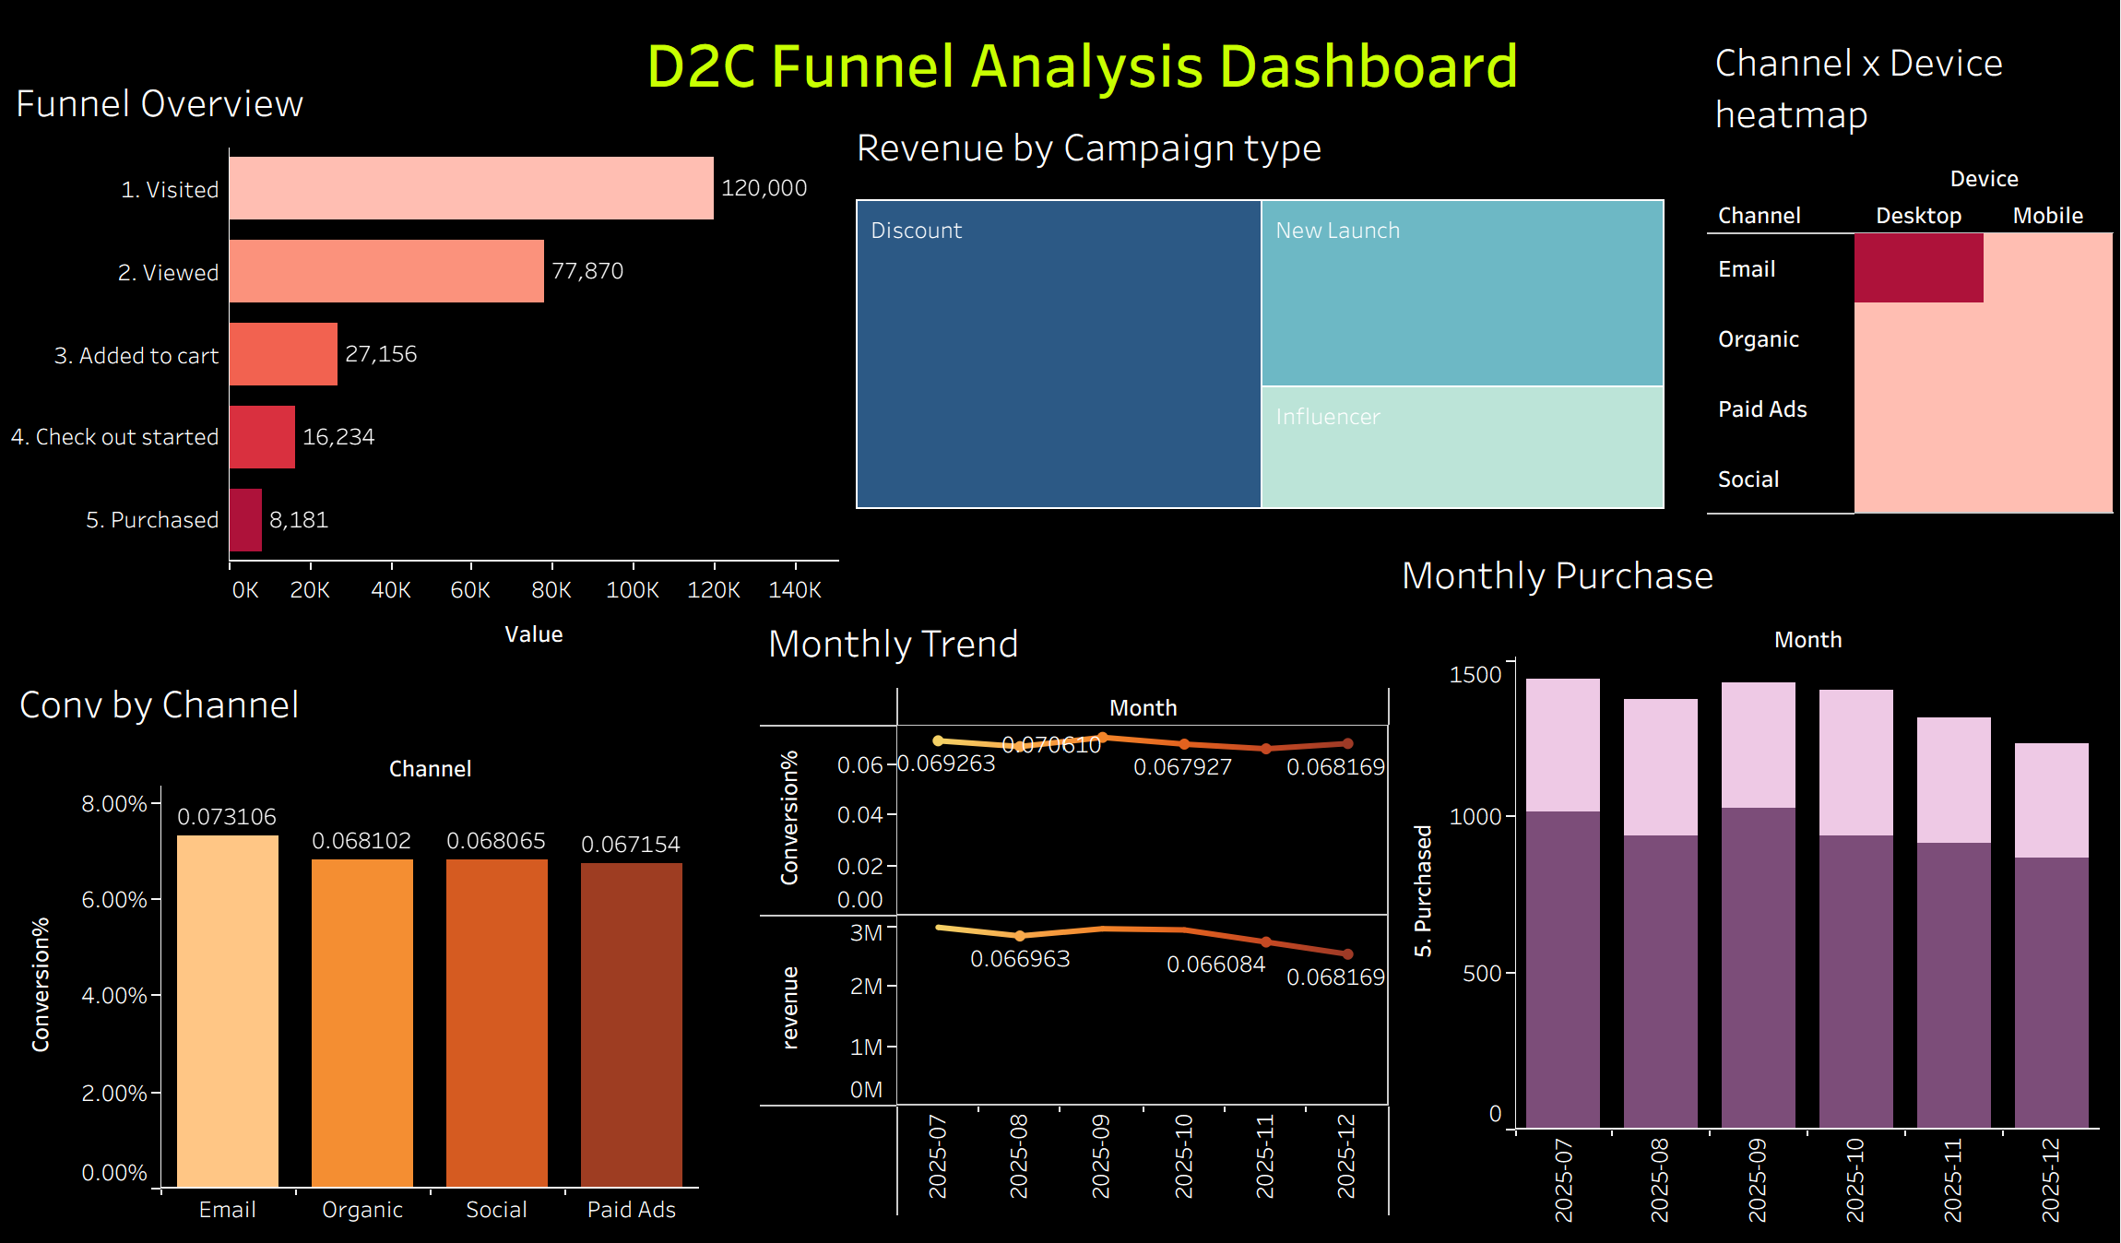

10. Summary
This analysis moves beyond surface-level funnel metrics to identify a specific, high-confidence intervention point (View → Cart), quantify its revenue impact, and correctly rule out channel/device as meaningful conversion levers at this data scale — while also surfacing and transparently reporting a data quality issue rather than overstating a finding. The complete SQL query set and Tableau workbook accompany this report in the project repository.

