 

**Statistics Assignment**

*By* *Anish Mahapatra (email id:* [*anishmahapatra01@gmail.com*](mailto:anishmahapatra01@gmail.com)*)* - *8th December 2019*

**Comprehension:**

The pharmaceutical company Sun Pharma is manufacturing a new batch of painkiller drugs, which are due for testing. Around 80,000 new products are created and need to be tested for their time of effect (which is measured as the time taken for the drug to completely cure the pain), as well as the quality assurance (which tells you whether the drug was able to do a satisfactory job or not).

**Question 1:**

The quality assurance checks on the previous batches of drugs found that — it is 4 times more likely that a drug can produce a satisfactory result than not. Given a small sample of 10 drugs, you are required to find the theoretical probability that at most, 3 drugs are not able to do a satisfactory job.

a.) Propose the type of probability distribution that would accurately portray the above scenario and list out the three conditions that this distribution follows.

b.)  Calculate the required probability.

**Answer: Q1 – A, B**

1. The trial for the previous batches of drugs as mentioned in the above question follows a **Binomial Distribution**.  
   The three conditions that the distribution follows are:
   1. The total number of trials are fixed
   2. Each trial is binary i.e., has only two possible outcomes – success and failure
   3. The probability of success is the same for all trials
2. We shall denote the probabilities as the following:
   1. The probability of a *satisfactory* result as **P(S)** and
   2. The probability of *not satisfactory* result as **P(NS)**

< continued in the next page .. >

Q1, part b.) continued ..

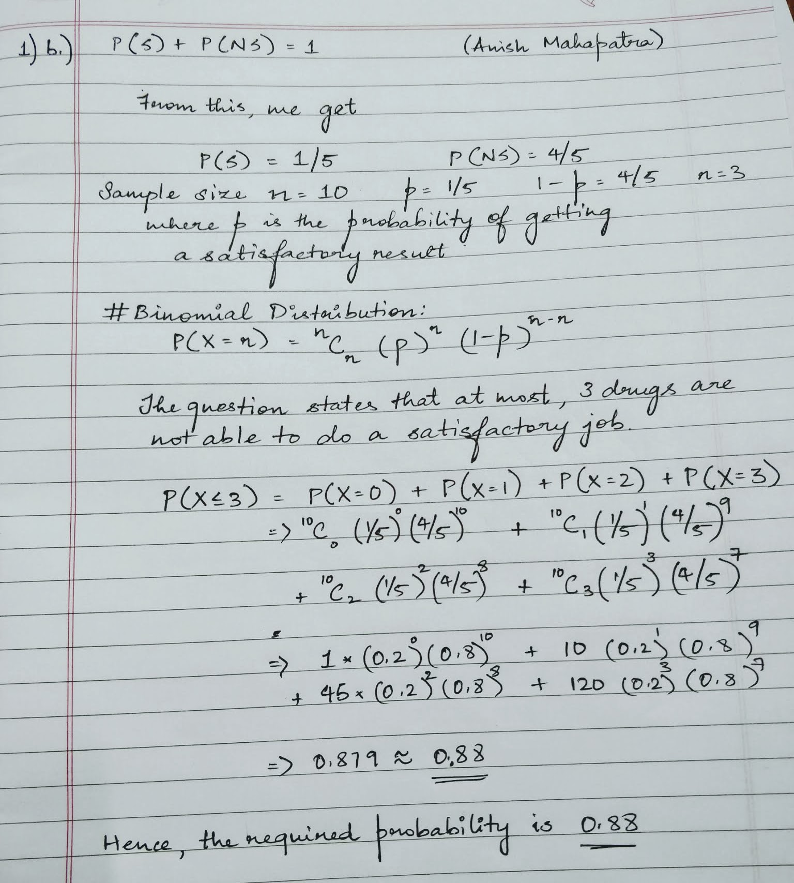

**Question 2:**

For the effectiveness test, a sample of 100 drugs was taken. The mean time of effect was 207 seconds, with the standard deviation coming to 65 seconds. Using this information, you are required to estimate the range in which the population mean might lie — with a 95% confidence level.

a.) Discuss the main methodology using which you will approach this problem. State all the properties of the required method. Limit your answer to 150 words.

b.) Find the required range.

**Answer: Q2-A**

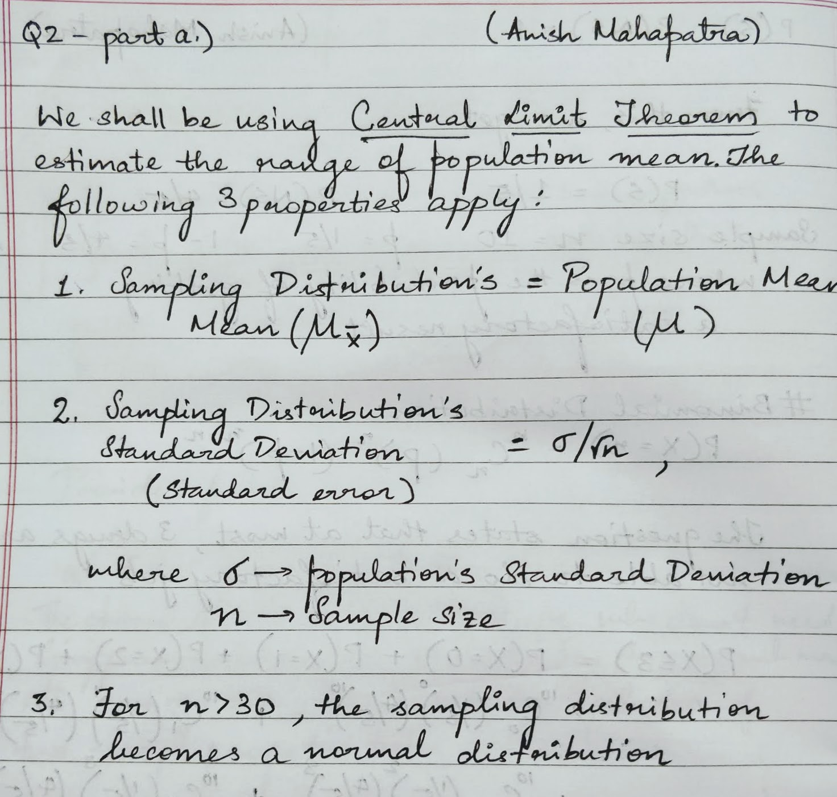

**Answer: Q2-B**

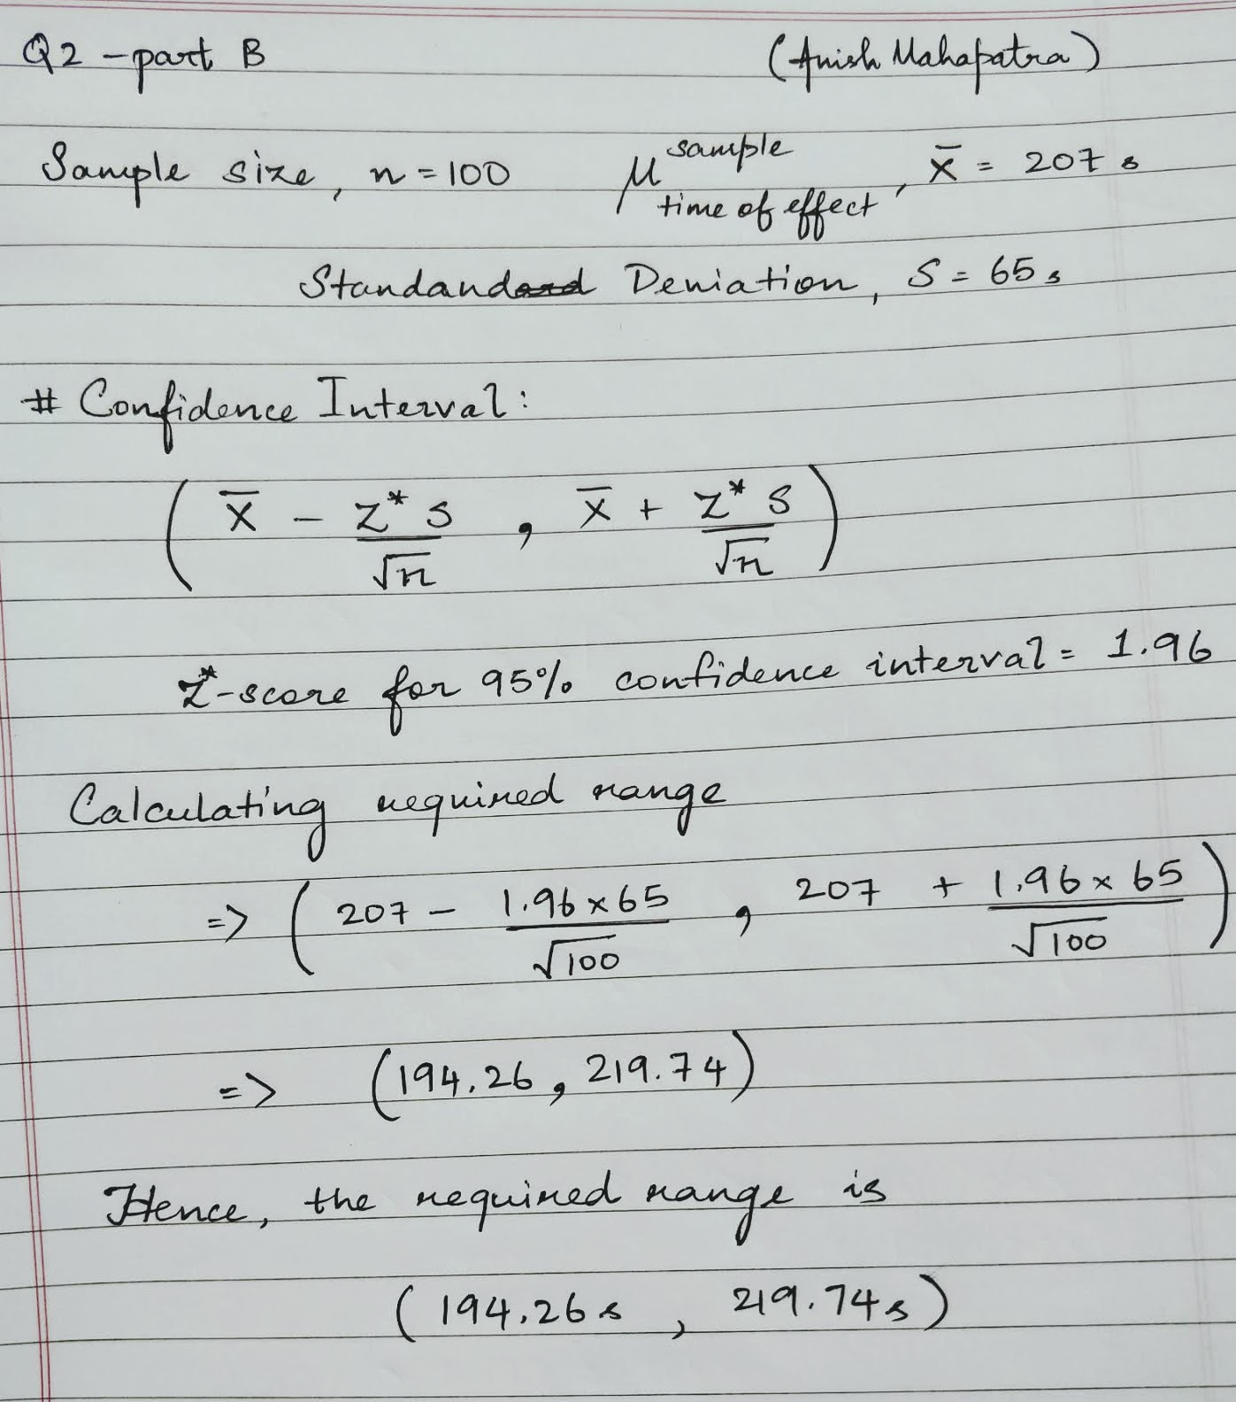

Hence, the required range is 194.26 seconds to 219.74 seconds.

**Question 3:**

a) The painkiller drug needs to have a time of effect of **at most 200 seconds** to be considered as having done a satisfactory job. Given the same sample data (size, mean, and standard deviation) of the previous question, test the claim that the newer batch produces a satisfactory result and passes the quality assurance test. Utilize 2 hypothesis testing methods to make your decision. Take the significance level at 5 %. Clearly specify the hypotheses, the calculated test statistics, and the final decision that should be made for each method.

b) You know that two types of errors can occur during hypothesis testing — namely Type-I and Type-II errors - whose probabilities are denoted by α and β respectively. For the current sample conditions (sample size, mean, and standard deviation), the value of α and β come out to be 0.05 and 0.45 respectively.

Now, a different sampling procedure (with different sample size, mean, and standard deviation) is proposed so that when the same hypothesis test is conducted, the values of α and β are controlled at 0.15 each. Explain under what conditions would either method be more preferred than the other, i.e. give an example of a situation where conducting a hypothesis test having α and β as 0.05 and 0.45 respectively would be preferred over having them both at 0.15. Similarly, give an example for the reverse scenario - a situation where conducting the hypothesis test with both α and β values fixed at 0.15 would be preferred over having them at 0.05 and 0.45 respectively. Also, provide suitable reasons for your choice (Assume that only the values of α and β as mentioned above are provided to you and no other information is available).

**Answer: Q3-A**

< continued in the next page .. >

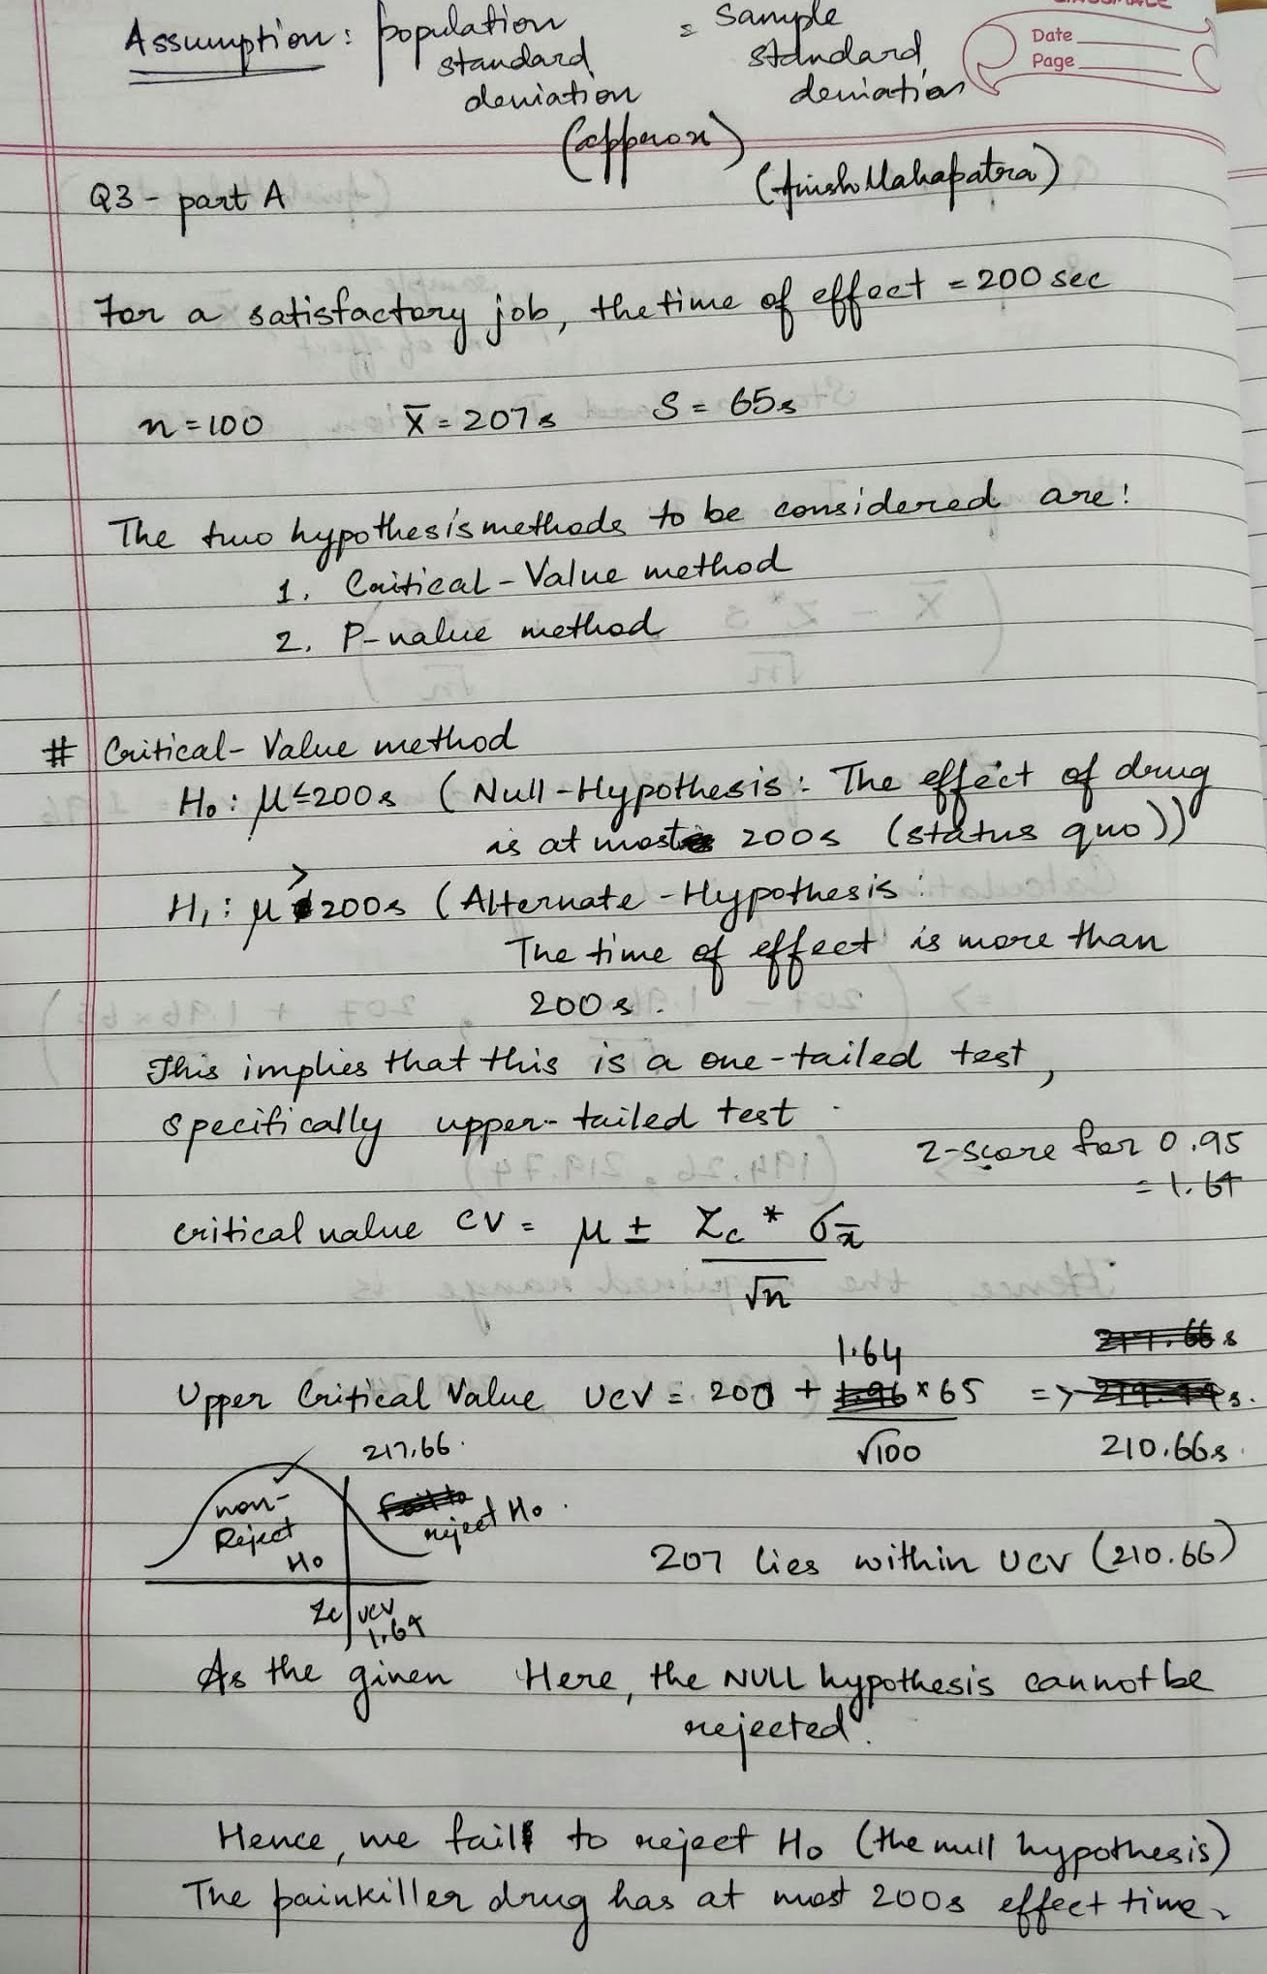

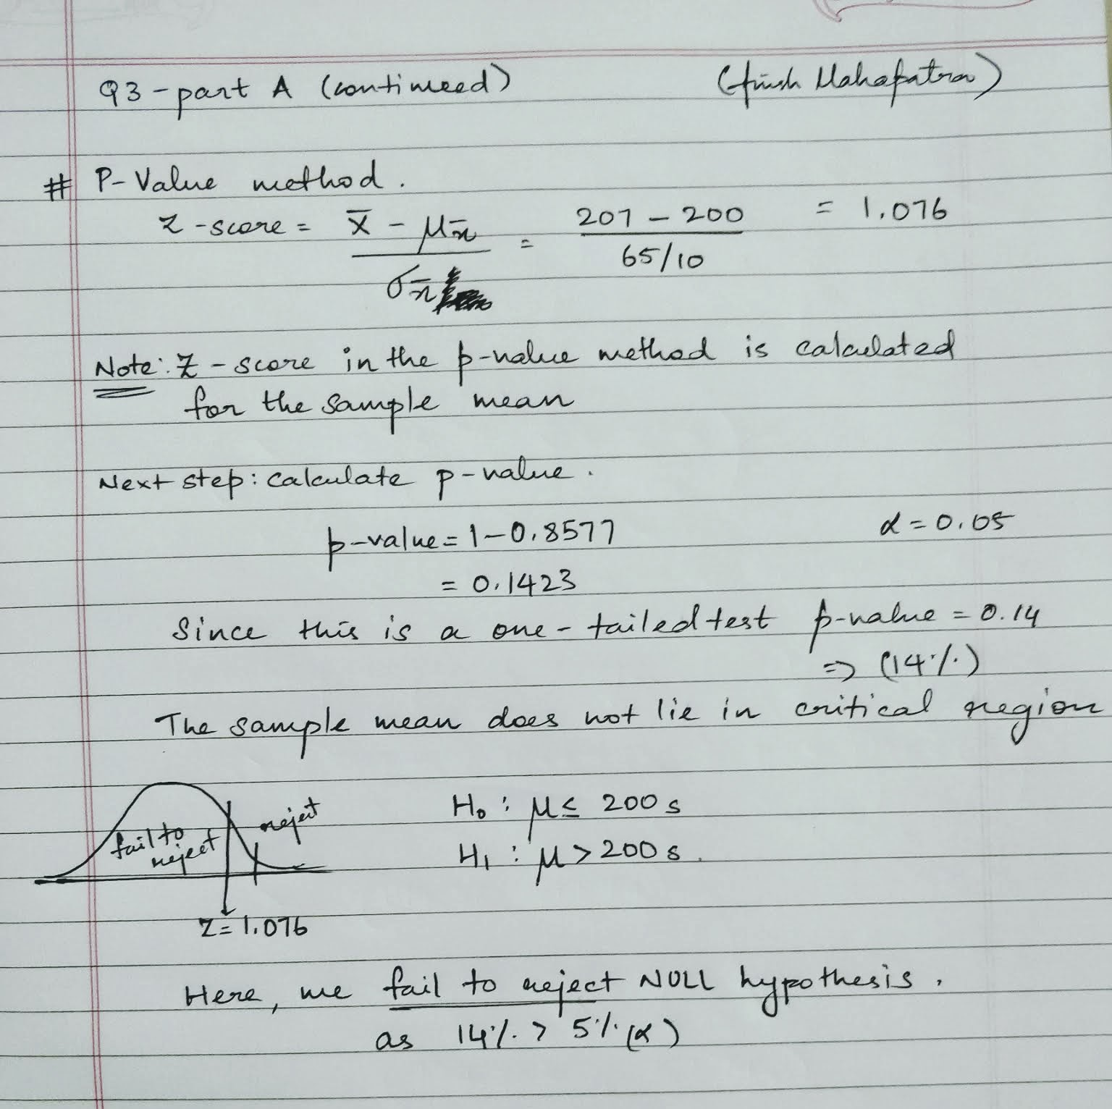

< continued in the next page .. >

**Answer: Q3-B**

Current value of α is 0.05 and current value of β is 0.45.

For this scenario, the value of Type-II error (β) is higher. A Type II error is when we fail to reject a false null hypothesis.

**Scenario 1**: Example of a situation where conducting a hypothesis test having α and β as 0.05 and 0.45 respectively would be preferred over having them both at 0.15.

**Answer:**

Let’s say that we have drinking water from Bengaluru Water Corporation (BWC). If the level of contaminants is too high, then, the service is temporarily closed for water treatment.

H0: The water quality is not acceptable   
H1: The water quality is acceptable

* The consequence of a Type I error in this setting would be that BWC does not close the service when it needs to be closed
* The consequence of a Type II error in this setting would be that BWC closes the service when it does not need to be closed

In terms of safety, the error that has a more dangerous consequence is that people drink/ use contaminated water.  
In such a situation, having α and β as 0.05 and 0.45 respectively would be preferred over having them both at 0.15.

**Scenario 2**: Example of a situation where conducting the hypothesis test with both α and β values fixed at 0.15 would be preferred over having them at 0.05 and 0.45 respectively.

**Answer**:

Let’s say that we are looking at the start of a murder investigation. An investigator finding out if the murderer is in the room at the crime scene.

H0: There is no murderer in the room  
H1: There is a murderer in the room

In such a situation, a type 2 error would indicate that the investigator finds and accuses the possible murderer in the room. This can lead to breach of trust with the members from the start. Essentially, it is better to carry out more investigation than have the chances of a false negative.

Here, having the hypothesis test with both α and β values fixed at 0.15 would be preferred over having them at 0.05 and 0.45 respectively.

**Question 4:**

Now, once the batch has passed all the quality tests and is ready to be launched in the market, the marketing team needs to plan an effective online ad campaign to attract new customers. Two taglines were proposed for the campaign, and the team is currently divided on which option to use.

Explain why and how A/B testing can be used to decide which option is more effective. Give a stepwise procedure for the test that needs to be conducted.

**Answer:**

**A/B testing** is a direct industry application of the two-sample proportion test sample. The choice of which tagline to choose is very subjective and is difficult to predict which option would perform better. To resolve such conflicts, we use A/B testing. A/B testing lets us test two different versions of taglines and see which one performs better.

The statistics or data gathered from A/B testing come from champions, challengers and variations.

1. The champion is the marketing asset that is suspected to perform well or has performed well in the past
2. The champion is tested against a challenger, which is a variation on the champion with one element changed
3. After the A/B test, you have either discovered a new champion or discover that the first variation performed best

Following is a stepwise approach to A/B testing used by some of the market leaders of the industry:

1. **Data Collection**: This can provide insight into areas that require attention
2. **Goal Identification**: Conversion goals are metrics that you can use to determine whether the new variation is more successful than the original version
3. **Hypothesis Generation**: Generate hypotheses of what can work out better than the current version. Prioritize these in terms of expected impact and difficulty of implementation
4. **Create Variations**: Make desired changes to the element under consideration. Quality check the experiment to make sure it works as expected
5. **Run Experiment**: The interaction with the new experience/ element is measured, counted and compared to determine how each performs
6. **Analyze Results**: Consider if the results are statistically significant and implement the champion!

A/B testing is a randomized experiment with two variants, A and B. A/B testing is a way to compare two versions of a single variable, typically by testing a subject's response to variant A against variant B and determining which of the two variants is more effective.

In the above-given scenario we can perform A/B testing with both the taglines and the one that has better results post the experiment will be chosen as the tagline of choice.