Time series forecasting 2

In this module, we shall talk about Timeseries forecasting and the requirements.

Stationarity: Where the mean does not change over time.  
 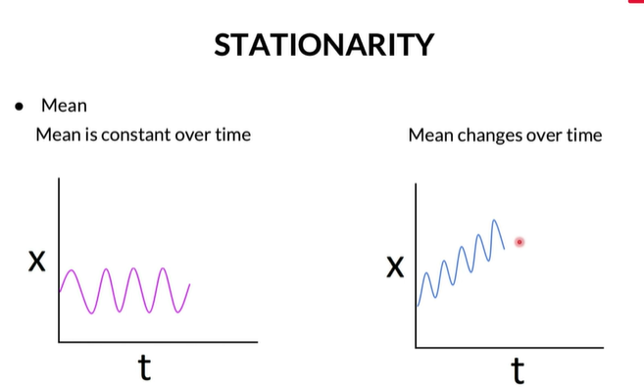

Variance: The variance should be constant over time.   
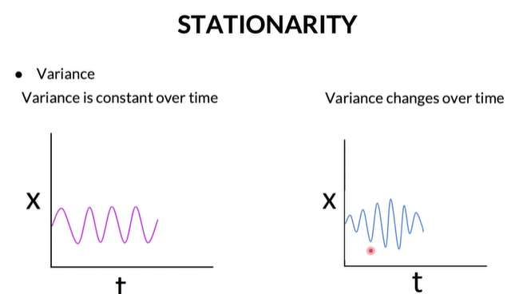

Covariance: The covariance at a fixed lag is constant over time  
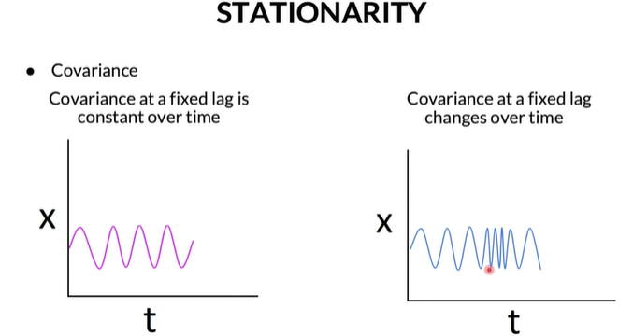_______________________________________________________________________________________  
White noise is an example of stationary series  with purely random, uncorrelated observations with no identifiable trend, seasonal or cyclical components.  
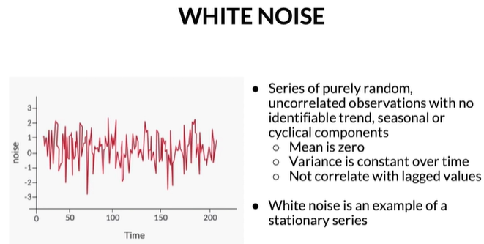  
Random walk is an example of stationary series.   
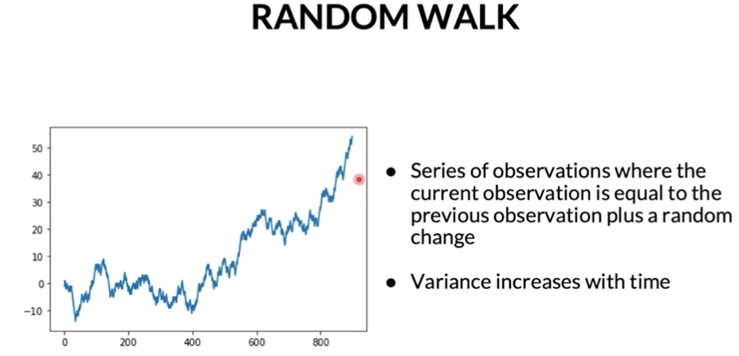

**White Noise**

Which of the following is FALSE for white noise?

**Covariance can be non-zero but should be constant.**

**Feedback :**

*Correct. Covariance must be constant over a given lag.*

Why is stationarity required for Timeseries models?

1. Stationary process are easier to analyse and model because its statistical properties remain constant over time
2. Like Linear regression, autoregression is built on the same assumptions of independent and identically distributed (IID) random variables

Stationarity tests  
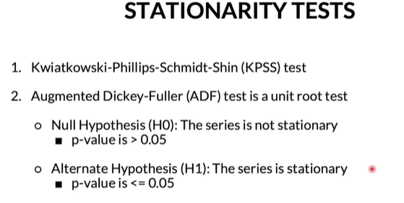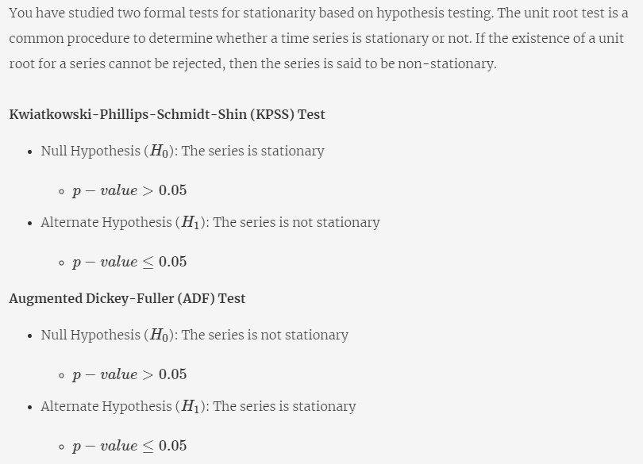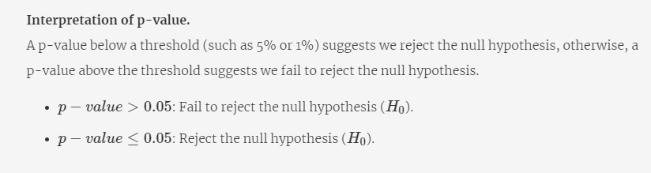

If we get a value less than the critical value, then we can REJECT the NULL hypothesis

How to make a timeseries stationary?  
Ans – Differencing and Box-Cox transformation  
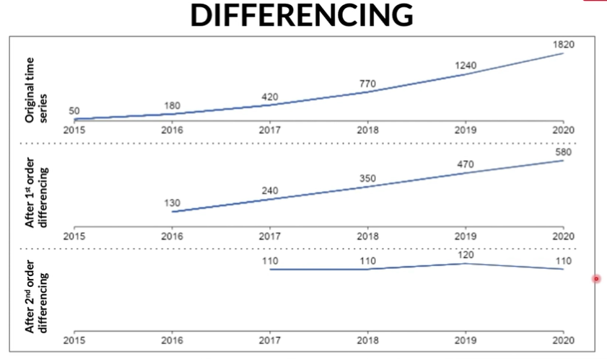  
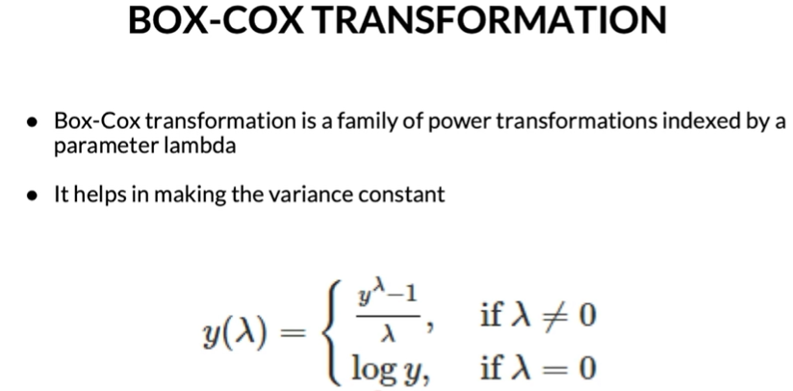

**Non-stationary to stationary**

Which of the following is true?

Top of Form

**Box-Cox Transformation makes the variance constant in a Time series.**

**Feedback :**

Box-Cox Transformation makes the variance constant in a Time series

**Correct**

Differencing is performed by subtracting the previous observation from the current observation.

**Feedback :**

Differencing as the name suggests is subtracting the previous observation from the current observation.

**Correct**You missed this!

**Differencing can remove both Trend and seasonality in a Time series.**

**Feedback :**

Differencing removes trend and seasonality in a Time series. When an entire cycle is used for differencing the other cycle, then the seasonality is removed.

**Correct**

**Differencing makes the variance constant in a Time-series**

**Feedback :**

Box-Cox Transformation makes the variance constant in a time series.

**Incorrect**

Bottom of Form

**ACF and PACF**:

Autocorrelation is capturing the relationship between observations yt at time t and  yt−k at time k time period before t. In simpler words, Autocorrelation helps us to know how a variable is influenced by its own lagged values. We will look at two Autocorrelation measures here:

1. Autocorrelation function (ACF)
2. Partial autocorrelation function (PACF)

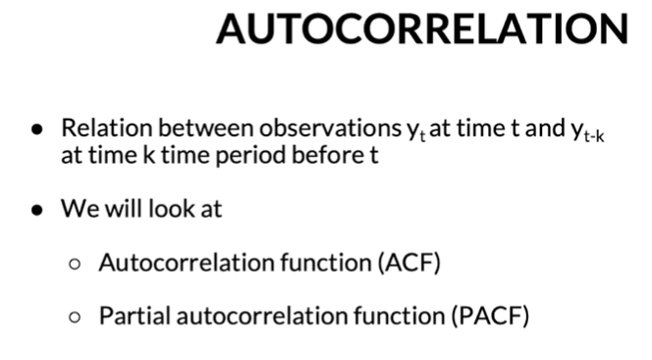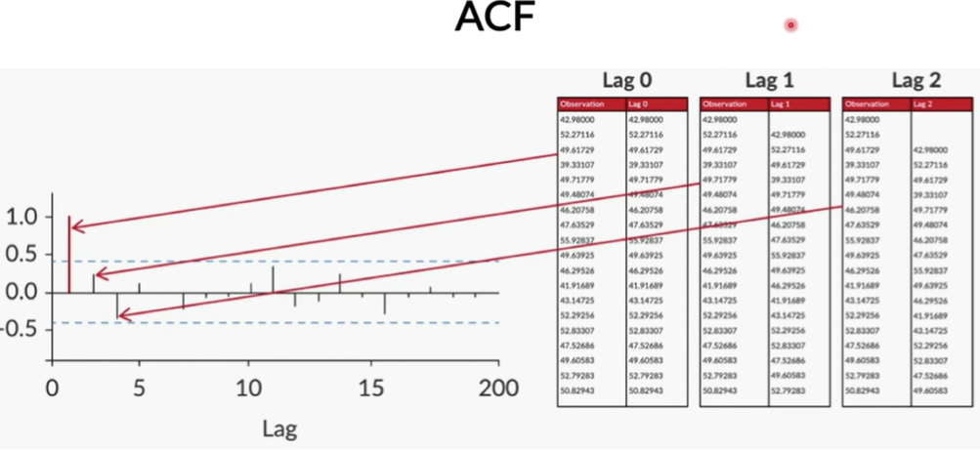

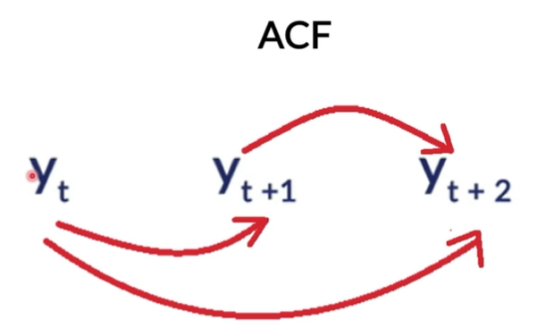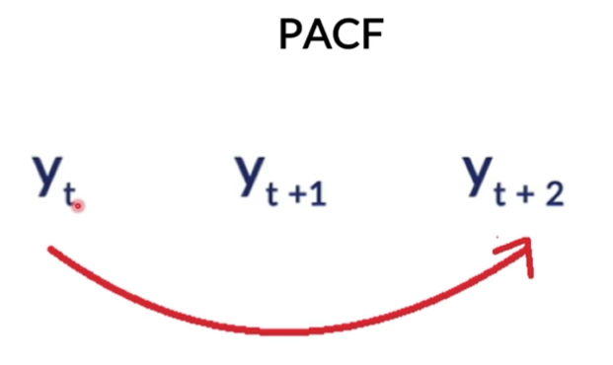

**The Simple Auto Regressive Model (AR)**

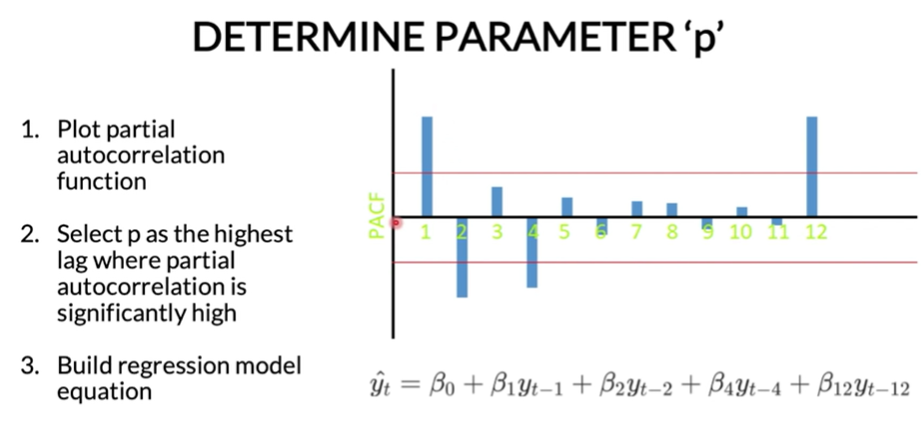  
The Simple Auto Regressive model predicts the future observation as linear regression of one or more past observations. In simpler terms, the simple autoregressive model forecasts the dependent variable (future observation) when one or more independent variables are known (past observations). This model has a parameter **‘p’** called **lag order**. Lag order is the maximum number of lags used to build ‘p’ number of past data points to predict future data points.

**To determine the value of parameter ‘p’.**

* Plot partial autocorrelation function

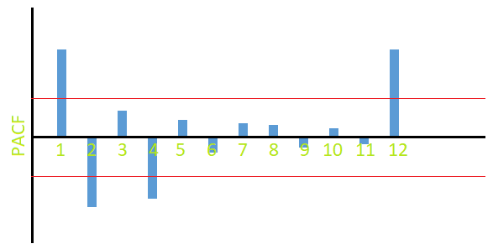

* **Select p as the highest lag where partial autocorrelation is significantly high**

Here, the lag value of 1, 2, 4 and 12 has a significant level of confidence. i.e., significant level of influence on future observation (refer the red line). Hence, the value of 'p' will be set to 12 since that is the highest lag where partial autocorrelation is significantly high.

* Build autoregression model equation:

https://images.upgrad.com/716c0ecb-082f-42d3-96e2-89a63e3431a7-3.3.png

**3.3**

The past values which have a significant value are 1, 2, 4 and 12. Therefore, in the regression model the independent variables yt−1, yt−2, yt−4 and yt−12  which are the observations from the past has been taken to predict the dependent variable ^yt.

**AR model**

Which of the following is true for Auto Regressive (AR) models?

Top of Form



**It models the future observation as a linear regression of one or more past observations.**

**Feedback :**

 Auto Regression as the name suggests models the future observation with the lag of one or more past observation.

**Correct**



This model uses past forecast errors.



**The parameter of the autoregressive model 'p' is calculated from the Partial Autocorrelation Function plot.**

**Feedback :**

p is calculated from the PACF plot.

**Correct**



p is calculated from the Autocorrelation Function plot.

Bottom of Form

**MOVING AVERAGE MODEL - Q**

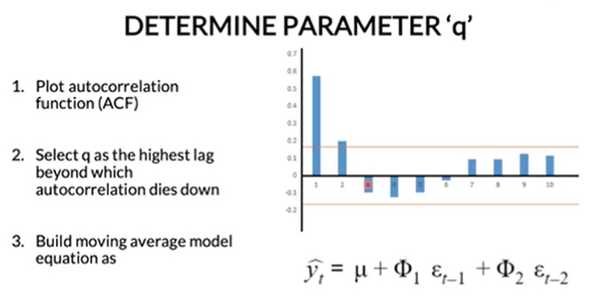 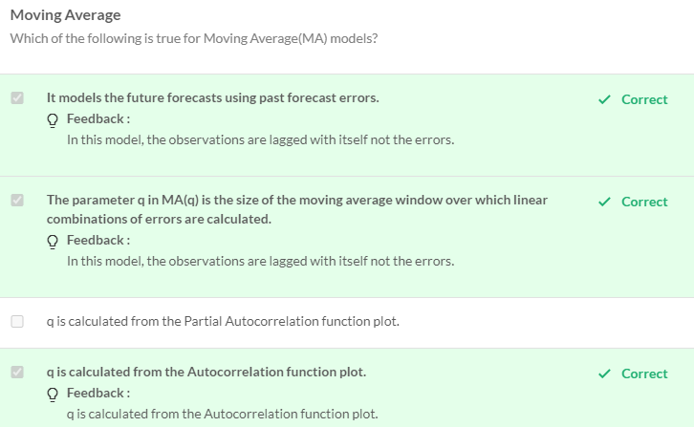

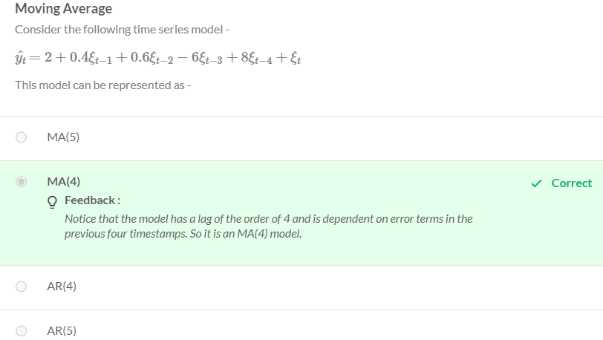 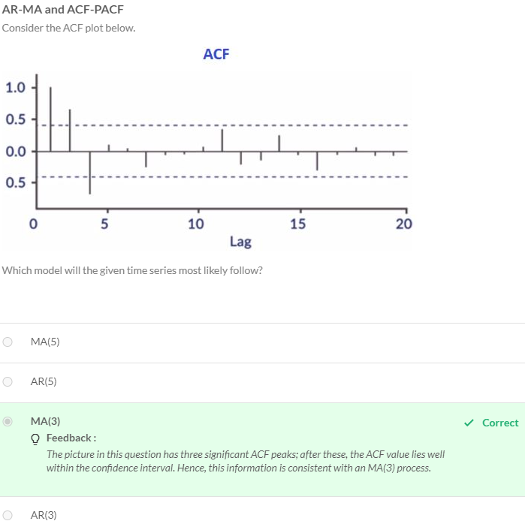

**Auto Regressive Moving Average (ARMA) Model**:

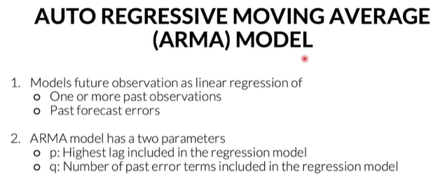 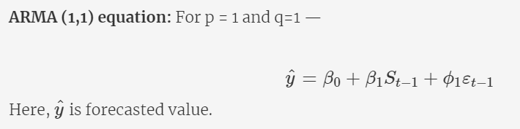 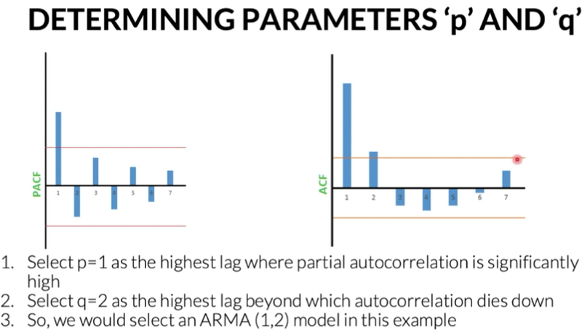 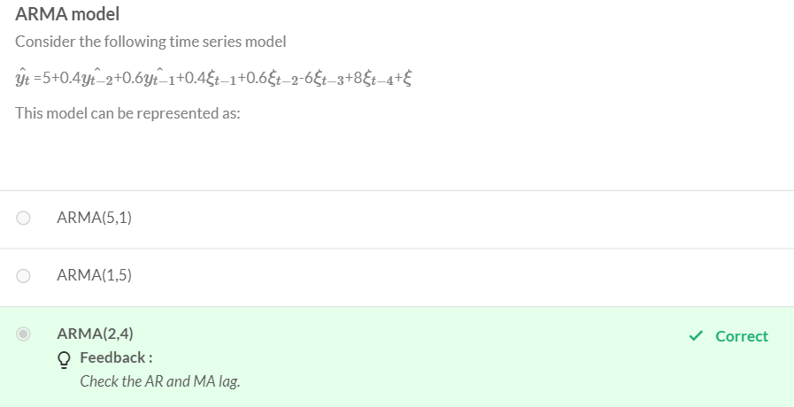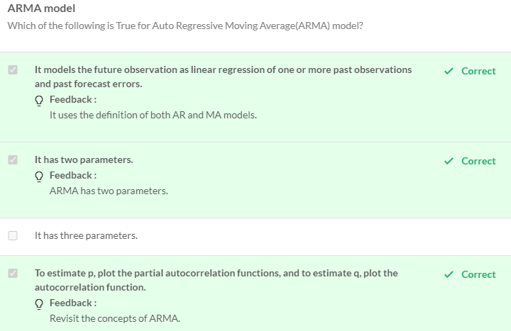

**Auto Regressive Integrated moving Average**:

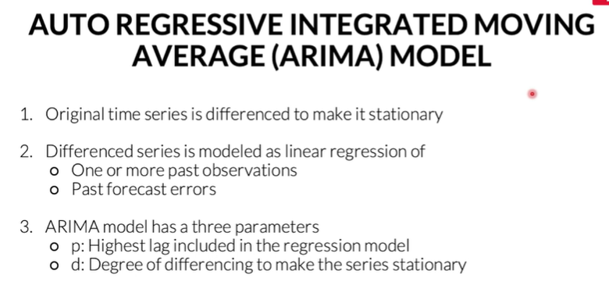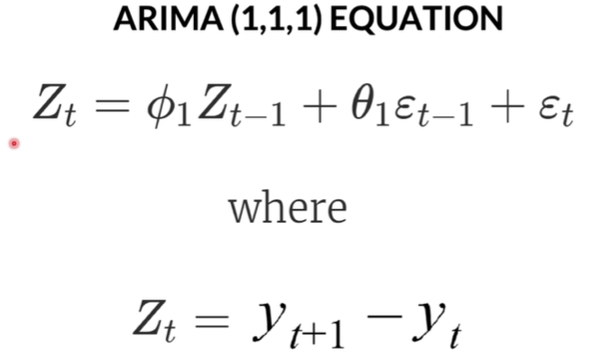

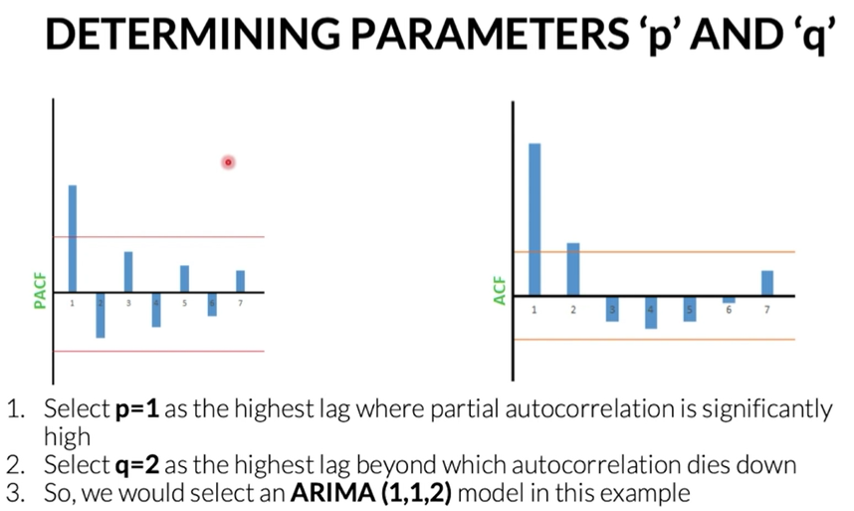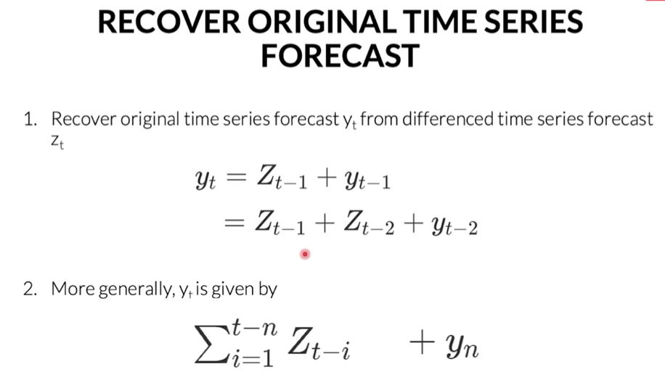

**Steps of ARIMA model**

* Original time series is differenced to make it stationary
* Differenced series is modeled as a linear regression of
  + One or more past observations
  + Past forecast errors
* ARIMA model has three parameters
  + **p:** Highest lag included in the regression model
  + **d:** Degree of differencing to make the series stationary
  + **q:** Number of past error terms included in the regression model
  + Here the new parameter introduced is the ‘I’ part called integrated. It removes the trend non-stationarity and later integrates the trend to the original series.

So if you think about it, ARIMA is nothing different from what you had done so far. Initially you applied both the boxcox transformation and differencing in order to covert the data into a stationary time-series data. Here, you are just applying boxcox before building the model and letting the model take care of the differencing, i.e., trend component itself.

Let's now quickly revisit the equations.

**ARIMA(1,1,1) Equations:**

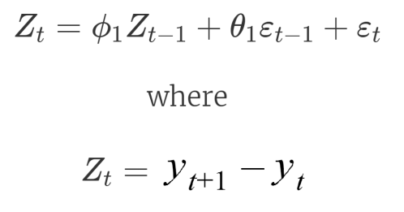

**10.3**

Here, Zt is the first order differencing for time series.

**To determine the parameters ‘p’, ‘d’ and ‘q’**

* For ‘d’: Select d as the order of difference required to make the original time series stationary. We can verify if this differenced series is stationary or not by the studied stationarity test: ADF and KPSS test.
* For ‘p’ and ‘q’: Plot ACF and PACF of the 1st order differenced time series. Find the value of ‘p’ and ‘q’ as discussed in the previous Auto Regressive Models.
* The last step in the ARIMA model is to recover the original time series forecast.

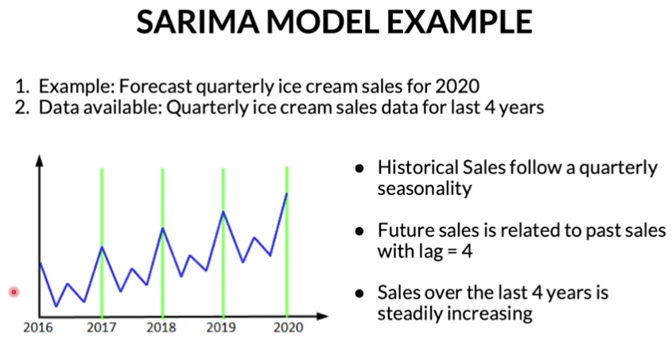

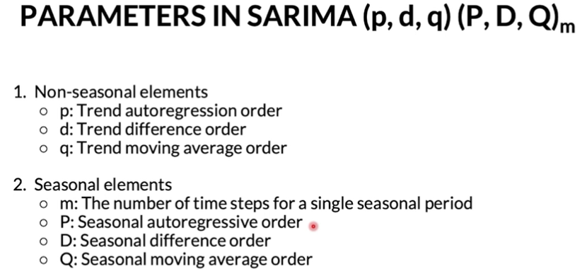

SARIMA brings all the features of an ARIMA model with an extra feature, seasonality. 

**The non-seasonal elements of SARIMA**

* Time series is differenced to make it stationary.
* Models future observation as linear regression of past observations and past forecast errors.

**The seasonal elements of SARIMA**

* Perform seasonal differencing on time series.
* Model future seasonality as linear regression of past observations of seasonality and past forecast errors of seasonality.

**The parameters ‘p’, ‘d’, ‘q’ and ‘P’, ‘D’, ‘Q’:**

* Non-seasonal elements
  + **p:** Trend autoregression order
  + **d:** Trend difference order
  + **q:** Trend moving average order
* Seasonal elements
  + **m:** The number of time steps for a single seasonal period
  + **P:** Seasonal autoregressive order
  + **D:** Seasonal difference order
  + **Q:** Seasonal moving average order

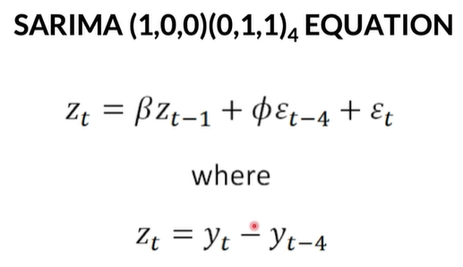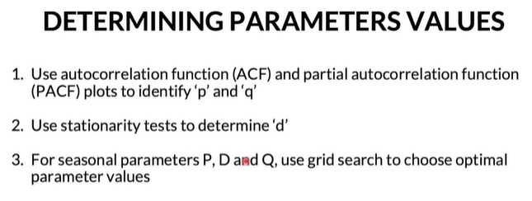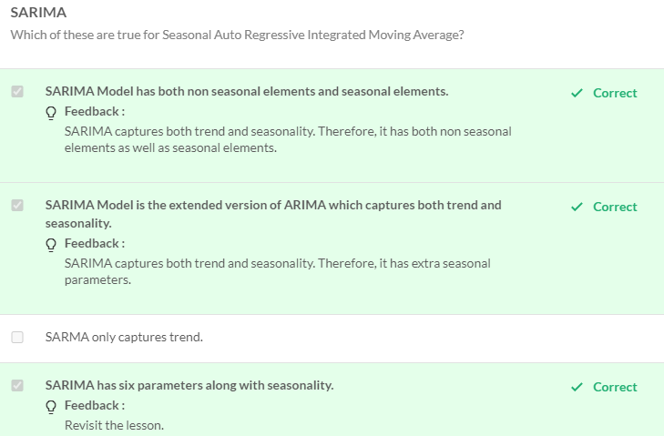  
  
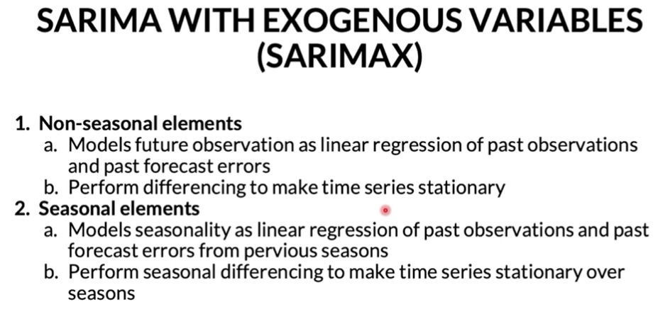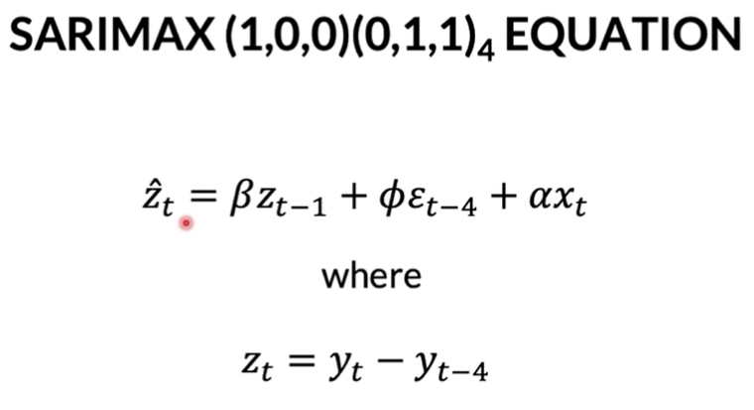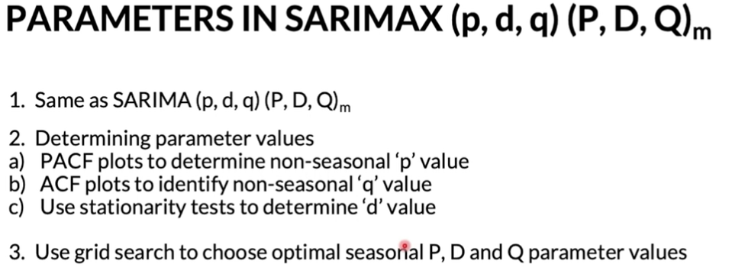

**SARIMAX has three components:**

* Non-seasonal elements
  + Models future observation as a linear regression of past observations and past forecast errors
  + Perform differencing to make time-series stationary
* Seasonal elements
  + Models seasonality as the linear regression of past observations and past forecast errors from previous seasons.
  + Perform seasonal differencing to make time-series stationary over seasons.
* Exogenous variable
  + Models future observations as linear regression of external variable

**Equations:**  
SARIMAX(1,0,0)(0,1,1)4

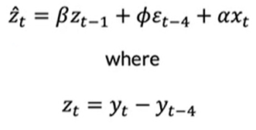

**11.1**

The parameters**‘p’, ‘d’, ‘q’**and**‘P’, ‘D’, ‘Q’**will be the same as SARIMA(p,d,q)(P,D,Q)m.

* Determining parameter values
  + PACF plots to determine non-seasonal ‘p’ value
  + ACF plots to identify non-seasonal ‘q’ value
* Use stationarity tests to determine the  value 'd'
* Use grid search to choose optimal seasonal P, D and Q parameter values

So, you have got a theoretical understanding of the SARIMAX model. Let us now build the SARIMAX model using Python.

