
CAP455 – OBJECT-ORIENTED PROGRAMMING USING C++

MINOR PROJECT – CA1 REPORT
AMUSEMENT PARK RIDE QUEUE SIMULATOR

Particulars | Details
Student Name | Anish Kumar
Registration / Roll Number | 12626434
Programme | MCA – Core
Course Code and Name | CAP455 – Object-Oriented Programming Using C++
CA Phase | CA1
Faculty Name | Adarsh Singh
Academic Session | 2026–2027
Submission Date | 06-11-2026
Repositories Link | https://github.com/anishmm098/AmusementParkRideQueueSimulator.git

DECLARATION
I, ANISH KUMAR bearing Registration/Roll Number 12626434, declare that the CA1 project report titled “Amusement Park Ride Queue Simulator” is my original work completed as part of the course CAP455 – Object-Oriented Programming Using C++. The project has been developed using C++ programming concepts and represents my understanding and implementation of the requirements specified for CA1.
I further declare that the work presented in this report has been completed by me and has not been submitted previously for any other academic purpose.
Student Signature: Anish Kumar Date: 06-11-2026

ACKNOWLEDGEMENT
I would like to express my sincere gratitude to my faculty, Adarsh Singh, for his guidance and support throughout the development of this Minor Project – CA1. His suggestions and feedback helped me understand the requirements of the project and apply the concepts of Object-Oriented Programming using C++ effectively.
I am also thankful to my institution and course faculty for providing the necessary learning environment and resources to complete this project.
Finally, I would like to thank my friends, for their encouragement and support during the completion of this work.

TABLE OF CONTENTS
1. Introduction 3
2. Problem Statement 3
3. Aim and Objectives 4
4. Scope and Limitations 4
5. Feasibility and Requirements 5
6. System Analysis and Design 5
7. Data Dictionary 7
8. Algorithms and Program Flow 8
9. C++ Concepts Used 10
10. Source Code Screenshot 11
11. Testing and Test Cases 15
12. Sample Output and Evidence 16
13. Future Enhancements 21
14. Conclusion 22

1. INTRODUCTION
The Amusement Park Ride Queue Simulator is a C++ based console application developed to manage basic visitor registration and ride information in an amusement park. It provides a simple menu-driven system to add visitors, display their records, and view the total number of registered visitors.
The project is developed for Minor Project – CA1 of CAP455 – Object-Oriented Programming Using C++. It applies basic C++ and Object-Oriented Programming concepts such as classes, arrays, functions, validation, static members, pointers, and friend functions.

2. PROBLEM STATEMENT
Managing visitor and ride information manually in an amusement park can be time-consuming and may lead to errors or duplicate records. A simple computerized system
is required to register visitors, store their basic ride information, and display records efficiently.
The proposed Amusement Park Ride Queue Simulator addresses this problem by providing a menu-driven C++ application for visitor registration, record display, duplicate ticket ID checking, and visitor counting.

3. AIM AND OBJECTIVES
Aim
The main aim of this project is to develop a simple C++ based system for registering visitors and managing their basic ride information in an amusement park.
Objectives
- To register visitors with their ticket ID, name, age, and ride name.
- To display the registered visitor records.
- To maintain the total number of registered visitors.
- To prevent duplicate ticket IDs.
- To validate user input and reject invalid data.
- To apply basic Object-Oriented Programming concepts in C++.

4. SCOPE AND LIMITATIONS
4.1 Features Covered in CA1
- New visitors can be registered using their ticket ID, name, age, and selected ride.
- Registered visitor records can be viewed through the Display option.
- The system checks that each ticket ID is unique.
- Visitor name and ride name cannot be left blank.
- Age is accepted only within the range of 1 to 80 years.
- Invalid numeric entries are rejected and the user is asked to enter the value again.
- The system automatically maintains the number of successfully registered visitors.
- A fixed array is used to store up to 100 Visitor objects.

4.2 Features Outside the CA1 Scope
- Permanent storage using files or databases.
- Updating or removing an existing visitor record.
- Complete queue management and automatic ride allocation.
- Managing the maximum capacity of individual rides.
- Calculating visitor waiting time.
- User login, networking, or graphical user interface.
Note: Visitor information is maintained only during the current program execution. Once the application is closed, the stored records are removed. CA1 does not use file or database storage.
- FEASIBILITY AND REQUIREMENTS
5.1 Technical Feasibility
The project is technically feasible because it uses basic C++ features and can run on a standard computer with a C++ compiler. The application does not require an internet connection, database, or external software.
5.2 Hardware Requirements
- Standard computer or laptop
- Minimum 4 GB RAM
- Keyboard and monitor
5.3 Software Requirements
- Windows operating system
- C++ compiler such as MinGW/G++
- Visual Studio Code or any suitable C++ IDE
- Command Prompt or terminal for program execution
5.4 Functional Requirements
- The system should allow visitor registration.
- The system should validate visitor details.
- The system should reject duplicate ticket IDs.
- The system should display registered visitors.
- The system should show the total number of visitors.

- SYSTEM ANALYSIS AND DESIGN
6.1 User and Use Cases
The CA1 application has a single console user who interacts with the system through the main menu. The user can add visitors, display registered visitors, check the total number of visitors, or exit the application.
Use Case | Input / Action | System Response
Add Visitor | Select option 1 and enter visitor details | Validates the entered data, checks the ticket ID, stores the visitor, and updates the total count.
Display Visitors | Select option 2 | Displays all registered visitor records or shows a message when no records are available.
Total Visitors | Select option 3 | Displays the total number of successfully registered visitors.
Exit | Select option 4 | Terminates the program.

6.2 Menu Design
The application uses a simple menu-driven interface:
----------- AMUSEMENT PARK RIDE QUEUE SIMULATOR -----------
- Add Visitor
- Display Visitors
- Total Visitors
- Exit
Enter your choice:
6.3 UML Class Diagram
The UML class diagram represents the structure of the Visitor class, including its private data members, public member functions, and friend function.
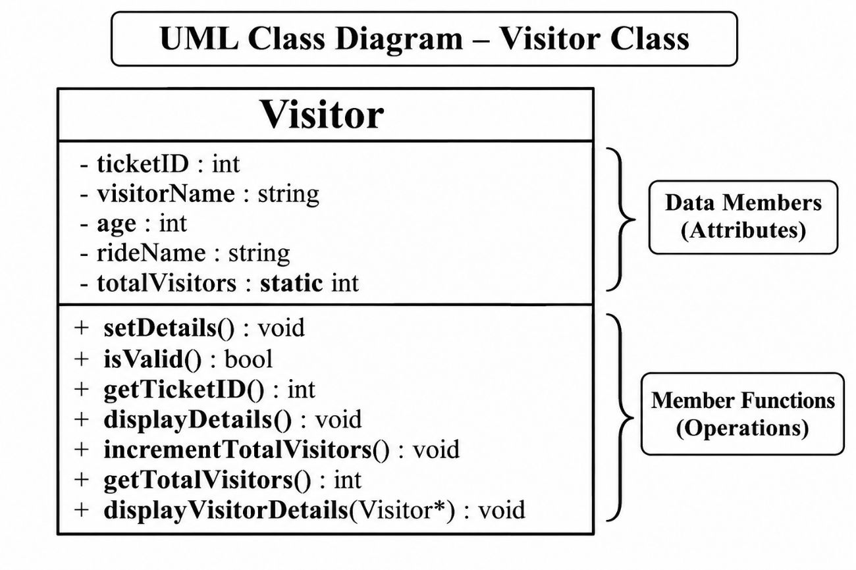
6.4 Array and Pointer Design
Visitor visitors[MAX_VISITORS];
Visitor *ptr = visitors;
displayVisitorDetails(ptr + i);
The array can store up to 100 Visitor objects. The pointer initially points to the first object in the array. Pointer arithmetic is then used to access individual visitor objects while displaying their details.

- DATA DICTIONARY
The data dictionary describes the main data members and functions used in the CA1 implementation.
7.1 Data Members
Name | Data Type | Purpose
ticketID | int | Stores the unique ticket ID of a visitor.
visitorName | string | Stores the visitor's name.
age | int | Stores the visitor's age.
rideName | string | Stores the selected ride name.
totalVisitors | static int | Maintains the total number of successfully registered visitors.

7.2 Important Functions
Function | Return Type | Purpose
setDetails() | void | Accepts visitor details from the user.
isValid() | bool | Checks whether the visitor data is valid.
getTicketID() | int | Returns the visitor's ticket ID.
displayDetails() | void | Displays the visitor's details.
incrementTotalVisitors() | void | Increases the total visitor count.
getTotalVisitors() | int | Returns the current visitor count.
displayVisitorDetails(Visitor *v) | void | Displays private visitor details using a pointer.

- ALGORITHMS AND PROGRAM FLOW
The CA1 program follows a simple menu-driven flow. The user selects an operation, provides the required input, and the system performs validation before processing the request.
8.1 Algorithm for Adding a Visitor
- Start the program and display the main menu.
- Select Add Visitor.
- Enter ticket ID, visitor name, age, and ride name.
- Validate the entered values.
- Check whether the ticket ID already exists.
- If the data is invalid or the ID is duplicate, display an error message.
- If the data is valid, store the visitor in the array.
- Increase the total visitor count.
- Return to the main menu.

8.2 Algorithm for Displaying Visitors
- Select Display Visitors from the menu.
- Check whether any visitor records are available.
- If no records exist, display an appropriate message.
- Otherwise, access each Visitor object using the array and pointer.
- Display the details of each registered visitor.
- Return to the main menu.

8.3 Algorithm for Total Visitors
- Select Total Visitors from the main menu.
- Retrieve the value of the static totalVisitors member.
- Display the total number of successfully registered visitors.
- Return to the main menu.

8.4 Program Flowchart
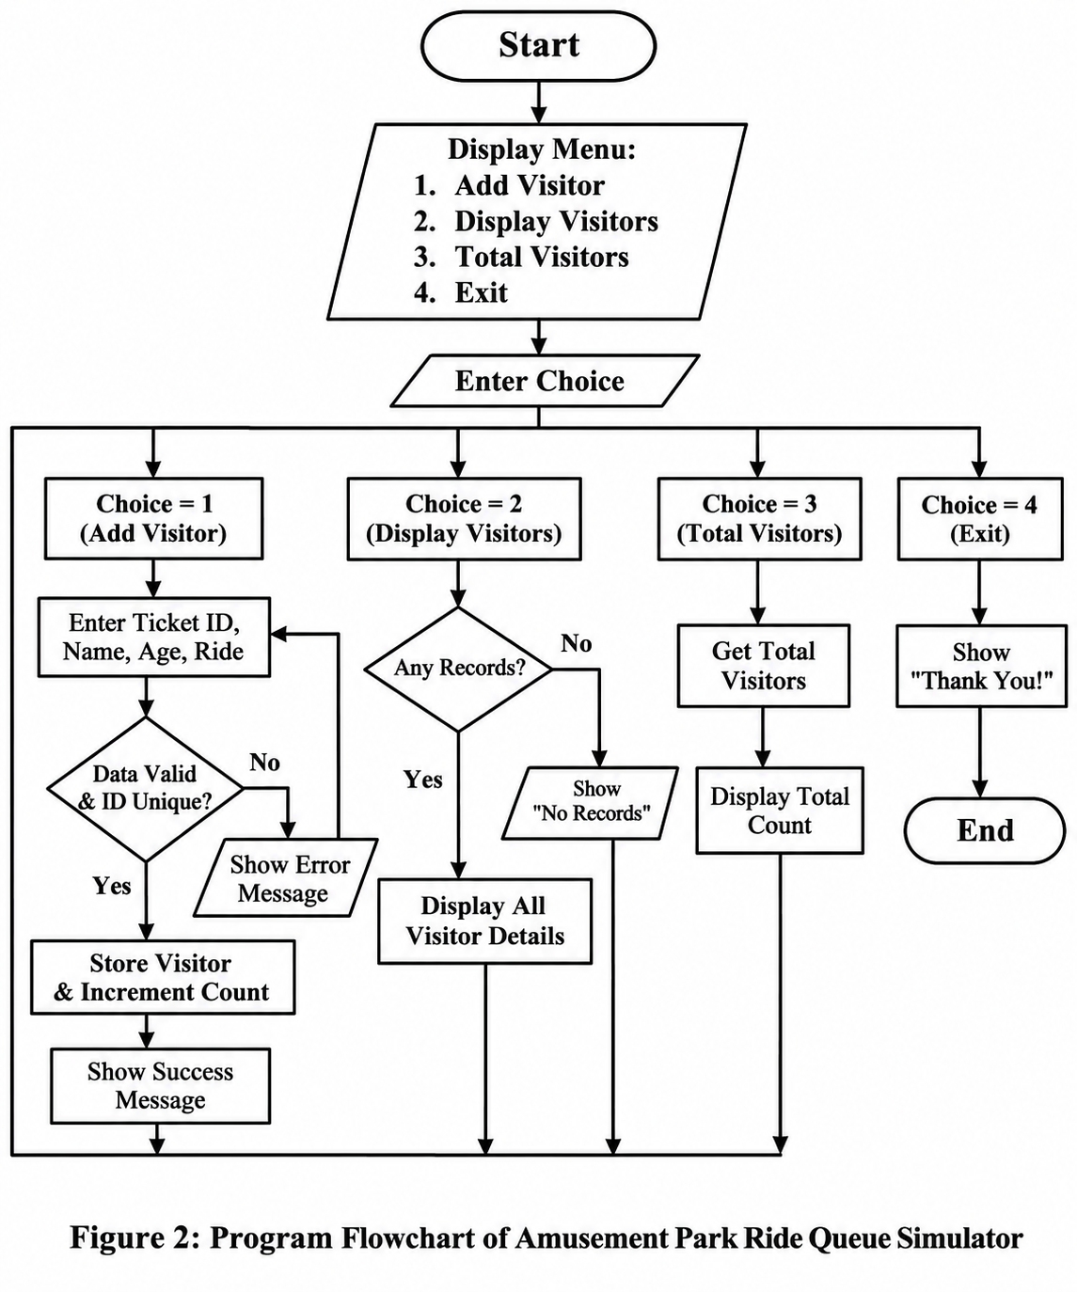
9. C++ CONCEPTS USED
9.1 Class and Objects
A class named Visitor is created to store visitor information. Objects of this class are used to maintain individual visitor records.
9.2 Array of Objects
An array of 100 Visitor objects is used to store visitor records temporarily while the program is running.
9.3 Encapsulation
The data members of the Visitor class are declared private. Public member functions are used to access and manage visitor information.
9.4 Static Data Member
A static variable named totalVisitors maintains the total number of successfully registered visitors. It is shared among all objects of the Visitor class.
9.5 Inline Member Function
The displayDetails() function is defined inside the Visitor class. It demonstrates the use of an inline member function.
9.6 Friend Function
The displayVisitorDetails() function is declared as a friend of the Visitor class. It accesses private data members to display visitor information.
9.7 Pointers
A pointer of type Visitor* is used to access visitor objects stored in the array.
9.8 This Pointer
The this pointer is used inside the setDetails() function to refer to the current object.
9.9 String Handling
The string data type is used to store visitor names and ride names.
9.10 Input Validation
Input validation is implemented to reject invalid numeric values, empty names, invalid ages, and duplicate ticket IDs.

10. SOURCE CODE SCREENSHOT
The complete source code of main.cpp is shown below in screenshot form (with line numbers) for reference and verification.
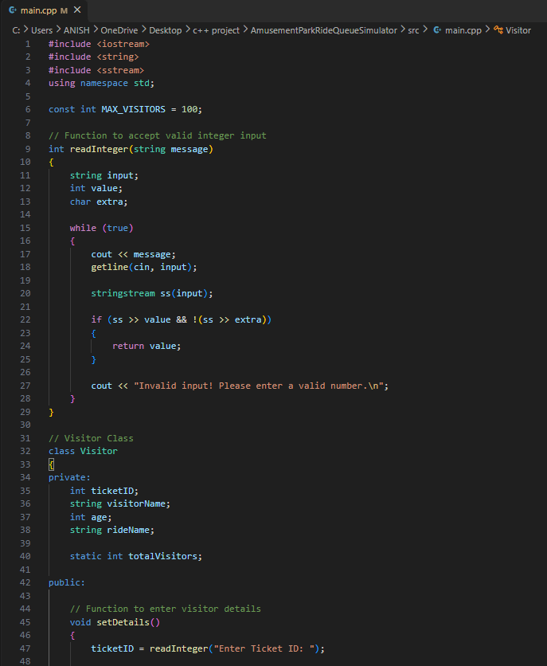
Figure 10.1 – Source code of main.cpp (lines 1–48)
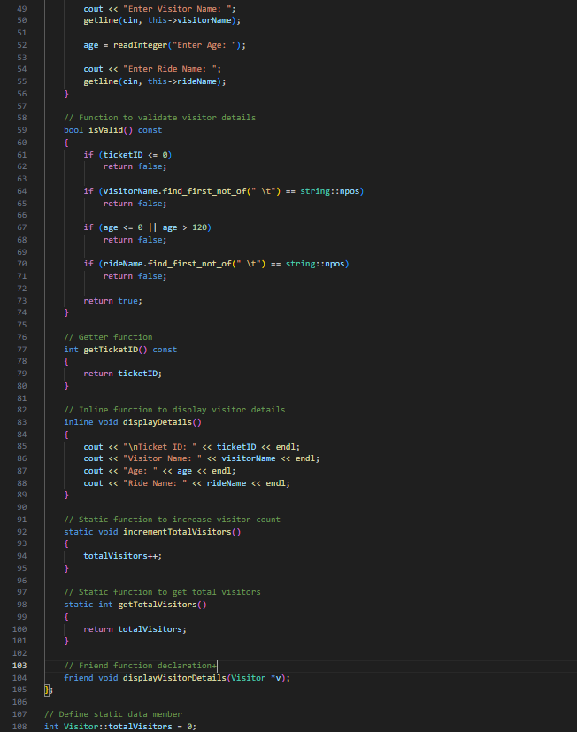
Figure 10.2 – Source code of main.cpp (lines 49–108)
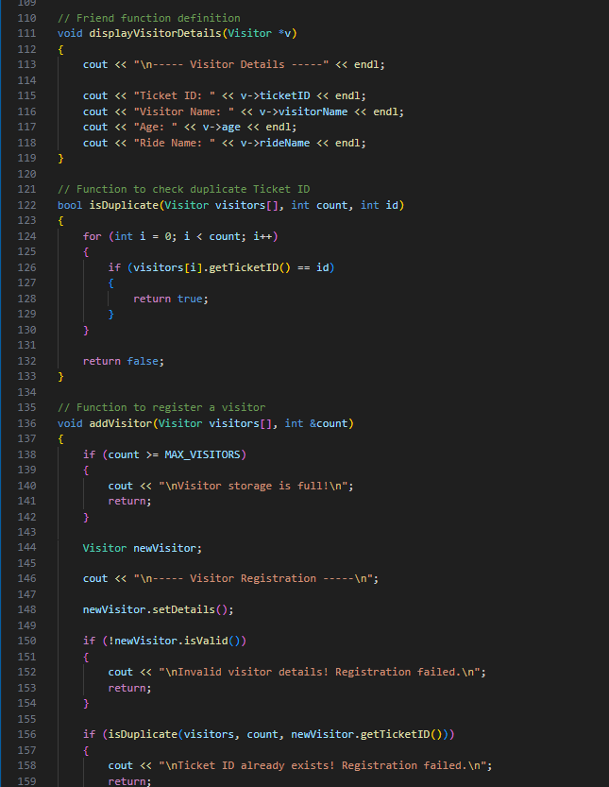
Figure 10.3 – Source code of main.cpp (lines 109–159)
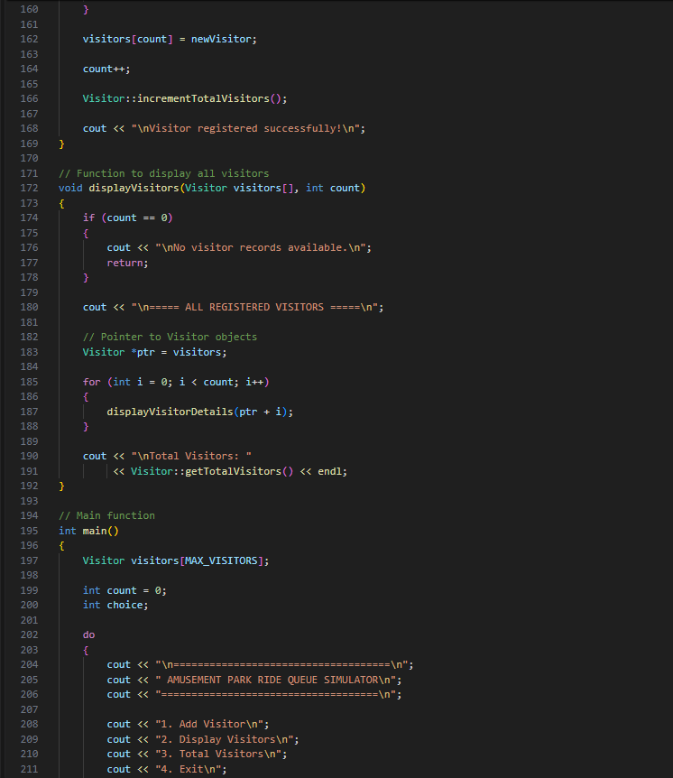
Figure 10.4 – Source code of main.cpp (lines 160–211)
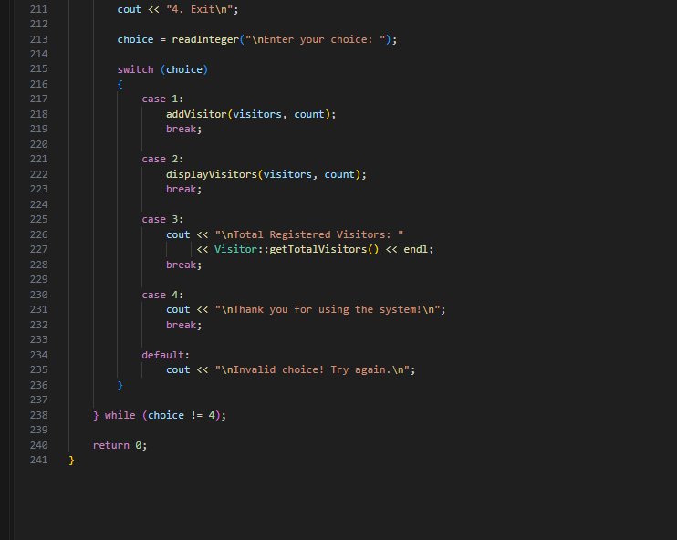
Figure 10.5 – Source code of main.cpp (lines 211–241)

11. TESTING AND TEST CASES
The application was tested with different valid and invalid inputs to verify visitor registration, input validation, duplicate ticket checking, record display, and visitor counting.
Test ID | Test Input / Action | Expected Result | Actual Result / Status
TC01 | Register a visitor with valid details | Visitor should be added successfully. | Visitor added successfully – Pass
TC02 | Enter an already registered ticket ID | System should reject the duplicate ID. | Duplicate ID rejected – Pass
TC03 | Enter age as 150 | System should reject the invalid age. | Invalid age rejected – Pass
TC04 | Enter invalid text instead of a number | System should ask for valid numeric input. | User was prompted again – Pass
TC05 | Select Display Visitors after registration | Stored visitor details should be displayed. | Visitor records displayed – Pass
TC06 | Register more than one visitor | All valid records should be stored correctly. | Multiple visitors handled correctly – Pass
TC07 | Select Total Visitors | System should display the correct visitor count. | Correct total displayed – Pass
TC08 | Display visitors without registering anyone | System should show that no records are available. | Empty-record message displayed – Pass

12. SAMPLE OUTPUT AND EVIDENCE
The following screenshots provide evidence of the working CA1 implementation. They show the main menu, visitor registration, record display, validation, and visitor count operations performed during testing.
12.1 Main Menu Screenshot
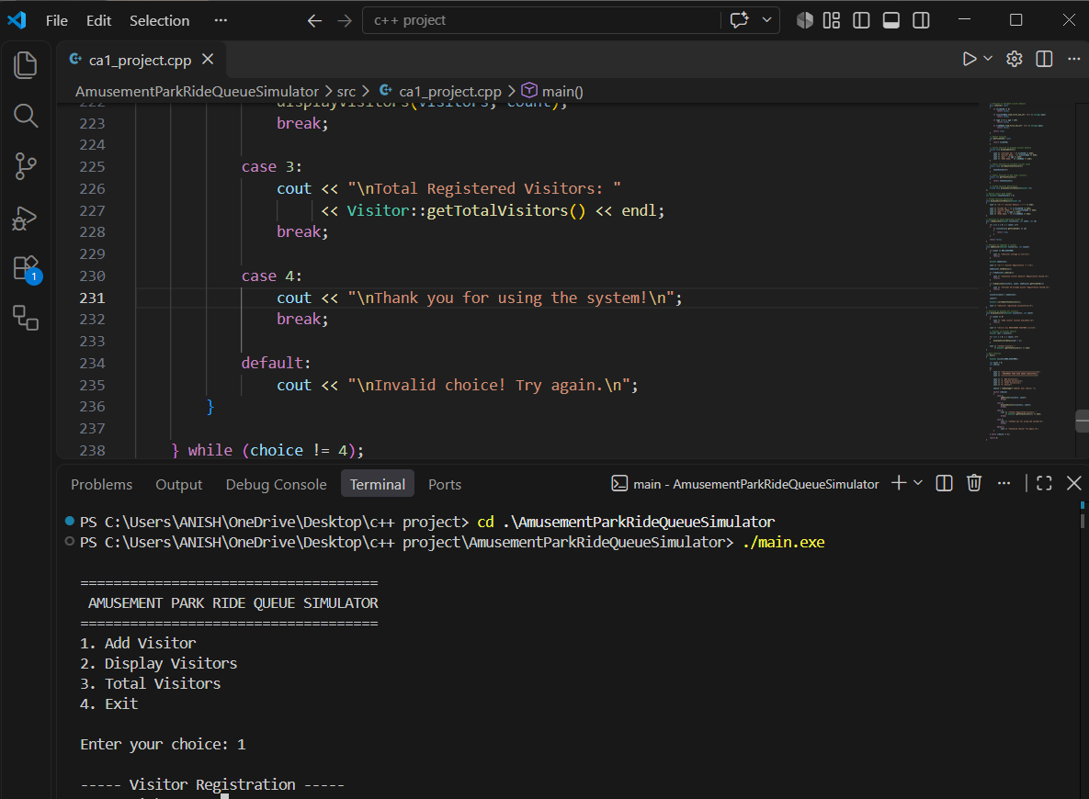
12.2 Successful Visitor Registration Screenshot
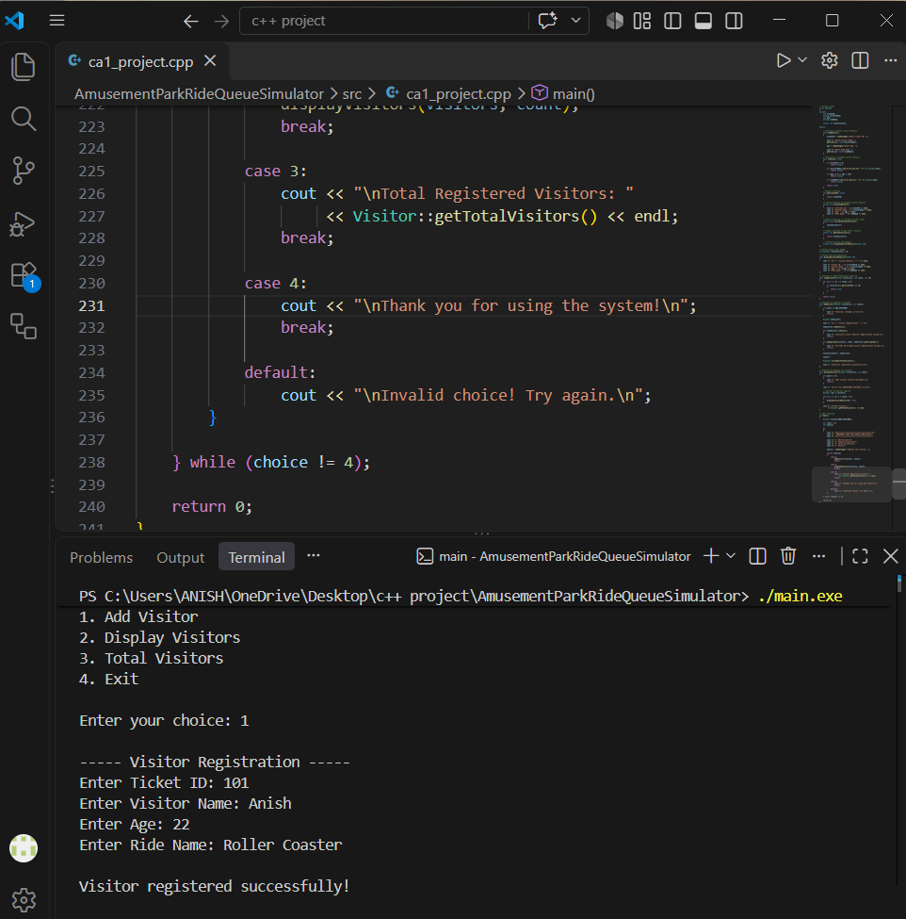

12.3 Display Visitor Records Screenshot
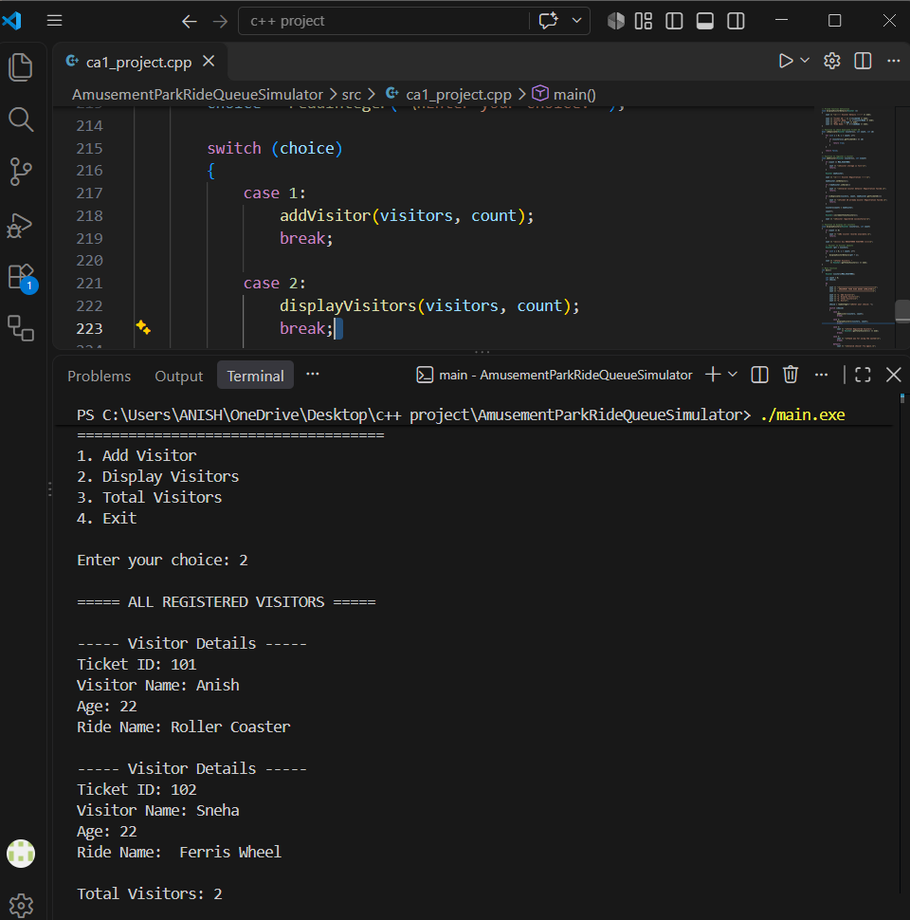

12.4 Duplicate Ticket ID Validation
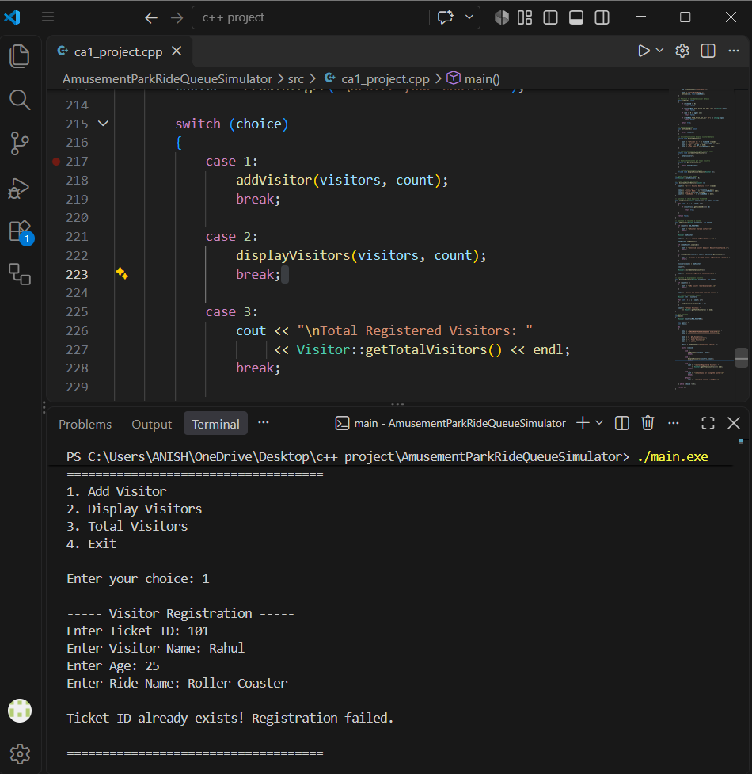

12.5 Total Visitor Count
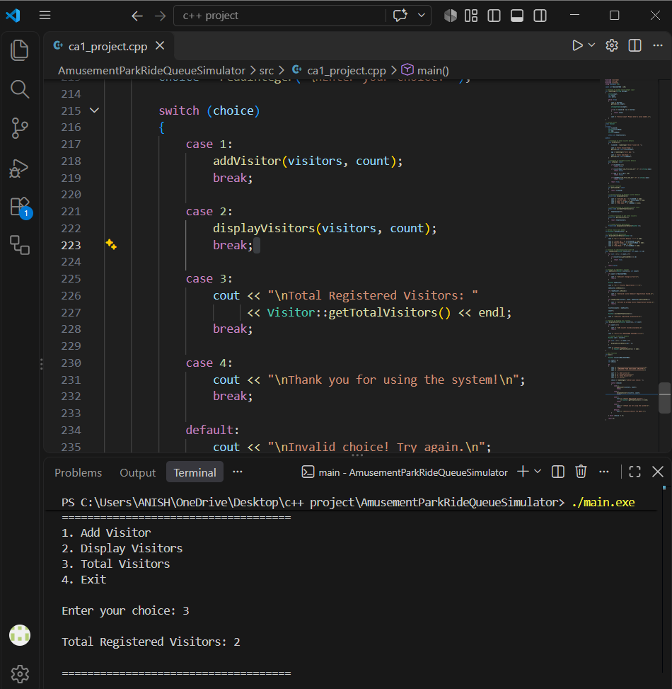

12.6 Invalid Input Validation
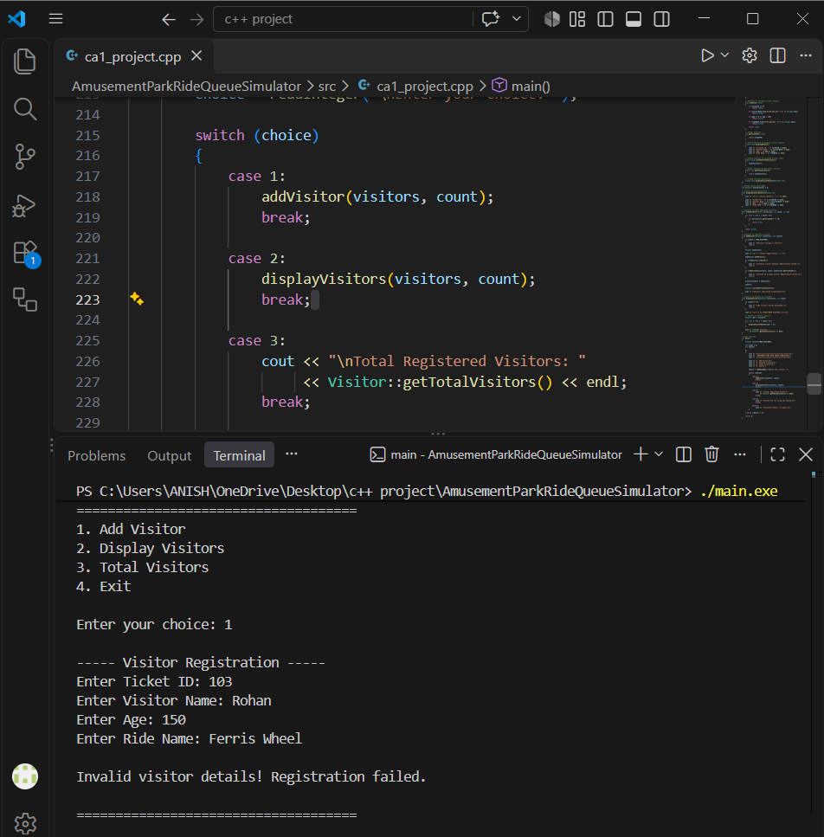

13. FUTURE ENHANCEMENTS
The current CA1 version provides the basic foundation of the Amusement Park Ride Queue Simulator. The following features can be added in future phases:
- File handling for permanent storage of visitor records.
- Update and delete operations for existing visitor records.
- Proper queue management for different rides.
- Ride capacity management and automatic ride allocation.
- Waiting-time calculation for visitors.
- Use of inheritance and polymorphism for different types of visitors or rides.
- Exception handling for better error management.
- Use of STL containers for more flexible data management.
- A graphical user interface for easier interaction.

14. CONCLUSION
The Amusement Park Ride Queue Simulator successfully provides a simple menu-driven system for registering visitors and managing their basic ride information. The CA1 implementation allows users to add visitor records, validate input, prevent duplicate ticket IDs, display registered visitors, and view the total number of visitors.
The project demonstrates the practical use of C++ and Object-Oriented Programming concepts such as classes, objects, encapsulation, arrays, functions, static members, pointers, and friend functions. Although the current version stores data only during program execution, it provides a strong foundation for adding advanced features in future phases.
Overall, the CA1 project achieves its main objectives and provides a functional base for further development of the Amusement Park Ride Queue Simulator.

