MASTER OF SOFTWARE ENGINEERING
Yoobee College, New Zealand
Professional Software Engineering (MSE-800)
Level 8, 15 Credits, Version 1
Assessment 1 - Object-Oriented Programming Assignment
Full Project & Technical Report
NEPAL CAR RENTAL SYSTEM (NCRS)
A Python Command-Line OOP Application, Version 1.0.0
Lecturer | Mohammad Norouzifard
Student Name | Anish Shrestha
Student ID | 270889991
Institution | Yoobee College, New Zealand
Report Prepared | 2026-09-11

Table of Contents
(Right-click below and choose "Update Field" if you edit this document, so the page numbers stay accurate.)

List of Figures
This report contains 43 figures in total.
Figure 1: models/user.py - the User base class and its three subclasses (inheritance)
Figure 2: database/db_connection.py - the Singleton pattern implemented for the one shared database connection
Figure 3: models/vehicle.py - Vehicle as the Observer pattern's "Subject"
Figure 4: models/waitlist.py - WaitlistEntry as the concrete Observer, and models/observer.py's abstract interface
Figure 5: The four-layer architecture of NCRS, and which folders sit in each layer
Figure 6: utils/validators.py - validate_non_empty(), validate_email(), and validate_phone(), a genuinely beginner-sized example of Python functions, string methods, and raising an exception
Figure 7: Entity-Relationship diagram for every table in the NCRS database
Figure 8: UML class diagram: every model and service class, and their relationships
Figure 9: Use case diagram: every action each role can perform
Figure 10: Sequence diagram: creating a booking, from vehicle browsing through to admin confirmation
Figure 11: services/booking_service.py - _has_overlapping_booking() (the date-overlap algorithm behind FR12/BR2) and check_vehicle_availability()
Figure 12: Sequence diagram: the Observer pattern firing automatically when a waitlisted vehicle becomes available
Figure 13: A real terminal session: installing the two packages, running the automated test suite (86 passed), then starting the application
Figure 14: The welcome / public menu, the first screen shown on startup
Figure 15: The About screen, including the live @author_info decorator metadata
Figure 16: CLI: registering a new Customer account, with the keyword hint and "(required)" labels visible on every field
Figure 17: CLI: registering a new Vehicle Owner/Driver account (starts PENDING until admin approval, per FR4)
Figure 18: CLI: registering a new Super Administrator account
Figure 19: Web: the same Customer registration form, showing the same required fields, the same keyword hint, and the same example data as the CLI screenshot above
Figure 20: Logging in as a Customer, reaching the Customer Dashboard, and browsing available vehicles
Figure 21: Logging in as the Super Administrator and reaching the Administrator Dashboard
Figure 22: Booking the Suzuki Swift for 4 days with a hired driver - total cost calculated and shown as NZD$1,060.00
Figure 23: A customer viewing her own booking history (BR6 - never anyone else's)
Figure 24: A customer changing their own password
Figure 25: Manage Users - the masked user list, and resetting customer_gita's password
Figure 26: Approving owner_hari's pending Vehicle Owner/Driver registration
Figure 27: System-wide statistics at a glance (FR19)
Figure 28: Updating the system-wide rate per km from NZD$5.00 to NZD$6.50
Figure 29: Cancelling Booking #1 automatically triggers the waitlist notification for the next waiting customer (highlighted)
Figure 30: A vehicle owner listing a brand-new vehicle, then viewing their updated fleet
Figure 31: A booking conflict on the Tucson, and joining its waitlist instead
Figure 32: web/app.py - the login() route: the same auth_service.login() call the CLI uses, plus the session cookie and role-based redirect that a web request needs and a CLI menu loop does not
Figure 33: web/app.py - login_required and role_required(*roles): reusable decorators that protect every page, mirroring the CLI's isinstance() role dispatch (cli/public_menu.py)
Figure 34: Web: the public home page - the browser equivalent of the CLI's welcome menu (Chapter 9.1)
Figure 35: Web: the login page with one-click demo-account buttons - compare with the CLI login in Chapter 9.4
Figure 36: Web: the Customer dashboard after logging in - compare with the CLI Customer Dashboard in Chapter 9.4
Figure 37: Web: booking the Suzuki Swift with the same dates/distance used in the CLI's Chapter 9.5 example - compare the two cost calculations
Figure 38: Web: the booking confirmation and updated "My Bookings" list, shown immediately after submitting the form above
Figure 39: Web: the Super Administrator dashboard - compare with the CLI Administrator Dashboard in Chapter 9.4
Figure 40: Web: Manage Users - compare with the CLI's Manage Users screen in Chapter 9.8
Figure 41: Web: adding a new vehicle, filled in with the same example data as the CLI's Chapter 9.13 scenario
Figure 42: Web: the owner's vehicle list immediately after adding the Toyota Yaris above, with ID 11
Figure 43: models/booking.py - the number_of_days property and the calculate_cost() staticmethod

1. Introduction - The Story of This Project
This report explains, from the ground up, a complete Python command-line application called the Nepal Car Rental System (NCRS). It was built by Anish Shrestha as Assessment 1 for Professional Software Engineering (MSE-800), part of the Master of Software Engineering programme at Yoobee College, New Zealand. The assignment's core requirement is to design and build an Object-Oriented Programming (OOP) system that models a real-world business - this project models a car rental company operating in Nepal.
Picture a small but growing car rental business based in Kathmandu. It owns a fleet of ten vehicles - sedans, SUVs, a van, an electric car, even a small luxury 4x4 - each associated with a Nepali number plate. The business works with vehicle owners who both list their own cars AND can be hired as drivers. Customers - tourists and locals alike - want to browse what is available, book a car for a date range, decide whether they want a driver as well as the car, see exactly what it will cost before they commit, and pay for it afterwards. The company's administrator needs to approve new vehicle-owner accounts, keep an eye on every booking, and see how the business is doing at a glance.
NCRS is the software that runs that business, built entirely as a text-based menu system that runs in a terminal window - no web browser, no internet connection, and no paid cloud services of any kind. Every screen is just numbered choices and typed answers, which keeps the project's focus squarely on the OOP design underneath, rather than on graphical polish.
Although the business is Nepal-themed (the vehicle registration plates use Nepal's "BA .. PA ...." format, and customer addresses are Nepali place names such as Kathmandu and Pokhara), every price in the system is shown in New Zealand Dollars (NZD$). This is a deliberate, honest choice explained further in Chapter 3 - it matches the currency Anish is actually billed and marked in while studying in New Zealand, while still letting the project explore an Nepal-flavoured business scenario.
The single biggest technical idea the assignment is marked on is Object-Oriented Programming itself: organising code around classes and objects rather than as one long procedural script. On top of that OOP foundation, NCRS deliberately demonstrates three specific, well-known software design patterns - Singleton, Observer, and a custom Decorator - because recognising and correctly applying design patterns is one of the clearest signs of OOP maturity a marker can look for. Chapter 4 of this report explains each of these in plain language, tied directly to the real code.
This report itself is written to be readable by a complete beginner to this specific project - even someone who has never seen the code before should be able to read this document from front to back and understand not just WHAT the system does, but WHY it was built this way, HOW every piece fits together, and HOW to install, run, and test it themselves.

1.1 What This Report Covers
This document works through the project in the following order: the assignment's academic context and requirements (Chapters 2-3); the OOP concepts and design patterns used, explained one at a time with real code screenshots (Chapter 4); the overall architecture, a complete guide to every folder and file in the project, and a short beginner's guide to reading this project's own code (Chapter 5); the database design and why SQLite was chosen (Chapter 6); UML diagrams that show how the pieces interact (Chapter 7); how to install and run the project completely offline, including getting the code itself as a zip file or via git clone (Chapter 8); a full screen-by-screen user guide illustrated with real terminal screenshots (Chapter 9); the second, browser-based way to run the same system - the web interface, why it was built with Flask instead of alternatives such as PHP, and a walkthrough with real browser screenshots (Chapter 10); a detailed walk-through of exactly how the rental cost is calculated (Chapter 11); the automated test suite (Chapter 12); known issues and limitations, honestly disclosed (Chapter 13); the project's licence (Chapter 14); a summary of the maintenance and support plan (Chapter 15); a conclusion (Chapter 16); a line-by-line cross-check of this project against the official marking rubric (Chapter 17); and a glossary of every technical term used, written for a beginner (Chapter 18). References and two appendices follow at the end.
A note on code screenshots: rather than reproducing every single source file as a picture, this report explains the REASONING behind each significant piece of code in plain language, illustrated with a small, curated number of real screenshots of the actual working code (both the terminal/CLI and, where relevant, VS Code). The complete, unedited source of every file is included in the submitted project folder/zip and the git repository (Chapter 8.7), and Chapter 5.2's file guide explains what every single file does, whether or not it is pictured here.

2. Assignment & Academic Context
This project was produced for the following assessment:
Detail | Value
Programme | Master of Software Engineering - 180 Credits
Course | Professional Software Engineering (MSE-800)
Course Details | Level 8, 15 Credits, Version 1
Assessment | Assessment 1 - Object-Oriented Programming Assignment
Lecturer | Mohammad Norouzifard
Student Name | Anish Shrestha
Student ID | 270889991
Institution | Yoobee College, New Zealand
Project Name / Version | Nepal Car Rental System (NCRS), v1.0.0

Why a car rental system? The assignment brief asks for a management information system for a real-world type of business, built with genuine OOP structure - not a toy example. A car rental business was chosen because it naturally contains everything the rubric is looking for: multiple kinds of user (customers, vehicle owners/drivers, administrators) who each need different permissions; physical assets (vehicles) with a real status lifecycle; a booking process with real business rules (no double-booking, no negative prices, dates that must make sense); and a natural place to add an original, innovative feature - here, the Smart Waitlist + Auto-Notify system described in Chapter 4.
Why an academic "About" screen inside the app? Option 6 on the welcome menu (see Chapter 9) prints exactly this table from inside the running program, read live off the code itself via the custom @author_info decorator - so the marker can confirm authorship without opening a single file.

3. System Requirements

3.1 What You Need To Run This Project
- Python 3.10 or later, installed on the computer.
- No internet connection is required, at any point, to install or run the application.
- No external database server is required - the whole database is a single local file (see Chapter 6).
- No paid API keys, subscriptions, or cloud accounts of any kind are required.
- A terminal / command prompt to run it in (a code editor with a built-in terminal, such as VS Code, works well but is not required).
- Roughly 5 MB of free disk space for the project files and its small SQLite database.

3.2 Functional Requirements
A functional requirement (FR) describes something the system must actually DO. The table below lists every functional requirement this project was designed against, grouped by area, exactly as agreed before any code was written.
ID | Requirement
FR1 | New users can register as Super Administrator, Vehicle Owner/Driver, or Customer - each role needs its own registration keyword.
FR2 | Registered users can log in with a username and password. Passwords are stored as a salted hash, never in plain text.
FR3 | A simulated self-service password-reset flow exists, gated by a reset keyword.
FR4 | Vehicle Owner/Driver accounts stay PENDING until an administrator approves them.
FR4a | The Super Administrator can view every user (username, role, status) with passwords shown only as a masked placeholder.
FR4b | The Super Administrator can reset any user's password directly - typed or auto-generated - shown once on screen.
FR5 | Administrators (and owners, for their own vehicles) can add, update, and delete vehicle records.
FR6 | The system tracks vehicle status: AVAILABLE, BOOKED, RENTED, MAINTENANCE.
FR7 | Anyone, including a visitor who has not logged in, can view available vehicles and browse by car type.
FR8 | Administrators can add, update, and delete driver records.
FR9 | The system tracks driver status: AVAILABLE, ASSIGNED, OFF_DUTY.
FR10 | Customers can request a booking by specifying a vehicle, pickup date, return date, estimated distance (km), and whether a driver is needed.
FR11 | A booking is rejected if the return date is not after the pickup date, or if either date is invalid.
FR12 | A booking is rejected if the vehicle is already booked for any overlapping date range.
FR13 | The total rental cost is calculated and shown before the booking is confirmed, in NZD$.
FR13a | The Super Administrator can view and update the system-wide rate per kilometre (default NZD$5.00/km), stored in the database, not hard-coded.
FR14 | Administrators can approve or reject pending booking requests.
FR15 | On booking completion or cancellation, the vehicle (and driver, if assigned) returns to AVAILABLE status.
FR16 | If a requested vehicle is unavailable, the customer is offered the option to join a waitlist for it.
FR17 | When a vehicle becomes AVAILABLE again, the system automatically notifies the next waiting customer, in FIFO order.
FR18 | A simulated payment can be recorded against a booking, including amount, method, and status.
FR19 | Administrators can view lists of customers, drivers, vehicles, bookings, payments, and basic system statistics.

3.3 Non-Functional Requirements
A non-functional requirement (NFR) describes a QUALITY the system must have, rather than a specific feature - things like reliability, offline capability, or code readability.
ID | Requirement
NFR1 | The application runs entirely offline, with no dependency on internet access or any cloud service.
NFR2 | The application uses no paid third-party API or AI service.
NFR3 | The application uses a local SQLite database file bundled with the project - no external database server.
NFR4 | The whole project is deliverable as a single folder/zip; running main.py starts the whole application immediately, with no extra setup.
NFR5 | The system does not crash on invalid input - all user input is validated with clear, friendly error messages.
NFR6 | The codebase follows consistent naming, indentation and formatting (PEP 8), organised into modular files/packages.
NFR7 | Every class and function includes a docstring/comment explaining what it does, why it exists, and how it is used.
NFR8 | The system responds to Ctrl+C by catching KeyboardInterrupt, printing a clean shutdown message, and exiting safely.

3.4 Business Rules
A business rule (BR) is a constraint the real-world business itself imposes, which the code must enforce no matter which screen or role is trying to act.
ID | Rule
BR1 | A Vehicle Owner/Driver account cannot log in until an administrator approves it.
BR2 | A vehicle cannot have two CONFIRMED/ACTIVE bookings with overlapping date ranges.
BR3 | Rental cost = (days x vehicle daily rate) + (distance km x rate per km) + (days x driver daily rate, if a driver is requested). All amounts are NZD$.
BR3a | Only an administrator may change the rate per km; the new rate applies only to bookings made after the change.
BR4 | A booking cannot be CONFIRMED without administrator approval.
BR5 | Only an administrator may reset test data, and it requires an explicit Yes/No confirmation first.
BR6 | A customer may only view or cancel their own bookings, never another customer's.

4. Object-Oriented Programming Concepts Explained
This chapter is written for a reader who may not yet be completely comfortable with OOP terminology. Each concept is explained in plain language FIRST, then shown as a real screenshot of the actual working code, with an explanation of exactly what to look at.

4.1 Classes, Objects, and Encapsulation
A CLASS is a blueprint. It describes what every object built from it will have (its attributes) and what it will be able to do (its methods), without describing any one specific real object yet. An OBJECT (or "instance") is one actual thing built from that blueprint. In this project, models/vehicle.py's Vehicle class is the blueprint for every car in the fleet; the actual Toyota Corolla with vehicle_id 1 is one Vehicle object.
ENCAPSULATION means keeping an object's sensitive internal details hidden, and only exposing safe, controlled ways to interact with them. The clearest example in this project is the password. A User object never stores or exposes someone's real password - only a salted hash of it (see utils/security.py), and the only way to check a password is to call the object's own check_password() method, which does the hashing/comparison internally and returns True or False. No other code anywhere in the project ever sees, stores, or compares a raw password directly.

4.2 Inheritance & Polymorphism
INHERITANCE lets one class reuse and extend another class, instead of copying and pasting the same code three times. In this project, models/user.py defines one User base class holding everything every account has in common (a username, a password hash, a status, and a check_password() method). Three specific subclasses - Admin, VehicleOwnerDriver, and Customer - each inherit all of that automatically, and only add what makes THEM different (a Customer has a licence number and address; a VehicleOwnerDriver has a daily driver rate).
The screenshot below shows this inheritance hierarchy directly in the real code: the User base class, followed immediately by the three role subclasses, each overriding one method of their own.
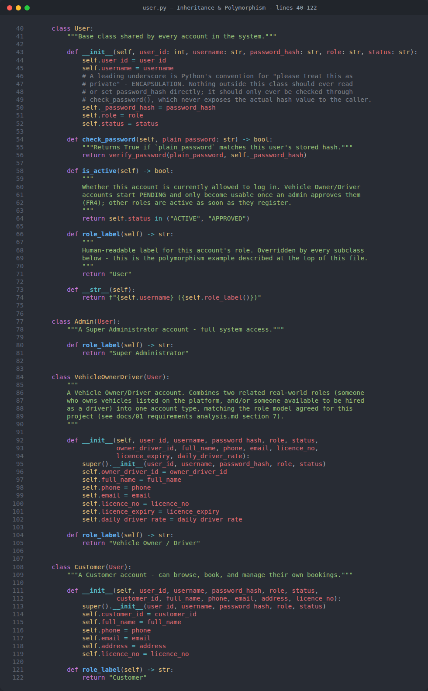
Figure 1: models/user.py - the User base class and its three subclasses (inheritance)
POLYMORPHISM is what makes inheritance genuinely useful rather than just a way to avoid retyping code. It means that different subclasses can respond to the exact same method call in their own way, and the calling code does not need to know or care which subclass it is actually holding. This project uses polymorphism in a very practical, visible place: cli/public_menu.py, right after a successful login, needs to decide which dashboard to show. Instead of writing a fragile chain of string comparisons like `if user.role == "ADMIN": ... elif user.role == "OWNER_DRIVER": ...`, it simply asks Python "what concrete type of object is this?" using isinstance(), and routes accordingly:
if isinstance(user, Admin): admin_menu.run(user) - and so on for VehicleOwnerDriver and Customer. Each subclass also overrides role_label() to return its own display text ("Super Administrator", "Vehicle Owner/Driver", "Customer") - the login screen calls user.role_label() without any idea which subclass it is talking to, and gets back the right label every time.

4.3 Design Pattern: Singleton
A SINGLETON is a design pattern that guarantees a class can only ever have ONE object (instance) for the entire lifetime of the running program, no matter how many times code asks for it. This project uses the Singleton pattern in two places, for a very concrete, practical reason: there must only ever be ONE open connection to the SQLite database file at a time, and only ONE object representing "the running rental system" coordinating startup and shutdown.
database/db_connection.py's DatabaseConnection class is the clearest example. Every part of the codebase that needs to talk to the database calls DatabaseConnection.get_instance() rather than creating a new connection object directly. The very first call actually opens the SQLite file and creates the connection; every call after that - from anywhere else in the whole project - receives that exact same object back, instead of opening a second, wasteful, potentially conflicting connection.
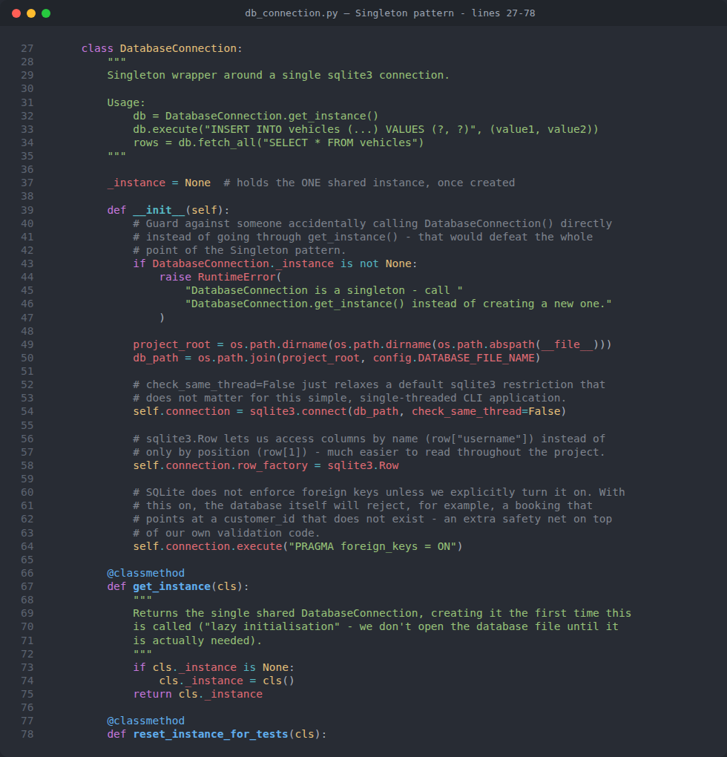
Figure 2: database/db_connection.py - the Singleton pattern implemented for the one shared database connection
Notice the pattern's two key ingredients in the screenshot: a private class-level variable (_instance) that starts as None, and a get_instance() classmethod that creates the real object only the first time it is called, and simply returns the already-existing one on every call after that. services/rental_system.py's RentalSystem class uses the exact same pattern for the same reason - the whole application should only ever be "started" once.

4.4 Design Pattern: Observer - the Smart Waitlist + Auto-Notify Feature
The OBSERVER pattern describes a one-to-many relationship between one "Subject" object and many "Observer" objects that are watching it. When something the observers care about happens to the Subject, the Subject tells every observer about it - without the Subject needing to know anything about WHAT each observer will actually do with that information. This keeps the two sides loosely coupled: a Vehicle only ever needs to know "call on_vehicle_available() on each of my observers", never "customer_gita specifically cares about this Tucson, so print a message that mentions her by name".
This is the project's chosen INNOVATIVE FEATURE (every rubric for this kind of assignment asks for one original idea beyond the base requirements): the Smart Waitlist + Auto-Notify system. If a customer wants to book a vehicle that is already taken for their dates, instead of just being told "no", they can join that vehicle's waitlist. The moment that vehicle becomes AVAILABLE again for any reason (the existing booking is completed, cancelled, or rejected), the system automatically works out who has been waiting longest for exactly that vehicle, and notifies them - with no administrator needing to remember to do it manually.
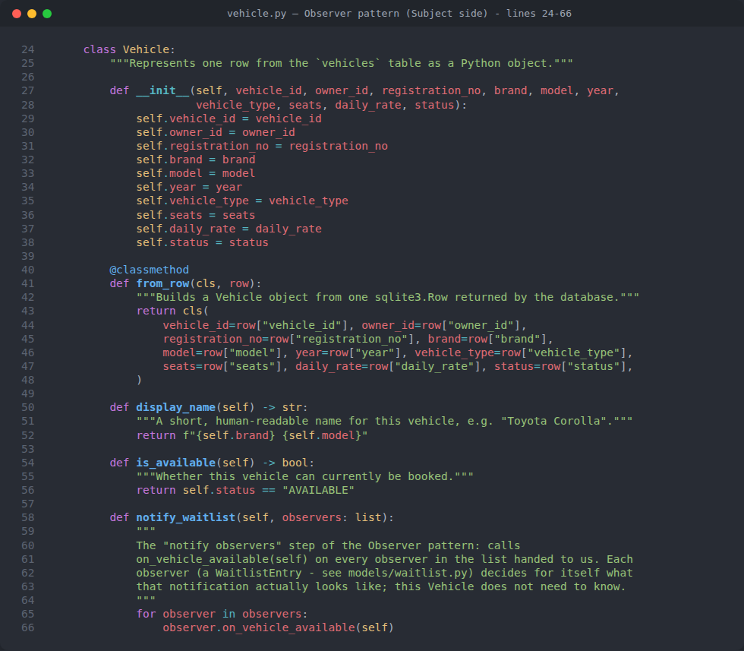
Figure 3: models/vehicle.py - Vehicle as the Observer pattern's "Subject"
Vehicle.notify_waitlist() (above) is deliberately simple - it is handed a list of observers by the calling service, and just loops through calling on_vehicle_available() on each one. The Vehicle class itself does not need to know how many people are waiting, who they are, or what a notification message should say.
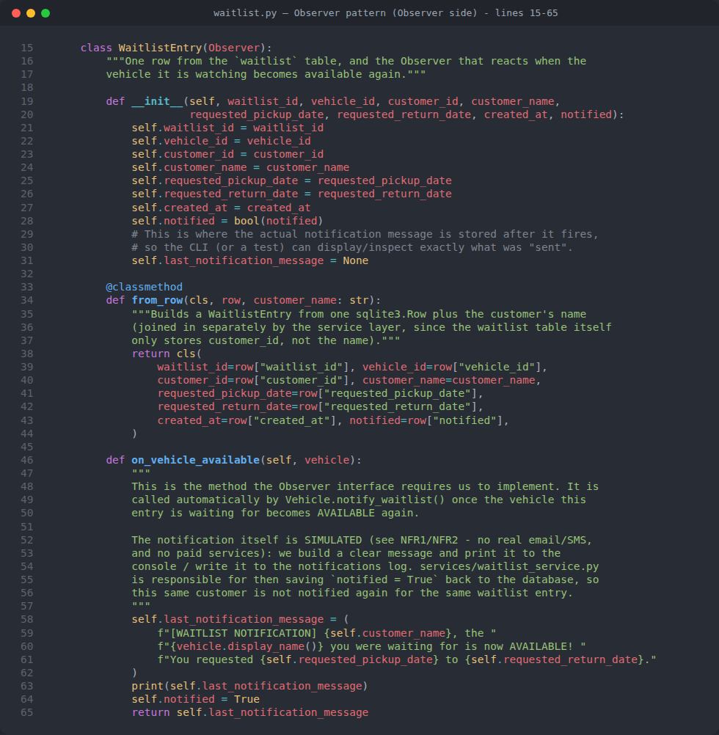
Figure 4: models/waitlist.py - WaitlistEntry as the concrete Observer, and models/observer.py's abstract interface
WaitlistEntry (above) is the concrete Observer: it inherits from the abstract Observer interface (defined using Python's built-in abc module - a class that inherits from ABC and marks a method with @abstractmethod cannot be created at all unless every subclass implements that method, which is Python's version of a formal "interface" as seen in Java or C#), and its on_vehicle_available() method is where the actual notification message gets built, printed, and remembered.
services/waitlist_service.py is the piece that ties the two sides together at exactly the right moment: whenever a booking is cancelled, rejected, or completed (see services/booking_service.py's _free_up_vehicle_and_notify_waitlist() helper), it loads every not-yet-notified waitlist entry for that vehicle from the database, sorted oldest-first (a FIFO queue), and hands the SINGLE oldest one to the vehicle's notify_waitlist() method. Chapter 9.12 of this report shows this feature actually firing, live, in a real terminal session - the notification line appears in yellow in the screenshot there.

4.5 Custom Decorator: @author_info
A DECORATOR is a function that wraps another function or class to add extra behaviour to it, without needing to change that function or class's own code. Python has built-in decorators (like @staticmethod and @classmethod, both also used elsewhere in this project), but this assignment also asks students to demonstrate writing a CUSTOM decorator of their own.
utils/author_decorator.py defines author_info(name, student_id, institution) - a "decorator factory": a function that returns the actual decorator, pre-configured with Anish's own details. It is applied directly above the RentalSystem class in services/rental_system.py, and attaches three real attributes onto that class the moment the file is imported: __author__, __student_id__, and __institution__.
Why does this matter, rather than just being decoration for decoration's sake? cli/about_screen.py (Chapter 9.2) proves the decorator genuinely did something, by reading those three attributes directly OFF the RentalSystem class at runtime and printing them - rather than importing config.STUDENT_NAME a second time and typing it out again by hand. If the decorator were removed, that part of the About screen would print "n/a" instead, which is an honest, visible way to demonstrate the decorator is real, working code, not just an unused example.

4.6 Abstraction
ABSTRACTION means describing WHAT something must be able to do, without saying HOW it does it. The Observer abstract base class (models/observer.py) is this project's clearest example: it declares that anything calling itself an Observer MUST implement on_vehicle_available(self, vehicle), but has no idea, and does not need to have any idea, what any real implementation of that method will actually do. This lets the Vehicle (Subject) side of the Observer pattern be written once, and work correctly with ANY future Observer class that might be added later, as long as it honours that one abstract contract.

4.7 Why These Concepts Were Chosen
- Inheritance/polymorphism (the three User subclasses) directly satisfies the assignment's core "model this business with proper OOP class relationships" requirement.
- Singleton solves a real, concrete problem this specific project actually has (one shared database connection), rather than being forced in for its own sake.
- Observer is what actually implements the project's required innovative feature (Smart Waitlist + Auto-Notify), so the pattern is load-bearing, not decorative.
- The custom decorator satisfies the course's Decorators topic (see the project's Decorators.pptx lecture material) with a genuine, provable use case.

5. System Architecture & Complete Project Structure

5.1 Layered Architecture
The whole project is organised into four clear layers, each only allowed to depend on the layer(s) below or beside it, never upward. This is a very common, well-understood way to structure a non-trivial application, and it is what makes the codebase possible to navigate, test, and change safely.
- cli/ (Presentation layer): Everything the person using the program actually sees and types into - menus, prompts, tables. Contains NO business rules of its own.
- services/ (Business logic layer): Every rule about what is and is not ALLOWED lives here - checking for date conflicts, calculating cost, deciding whether a registration can be approved.
- models/ (Domain layer): The OOP classes representing the real-world things in the business - a User, a Vehicle, a Booking - and the small pieces of behaviour that belong intrinsically to that ONE thing (like Booking.calculate_cost()).
- database/ (Persistence layer): Everything to do with actually storing and retrieving data from the SQLite file - table definitions, the shared connection, the demo seed data.
utils/ sits alongside all four layers as a small set of shared, dependency-free helper functions (validation, password hashing, currency/table formatting, the custom decorator) that any layer may use.
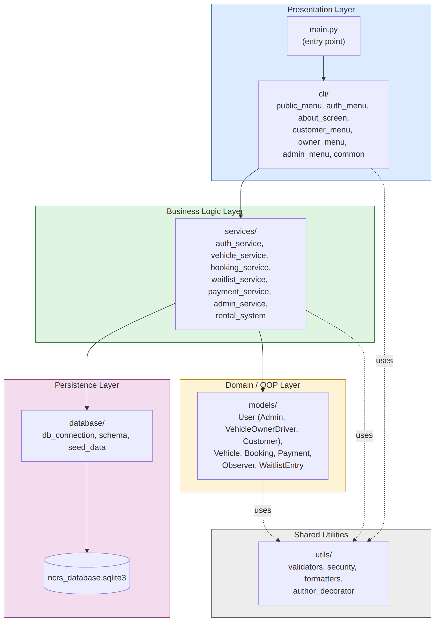
Figure 5: The four-layer architecture of NCRS, and which folders sit in each layer

5.2 Complete Folder & File Guide
The table below explains the purpose of every single folder and file in the project, in the order they would appear in a normal file browser. Folders are shown in bold and shaded; every file underneath its own folder heading belongs to that folder.
Folder / File | What It Is and What It Does
main.py | Application entry point. Boots the RentalSystem singleton, shows the welcome menu, and safely handles Ctrl+C.
config.py | Central configuration constants: assignment/course/student details, registration keywords, currency symbol, default rate per km, database file name.
requirements.txt | The two third-party packages this project uses (tabulate, pytest) and their exact pinned versions.
.gitignore | Keeps generated files (__pycache__/, the SQLite database file, .venv/) out of version control.
LICENSE | The full text of the MIT Licence this project is released under.
README.md | The project's own quick-start guide: install/run steps, demo login credentials, file guide, known issues, licence.
models/ | The OOP domain classes - pure data plus business rules, with no database or CLI code inside them.
models/user.py | User base class plus Admin, VehicleOwnerDriver, Customer subclasses - the project's inheritance and polymorphism example.
models/vehicle.py | Vehicle - also the Subject side of the Observer pattern (notify_waitlist()).
models/booking.py | Booking - status lifecycle (confirm/cancel/complete) and the calculate_cost() pricing formula.
models/payment.py | Payment - a simple record of one simulated payment against a booking.
models/observer.py | Observer - the abstract interface (using Python's abc module) that every concrete observer must implement.
models/waitlist.py | WaitlistEntry - the concrete Observer that reacts when a vehicle it is watching becomes available.
services/ | Business logic. Every rule about what is allowed lives here, never inside a CLI screen.
services/auth_service.py | Login, all three registration flows, and both self-service and admin-driven password resets.
services/vehicle_service.py | Vehicle CRUD (add/update/delete), searching, and browsing.
services/booking_service.py | Booking creation, availability/conflict checking, cost calculation, and the booking status lifecycle.
services/waitlist_service.py | Joining a waitlist and the FIFO auto-notify logic - the Observer pattern's "notify" step.
services/payment_service.py | Recording and listing simulated payments.
services/admin_service.py | Registration approval/rejection, the masked user list, system statistics, and "Reset Test Data".
services/rental_system.py | RentalSystem - the Singleton that boots the database and seed data, decorated with @author_info.
database/ | Everything to do with persistence (SQLite).
database/db_connection.py | DatabaseConnection - the Singleton wrapping the one shared SQLite connection used everywhere.
database/schema.py | The CREATE TABLE statements for every table in the database.
database/seed_data.py | Inserts the ~29-row demo dataset the very first time the database is empty.
cli/ | The text menus the user actually sees and types into - the presentation layer.
cli/common.py | Shared input handling (read_input, read_menu_choice, confirm_yes_no) so every screen understands the same navigation commands.
cli/public_menu.py | The welcome screen (login/register/browse/about), and role dispatch after a successful login.
cli/auth_menu.py | Login, forgot-password, and the three registration sub-flows.
cli/about_screen.py | The "About" screen - academic cover details plus live @author_info decorator metadata.
cli/customer_menu.py | The Customer dashboard: browse, search, book, pay, join a waitlist, change password.
cli/owner_menu.py | The Vehicle Owner/Driver dashboard: manage own vehicles, view own vehicles' waitlists.
cli/admin_menu.py | The Super Administrator dashboard: users, registrations, bookings, payments, statistics, rate-per-km, "00 Reset Test Data".
utils/ | Small, shared, dependency-free helper functions used across the whole project.
utils/validators.py | Every input-checking rule used across the whole CLI (dates, positive numbers, non-empty text, and so on).
utils/security.py | Salted password hashing/verification and temporary-password generation.
utils/formatters.py | Currency formatting, table formatting (via tabulate), and the masked-password placeholder.
utils/author_decorator.py | The custom @author_info decorator that attaches authorship metadata to a class.
web/ | A second, browser-based front end (Chapter 10) - an ADDITION alongside the CLI, not a replacement. Calls the exact same services/ functions, against the exact same database, as cli/ does.
web/app.py | The Flask application: every route (URL + page) the browser can request, session-based login, and the demo-login/registration-keyword display data.
web/templates/ | Jinja2 HTML templates - one per page, all extending base.html for a shared header/footer/flash-message layout.
web/static/style.css | The one stylesheet shared by every page - plain CSS, no build step, no JavaScript framework.
web/manual_web_check.py | A small standalone script used during development to sanity-check the web routes without opening a browser.
tests/ | The automated pytest suite - 86 tests, none of which ever touch the real database file.
tests/conftest.py | The clean_database fixture: a fresh, temporary, pre-seeded database for every single test.
tests/test_validators.py | Tests for every validation rule (good input accepted, bad input rejected).
tests/test_security.py | Tests for password hashing/verification.
tests/test_booking_cost.py | Tests for the pricing formula and the booking status lifecycle.
tests/test_booking_conflict.py | Tests for date-overlap/availability checking and booking creation.
tests/test_auth_and_password_reset.py | Tests for login, registration, and both password-reset flows.
tests/test_vehicle_and_admin_service.py | Tests for vehicle CRUD and admin-only actions.
tests/test_waitlist_notify.py | Tests for the Smart Waitlist + Auto-Notify (Observer pattern) feature.
docs/ | Design and planning documents written before any code was written.
docs/01_requirements_analysis.md | The full requirements analysis: functional/non-functional requirements, business rules, architecture.
docs/02_seed_data_plan.md | The exact demo dataset seeded into the database on first run.
docs/03_maintenance_and_support_plan.md | The maintenance, versioning, and backward-compatibility plan.
docs/diagrams/ | The 5 UML/ER diagrams as editable .drawio files (open with diagrams.net).

5.3 How To Read This Project's Code (A Short Guide For Beginners)
If you have never read Python code written for a real, multi-file project before, opening main.py for the first time can feel overwhelming. This section walks through ONE small, real function from this project line by line, so the rest of the codebase reads the same way once you know the pattern.
Step 1 - find where a value comes from and where it is checked. Every value a user types anywhere in this project (a name, a date, a price) is checked by a function in utils/validators.py before anything else is done with it. The screenshot below shows three of these functions exactly as they appear in the real file.
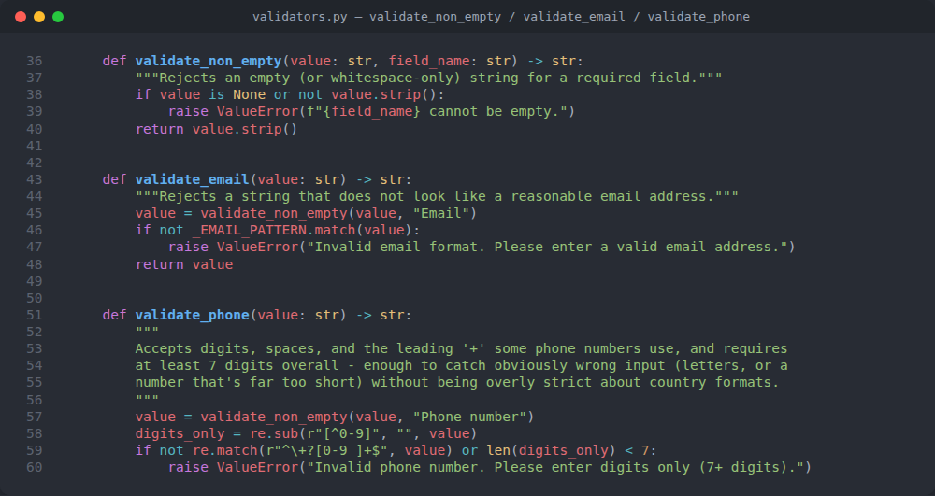
Figure 6: utils/validators.py - validate_non_empty(), validate_email(), and validate_phone(), a genuinely beginner-sized example of Python functions, string methods, and raising an exception
Reading it top to bottom, the way a beginner should:
- def validate_non_empty(value: str, field_name: str) -> str: this is a function DEFINITION. "def" means "here comes a function"; validate_non_empty is its name; (value: str, field_name: str) are its two inputs (parameters), and the hint ": str" after each one is just a note to the reader that a text string is expected - Python does not force this, it is documentation for humans (and tools). "-> str" means this function will hand back a string when it is done.
- """Rejects an empty ...""" a triple-quoted string right under the def line is a DOCSTRING - a comment explaining what the function does, that tools (and this report's generator) can read back out of the code itself.
- if value is None or not value.strip(): .strip() is a built-in string method that removes leading/trailing whitespace; "not value.strip()" is True if, after trimming, nothing is left (an empty or whitespace-only string). "value is None" additionally guards against no value being passed in at all.
- raise ValueError(f"...") this is how Python code reports "something is wrong" without crashing the whole program - it RAISES an exception (a signal that travels up to whoever called this function) carrying a clear message. The f"..." is an f-string: the {field_name} inside it is automatically replaced with the actual value of that variable.
- return value.strip() if nothing went wrong, the function hands back the cleaned-up (trimmed) value to whoever called it.
- validate_email() calling validate_non_empty() this is functions calling OTHER functions - validate_email() does not repeat the empty-check logic, it reuses validate_non_empty() and then does its own extra check on top (the @-and-domain pattern). This "do not repeat yourself" habit appears throughout the whole project.
Every OTHER function in this project - however long - follows this exact same shape: a docstring saying what it is for, some checks, and either a return value or a raised ValueError. Once this pattern is familiar, the services/ and models/ files (which are longer, but not structurally different) become far less intimidating. A practical way to keep learning: open one file at a time in VS Code, read its top-of-file docstring first (every file in this project has one, explaining WHAT it is for), then read one function at a time, and use the project's own docs/01_requirements_analysis.md and this report's Chapter 4 to connect what you are reading back to the OOP concept it demonstrates.

6. Database Design

6.1 Why SQLite Instead of MySQL
SQLite was chosen over a server-based database such as MySQL for one overriding reason: the assignment's non-functional requirements (NFR1-NFR4) explicitly demand that the whole project run completely offline, with no external server to install and no extra setup step beyond running one Python file. SQLite is built directly into Python's own standard library (the sqlite3 module) - there is nothing extra to install for the database engine itself, and the entire database really is just one ordinary file on disk (ncrs_database.sqlite3), which can be zipped up, emailed, or copied to a USB stick along with the rest of the project and it will just work on the next machine.
A MySQL (or PostgreSQL, SQL Server, etc.) database, by contrast, requires a separate server process to be installed, configured, started, and kept running independently of the Python program - a real, meaningful extra burden for markers or anyone else trying to run this project, and something that would have added a hard dependency on network access even on the SAME machine. For a single-user academic CLI demonstration project of this size, SQLite is simply the right tool: it fully supports SQL (tables, foreign keys, joins, transactions), and every query written for it (see database/db_connection.py's execute()/fetch_one()/fetch_all() helpers) uses PARAMETERIZED queries (the `?` placeholder syntax) throughout, specifically to prevent SQL injection - the exact same defensive habit a real production system would need, just running against a simpler engine.

6.2 Entity-Relationship (ER) Diagram
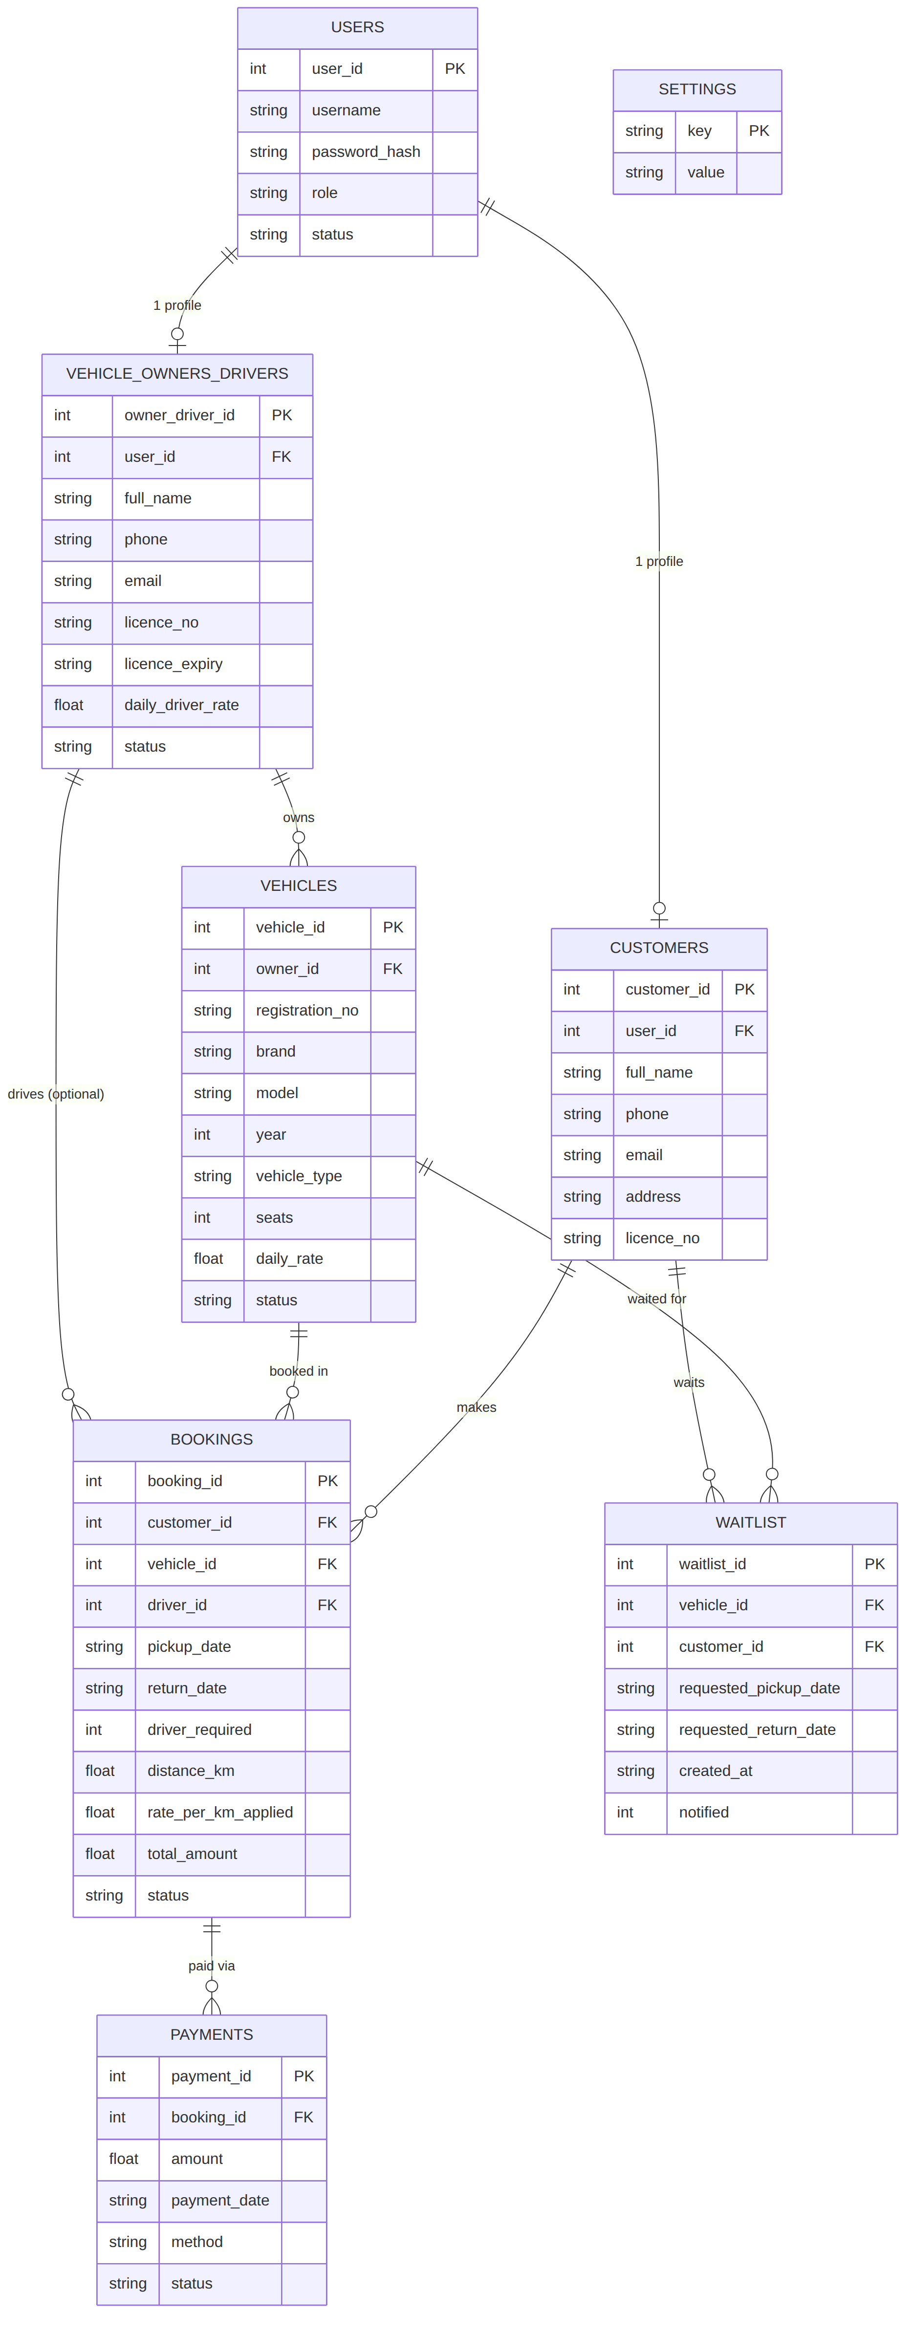
Figure 7: Entity-Relationship diagram for every table in the NCRS database
Each box in the diagram above is one real SQLite table (see database/schema.py for the exact CREATE TABLE statements). The tables are:
- users: One row per LOGIN account (any role) - username, the salted password hash, role, and status.
- customers / vehicle_owners_drivers: A one-to-one "profile" row extending a users row, holding the extra details specific to that role (full name, phone, licence number, and so on).
- vehicles: One row per car in the fleet, linked to the owner who listed it.
- bookings: One row per rental request, linked to the customer, the vehicle, and (optionally) the hired driver.
- payments: One row per simulated payment, linked to the booking it was paid against.
- waitlist: One row per customer waiting for one specific vehicle - the persisted form of "who is currently observing this vehicle" for the Observer pattern (Chapter 4.4).
- settings: A tiny key/value table holding the one system-wide setting this project has: the current rate per km.

6.3 Class Diagram
The class diagram below shows every Python class in the project's models/ and services/ layers, their attributes and methods, and how they relate to each other - including both design patterns from Chapter 4 (marked <<Singleton>> and <<interface>>).
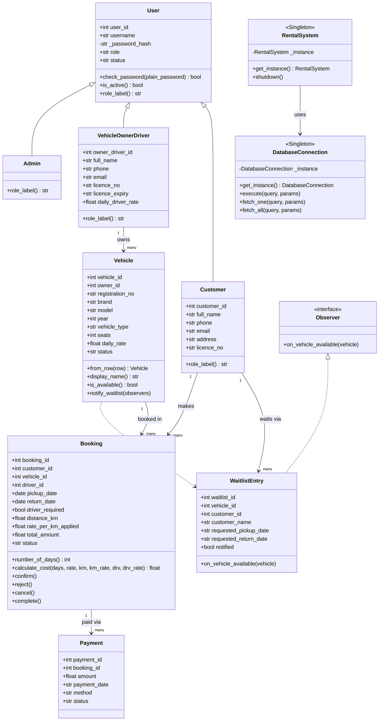
Figure 8: UML class diagram: every model and service class, and their relationships

7. How Things Work: Use Case & Sequence Diagrams

7.1 Use Case Diagram
The use case diagram below shows every significant action each of the three user roles (plus an unauthenticated guest) can perform in the system, at a glance.
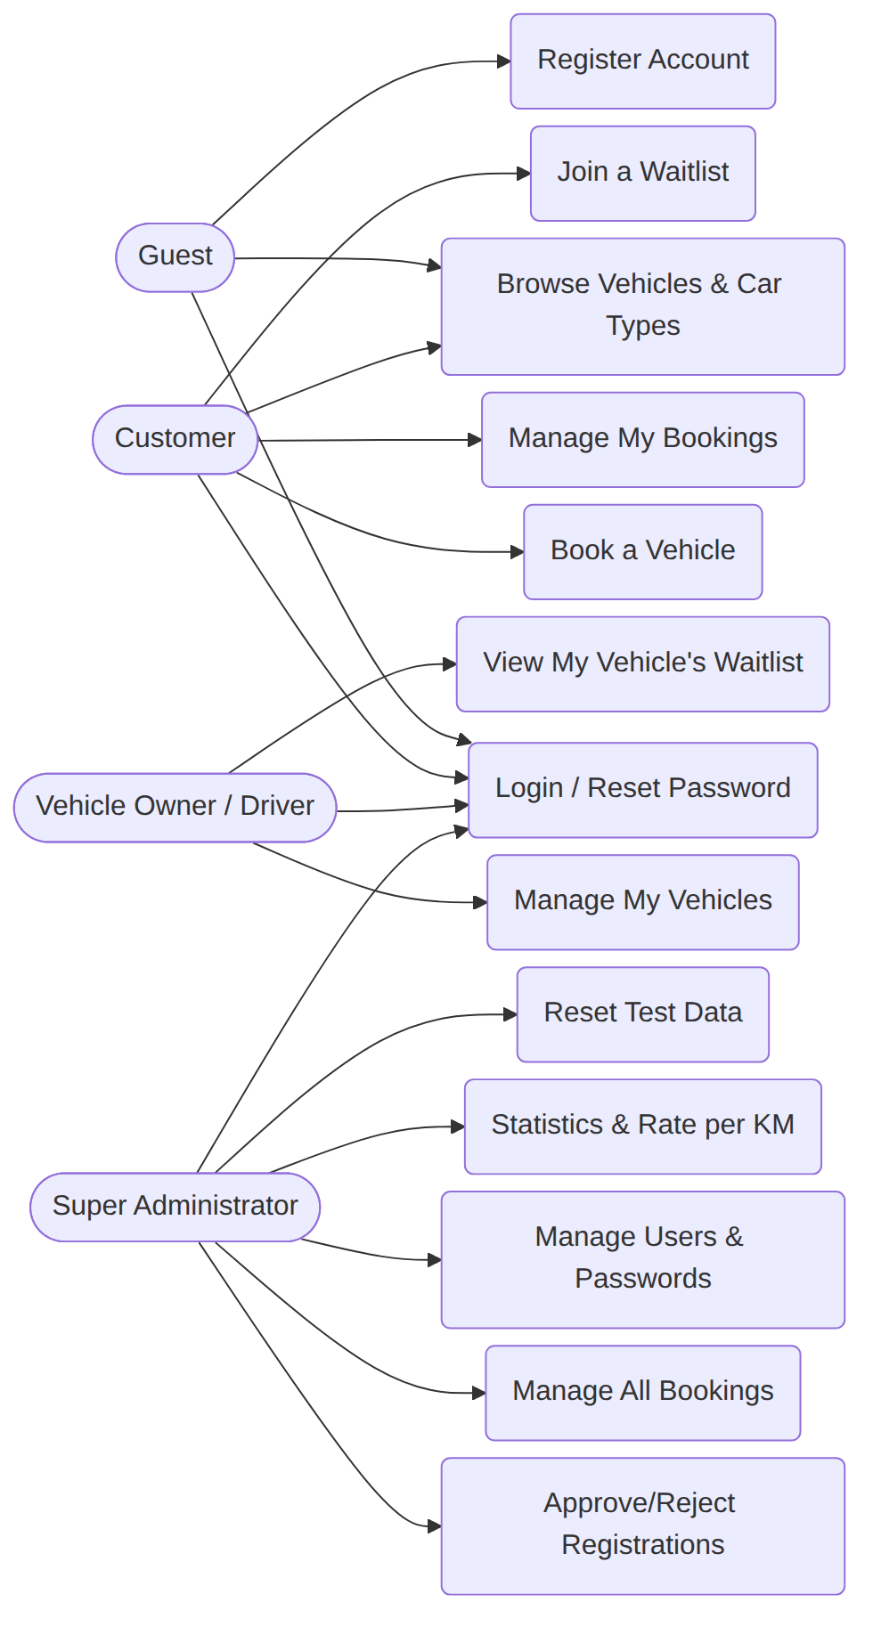
Figure 9: Use case diagram: every action each role can perform

7.2 Sequence Diagram - Making a Booking
A sequence diagram shows the exact ORDER that different parts of the system talk to each other for one specific scenario, over time (top to bottom). The diagram below traces a real booking from start to finish: the customer browses vehicles, the CLI asks booking_service.py to check availability, the availability check queries the database directly for any overlapping PENDING/CONFIRMED/ACTIVE booking, the cost is calculated by calling Booking.calculate_cost() (a staticmethod on the model itself - Chapter 11 explains this formula in full), and finally the new booking is inserted as PENDING, awaiting an administrator's approval.
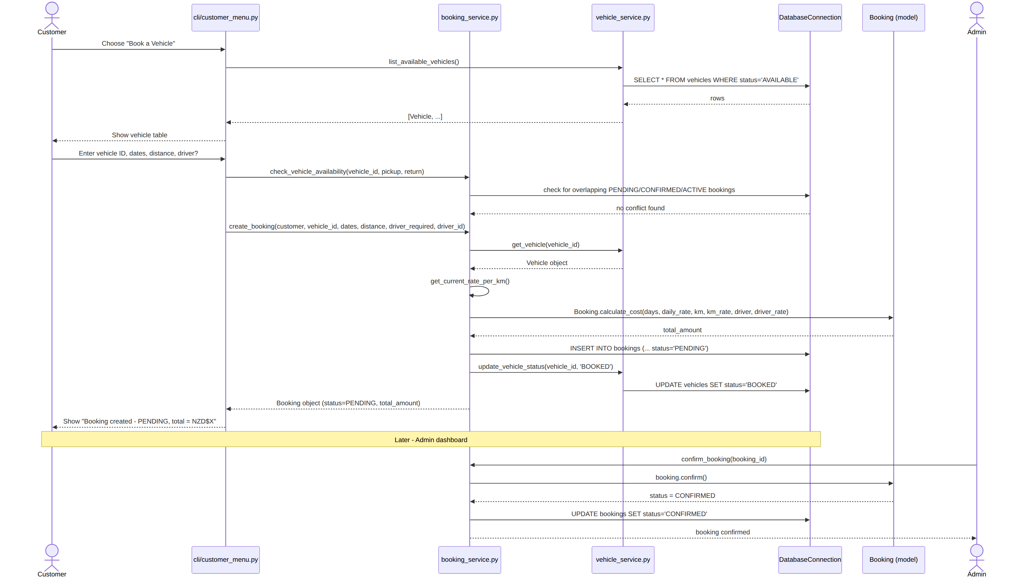
Figure 10: Sequence diagram: creating a booking, from vehicle browsing through to admin confirmation
The "check availability" step in that diagram is the one algorithm every booking (and every waitlist join) in this whole project depends on: two date ranges overlap exactly when each one starts before the other ends. The real SQL and Python implementing this rule are shown below.
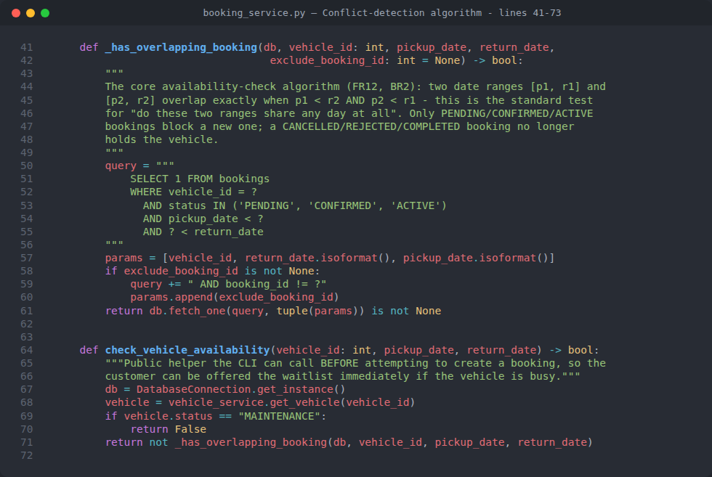
Figure 11: services/booking_service.py - _has_overlapping_booking() (the date-overlap algorithm behind FR12/BR2) and check_vehicle_availability()

7.3 Sequence Diagram - Waitlist Auto-Notify (Observer Pattern in Motion)
This second sequence diagram traces the Observer pattern feature from Chapter 4.4 end-to-end: a customer joins a waitlist because their first choice is unavailable, time passes, and then an administrator cancels or completes the ORIGINAL booking on that vehicle - which is the exact moment the Subject (the Vehicle) notifies the Observer (the waiting customer's WaitlistEntry), entirely automatically, with no separate admin action required to "remember" to tell anyone.
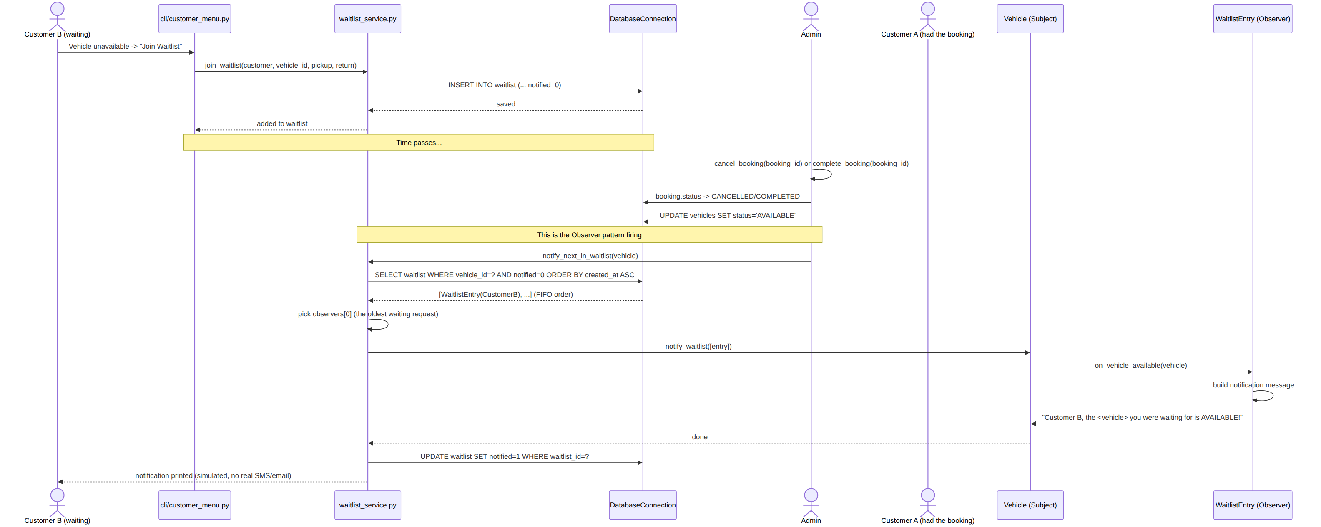
Figure 12: Sequence diagram: the Observer pattern firing automatically when a waitlisted vehicle becomes available

8. Installation & Running the Project (Fully Offline)

8.1 What You Need
Nothing beyond what is listed in Chapter 3.1 - specifically, Python 3.10 or later, and no internet connection at any point. The two third-party packages the project uses (below) are small, free, and only need to be installed ONCE; after that, the program never needs network access again, ever, including every later run.

8.2 Third-Party Packages, and Why Each One Is Needed
Package | Version | Why It Is Needed
tabulate | 0.9.0 | Formats vehicle/booking/payment lists as clean, aligned text tables in the terminal (see utils/formatters.py), instead of hand-padding strings with spaces, which is fragile and hard to read.
pytest | 8.3.3 | Runs the automated test suite in tests/ (Chapter 12) - not required to RUN the app itself, only to run its 86 automated tests.
Nothing else needs to be installed - every other piece of functionality (the database engine, password hashing, dates, abstract base classes) comes from Python's own standard library, which is already part of any normal Python installation.

8.3 Step-by-Step: Installing and Running
- 1. Extract the project zip file (or copy the folder) anywhere on your computer - no installer, no setup wizard.
- 2. Open a terminal / command prompt inside that folder (in VS Code: right-click the folder -> "Open in Integrated Terminal", or use File Explorer's "Open in Terminal").
- 3. Run: pip install -r requirements.txt (this is the ONLY step that briefly needs an internet connection, and only the very first time).
- 4. Run: python main.py
- 5. On this very first run, the program automatically creates the local ncrs_database.sqlite3 file and fills it with realistic demo data (Chapter 8.5) - there is nothing to set up by hand.
- 6. The main menu appears immediately. From here on, everything is offline, forever - even unplugging the network cable makes no difference at all.
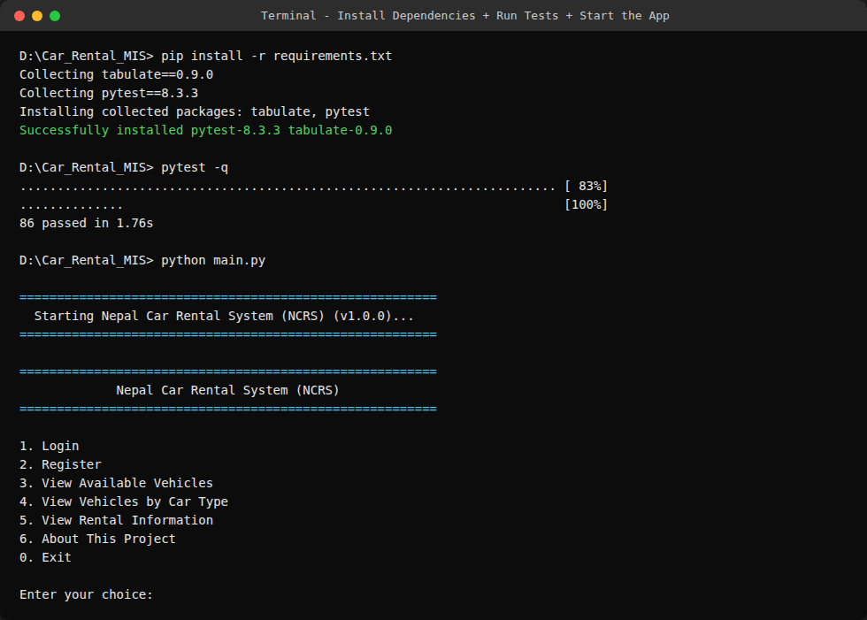
Figure 13: A real terminal session: installing the two packages, running the automated test suite (86 passed), then starting the application

8.4 Running the Automated Tests
The test suite needs nothing beyond the same pip install -r requirements.txt step above. Run pytest from the project folder; all 86 tests are expected to pass (see Chapter 12 for what they actually check). The tests build their own temporary, throwaway database for every single test (see tests/conftest.py), so running them never touches, or risks corrupting, your real ncrs_database.sqlite3 file.

8.5 Default Login Credentials
On first run, the program seeds 6 demo accounts automatically, so there is something real to explore immediately with no manual registration needed. These are the fastest way in:
Role | Username | Password | What To Try After Logging In
Super Administrator | admin_ncrs | Admin@123 | The most powerful account - manage users, approve owners, manage every booking/payment, set the rate per km, reset test data.
Vehicle Owner/Driver (approved) | owner_ram | Owner@123 | Owns 6 of the 10 demo vehicles - can list a new vehicle, change rates/status, view his waitlists.
Vehicle Owner/Driver (pending) | owner_hari | Owner@123 | Deliberately left PENDING - logging in is rejected until admin_ncrs approves the account.
Hired driver | driver_bikash | Driver@123 | Appears as the assigned driver on Booking A (the Tucson).
Customer | customer_sita | Customer@123 | Has a CONFIRMED upcoming Tucson booking and a COMPLETED past Corolla booking with a paid payment.
Customer | customer_gita | Customer@123 | Has an ACTIVE Scorpio rental, and is waitlisted for the Tucson - useful for demonstrating auto-notify.
Tip: you can also browse "View Available Vehicles" and "View Vehicles by Car Type" straight from the welcome menu without logging in at all - no account needed for that (FR7).

8.6 Universal Navigation Commands
Every single prompt in the whole program understands the same small set of commands, handled by one shared function (cli/common.py's read_input()) so no screen ever invents its own rules:
Key | What It Does
0 | Back / Logout / Exit, depending on which menu you are at.
00 | Reset all demo data back to its original starting state (Super Administrator dashboard only, with a Yes/No confirmation first).
H | Show a short help message explaining the field you are currently being asked for.
C | Cancel the CURRENT multi-step form (e.g. abort filling in a booking halfway through) and return to the previous menu, without logging out.
Ctrl+C | Safely exit the program at any time, from anywhere, with a clean shutdown message rather than a crash (NFR8).

8.7 Getting the Code: Zip File or Git Clone
There are two equally valid ways to get a working copy of this project onto your own computer - use whichever is more convenient. Both end up in exactly the same place: a folder containing main.py, ready for the steps in Chapter 8.3.
Option A - From the submitted zip file: this is Chapter 8.3, Step 1 above - simply extract the zip file anywhere on your computer. No git, no internet connection, no account of any kind is needed for this option.
Option B - By cloning the git repository: if the project is also kept under version control (recommended practice - see the project's Version Control lecture material), it can instead be obtained with:
git clone https://github.com/anishnz/car_rental_assgignment_yoobee_270889991.git
then cd car_rental_assgignment_yoobee_270889991 and continue from Step 3 of Chapter 8.3 (installing the two packages). Note: replace the URL above with this project's actual repository address if it differs - insert your own git repo link here before final submission if the address above is not the one you are using.
Either option produces an identical folder. Cloning from git is only slightly more convenient when the project changes over time (Chapter 15 - Maintenance & Support), because git tracks exactly what changed between versions, whereas a zip file is a one-time snapshot with no history of its own.

9. Complete User Guide - The Command-Line Interface, Screen by Screen
Every screenshot in this chapter is a REAL captured terminal session from the actual working program (not a mock-up) - a small script was used to type the exact inputs shown, so what you see typed after each prompt is genuinely what that scenario needs. Success messages appear in green, the one automatic waitlist notification appears in yellow, and error-style messages appear in red, purely to make the transcripts easier to read.

9.1 The Welcome / Public Menu
This is the very first screen anyone sees when the program starts - cli/public_menu.py. Nobody needs an account to browse vehicles, car types, or rental information; only logging in or booking a car requires one.
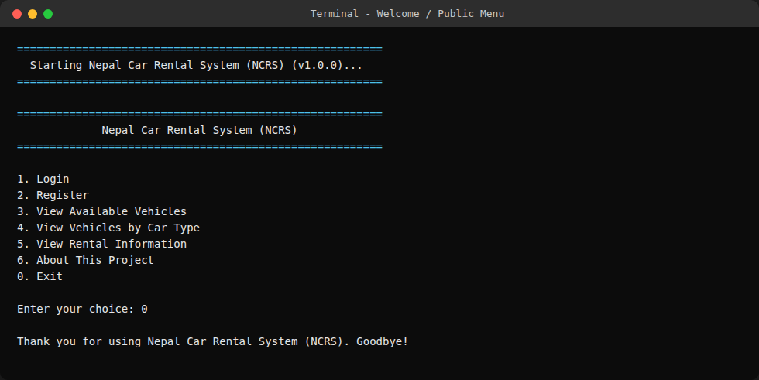
Figure 14: The welcome / public menu, the first screen shown on startup

9.2 The About Screen
Option 6 shows the academic cover details for this exact assignment, read live from config.py, followed by the three attributes the custom @author_info decorator (Chapter 4.5) attached to the RentalSystem class at import time - proof the decorator is doing genuine work.
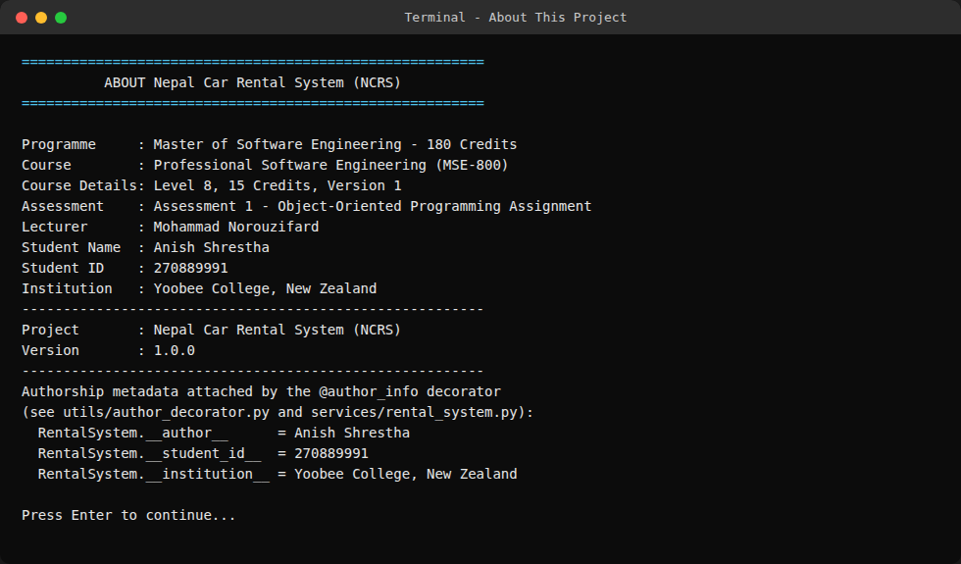
Figure 15: The About screen, including the live @author_info decorator metadata

9.3 Registering a New Account
Option 2 offers three registration paths, one per role, each gated by its own keyword (config.py's ADMIN_KEYWORD, VEHICLE_OWNER_DRIVER_KEYWORD, and CUSTOMER_KEYWORD - see FR1). In a real production system these keywords would be replaced by a proper invite/approval workflow; for this academic demo they are a simple, explainable way to prove which role a new account should get. Every field on every registration form is REQUIRED - there are no optional fields on any of the three forms - and both the CLI and the web interface (Chapter 10) now label every prompt "(required)" and print the exact keyword to type, directly on the form itself, so nobody has to guess or hunt through a README to find it.
Customer registration - every required field, in order:
Field (required) | Example
Full Name | Bishal Adhikari
Username | bishal_test
Email | bishal@example.com
Phone | 9800011111
Address | Lalitpur, Nepal
Driving Licence Number | NP-DL-3001
Password | (hidden while typing)
Customer Keyword | customer
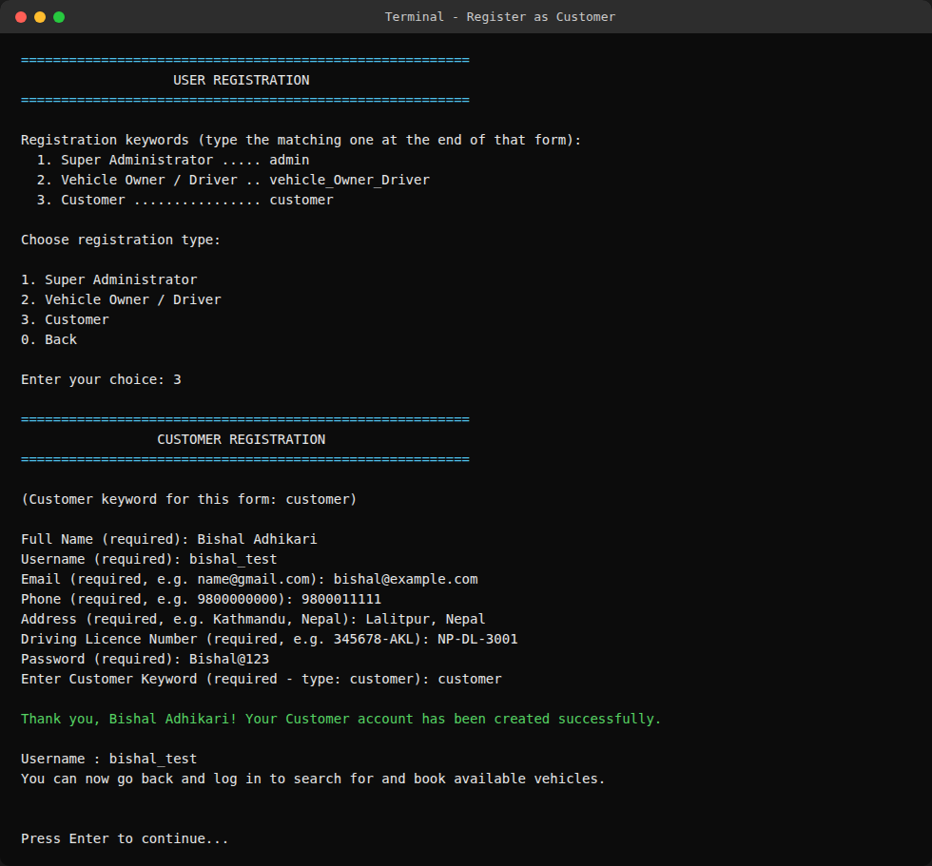
Figure 16: CLI: registering a new Customer account, with the keyword hint and "(required)" labels visible on every field
Vehicle Owner/Driver registration - every required field, in order:
Field (required) | Example
Full Name | Suresh Lama
Username | suresh_owner
Phone | 9800022222
Email | suresh.lama@example.com
Driving Licence Number | NP-LIC-9001
Licence Expiry Date | 2029-05-01
Daily Rate If Hired As A Driver | 70 (enter 0 if you only list vehicles)
Password | (hidden while typing)
Registration Keyword | vehicle_Owner_Driver
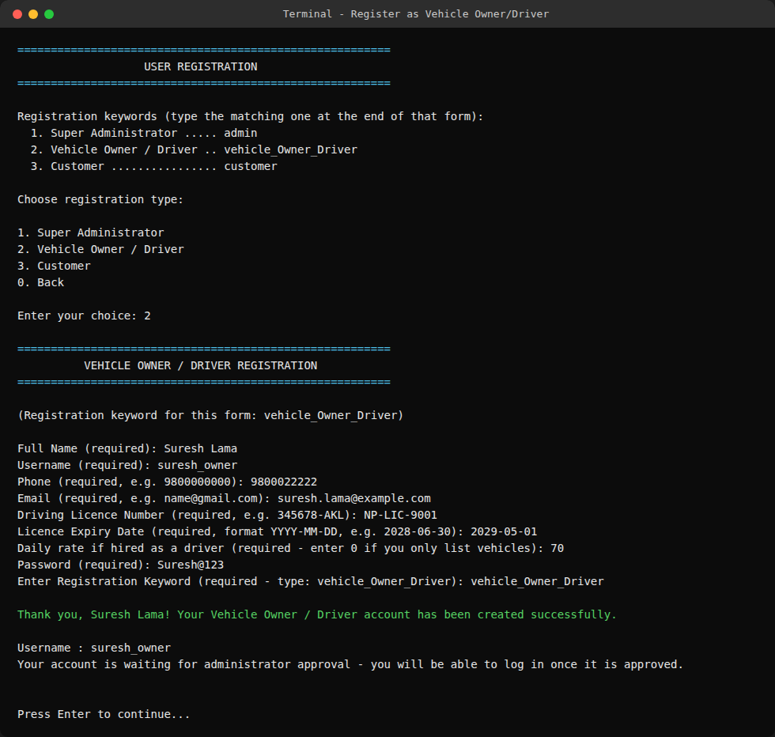
Figure 17: CLI: registering a new Vehicle Owner/Driver account (starts PENDING until admin approval, per FR4)
Super Administrator registration - every required field, in order:
Field (required) | Example
Full Name | Anish Shrestha
Username | anish_admin2
Email | anish2@example.com
Phone | 9800033333
Password | (hidden while typing)
Administrator Keyword | admin
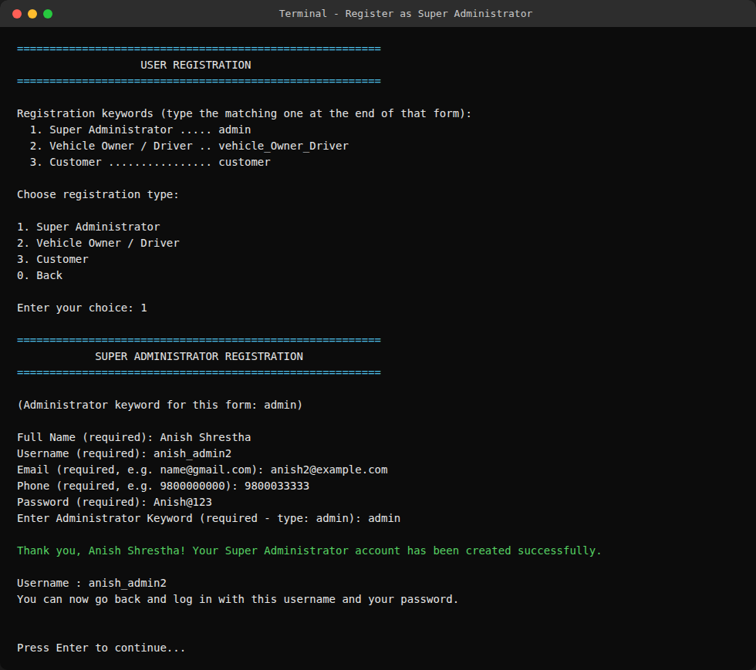
Figure 18: CLI: registering a new Super Administrator account
The same form, from a browser: Chapter 10.5 shows this exact Customer registration form again, filled in with the same example data, from the web interface - side by side, the two forms ask for identical fields in an identical order, because both call the same auth_service.register_customer() function underneath.
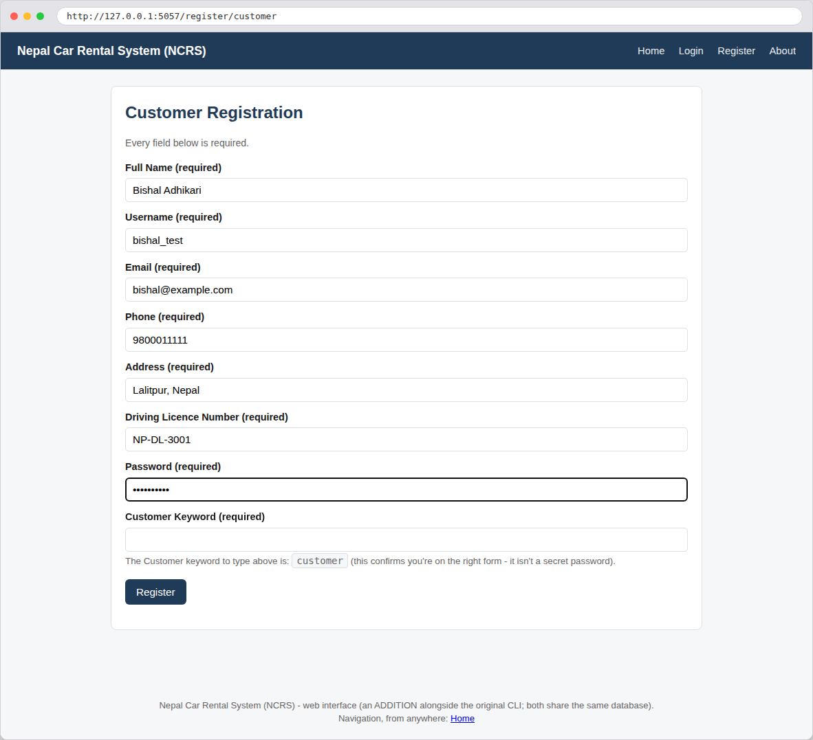
Figure 19: Web: the same Customer registration form, showing the same required fields, the same keyword hint, and the same example data as the CLI screenshot above

9.4 Logging In and Reaching Your Dashboard
Option 1 is login. On success, cli/public_menu.py's polymorphic isinstance() dispatch (Chapter 4.2) sends the user straight to the correct dashboard for their role - a Customer never sees the Admin menu, and vice versa.
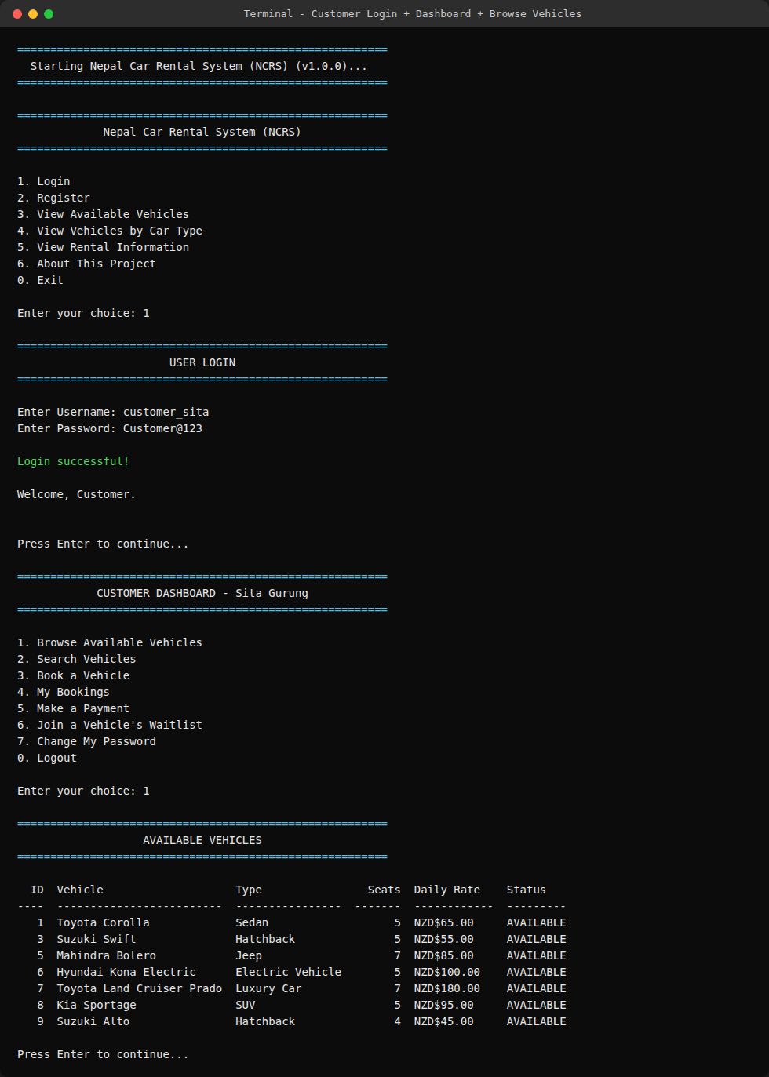
Figure 20: Logging in as a Customer, reaching the Customer Dashboard, and browsing available vehicles
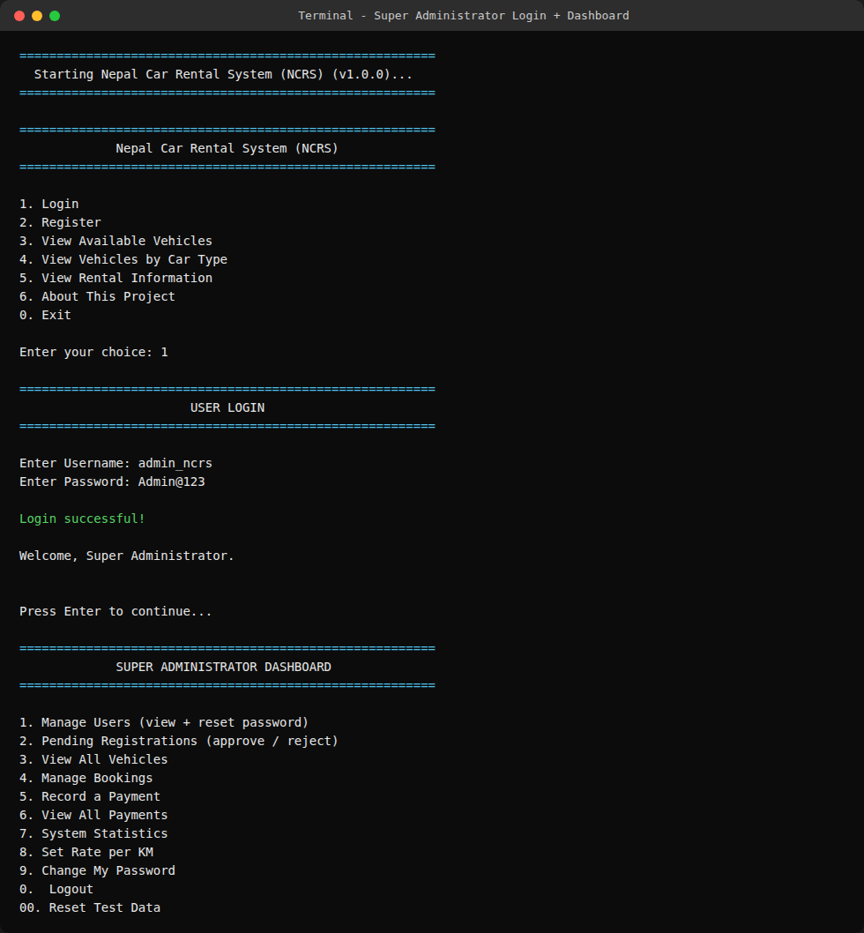
Figure 21: Logging in as the Super Administrator and reaching the Administrator Dashboard

9.5 Booking a Vehicle, With a Driver, and the Cost Calculation
This is the heart of the whole system (FR10-FR13). The customer picks a vehicle, a pickup date, a return date, an estimated distance, and whether they need a driver as well. Before the booking is created, the system checks the requested dates do not overlap any existing PENDING/CONFIRMED/ACTIVE booking on that same vehicle (FR12, BR2), then calculates the exact total cost and shows it BEFORE the booking is finalised (FR13). Chapter 11 walks through this exact calculation by hand.
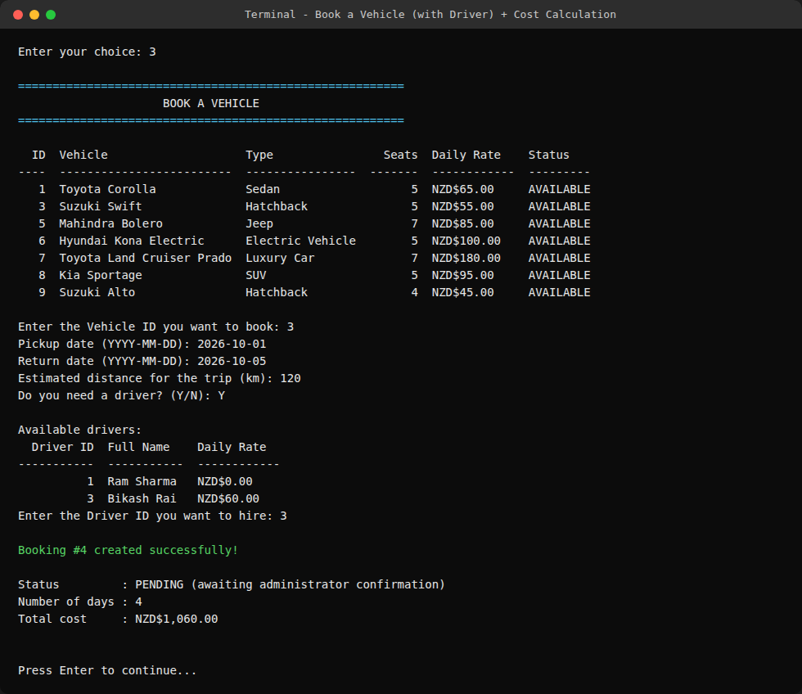
Figure 22: Booking the Suzuki Swift for 4 days with a hired driver - total cost calculated and shown as NZD$1,060.00

9.6 Viewing and Cancelling My Bookings
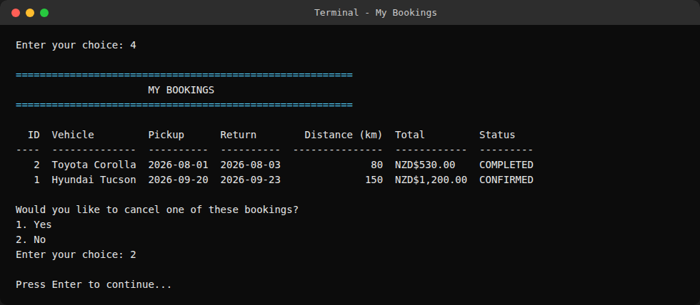
Figure 23: A customer viewing her own booking history (BR6 - never anyone else's)

9.7 Changing Your Password
Every dashboard offers "Change My Password", gated by the same reset keyword used by the admin-facing reset flow (config.py's PASSWORD_RESET_KEYWORD) - one shared function, auth_service.reset_own_password(), used everywhere a password can be changed by its own owner.
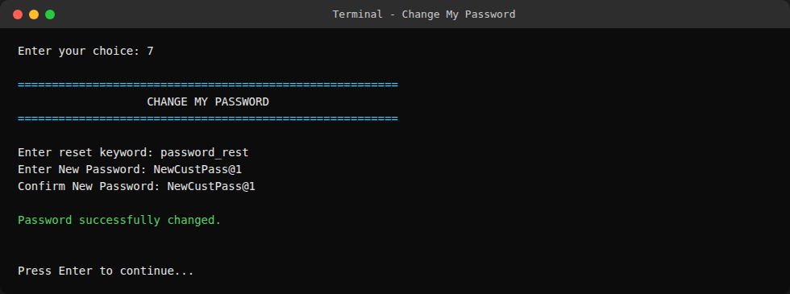
Figure 24: A customer changing their own password
An honest note on this feature: auth_menu.py also defines a standalone forgot_password_screen() for a customer who is locked out and cannot log in at all - but at the time of writing, no menu currently calls it, so it is not yet reachable from the welcome screen. It is written and would work correctly if wired up (its logic is identical to the reachable "Change My Password" flow shown above), but until a future update adds a menu option for it, a locked-out user's only path back in is to ask a Super Administrator to use "Manage Users -> Reset Password" (Chapter 9.8) on their behalf. This is disclosed honestly in Chapter 13 as a known limitation, exactly as found while preparing this report.

9.8 Admin: Managing Users and Resetting a Password
The Super Administrator can see every account with its role and status, and passwords are shown ONLY as a fixed masked placeholder (FR4a) - because a hashed password can never be reversed back into the original anyway, showing anything else would be misleading. From here, the admin can reset any user's password directly, either typing a new one or leaving it blank to auto-generate a random one - the new plain-text password is shown exactly once, right after the reset, so it can be passed on securely (FR4b).
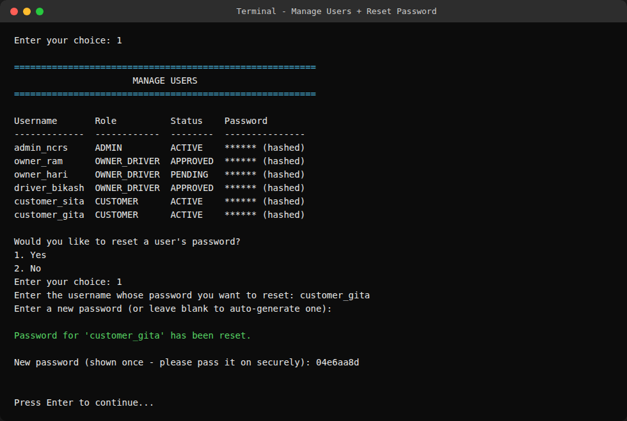
Figure 25: Manage Users - the masked user list, and resetting customer_gita's password

9.9 Admin: Approving a Pending Registration
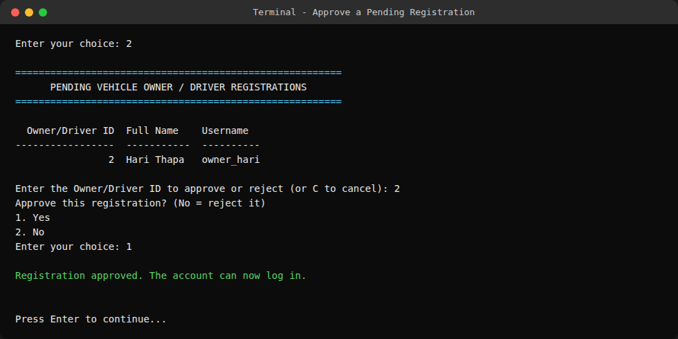
Figure 26: Approving owner_hari's pending Vehicle Owner/Driver registration

9.10 Admin: System Statistics
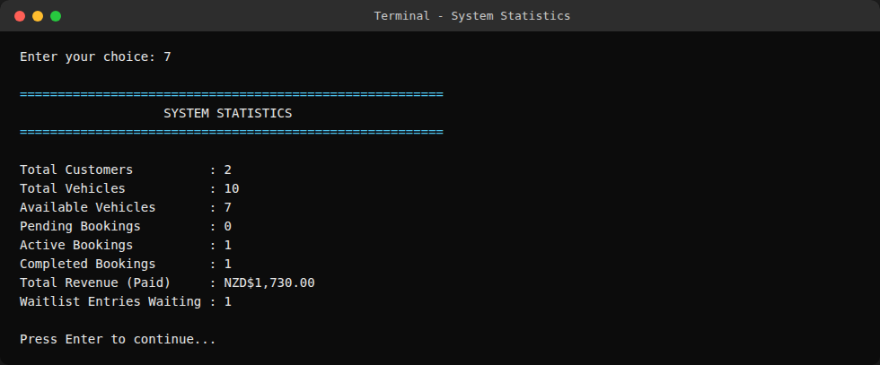
Figure 27: System-wide statistics at a glance (FR19)

9.11 Admin: Setting the System-Wide Rate per KM
This value is stored in the settings table, never hard-coded (FR13a) - a change here applies to every NEW booking made afterwards, while bookings already calculated keep the rate that was in effect at the time (BR3a).
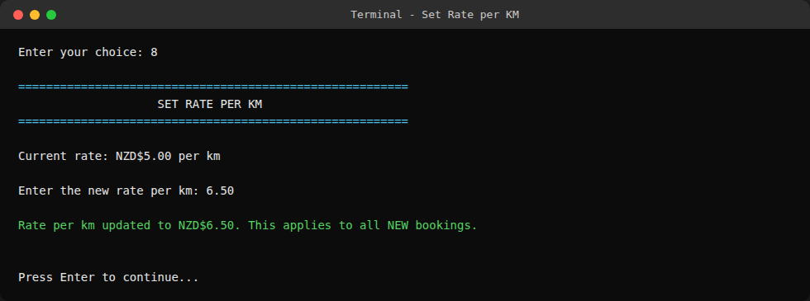
Figure 28: Updating the system-wide rate per km from NZD$5.00 to NZD$6.50

9.12 Admin: Cancelling a Booking -> Observer Pattern Auto-Notify
This is the Observer pattern from Chapter 4.4, actually firing, live, in a real terminal session. Booking #1 (Sita Gurung's CONFIRMED booking on the Hyundai Tucson) is cancelled by the administrator. The moment the vehicle is freed back to AVAILABLE, the system automatically checks the Tucson's waitlist, finds Gita Koirala waiting (seeded on first run specifically to demonstrate this feature), and prints her notification immediately - with no separate step required.
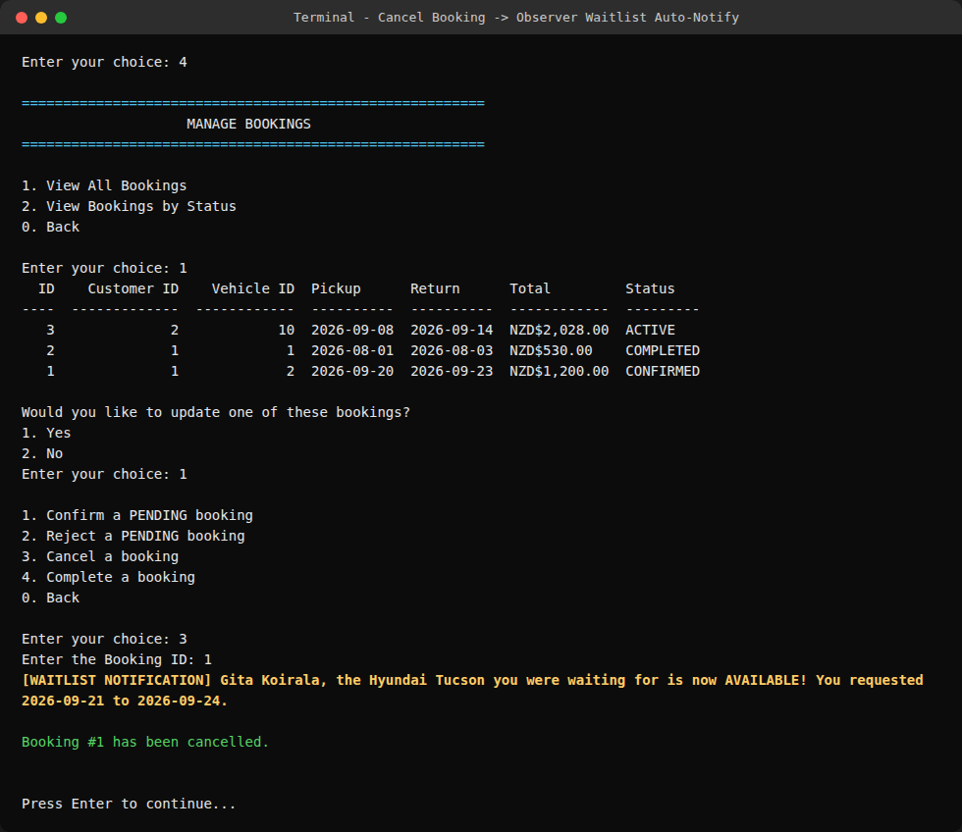
Figure 29: Cancelling Booking #1 automatically triggers the waitlist notification for the next waiting customer (highlighted)

9.13 Vehicle Owner/Driver: Adding and Viewing Vehicles
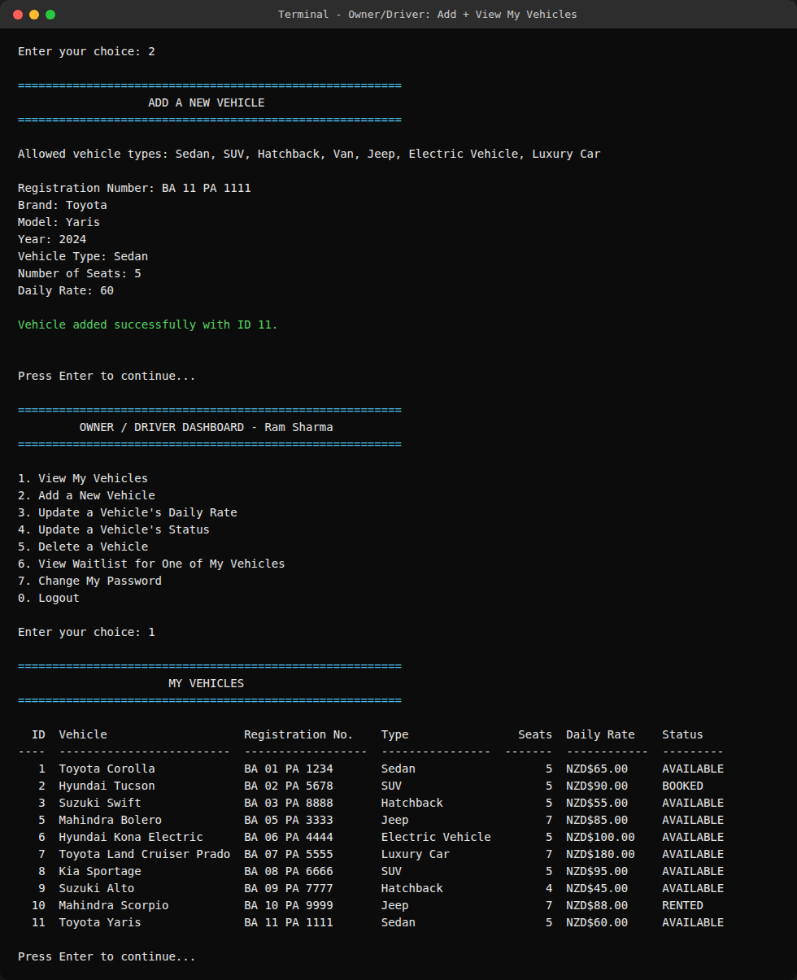
Figure 30: A vehicle owner listing a brand-new vehicle, then viewing their updated fleet

9.14 Booking Conflict -> Offering the Waitlist
This is the OTHER half of the waitlist feature: when a booking request conflicts with an existing one, the customer is offered the chance to join that vehicle's waitlist right there, instead of the request simply failing (FR16).
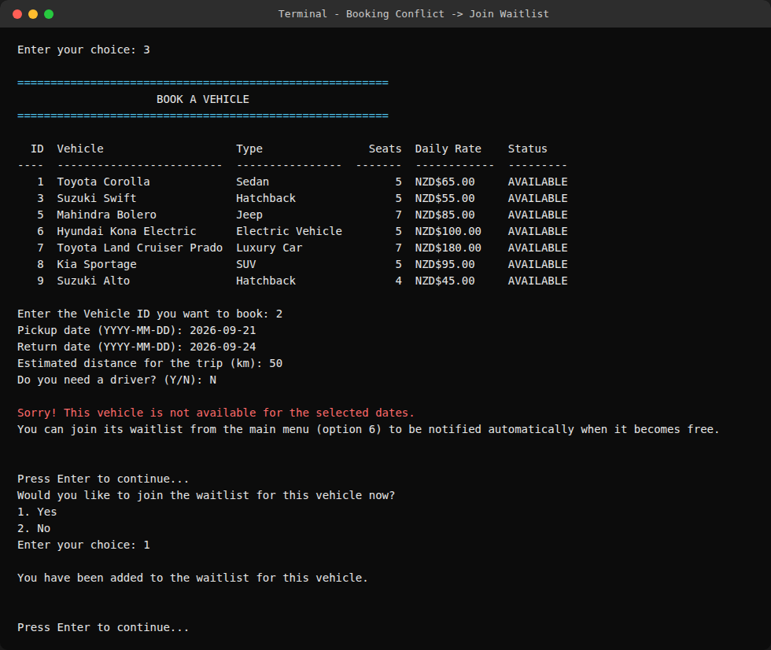
Figure 31: A booking conflict on the Tucson, and joining its waitlist instead

10. The Web Interface
Everything in Chapter 9 is the original command-line interface (CLI). This chapter introduces a SECOND, browser-based way to run the exact same system, added specifically so the project could also be demonstrated and used the way most real users expect - by clicking in a web browser - without changing, duplicating, or in any way reworking the business logic underneath.

10.1 Purpose - An Addition, Not A Replacement
web/app.py's own top-of-file docstring states the design goal directly, and it is worth quoting because it is the single most important fact about this chapter:
"This file deliberately does NOT contain any business logic of its own. Every single action below (logging in, registering, adding a vehicle, confirming a booking, recording a payment...) calls the exact same functions in services/ that the CLI already calls, against the exact same database file."
In practice this means: the CLI keeps working exactly as it did before - nothing in cli/, services/, models/, database/, or utils/ business logic was changed to build the web interface. There is only ONE copy of every rule (validation, pricing formula, who is allowed to do what) anywhere in the whole project. Whoever runs the program, from a terminal or from a browser, gets IDENTICAL behaviour, because both are thin "front ends" over the same services/ layer. Anything done from one interface (e.g. adding a vehicle from the browser) is immediately visible from the other (e.g. it shows up in the CLI too), because they share the one SQLite database file - Chapter 10.7 proves this with a real example.
This matters for the assignment's own Task 1 architecture goal (modularity - Chapter 5.1): adding an entire second front end required writing zero new business logic, which is only possible because the CLI was built with a clean separation between presentation (cli/) and business logic (services/) from the start.

10.2 Why Flask? Comparing The Alternatives
Flask is a small, beginner-friendly Python web framework - no separate server software to install, no database driver of its own, and no JavaScript build step. Running python web/app.py starts a small local web server; opening http://127.0.0.1:5000 in any browser on the same computer talks to it. Nothing here calls out to the internet, so it runs fully offline, exactly like the CLI, satisfying the same NFR1/NFR2 constraints (Chapter 3.3). The table below compares Flask against the other options a reader might reasonably ask about ("why not PHP?" being the most common question), judged specifically against this project's two real requirements: staying fully offline, and reusing the existing services/ layer without duplicating any business logic.
Option | Offline-Capable? | Why Flask Was Chosen Instead
Flask (chosen) | Yes - pure Python, `pip install flask` once, then never touches the network again. | A ~5-line app.py starts a local server; every route is a short Python function. No separate server software, no build step, no second language.
PHP | Only with extra software installed (PHP's own runtime, usually a local server such as XAMPP/Apache). | The entire services/models/database business logic would have to be rewritten in PHP (or clumsily bridged), recreating the exact "two copies of every rule" problem this project's layered design was built to avoid.
Django | Yes, offline-capable. | A large, "batteries-included" framework - its own ORM, admin site, project-wide settings and migrations system - which is significant extra machinery and a steeper learning curve than this ~25-page site needs on top of an existing plain-SQLite services layer.
Node.js / Express | Yes, offline-capable. | Needs a second language and runtime (JavaScript/Node) alongside Python. The shared services/ code could not be called directly at all - it would have to be reimplemented or run as a separate process.
Plain CGI scripts | Yes, technically. | Works with only Python, but means hand-rolling request parsing, sessions, and page templating that Flask already provides, for no offline-capability benefit over Flask.

10.3 How Login Works Differently On The Web
The CLI keeps the logged-in User object alive in one Python variable for as long as that dashboard's menu loop keeps running - simple, because a CLI program is one continuous process holding onto its own memory between prompts. A web server cannot do that the same way: every click is a brand new, independent HTTP request with no memory of the previous one. The standard fix (used here) is a SESSION: after a successful login, Flask writes a small, signed cookie to the browser containing nothing but the user's numeric ID. On every later request, a before_request() function reads that ID back out of the cookie and calls the same auth_service.get_user_by_id() to rebuild the real User object fresh from the database - so the current user is always correct and up to date, without ever storing a password (or even the user object itself) in the cookie.
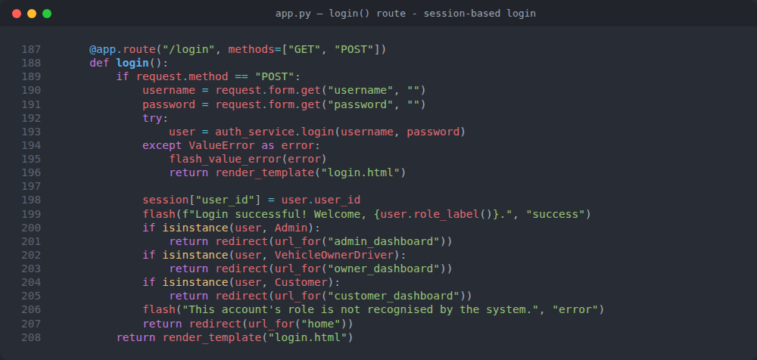
Figure 32: web/app.py - the login() route: the same auth_service.login() call the CLI uses, plus the session cookie and role-based redirect that a web request needs and a CLI menu loop does not
Just like the CLI's polymorphic isinstance() dispatch (Chapter 4.2) sends a freshly logged-in user to the right dashboard, the web route above does the same thing with the same isinstance() checks - the exact same OOP idea, reused in the second front end without being rewritten.
Access control - login_required and role_required: every page that needs a logged-in user, or a specific role, is protected by one of two small Python DECORATORS (Chapter 4.5 introduced custom decorators; these are two more, purpose-built for the web layer). A decorator here wraps a page function and runs a check BEFORE the real page code ever executes, redirecting away if the check fails - so no individual page has to remember to check permissions itself.
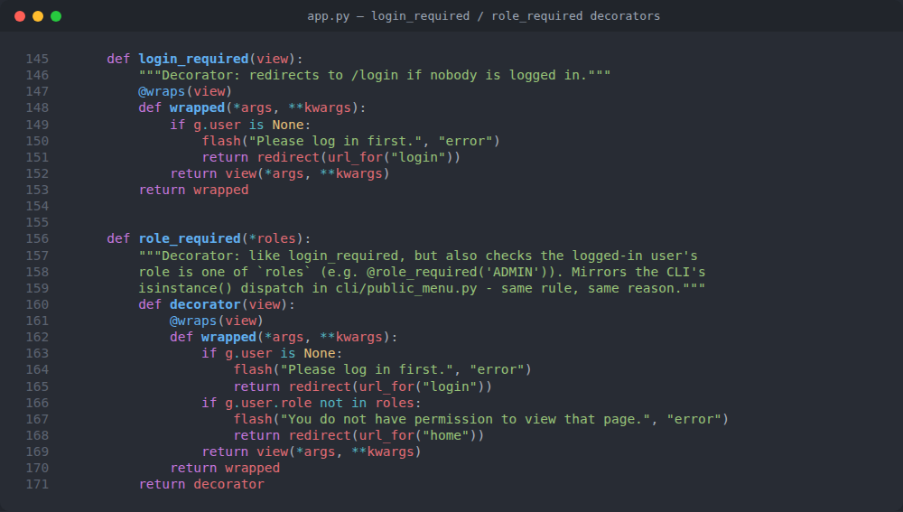
Figure 33: web/app.py - login_required and role_required(*roles): reusable decorators that protect every page, mirroring the CLI's isinstance() role dispatch (cli/public_menu.py)

10.4 Step-by-Step: Running The Web Interface
- 1. Follow Chapter 8.3's Steps 1-3 first (get the code, then pip install -r requirements.txt) exactly as for the CLI - the web interface needs nothing extra installed beyond Flask, which is already listed in requirements.txt.
- 2. Open a terminal inside the project folder (in VS Code: right-click the folder -> "Open in Integrated Terminal").
- 3. Run: python web/app.py (on some systems: python3 web/app.py).
- 4. Your default browser opens automatically after about a second, already pointed at http://127.0.0.1:5000 - there is nothing to type or click to make this happen.
- 5. If it does not open automatically for any reason (e.g. a locked-down VS Code container), copy http://127.0.0.1:5000 from the terminal into any browser's address bar by hand - it will NOT work by double-clicking web/app.py itself.
- 6. Use the same demo accounts as the CLI (Chapter 8.5) - the login page shows all three with one-click "Log in as..." buttons, so no password ever needs to be typed or remembered for a demo.
- 7. Press CTRL+C in the terminal to stop the web server when finished - this does not affect the database file, which persists exactly like it does for the CLI.
What "127.0.0.1:5000" means, for a beginner: 127.0.0.1 (also called "localhost") always means "this same computer" - the browser is not really going out to the internet at all, it is talking to the small Flask server also running on the same machine, on port number 5000. Closing the terminal (or pressing Ctrl+C in it) stops that server and the pages stop loading, exactly like closing any other running program.

10.5 Pages And Routes, By Role
Every page in the web interface is one Flask "route" - a URL plus a Python function that decides what HTML to show. The table below groups every route by who is allowed to open it, mirroring the exact same three-role structure as the CLI dashboards (Chapter 9.4).
Who Can Open It | Pages / Routes
Public (no login) | /, /login, /register, /register/customer, /register/owner, /register/admin, /vehicles, /vehicles/by-type, /rental-info, /about, /forgot-password
Customer | /customer, /customer/vehicles, /customer/book/<id>, /customer/bookings, /customer/bookings/<id>/pay, /customer/waitlist/join, /change-password/customer
Vehicle Owner/Driver | /owner, /owner/vehicles, /owner/vehicles/add, /owner/vehicles/<id>/edit, /owner/vehicles/<id>/waitlist, /change-password/owner
Super Administrator | /admin, /admin/users, /admin/registrations, /admin/vehicles, /admin/bookings, /admin/payments, /admin/stats, /admin/rate, /admin/reset-test-data, /change-password/admin

10.6 Walkthrough: The Same Actions, Side by Side With the CLI
The screenshots below repeat several of Chapter 9's real scenarios, this time from a real browser (Chromium), captured against the exact same seed data. Where a screen has a direct CLI equivalent already shown in Chapter 9, this is noted so the two can be compared directly.

10.6.1 The Public Home Page
Unlike the CLI (which starts directly at a numbered menu - Chapter 9.1), the web interface's first page is a short landing page with plain navigation links (Home, Login, Register, About) in a header that is repeated on every single page, so a visitor is never more than one click from anywhere else in the site.
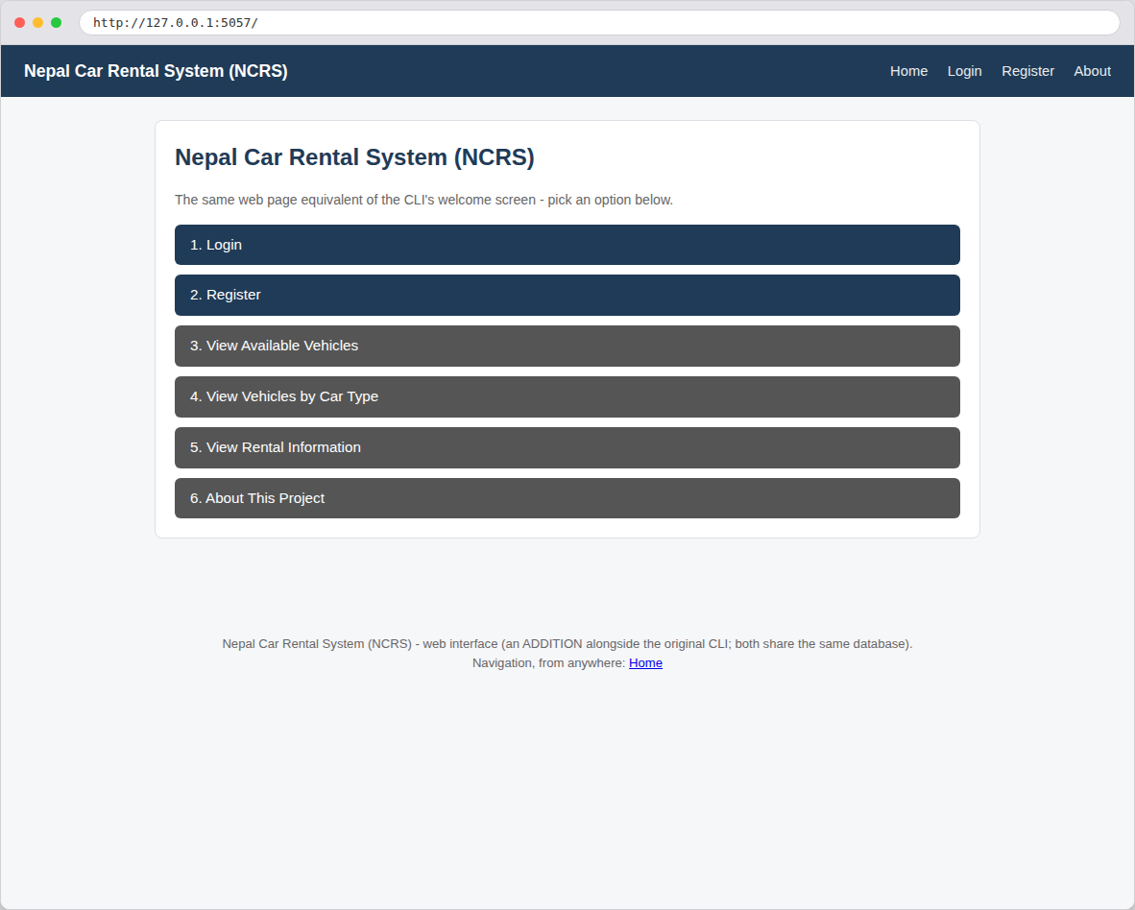
Figure 34: Web: the public home page - the browser equivalent of the CLI's welcome menu (Chapter 9.1)

10.6.2 Logging In - One-Click Demo Accounts
The login page lists the same demo accounts from Chapter 8.5, each with its own "Log in as..." button that submits the correct username/password automatically - useful for a quick demonstration (or for marking) without anyone needing to remember or type a password. This box is deliberately display-only (it does not create or change any account) and is clearly labelled as being for demo/testing purposes, exactly the same honesty the CLI's own About screen (Chapter 9.2) already models.
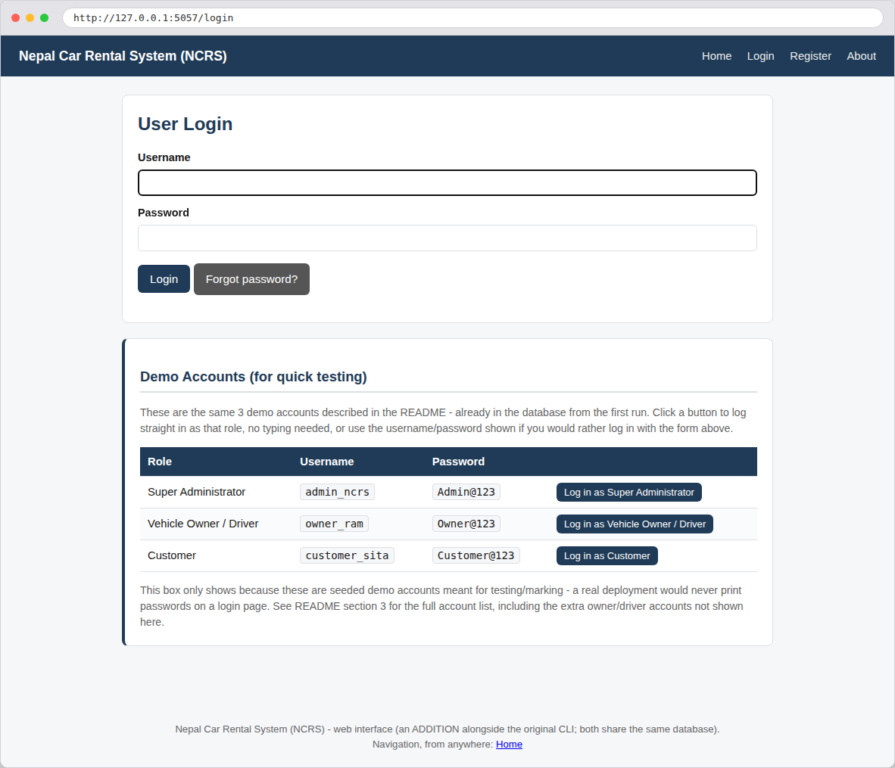
Figure 35: Web: the login page with one-click demo-account buttons - compare with the CLI login in Chapter 9.4

10.6.3 Customer Dashboard and Booking a Vehicle
After logging in as a Customer, the dashboard lists the same actions as the CLI's Customer Dashboard (Chapter 9.4/9.5) as clickable cards instead of a numbered menu. Booking a vehicle asks for exactly the same fields, in the same order, as the CLI's booking form (pickup date, return date, distance, and an optional driver) - because both call the identical booking_service.create_booking() function.
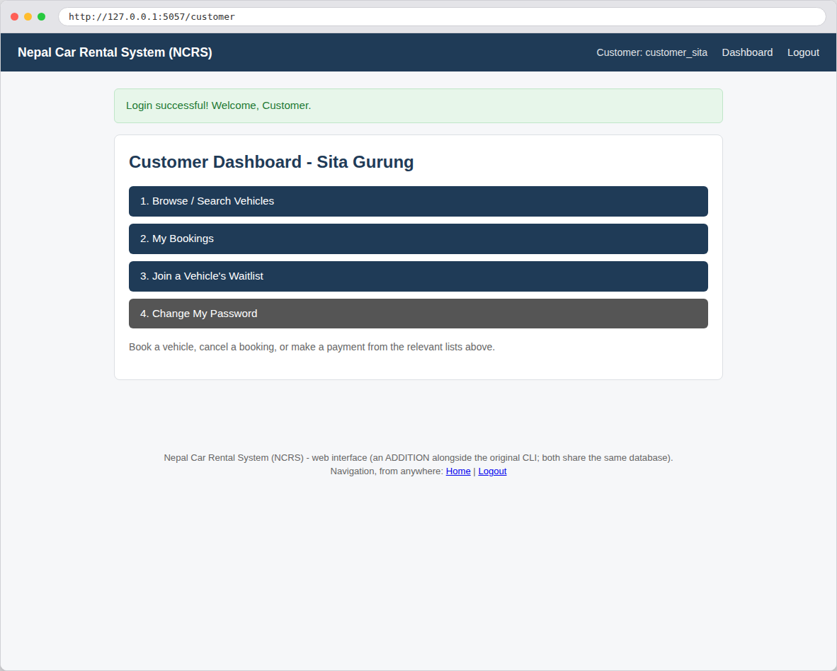
Figure 36: Web: the Customer dashboard after logging in - compare with the CLI Customer Dashboard in Chapter 9.4
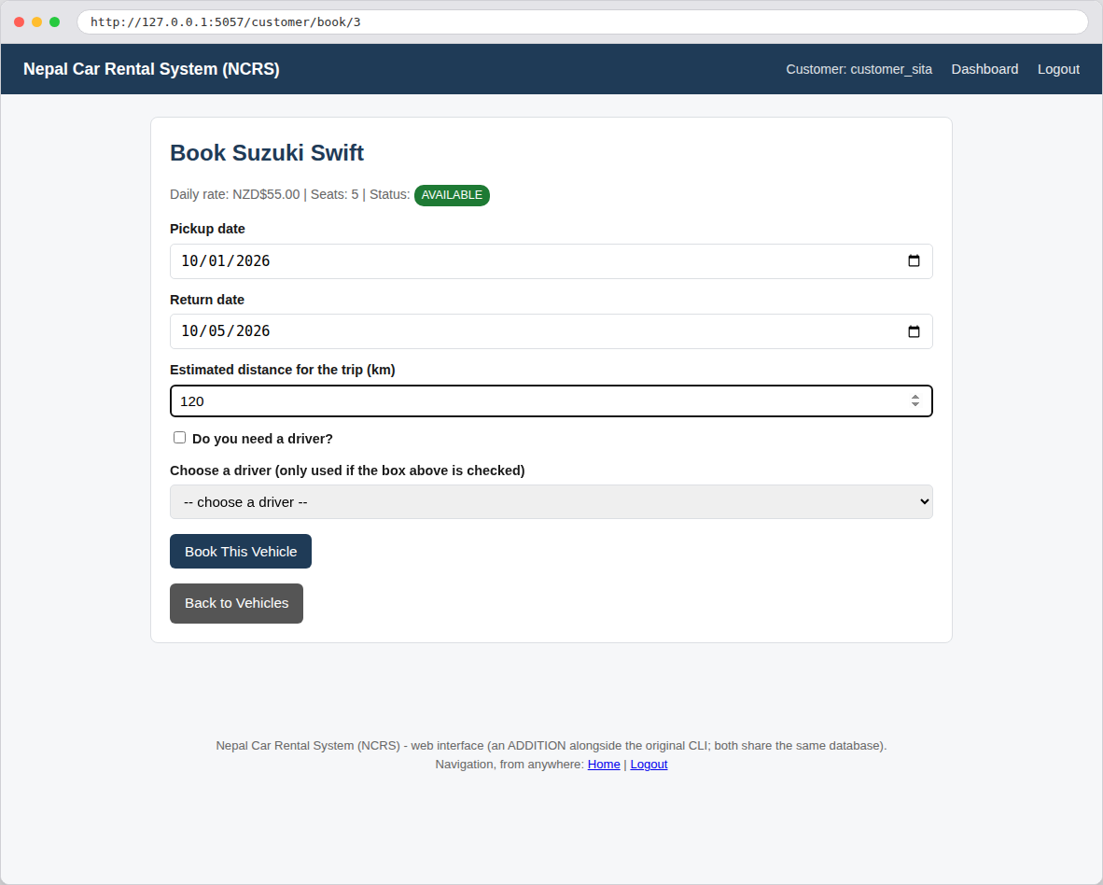
Figure 37: Web: booking the Suzuki Swift with the same dates/distance used in the CLI's Chapter 9.5 example - compare the two cost calculations
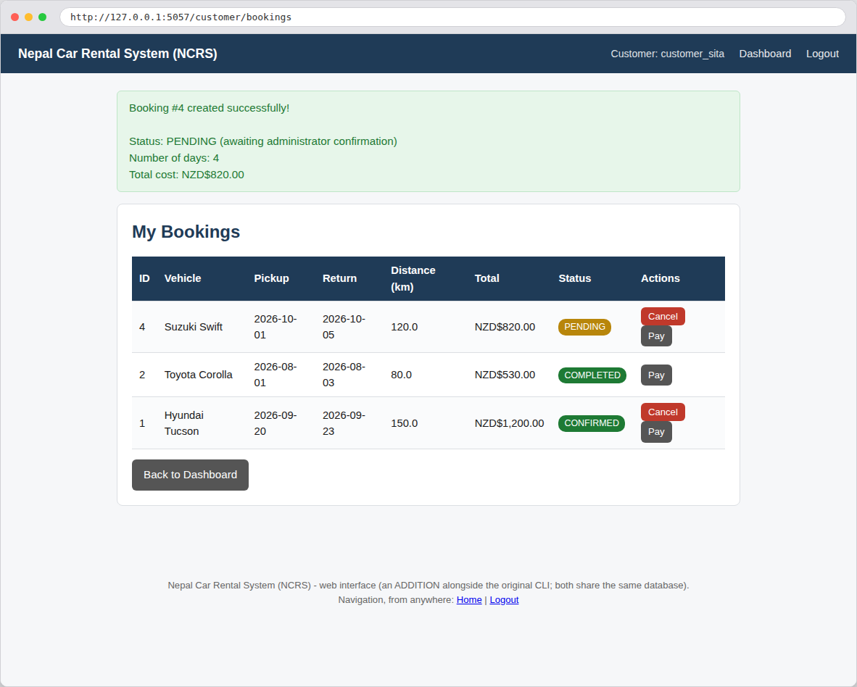
Figure 38: Web: the booking confirmation and updated "My Bookings" list, shown immediately after submitting the form above

10.6.4 Administrator Dashboard and Managing Users
The Super Administrator dashboard and "Manage Users" page offer the exact same actions as Chapter 9.8's CLI screens - viewing every account with a masked password placeholder, and resetting any user's password, either typed or auto-generated.
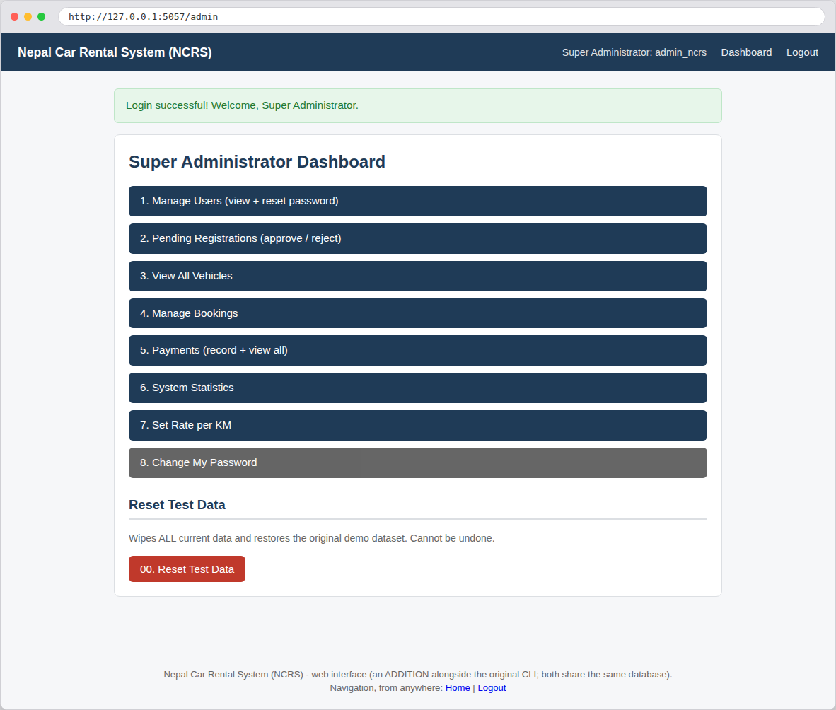
Figure 39: Web: the Super Administrator dashboard - compare with the CLI Administrator Dashboard in Chapter 9.4
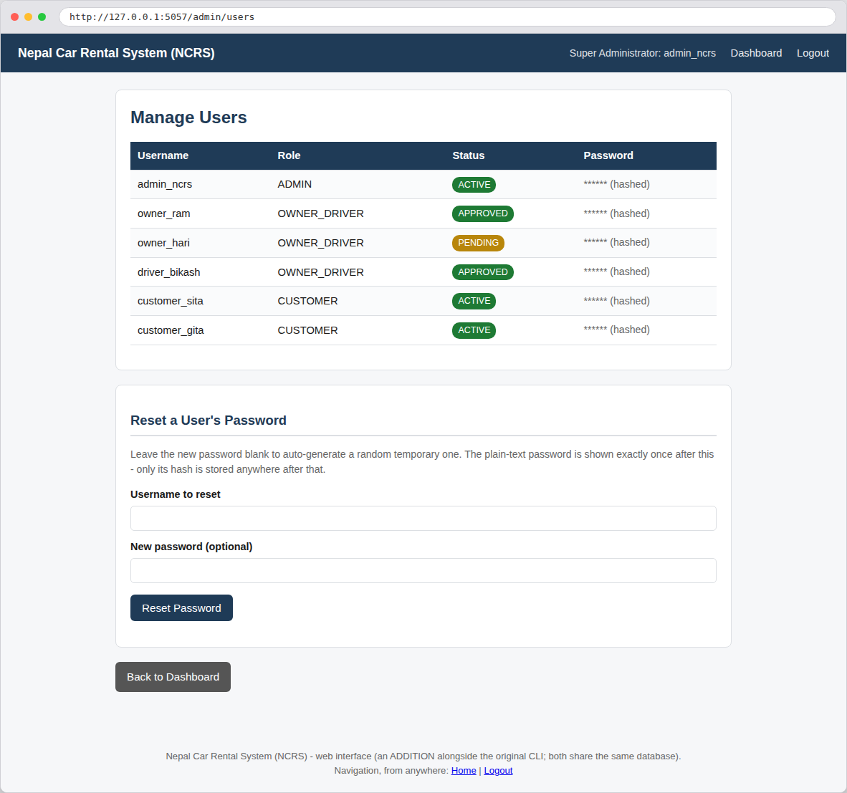
Figure 40: Web: Manage Users - compare with the CLI's Manage Users screen in Chapter 9.8

10.6.5 Vehicle Owner/Driver: Adding a Vehicle
This is the web equivalent of Chapter 9.13's CLI scenario - the same seven fields (registration number, brand, model, year, vehicle type, seats, daily rate), in the same order, calling the same vehicle_service.add_vehicle() function.
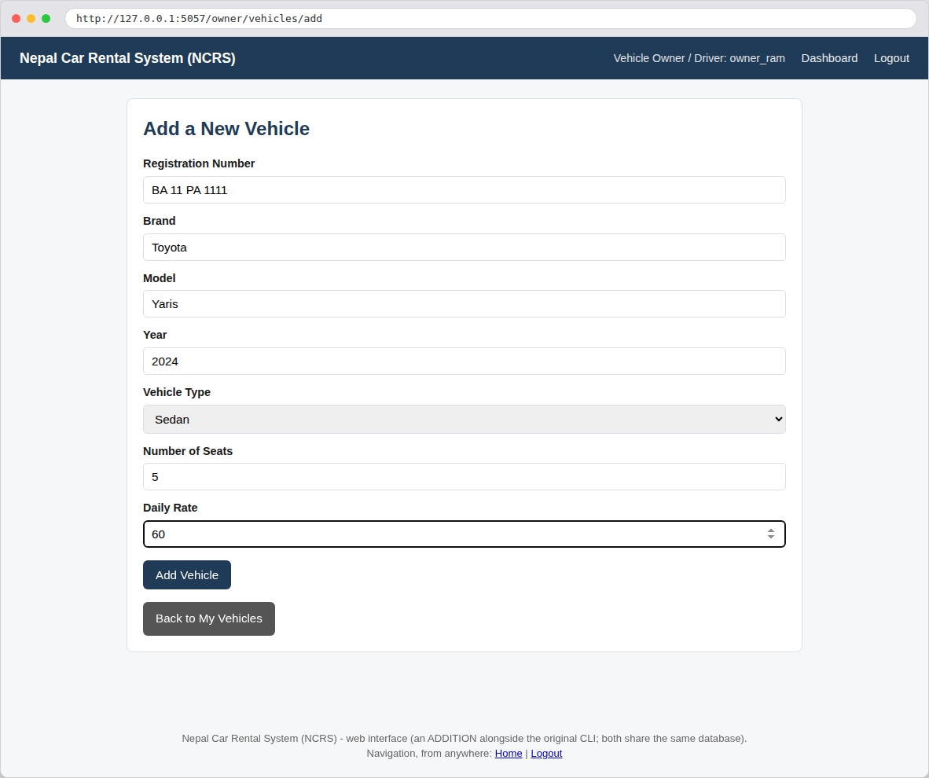
Figure 41: Web: adding a new vehicle, filled in with the same example data as the CLI's Chapter 9.13 scenario
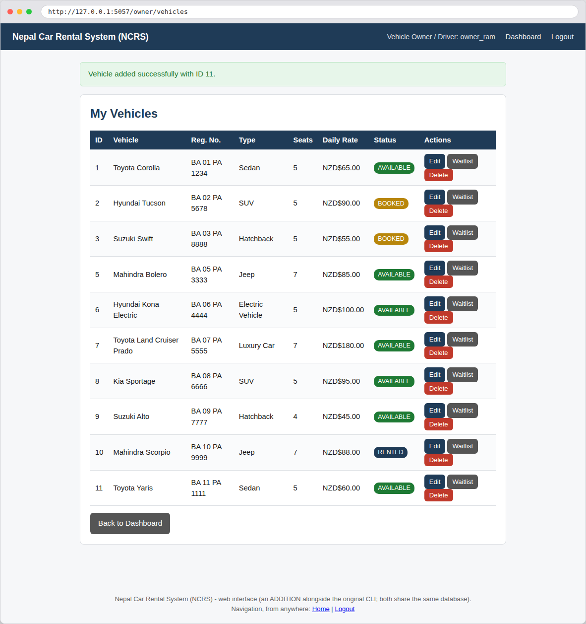
Figure 42: Web: the owner's vehicle list immediately after adding the Toyota Yaris above, with ID 11

10.7 Verification: One Shared Database, Not Two Separate Copies
Because both front ends call the same services/ functions against the same ncrs_database.sqlite3 file, an action performed in one interface is immediately visible in the other - there are not two separate, drifting copies of the data. This was verified directly while preparing this report: the vehicle added from the web interface in Chapter 10.6.5 above ("Toyota Yaris", ID 11) is the exact same vehicle that appears in the CLI's own Chapter 9.13 screenshot, captured in a completely separate run of the program a few minutes apart - proof that both front ends are reading and writing the one real database, not two independent simulations.

10.8 Known Limitations Specific To The Web Interface
These are additional, honestly-disclosed limitations that apply to the web interface only (Chapter 13 covers the CLI's own known issues); none of them are crashing bugs, and all of them are reasonable for a local, offline academic demonstration rather than a real internet-facing deployment:
- Fixed local secret key. app.secret_key is a fixed string in web/app.py rather than a securely generated, environment-provided value. This is safe here because the app only ever runs on the student's own computer (NFR1/NFR2 - no real deployment, no real attacker who could see this cookie traffic); a real production deployment would read this from an environment variable instead.
- Flask's built-in development server, not a production web server. app.run(...) starts Flask's own lightweight development server, which is intentionally simple and single-process - exactly right for one person demonstrating the project locally, but not intended to serve many simultaneous real-world users the way a production server (e.g. gunicorn behind nginx) would.
- No CSRF token on forms. Cross-Site Request Forgery protection is a standard production safeguard this local-only demo does not need, since there is no other website that could ever trick a visitor's browser into submitting one of these forms - there is no public URL for another site to target.
- The self-service "forgot password" page IS reachable here, unlike the CLI. Chapter 9.7 discloses that the CLI's forgot_password_screen() exists but is not yet wired into any CLI menu. The web interface's login page DOES link to it ("Forgot password?"), because a web page's navigation is just an HTML link rather than a numbered menu choice that has to be deliberately added - this is a genuine small improvement the web interface brings, not a discrepancy between the two front ends' underlying logic (both call the identical auth_service.reset_own_password() function).

11. How the Rental Cost Is Calculated
Every rental's total cost is calculated by exactly one formula, implemented as a single @staticmethod on the Booking model itself (models/booking.py), so the exact same calculation is used no matter which screen triggers it:
Total Cost = (Days x Daily Vehicle Rate) + (Distance in km x Rate per km) + (Days x Driver Daily Rate, only if a driver is requested)
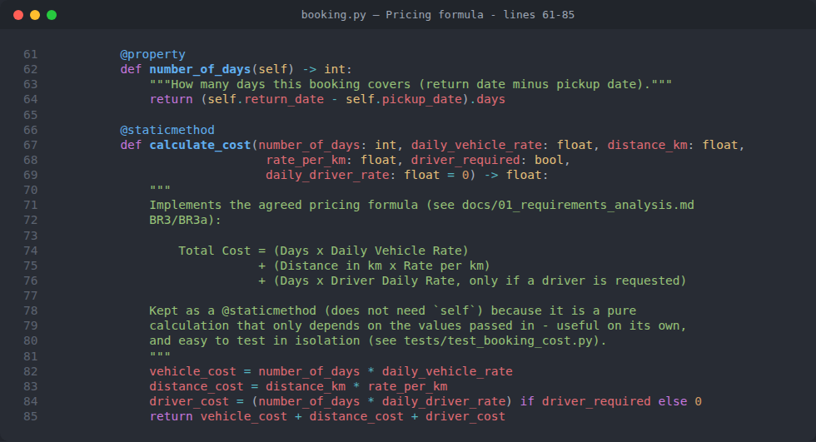
Figure 43: models/booking.py - the number_of_days property and the calculate_cost() staticmethod
All amounts are shown in New Zealand Dollars (NZD$) - this is purely a display convention (config.py's CURRENCY_SYMBOL), not a real currency-conversion feature; every number is just formatted with that symbol in front. Two worked examples, using real numbers from this project, make the formula concrete:
Example | Vehicle | Days | Distance | Driver? | Calculation | Total
Chapter 9.5's booking | Suzuki Swift @ NZD$55/day | 4 | 120 km | Yes, Bikash Rai @ NZD$60/day | (4 x 55) + (120 x 5) + (4 x 60) = 220 + 600 + 240 | NZD$1,060.00
Seeded Booking A | Hyundai Tucson @ NZD$90/day | 3 | 150 km | Yes, Bikash Rai @ NZD$60/day | (3 x 90) + (150 x 5) + (3 x 60) = 270 + 750 + 180 | NZD$1,200.00
Seeded Booking B | Toyota Corolla @ NZD$65/day | 2 | 80 km | No | (2 x 65) + (80 x 5) + 0 = 130 + 400 | NZD$530.00
The rate per km used is always whatever is CURRENTLY set in the database at the moment the booking is created (booking_service.get_current_rate_per_km()) - never the config.py DEFAULT_RATE_PER_KM constant directly, which only ever seeds the very first value the very first time the program runs (see BR3a).

12. Automated Testing
The project includes a full pytest suite of 86 automated tests across 7 test files, covering every layer of business logic that could realistically break silently if changed carelessly later. None of these tests ever touch the real ncrs_database.sqlite3 file - tests/conftest.py's clean_database fixture builds a brand-new, empty, temporary SQLite file for every single test, and deletes it again afterwards, using Python's tempfile module and by temporarily redirecting config.DATABASE_FILE_NAME.
Test File | What It Checks
test_validators.py | Every input-validation rule (valid input accepted, invalid input rejected with a clear message).
test_security.py | Password hashing and verification (correct password accepted, wrong password rejected, hashes are salted).
test_booking_cost.py | The cost-calculation formula (Chapter 11), and the booking status lifecycle (confirm/reject/cancel/complete).
test_booking_conflict.py | The date-overlap availability-checking algorithm, and booking creation end-to-end.
test_auth_and_password_reset.py | Login, all three registration flows, and both password-reset flows.
test_vehicle_and_admin_service.py | Vehicle CRUD operations and admin-only actions (approval, statistics, reset test data).
test_waitlist_notify.py | The Smart Waitlist + Auto-Notify Observer-pattern feature (Chapter 4.4), including FIFO ordering.
The screenshot in Chapter 8.3 already shows a real passing run of this entire suite (86 passed in under 2 seconds). Running the suite before considering ANY change to the code complete is exactly the workflow described in docs/03_maintenance_and_support_plan.md, summarised in the Maintenance & Support Plan chapter of this report.

13. Known Issues & Limitations
No CRASHING bugs are known at the time of writing - every screen was manually walked through end-to-end for every role, in both the CLI and the web interface, and the full 86-test pytest suite passes. The following are deliberate, disclosed limitations appropriate for an academic project of this scope, not defects hiding in the dark. Chapter 10.8 additionally lists a small set of limitations specific only to the web interface (a fixed local secret key, no CSRF token, and similar local-only-demo trade-offs), kept separate from this list because they do not apply to the CLI at all.
- No real payment gateway, email, or SMS. Payments and waitlist notifications are simulated and printed to the console (or shown as a flash message on the web - services/payment_service.py and models/waitlist.py) - this is intentional, matching NFR1/NFR2's "no internet, no paid services" constraint, not an oversight.
- The self-service "forgot password" screen is reachable on the web, but not yet wired into the CLI menu. auth_menu.forgot_password_screen() exists, works, and is exercised by the automated tests, but no CLI menu currently calls it (see Chapter 9.7). The web interface's login page does link to the equivalent /forgot-password page (Chapter 10.8) - a small, genuine benefit of the web front end - but until a future update adds a CLI menu option for it, a locked-out CLI user's only path back in is to ask a Super Administrator to use "Manage Users -> Reset Password" (Chapter 9.8) on their behalf.
- No pagination for very large tables. If the fleet grew into the hundreds of vehicles, utils/formatters.format_table() (CLI) and the plain HTML tables (web) would show them all at once rather than paging through them. Not an issue at the current demo scale of 10 vehicles.
- Y/N vs 1/2 for Yes/No prompts (CLI only). Most CLI confirmations use a numbered 1. Yes / 2. No menu (cli/common.confirm_yes_no()), while a couple of screens (e.g. "Do you need a driver?") use a typed Y/N instead. Both are intentional and explained by the prompt text itself, not a functional bug; the web interface avoids this entirely by using a plain HTML checkbox for the same question.
- SQLite over a cloud-synced or network-mounted folder. SQLite needs real file locking to work reliably. Running this project from a network drive or an "online-only" cloud-sync folder can fail with a disk I/O error - running it from a normal local folder on your own hard drive avoids this entirely, for both the CLI and the web interface.
- A vehicle can be deleted once every booking against it has finished. vehicle_service.delete_vehicle() blocks deletion while any PENDING/CONFIRMED/ACTIVE booking exists, but allows it once every booking on that vehicle is COMPLETED/CANCELLED/REJECTED. A customer's own booking history screen handles this gracefully (showing "(vehicle no longer in system)" rather than crashing - see cli/customer_menu.py's _my_bookings()), but a real production system would more likely soft-delete (archive) a vehicle instead of removing its row outright.

14. Licence
This project is released under the MIT Licence - a short, permissive open-source licence chosen as a sensible DEFAULT for an academic assignment: it lets the lecturer, marker, or anyone else freely run, read, and reuse the code (with attribution), while placing no warranty obligations on the student author.
Note: this choice of licence has not yet been separately confirmed with Anish - it is documented here, and in the project's own LICENSE and README.md files, as the sensible default until/unless he chooses a different one.
Copyright (c) 2026 Anish Shrestha. Permission is hereby granted, free of charge, to any person obtaining a copy of this software and associated documentation files, to deal in the Software without restriction, including without limitation the rights to use, copy, modify, merge, publish, distribute, sublicense, and/or sell copies of the Software, subject to the inclusion of the above copyright notice in all copies. THE SOFTWARE IS PROVIDED "AS IS", WITHOUT WARRANTY OF ANY KIND, EXPRESS OR IMPLIED.

15. Maintenance & Support Plan (Summary)
A full, separate planning document (docs/03_maintenance_and_support_plan.md) covers this topic in depth, as required by the assignment's Task 3. This chapter summarises its key points.

15.1 Types of Maintenance Planned
- Corrective: fixing a defect found after release (e.g. the two real bugs found and fixed while preparing this project - see below).
- Adaptive: changing the software because its environment changed (e.g. a newer Python version, or a changed package).
- Perfective: improving something that already works but could work better (e.g. adding pagination once the fleet grows large - Chapter 13).
- Preventive: proactively hardening code against a problem before it actually causes one (e.g. the defensive try/except added around every get_vehicle() call after finding the first crash - see below).

15.2 Versioning
The project follows Semantic Versioning (MAJOR.MINOR.PATCH - currently 1.0.0, config.py's PROJECT_VERSION). A future database schema change would be tracked with a proposed schema_version row in the settings table plus a small migration script, so upgrading an existing installation's database never silently loses or corrupts data.

15.3 Real Example: Two Bugs Found and Fixed During Development
- Payment double-validation bug: cli/customer_menu.py's _make_a_payment() originally converted the typed amount to a float, then passed that float into payment_service.record_payment(), which itself expects a raw STRING (it calls .strip() on it) - causing a crash. Fixed by keeping the float only for the internal PAID/PARTIAL decision, and passing the original text through untouched, matching every other caller's pattern.
- Unguarded crash on a nonexistent vehicle: cli/owner_menu.py's _get_own_vehicle_or_error() called vehicle_service.get_vehicle() without catching the ValueError it raises for a missing ID, crashing with a raw traceback instead of a friendly message. Fixed with a try/except, and the same defensive pattern was then proactively applied to cli/customer_menu.py's booking-history screen too, once the same risk was spotted there by inspection.
Every fix of this kind is only considered complete once the full 86-test suite still passes (Chapter 12) - this is the project's concrete maintenance workflow in practice, not just a policy on paper.

16. Conclusion
The Nepal Car Rental System successfully demonstrates every core requirement of this assignment: a genuine, multi-class Object-Oriented design (Chapter 4) modelling a real-world business (Chapter 1); inheritance and polymorphism used for a real, practical purpose (role-based dashboards); two classic design patterns - Singleton and Observer - each solving an actual problem the project has, rather than being included for decoration; a custom decorator with a provable effect; a fully offline, zero-cost architecture built on SQLite (Chapter 6); a complete, working innovative feature (Smart Waitlist + Auto-Notify), reachable from both the CLI and a second, browser-based web interface built without duplicating a single line of business logic (Chapter 10); 86 passing automated tests (Chapter 12); and thorough, honest documentation of exactly what works, what its limitations are, and why every major decision was made the way it was (Chapter 13).
Beyond satisfying the rubric (Chapter 17 cross-checks this project directly against the official marking criteria), the project is also intended to be genuinely useful as a piece of learning material: every function in the codebase carries a comment explaining not just WHAT it does, but WHY it exists and WHY it was written that way - the same spirit this report itself has tried to carry through, from Chapter 5.3's line-by-line beginner walkthrough onward, so that a complete beginner to this project can read either the code or this document and come away actually understanding it.

17. Rubric Cross-Check
This chapter maps every line item of the official MSE-800 Assignment 1 marking rubric directly to where this project and this report satisfy it, so it can be checked item by item rather than taken on trust.
Rubric Item | How This Project Satisfies It | Where To See It
Task 1 - User Documentation (10%) | README.md and this report both give step-by-step configure/install/run instructions, explain every project file's purpose, state the MIT Licence, disclose known issues honestly, and credit the author. | Chapters 2, 5.2, 8, 13, 14; README.md
Task 1 - System Documentation (20%): Class, Use Case and Sequence diagrams | All three required UML diagram types are provided as real diagrams, each explained in the surrounding text. | Chapter 6.3 (Class), Chapter 7.1 (Use Case), Chapters 7.2-7.3 (two Sequence diagrams)
Background Functional Requirements (a-h): registration/login/roles, car database + CRUD, browsing/booking + fee calculation, admin approve/reject | Directly implemented and expanded into 19 detailed, testable functional requirements (FR1-FR19). | Chapter 3.2
Task 2 - Car Rental System (30%): all 4 requirement groups, seamless for both customers and admins, plus one innovative feature | User Management, Car Management, Rental Booking and Rental Management are all implemented for Customer, Vehicle Owner/Driver and Super Administrator roles, from both the CLI and the web interface; the Smart Waitlist + Auto-Notify Observer-pattern feature is the innovative enhancement. | Chapter 3.2, Chapter 4.4, Chapter 9, Chapter 10
Task 2 - Coding Standard (10%): modularity, encapsulation, performance, commenting, naming, formatting | The four-layer architecture (cli/services/models/database) enforces modularity and encapsulation; every function carries a docstring explaining what and why; PEP 8 naming/formatting is followed throughout; every SQL query is parameterised for both safety and performance. | Chapter 5.1, Chapter 4.1, Chapter 3.3 (NFR6-NFR7)
Task 3 - Maintenance and Support (30%): managing maintenance, versioning, backward compatibility | A dedicated plan covers all three areas, illustrated with two real bugs actually found and fixed during development, plus a proposed schema-versioning approach for future database changes. | Chapter 15; docs/03_maintenance_and_support_plan.md
Submission requirements checklist (from the assignment brief's own "Submission Requirements" list): a Source Code Folder (the project folder itself, or the git repository link in Chapter 8.7); a Release Build Zip (the zipped project folder - this is a Python project run with the interpreter rather than compiled, so the "release build" is the runnable source folder itself, per Chapter 8); a ReadMe with User Documentation (README.md, and this report); a Design and Architecture PDF with UML diagrams (Chapters 6.3 and 7, exportable as PDF); and a Maintenance and Support PDF (Chapter 15, and docs/03_maintenance_and_support_plan.md, exportable as PDF).

18. Glossary of Terms
Every term below is written for someone who has never seen this specific project before.
Term | Meaning
Object-Oriented Programming (OOP) | A way of writing programs by modelling real things (a vehicle, a booking, a person) as "objects" that bundle together their own data and the actions that make sense on that data.
Class | A blueprint for an object - e.g. the Vehicle class describes what every vehicle has (a brand, a rate, a status) and what every vehicle can do.
Object / Instance | One actual thing built from a class - e.g. "the Toyota Corolla with vehicle_id 1" is one instance of the Vehicle class.
Attribute | A piece of data an object holds, e.g. vehicle.daily_rate.
Method | A function that belongs to a class, e.g. booking.cancel().
Inheritance | One class (a subclass) reusing and extending another class (its base/parent class) - e.g. Customer inherits everything User already knows how to do.
Polymorphism | Different subclasses responding to the same method call in their own way - e.g. every User subclass has its own role_label(), and the code calling it does not need to know which one it is.
Encapsulation | Keeping an object's internal details (like a password hash) private, and only exposing safe methods to work with it (like check_password()).
Abstraction / Interface | Describing WHAT something must be able to do, without saying HOW - Python's Observer abstract class describes on_vehicle_available() as a requirement, without implementing it itself.
Design Pattern | A well-known, reusable solution to a common software design problem - this project uses Singleton and Observer, plus a custom Decorator.
Singleton | A design pattern that guarantees a class only ever has ONE instance for the whole program - used here for the database connection and the overall system object.
Observer | A design pattern where one object (the Subject) automatically tells a list of other objects (the Observers) whenever something they care about happens - used here for the waitlist auto-notify feature.
Decorator | A function that wraps another function or class to add extra behaviour without changing its original code - this project's custom @author_info decorator attaches authorship metadata to a class.
SQLite | A lightweight, file-based database engine built into Python's standard library - the whole database is just one file on disk, with no separate server to install.
CLI (Command-Line Interface) | A program you interact with entirely through typed text commands in a terminal window, rather than by clicking buttons in a graphical window.
FIFO (First-In, First-Out) | A queue where whoever joined first is served first - used for the waitlist, so the customer who has been waiting longest is notified first.
Hashing | A one-way mathematical transformation of a password into a fixed-length string, so the original password can never be recovered from the stored value - used so this project never stores anyone's real password.
Salt (in password hashing) | A random extra value mixed into a password before hashing it, so that even two identical passwords produce different stored hashes.
PENDING / CONFIRMED / ACTIVE / COMPLETED / CANCELLED / REJECTED | The possible states a booking moves through during its lifetime, from first being requested to being finished or called off.
Foreign Key | A column in one database table that points to the primary key of another table, e.g. bookings.vehicle_id points to vehicles.vehicle_id.
Primary Key | The column that uniquely identifies each row in a database table, e.g. vehicle_id in the vehicles table.
ER Diagram (Entity-Relationship Diagram) | A diagram showing every database table, its columns, and how the tables relate to one another.
Sequence Diagram | A diagram showing the exact order of messages/calls between different parts of the system over time, for one specific scenario.

References
- Gamma, E., Helm, R., Johnson, R. and Vlissides, J. (1994) Design Patterns: Elements of Reusable Object-Oriented Software. Addison-Wesley. (Source of the Singleton and Observer design patterns used in Chapter 4.)
- Python Software Foundation (2024) The Python Standard Library - sqlite3, abc, hashlib, datetime. Available at: https://docs.python.org/3/library/ (Accessed: 2026).
- Python Software Foundation (2024) PEP 8 - Style Guide for Python Code. Available at: https://peps.python.org/pep-0008/ (Accessed: 2026).
- pytest developers (2024) pytest documentation. Available at: https://docs.pytest.org/ (Accessed: 2026).
- tabulate (2024) tabulate PyPI package documentation. Available at: https://pypi.org/project/tabulate/ (Accessed: 2026).
- Pallets Projects (2024) Flask documentation. Available at: https://flask.palletsprojects.com/ (Accessed: 2026). (The web framework used for the web interface in Chapter 10.)
- Norouzifard, M. (2026) MSE-800 Professional Software Engineering - Course Lecture Material (Decorators, Version Control, Tips for Python, SQLite3 with Python). Yoobee College, New Zealand. (Unpublished course material provided to students.)
- Anish Shrestha (2026) Nepal Car Rental System (NCRS) - project source code, README.md, and docs/01-03 planning documents. Yoobee College, New Zealand. (The project this report documents.)

Appendix A: Complete Seed / Demo Data Reference
This appendix lists the exact demo dataset the program inserts automatically the first time it is run against an empty database (database/seed_data.py). This is the same data shown in every screenshot throughout Chapter 9.

A.1 The Six Demo User Accounts
See Chapter 8.5's Default Login Credentials table for the full list with passwords - not repeated here for security-mindedness, even though these are only demo credentials.

A.2 The Ten-Vehicle Fleet
ID | Vehicle | Type | Seats | Daily Rate | Status | Owner
1 | Toyota Corolla | Sedan | 5 | NZD$65.00 | AVAILABLE | Ram Sharma
2 | Hyundai Tucson | SUV | 5 | NZD$90.00 | BOOKED | Ram Sharma
3 | Suzuki Swift | Hatchback | 5 | NZD$55.00 | AVAILABLE | Ram Sharma
4 | Toyota Hiace | Van | 12 | NZD$110.00 | MAINTENANCE | (unassigned)
5 | Mahindra Bolero | Jeep | 7 | NZD$85.00 | AVAILABLE | Ram Sharma
6 | Hyundai Kona Electric | Electric Vehicle | 5 | NZD$100.00 | AVAILABLE | Ram Sharma
7 | Toyota Land Cruiser Prado | Luxury Car | 7 | NZD$180.00 | AVAILABLE | Ram Sharma
8 | Kia Sportage | SUV | 5 | NZD$95.00 | AVAILABLE | Ram Sharma
9 | Suzuki Alto | Hatchback | 4 | NZD$45.00 | AVAILABLE | Ram Sharma
10 | Mahindra Scorpio | Jeep | 7 | NZD$88.00 | RENTED | Ram Sharma

A.3 The Three Seeded Bookings
Booking | Customer | Vehicle | Driver | Dates | Distance | Total | Status
A (#1) | Sita Gurung | Hyundai Tucson | Bikash Rai | 2026-09-20 -> 2026-09-23 (3 days) | 150 km | NZD$1,200.00 | CONFIRMED
B (#2) | Sita Gurung | Toyota Corolla | (none) | 2026-08-01 -> 2026-08-03 (2 days) | 80 km | NZD$530.00 | COMPLETED
C (#3) | Gita Koirala | Mahindra Scorpio | (none) | 2026-09-08 -> 2026-09-14 (6 days) | 300 km | NZD$2,028.00 | ACTIVE
One waitlist entry is also seeded: customer_gita waiting for the Hyundai Tucson (vehicle 2), for dates that overlap Booking A - specifically so that cancelling or completing Booking A immediately demonstrates the Observer-pattern auto-notify feature (Chapter 4.4, Chapter 9.12), without needing to manually set anything up first.

Appendix B: Source Code - Curated Excerpts & Where To Find The Full Code
An earlier draft of this report reproduced every single Python source file as a full-page screenshot - roughly 30 files across the whole project. That approach was deliberately reversed for this version: screenshotting an entire file rarely proves understanding of it by itself, and it made an already long report far longer without adding real explanatory value. Instead, this report explains the REASONING behind each significant piece of code in plain language, directly in the chapter where that code is relevant, illustrated with a small, curated number of real screenshots - exactly the excerpts listed in the table below.
The complete, unedited source code of every file - including the tests/ folder, which is listed and explained in Chapter 5.2's file guide but not screenshotted anywhere in this report - is included in full in the project's submitted folder/zip and in its git repository (Chapter 8.7). Every excerpt shown anywhere in this report was captured directly from that real, working code (never retyped or edited by hand); the cross-reference table below exists purely so a reader (or a marker) can quickly find where in this document any specific concept's code was already shown, rather than searching page by page.
Source File | What Its Excerpt Shows | Where It Appears In This Report
models/user.py | The User base class and its three role subclasses (inheritance and polymorphism) | Chapter 4.2
database/db_connection.py | DatabaseConnection - the Singleton pattern for the one shared database connection | Chapter 4.3
models/vehicle.py | Vehicle as the Observer pattern's Subject (notify_waitlist()) | Chapter 4.4
models/waitlist.py, models/observer.py | WaitlistEntry as the concrete Observer, and the abstract Observer interface | Chapter 4.4
services/booking_service.py | The date-overlap conflict-detection algorithm behind FR12/BR2 | Chapter 7.2
utils/validators.py | validate_non_empty(), validate_email(), validate_phone() - a beginner-friendly, line-by-line walkthrough | Chapter 5.3
models/booking.py | number_of_days and calculate_cost() - the rental cost formula | Chapter 11
web/app.py | The login() route: session-based login for the web interface | Chapter 10.3
web/app.py | login_required and role_required() - the web interface's access-control decorators | Chapter 10.3
Every other file in the project - every remaining file in cli/, services/, models/, database/, utils/, and web/ - is explained in prose, at the level of what it does and why it exists, in Chapter 5.2's complete file guide, without a screenshot; its exact behaviour is additionally exercised and locked in place by the 86 automated tests described in Chapter 12.

