Yoobee College of Creative Innovation
Master of Software Engineering — Level 8
MSE802 Quantum Computing
Assessment 2 — Quantum Project (60%)
Designing, Running and Evaluating Quantum Circuits:
Bell States, Qiskit and QASM Circuits, Quantum Tic-Tac-Toe and a Quantum Classifier on the Quokka Device
GROUP PROJECT
Student 1 | Anish Shrestha — Student ID 270889991
Student 2 | Sandhya Tiwari — Student ID 270888992
Lecturer | Dr Helena Bahrami
Course | MSE802 Quantum Computing (15 credits)
Date | 31 October 2026
GitHub repository | github.com/anishnz/quantumcomputing_YB_Anish
Referencing style | APA 7th edition

Auckland, New Zealand

Declaration of Originality
We, the undersigned members of this group, declare that this report and the accompanying code are our own group work, completed for MSE802 Assessment 2. All sources of information, code and ideas from others, including the lecture notes and the supplied lab notebooks, have been acknowledged and referenced in APA 7th style. This work has not been submitted for any other course. We understand Yoobee College's policies on plagiarism and collusion as described in the Student Handbook.
We confirm that the results reported here come from the notebooks submitted with this report. Results produced on a local simulator because the Quokka device was unavailable are clearly labelled as such and are not presented as device measurements.
Use of digital tools: Python libraries (Cirq, Qiskit, NumPy, Matplotlib) were used for all computation. A generative AI assistant was used to support code drafting, debugging and language editing; all code was run, checked and understood by the group, and the analysis and conclusions are our own. [Edit this sentence to match Yoobee's AI-use policy and your actual use.]
Name | Student ID | Signature / date
Anish Shrestha | 270889991
Sandhya Tiwari | 270888992

Table of Contents

(If page numbers are missing, right-click the table and choose Update Field.)

Abstract
This group project designs, runs and evaluates quantum circuits for the four tasks of MSE802 Assessment 2. Every circuit was written in Python (Cirq or Qiskit) or directly in OpenQASM 2.0 and executed with 1000 shots. In Task 1, a Hadamard gate and a CNOT gate prepare the Bell state (|00⟩ + |11⟩)/√2; all 1000 shots gave correlated results (508 × 00, 492 × 11). In Task 2, the given H–X–C circuit was identified as an H gate and an X gate feeding a CNOT. It produces the second Bell state (|01⟩ + |10⟩)/√2, and our own four-qubit QASM circuit, a quantum half adder, computed all four one-bit additions in a single circuit with 1000 correct results out of 1000. In Task 3, we completed the quantum tic-tac-toe game (four missing gates, the eight winning lines and three bug fixes) and analysed four recorded games. The analysis shows how each click becomes a gate and why a NOT gate has no effect on an undecided tile. In Task 4, we analysed a tree-shaped variational classifier, logged the output and time of all 100 training iterations, and compared it with three local versions. The circuit reached zero training loss and classified all four images. Removing the quantum device made each iteration about 520 times faster, while linear classical models failed because the data is an XOR-type problem. The Quokka endpoint was offline when the results in this draft were produced (ERR_NGROK_3200), so these results come from a local simulator and are clearly labelled; one script re-runs everything on Quokka. Sources are cited in APA 7th style.
Keywords: Bell state, entanglement, Cirq, Qiskit, OpenQASM, Quokka, half adder, quantum tic-tac-toe, variational quantum classifier, SPSA

1. Introduction

1.1 What is this project about?
The aim of Assessment 2 is to implement different quantum circuits, test programs and algorithms on a practical quantum computer, and judge how effective these systems are. The four tasks move from a two-qubit circuit (Task 1) to a hand-written circuit (Task 2), to reading someone else's quantum code (Task 3), and finally to a small quantum machine-learning model (Task 4). Each task is answered with working code, real measurements, an expected-versus-measured comparison and a short critical discussion.

1.2 Which learning outcomes does each task show?
Table 1. Assessment tasks, weights and learning outcomes
Task | Topic | Weight | LOs | Main evidence in this report
Task 1 | Entanglement demonstration (Cirq) | 25% | LO2 | Bell circuit, state maths, 1000-shot results, statistics
Task 2 | Qiskit circuit + own QASM circuit | 35% | LO1, LO2 | Gate-by-gate maths, two circuits, theory vs measurement
Task 3 | Investigate quantum tic-tac-toe | 25% | LO1, LO2, LO4 | Completed code, four recorded games, gate section
Task 4 | Machine-learning quantum analysis | 15% | LO1, LO2, LO4 | Circuit analysis, iteration log, two graphs, local comparison

1.3 Which tools and device did we use?
All code runs in Jupyter notebooks (VS Code or Jupyter) with Python 3.12 or newer. Circuits are built with Cirq 1.7 (Task 1) and Qiskit 2.6 (Tasks 2–4) and sent to the device as OpenQASM 2.0 text (Cross et al., 2017). The device is Quokka, a personal quantum computer developed at the University of Technology Sydney. Quokka is an emulator: classical hardware that reproduces the behaviour of an ideal, fault-tolerant 30-qubit quantum computer (University of Technology Sydney [UTS], 2024). The course notebook reaches it with an HTTP request containing a QASM script and a shot count (Bahrami, 2026e). This matters for the analysis: because Quokka emulates an *error-free* machine, its results should match ideal theory except for random shot noise, unlike today's noisy hardware (Preskill, 2018).
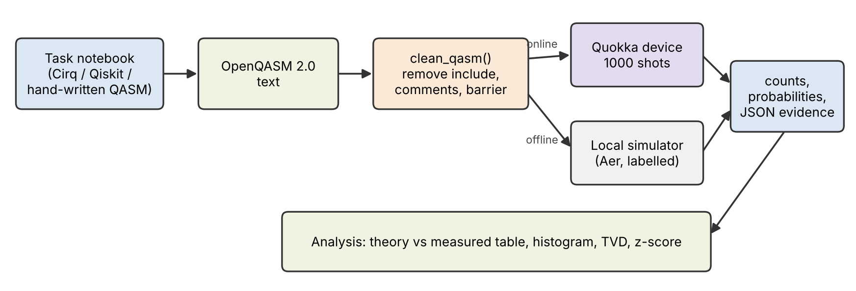
Figure 1. Shared execution pipeline used by Tasks 1, 2 and 4 (file common/quokka_helper.py)
To avoid repeating code, we wrote one shared helper (Figure 1). It (1) cleans the QASM text, removing the include "qelib1.inc" line, comments and barriers that Quokka does not accept; (2) posts it to Quokka with 1000 shots; (3) turns the raw shot list into counts; and (4) saves every run as JSON evidence with its source, time stamp and run time.
Honesty note on the Quokka device. On 30–31 October 2026 the Quokka address replied: "endpoint quokka1.quokkacomputing.com is offline (ERR_NGROK_3200)". The helper therefore ran the identical QASM scripts on the Qiskit Aer simulator with a fixed seed, and every result in this draft is labelled LOCAL SIMULATOR in the notebooks and JSON files. Because Quokka itself emulates an ideal machine, the expected behaviour is the same, but these numbers are not Quokka data. Running run_all.bat when Quokka is online replaces them with device results and the label changes to QUOKKA DEVICE.

1.4 How should the reader read the results?
Bit-strings follow the Qiskit convention: the left-most character is the highest-numbered bit. Two measures are used to compare theory with measurement. The total variation distance (TVD) is half the sum of the absolute differences between two probability distributions: 0 means identical and 1 means completely different. For a 50/50 outcome, the z-score tells us whether a count is within normal shot noise: with 1000 shots the standard deviation is √(1000 × 0.5 × 0.5) ≈ 15.8, so counts between about 468 and 532 are normal.

2. Project Setup and How to Run
All code, results and this report are stored in the GitHub repository https://github.com/anishnz/quantumcomputing_YB_Anish in the folder Assignment_2_Quantum. The project can be run in four ways: one click on Windows, one command on any computer, cell by cell in VS Code or Jupyter, or fully online in Google Colab with no installation. Every route runs the same notebooks with 1000 shots per circuit and saves the same evidence files.

2.1 What is in the project folder?
Table 2. Project folders and files (one folder per task, as the brief requires)
Folder / file | What it contains
Task_1_Bell_State/ | Task 1 notebook (Cirq Bell state) and results/ (counts JSON, table CSV, histogram, QASM)
Task_2_Qiskit_QASM/ | Task 2 notebook, our custom_half_adder.qasm, results/ (circuits, counts, histograms)
Task_3_Quantum_TicTacToe/ | completed game notebook, the original supplied notebook, results/ (game circuits, summaries)
Task_4_Quantum_ML/ | modified ML notebook (.ipynb, as required), the original notebook, results/ (iteration logs, graphs)
Alternative_Code/ | a second way to solve each task: Qiskit Bell state, Cirq circuits, terminal game, Statevector classifier
common/quokka_helper.py | shared code: clean QASM, send to Quokka, labelled fallback, counts, charts
run_project.py / run_project.bat / run_all.bat | the runner: menu, all tasks together, one task, or the alternative code
Colab_Run_All_Tasks.ipynb | runs the whole project in Google Colab
requirements.txt, MAINTENANCE.md, README.md | package versions, maintenance guide, step-by-step instructions
Report/ | this report (Assignment2.docx and Assignment2.pdf) and its figures

2.2 How do we run it on a Windows PC?
- Install Python 3.12 or newer (tick "Add to PATH") and download the repository: green Code button → Download ZIP, or git clone https://github.com/anishnz/quantumcomputing_YB_Anish.git.
- Open the Assignment_2_Quantum folder and double-click `run_project.bat`. The first time, it creates a virtual environment and installs requirements.txt (a few minutes).
- A menu appears: 1–4 runs one task, A runs Tasks 1–4 together, L runs the alternative code, S tests the Quokka connection. run_all.bat runs all four tasks without the menu.
- From a terminal the same runner takes arguments: python run_project.py all, python run_project.py 2 or python run_project.py alt. On macOS/Linux use ./run_project.sh all.
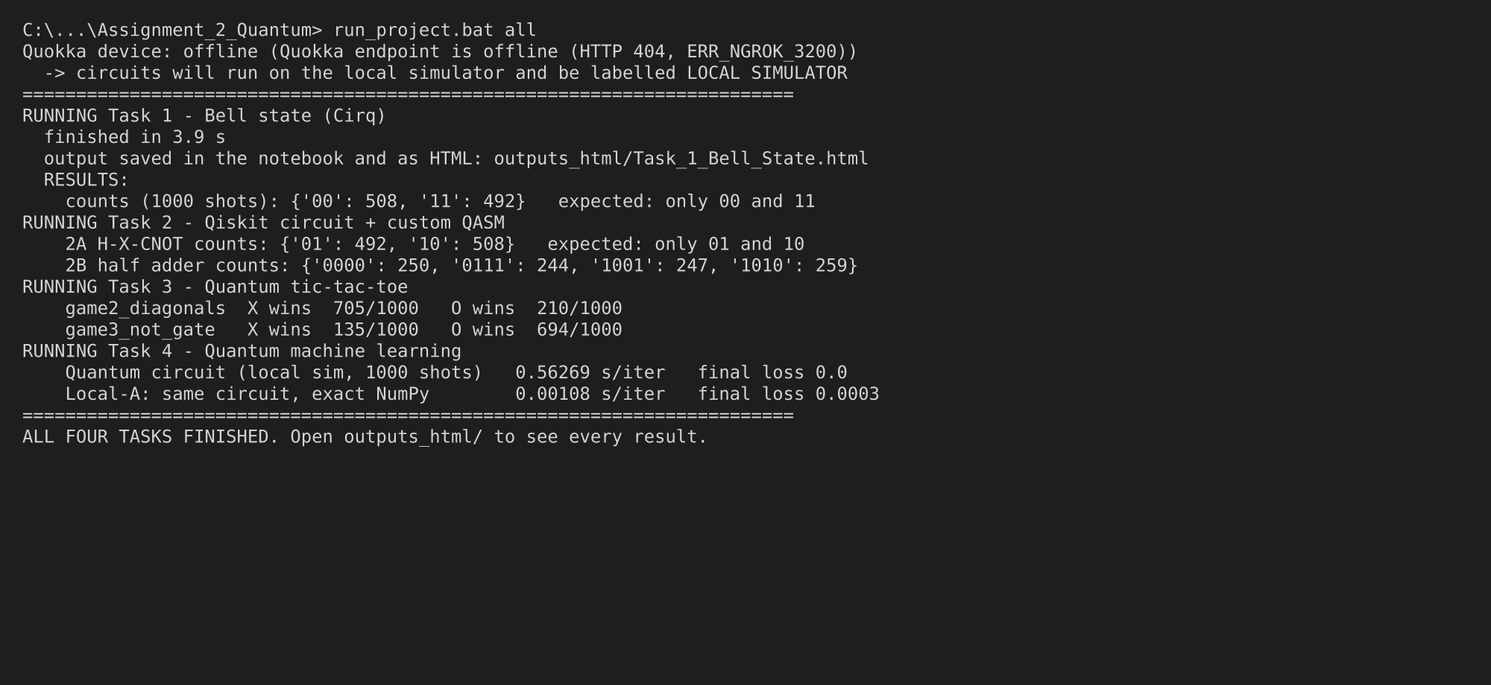
Figure 2. Terminal output of run_project.bat all (shortened): Quokka status, each task's run and its key results

2.3 Where can we see the output?
- In the terminal: after each task, the runner prints the key numbers (Figure 2).
- Inside each notebook: circuits, tables, histograms and graphs are saved in the executed .ipynb, ready to open in VS Code, Jupyter or Colab.
- As web pages: outputs_html/ contains one HTML file per task; double-click to open in any browser.
- As evidence files: each results/ folder stores the raw counts with their source (QUOKKA DEVICE or LOCAL SIMULATOR), CSV tables and PNG charts used in this report.

2.4 How do we run it in Google Colab?
Colab runs the notebooks on Google's computers, so nothing needs to be installed. The repository is connected to Colab through its GitHub address:
- Open https://colab.research.google.com/github/anishnz/quantumcomputing_YB_Anish/blob/main/Assignment_2_Quantum/Colab_Run_All_Tasks.ipynb (or, in Colab, choose File → Open notebook → GitHub, enter anishnz/quantumcomputing_YB_Anish and pick Colab_Run_All_Tasks.ipynb).
- Click Runtime → Run all. The notebook clones the repository, installs Cirq and Qiskit, tests Quokka, runs Tasks 1–4 together, shows the results and charts, runs the alternative code, and offers a zip of all outputs.
- To run one task, open its notebook from GitHub the same way. Its first code cell detects Colab, downloads the project and moves into the task folder, so the rest runs unchanged.

2.5 What alternative code did we provide?
Table 3. Alternative implementations in Alternative_Code/ (run with python run_project.py alt)
Task | Alternative | Why it is useful
Task 1 | Bell state written in Qiskit instead of Cirq | shows the result does not depend on the library; same QASM reaches Quokka
Task 2 | Both circuits written in Cirq and run on Cirq's own simulator | independent check of Part A and the half adder
Task 3 | Text-only tic-tac-toe in the terminal (X n, O n, NOT n, SWAP a b, PROB, MEASURE) | plays without widgets; --demo replays a game
Task 4 | Same classifier as a Qiskit circuit, exact Statevector output, COBYLA optimiser | shows the circuit, not the optimiser, solves the problem (loss 0 in 87 evaluations)

3. Task 1 – Entanglement Demonstration (Cirq + Quokka)
Task question: Create an entangled Bell state using Cirq and run the system on the Quokka device. The Bell state is |ψ⟩ = (1/√2)(|00⟩ + |11⟩). Generate qubits and apply the necessary gates to generate the state, and generate the necessary results. Notebook: Task_1_Bell_State/Task1_Bell_State_Cirq_Quokka.ipynb

3.1 What is a Bell state, and why is it special?
A qubit is a two-level quantum system whose state is |ψ⟩ = α|0⟩ + β|1⟩, where α and β are complex amplitudes with |α|² + |β|² = 1 (Nielsen & Chuang, 2010). Two qubits live in a four-dimensional space with basis |00⟩, |01⟩, |10⟩ and |11⟩. The Bell state asked for in the task is
|Φ⁺⟩ = (1/√2) ( |00⟩ + |11⟩ )
It is entangled: it cannot be written as (state of qubit 0) ⊗ (state of qubit 1). Suppose it could; then (a|0⟩ + b|1⟩) ⊗ (c|0⟩ + d|1⟩) would need ac = bd = 1/√2 but ad = bc = 0, which is impossible. In practice, each qubit on its own is a fair coin, but the two coins always land the same way. Einstein, Podolsky and Rosen (1935) used such correlations to question quantum theory; Bell (1964) showed they cannot be explained by hidden classical values, and loophole-free experiments have confirmed this (Hensen et al., 2015).

3.2 Which gates make the state, and why?
Two gates are enough, as taught in the course (Bahrami, 2026a). The Hadamard (H) gate creates an equal superposition, and the controlled-NOT (CNOT) gate copies the control's value into the target *for every branch of the superposition at once*, which links (entangles) the qubits.
H = (1/√2) [ [1, 1], [1, −1] ] CNOT = [ [1,0,0,0], [0,1,0,0], [0,0,0,1], [0,0,1,0] ]
Table 4. State of the two qubits after each gate (written |q0 q1⟩)
Step | Gate | State
0 | start | |00⟩
1 | H on q0 | (1/√2)(|0⟩ + |1⟩) ⊗ |0⟩ = (1/√2)(|00⟩ + |10⟩)
2 | CNOT (control q0, target q1) | (1/√2)(|00⟩ + |11⟩) = |Φ⁺⟩
3 | measure both | 00 with probability |1/√2|² = 0.5; 11 with probability 0.5

3.3 How did we build it in Cirq?
The Cirq code creates two LineQubit objects, applies cirq.H(q0) and cirq.CNOT(q0, q1), and measures both qubits into one register. Before using the device, the notebook simulates the circuit without measurement to obtain the exact amplitudes: 0.7071 for |00⟩ and |11⟩ and 0 for the others, matching Table 4. The circuit is then exported with cirq.qasm(), cleaned by the helper and sent with 1000 shots.
q0, q1 = cirq.LineQubit.range(2) # two qubits, both start in |0>
bell = cirq.Circuit(
cirq.H(q0), # superposition on q0
cirq.CNOT(q0, q1), # entangle q1 with q0
cirq.measure(q0, q1, key="c")) # read both qubits
run = qh.run_qasm(qh.clean_qasm(cirq.qasm(bell)), shots=1000)
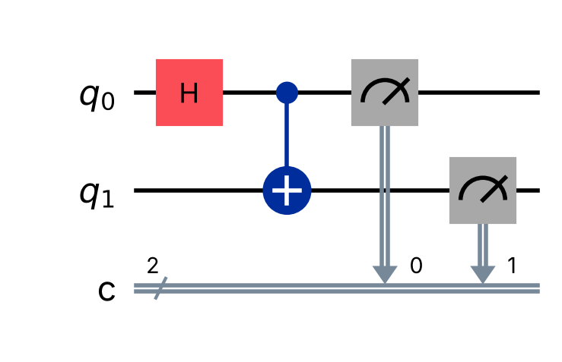
Figure 3. Task 1 Bell-state circuit: H on q0, CNOT from q0 to q1, then measurement

3.4 What did the measurement show?
Table 5. Task 1 results: theory versus 1000-shot measurement (source: local simulator, Quokka offline)
Outcome | Theory P | Counts (of 1000) | Measured P | Difference
00 | 0.500 | 508 | 0.508 | +0.008
01 | 0.000 | 0 | 0.000 | 0.000
10 | 0.000 | 0 | 0.000 | 0.000
11 | 0.500 | 492 | 0.492 | −0.008

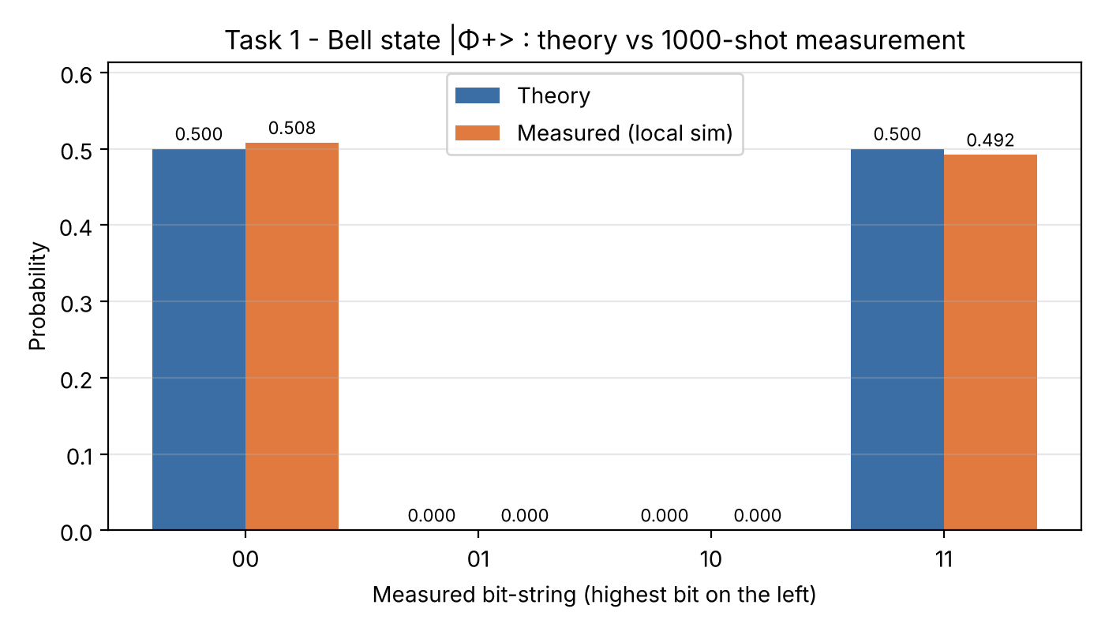
Figure 4. Task 1 histogram: theory and measured probabilities for each outcome
All 1000 shots were correlated (00 or 11), and none were 01 or 10. The 00 count of 508 is only 0.51 standard deviations above 500 (z = +0.51), and the TVD between theory and measurement is 0.008. The result therefore agrees with the Bell state within normal shot noise.

3.5 Why is the split not exactly 500/500?
Measurement is random. Each shot is an independent trial with p = 0.5, so the 00 count follows a binomial distribution with mean 500 and standard deviation 15.8. A perfect 500/500 split would itself be unusual (it happens only about 2.5% of the time). Small differences are expected and are not errors.

3.6 Would a real superconducting or ion-trap computer give the same result?
Not exactly. Physical devices have gate errors, decoherence and readout errors, which produce a few percent of 01 and 10 outcomes (Preskill, 2018). Quokka is designed to emulate an ideal fault-tolerant machine (UTS, 2024), so Quokka results should look like Table 5, with zero 01/10 counts. If 01 or 10 appear when the notebook is re-run on Quokka, the first things to check are the qubit order in the QASM and the bit order in the reply. The helper checks bit order by reading each shot as [c0, c1] and reversing it to the Qiskit convention.

3.7 What does Task 1 prove?
- The circuit H → CNOT → measure correctly prepares |Φ⁺⟩ = (|00⟩ + |11⟩)/√2 (LO2).
- Each qubit alone looks random (50/50), but the pair is perfectly correlated, which is the measurable signature of entanglement.
- Agreement between theory and measurement is quantified (TVD = 0.008, z = +0.51), not just claimed.

4. Task 2 – Qiskit Circuits and a Custom QASM Circuit
Task question: Using Qiskit, generate the given circuit (H on one line, X on the other, both entering block C). Measure the output by running it on a Quokka device and print the output. Then write a QASM script for a circuit of your own using different qubits and various gates, run it on Quokka and print the output. Notebook: Task_2_Qiskit_QASM/Task2_Qiskit_Circuits_and_QASM.ipynb

4.1 Part A – What is block "C" in the given circuit?
The brief draws an H gate on the top line and an X gate on the bottom line, both entering a box labelled C that has two inputs and one output arrow (on the lower line). This is the standard way of drawing a controlled-NOT used as a function block: the top line is the *control*, the bottom line is the *target*, and the target carries the result (Nielsen & Chuang, 2010). We therefore implemented C as cx(0, 1). Because the diagram shows a single output, we ran two versions: one measuring both qubits (full analysis) and one measuring only the output line (exactly as drawn).

4.2 What should the circuit do? (Step-by-step maths)
Table 6. Task 2A state after each gate (Qiskit order |q1 q0⟩)
Step | Gate | State |q1 q0⟩
0 | start | |00⟩
1 | H on q0 | (1/√2)(|00⟩ + |01⟩)
2 | X on q1 | (1/√2)(|10⟩ + |11⟩)
3 | C = CNOT (q0 → q1) | (1/√2)(|10⟩ + |01⟩) = |Ψ⁺⟩

The final state is the Bell state |Ψ⁺⟩: the two qubits are entangled and always opposite. The X gate is what turns the Task 1 state (always equal) into this one (always different). The output line q1 equals NOT(q0), so it is a fair 50/50 random bit. Predictions: 01 and 10 at 0.5 each, 00 and 11 never; the output line alone gives 0 and 1 at 0.5 each.
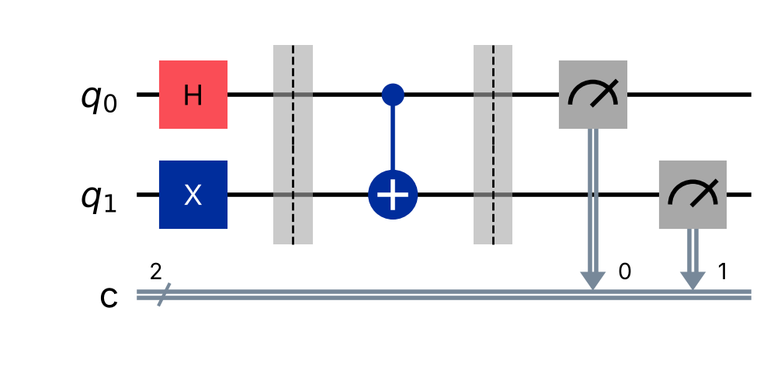
Figure 5. Task 2A circuit in Qiskit: H and X, then block C implemented as a CNOT

4.3 What did Quokka (or the labelled simulator) return?
Table 7. Task 2A results, both qubits measured (1000 shots)
Outcome |q1 q0⟩ | Theory P | Counts (of 1000) | Measured P | Difference
00 | 0.000 | 0 | 0.000 | 0.000
01 | 0.500 | 492 | 0.492 | −0.008
10 | 0.500 | 508 | 0.508 | +0.008
11 | 0.000 | 0 | 0.000 | 0.000

The output-only version returned 0: 491 and 1: 509. Both runs agree with theory: only anti-correlated outcomes appear, and the TVD is 0.008. The printed output in the notebook is the counts dictionary, {'01': 492, '10': 508}.
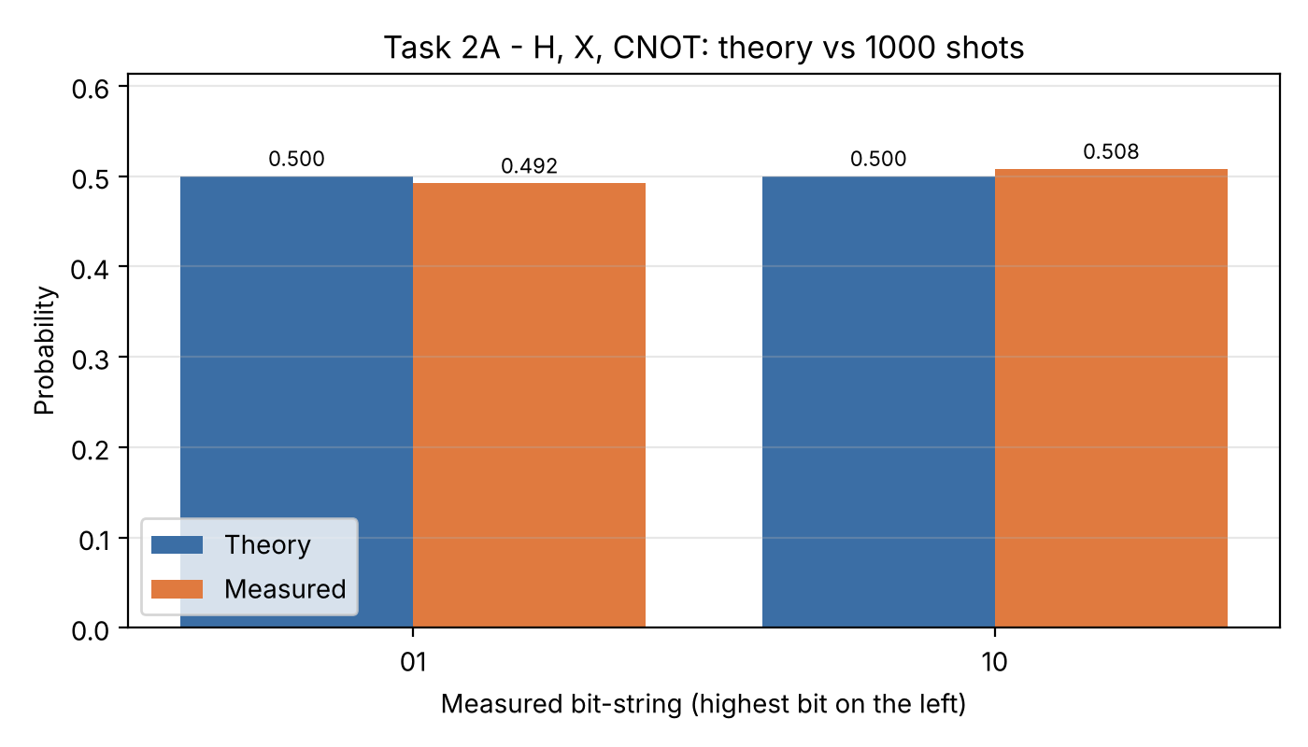
Figure 6. Task 2A histogram: theory versus 1000-shot measurement

4.4 Part B – Why did we design a quantum half adder?
The brief asks for a circuit of our own with different qubits and various gates, and the rubric rewards creativity *and* understanding. We chose a circuit with a clear purpose that we could check fully: a half adder, the basic building block of computer arithmetic, which returns SUM = A XOR B and CARRY = A AND B. Quantum adders built from CNOT and Toffoli gates are well known (Vedral et al., 1996). Our twist is to place the inputs in superposition, so one circuit holds all four additions (0+0, 0+1, 1+0, 1+1) at the same time. Each shot then reveals one complete, correct row of the truth table.
Table 8. Qubits and gates in our custom circuit (file custom_half_adder.qasm)
Qubit | Role | Gates | Why this gate
q0 | input A | H, Z | H makes A = 0 and 1 at once; Z adds a −1 phase to show that phase is invisible to direct measurement
q1 | input B | H, S | H for superposition; S adds an i phase (same lesson)
q2 | CARRY | CCX (Toffoli) | Flips to 1 only if A = 1 AND B = 1
q3 | SUM | CX, CX | Two CNOTs give SUM = A ⊕ B

OPENQASM 2.0;
include "qelib1.inc";
qreg q[4]; creg c[4];
h q[0]; h q[1]; // A and B in superposition
z q[0]; s q[1]; // phase gates: change amplitudes, not probabilities
ccx q[0],q[1],q[2]; // CARRY = A AND B
cx q[0],q[3]; cx q[1],q[3]; // SUM = A XOR B
measure q[0] -> c[0]; measure q[1] -> c[1];
measure q[2] -> c[2]; measure q[3] -> c[3];
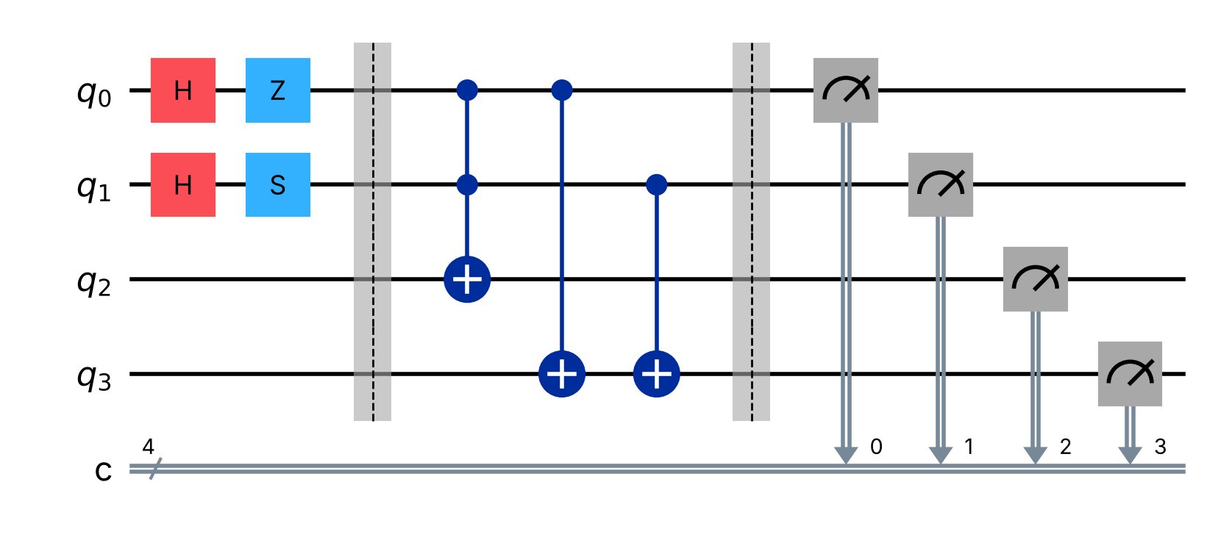
Figure 7. Task 2B custom circuit (quantum half adder) loaded from our QASM file

4.5 What does the theory predict?
After the two H gates the inputs are (1/2)(|00⟩ + |01⟩ + |10⟩ + |11⟩). The Z and S gates multiply some amplitudes by −1 or i. The state vector in the notebook shows amplitudes 0.5, −0.5i, −0.5 and 0.5i, but every probability is still |±0.5|² = |±0.5i|² = 0.25. The Toffoli and CNOT gates then write CARRY and SUM. Writing strings as c3c2c1c0 = SUM, CARRY, B, A, only four strings are possible: 0000, 1001, 1010 and 0111, each with probability 0.25.

4.6 Did the measurement agree?
Table 9. Task 2B results (1000 shots); every observed string is a correct addition
String | A | B | SUM | CARRY | Theory P | Counts | Measured P
0000 | 0 | 0 | 0 | 0 | 0.25 | 250 | 0.250
1001 | 1 | 0 | 1 | 0 | 0.25 | 247 | 0.247
1010 | 0 | 1 | 1 | 0 | 0.25 | 259 | 0.259
0111 | 1 | 1 | 0 | 1 | 0.25 | 244 | 0.244

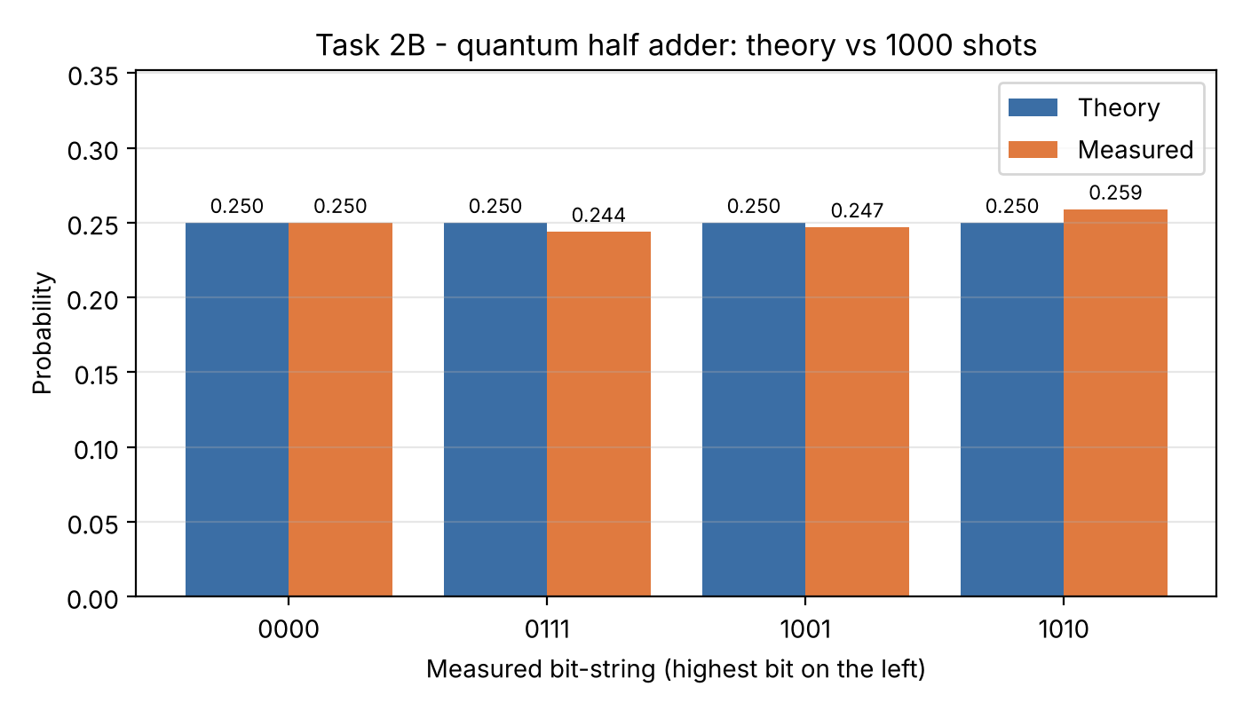
Figure 8. Task 2B histogram: the four rows of the half-adder truth table
All 1000 of 1000 shots were correct additions, the four rows appeared 244–259 times (expected 250 ± 13.7), and the TVD is 0.009. The circuit therefore works as designed.

4.7 What if the device does not support the Toffoli gate?
Real devices only run a small native gate set, and a Toffoli must be decomposed into one- and two-qubit gates (Barenco et al., 1995). Our notebook builds an equivalent circuit from H, T, T†, S, Z and CX gates (8 CNOTs, 4 T and 3 T†). If Quokka rejects ccx, the notebook automatically sends this version. This also shows a real engineering cost: the 'one-line' Toffoli becomes about 15 basic gates, which on noisy hardware would add error.

4.8 What did Task 2 teach us? (Critical evaluation)
- Two Bell states, one gate apart. Adding X before the CNOT changes |Φ⁺⟩ (always equal) into |Ψ⁺⟩ (always different). Mathematics predicted this before we ran anything (LO1).
- Superposition is not free parallel output. The half adder holds four additions, but each shot shows only one of them. Reading all rows took 1000 shots; a classical half adder needs only 4 runs. A quantum advantage needs interference that concentrates probability on useful answers, as in Grover's or Shor's algorithms, and simple superposition does not do that.
- Phase matters only with interference. Z and S changed amplitudes but not one count. They would matter only if a later H gate made the amplitudes interfere.
- QASM is the common language. The same OpenQASM 2.0 text ran through Qiskit, the helper and the device interface, which made the work portable between tools (Cross et al., 2017).

5. Task 3 – Investigating a Quantum Code: Quantum Tic-Tac-Toe
Task question: Complete the provided code by filling in missing instructions or comments; play multiple games and analyse the generated code; as a quantum software engineer, explain the purpose, functionality, gameplay dynamics and how circuits are generated (Word document); and describe each quantum gate used in a separate section. Notebook: Task_3_Quantum_TicTacToe/Task3_Quantum_TicTacToe_Completed.ipynb (original kept unchanged beside it)

5.1 What is the purpose of the program?
The program is a teaching game. Quantum games have long been used to make superposition and measurement intuitive (Goff, 2006). Here every tile of the 3 × 3 board is one qubit, and every move adds a gate to a nine-qubit circuit. Nobody owns a tile until the end, when the circuit is measured once: a 0 makes the tile X's and a 1 makes it O's. Playing therefore means *designing a quantum circuit*, and the result is probabilistic. The game makes three ideas visible: superposition (undecided tiles), unitary gates as moves, and measurement collapse.

5.2 How is the code organised?
The code has two classes. `Board` is the quantum part: it owns the QuantumCircuit(9, 9), adds gates in make_move, measures in measure, and counts winning lines in countWinners. `Game` is the classical user interface: it creates buttons with ipywidgets, reacts to clicks in handle_game, and redraws the board. This separation of quantum logic from the user interface is good software design. It is also how real quantum applications are built: a classical program prepares and sends circuits and then interprets the results.
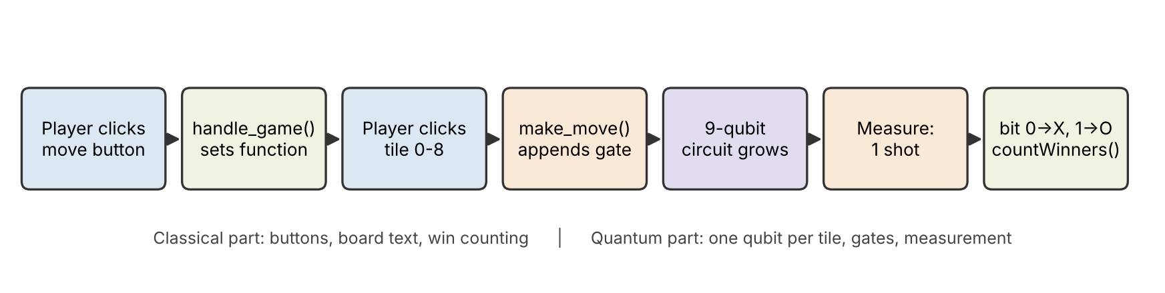
Figure 9. How one move travels through the code: from a click to a gate, and from measurement to the score

5.3 What was missing, and what did we complete or fix?
Table 10. Code completion and fixes (marked [ADDED], [FIXED] or [CHANGED] in the notebook)
# | Location | Problem in supplied code | Our completion
1 | make_move – Not | comment only, no gate | self.qc.x(cell)
2 | make_move – O | comment only, no gate | self.qc.ry(+π/4, cell) (toward |1⟩ = O)
3 | make_move – X | comment only, no gate | self.qc.ry(−π/4, cell) (toward |0⟩ = X)
4 | make_move – SWAP | comment only, no gate | self.qc.swap(cell, self.target)
5 | countWinners | winners = () – nobody could ever win | the 8 lines: 3 rows, 3 columns, 2 diagonals
6 | SWAP branch | dead inner if; crash if no first tile | guard target ≥ 0; reset target after swap
7 | new() | empty tile '' but __init__ uses ' ' | made consistent
8 | imports / grid | google.colab widgets only work in Colab | ipywidgets HBox/GridBox (VS Code, Jupyter, Colab)

An important finding: the supplied comments had the rotation directions swapped. measure() maps bit 0 to X and bit 1 to O, but the comments said the O button rotates toward |0⟩ and the X button toward |1⟩. Followed literally, pressing O would help player X. The game's own rules say "O turns the tile toward a tile owned by O", so we implemented O as a rotation toward |1⟩ and X toward |0⟩ and corrected the comments. Finding a mismatch between comments, code and specification, and resolving it against the specification, is a normal part of investigating someone else's code.

5.4 How does a move become a gate? (Circuit generation)
- Start of a round. __init__ (and new()) adds reset and H to all nine qubits, then a barrier. Every tile is |+⟩ = (|0⟩ + |1⟩)/√2, i.e. 50% X and 50% O.
- Choose a move. Clicking Not, O, X or SWAP raises a ValueError when int(b.description) is tried, and the except branch stores the move in board.function. This is a slightly unusual way to tell text buttons from number buttons.
- Choose a tile. Clicking 0–8 calls make_move(cell), which appends one gate to self.qc. For SWAP, the first tile click sets board.target and the second click applies the swap.
- The circuit grows. After each move the circuit is redrawn. The text on the board is only a move history; as the original notes say, "the game circuit is the true state of the game".
- Measure. Barrier and nine measure instructions are added, and the circuit runs once (1 shot) on AerSimulator. Bit i of the result decides tile i, read from the right-hand end of Qiskit's string (output[9-1-i]).
- Score. countWinners checks the eight lines for each player. Both players can win lines in the same round, because the tiles are decided independently.

5.5 How does a rotation move change the odds?
On the Bloch sphere, |+⟩ sits at angle θ = π/2 from |0⟩, and P(X) = P(0) = cos²(θ/2). Each X move applies Rᵧ(−π/4), which reduces θ by π/4 (Figure 10). One X move gives P(X) = cos²(π/8) = 0.854, two moves give 1.000, and a third move over-rotates back to 0.854. Moves are rotations, not counters, so "too many" moves undo themselves. This is a quantum effect that classical tic-tac-toe does not have.
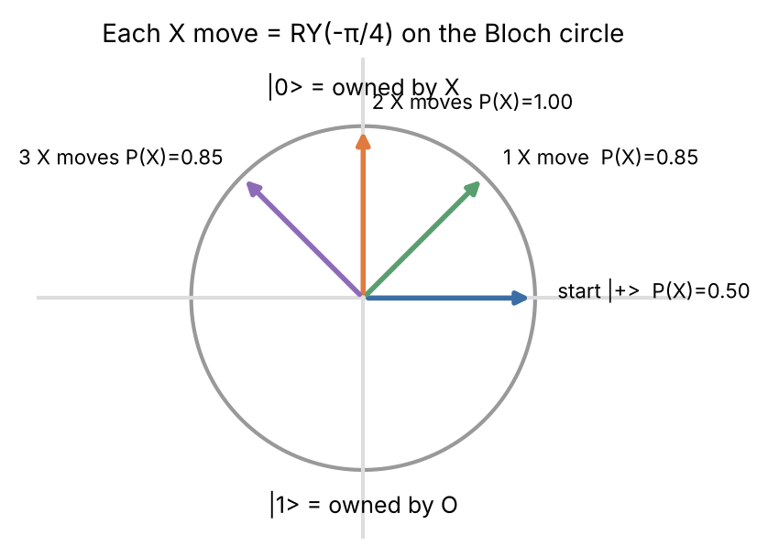
Figure 10. Effect of repeated X moves on one tile (x–z plane of the Bloch sphere)

5.6 What happened when we played? (Four recorded games)
Button clicks cannot be saved in a notebook, so we replayed four games as scripts that call exactly the same make_move and measure code with fixed seeds. For each game we saved the circuit picture, the one-shot result, and a 1000-shot study of the same circuit, which estimates each tile's chance of becoming X and each player's chance of winning (more X lines than O lines).
Table 11. Recorded games: moves, generated gates, the one-shot result and 1000-shot win chances
Game | Moves | Gates added | 1-shot lines X:O | X wins /1000 | O wins /1000 | Draws /1000
1 Baseline | none | 9 H only | 4 : 0 | 392 | 405 | 203
2 Diagonals | X on 0, 4, 8; O on 2, 6 | +5 RY | 4 : 0 | 705 | 210 | 85
3 NOT test | X, X on 4; Not on 4; O on 0; Not on 1 | +3 RY, 2 X | 0 : 2 | 135 | 694 | 171
4 SWAP | X, X on 0; O, O on 4; SWAP 0↔8; X × 3 on 2 | +7 RY, 1 SWAP | 0 : 2 | 404 | 289 | 307

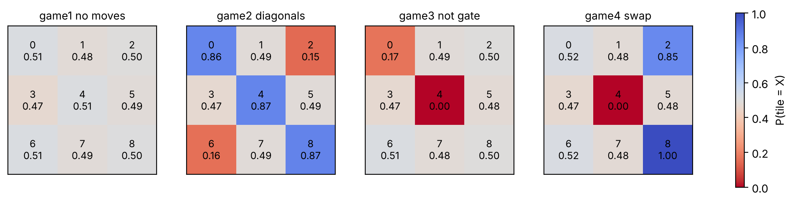
Figure 11. Chance that each tile becomes X after each recorded game (1000 shots; blue = X likely, red = O likely)
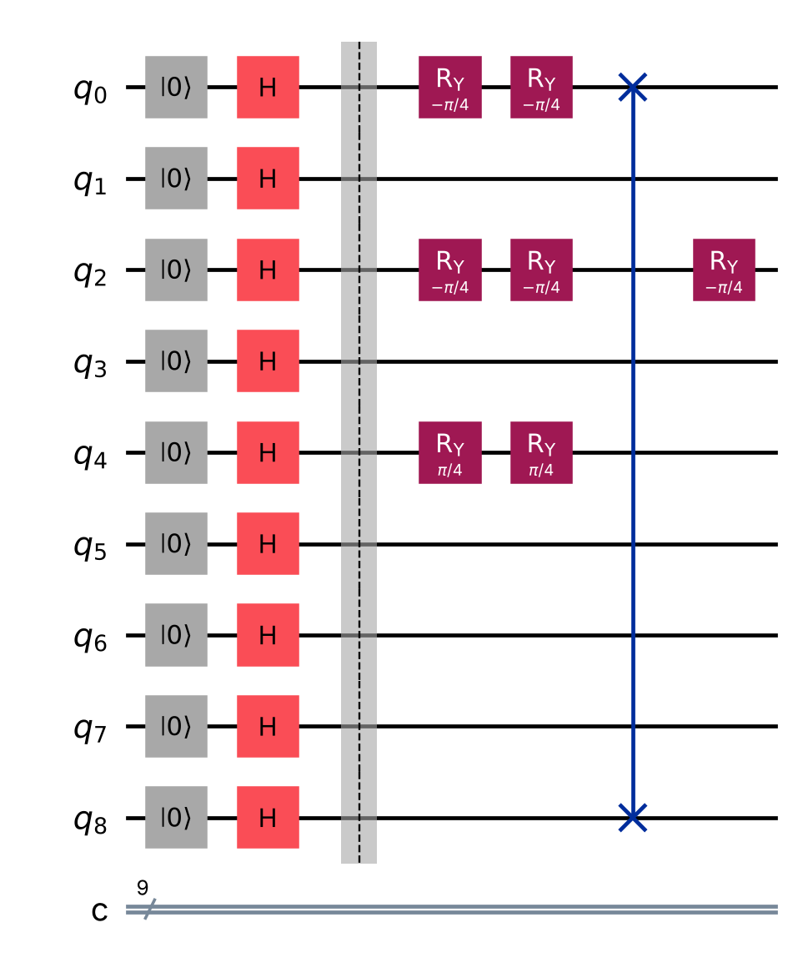
Figure 12. Circuit generated by Game 4: H start layer, RY moves, and the SWAP between tiles 0 and 8

5.7 What do the games show? (Analysis)
- Game 1 (baseline): with no moves every tile is 50/50, so X and O win about equally often (392 vs 405). The one-shot result (X 4 lines) was simply luck. A single game says little; the 1000-shot study shows the real odds.
- Game 2: three X moves on the main diagonal (P(X) ≈ 0.86 each) and two O moves on the other corners raised X's win chance from 39% to 71%. Strategy works, but only in probability.
- Game 3 (NOT gate): two X moves made tile 4 certainly X, and NOT then made it certainly O (P(X) = 0.00). NOT on the *undecided* tile 1 did nothing (0.49), because |+⟩ is an eigenstate of X: X|+⟩ = |+⟩. This matches the rule "if the tile is not owned, Not does nothing", and it is explained by linear algebra, not by an if-statement.
- Game 4 (SWAP): tile 0 was made certainly X and then swapped with tile 8. Afterwards tile 8 is certainly X (1.00) and tile 0 is back to 50/50, because SWAP moved the quantum *states*, not labels. Tile 2 received three X moves and shows the over-rotation (0.85, not 1.00).
- Circuit growth: every move adds one gate and does not remove any, so circuit depth rose from 2 to 5. On noisy hardware, longer games would therefore be less reliable.

5.8 Can the game circuit run on Quokka?
Yes. The notebook removes the reset instructions (qubits already start at |0⟩), translates the Game 2 circuit to H, RY, X and CX gates, exports it to QASM and sends it with 1000 shots. With the labelled local fallback, the per-tile chances were 0.87, 0.50, 0.13, 0.51, 0.86, 0.50, 0.14, 0.53 and 0.87, the same pattern as Figure 11. This links the game back to the device used in Tasks 1 and 2.

5.9 Which quantum gates does the game use? (Gate section)
Table 12. Quantum gates used in circuit generation: characteristics and function in the game
Gate | Matrix / action | Key characteristic | Function in this game
H (Hadamard) | (1/√2)[[1,1],[1,−1]]; |0⟩ → |+⟩ | creates equal superposition; H·H = I | start layer: every tile undecided (50/50)
Rᵧ(θ) | [[cos θ/2, −sin θ/2],[sin θ/2, cos θ/2]] | rotation about the y-axis; real amplitudes; changes probabilities smoothly | X move: Rᵧ(−π/4) toward |0⟩; O move: Rᵧ(+π/4) toward |1⟩
X (NOT) | [[0,1],[1,0]]; |0⟩ ↔ |1⟩ | bit flip; X|+⟩ = |+⟩ (eigenstate) | Not move: flips ownership of a decided tile
SWAP | exchanges two qubits' states (= 3 CNOTs) | two-qubit, permutes |01⟩ ↔ |10⟩ | SWAP move: exchanges two tiles
reset | sets qubit to |0⟩ (not unitary) | non-reversible initialisation | clean start of each round
measure | projects onto |0⟩ or |1⟩ | irreversible; Born rule | decides each tile's owner (0 → X, 1 → O)
barrier | no operation | visual / compiler boundary | separates start, moves and measurement in the drawing

5.10 What are the strengths and limits of the program?
Strengths: the program is short, has clear quantum/classical separation and a good visual circuit, and it demonstrates superposition, rotation and measurement in a playful way. Limitations: (1) tiles are never *entangled*, because the only two-qubit gate is SWAP, which keeps tiles independent; adding a CNOT move would create linked tiles and is a natural improvement. (2) One-shot measurement makes single games very random. (3) The board text is "not 100% accurate", so it can mislead players. (4) Using exceptions to tell buttons apart is fragile. (5) There is no turn order, so one player can make every move. Despite these limits, as a teaching tool it shows clearly that a quantum program is a circuit that is built step by step and only gives answers when measured.

6. Task 4 – Machine Learning Quantum Analysis
Task question: Analyse the code (circuit and problem formulation; data input; quantum functionality, excluding the optimiser); execute it, monitor the output at each iteration and plot iteration vs output and iteration vs time; modify it to run locally without the quantum computer or circuit and document differences in efficiency and effectiveness; submit the modified .ipynb and a report. Notebook: Task_4_Quantum_ML/Task4_Quantum_ML_Modified.ipynb (original kept beside it)

6.1 What problem does the code solve? (Problem formulation)
The notebook trains a quantum circuit to classify tiny 2 × 2 black-and-white images into two classes, which the code calls stripes (label 0) and bars (label 1). generate_data(2) creates all line patterns and removes the all-black and all-white images, because they belong to both classes. Four images remain: [1,0,1,0] and [0,1,0,1] (label 0), and [1,1,0,0] and [0,0,1,1] (label 1). Three are used for training and one for testing (75/25 split).
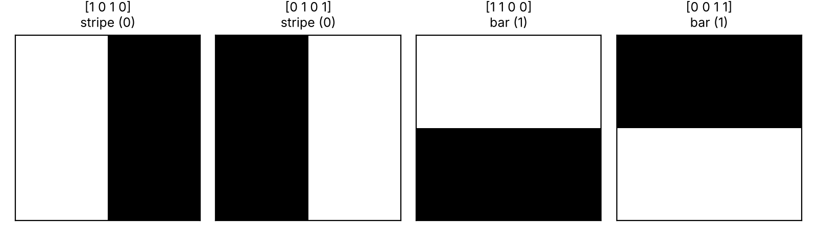
Figure 13. The four images, their pixel vectors and labels
The model output is the probability that the last qubit is measured as 1, estimated from shots: ŷ(θ, x) ≈ (number of 1s) / shots. The loss minimised is the mean absolute error over the training images:
L(θ) = (1/N) Σₙ | ŷ(θ, xₙ) − yₙ |
A good model gives ŷ → 1 for bars and ŷ → 0 for stripes; an image is classified as a bar when ŷ > 0.5.

6.2 Which part of the code is the input to the circuit?
The input is the loop at the top of create_circuit: for every pixel i, if data[i] > 0.5, an X gate is added to qubit i. Each pixel is one qubit, and a white pixel flips its qubit from |0⟩ to |1⟩. This is basis encoding: the image becomes the starting basis state, e.g. [1,0,1,0] → |q3q2q1q0⟩ = |0101⟩ (Schuld & Petruccione, 2021). The data enters only here; everything after it is the trainable model.

6.3 How does the circuit work? (Quantum part, excluding the optimiser)
The trainable part is built from blocks. block(angles, qubits) applies Rᵧ(θₐ) to one qubit, Rᵧ(θ_b) to another, and then a CNOT between them. generate_pairs splits the qubits in half again and again and joins the halves, giving the pairs (0,1), (2,3) and then (1,3). Information from all four pixels therefore flows into qubit 3 in only log₂4 = 2 layers. This is a tree tensor network (TTN) classifier of the kind studied by Grant et al. (2018) and Huggins et al. (2019). With 3 blocks × 2 angles there are 6 trainable parameters, and only qubit 3 is measured.
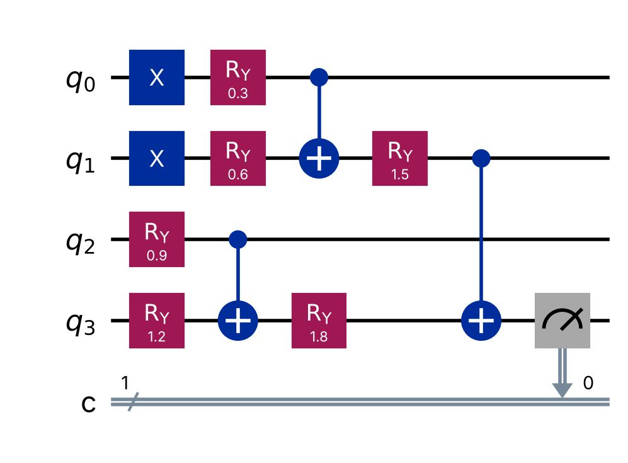
Figure 14. Classifier circuit for image [1,1,0,0]: X gates encode the pixels, then three RY–RY–CNOT blocks form a tree into q3
The RY gates give each block adjustable 'weights', while the CNOTs make the output depend on *combinations* of pixels. If a control qubit is in |1⟩, the CNOT flips the target, so the final value of q3 behaves like an XOR (parity) of pixels that is smoothly adjusted by the angles. This structure turns out to be the key to the results below.

6.4 What did we add to monitor every iteration?
We modified the SPSA optimiser (Spall, 1992) without changing its algorithm. SPSA estimates the gradient from just two loss evaluations per iteration, whatever the number of parameters, which suits noisy, expensive quantum evaluations. We added a timer around each update and, after each update, one extra evaluation of the training loss, the output measure. This monitoring evaluation is timed separately so it does not inflate the iteration time. Settings were kept as in the original (a = 1, c = 0.5, α = 0.602, γ = 0.101, 100 iterations), except that the shots per circuit were raised from 100 to the group's agreed 1000, and a fixed seed (2026) makes runs repeatable. Each iteration runs 3 evaluations × 3 training images = 9 circuits, so the run executed 900 circuits in total.

6.5 What do the two required graphs show?
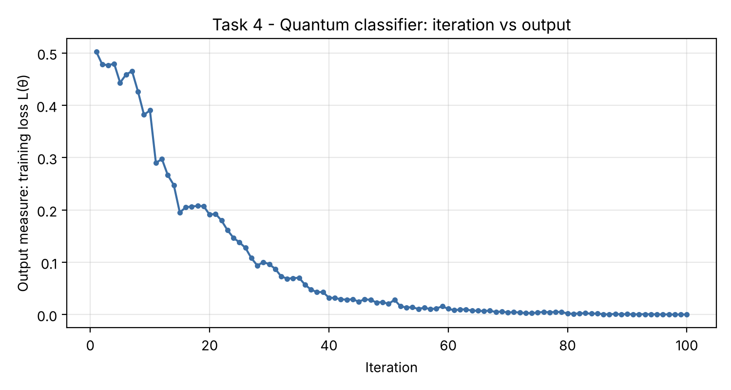
Figure 15. Required graph 1: iteration number versus output measure (training loss)
Table 13. Excerpt from the 100-iteration log (task4_quantum_iterations.csv)
Iteration | Output (training loss) | Note
1 | 0.503 | random start: no better than guessing
10 | 0.390
20 | 0.191
30 | 0.096
37 | < 0.05 | first iteration below 0.05
50 | 0.020
70 | 0.004
100 | 0.000 | all training images perfectly separated

Graph 1 shows the loss falling from 0.50, which is equal to random guessing, to 0.00 by iteration 100. It fell quickly in the first 40 iterations and then flattened. The curve is not perfectly smooth. Each loss value is itself an estimate from 1000 shots per image, and SPSA's random ±1 directions sometimes give a slightly worse step (e.g. iterations 10–11 and 15–20). The step size aₖ = 1/(k+1)^0.602 shrinks over time, which explains the slow final convergence.
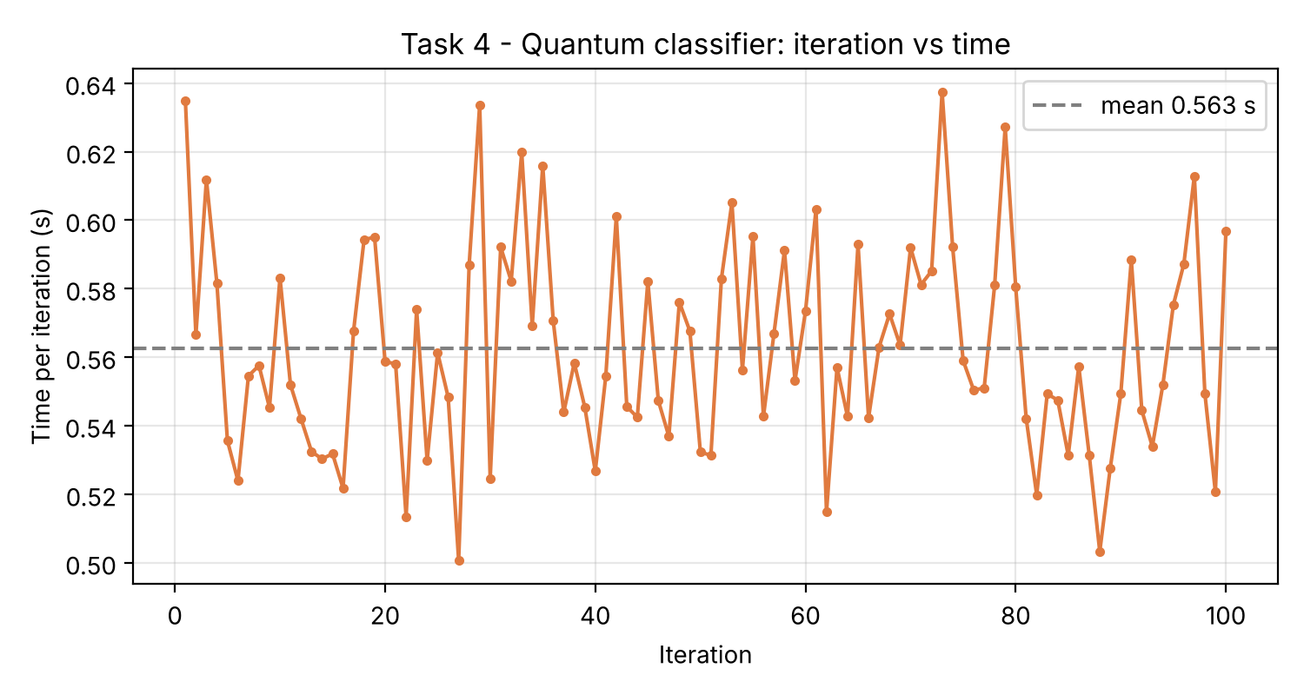
Figure 16. Required graph 2: iteration number versus time per iteration
Graph 2 shows an almost constant time per iteration of 0.56 s on average (range 0.50–0.64 s). This is expected: every iteration runs the same number of circuits (6 for the update) with the same size and shot count, so the cost does not depend on how good the model is. The small spikes are background noise from the operating system. On the real Quokka, each circuit adds a network round trip, so the line would sit higher and be more irregular, and the total would be dominated by communication rather than computation.

6.6 How did we make the code run without the quantum computer or circuit?
The brief can be read in two ways, so we built both and added one fairer baseline. Every version uses the same loss, the same SPSA settings and the same random seed, so only the model changes:
- Local-A: no quantum computer. The same circuit is simulated exactly with our own NumPy state-vector code: 16 complex amplitudes, with gates applied as matrices. It computes P(q3 = 1) exactly, so there is no shot noise. It was verified against Qiskit (both gave 0.500625 for a random test case).
- Local-B: no quantum circuit. A classical logistic regression ŷ = σ(w·x + b) with 5 parameters, close to the circuit's 6.
- Local-C: a fair classical baseline. Logistic regression with pairwise pixel products added (4 + 6 features, 11 parameters). This is the standard classical way to model interactions.

6.7 What were the differences in efficiency and effectiveness?
Table 14. Quantum circuit versus local versions (100 SPSA iterations, seed 2026). Accuracy uses each trained model's exact output; times vary slightly between runs
Version | Total time (s) | Time / iteration (s) | Circuit runs | Final loss | Test acc. | All 4 images
Quantum circuit (1000 shots; local sim, Quokka offline) | 84.6 | 0.563 | 900 | 0.000 | 1/1 | 4/4
Local-A: same circuit, exact NumPy | 0.16 | 0.0011 | 0 | 0.0003 | 1/1 | 4/4
Local-B: classical linear | 0.007 | 0.00005 | 0 | 0.296 | 0/1 | 3/4
Local-C: classical + pairwise features | 0.034 | 0.00023 | 0 | 0.206 | 0/1 | 3/4

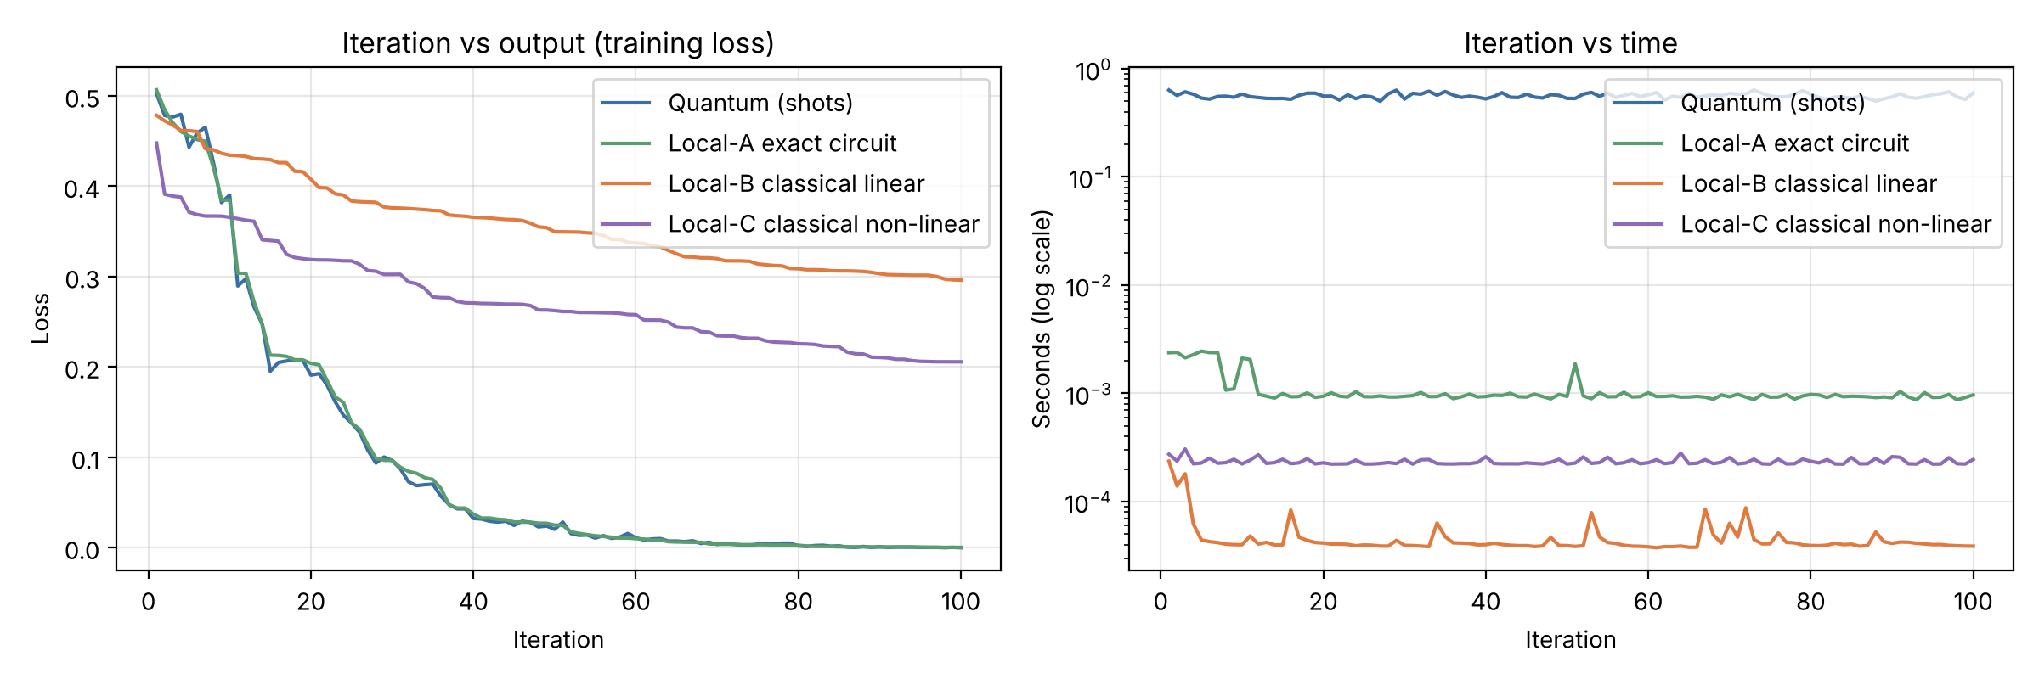
Figure 17. All versions: loss per iteration (left) and time per iteration on a log scale (right)
Efficiency. Removing the quantum device made each iteration about 520 times faster (0.563 s → 0.0011 s). A shot-based run needs 1000 samples per circuit, plus QASM parsing and, on Quokka, a network request, whereas the exact simulation needs one small matrix calculation. Local-A and the quantum run followed almost the same loss curve, both first dropping below 0.05 at iteration 37. The shot noise therefore slowed the computer, not the learning. This advantage disappears as problems grow: exact simulation needs 2ⁿ amplitudes, so 50 qubits would need about 10¹⁵ complex numbers, which is why real quantum hardware becomes useful only at scale.
Effectiveness. The circuit (both quantum and Local-A) reached zero training loss and also classified the unseen test image correctly. Both classical models fitted the training images but failed the test image, and their losses stayed high (0.30 and 0.21). The reason is the shape of the data. In each class the two images are exact opposites, so the class sums are identical and no straight line can separate the classes. Like XOR, this is the classic limit of linear models (Minsky & Papert, 1969). In fact, the label equals x₁ XOR x₃ (Figure 18).
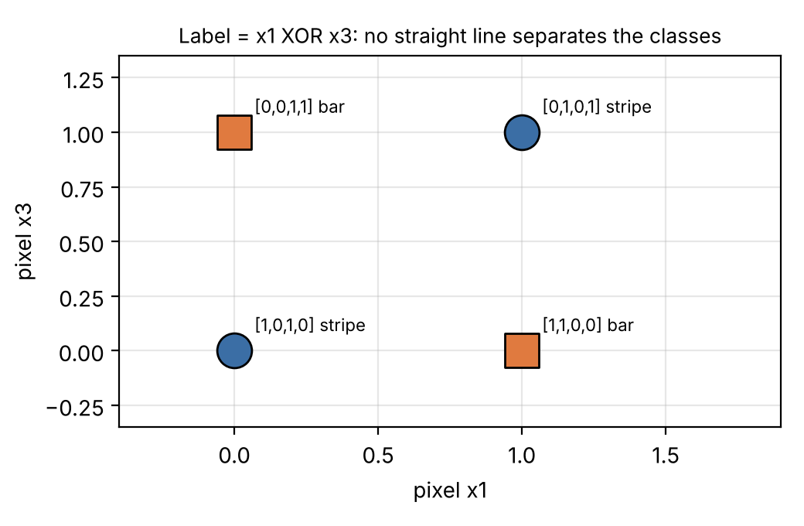
Figure 18. The data is XOR-shaped: label = x1 XOR x3, so a linear classifier cannot separate it
Local-C has the right *kind* of features, but the test image's key feature (the product x₀·x₁) is zero in all three training images, so its weight is never learned. The circuit generalised because its CNOT tree computes parity naturally. Its built-in bias (an XOR-like structure) happens to match this problem. This is an honest, limited claim: with one test image the test score is weak evidence, and a classical model designed with XOR features would also succeed. The fair conclusion is that the circuit's structure, not quantum speed, made it effective here.

6.8 Did anything not work as expected?
Yes. The original warm-up (one qubit learning to output 1 with Nelder–Mead, 10 iterations) failed in our run: it stopped at θ = −0.47 with loss 0.87 instead of θ = π. Near θ = 0 the loss cos⁴(θ/2) is almost flat, and differences between nearby points are smaller than the shot noise, so the simplex method (Nelder & Mead, 1965) could not tell which way to move in 10 iterations. This small failure illustrates a real problem in quantum machine learning: noise plus flat loss landscapes make training hard, and in large circuits this becomes the 'barren plateau' problem (McClean et al., 2018). SPSA was more robust because it uses large, random perturbations.

6.9 What is our overall judgement for Task 4?
- Input: pixels → X gates (basis encoding) in create_circuit; model: 6 RY angles in a TTN of RY–RY–CNOT blocks; output: P(q3 = 1).
- Monitoring: the loss fell from 0.50 to 0.00 in 100 iterations; time per iteration was flat at about 0.56 s.
- Efficiency: at 4 qubits, simulation without the device is about 520 times faster; real devices only pay off where simulation is impossible.
- Effectiveness: the circuit solved an XOR-type problem that linear classical models could not. This comes from its CNOT structure, not from a proven quantum advantage (Benedetti et al., 2019).

7. Critical Discussion Across the Four Tasks

7.1 How does the evidence meet each learning outcome?
Table 15. Evidence for each learning outcome
LO | Requirement | Where this report shows it
LO1 | Critically evaluate quantum protocols with the maths of quantum mechanics to validate performance claims | State evolution tables (Tables 4, 6); TVD and z-scores; the Z/S phase lesson; the eigenstate explanation of NOT; the XOR analysis and the limits of the Task 4 'advantage'
LO2 | Design and create quantum circuits for quantum algorithms to run on quantum computers | Cirq Bell circuit, Qiskit H–X–CNOT, original QASM half adder with an automatic Toffoli decomposition, completed game gates, QASM export of a game circuit, the ML circuit run through the device interface
LO4 | Communicate application and critical analysis to software-industry audiences | WH-question structure, data-flow and pipeline diagrams, GitHub README with Colab instructions, maintenance guide, labelled evidence files and an honest offline note

7.2 What are the main limitations of our work?
- Quokka availability. The results in this draft came from the labelled local simulator because the Quokka endpoint was offline. The code is ready, and run_all.bat repeats every experiment on Quokka with one click.
- An ideal device hides noise. Quokka emulates a fault-tolerant machine, so our experiments cannot show decoherence or gate errors. A future step would be to add a Qiskit noise model, or a real noisy backend, and repeat Tasks 1 and 2 to see 01/10 leakage.
- Small data in Task 4. Four images and one test image are too few for strong conclusions about generalisation.
- Interpretation of block C. The brief's diagram does not label block C, so we chose the CNOT from the drawing convention and explained the choice. If the lecturer intended a different gate, only one line of code (qc_a.cx(0, 1)) needs to change.

7.3 What would we do next?
With more time we would: (1) re-run all tasks on Quokka and compare the device with the simulator using the TVD; (2) add an entangling CNOT move to the tic-tac-toe game so that tiles can be linked; (3) test the Task 4 classifier on larger images (3 × 3 = 9 qubits) to see when exact simulation slows down; and (4) add a noise model to measure how fidelity falls as circuits get deeper.

8. Conclusion
The project answered all four tasks with working, commented and repeatable code. Task 1 prepared the Bell state |Φ⁺⟩ in Cirq and confirmed perfect correlation in 1000 shots. Task 2 built the given circuit in Qiskit, identified block C as a CNOT and showed it creates |Ψ⁺⟩. Our original QASM half adder produced a correct addition in every one of 1000 shots. Task 3 completed and debugged the quantum tic-tac-toe game, explained how each click becomes a gate, and used four recorded games to show superposition, over-rotation, the eigenstate behaviour of NOT, and SWAP. Task 4 explained the data encoding and the tree-shaped circuit of a variational classifier, logged and plotted all 100 iterations, and compared the circuit with three local versions. The local versions were about 520 times faster, but only the circuit solved the XOR-shaped data. Across the project, the most important lesson was to predict with mathematics first, then measure, then explain the difference. That habit turned code that runs into evidence that convinces.

References
Bahrami, H. (2026a). From quantum gates to quantum algorithms: Deutsch's algorithm [Lecture slides, Week 7]. MSE802 Quantum Computing, Yoobee College of Creative Innovation.
Bahrami, H. (2026b). Grover's search algorithm [Lecture slides, Week 10]. MSE802 Quantum Computing, Yoobee College of Creative Innovation.
Bahrami, H. (2026c). Lab 5 — Quantum tic-tac-toe [Unpublished Jupyter notebook, Quantum_Tic_Tac_Toe__AS2.ipynb]. MSE802 Quantum Computing, Yoobee College of Creative Innovation.
Bahrami, H. (2026d). Lab 10 — Quantum ML [Unpublished Jupyter notebook, Quantum_ML_AS2.ipynb]. MSE802 Quantum Computing, Yoobee College of Creative Innovation.
Bahrami, H. (2026e). Quokka access [Unpublished Jupyter notebook, quokka_access.ipynb, Week 4]. MSE802 Quantum Computing, Yoobee College of Creative Innovation.
Barenco, A., Bennett, C. H., Cleve, R., DiVincenzo, D. P., Margolus, N., Shor, P., Sleator, T., Smolin, J. A., & Weinfurter, H. (1995). Elementary gates for quantum computation. Physical Review A, 52(5), 3457–3467. https://doi.org/10.1103/PhysRevA.52.3457
Bell, J. S. (1964). On the Einstein Podolsky Rosen paradox. Physics Physique Fizika, 1(3), 195–200. https://doi.org/10.1103/PhysicsPhysiqueFizika.1.195
Benedetti, M., Lloyd, E., Sack, S., & Fiorentini, M. (2019). Parameterized quantum circuits as machine learning models. Quantum Science and Technology, 4(4), Article 043001. https://doi.org/10.1088/2058-9565/ab4eb5
Cirq Developers. (2025). Cirq (Version 1.7) [Computer software]. Zenodo. https://doi.org/10.5281/zenodo.4062499
Cross, A. W., Bishop, L. S., Smolin, J. A., & Gambetta, J. M. (2017). Open quantum assembly language (arXiv:1707.03429). arXiv. https://doi.org/10.48550/arXiv.1707.03429
Einstein, A., Podolsky, B., & Rosen, N. (1935). Can quantum-mechanical description of physical reality be considered complete? Physical Review, 47(10), 777–780. https://doi.org/10.1103/PhysRev.47.777
Goff, A. (2006). Quantum tic-tac-toe: A teaching metaphor for superposition in quantum mechanics. American Journal of Physics, 74(11), 962–973. https://doi.org/10.1119/1.2213635
Grant, E., Benedetti, M., Cao, S., Hallam, A., Lockhart, J., Stojevic, V., Green, A. G., & Severini, S. (2018). Hierarchical quantum classifiers. npj Quantum Information, 4, Article 65. https://doi.org/10.1038/s41534-018-0116-9
Hensen, B., Bernien, H., Dréau, A. E., Reiserer, A., Kalb, N., Blok, M. S., Ruitenberg, J., Vermeulen, R. F. L., Schouten, R. N., Abellán, C., Amaya, W., Pruneri, V., Mitchell, M. W., Markham, M., Twitchen, D. J., Elkouss, D., Wehner, S., Taminiau, T. H., & Hanson, R. (2015). Loophole-free Bell inequality violation using electron spins separated by 1.3 kilometres. Nature, 526(7575), 682–686. https://doi.org/10.1038/nature15759
Huggins, W., Patil, P., Mitchell, B., Whaley, K. B., & Stoudenmire, E. M. (2019). Towards quantum machine learning with tensor networks. Quantum Science and Technology, 4(2), Article 024001. https://doi.org/10.1088/2058-9565/aaea94
Javadi-Abhari, A., Treinish, M., Krsulich, K., Wood, C. J., Lishman, J., Gacon, J., Martiel, S., Nation, P. D., Bishop, L. S., Cross, A. W., Johnson, B. R., & Gambetta, J. M. (2024). Quantum computing with Qiskit (arXiv:2405.08810). arXiv. https://doi.org/10.48550/arXiv.2405.08810
McClean, J. R., Boixo, S., Smelyanskiy, V. N., Babbush, R., & Neven, H. (2018). Barren plateaus in quantum neural network training landscapes. Nature Communications, 9, Article 4812. https://doi.org/10.1038/s41467-018-07090-4
Minsky, M., & Papert, S. (1969). Perceptrons: An introduction to computational geometry. MIT Press.
Nelder, J. A., & Mead, R. (1965). A simplex method for function minimization. The Computer Journal, 7(4), 308–313. https://doi.org/10.1093/comjnl/7.4.308
Nielsen, M. A., & Chuang, I. L. (2010). Quantum computation and quantum information (10th anniversary ed.). Cambridge University Press. https://doi.org/10.1017/CBO9780511976667
Preskill, J. (2018). Quantum computing in the NISQ era and beyond. Quantum, 2, 79. https://doi.org/10.22331/q-2018-08-06-79
Schuld, M., & Petruccione, F. (2021). Machine learning with quantum computers (2nd ed.). Springer. https://doi.org/10.1007/978-3-030-83098-4
Spall, J. C. (1992). Multivariate stochastic approximation using a simultaneous perturbation gradient approximation. IEEE Transactions on Automatic Control, 37(3), 332–341. https://doi.org/10.1109/9.119632
University of Technology Sydney. (2024, June 25). Quokka: A quantum hop into the future of computing. https://www.uts.edu.au/news/2024/06/quokka-quantum-hop-future-computing
Vedral, V., Barenco, A., & Ekert, A. (1996). Quantum networks for elementary arithmetic operations. Physical Review A, 54(1), 147–153. https://doi.org/10.1103/PhysRevA.54.147
Yanofsky, N. S., & Mannucci, M. A. (2008). Quantum computing for computer scientists. Cambridge University Press. https://doi.org/10.1017/CBO9780511813887

Appendix A – Submission Structure and How to Run
quantumcomputing_YB_Anish/ (GitHub repository)
├── README.md step-by-step run instructions
└── Assignment_2_Quantum/
├── Task_1_Bell_State/ notebook + results/
├── Task_2_Qiskit_QASM/ notebook, custom_half_adder.qasm, results/
├── Task_3_Quantum_TicTacToe/ completed + original notebook, results/
├── Task_4_Quantum_ML/ modified + original notebook, results/
├── Alternative_Code/ second solution for each task + outputs/
├── common/quokka_helper.py shared Quokka / fallback / counts
├── Report/ Assignment2.docx, Assignment2.pdf
├── run_project.py run_project.bat run_all.bat run_project.sh
├── Colab_Run_All_Tasks.ipynb whole project in Google Colab
└── requirements.txt MAINTENANCE.md
To reproduce every result: double-click run_all.bat (Windows), run python run_project.py all (any computer) or open Colab_Run_All_Tasks.ipynb in Google Colab and choose Runtime → Run all. Each results/ folder then holds the JSON (raw counts, source, time), CSV and PNG evidence used in this report, and outputs_html/ holds a web-page copy of every notebook. Repository: https://github.com/anishnz/quantumcomputing_YB_Anish. MAINTENANCE.md explains common errors and safe changes.

Appendix B – Key Code Excerpts
B.1 Sending a circuit to Quokka with a labelled fallback (common/quokka_helper.py, shortened)
def run_qasm(qasm_text, shots=1000, label="run", save_dir=None,
allow_fallback=True):
try:
data = run_on_quokka(qasm_text, shots) # POST script + count
shot_list = list(data["result"].values())[0] # [c0, c1] per shot
source = SOURCE_QUOKKA
except Exception as exc: # offline / error reply
if not allow_fallback: raise
shot_list = run_locally(qasm_text, shots) # SAME script on Aer
source = SOURCE_LOCAL # never called Quokka data
counts = shots_to_counts(shot_list) # {'00': 508, '11': 492}
B.2 Completed moves in the tic-tac-toe game (Task 3, Board.make_move)
if self.function == 'Not':
self.qc.x(cell) # [ADDED] bit flip: swap ownership
elif self.function == 'O':
self.qc.ry(ROTATION, cell) # [ADDED] quarter turn toward |1>
elif self.function == 'X':
self.qc.ry(-ROTATION, cell) # [ADDED] quarter turn toward |0>
elif (self.function == 'SWAP' and self.target >= 0
and self.target != cell): # [FIXED] needs a first tile
self.qc.swap(cell, self.target) # [ADDED] exchange two tiles
self.target = -1 # [FIXED] clear the first tile
B.3 Per-iteration monitoring added to SPSA (Task 4)
t0 = time.perf_counter() # [ADDED] start timer
grad = (func(xp) - func(xm)) / (2 * ck) * delta # 2 evaluations
x = x - ak * grad # update parameters
step_time = time.perf_counter() - t0 # [ADDED] iteration time
fx = func(x) # [ADDED] output measure
history.append({"iteration": k + 1, "output": fx,
"time_s": step_time})

