Yoobee College of Creative Innovation
Master of Software Engineering — Level 8
MSE802 Quantum Computing
Assessment 2 — Quantum Project (60%)
Task 3 Report: Investigating a Quantum Code
Quantum Tic-Tac-Toe: Code Completion, Gameplay, Circuit Generation and Quantum Gates
GROUP PROJECT
Student 1 | Anish Shrestha — Student ID 270889991
Student 2 | Sandhya Tiwari — Student ID 270888992
Lecturer | Dr Helena Bahrami
Course | MSE802 Quantum Computing (15 credits)
Date | 31 October 2026
GitHub repository | github.com/anishnz/quantumcomputing_YB_Anish
Referencing style | APA 7th edition

Auckland, New Zealand

Declaration of Originality
We, the undersigned members of this group, declare that this report and the accompanying code are our own group work, completed for MSE802 Assessment 2. All sources of information, code and ideas from others, including the lecture notes and the supplied lab notebooks, have been acknowledged and referenced in APA 7th style. This work has not been submitted for any other course. We understand Yoobee College's policies on plagiarism and collusion as described in the Student Handbook.
We confirm that the results reported here come from the notebooks submitted with this report. Results produced on a local simulator because the Quokka device was unavailable are clearly labelled as such and are not presented as device measurements.
Use of digital tools: Python libraries (Cirq, Qiskit, NumPy, Matplotlib) were used for all computation. A generative AI assistant was used to support code drafting, debugging and language editing; all code was run, checked and understood by the group, and the analysis and conclusions are our own. [Edit this sentence to match Yoobee's AI-use policy and your actual use.]
Name | Student ID | Signature / date
Anish Shrestha | 270889991
Sandhya Tiwari | 270888992

Table of Contents

(If page numbers are missing, right-click the table and choose Update Field.)

This is the separate Task 3 report requested by the brief. Its content is identical to Section 5 of the group report Assignment2.docx, which also contains the introduction, the other tasks and the full discussion.

1. Task 3 – Investigating a Quantum Code: Quantum Tic-Tac-Toe
Task question: Complete the provided code by filling in missing instructions or comments; play multiple games and analyse the generated code; as a quantum software engineer, explain the purpose, functionality, gameplay dynamics and how circuits are generated (Word document); and describe each quantum gate used in a separate section. Notebook: Task_3_Quantum_TicTacToe/Task3_Quantum_TicTacToe_Completed.ipynb (original kept unchanged beside it)

1.1 What is the purpose of the program?
The program, supplied as Lab 5 (Bahrami, 2026b), is a teaching game. Quantum games have long been used to make superposition and measurement intuitive (Goff, 2006). Here every tile of the 3 × 3 board is one qubit, and every move adds a gate to a nine-qubit circuit. Nobody owns a tile until the end, when the circuit is measured once: a 0 makes the tile X's and a 1 makes it O's. Playing therefore means *designing a quantum circuit*, and the result is probabilistic. The game makes three ideas visible: superposition (undecided tiles), unitary gates as moves, and measurement collapse.

1.2 How is the code organised?
The code has two classes. `Board` is the quantum part: it owns the QuantumCircuit(9, 9), adds gates in make_move, measures in measure, and counts winning lines in countWinners. `Game` is the classical user interface: it creates buttons with ipywidgets, reacts to clicks in handle_game, and redraws the board. This separation of quantum logic from the user interface is good software design. It is also how real quantum applications are built: a classical program prepares and sends circuits and then interprets the results.
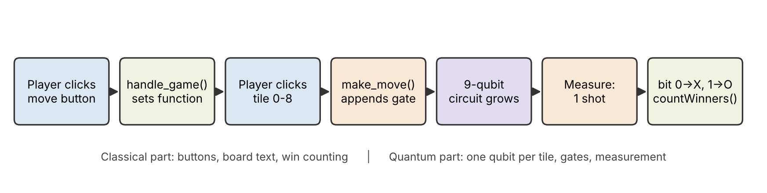
Figure 1. How one move travels through the code: from a click to a gate, and from measurement to the score

1.3 What was missing, and what did we complete or fix?
Table 1. Code completion and fixes (marked [ADDED], [FIXED] or [CHANGED] in the notebook)
# | Location | Problem in supplied code | Our completion
1 | make_move – Not | comment only, no gate | self.qc.x(cell)
2 | make_move – O | comment only, no gate | self.qc.ry(+π/4, cell) (toward |1⟩ = O)
3 | make_move – X | comment only, no gate | self.qc.ry(−π/4, cell) (toward |0⟩ = X)
4 | make_move – SWAP | comment only, no gate | self.qc.swap(cell, self.target)
5 | countWinners | winners = () – nobody could ever win | the 8 lines: 3 rows, 3 columns, 2 diagonals
6 | SWAP branch | dead inner if; crash if no first tile | guard target ≥ 0; reset target after swap
7 | new() | empty tile '' but __init__ uses ' ' | made consistent
8 | imports / grid | google.colab widgets only work in Colab | ipywidgets HBox/GridBox (VS Code, Jupyter, Colab)

An important finding: the supplied comments had the rotation directions swapped. measure() maps bit 0 to X and bit 1 to O, but the comments said the O button rotates toward |0⟩ and the X button toward |1⟩. Followed literally, pressing O would help player X. The game's own rules say "O turns the tile toward a tile owned by O", so we implemented O as a rotation toward |1⟩ and X toward |0⟩ and corrected the comments. Finding a mismatch between comments, code and specification, and resolving it against the specification, is a normal part of investigating someone else's code.

1.4 How does a move become a gate? (Circuit generation)
- Start of a round. __init__ (and new()) adds reset and H to all nine qubits, then a barrier. Every tile is |+⟩ = (|0⟩ + |1⟩)/√2, i.e. 50% X and 50% O.
- Choose a move. Clicking Not, O, X or SWAP raises a ValueError when int(b.description) is tried, and the except branch stores the move in board.function. This is a slightly unusual way to tell text buttons from number buttons.
- Choose a tile. Clicking 0–8 calls make_move(cell), which appends one gate to self.qc. For SWAP, the first tile click sets board.target and the second click applies the swap.
- The circuit grows. After each move the circuit is redrawn. The text on the board is only a move history; as the original notes say, "the game circuit is the true state of the game".
- Measure. Barrier and nine measure instructions are added, and the circuit runs once (1 shot) on AerSimulator. Bit i of the result decides tile i, read from the right-hand end of Qiskit's string (output[9-1-i]).
- Score. countWinners checks the eight lines for each player. Both players can win lines in the same round, because the tiles are decided independently.

1.5 How does a rotation move change the odds?
On the Bloch sphere, |+⟩ sits at angle θ = π/2 from |0⟩, and P(X) = P(0) = cos²(θ/2). Each X move applies Rᵧ(−π/4), which reduces θ by π/4 (Figure 2). One X move gives P(X) = cos²(π/8) = 0.854, two moves give 1.000, and a third move over-rotates back to 0.854. Moves are rotations, not counters, so "too many" moves undo themselves. This is a quantum effect that classical tic-tac-toe does not have.
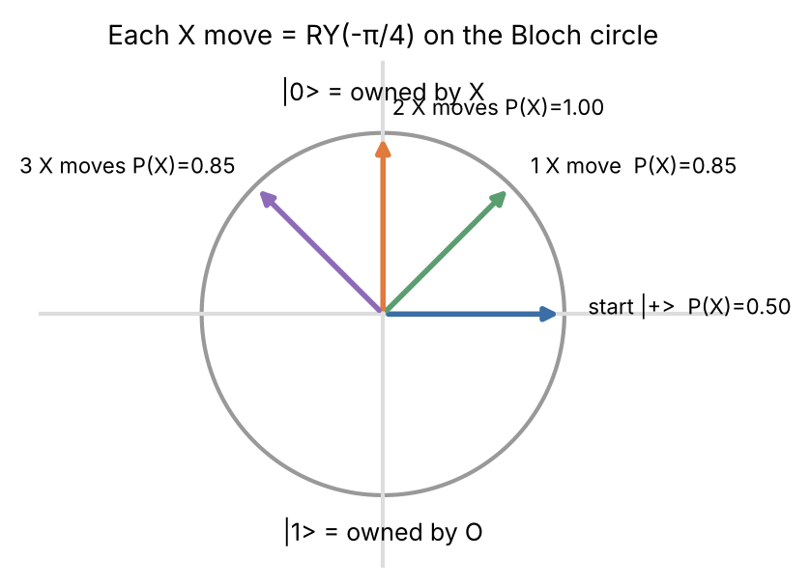
Figure 2. Effect of repeated X moves on one tile (x–z plane of the Bloch sphere)

1.6 What happened when we played? (Four recorded games)
Button clicks cannot be saved in a notebook, so we replayed four games as scripts that call exactly the same make_move and measure code with fixed seeds. For each game we saved the circuit picture, the one-shot result, and a 1000-shot study of the same circuit, which estimates each tile's chance of becoming X and each player's chance of winning (more X lines than O lines).
Table 2. Recorded games: moves, generated gates, the one-shot result and 1000-shot win chances
Game | Moves | Gates added | 1-shot lines X:O | X wins /1000 | O wins /1000 | Draws /1000
1 Baseline | none | 9 H only | 4 : 0 | 392 | 405 | 203
2 Diagonals | X on 0, 4, 8; O on 2, 6 | +5 RY | 4 : 0 | 705 | 210 | 85
3 NOT test | X, X on 4; Not on 4; O on 0; Not on 1 | +3 RY, 2 X | 0 : 2 | 135 | 694 | 171
4 SWAP | X, X on 0; O, O on 4; SWAP 0↔8; X × 3 on 2 | +7 RY, 1 SWAP | 0 : 2 | 404 | 289 | 307

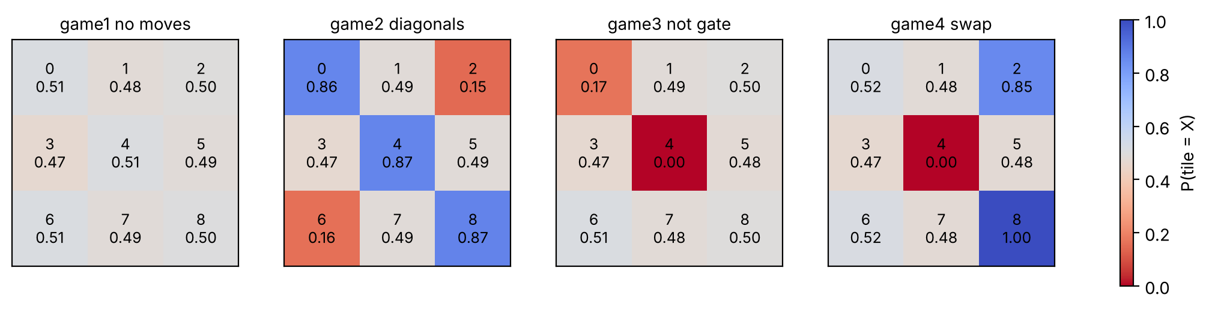
Figure 3. Chance that each tile becomes X after each recorded game (1000 shots; blue = X likely, red = O likely)
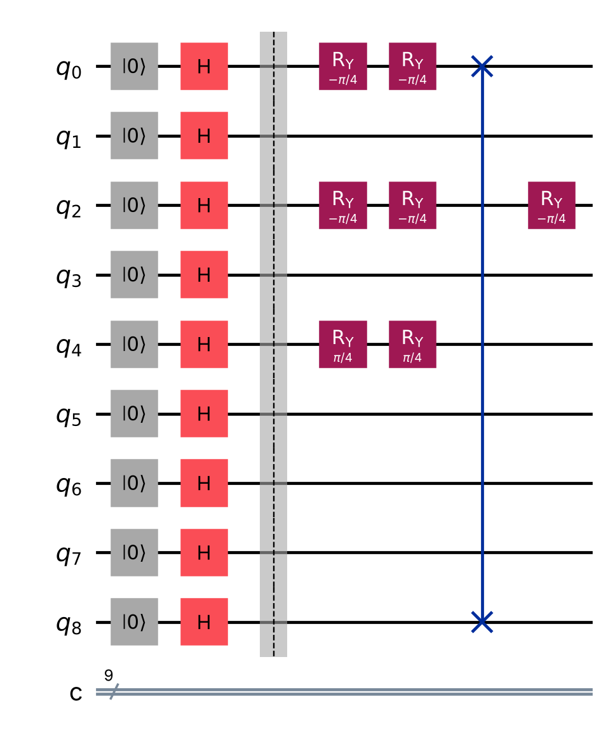
Figure 4. Circuit generated by Game 4: H start layer, RY moves, and the SWAP between tiles 0 and 8

1.7 What do the games show? (Analysis)
- Game 1 (baseline): with no moves every tile is 50/50, so X and O win about equally often (392 vs 405). The one-shot result (X 4 lines) was simply luck. A single game says little; the 1000-shot study shows the real odds.
- Game 2: three X moves on the main diagonal (P(X) ≈ 0.86 each) and two O moves on the other corners raised X's win chance from 39% to 71%. Strategy works, but only in probability.
- Game 3 (NOT gate): two X moves made tile 4 certainly X, and NOT then made it certainly O (P(X) = 0.00). NOT on the *undecided* tile 1 did nothing (0.49), because |+⟩ is an eigenstate of X: X|+⟩ = |+⟩. This matches the rule "if the tile is not owned, Not does nothing", and it is explained by linear algebra, not by an if-statement.
- Game 4 (SWAP): tile 0 was made certainly X and then swapped with tile 8. Afterwards tile 8 is certainly X (1.00) and tile 0 is back to 50/50, because SWAP moved the quantum *states*, not labels. Tile 2 received three X moves and shows the over-rotation (0.85, not 1.00).
- Circuit growth: every move adds one gate and does not remove any, so circuit depth rose from 2 to 5. On noisy hardware, longer games would therefore be less reliable.

1.8 Can the game circuit run on Quokka?
Yes. The notebook removes the reset instructions (qubits already start at |0⟩), translates the Game 2 circuit to H, RY, X and CX gates, exports it to QASM and sends it with 1000 shots. With the labelled local fallback, the per-tile chances were 0.87, 0.50, 0.13, 0.51, 0.86, 0.50, 0.14, 0.53 and 0.87, the same pattern as Figure 3. This links the game back to the device used in Tasks 1 and 2.

1.9 Which quantum gates does the game use? (Gate section)
Table 3. Quantum gates used in circuit generation: characteristics and function in the game
Gate | Matrix / action | Key characteristic | Function in this game
H (Hadamard) | (1/√2)[[1,1],[1,−1]]; |0⟩ → |+⟩ | creates equal superposition; H·H = I | start layer: every tile undecided (50/50)
Rᵧ(θ) | [[cos θ/2, −sin θ/2],[sin θ/2, cos θ/2]] | rotation about the y-axis; real amplitudes; changes probabilities smoothly | X move: Rᵧ(−π/4) toward |0⟩; O move: Rᵧ(+π/4) toward |1⟩
X (NOT) | [[0,1],[1,0]]; |0⟩ ↔ |1⟩ | bit flip; X|+⟩ = |+⟩ (eigenstate) | Not move: flips ownership of a decided tile
SWAP | exchanges two qubits' states (= 3 CNOTs) | two-qubit, permutes |01⟩ ↔ |10⟩ | SWAP move: exchanges two tiles
reset | sets qubit to |0⟩ (not unitary) | non-reversible initialisation | clean start of each round
measure | projects onto |0⟩ or |1⟩ | irreversible; Born rule | decides each tile's owner (0 → X, 1 → O)
barrier | no operation | visual / compiler boundary | separates start, moves and measurement in the drawing

1.10 How do these gates fit the wider theory of quantum logic gates?
Every quantum gate is a unitary matrix (U†U = I), so every gate is reversible: applying U† undoes it. reset and measure in the table above are the exceptions; they are not gates in this strict sense because they cannot be undone, and measurement follows the Born rule (Nielsen & Chuang, 2010; "Quantum logic gate," n.d.). Gates in sequence combine by matrix multiplication, written in the reverse of the drawing order (X then Y gives the matrix YX), and gates on different qubits combine by the tensor product. That is how the nine-qubit game state is built from nine single-qubit operations.
A gate set is universal if it can approximate any unitary operation; examples are {H, T, CNOT}, the Clifford+T set, or arbitrary rotations plus CNOT (Barenco et al., 1995; "Quantum logic gate," n.d.). This idea explains two of our findings:
- The game's gates are not universal and cannot entangle tiles. H, Rᵧ and X keep every amplitude real, and SWAP only moves states between tiles. The game has no entangling gate such as CNOT, so its nine tiles always stay independent. Adding a CNOT move ("link two tiles") would make the gate set universal and allow entangled tiles.
- Quokka's gate set is universal. Its QASM gates include Rx, Ry, Rz and CNOT, which form a universal set. That is why to_quokka_gates() can always rewrite S, T or the Toffoli into supported gates (Task 2B). The rewritten circuit can differ only by a global phase, which never changes a measurement result.

1.11 What are the strengths and limits of the program?
Strengths: the program is short, has clear quantum/classical separation and a good visual circuit, and it demonstrates superposition, rotation and measurement in a playful way. Limitations: (1) tiles are never *entangled*, because the only two-qubit gate is SWAP, which keeps tiles independent; adding a CNOT move would create linked tiles and is a natural improvement. (2) One-shot measurement makes single games very random. (3) The board text is "not 100% accurate", so it can mislead players. (4) Using exceptions to tell buttons apart is fragile. (5) There is no turn order, so one player can make every move. Despite these limits, as a teaching tool it shows clearly that a quantum program is a circuit that is built step by step and only gives answers when measured.

References
Bahrami, H. (2026b). Lab 5 — Quantum tic-tac-toe [Unpublished Jupyter notebook, Quantum_Tic_Tac_Toe__AS2.ipynb]. MSE802 Quantum Computing, Yoobee College of Creative Innovation.
Barenco, A., Bennett, C. H., Cleve, R., DiVincenzo, D. P., Margolus, N., Shor, P., Sleator, T., Smolin, J. A., & Weinfurter, H. (1995). Elementary gates for quantum computation. Physical Review A, 52(5), 3457–3467. https://doi.org/10.1103/PhysRevA.52.3457
Goff, A. (2006). Quantum tic-tac-toe: A teaching metaphor for superposition in quantum mechanics. American Journal of Physics, 74(11), 962–973. https://doi.org/10.1119/1.2213635
Nielsen, M. A., & Chuang, I. L. (2010). Quantum computation and quantum information (10th anniversary ed.). Cambridge University Press. https://doi.org/10.1017/CBO9780511976667
Quantum logic gate. (n.d.). In Wikipedia. Retrieved October 31, 2026, from https://en.wikipedia.org/wiki/Quantum_logic_gate

