




Bi-Weekly assignment I

Sample Input and Output

Name: Anish Kumar Patel Student ID: 26007997 Module: UFCFK1-15-0
Tutor: Kaushal Rimal Academic Year: 2025–2026

Q2. Arithmetic Operations Program

This program takes two numbers from the user and performs basic arithmetic operations such as addition, multiplication, division, modulus and Exponentiation.

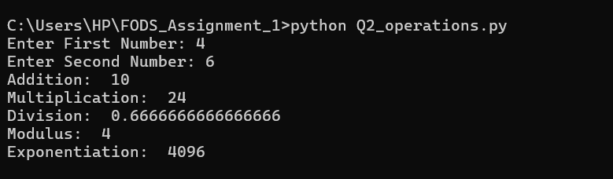

Q3. Number Type Program

This program takes numbers from the user and checks whether the entered number is Positive Odd or Even and Negative Odd or Even.
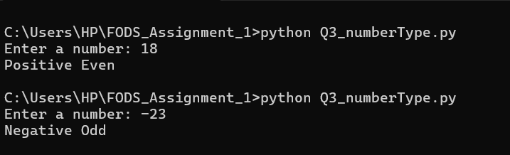

Q4. Mathematical Operations
This program takes a number as input and calculates different mathematical values such as cube, cube root, natural logarithm, base-2 logarithm, and the number raised to the power of six.
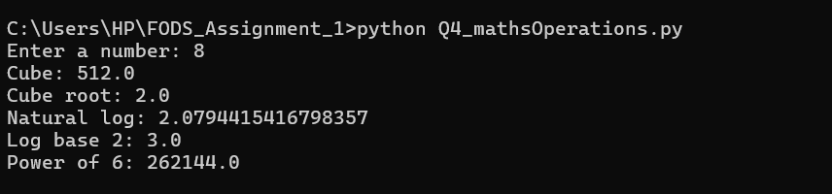

Q5. Marks Calculator
This program asks the user to enter marks for six subjects. It then calculates the total marks, average, percentage, and assigns a grade based on the given grading criteria.

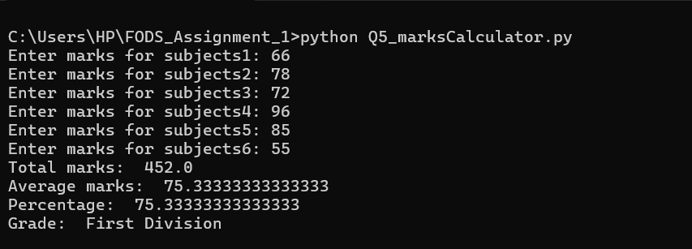

Q6. Prime Numbers within a user-defined range
This program takes a starting and ending number from the user and displays all prime numbers within that range. It also calculates the total number of prime numbers and their sum.
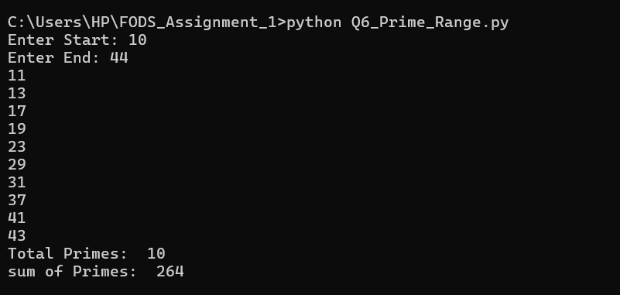

Q7. Divisible Numbers Program
This program finds all numbers within a given range that are divisible by 9 but not divisible by 6.
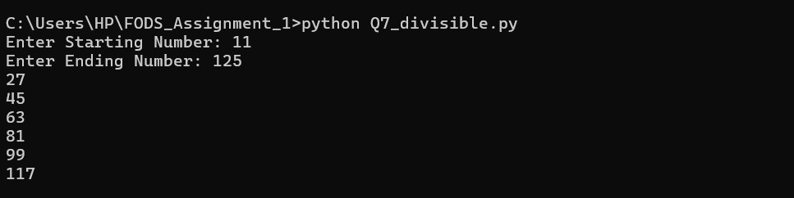

Q8. Factorial of a Number

This program calculates the factorial of a number entered by the user. It also checks whether the input is a valid positive integer and displays an error message if the input is invalid.
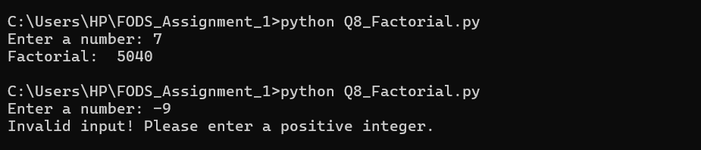

Q9. Sum of Positive and Negative Numbers
This menu-driven program repeatedly asks the user to enter numbers and calculates the separate sums of positive and negative numbers until the user chooses to exit the program.

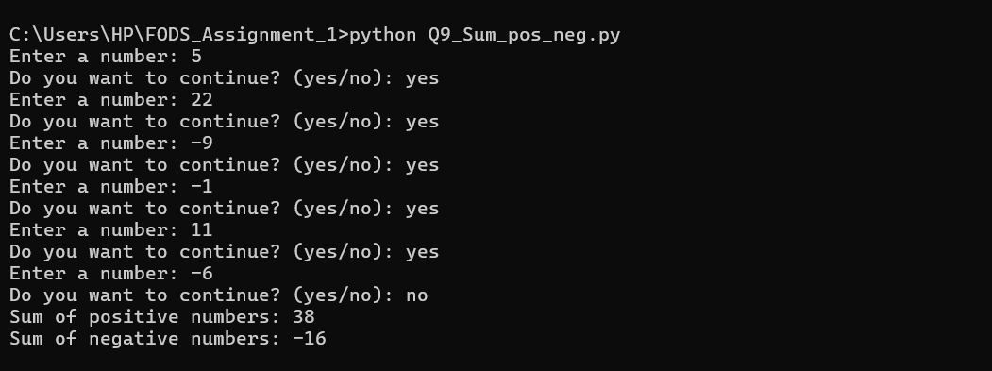

Q10. Number Guessing Game
This program creates a simple number guessing game where the computer generates a random number between 1 and 50. The user tries to guess the number within a maximum of seven attempts, and the program provides feedback if the guess is too high, too low, or correct.
