




Bi-Weekly assignment II

Sample Input and Output

Name: Anish Kumar Patel Student ID: 26007997 Module: UFCFK1-15-0
Tutor: Kaushal Rimal Academic Year: 2025–2026

Q1. Basic Functions Operations

This program takes two numbers from the user and performs basic arithmetic operations such as Sum, Difference, Product and Quotient using a function.
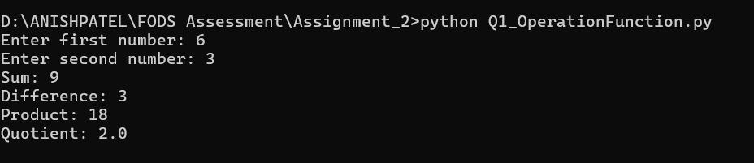

Q2. Separate Mathematical Functions

This program creates a separate function that takes two inputs from the user as parameters and returns the result with proper formatting by suing different functions for addition, multiplication, division, floor division, and exponentiation.
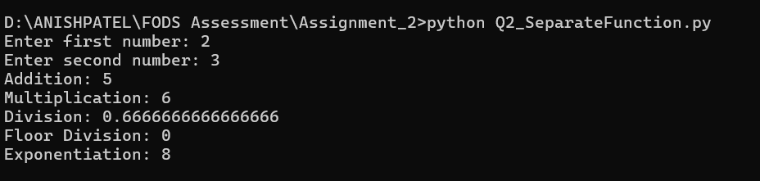

Q3. Armstrong Number
This Program creates a function that accepts a string as input and checks whether it is Armstrong or not.
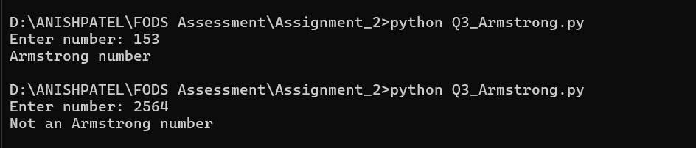

Q4. Frequency counter

This program creates a function that takes a list of numbers as input and returns a dictionary showing how many times each number occurs in the list.
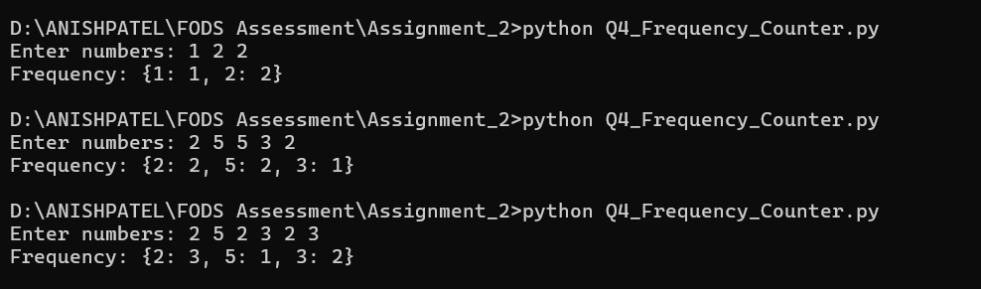

Q5. Reverse Alphabetical Order

This program creates a function that accepts a list of names and returns the names in reverse alphabetical order.
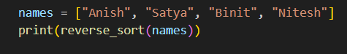

Q6. Country Search
This Program creates a function that searches for a country in a list and returns its index.
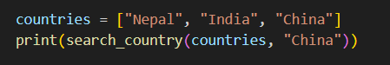

Q7. Characters Count
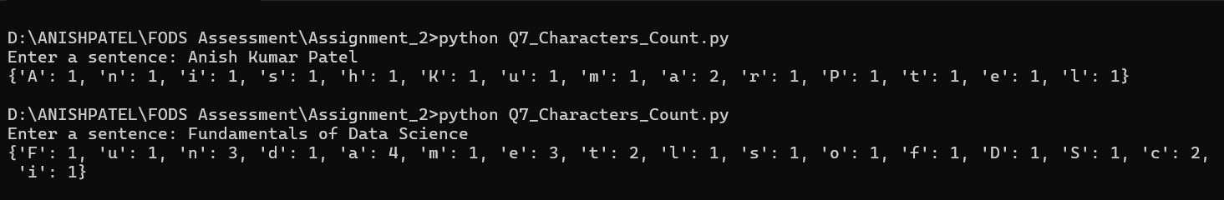
This program creates a function that takes a sentence as input and returns a dictionary showing how many times each character (excluding spaces) occurs.

Q8. Remove Duplicates and Sort

This program creates a function that accepts a list of numbers from the user and returns a new list with all duplicates removed and the numbers sorted in ascending order.
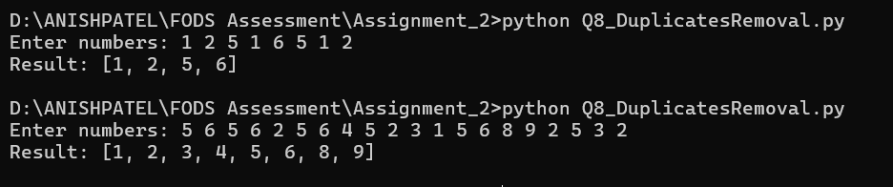

Q9. Movie Dictionary

This program creates a function that asks for details of 3 movies and displays output in well formatted manner.
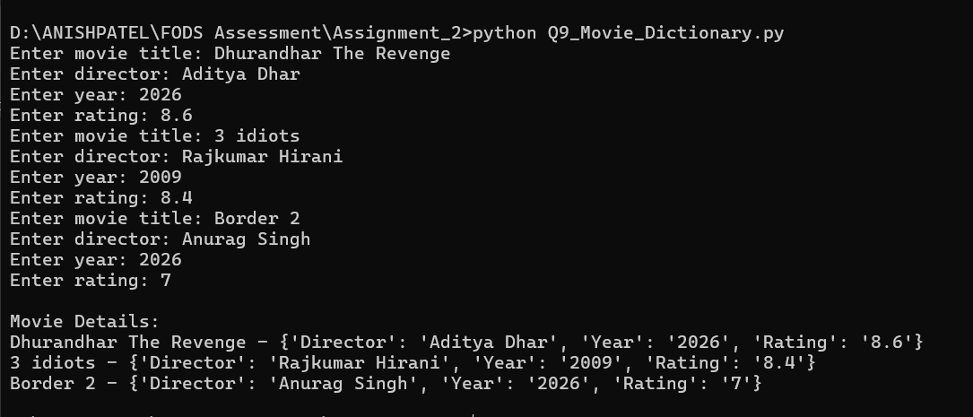

Q10. Dice Guessing Game
This program creates a function that allows the user to guess a dice value.

