

Module: Fundamentals of
Data Science

Bi-Weekly assignment III

Sample Input and Output

Name: Anish Kumar Patel
Student ID: 26007997
Module: UFCFK1-15-0
Tutor: Kaushal Rimal
Academic Year: 2025–2026

Q1. Read CSV File

This program reads a CSV file named "records.csv" and displays its contents.
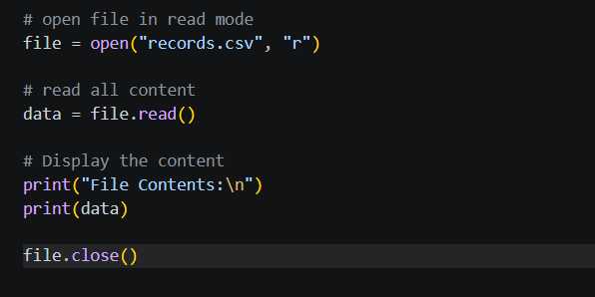

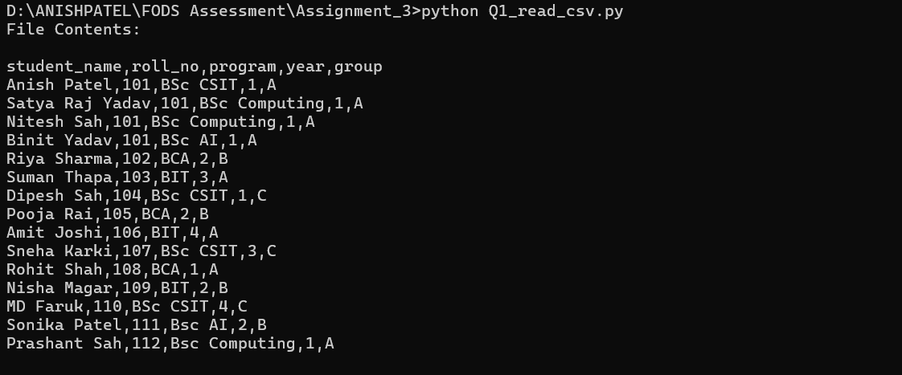

Q2. Append to CSV File

This Program takes user details as input and append them to an existing CSV file named "records.csv".

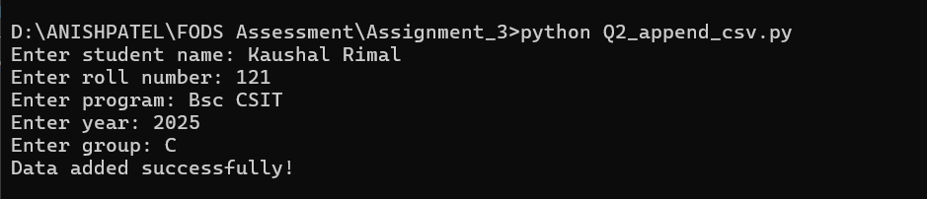
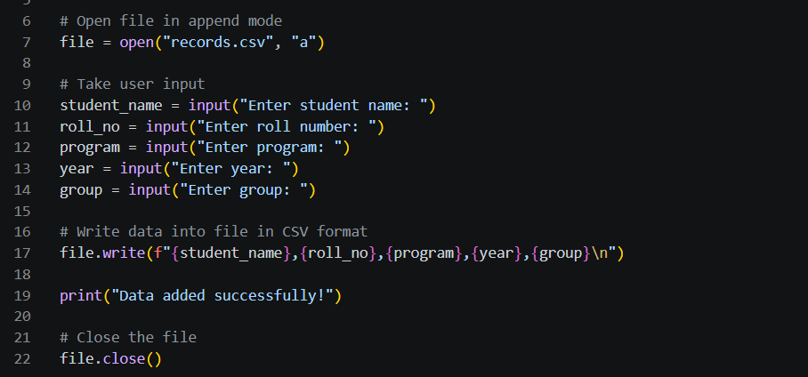

Q3. File Operations

This program takes two numbers from the user, perform basic arithmetic operations like addition, subtraction, multiplication and division and store the results in a file named “result.txt” along with date and time.
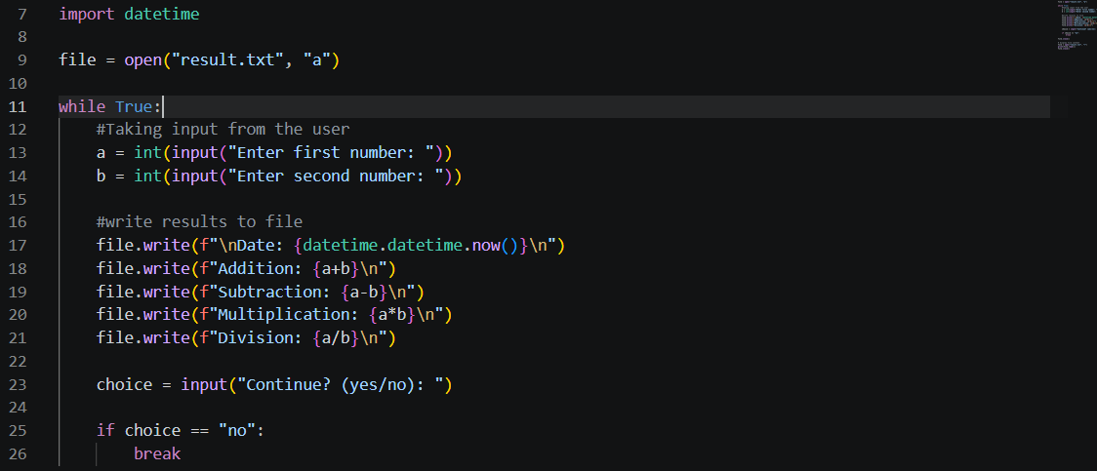

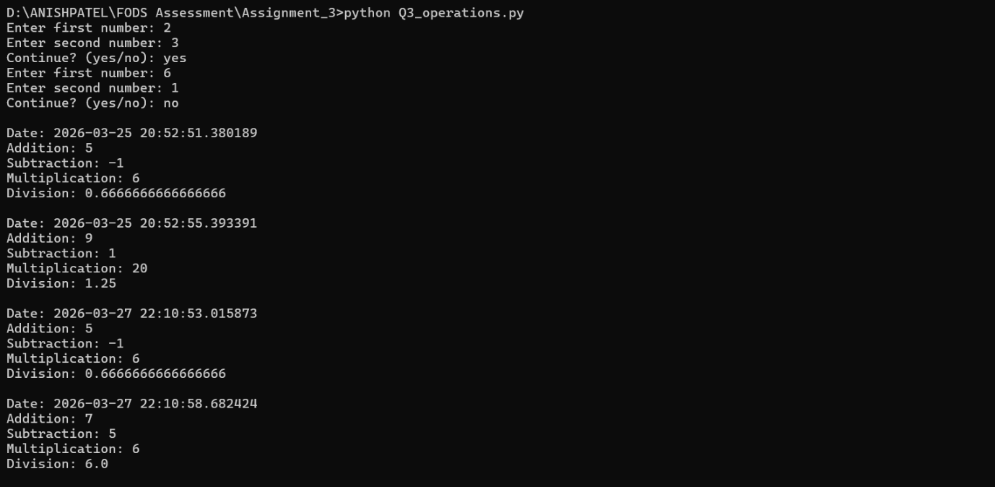

Q4. Copy File

This program copies contents from one file to another file.
Use try/except to handle exceptions and display an error message if the input file does not exist, and if the output file already exists.

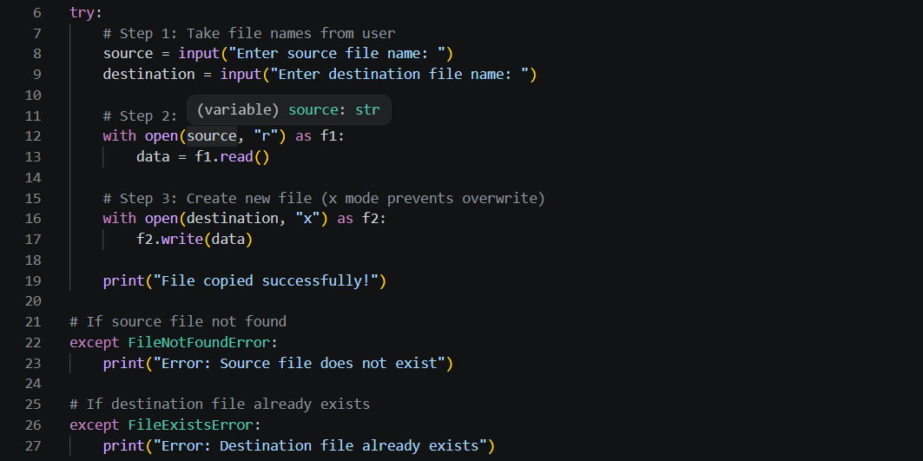

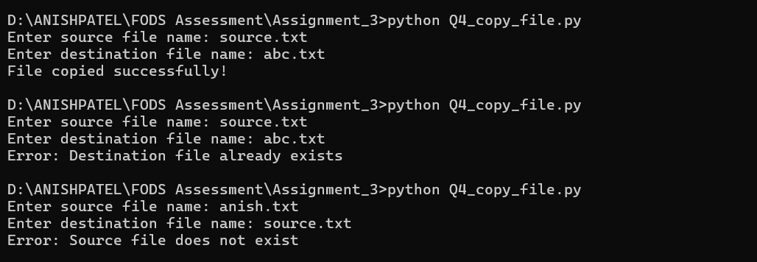

Q5. Learner class

This program creates a class Learner with the attributes:
roll_no ,full_name, address, enrollment_year, program, and group and display details of a learner.

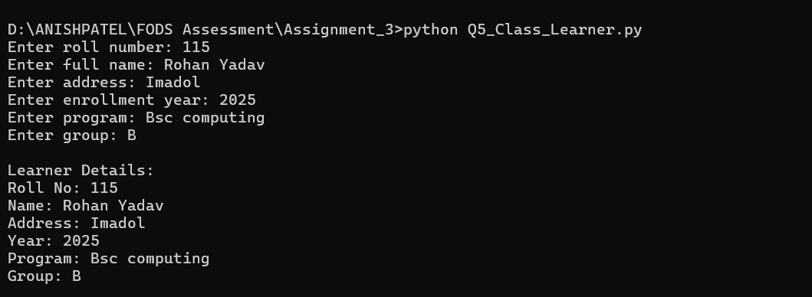
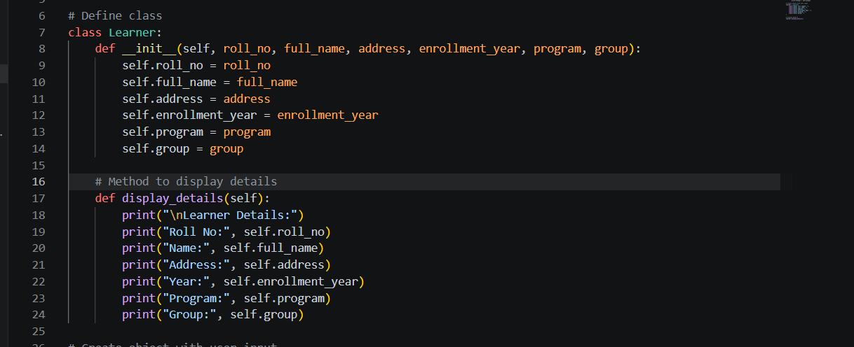
Q6. Dish Class

This program creates a class Dish with attributes:
dish_id, dish_name, ingredients, and instructions.
Also create a Cookbook class to manage a collection of dishes.
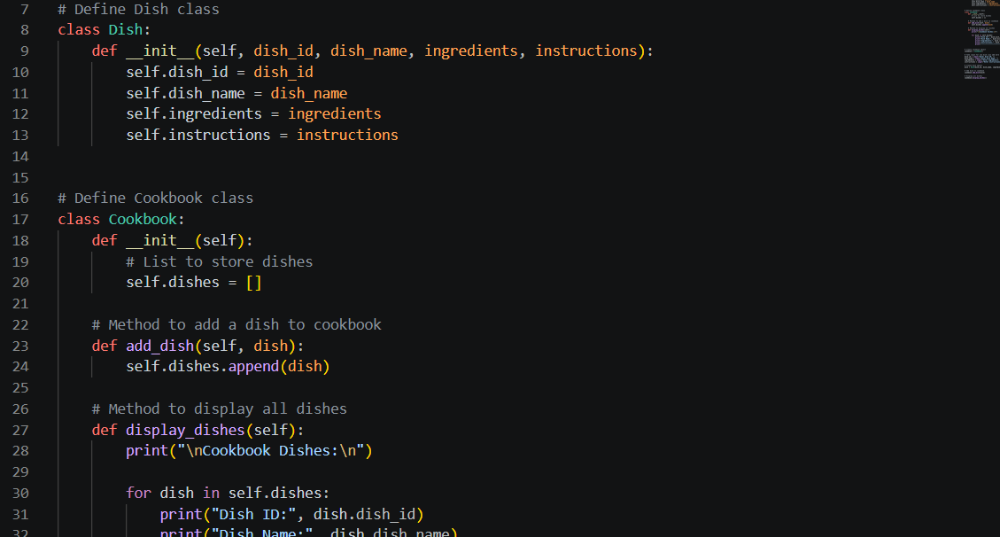
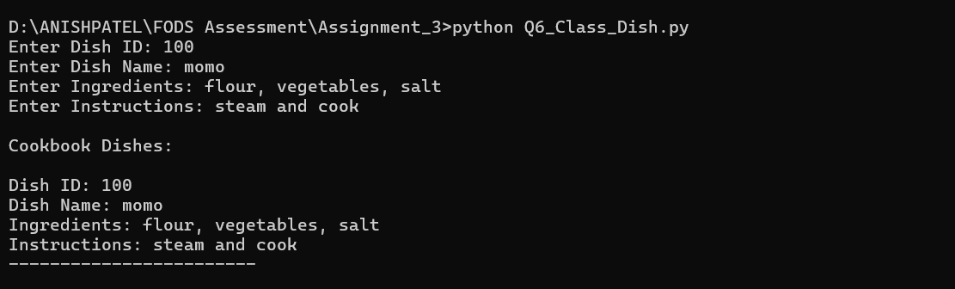

Q7. Staff Management System
This program creates a class Staff and store multiple staff details in a CSV file (staff.csv). The program also allows the user to view staff records. Exception handling is used.

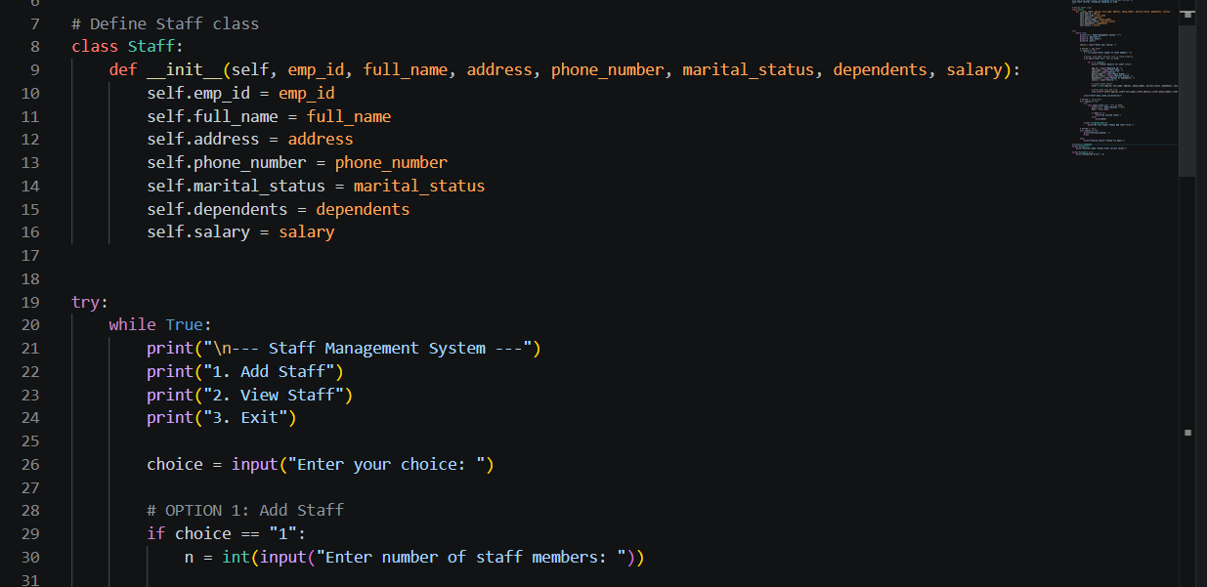

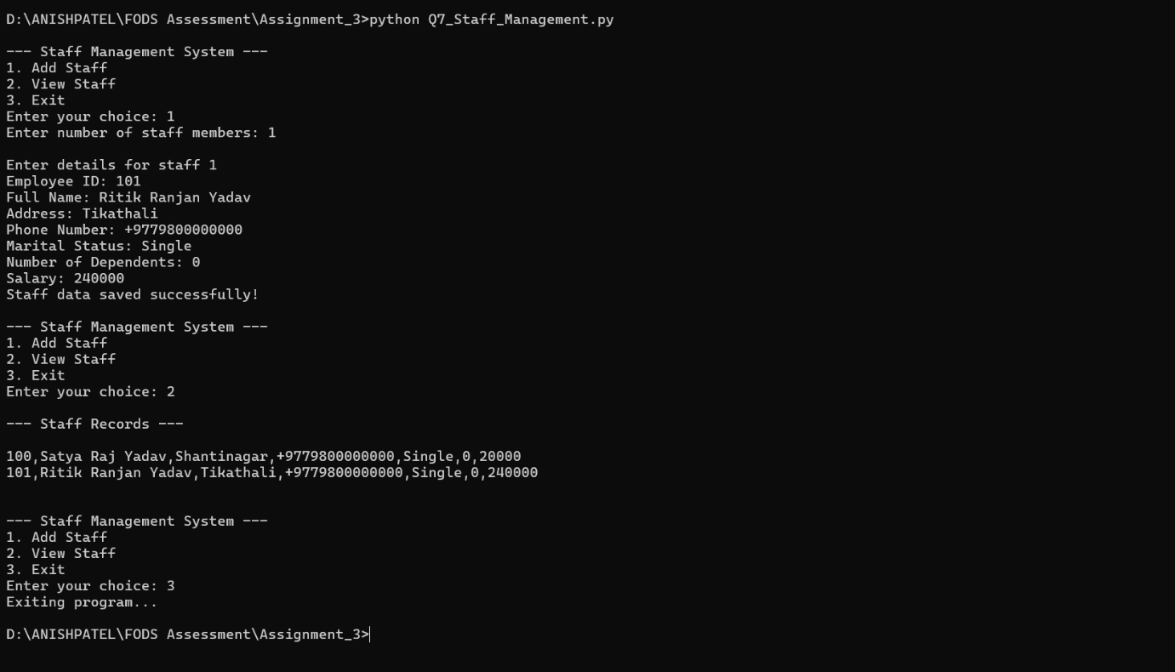

Q8. Library Management System

This program creates a simple Library Management System using class. It allows users to search, borrow and return books.
