

Module: Fundamentals of
Data Science

Bi-Weekly assignment IV

Sample Input and Output

Name: Anish Kumar Patel
Student ID: 26007997
Module: UFCFK1-15-0
Tutor: Kaushal Rimal
Academic Year: 2025–2026

Q1. NumPy Basics

This program performs basic operations like sum, mean value, largest and
smallest value on a NumPy array.

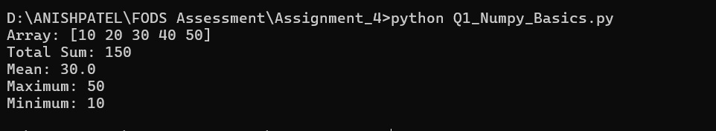
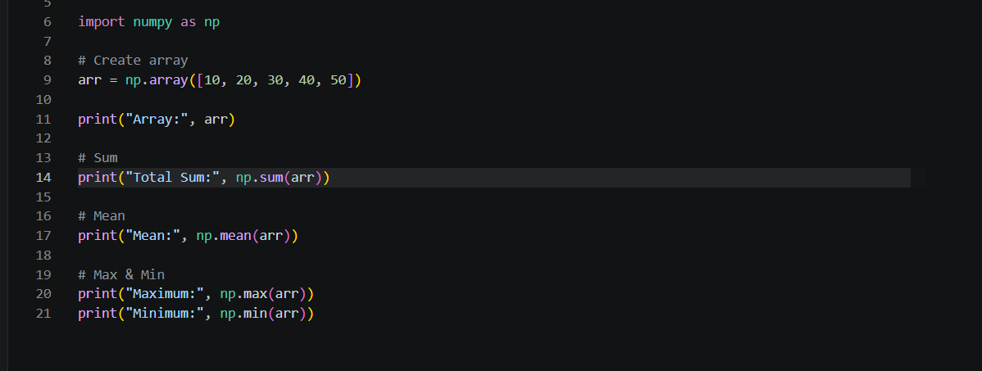

Q2. List and Slicing

This program takes list of numbers as input from the user, Sort the list
and perform slicing operations.
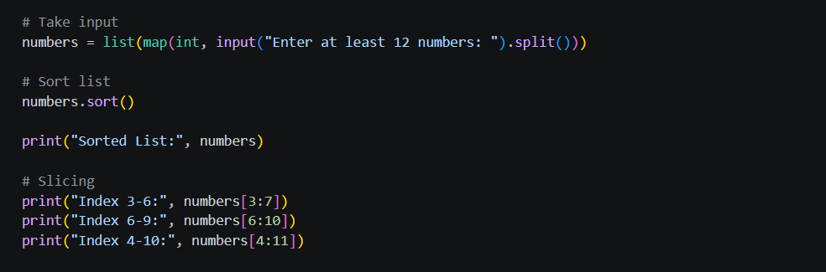

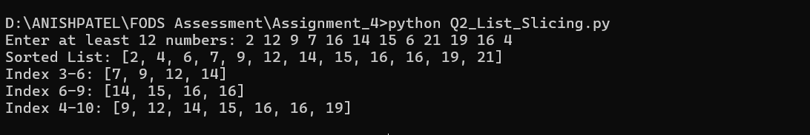

Q3. Random Array and Reshape

This program creates a random array using NumPy and reshaping into matrix
of valid dimensions.

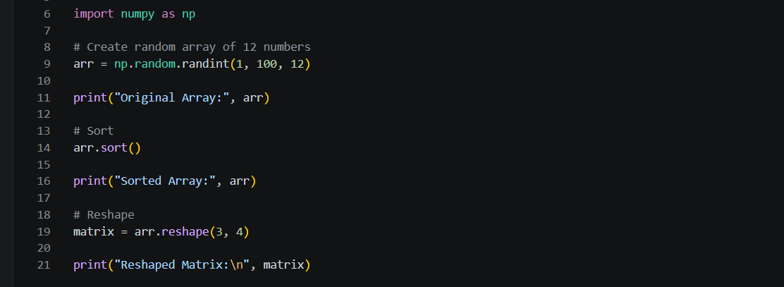

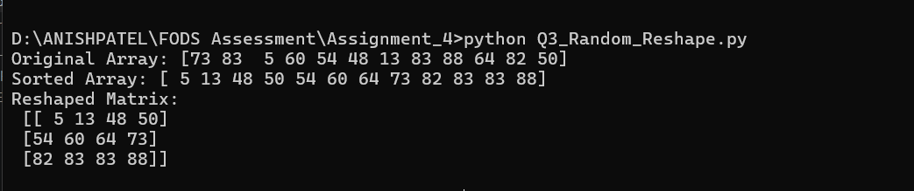

Q4. Matrix Operations

This program takes two matrices as input from the user and performs matrix operations such as addition, subtraction and multiplication using NumPy with validation.
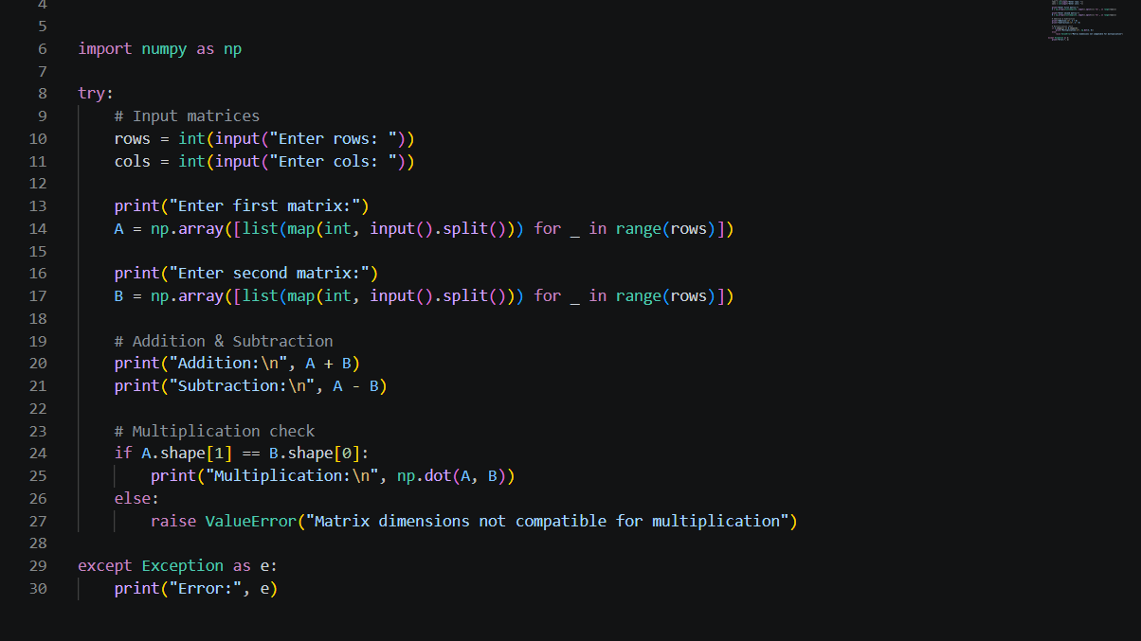

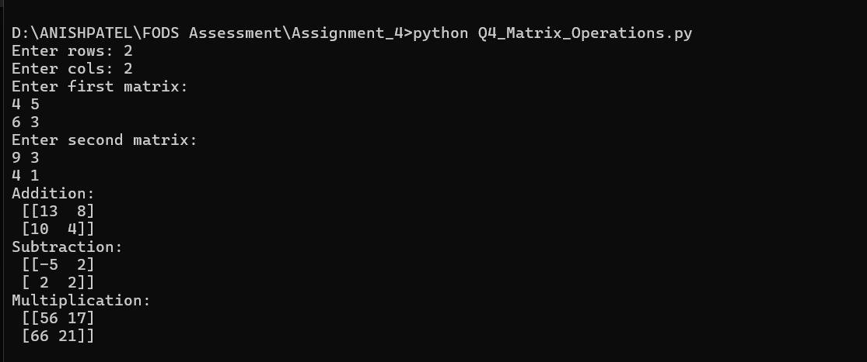

Q5. Data Visualization

This program reads CSV file "health_data.csv" using pandas and plot the data using Matplotlib.

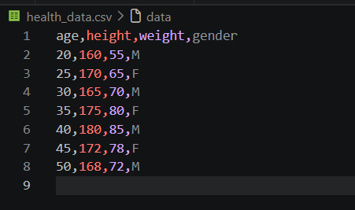
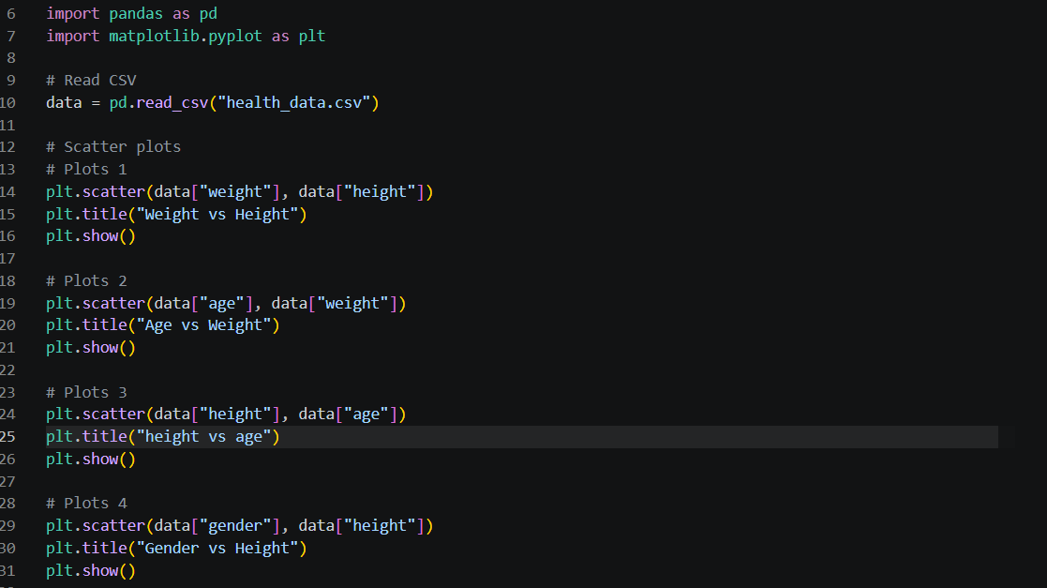

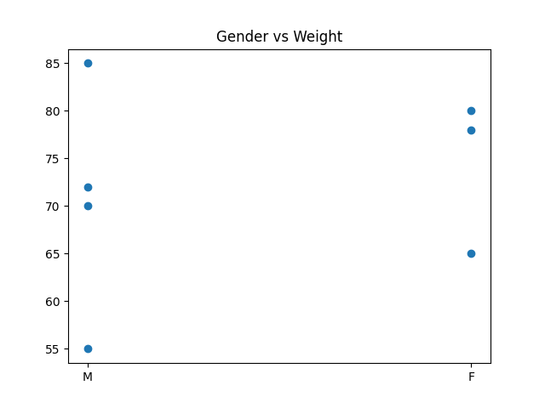
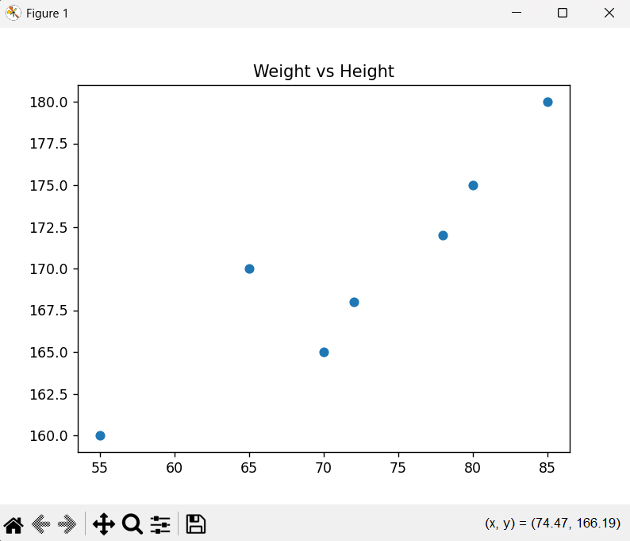
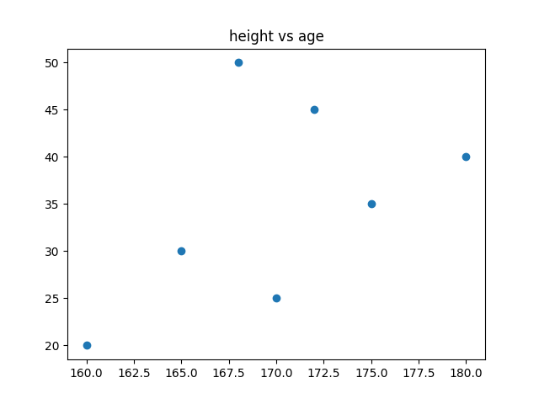
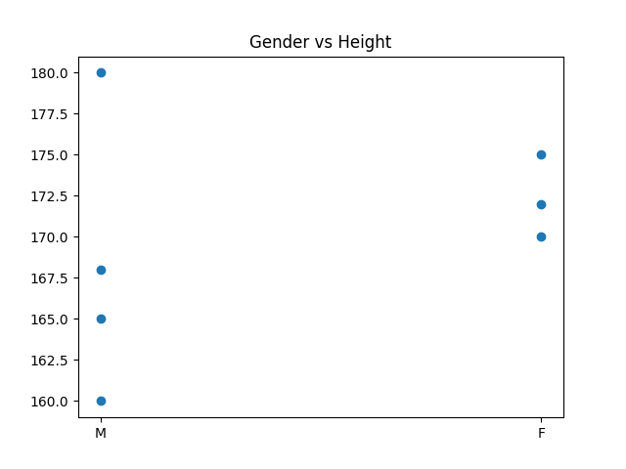

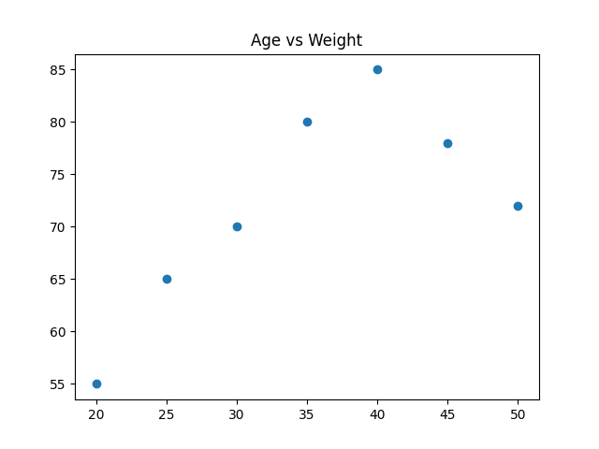

Q6. BMI and Health Status

This program calculates BMI and health status from CSV file.
