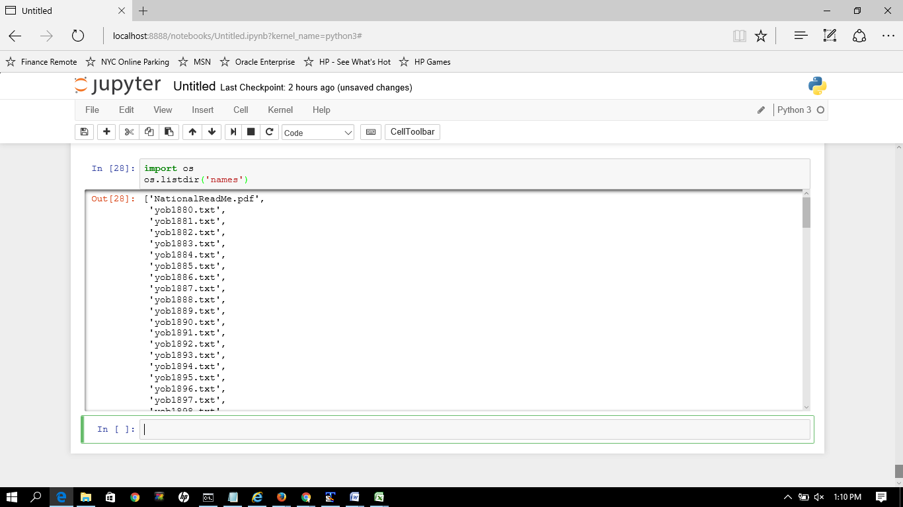

Loading datafiles from year 1880 to 2014.

**National Data on the relative frequency of given names in the population of U.S. births where the individual has a Social Security Number (Tabulated based on Social Security records as of March 8, 2015)**

For each year of birth YYYY after 1879, we created a comma-delimited file called yobYYYY.txt. Each record in the individual annual files has the format "name,sex,number," where name is 2 to 15 characters, sex is M (male) or F (female) and "number" is the number of occurrences of the name. Each file is sorted first on sex and then on number of occurrences in descending order. When there is a tie on the number of occurrences, names are listed in alphabetical order. This sorting makes it easy to determine a name's rank. The first record for each sex has rank 1, the second record for each sex has rank 2, and so forth. To safeguard privacy, we restrict our list of names to those with at least 5 occurrences.