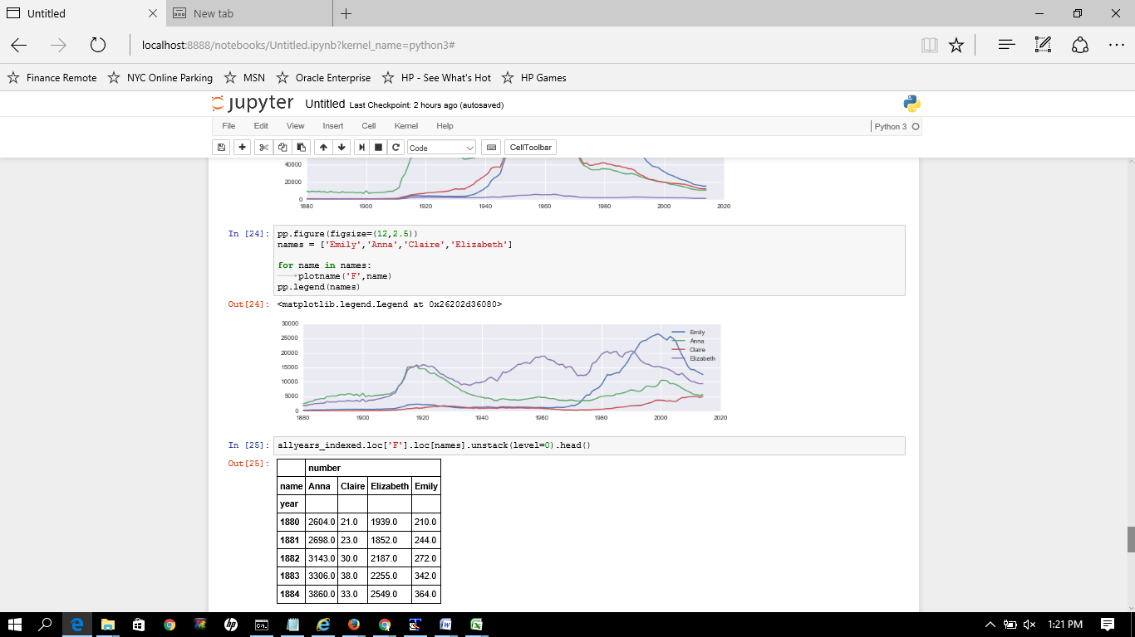

Screen 4 : Shows plotting 5 names.