**BIGMOVE**

**Mockup of The Home Page for A Moving Site**

## About Project

This application was created as material as part of learning & pre-screen test.

Its a Angular 2 project created with Angular CLI. It includes some common libraries:

* Bootstrap
* ng2-bootstrap

## What You Need to Install?

* [Node.js](https://nodejs.org/en/)
* [Angular CLI](https://cli.angular.io/)

## How to Start Application?

To start application, execute below commands from big-move directory:

* npm install
* ng serve

## Screenshots

Desktop View:

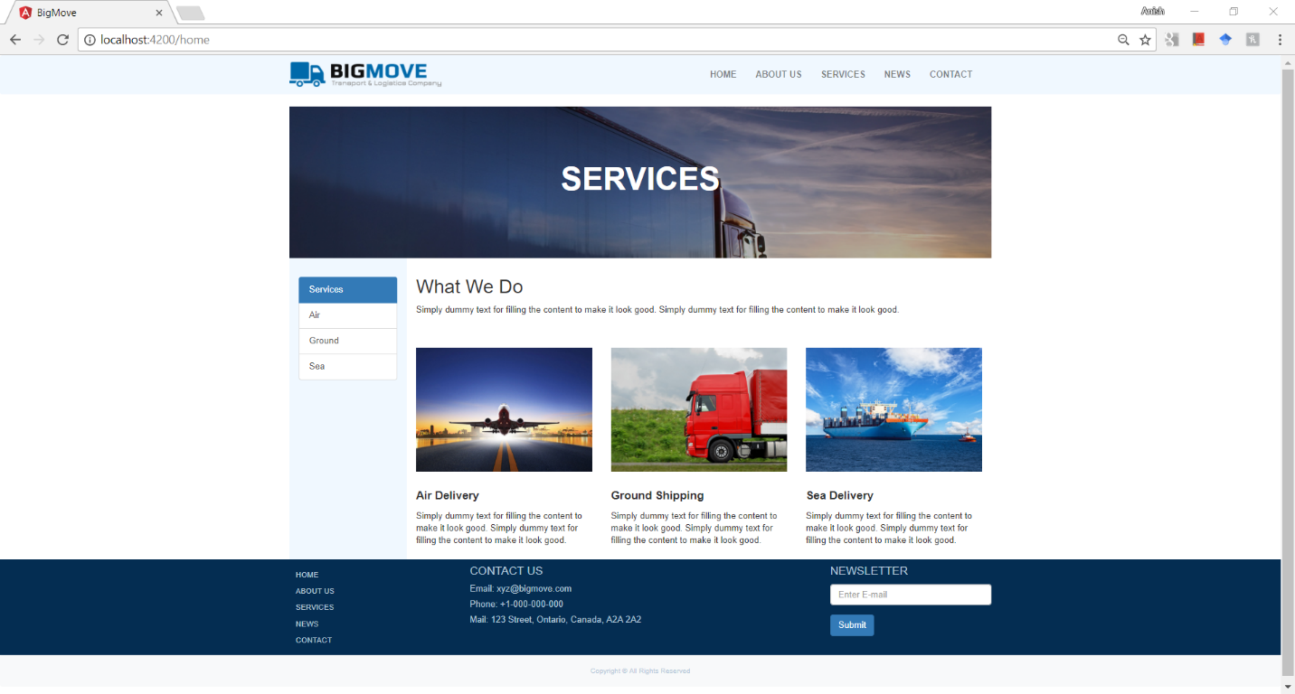

Mobile View:

