LIFETRACK HEALTH
A Patient-Owned, Local-First Health Record with Consent-Controlled Sharing

NTCC Project Report
submitted in partial fulfilment of the requirements for the degree of
[Programme, e.g. Bachelor of Science in Information Technology (B.Sc. IT)]

Submitted by
[Student 1 name — Enrolment no.]
[Student 2 name — Enrolment no.]
[Student 3 name — Enrolment no.]
[Student 4 name — Enrolment no.]

Under the supervision of
Dr. Priyadarshini Gupta
[Designation], Amity Institute of Information Technology

AMITY INSTITUTE OF INFORMATION TECHNOLOGY
AMITY UNIVERSITY PATNA
Patna – 801503
Academic Session [2025–2028] · October 2026

DECLARATION
We hereby declare that the project report entitled “LifeTrack Health: A Patient-Owned, Local-First Health Record with Consent-Controlled Sharing”, submitted to Amity Institute of Information Technology, Amity University Patna, in partial fulfilment of the requirements for the degree of [Programme], is a record of original work carried out by us under the supervision of Dr. Priyadarshini Gupta.
The software described in this report was designed, built and tested by the project team. Published standards, laws and libraries used in the work are acknowledged in the References. This report has not been submitted, in part or in full, to any other university or institution for the award of any degree or diploma.

Name | Enrolment number | Signature
[Student 1] | [Enrolment no.]
[Student 2] | [Enrolment no.]
[Student 3] | [Enrolment no.]
[Student 4] | [Enrolment no.]

Place: Patna Date: [Date of submission]

CERTIFICATE
This is to certify that the project report entitled “LifeTrack Health: A Patient-Owned, Local-First Health Record with Consent-Controlled Sharing”, submitted by [Student 1], [Student 2], [Student 3] and [Student 4] in partial fulfilment of the requirements for the degree of [Programme] at Amity Institute of Information Technology, Amity University Patna, is a bona fide record of work carried out by them under my supervision during the academic session [2025–2028].
To the best of my knowledge, the work presented in this report is original and has not been submitted elsewhere for the award of any degree or diploma.

Dr. Priyadarshini Gupta
[Designation]
Amity Institute of Information Technology, Amity University Patna
Signature: ____________________ Date: ____________

ACKNOWLEDGEMENT
We express our sincere gratitude to our supervisor, Dr. Priyadarshini Gupta, for her guidance, encouragement and critical feedback throughout this project. Her questions about how an analytical or clinical claim can be proven correct shaped the testing approach described in this report.
We thank the Director and faculty of Amity Institute of Information Technology, Amity University Patna, for providing the environment and resources to carry out this work, and our classmates for testing early versions of the apps and reporting what confused them.
We also acknowledge the open-source communities behind Flutter, Dart, the cryptography package, Tesseract OCR and the many other libraries this project builds on.
Finally, we thank our families for their patience and support.

[Student 1]
[Student 2]
[Student 3]
[Student 4]

ABSTRACT
In India a patient’s medical history is usually spread across the clinics, hospitals and laboratories they have visited, with the patient carrying paper reports between them. When the history is not available, investigations are repeated, medicines are duplicated and family patterns are missed — not because of poor clinical judgement but because the data is fragmented. The patient is the only person present at every encounter, yet rarely holds a complete record.
LifeTrack Health is a working prototype of a patient-owned, local-first health record that addresses this problem. It consists of four parts: an Android patient app built in Flutter; LifeTrack Clinic, a doctor app; a small Dart server that acts as a doctor registry, an encrypted relay and a backup store; and a shared protocol package. Records live on the patient’s phone, sealed with AES-256-GCM under a hardware-backed device key. A doctor sees records only after the patient scans the doctor’s registry-verified code and approves a level of access — Summary, All reports, Family illnesses or Home readings — for a chosen time between one hour and two days. The share is encrypted on the phone to that doctor’s device key alone (X25519 with AES-GCM); the server carries it but can never open it. Prescriptions return to the patient signed with the doctor’s Ed25519 key.
The patient app also reads photographed or PDF lab reports on the device with Tesseract OCR, compares results with published reference ranges without ever stating a diagnosis, tracks medicines with reminders, keeps a child vaccination schedule, manages a family under a head-of-family model, offers an Emergency ID readable from the lock screen, and makes an end-to-end encrypted backup protected by an app-generated password and Shamir 2-of-3 recovery codes. Every read, share, refusal and export is written to an append-only audit log before it happens.
The system was built in Dart and Flutter (about 21,700 lines of application code) and is verified by 354 automated tests across unit, widget, invariant and end-to-end integration levels, all passing, with a clean static analysis. The invariant tests turn the project’s privacy promises — for example that no screen may claim the server “cannot read” the data, or that no agent may issue itself a grant — into checks that fail the build. The report describes the problem, the related work, the requirements, the architecture and security design, the implementation, the testing and the results, and closes with limitations and future work, notably ABDM/ABHA integration and legal review before any pilot with real patients.
Keywords: personal health record, patient consent, end-to-end encryption, local-first software, Flutter, digital health India, DPDP Act 2023.

TABLE OF CONTENTS

(If page numbers do not appear, right-click the table in Word and choose “Update Field”.)

LIST OF FIGURES
Figure 4.1 System architecture
Figure 4.2 Level 0 data flow diagram
Figure 4.3 Layers of the patient app
Figure 4.4 Clinical share and prescription sequence
Figure 4.5 Backup key hierarchy
Figure 5.1 Patient app: Reminders, Records and Insights
Figure 5.2 Patient app: Share and Me
Figure 5.3 LifeTrack Clinic: verified code, request by ID and an arrived share
Figure 5.4 LifeTrack Clinic: a shared summary and a prescription being written

LIST OF TABLES
Table 2.1 Existing solution categories compared
Table 3.1 Stakeholders and their needs
Table 3.2 Functional requirements — patient app
Table 3.3 Functional requirements — doctor app and server
Table 3.4 Non-functional requirements
Table 3.5 Hardware and software requirements
Table 4.1 Access levels
Table 5.1 Technology stack
Table 5.2 Code size by part
Table 5.3 Server routes
Table 6.1 Test results by part
Table 6.2 Selected test cases
Table 7.1 Objectives and outcomes
Table A.1 Version history

LIST OF ABBREVIATIONS
ABDM Ayushman Bharat Digital Mission
ABHA Ayushman Bharat Health Account
AES-GCM Advanced Encryption Standard, Galois/Counter Mode
APK Android Package
DFD Data Flow Diagram
DPDP Digital Personal Data Protection (Act, 2023)
EMR Electronic Medical Record
FHIR Fast Healthcare Interoperability Resources
HKDF HMAC-based Key Derivation Function
OCR Optical Character Recognition
QR Quick Response (code)
SaMD Software as a Medical Device
UI User Interface
WCAG Web Content Accessibility Guidelines

Chapter 1: Introduction

1.1 Background
Health care in India is delivered by a very large number of independent providers: government hospitals, private hospitals, single-doctor clinics, diagnostic laboratories and pharmacies. Each keeps its own records, if it keeps them digitally at all, and very few exchange them. For the patient, the practical result is a carry bag of paper — prescriptions, lab printouts, discharge summaries and scan reports — that is incomplete, easily lost and hard for a new doctor to read in a ten-minute consultation.
The Government of India’s Ayushman Bharat Digital Mission (ABDM) is building national rails for health data exchange, including the ABHA health ID and consent managers. At the same time, the Digital Personal Data Protection Act, 2023 (DPDP Act) makes consent, purpose limitation and the right to access one’s data legal obligations. Both point in the same direction: the patient should be at the centre of their own record and should decide who sees it.

1.2 Problem statement
A patient is the only person present at every one of their medical encounters, but has no single, trustworthy, consolidated view of their own history and no safe way to show the relevant part of it to a new doctor. Three consequences follow:
- Repeated investigations. When a previous test result is not available, or its source cannot be trusted, the test is ordered again, costing the patient money and time.
- Duplicate or conflicting medication. A doctor who does not know what the patient already takes may prescribe the same ingredient under a different brand name.
- Missed hereditary patterns. Illnesses in the family are rarely recorded in a way a doctor can use.
Existing solutions either keep the data inside one institution (hospital EMRs), are designed for large organisations (enterprise systems), establish identity without holding the record (government health IDs), or store documents without making them useful or safely shareable (document-locker apps). The project therefore asks: can a patient keep a complete, useful health record on their own phone and share exactly the right part with exactly the right doctor, for a limited time, without any server ever being able to read it?

1.3 Motivation
Health data is among the most sensitive personal data. A design in which a company’s servers hold readable copies of millions of records creates a single point of failure for breaches, misuse and function creep. A local-first design — where the authoritative copy lives on the patient’s device and leaves it only encrypted, on the patient’s explicit action — reduces that risk by construction. Building such a system end to end, including the cryptography, the consent rules and a doctor-side app, is a demanding software-engineering exercise that touches mobile development, security, distributed systems, user-interface design and law.

1.4 Objectives
- Build a patient-owned record on the phone that holds prescriptions, lab reports, scans, notes, allergies, conditions, vitals and vaccinations for every member of a family, with all data encrypted at rest.
- Make clinician access explicit, time-limited and revocable: the patient approves a level of access for one verified doctor for a chosen time, and can shorten, extend or end it.
- Guarantee that no server can read shared records or backups: shares are encrypted to the doctor’s device key and backups to a key derived from a password only the patient holds.
- Provide useful, safe insights on the device: compare results with published reference ranges, notice movement between reports and spot duplicate medicines, without ever stating a diagnosis or a forecast.
- Reduce data-entry effort by reading photographed and PDF lab reports on the device (OCR), with the patient confirming uncertain fields.
- Build a doctor app with a verified identity, so that a patient knows who they are sharing with, and so that prescriptions returned to the patient are signed.
- Make every privacy promise verifiable: express the system’s rules as automated tests that fail the build when broken.

1.5 Scope
In scope. An Android patient app; a doctor app (Flutter, runs in a browser or on a phone); a local server providing a doctor registry, an encrypted relay, a LifeTrack ID directory, a backup vault and an identity-check flow; and a shared protocol package. Sample (synthetic) patients and doctors are used throughout.
Out of scope for this phase. Real patient data; live ABDM/ABHA exchange; real DigiLocker partner integration (a “practice” stand-in drives the same flow); cloud-based AI analysis (designed as “Plane C” but disabled); iOS OCR; clinical decision support and predictive modelling; deployment on the public internet.

1.6 Organisation of the report
Chapter 2 reviews existing systems, standards and laws. Chapter 3 sets out the requirements and feasibility. Chapter 4 describes the architecture, data design and security design. Chapter 5 explains the implementation, module by module, with screenshots. Chapter 6 covers testing and results. Chapter 7 discusses outcomes against the objectives, and Chapter 8 concludes with limitations and future work. Appendices give the version history and instructions to run the system.

Chapter 2: Literature Review and Existing Systems

2.1 Categories of existing solutions
Table 2.1: Existing solution categories compared
Category | Examples | Strengths | Gaps for the patient
Hospital EMR / HIS | Systems used inside a hospital chain | Complete within the institution; integrated with billing and labs | Data stays inside the institution; patient has no consolidated view
Enterprise health platforms | Large vendor suites | Powerful, standards-based | Expensive and complex; built for organisations, not individuals
Government health ID and exchange | ABHA, ABDM consent managers, PHR apps | National identity and consent rails; legal backing | Identity and exchange rather than a patient-held, analysed record; depends on provider adoption
Document lockers | DigiLocker and general cloud storage | Easy storage of issued documents | Stores files, does not interpret results; provider holds readable copies
Personal record apps | Consumer health-record apps | Convenient capture and reminders | Usually cloud-first with readable server copies; sharing is often an open link

2.2 Relevant standards
- HL7 FHIR R4. The widely adopted standard for exchanging health data as resources (Patient, Observation, MedicationRequest, Provenance). ABDM uses FHIR-based profiles. LifeTrack’s record model keeps provenance and source on every record so that a later FHIR export can say where each value came from; FHIR export itself is future work (Section 8.3).
- Ayushman Bharat Digital Mission (ABDM). Defines the ABHA number, health information providers and users, and consent artefacts. LifeTrack records an ABHA number as optional, typed in, and shown as “not verified” until ABDM integration exists.
- Cryptographic standards. AES-GCM (NIST SP 800-38D) for authenticated encryption; X25519 (RFC 7748) for key agreement; Ed25519 (RFC 8032) for signatures; HKDF (RFC 5869) for key derivation; Argon2id (RFC 9106) for password hashing, using the OWASP-recommended minimum parameters; Shamir’s secret sharing for recovery codes.
- WCAG 2.1 AA. Contrast requirements for readable text; the apps are tested against them in both light and dark mode.

2.3 Legal and regulatory context
- Digital Personal Data Protection Act, 2023. Requires free, specific, informed and unambiguous consent, purpose limitation, a right of access and erasure, and verifiable parental consent for children (Section 9). LifeTrack implements consent per purpose and time, an export of all data (the access right), erasure, and parent-declared consent for children that stops at 18.
- Aadhaar Act, 2016, Section 29 restricts storing and sharing Aadhaar numbers. LifeTrack never asks for or stores an Aadhaar number; LifeTrack IDs always begin with 1 so that they can never be, or validate as, an Aadhaar number.
- Justice K.S. Puttaswamy v. Union of India (2018) and the 2019 Aadhaar amendment limit mandatory Aadhaar authentication by private entities. The project’s optional “identity required” mode, which verifies every profile through DigiLocker, is therefore flagged for legal review before any pilot (Section 8.2).
- Telemedicine Practice Guidelines, 2020 require a doctor to keep a record of the consultation and prescription. LifeTrack therefore never promises that a doctor “keeps no copy”; it says that shared records close when access ends.
- Information Technology (SPDI) Rules, 2011 apply to sensitive personal data, including health data, until the DPDP Rules commence.

2.4 Design principles drawn from the literature
The local-first software movement argues that the user’s device should hold the authoritative copy of their data, with the network used for synchronisation and collaboration rather than custody. End-to-end encryption, familiar from messaging, shows that a relay can carry data it cannot read. Clinical-safety guidance for software as a medical device distinguishes between displaying information (low risk) and diagnosing or predicting (regulated). LifeTrack combines these: a local-first record, an end-to-end encrypted relay, and insights that state only position and movement and route the patient to a person.

2.5 Research gap
No widely available system combines (a) a patient-held, encrypted, family-aware record, (b) on-device interpretation of results that is deliberately non-diagnostic, (c) sharing to a registry-verified doctor that the server cannot read, with a time limit the patient sets, and (d) privacy promises enforced by automated tests. LifeTrack Health is a prototype of that combination.

Chapter 3: Requirements Analysis

3.1 Stakeholders
Table 3.1: Stakeholders and their needs
Stakeholder | Needs
Patient / head of family | Keep everyone’s records in one place; understand results; share safely with a doctor; get reminders; recover the record if the phone is lost
Doctor | See a trustworthy summary quickly, with where each result came from; ask a patient for access remotely; send a prescription back
Registry administrator | Approve, reject and revoke doctors; keep the registry key safe
Linked family member | See a parent’s Emergency ID and current medicines when the parent chooses to share them
Paramedic / bystander | Read the Emergency ID from the lock screen in an emergency

3.2 Functional requirements

Patient app
Table 3.2: Functional requirements — patient app
ID | Requirement
FR-1 | Create profiles for the phone owner (head of family) and family members with roles; children only as the head’s son or daughter
FR-2 | Add, view, edit and delete prescriptions, reports, scans and notes; keep the original image or PDF with each record
FR-3 | Read a photographed or PDF lab report on the device and turn it into a draft record; uncertain fields must be confirmed by the patient
FR-4 | Show each test’s results over time; compare with published reference ranges for age and sex; mark unit mismatches as “not checked”
FR-5 | Detect duplicate medicines (same ingredient, different brand) and meaningful changes between reports
FR-6 | Medicine reminders from active prescriptions, plus the patient’s own reminders; names hidden on the lock screen by default
FR-7 | Child vaccination schedule (India Universal Immunisation Programme) with due dates from date of birth
FR-8 | Home readings diary for blood pressure and sugar, with charts
FR-9 | Emergency ID (blood type, conditions, medicines, contact) readable from the lock screen, every read logged; plain-text QR
FR-10 | Share with a doctor by scanning the doctor’s verified code; choose level and time (1 h, 4 h, 12 h, 1 day, 2 days); change or end it later
FR-11 | Receive and approve or decline access requests a doctor sends by LifeTrack ID
FR-12 | Collect signed prescriptions from the doctor and file them as doctor-issued
FR-13 | Encrypted backup of all profiles to the server; restore onto an empty phone with the password or recovery codes
FR-14 | Export all data as a zip (HTML, JSON, originals, access log), password-protected by default
FR-15 | Access log showing every read, share, refusal, export and Emergency ID open
FR-16 | Family link: share Emergency ID and/or medicine list with a linked adult’s phone, each off by default

Doctor app and server
Table 3.3: Functional requirements — doctor app and server
ID | Requirement
FR-17 | Doctor enrols with name, registration number and specialty; the device generates its own keys; the administrator approves
FR-18 | Doctor shows a verified QR code for the patient to scan; certificate lasts 30 days and renews automatically
FR-19 | Doctor requests access by a patient’s 12-digit LifeTrack ID, asking for levels and a time
FR-20 | Doctor sees shared records with provenance and a countdown; access closes at the end time
FR-21 | Doctor writes, signs, prints and sends a prescription back to the patient
FR-22 | Doctor keeps their own sealed notes and a patient register
FR-23 | Server: registry with admin approve/reject/revoke; relay that deletes on pickup or expiry; ID directory; backup vault with rate-limited proofs; identity-check flow

3.3 Non-functional requirements
Table 3.4: Non-functional requirements
Quality | Requirement and how it is met
Confidentiality | Every blob on disk sealed with AES-256-GCM; shares and backups end-to-end encrypted; server holds no key that opens records
Integrity | Authenticated encryption binds each blob to its name; prescriptions and certificates are signed; audit log is append-only
Accountability | Every read, change, grant, refusal, egress, restore and erasure is audited; egress is logged before it happens
Availability / offline | The patient app works fully offline; the network is needed only to share, back up, or check a doctor’s status
Usability | Plain-language screens; one confirmation for scanned reports; levels as presets; dark mode
Accessibility | All visible text meets WCAG AA contrast in light and dark mode (tested); semantic colours checked for colour-vision deficiency
Safety | Insights never diagnose or forecast; banned phrases are dropped, not rephrased; adult ranges never applied to children or in pregnancy
Maintainability | Strict static analysis; 354 automated tests; every update raises the version and adds a changelog line
Portability | Flutter: one code base for the patient app (Android) and the doctor app (web or mobile)

3.4 Hardware and software requirements
Table 3.5: Hardware and software requirements
Item | Development | Deployment (prototype)
Hardware | Laptop with 8 GB+ RAM; Android phone with USB debugging | Android 8.0+ phone with a screen lock; any modern browser for the doctor app
Operating system | macOS / Windows / Linux | Android; server runs on any OS with Dart
Languages | Dart 3, Kotlin (Android platform code) | —
Frameworks | Flutter, shelf (server) | —
Tools | Android SDK, adb, Git and GitHub, VS Code / Android Studio | —
Key libraries | cryptography, flutter_secure_storage, local_auth, flutter_zxing, qr_flutter, Tesseract4Android, flutter_local_notifications, archive, printing | —

3.5 Feasibility study
- Technical. Flutter and Dart provide mature cryptography, camera, QR and notification support; Tesseract runs fully on-device. The prototype demonstrates every required flow end to end.
- Economic. All tools and libraries are free and open source. The server is a single small Dart process; hosting costs would be minimal because it stores only ciphertext and short-lived messages.
- Operational. Patients already use smartphones and QR codes; doctors already use computers in clinics. The share flow requires one scan and one approval.
- Legal. The design follows DPDP principles and avoids storing Aadhaar numbers. Mandatory identity verification and the clinical status of insights need confirmation from legal counsel before a pilot.

Chapter 4: System Design

4.1 Overall architecture
LifeTrack Health has four parts (Figure 4.1). The patient app is the custodian of the record. The doctor app, LifeTrack Clinic, is the only other place records can be read, and only while a share is open. The server is deliberately small and untrusted with content: it signs doctor certificates, carries sealed messages, maps LifeTrack IDs to mailboxes, stores encrypted backups and runs the identity-check flow. A shared Dart package, lifetrack_protocol, defines the message formats, certificates and ID rules used by all three, so that the apps and the server cannot drift apart.
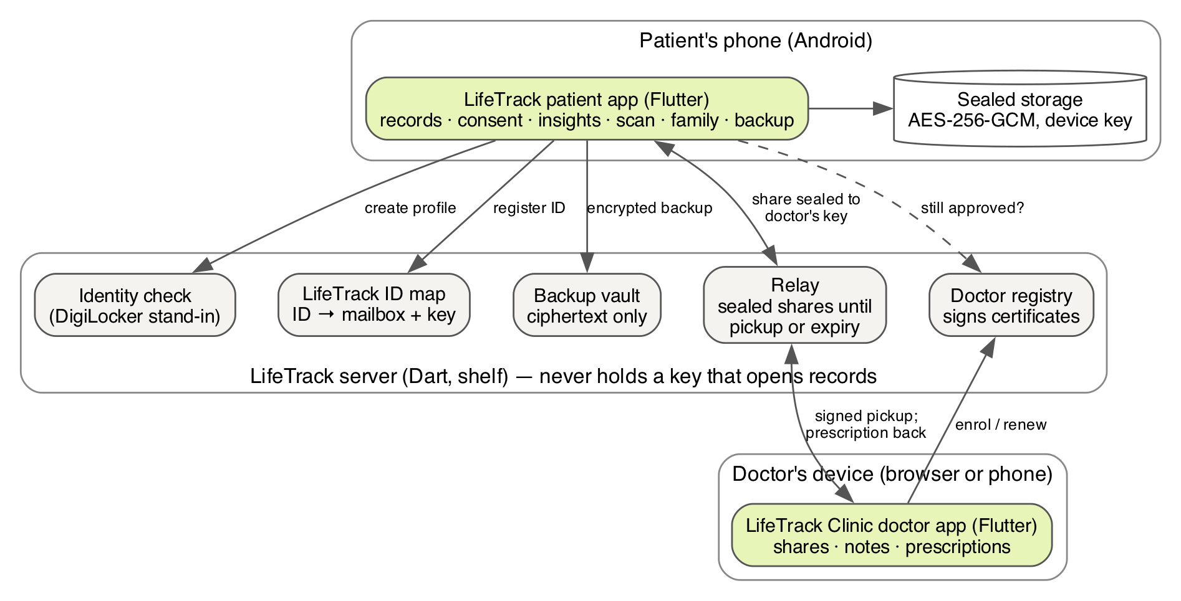
Figure 4.1: System architecture

4.2 Data flow — Level 0
Figure 4.2 shows the system as a single process with its external entities. Records enter only from the patient (typed, scanned, imported) or from a doctor (signed prescriptions). Records leave only in three ways: a clinical share the patient approved, encrypted backup ciphertext, or a family-link message the patient ticked.
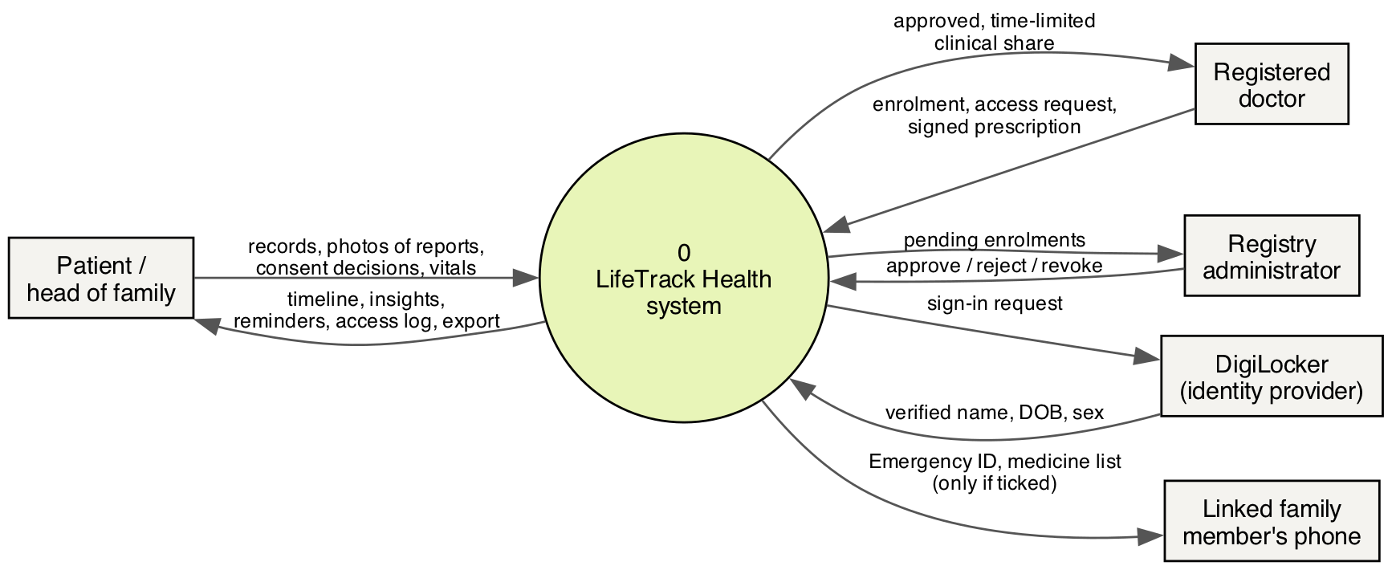
Figure 4.2: Level 0 data flow diagram

4.3 Patient app architecture
Inside the patient app (Figure 4.3), screens never touch storage or compare values with ranges themselves. They call AppServices, the single entry point, and render Insight objects. Any reader other than the patient — on-device insights, a share, the disabled cloud plane — must go through RecordAccess, which asks ConsentStore whether a stored grant allows the read and writes an audit entry for every read and every refusal. Below that, SealedStore encrypts every blob and FileByteStore writes it atomically (write to a temporary file, flush, rename).
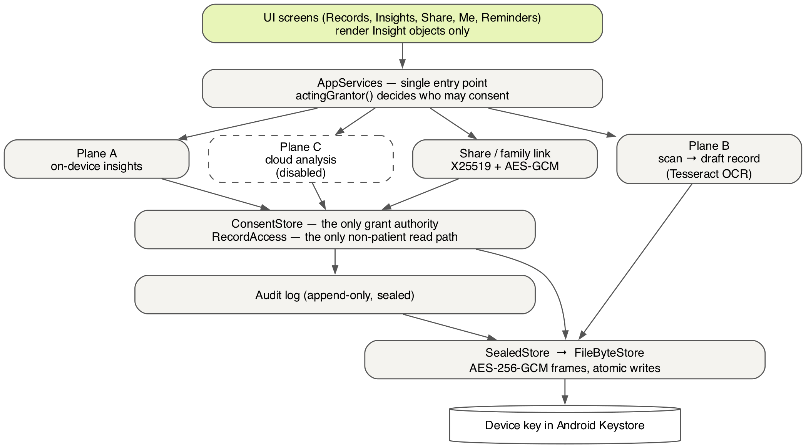
Figure 4.3: Layers of the patient app

The three planes
- Plane A — on-device insights (Tier 1). Deterministic rules that state where a value sits relative to a published range, whether it moved meaningfully since the last report, and whether two prescriptions share an ingredient. It reads records only under its own actor and a 24-hour grant the patient turns on, and it is forbidden from calling the clock directly so that its output is reproducible in tests.
- Plane B — capture. Turns a photographed or PDF page into a draft record using Tesseract OCR on the phone. Fields read with low confidence must be ticked or corrected before one final confirmation.
- Plane C — cloud analysis (Tier 2). Designed but switched off. It can only cross on a fresh human tap bound to the disclosure the patient read, with its own one-time grant. It stays dark until a certified service exists.

4.4 Consent model
A grant (consent token) records the patient, who granted it (the patient, or a parent or custodian for a dependent), the grantee, the purpose, the level and filter, the validity window, and whether it is revoked or spent. Authorisation always resolves the stored grant by id and re-checks every field; a token presented by a caller is never trusted on its own. Further rules:
- No grant exceeds 48 hours. A clinical share lasts one hour unless the patient chooses 4 h, 12 h, 1 day or 2 days; a doctor may ask for a time, and the patient may give less or change it later.
- A live grant cannot be silently re-issued with any difference; changing the time replaces the doctor’s copy with one that ends at the new time.
- No component under the AI planes may create, extend or exercise a grant it was not given.
- Proxy consent applies only to dependents: a parent for a child under 18 (sharing stops at 18), or a custodian for an adult who delegated in person. One function, actingGrantor(), makes that decision for every share.
Table 4.1: Access levels
Level | What the doctor sees
Summary (default) | Allergies, conditions, active medicines and the latest result for each test — the level that prevents repeat tests
All my reports | Every report, prescription and scan, optionally filtered by date or test
Family illnesses | Illnesses in the family as the patient reports them, marked “patient-reported”
Home readings | Blood pressure and sugar readings from the last 30 days; off unless ticked

4.5 Data design
The main entities are Patient (profile, date of birth, sex, ABHA, role), Custody (who may consent for whom, and the family role), HealthRecord (kind: prescription, report, scan or note; source: typed by patient, smart capture, doctor-issued, restored, lab-signed; provenance badge; test results with the lab’s printed range; medicines with status), ClinicalProfile (allergies, conditions, family illnesses), VitalReading, EmergencyCard (fixed, bounded fields), ConsentToken, and AuditEntry. Every record keeps where it came from, because a doctor will reuse a result instead of re-ordering the test only if it can be traced to a laboratory. Results show their age and never “valid” or “expired”.
Each entity is serialised to JSON as {schemaVersion, body} and sealed into a frame “LT” ‖ version ‖ nonce ‖ MAC ‖ ciphertext. Version 2 frames bind the blob’s name as associated data, so a blob copied under another name will not open. The index of blob names is itself sealed.

4.6 Security design

Clinical share
Figure 4.4 shows the complete share sequence. The doctor’s device generates its own key pairs; the registry signs a certificate binding the doctor’s registration number to those keys. The patient’s phone verifies the certificate against the registry key pinned in the app and, when online, asks the registry that the doctor is still approved with the same keys. Only then does it show the doctor’s name and registration number. The share is encrypted on the phone to the doctor’s X25519 key; the audit entry is written before the bundle leaves; the relay deletes it after pickup or at expiry.
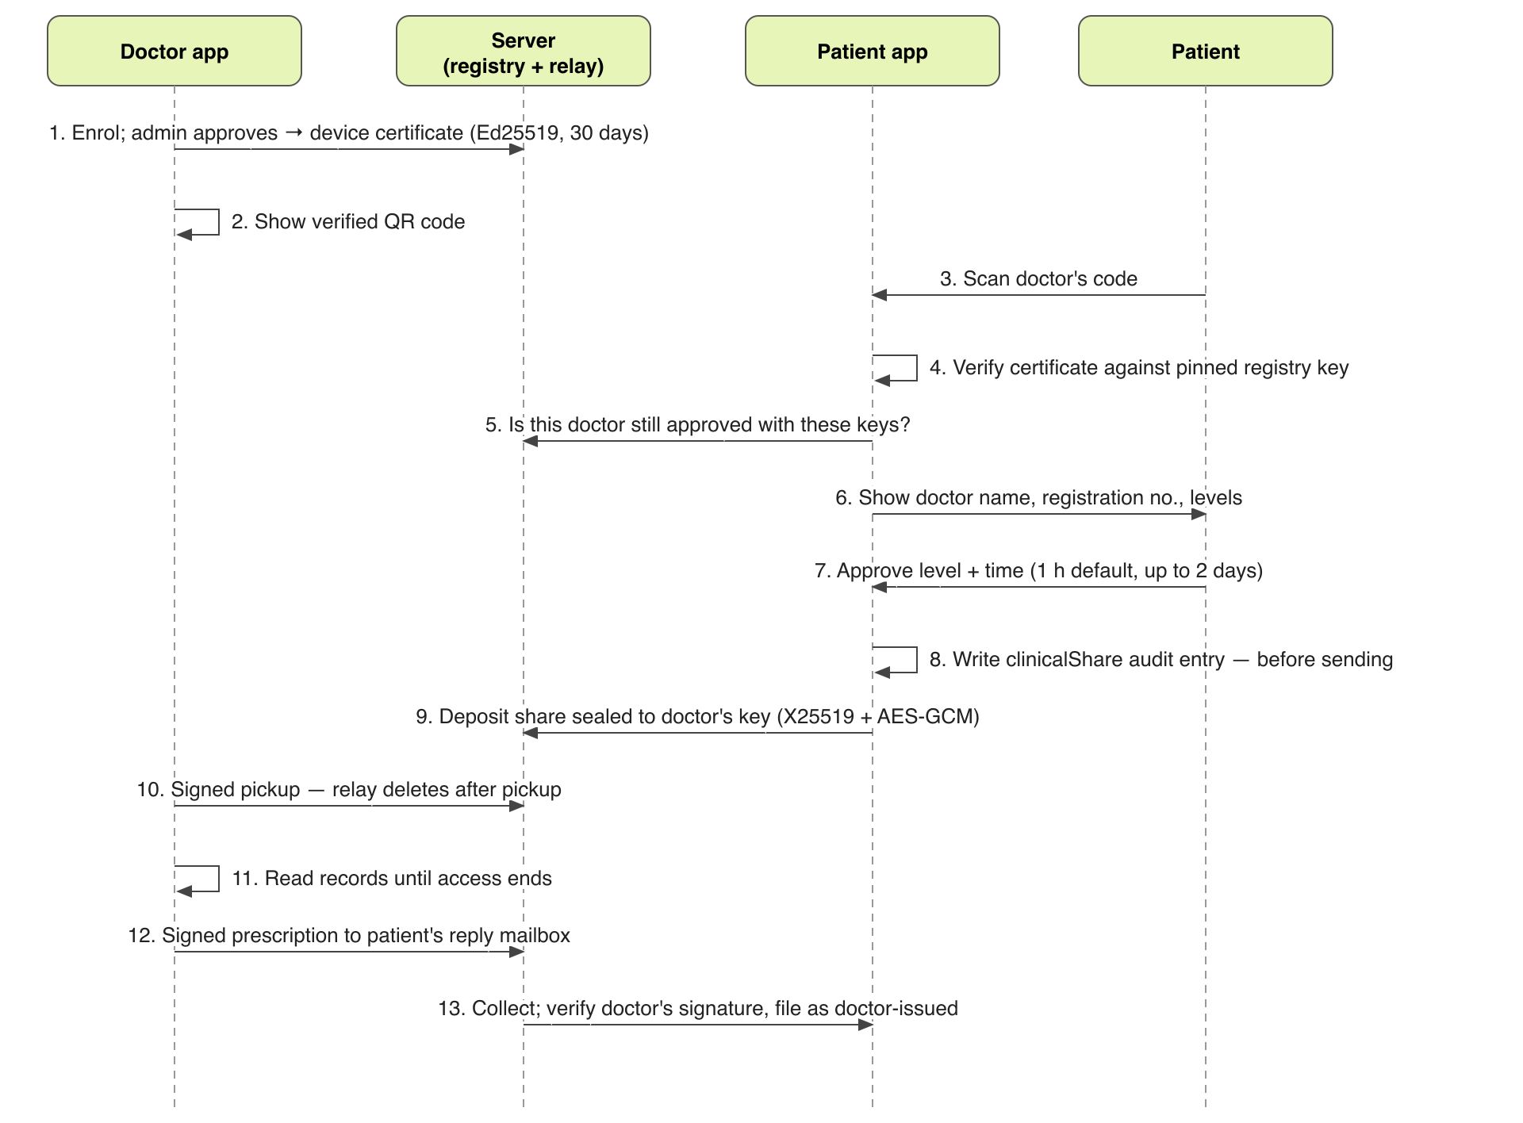
Figure 4.4: Clinical share and prescription sequence

Backup vault
A password chosen by people is the weakest link in any encrypted backup, so LifeTrack generates the password: 20 characters, about 100 bits of entropy, shown once with an account code and recovery codes. Figure 4.5 shows the key hierarchy. Argon2id stretches the password; HKDF derives a vault key and a login verifier. The vault key wraps a random data key, which encrypts the backup. The data key is also split into three Shamir shares, any two of which recover it. The server keeps only a hash of the verifier and rate-limits wrong proofs to ten per hour, a limit that survives restarts.
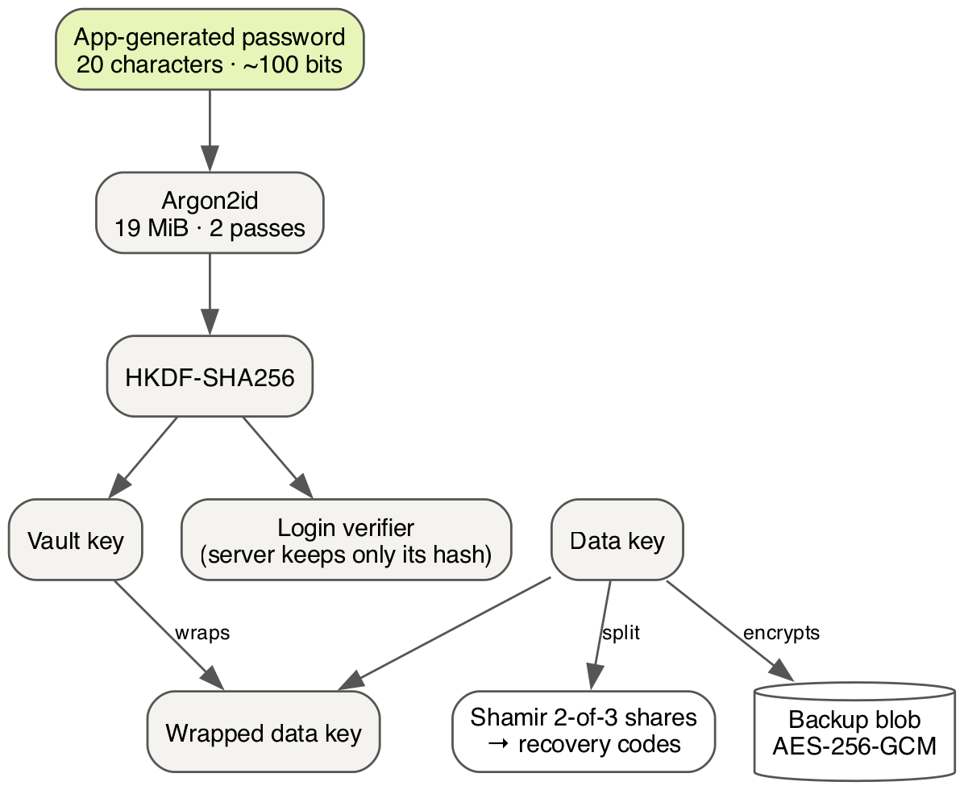
Figure 4.5: Backup key hierarchy

Other protections
- App lock. The app opens behind the phone’s own lock (fingerprint, face or PIN). A phone without a screen lock is asked to set one and the records stay closed. The app re-locks after one minute away.
- Screen privacy. Screenshots and the recent-apps preview are blocked by default.
- No plaintext on disk. Camera files, picked PDFs and share-sheet files are deleted after use and swept at start-up.
- Network discipline. One file in the app is allowed to use the network; a test fails the build if any other file becomes socket-capable.
- Sender proof. A share that carries a LifeTrack ID also proves it came from the phone holding that ID’s reply key, so a public ID lookup cannot be used to forge a share.
- Server hardening. Bound to 127.0.0.1 by default; DNS-rebinding and cross-origin pages refused; body size limits; per-caller rate limits; ID lookups throttled so the number space cannot be walked; enrolments awaiting review cannot be replaced; revocation follows keys.

4.7 LifeTrack ID
Each profile gets a random 12-digit LifeTrack ID shown as XXXX XXXX XXXX. The last digit is a Verhoeff check digit, which catches every single-digit error and every swap of neighbouring digits. IDs always start with 1, so they can never be confused with an Aadhaar number. The server maps an ID only to a reply mailbox and key — no name, no records — and only the token held on the phone can move or delete it.

Chapter 5: Implementation

5.1 Technology stack
Table 5.1: Technology stack
Layer | Technology | Reason
Patient app | Flutter (Dart), Kotlin for Android platform code | One code base, native performance, strong typing
Doctor app | Flutter (web and mobile) | Shares the protocol package and design language with the patient app
Server | Dart with shelf and shelf_router | Same language and protocol package as the apps; small and testable
Cryptography | cryptography package: AES-256-GCM, X25519, Ed25519, HKDF, HMAC-SHA256, Argon2id | Audited primitives; no home-made algorithms
Key storage | Android Keystore via flutter_secure_storage | Hardware-backed device key
OCR | Tesseract 4 (Tesseract4Android), English “best” model, checksum pinned | Fully offline; chosen over a cloud SDK that sends usage statistics
QR | flutter_zxing (scan), qr_flutter (draw) | Offline, no network permission
Other | local_auth, flutter_local_notifications, archive (encrypted zip), printing / pdf, share_plus | App lock, reminders, export, prescriptions

5.2 Code organisation and size
Table 5.2: Code size by part
Part | Folder | Source files | Lines of code
Patient app | app/lib | 99 | 16,083
Doctor app (LifeTrack Clinic) | doctor/lib | 16 | 3,292
Server | server/lib, server/bin | 8 | 1,599
Shared protocol | packages/lifetrack_protocol/lib | 8 | 713
Total application code |  | 131 | 21,687
Tests (all parts) | */test | 58 | 7,097

The patient app is divided into modules under app/lib/src/: ai (planes A, B, C and the Insight contract), app (AppServices and wiring), audit, capture (OCR and image handling), consent, crypto, emergency, export, family, identity, model, reminders, security, share, storage, ui, vaccines and vault.

5.3 Patient app
The app has five tabs — Reminders, Records, Insights, Share and Me — and a family bar at the top for switching between profiles (Figure 5.1).
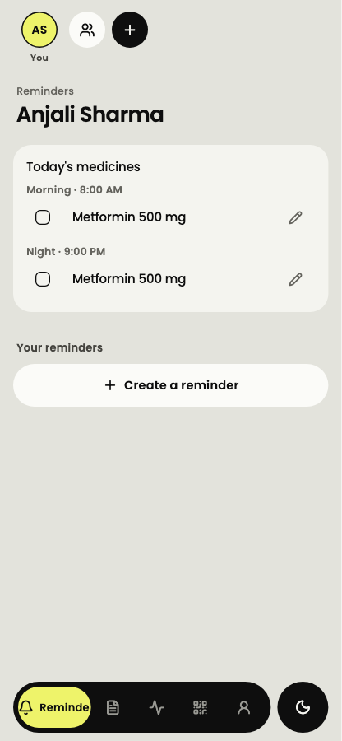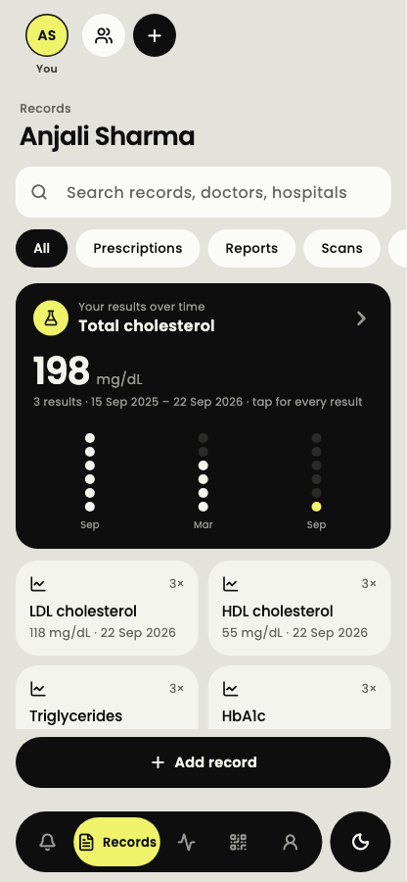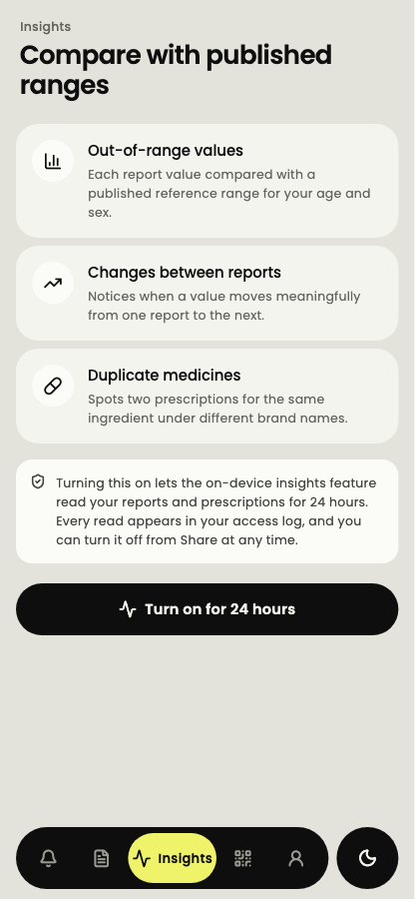
Figure 5.1: Patient app: Reminders, Records and Insights
- Reminders lists today’s medicines from active prescriptions, each with a tick, and the patient’s own reminders.
- Records shows a searchable timeline filtered by prescriptions, reports and scans, and a “results over time” card per test. Tapping a test opens every result with its laboratory, sample date and the lab’s printed range.
- Insights explains what the on-device insights do and asks the patient to turn them on for 24 hours. Every read they make appears in the access log.
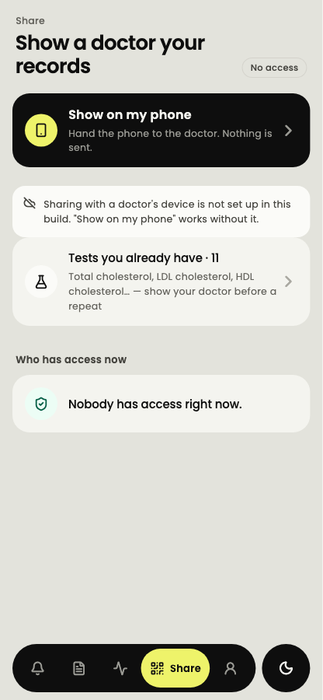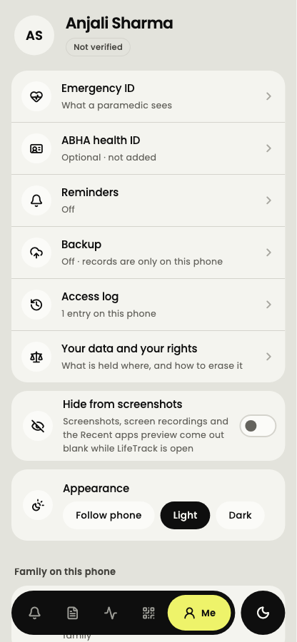
Figure 5.2: Patient app: Share and Me
- Share offers “Show on my phone” (no network), scanning a doctor’s code, “Tests you already have” to show a doctor before they order a repeat, and “Who has access now”, where any share can be shortened, extended or ended.
- Me holds the Emergency ID, ABHA (optional, “not verified”), reminders, backup, the access log, data rights (export and erasure), screenshot privacy, appearance and the family.

Scanning a report (Plane B)
A page arrives from the camera, the photo library, a PDF or another app’s share sheet. The image is straightened, resized and stripped of metadata, then passed to Tesseract in the Android activity. A parser recognises test names, values, units and printed ranges. Any field read with confidence below 0.85 — and every handwritten field — must be ticked or corrected before the patient confirms that the draft matches the report. The original image is kept, encrypted, with the record.

Insights (Plane A)
The engine takes records already obtained through RecordAccess and a clock, and returns Insight objects. A value is compared with a reference interval only when the units match and the interval applies to the patient’s age, sex and pregnancy status; otherwise it is reported as “not checked”, never as normal. Critical values change only the severity and suggested action (discuss soon, contact a doctor today, urgent care), never the wording of the finding. Every output is screened against a list of banned phrases covering diagnoses (“you have”) and forecasts (“risk of”, “may indicate”); a banned output is dropped, not rephrased.

Family
The phone owner is the head of the family. Each other profile has a role describing who the person is to the head. A child under 18 can be added only as the head’s son or daughter, with consent declared by the parent; sharing for that child stops at 18. An adult may delegate to a custodian in person, and can end it. Adults with their own phones can be linked: each may share their Emergency ID and/or current medicine list with the other — both off by default — sealed to the other phone’s key via the relay, with a safety code shown on both phones.

Emergency ID
The Emergency ID holds a fixed set of bounded fields (blood type, conditions, medicines, emergency contact, last four digits of ABHA). It is sealed like every other blob but can be opened from the app’s lock screen, and every such read is logged as an unauthenticated lock-screen read. Its QR code is plain text so any camera can read it without the internet.

5.4 Doctor app — LifeTrack Clinic
On first launch the doctor enrols with their name, registration number, council and specialty; the device generates its keys and the administrator approves the enrolment. The approved doctor’s home screen shows their verified code for patients to scan, a form to request access by LifeTrack ID, and the shares that have arrived, each with a countdown (Figure 5.3).
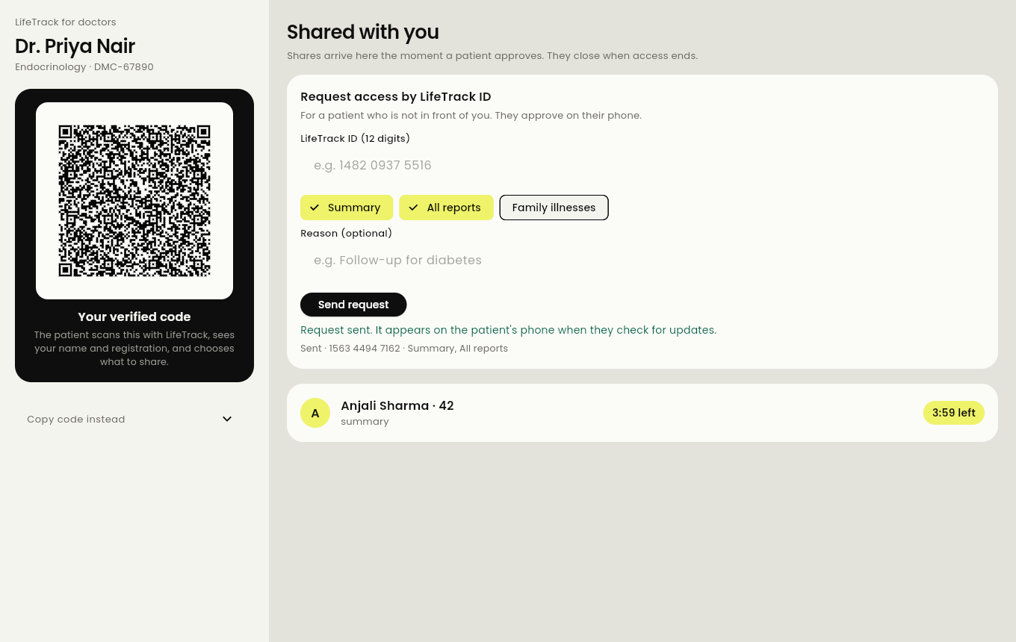
Figure 5.3: LifeTrack Clinic: verified code, request by ID and an arrived share
Opening a share shows the patient’s allergies prominently, current and past medicines with their status, conditions and the latest tests with their source and age, and a link to the original report image. Beside it, the doctor writes a prescription — medicine, active ingredient, morning-afternoon-night dose, timing relative to food, duration and a note — and signs and sends it (Figure 5.4). The prescription can also be printed with the registration number and a signature fingerprint. The doctor app keeps its own notes and a patient register, sealed in the browser.
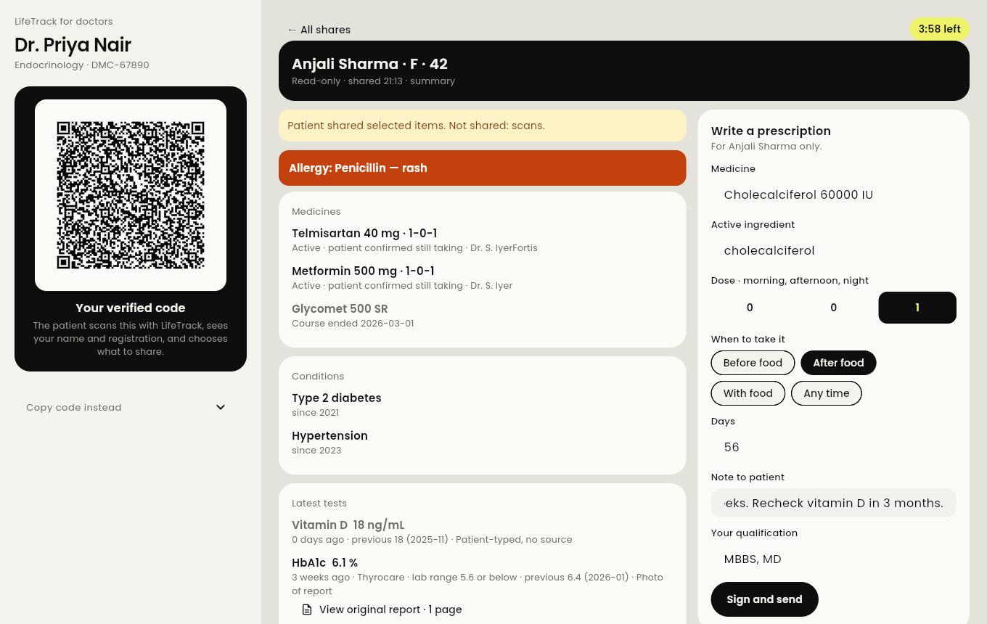
Figure 5.4: LifeTrack Clinic: a shared summary and a prescription being written

5.5 Server
The server is a single Dart process using shelf. Its routes are grouped under /v1/:
Table 5.3: Server routes
Route group | Purpose
/v1/health, /v1/registry/key | Health check; registry public key
/v1/doctors, /v1/admin/doctors/… | Enrolment, status lookup; administrator approve, reject, revoke (admin token required)
/v1/relay/<mailbox> | Deposit and signed pickup of sealed messages; deleted after pickup or at expiry; never beyond 48 hours
/v1/ids, /v1/ids/<id> | Register, move, delete and look up LifeTrack IDs (rate-limited)
/v1/vault/<account>/… | Salt, open, replace and delete backups with a password proof; ten wrong proofs per hour
/v1/verify/… | Identity check: start, callback, result released only with the hand-back code

By default the server binds only to 127.0.0.1. During development the phone reaches it over USB with adb reverse tcp:8787 tcp:8787. Data is kept in an owner-only folder: the registry signing key, the admin token, doctor enrolments, the ID map and the backup files.

5.6 Development practices
- Version control. Git with a private GitHub repository; every change is a reviewed commit.
- Versioning rule. Every update raises the version — a feature raises the middle number, a fix the last — and adds a line to the changelog in the same commit. At the time of writing the patient app is at 1.19.0 and the doctor app at 1.8.0 (Appendix A).
- Security reviews. Two dedicated hardening releases (patient 1.13.0 and 1.18.1/1.18.2, doctor 1.4.1/1.4.2) fixed issues found in review, such as binding the identity result to a hand-back code and proving the sender of a share.
- Release build. The APK is built obfuscated by a script; the symbol map stays on the developer machine.

Chapter 6: Testing and Results

6.1 Testing strategy
Testing followed one principle from the project proposal: a claim is accepted only if a test can prove it. Five kinds of tests were written:
- Unit tests for pure logic: reference ranges, trend thresholds, Verhoeff digits, Shamir splitting, frame encoding, grant checks.
- Widget tests that drive real screens: adding records, sharing, back-button behaviour, dark mode.
- Invariant tests that read the source code itself and fail the build if a rule is broken — for example, if any file other than the one network file becomes socket-capable, if the release manifest gains the INTERNET permission without review, if code under lib/src/ai/ calls ConsentStore.issue or DateTime.now(), or if any UI string claims that LifeTrack or the server “cannot read” the patient’s data. These tests strip comments first, so a comment cannot hide or fake a violation.
- Contrast tests that walk every visible text on every main screen, in light and dark mode, to the solid colour behind it and check WCAG AA contrast.
- Integration tests that run the real code of both apps against the real server handler: scan, share, confirmed sender, prescription back, request by ID, decline, time change and revocation.

6.2 Results
All tests were run on 5 October 2026 on the current version (patient app 1.19.0, doctor app 1.8.0). Static analysis (flutter analyze / dart analyze) reported no issues in any package.
Table 6.1: Test results by part
Part | Static analysis | Tests passed | Failed
Patient app (app/) | No issues | 285 | 0
Doctor app (doctor/) | No issues | 18 | 0
Server (server/) | No issues | 37 | 0
Shared protocol | No issues | 8 | 0
Both apps + server (integration/) | No issues | 6 | 0
Total |  | 354 | 0

One additional test in the patient app is a tool that renders screens to images for visual review; it runs only when asked to save screenshots and is not counted.

6.3 Selected test cases
Table 6.2: Selected test cases
# | Test case | Expected result | Result
1 | A pending (unapproved) doctor tries to show a code | No scannable code is produced | Pass
2 | Patient scans, shares; doctor opens; doctor prescribes; patient collects | Share opens only with the doctor’s key; prescription verified as signed and filed as doctor-issued | Pass
3 | Doctor requests by LifeTrack ID; patient approves once, declines once | Approval produces a share; decline is logged under Refused and the doctor is told | Pass
4 | A doctor is revoked after enrolment | Patient app refuses the doctor; doctor app stops showing as approved | Pass
5 | Doctor asks for 12 h; patient gives 4 h, later changes it | Doctor sees each new end time; old copy replaced | Pass
6 | Share made without choosing a time | Access lasts exactly 1 hour | Pass
7 | A doctor tries to pick up another doctor’s mailbox | Refused | Pass
8 | A signed pickup is replayed | Refused | Pass
9 | Ten wrong backup passwords | Account locked for an hour; server keeps only a hash | Pass
10 | An ID is mistyped by one digit or two neighbours swapped | Rejected by the Verhoeff check before any lookup | Pass
11 | A sealed blob is copied under another name | Fails to open (name bound as associated data) | Pass
12 | A unit on a report does not match the reference range’s unit | Shown as “not checked”, never as out of range or normal | Pass
13 | An insight’s wording contains a banned diagnostic or forecast phrase | Insight dropped | Pass
14 | A DigiLocker sign-in link is forwarded to someone else | Result released only with the hand-back code on the finishing page; five wrong codes end the check | Pass
15 | Any visible text in light or dark mode | Meets WCAG AA contrast | Pass

6.4 Manual testing on a device
The release APK was installed on an Android phone (Samsung Galaxy S25) connected to the local server over USB. The share, request-by-ID, prescription and backup flows were exercised by hand, and a medicine reminder was confirmed to fire on the device with names hidden on the lock screen. OCR accuracy has so far been tested mainly on synthetic report images; testing on a wider set of real photographed reports is listed as future work.

Chapter 7: Results and Discussion

7.1 Objectives achieved
Table 7.1: Objectives and outcomes
Objective | Outcome
1. Patient-owned, encrypted record for the family | Achieved. All data sealed with AES-256-GCM under a hardware-backed key; family with head-of-family roles
2. Explicit, time-limited, revocable clinician access | Achieved. Four levels; 1 h default up to 2 days; change or end at any time; every share audited before it leaves
3. No server can read shares or backups | Achieved by design and tested: shares sealed to the doctor’s key; backups to a key from an app-generated password
4. Safe on-device insights | Achieved for ranges, movement and duplicate medicines; non-diagnostic wording enforced by tests
5. On-device reading of reports | Achieved on Android with Tesseract; English only; accuracy on real photos still to be measured
6. Verified doctor app with signed prescriptions | Achieved: registry certificates, status checks, signed and printable prescriptions
7. Verifiable privacy promises | Achieved: invariant tests in the build; 354 tests passing

7.2 Changes from the original proposal
The proposal planned a mobile app, a separate web analytics dashboard and a clinician portal, with a FHIR R4 data model and a synthetic-dataset approach to verifying analytics. During development the team made three deliberate changes:
- Analytics moved onto the phone. A web dashboard would need a server that can read records, which contradicts the project’s central promise. The analytics were instead built into the patient app as on-device insights.
- The clinician portal became LifeTrack Clinic, a full doctor app with verified identity, request by ID and signed prescriptions, because safe sharing proved to be the most valuable feature for reducing repeat tests.
- FHIR alignment was reduced to provenance. Every record keeps its source and provenance so that a later FHIR export is possible, but FHIR resources and export were not implemented in this phase.
The proposal’s “ground-truth” principle was kept and widened: rather than one synthetic dataset, every rule the system promises is written as a test with a known expected result.

7.3 Discussion
The main lesson of the project is that privacy has to be designed into the structure of the code, not added as a feature. Making ConsentStore the only grant authority and RecordAccess the only non-patient read path meant that sharing, insights and the cloud plane all inherited the same checks and the same audit trail. Expressing the rules as source-scanning tests turned code review questions (“does anything else open a socket?”) into automatic answers.
A second lesson is that honest wording is a requirement. Early screens said the doctor “keeps no copy” and that the server “cannot read” the data. Both were withdrawn: a doctor is legally required to keep their consultation record, and an offline password-guessing attack on a human-chosen password would make “cannot read” untrue. The app now generates the password and the UI makes only claims the code can back, enforced by a test.
Finally, the work on provenance showed that what lets a doctor reuse a result instead of ordering it again is not access control alone but trust in where the result came from — the laboratory, the sample date, the printed range and the original image. These are shown on every result.

Chapter 8: Conclusion and Future Scope

8.1 Conclusion
LifeTrack Health demonstrates that a patient can hold a complete, useful health record on their own phone and share exactly the right part of it with a verified doctor for a limited time, while the server that carries the data can never read it. The prototype covers the full loop — capture, understanding, sharing, prescribing back, reminders, emergencies, family, backup and export — across a patient app, a doctor app and a server, and every privacy and safety promise it makes is checked by an automated test. All 354 tests pass and static analysis is clean.

8.2 Limitations
- Only synthetic patients and doctors have been used; no real patient data.
- The identity check uses a practice stand-in for DigiLocker until partner registration; the optional mode that requires Aadhaar-based verification for every profile must be reviewed by legal counsel in light of Puttaswamy (2018) and the 2019 Aadhaar amendment before any pilot.
- ABHA numbers are typed in and shown as “not verified”; ABDM integration is not yet built.
- OCR is English-only, Android-only, and not yet measured on a large set of real photographed reports.
- The critical-value table follows commonly published limits and must be replaced by a partner laboratory’s published list before a pilot.
- The server has run locally (over USB) and has not been deployed on the public internet.

8.3 Future scope
- ABDM / ABHA integration: verify ABHA, link records as a health information user, and map ABDM consent artefacts as a separate long-lived type.
- DigiLocker partner registration to replace the practice stand-in.
- FHIR R4 export of records with Provenance resources.
- Hosted deployment of the server behind a reverse proxy, with push notifications instead of polling.
- iOS support, including on-device OCR with Apple Vision.
- OCR accuracy study on real photographed reports from Indian laboratories.
- Relative-contributed family history, with that relative’s own consent per request.
- Plane C (Tier 2) cloud analysis, only with a certified service and the human-tap safeguards already designed.
- Pilot with a partner clinic and laboratory after legal and clinical review.

References
[1] Government of India. The Digital Personal Data Protection Act, 2023 (Act No. 22 of 2023). Ministry of Law and Justice, 2023.
[2] Government of India. The Aadhaar (Targeted Delivery of Financial and Other Subsidies, Benefits and Services) Act, 2016, Section 29; and the Aadhaar and Other Laws (Amendment) Act, 2019.
[3] Supreme Court of India. Justice K.S. Puttaswamy (Retd.) v. Union of India, (2019) 1 SCC 1 (Aadhaar judgment, 26 September 2018).
[4] Ministry of Electronics and Information Technology. Information Technology (Reasonable Security Practices and Procedures and Sensitive Personal Data or Information) Rules, 2011.
[5] Board of Governors, Medical Council of India. Telemedicine Practice Guidelines, March 2020.
[6] National Health Authority. Ayushman Bharat Digital Mission (ABDM) — ABHA and Health Information Exchange & Consent Manager specifications. https://abdm.gov.in
[7] Ministry of Health and Family Welfare. Universal Immunization Programme — National Immunization Schedule.
[8] HL7 International. FHIR Release 4 (R4). https://hl7.org/fhir/R4/
[9] M. Dworkin. Recommendation for Block Cipher Modes of Operation: Galois/Counter Mode (GCM) and GMAC. NIST SP 800-38D, 2007.
[10] A. Langley, M. Hamburg, S. Turner. Elliptic Curves for Security. RFC 7748, IETF, 2016.
[11] S. Josefsson, I. Liusvaara. Edwards-Curve Digital Signature Algorithm (EdDSA). RFC 8032, IETF, 2017.
[12] H. Krawczyk, P. Eronen. HMAC-based Extract-and-Expand Key Derivation Function (HKDF). RFC 5869, IETF, 2010.
[13] A. Biryukov, D. Dinu, D. Khovratovich, S. Josefsson. Argon2 Memory-Hard Function for Password Hashing and Proof-of-Work Applications. RFC 9106, IETF, 2021.
[14] OWASP Foundation. Password Storage Cheat Sheet (Argon2id parameters). https://cheatsheetseries.owasp.org
[15] A. Shamir. “How to Share a Secret.” Communications of the ACM, 22(11), 612–613, 1979.
[16] J. Verhoeff. Error Detecting Decimal Codes. Mathematical Centre Tracts 29, Mathematisch Centrum, Amsterdam, 1969.
[17] M. Kleppmann, A. Wiggins, P. van Hardenberg, M. McGranaghan. “Local-First Software: You Own Your Data, in Spite of the Cloud.” Proc. ACM Onward! 2019.
[18] R. Smith. “An Overview of the Tesseract OCR Engine.” Proc. ICDAR 2007, IEEE.
[19] W3C. Web Content Accessibility Guidelines (WCAG) 2.1, 2018.
[20] Google. Flutter documentation and Dart language documentation. https://docs.flutter.dev, https://dart.dev
[21] IMDRF SaMD Working Group. Software as a Medical Device: Possible Framework for Risk Categorization and Corresponding Considerations, 2014.

Appendix A: Version History
Selected releases from the project changelog. A feature raises the middle number, a fix the last.
Table A.1: Version history
Version | Date | Highlights
Patient 1.0.0 | 29 Sep 2026 | App scaffold, consent core, sealed storage, backup vault, Emergency ID
Patient 1.1–1.6 | 30 Sep – 1 Oct | Report capture with originals, family profiles, doctor sharing, edit and delete records
Patient 1.7–1.12 | 1 Oct | Medicine reminders, vaccinations, PDF import, “Tests you already have”, home readings
Patient 1.13.0 | 1 Oct | Security hardening
Patient 1.14–1.16 | 1 Oct | LifeTrack ID, request by ID, family roles, dark mode
Patient 1.17.0 | 2 Oct | On-device OCR (Tesseract) with confirm step
Patient 1.18.1–1.18.3 | 3 Oct | Security review fixes: hand-back code, proven family links, sender proof, back button
Patient 1.19.0 | 3 Oct | Choose and change how long a doctor can see the records
Doctor 1.0.0 | 30 Sep | Enrolment, verified code, view shares
Doctor 1.1–1.4 | 1 Oct | Prescriptions, printable PDF, request by ID, dark mode
Doctor 1.4.1–1.6.1 | 3 Oct | Security fixes, patient register, notes, “LifeTrack Clinic” branding, back button
Doctor 1.7.0–1.8.0 | 3 Oct | Ask for a time; Profile tab and screenshot setting

Appendix B: Running the System

Start the server
cd server && dart run bin/server.dart --practice-digilocker
The server prints its address (http://127.0.0.1:8787), the registry public key to pin in the apps, and where the admin token is kept.

Connect an Android phone
Enable USB debugging on the phone, connect it, and run adb reverse tcp:8787 tcp:8787. The phone’s 127.0.0.1:8787 then reaches the server on the computer.

Build and install the patient app
scripts/build_apk.sh builds an obfuscated release APK with the server address and registry key; install it with adb install.

Run the doctor app
cd doctor && flutter run -d chrome (or on a phone). Enrol, then approve the enrolment with the admin token.

Run all tests
flutter analyze && flutter test in app/, doctor/ and integration/; dart analyze && dart test in server/ and packages/lifetrack_protocol/.

