Anish Haresh Rao
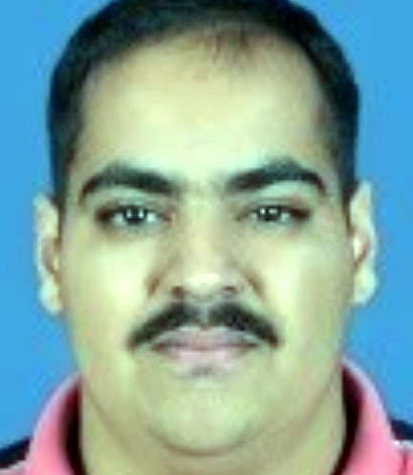
F-2 The Olive
Vidyanagar Lane-2 Margao, Goa
Contact No.: (+91) - 8830738447
Email ID: rao.anish63@gmail.com

Career Objective:
To utilize my skills to the best of my ability and make a difference to those around me and to improve the growth of the organisation.


Strengths include
- Appreciated communication skills
- Motivated & Enduring
- Enthusiastic and outgoing
- Adaptive team player
- Interpersonal skills

Qualifications:

EXAM | INSTITUTION | YEAR | CLASS |  | PERFORMANCE
MCA | Goa University | Appearing | TBA | Sem-1 | Sem-2 |  | Sem-3 | Sem-4 |  | CPI
 |  |  |  | TBA | TBA |  | TBA |  | TBA | TBA
BCA | Rosary College of  Commerce & Arts, Navelim | 2017 | First |  |  | CPI: 6.11
H.S.S.C.E | NIOS | 2013 | Second |  |  | 39.5%
S.S.C.E | M&N English High  School, Margao | 2011 | Second |  |  | 42.9%

Software Proficiency:

Languages | : C , Java (Basic), C++
Web/Mobile Technologies | : HTML5, CSS, JavaScript, PHP,
 |  | Android, React js, Node js
Database Technologies | : | MySQL, AWS
Development Methodology | : | Object-Oriented Development, MVC framework
IDEs & Tools | : | Eclipse, Android Studio, Matlab, GitHub, Intellij, Visual Studio, VS Code, Trello, Adobe XD
Academic Projects:

- 2019: Flappy Bird(ongoing)
Machine Learning Project using Python.

- 2019: Library Management System(ongoing)
Android Project.

- 2019: Canteen Management System (4th Sem MCA – Web Technology)
Website using React and Bootstrap.
- 2019: Canteen Billing System (4th Sem MCA – Software Engineering)
Billing software for canteen using electron java script app

- 2019: Guided Project: Profitable App Profiles for the App Store and Google Play Markets
Data Analysis project using python.

- 2018: Goa2Art (3rd Sem MCA – DBMS)
Website for Goan artist to sell their artworks using React, Node.js and MySQL

- 2018: Cricket Scorecard Game (3rd Sem MCA – Object Oriented Technology)
Cricket Scorecard game in C++ and Java.

- 2018: Polynomial (2nd Sem MCA – Data Structure)
Polynomial implemented in C.

- 2017: Tic Tac Toe Game (1st Sem MCA – Problem Solving)
Tic Tac Toe game implementation in C.

- 2017: School Management System (TYBSC)
School Management System implemented in HTML, CSS, PHP and MySQL.

Non-Academic Projects:
- Freelancing
- Digital Marketing.
- Bus Finder Android App (Going on).
- Canteen Management System (Going on)
Achievements:

- Certificate of merit securing 2nd Place in Gateways National Level Competition
- ACM Hackathon Final Stage.
Extra-Curricular Activities:

- Street Play for inter class event in Rosary College of Commerce & Arts, Navelim

Other Activities:

- Co-ordinated CoDS-COMAD, an International Conference at ICG on 11-13th January 2018.
- Organized State Level IT event Noesis in February 2017 at Rosary College Commerce & Arts, Navelim.

Hobbies & Interests:

Singing, Cooking, Acting & Travelling

Personal Information:

Date of Birth | : | 09th November 1994
Languages | : | English, Hindi, Marathi, Konkani
Religion | : | Hindu
Declaration:

I hereby declare that above information is true and correct to the best of my knowledge.

(Anish Haresh Rao)

