Heart disease prediction using SVM

Anish Singh Walia

11 march 2018

## Prediction of heart disease

### Aim of analysis

In the following document, I will be using SVM classification techinque to predict heart disease (angiographic disease status). From a set of 14 variables, the most important to predict heart failure are whether or not there is a reversable defect in Thalassemia followed by whether or not there is an occurrence of asymptomatic chest pain.

## Dataset:

The heart disease data are available at UCI The description of the database can be found [here](https://archive.ics.uci.edu/ml/machine-learning-databases/heart-disease/).

let’s read the dataset from the URL in R.

require(ggplot2)

## Loading required package: ggplot2

require(pROC) #to plot the ROC curves

## Loading required package: pROC

## Type 'citation("pROC")' for a citation.

##   
## Attaching package: 'pROC'

## The following objects are masked from 'package:stats':  
##   
## cov, smooth, var

heartdf <- read.csv("https://archive.ics.uci.edu/ml/machine-learning-databases/heart-disease/processed.cleveland.data",header=FALSE,sep=",",na.strings = '?')  
  
  
names(heartdf) <- c( "age", "sex", "cp", "trestbps", "chol","fbs", "restecg",  
 "thalach","exang", "oldpeak","slope", "ca", "thal", "num")  
  
attach(heartdf)

The variable we want to predict is num with Value 0: < 50% diameter narrowing and Value 1: > 50% diameter narrowing. We assume that every value with 0 means heart is okay, and 1,2,3,4 means heart disease.

From the possible values the variables can take, it is evident that the following need to be dummified because the distances in the values is random: cp,thal, restecg, slope

Let’s get a quick idea of data

head(heartdf,3)

## age sex cp trestbps chol fbs restecg thalach exang oldpeak slope ca thal  
## 1 63 1 1 145 233 1 2 150 0 2.3 3 0 6  
## 2 67 1 4 160 286 0 2 108 1 1.5 2 3 3  
## 3 67 1 4 120 229 0 2 129 1 2.6 2 2 7  
## num  
## 1 0  
## 2 2  
## 3 1

dim(heartdf)# dimensions of the dataset

## [1] 303 14

Let’s explore the data and find how many had heart attacks, women or men have of a particular age?

Let’s first convert the dependent(class variable) $Y−num$ to binary variable.

#converting the num variable to binary class variable   
  
heartdf$num<-ifelse(heartdf$num > 0,"Disease","noDisease")  
  
table(heartdf$num)

##   
## Disease noDisease   
## 139 164

#distribution of the target variable  
ggplot(heartdf,aes(x = num)) +  
 geom_bar(fill="black")

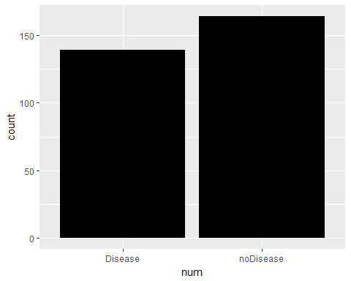

#converting to factor variable  
heartdf$sex<-ifelse(heartdf$sex==0,"female","male")  
  
table(heartdf$sex)

##   
## female male   
## 97 206

table(sex=heartdf$sex,disease=heartdf$num)

## disease  
## sex Disease noDisease  
## female 25 72  
## male 114 92

ggplot(heartdf,aes(x=sex)) +  
 geom_bar(fill="purple") +  
 facet_wrap(~num)

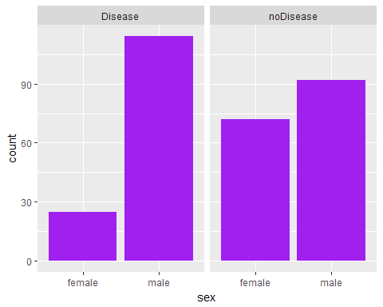

#heart disease and age  
#making a box plot to unserstand the statistical distribution  
  
by(heartdf$age,heartdf$num,summary)

## heartdf$num: Disease  
## Min. 1st Qu. Median Mean 3rd Qu. Max.   
## 35.00 52.00 58.00 56.63 62.00 77.00   
## --------------------------------------------------------   
## heartdf$num: noDisease  
## Min. 1st Qu. Median Mean 3rd Qu. Max.   
## 29.00 44.75 52.00 52.59 59.00 76.00

So people who had heart disease for them the mean age is 56.6

ggplot(heartdf,aes(x = num,y = age)) +  
 geom_boxplot()

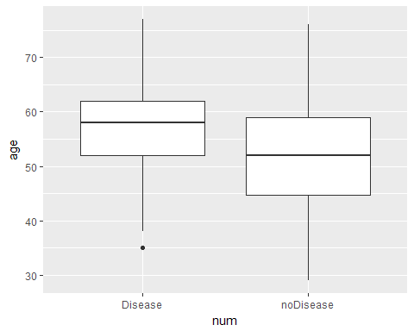

### Let’s do some correlation analysis between some variables-

cor.test(age,chol) #very low correlation

##   
## Pearson's product-moment correlation  
##   
## data: age and chol  
## t = 3.707, df = 301, p-value = 0.0002496  
## alternative hypothesis: true correlation is not equal to 0  
## 95 percent confidence interval:  
## 0.09859353 0.31423005  
## sample estimates:  
## cor   
## 0.2089503

We can see that age and cholestrol levlels have very low cor-relation.

#confusion matrix of chest pain and heart disease  
table(cp,num)

## num  
## cp 0 1 2 3 4  
## 1 16 5 1 0 1  
## 2 41 6 1 2 0  
## 3 68 9 4 4 1  
## 4 39 35 30 29 11

#confusuon matrix of exersice induced asthama and heart disease  
table(exang,num)

## num  
## exang 0 1 2 3 4  
## 0 141 30 14 12 7  
## 1 23 25 22 23 6

We can notice from the table that people who had heart diseases had severe level of chest pain. Also people who had heart diseases had exercise induced asthama.

Correlation between age and maximum heart rate achieved-

cor.test(age,thalach)

##   
## Pearson's product-moment correlation  
##   
## data: age and thalach  
## t = -7.4329, df = 301, p-value = 1.109e-12  
## alternative hypothesis: true correlation is not equal to 0  
## 95 percent confidence interval:  
## -0.4849644 -0.2941816  
## sample estimates:  
## cor   
## -0.3938058

ggplot(heartdf,aes(x = age,y = thalach )) +   
 geom_point() +   
 geom_smooth()

## `geom_smooth()` using method = 'loess' and formula 'y ~ x'

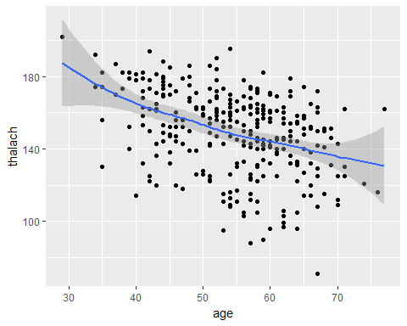

We can notice that as age increase maximum heart rate achived descreases, as the cor-relation is negetive.

## predictive Modelling

let’s now predict who is likely to have a hear disease and who is not?

Separating training and testing data

library(caret)

## Warning: package 'caret' was built under R version 3.4.3

## Loading required package: lattice

set.seed(20)  
  
  
inTrainRows <- createDataPartition(heartdf$num,p=0.7,list=FALSE)  
  
  
trainData <- heartdf[inTrainRows,]  
testData <- heartdf[-inTrainRows,]  
nrow(trainData)/(nrow(testData)+nrow(trainData)) #checking whether really 70% -> OK

## [1] 0.7029703

# Building a SVM classifier

Now SVM classifier tends to generate hyperplanes which separate the classes with maximum margins i.e in simpler terms it aims to generate maximum marginal hyperplane.

So amongst a set of competing hypothesis $h_{i}(x)$ we want to choose which maximizes the margin between both the classes on wither side of the separating hyperplane.

***So a linear SVM classifier will generate a simple linear hyperplane for linearlly separable data***.

# for this to work add names to all levels (numbers not allowed)  
feature.names=names(heartdf)  
  
for (f in feature.names) {  
 if (class(heartdf[[f]])=="factor") {  
 levels <- unique(c(heartdf[[f]]))  
 heartdf[[f]] <- factor(heartdf[[f]],  
 labels=make.names(levels))  
 }  
}  
  
#converting to factor variable with 2 levels  
heartdf$num<-as.factor(heartdf$num)  
levels(heartdf$num) <- c("Notdisease","Disease")  
  
table(heartdf$num)

##   
## Notdisease Disease   
## 139 164

set.seed(10)  
  
inTrainRows <- createDataPartition(heartdf$num,p=0.7,list=FALSE)  
trainData2 <- heartdf[inTrainRows,]  
testData2 <- heartdf[-inTrainRows,]  
  
  
#cross validation  
fitControl <- trainControl(method = "repeatedcv",  
 number = 10,  
 repeats = 10,  
 ## Estimate class probabilities  
 classProbs = TRUE,  
 ## Evaluate performance using  
 ## the following function  
 summaryFunction = twoClassSummary)  
  
  
  
  
svmModel <- train(num ~ ., data = na.omit(trainData2),  
 method = "svmRadial",  
 trControl = fitControl,  
 preProcess = c("center", "scale"),  
 tuneLength = 8,  
 metric = "ROC")  
  
svmModel

## Support Vector Machines with Radial Basis Function Kernel   
##   
## 209 samples  
## 13 predictor  
## 2 classes: 'Notdisease', 'Disease'   
##   
## Pre-processing: centered (13), scaled (13)   
## Resampling: Cross-Validated (10 fold, repeated 10 times)   
## Summary of sample sizes: 188, 189, 189, 187, 189, 188, ...   
## Resampling results across tuning parameters:  
##   
## C ROC Sens Spec   
## 0.25 0.8903140 0.7963333 0.8625758  
## 0.50 0.8907567 0.7860000 0.8634091  
## 1.00 0.8888721 0.7857778 0.8625000  
## 2.00 0.8912214 0.7941111 0.8680303  
## 4.00 0.8887837 0.7942222 0.8740152  
## 8.00 0.8792062 0.7970000 0.8594697  
## 16.00 0.8593729 0.7680000 0.8406818  
## 32.00 0.8329242 0.7380000 0.7964394  
##   
## Tuning parameter 'sigma' was held constant at a value of 0.05051126  
## ROC was used to select the optimal model using the largest value.  
## The final values used for the model were sigma = 0.05051126 and C = 2.

#prediction on test data-class labels  
svmPrediction <- predict(svmModel, testData2)  
  
#probability of no heart disease-finding probabilities value  
svmPredictionprob <- predict(svmModel, testData2, type='prob')[2]  
  
#generating a confusion matrix  
ConfMatrixPrediction <- confusionMatrix(svmPrediction, na.omit(testData2)$num)  
  
ConfMatrixPrediction$table

## Reference  
## Prediction Notdisease Disease  
## Notdisease 32 7  
## Disease 9 40

**In the confusion matrix the diagonals represent the correctly classified examples, whereas the offdiagonals are incorrectly classifier examples.**

### Let’s find the ROC curver and the AUC value to better understand the accuracy and performance-

ROC curve is the plot of True positive rate vs the true negetive rate.

#ROC and AUC value  
AUC<- roc(na.omit(testData2)$num,as.numeric(as.matrix((svmPredictionprob))))$auc  
  
Accuracy<- ConfMatrixPrediction$overall['Accuracy']   
  
svmPerformance<-cbind(AUC,Accuracy)  
  
svmPerformance

## AUC Accuracy  
## Accuracy 0.8993254 0.8181818

Hence we get an **AUC** value of 0.911 and overall **prediction** accuracy of 0.89