Experiment No. 1

Title
Demonstrate inline, internal, and external JavaScript; use console methods; create a webpage showing user information and a welcome message.
Software / Tools Required
- Google Chrome — Web browser used for execution and testing.
- Visual Studio Code (VS Code) — Code editor used for writing HTML, CSS
Theory
JavaScript can be integrated into an HTML document using three distinct methods, each suited to different development scenarios.
Inline JavaScript refers to code written directly within an HTML element using event attributes such as onclick, onload, or onmouseover. This method embeds JavaScript logic directly into the markup, making it quick to implement for small, isolated actions. However, it is generally discouraged for larger projects because it mixes structure (HTML) with behavior (JavaScript), reducing code readability and maintainability.
Internal JavaScript involves placing JavaScript code within a <script> tag inside the HTML document itself, typically within the <head> or <body> section. This approach keeps all code within a single file, which is convenient for small projects or quick testing, but it does not promote reusability across multiple pages.
External JavaScript involves writing JavaScript code in a separate .js file, which is then linked to the HTML document using the <script src="filename.js"></script> tag. This is considered the best practice for real-world web development, as it separates content (HTML) from behavior (JavaScript), allows the same script to be reused across multiple pages, improves caching and load performance, and makes the codebase easier to maintain and debug.
In addition to these integration methods, the JavaScript console object provides several methods that assist developers in testing, debugging, and monitoring code execution through the browser's Developer Tools:
- console.log() — Used to print general informational messages, variable values, or debugging output to the console. It is the most commonly used method for tracking program flow and verifying data.
- console.error() — Used to display error messages in the console, typically highlighted in red. It helps developers quickly identify and locate issues or exceptions within the code.
- console.table() — Used to display tabular data (such as arrays of objects) in a structured, readable table format within the console, making it easier to analyze complex data sets.
- console.trace() — Used to print a stack trace, showing the sequence of function calls that led to the point where console.trace() was invoked. This is particularly useful for debugging the flow of execution in nested or recursive functions.

CODE: -
Exp1.html :-

<!DOCTYPE html>
<html lang="en">
<head>
<meta charset="UTF-8">
<meta name="viewport" content="width=device-width, initial-scale=1.0">
<title>CSS - Three Methods Demo</title>

<!-- EXTERNAL CSS -->
<link rel="stylesheet" href="styles.css">

<!-- INTERNAL CSS -->
<style>
/* Remove default margins and padding from all elements */
* {
margin: 0;
padding: 0;
box-sizing: border-box;
}

/* Style for the entire page background and layout */
body {
font-family: 'Arial', sans-serif;
/* Set background color to light blue */
background-color: #667eea;
/* Set minimum height to full viewport height */
min-height: 100vh;
/* Add space inside the body (padding) */
padding: 30px;
}

/* Style for the container that holds all boxes */
.container {
/* Maximum width of 800px to keep content centered */
max-width: 800px;
/* Center the container with margin */
margin: 0 auto;
}

/* Style for the main heading */
h1 {
/* Center align the text */
text-align: center;
/* Change text color to white */
color: white;
/* Add space below the heading */
margin-bottom: 40px;
/* Make text larger */
font-size: 2.5em;
}

/* Style for each colored box */
.box {
/* Set background color to white */
background-color: white;
/* Round the corners of the box */
border-radius: 15px;
/* Add space inside the box */
padding: 30px;
/* Add space below each box */
margin-bottom: 30px;
/* Add a shadow effect around the box */
box-shadow: 0 8px 20px rgba(0,0,0,0.2);
/* Smooth animation for any changes (0.3 seconds) */
transition: transform 0.3s ease;
}

/* Make box move up slightly when you hover over it */
.box:hover {
/* Move box up by 5 pixels when hovering */
transform: translateY(-5px);
}

/* Style for headings inside boxes */
.box h2 {
/* Add space below the heading */
margin-bottom: 15px;
/* Make heading text larger */
font-size: 1.8em;
}

/* Style for paragraphs inside boxes */
.box p {
/* Set space between lines of text */
line-height: 1.6;
/* Add space below paragraph */
margin-bottom: 20px;
/* Set text size */
font-size: 1em;
}

/* Style for buttons inside boxes */
.box button {
/* Add space inside button (padding) */
padding: 12px 30px;
/* Set button text size */
font-size: 1em;
/* Remove button border */
border: none;
/* Round button corners */
border-radius: 8px;
/* Change cursor to pointer when hovering */
cursor: pointer;
/* Make text bold */
font-weight: bold;
/* Smooth animation when button changes (0.3 seconds) */
transition: all 0.3s ease;
}

/* Make button grow slightly when you hover over it */
.box button:hover {
/* Make button 5% larger when hovering */
transform: scale(1.05);
}

/* Style for Inline CSS Box - Red theme */
.inline-box {
/* Add red line on the left side */
border-left: 5px solid #FF6B6B;
}

/* Style for heading in Inline CSS Box */
.inline-box h2 {
/* Set heading color to red */
color: #FF6B6B;
}

/* Style for Internal CSS Box - Green theme */
.internal-box {
/* Add green line on the left side */
border-left: 5px solid #4ECDC4;
}

/* Style for heading in Internal CSS Box */
.internal-box h2 {
/* Set heading color to green */
color: #4ECDC4;
}
</style>
</head>
<body>
<div class="container">
<h1> CSS - Three Methods Demo</h1>

<!-- BOX 1: INLINE CSS -->
<div class="box inline-box" style="background-color: #FFE5E5; border: 2px solid #FF6B6B;">
<h2 style="color: #FF6B6B; font-size: 2em;">1️⃣ Inline CSS</h2>
<p style="color: #333; font-size: 16px; line-height: 1.8;">
<strong style="color: #FF6B6B; font-size: 24px;">Hello World from Anish Singh Prn:-24070521214</strong>
</p>
<button style="background-color: #FF6B6B; color: white;" onclick="inlineButtonClick()">
Click Me!
</button>
</div>

<!-- BOX 2: INTERNAL CSS -->
<div class="box internal-box" style="background-color: #E5F9F7;">
<h2>2️⃣ Internal CSS</h2>
<p style="color: #333; font-size: 16px; line-height: 1.8;">
<strong style="color: #4ECDC4; font-size: 24px;">Hello World from Anish Singh Prn:-24070521214</strong>
</p>
<button style="background-color: #4ECDC4; color: white;" onclick="internalButtonClick()">
Click Me!
</button>
</div>

<!-- BOX 3: EXTERNAL CSS -->
<div class="box external-box">
<h2>3️⃣ External CSS</h2>
<p style="color: #333; font-size: 16px; line-height: 1.8;">
<strong style="color: #FFD93D; font-size: 24px;">Hello World from Anish Singh Prn:-24070521214</strong>
</p>
<button onclick="externalButtonClick()">
Click Me!
</button>
</div>
</div>

<!-- JavaScript for Buttons -->
<script>
function inlineButtonClick() {
alert('✅ Inline CSS Button Clicked!\n\nInline styles are applied directly in HTML tags.');
}

function internalButtonClick() {
alert('✅ Internal CSS Button Clicked!\n\nInternal styles are in the <style> tag within HTML.');
}

function externalButtonClick() {
alert('✅ External CSS Button Clicked!\n\nExternal styles are in a separate .css file!');
}
</script>
</body>
</html>

Style.css

/* External CSS file */

.external-box {
border-left: 4px solid #4a90e2;
background-color: #f5faff;
}

.external-box h2 {
color: #4a90e2;
}

.external-box button {
background-color: #4a90e2;
color: white;
}

.external-box button:hover {
background-color: #357abd;
}

Output
The webpage was executed for each of the three CSS methods. The Name, PRN, and file path are visible in the browser address bar for each case, as shown below.
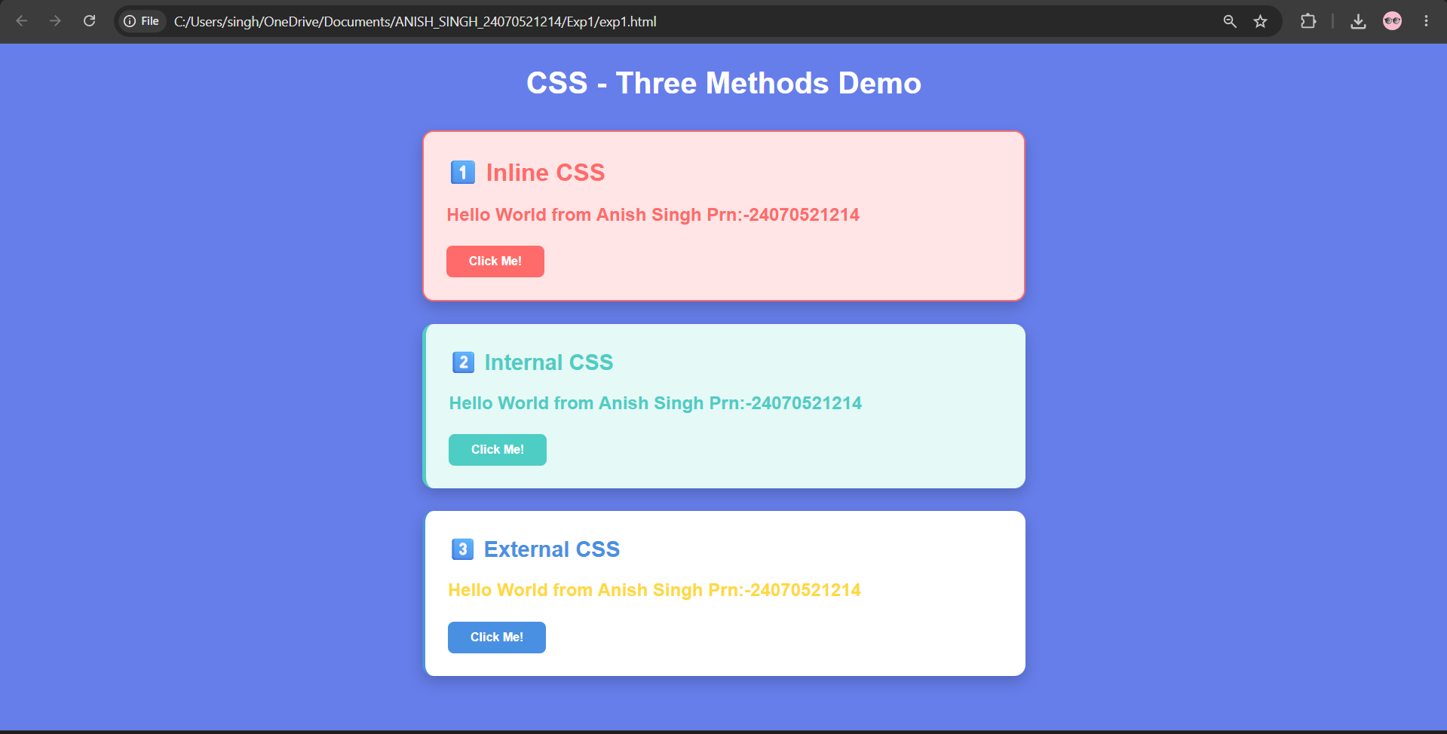
Result / Conclusion
The experiment was successfully performed by implementing JavaScript through three different integration methods. Console functions were verified using browser developer tools, and the required environment information was displayed on the webpage.

Case Study No.: 1

Case Study Title
Create a Webpage for College Department and Link the Student Information Page with It and Write a JavaScript Program to Display "Welcome to SIT Nagpur" in an Alert Box.

- Case Study Program Code
Case_study_1.html
<!DOCTYPE html>
<html lang="en">
<head>
<meta charset="UTF-8">
<meta name="viewport" content="width=device-width, initial-scale=1.0">
<title>SIT Nagpur - Department Page</title>
<style>
* {
margin: 0;
padding: 0;
box-sizing: border-box;
}

body {
font-family: Arial, sans-serif;
background: linear-gradient(135deg, #667eea 0%, #764ba2 100%);
color: #333;
line-height: 1.6;
min-height: 100vh;
}

.navbar {
background: rgba(0, 0, 0, 0.8);
padding: 15px 0;
text-align: center;
box-shadow: 0 2px 5px rgba(0, 0, 0, 0.2);
}

.navbar a {
color: white;
text-decoration: none;
margin: 0 20px;
font-weight: bold;
transition: color 0.3s;
}

.navbar a:hover {
color: #667eea;
}

.container {
max-width: 900px;
margin: 30px auto;
background: white;
padding: 40px;
border-radius: 10px;
box-shadow: 0 8px 20px rgba(0, 0, 0, 0.3);
}

.header {
text-align: center;
margin-bottom: 30px;
border-bottom: 3px solid #667eea;
padding-bottom: 20px;
}

.header h1 {
color: #667eea;
font-size: 2.5em;
margin-bottom: 10px;
}

.header p {
color: #666;
font-size: 1.1em;
}

.section {
margin-bottom: 30px;
}

.section h2 {
color: #667eea;
font-size: 1.8em;
margin-bottom: 15px;
border-left: 4px solid #667eea;
padding-left: 15px;
}

.content {
background: #f9f9f9;
padding: 15px;
border-radius: 6px;
margin-bottom: 15px;
line-height: 1.8;
}

.student-info-box {
background: #f0f5ff;
border-left: 4px solid #2e8b57;
padding: 15px;
border-radius: 6px;
margin: 15px 0;
}

.student-info-box p {
margin: 8px 0;
font-weight: 500;
}

.button-group {
text-align: center;
margin: 25px 0;
}

.btn {
background: #667eea;
color: white;
padding: 12px 30px;
margin: 8px;
border: none;
border-radius: 6px;
cursor: pointer;
font-size: 1em;
font-weight: bold;
transition: background 0.3s;
text-decoration: none;
display: inline-block;
}

.btn:hover {
background: #764ba2;
transform: translateY(-2px);
box-shadow: 0 4px 12px rgba(0, 0, 0, 0.2);
}

.btn-secondary {
background: #2e8b57;
}

.btn-secondary:hover {
background: #1f5a3a;
}

.footer {
text-align: center;
margin-top: 40px;
padding-top: 20px;
border-top: 1px solid #ddd;
color: #666;
font-size: 0.9em;
}

ul {
margin-left: 20px;
margin-bottom: 15px;
}

li {
margin-bottom: 8px;
}
</style>
</head>
<body>
<!-- Navigation -->
<div class="navbar">
<a href="case_study_1.html">Home</a>
<a href="student_info.html">Student Info</a>
<a href="#contact">Contact</a>
</div>

<!-- Main Container -->
<div class="container">
<!-- Header -->
<div class="header">
<h1>🎓 Symbiosis Institute of Technology, Nagpur</h1>
<p>Excellence in Engineering Education</p>
</div>

<!-- About Section -->
<div class="section">
<h2>About Our College</h2>
<div class="content">
<p>Symbiosis Institute of Technology (SIT), Nagpur is a premier educational institution dedicated to providing quality engineering education. We focus on developing skilled professionals who can contribute to technological advancement and innovation.</p>
<ul>
<li>Founded with a mission to excel in technical education</li>
<li>State-of-the-art infrastructure and facilities</li>
<li>Experienced faculty members with industry expertise</li>
<li>Strong industry partnerships and placements</li>
</ul>
</div>
</div>

<!-- Departments Section -->
<div class="section">
<h2>Our Departments</h2>
<div class="content">
<ul>
<li><strong>Computer Science and Engineering</strong> - Latest technologies and programming</li>
<li><strong>Electrical Engineering</strong> - Power systems and automation</li>
<li><strong>Mechanical Engineering</strong> - Design and manufacturing</li>
<li><strong>Civil Engineering</strong> - Infrastructure and construction</li>
</ul>
</div>
</div>

<!-- Student Information -->
<div class="section">
<h2>Student Details</h2>
<div class="student-info-box">
<p><strong>Name:</strong> Anish Singh</p>
<p><strong>PRN:</strong> 24070521214</p>
<p><strong>Department:</strong> Computer Science and Engineering</p>
<p><strong>Year:</strong> 2nd Year</p>
</div>
</div>

<!-- Actions -->
<div class="button-group">
<button class="btn" onclick="displayWelcome()">Click for Welcome Message</button>
<a href="student_info.html" class="btn btn-secondary">View Full Student Information</a>
</div>

<!-- Footer -->
<div class="footer">
<p>Created by: Anish Singh | PRN: 24070521214</p>
<p>File: case_study_1.html | Location: CaseStudy Folder</p>
</div>
</div>

<!-- JavaScript -->
<script>
// Display welcome alert on page load
window.onload = function() {
alert('Welcome to SIT Nagpur');
};

// Function to display welcome message on button click
function displayWelcome() {
alert('Welcome to SIT Nagpur\n\nDepartment of Computer Science and Engineering\n\nStudent: Anish Singh\nPRN: 24070521214');
}
</script>
</body>
</html>

Student_info.html code

<!DOCTYPE html>
<html lang="en">
<head>
<meta charset="UTF-8">
<meta name="viewport" content="width=device-width, initial-scale=1.0">
<title>Student Information - SIT Nagpur</title>
<style>
* {
margin: 0;
padding: 0;
box-sizing: border-box;
}

body {
font-family: Arial, sans-serif;
background: linear-gradient(135deg, #667eea 0%, #764ba2 100%);
color: #333;
line-height: 1.6;
min-height: 100vh;
}

.navbar {
background: rgba(0, 0, 0, 0.8);
padding: 15px 0;
text-align: center;
box-shadow: 0 2px 5px rgba(0, 0, 0, 0.2);
}

.navbar a {
color: white;
text-decoration: none;
margin: 0 20px;
font-weight: bold;
transition: color 0.3s;
}

.navbar a:hover {
color: #667eea;
}

.container {
max-width: 800px;
margin: 30px auto;
background: white;
padding: 40px;
border-radius: 10px;
box-shadow: 0 8px 20px rgba(0, 0, 0, 0.3);
}

.header {
text-align: center;
margin-bottom: 30px;
border-bottom: 3px solid #667eea;
padding-bottom: 20px;
}

.header h1 {
color: #667eea;
font-size: 2em;
margin-bottom: 10px;
}

.section {
margin-bottom: 25px;
}

.section h2 {
color: #667eea;
font-size: 1.5em;
margin-bottom: 15px;
border-left: 4px solid #667eea;
padding-left: 15px;
}

.info-box {
background: #f0f5ff;
border-left: 4px solid #2e8b57;
padding: 20px;
border-radius: 6px;
margin-bottom: 15px;
}

.info-row {
display: flex;
justify-content: space-between;
padding: 10px 0;
border-bottom: 1px solid #e0e0e0;
}

.info-row:last-child {
border-bottom: none;
}

.info-label {
font-weight: bold;
color: #667eea;
min-width: 150px;
}

.info-value {
color: #333;
}

.btn {
background: #667eea;
color: white;
padding: 12px 30px;
border: none;
border-radius: 6px;
cursor: pointer;
font-size: 1em;
font-weight: bold;
transition: background 0.3s;
text-decoration: none;
display: inline-block;
margin-top: 15px;
}

.btn:hover {
background: #764ba2;
}

.footer {
text-align: center;
margin-top: 40px;
padding-top: 20px;
border-top: 1px solid #ddd;
color: #666;
font-size: 0.9em;
}

ul {
margin-left: 20px;
margin-bottom: 15px;
}

li {
margin-bottom: 8px;
}
</style>
</head>
<body>
<!-- Navigation -->
<div class="navbar">
<a href="case_study_1.html">Home</a>
<a href="student_info.html">Student Info</a>
<a href="#contact">Contact</a>
</div>

<!-- Main Container -->
<div class="container">
<!-- Header -->
<div class="header">
<h1>📋 Student Information</h1>
<p>Symbiosis Institute of Technology, Nagpur</p>
</div>

<!-- Personal Information -->
<div class="section">
<h2>Personal Information</h2>
<div class="info-box">
<div class="info-row">
<span class="info-label">Name:</span>
<span class="info-value">Anish Singh</span>
</div>
<div class="info-row">
<span class="info-label">PRN:</span>
<span class="info-value">24070521214</span>
</div>
<div class="info-row">
<span class="info-label">Email:</span>
<span class="info-value">anish.singh@sitnagpur.edu</span>
</div>
<div class="info-row">
<span class="info-label">Phone:</span>
<span class="info-value">+91-9876543210</span>
</div>
</div>
</div>

<!-- Academic Information -->
<div class="section">
<h2>Academic Information</h2>
<div class="info-box">
<div class="info-row">
<span class="info-label">Department:</span>
<span class="info-value">Computer Science and Engineering</span>
</div>
<div class="info-row">
<span class="info-label">Year:</span>
<span class="info-value">3rd Year</span>
</div>
<div class="info-row">
<span class="info-label">Semester:</span>
<span class="info-value">5th Semester</span>
</div>
<div class="info-row">
<span class="info-label">CGPA:</span>
<span class="info-value">8.5/10</span>
</div>
</div>
</div>

<!-- Courses -->
<div class="section">
<h2>Current Courses</h2>
<div class="info-box">
<ul>
<li>Data Structures and Algorithms</li>
<li>Database Management Systems</li>
<li>Web Development (HTML, CSS, JavaScript)</li>
<li>Operating Systems</li>
<li>Software Engineering</li>
</ul>
</div>
</div>

<!-- Actions -->
<button class="btn" onclick="alert('Welcome to SIT Nagpur\n\nStudent: Anish Singh\nPRN: 24070521214')">Show Welcome Message</button>
<a href="case_study_1.html" class="btn" style="background: #2e8b57; margin-left: 10px;">Back to Home</a>

<!-- Footer -->
<div class="footer">
<p>Created by: Anish Singh | PRN: 24070521214</p>
<p>File: student_info.html | Location: CaseStudy Folder</p>
</div>
</div>

<!-- JavaScript for Additional Functionality -->
<script>
// Display welcome message when page loads
window.onload = function() {
console.log('Student Information Page Loaded');
};
</script>
</body>
</html>

7. Output

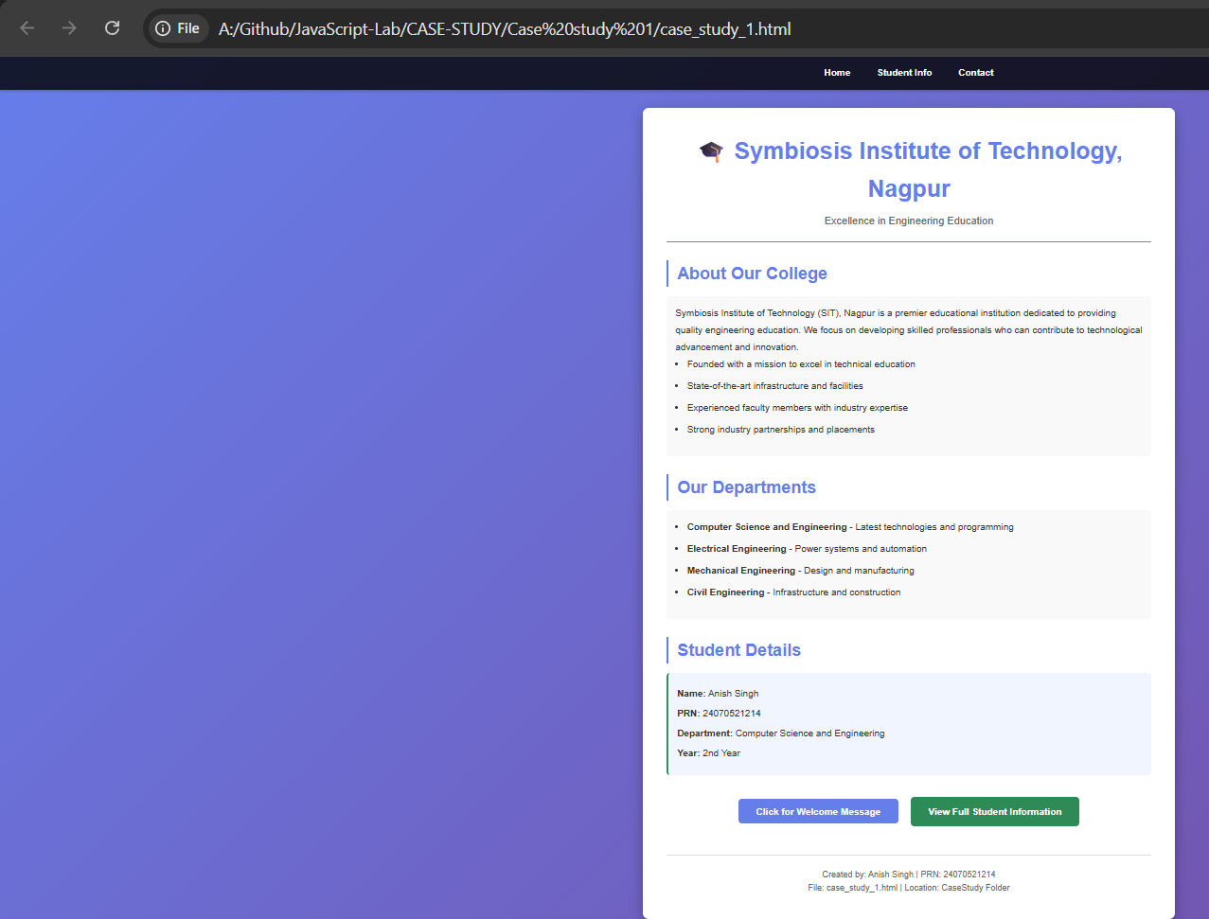

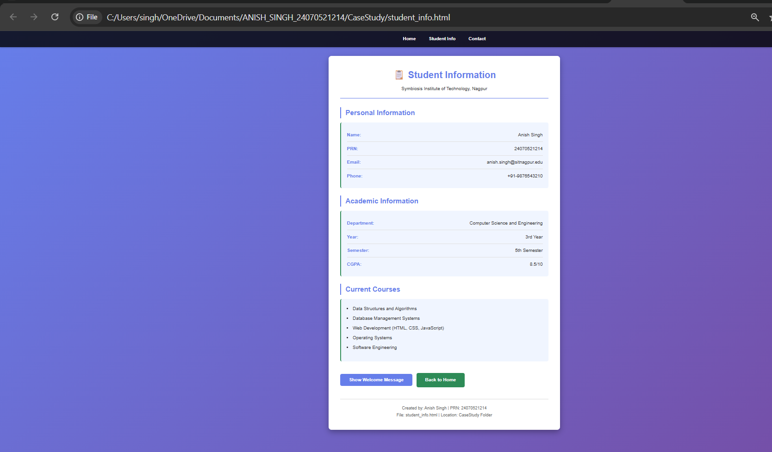

8. Result / Conclusion
The case study was successfully implemented by creating a college department webpage and linking it to a student information page. JavaScript was used to display the welcome message "Welcome to SIT Nagpur" in an alert box. The webpages were designed using HTML and CSS, while JavaScript provided the required interactivity. The objectives of the case study were successfully achieved.

Experiment No: 2

Title: Use var, let, const, and demonstrate basic features like template literals and destructuring; build a billing calculator with user input.

Software/Tools Required: Visual Studio Code (or any text editor), Web Browser (Google Chrome, Microsoft Edge, Firefox, etc.)

Theory:
JavaScript provides three keywords to declare variables: var, let, and const.
1. var
- var is function-scoped.
- Variables declared with var can be redeclared and updated.
- It is hoisted and initialized with undefined.
- Generally avoided in modern JavaScript because it may cause unexpected behavior.
2. let
- let is block-scoped.
- Variables can be updated but cannot be redeclared within the same scope.
- Preferred for variables whose values change.
3. const
- const is also block-scoped.
- Variables cannot be reassigned after initialization.
- Used for fixed values..
Billing Calculator
A billing calculator is a JavaScript application that accepts user input such as customer name, product name, quantity, and price. It calculates the subtotal, applies any discount or GST if required, and displays the final payable amount using template literals and modern JavaScript features like let, const, and destructuring.

CODE:-
EXP2.HTML

<!DOCTYPE html>
<html lang="en">
<head>
<meta charset="UTF-8">
<meta name="viewport" content="width=device-width, initial-scale=1.0">
<title>Billing Calculator - ES6 JavaScript Demo</title>
<!-- Link to external stylesheet -->
<link rel="stylesheet" href="styles.css">
</head>
<body>

<div class="container">
<h2>Billing Calculator</h2>
<p class="info-text">Demonstrates basic ES6 features: const, var, let, destructuring, and template literals.</p>

<!-- Button to trigger the calculation -->
<button class="btn-calc" onclick="generateBill()">Generate New Bill</button>

<!-- Card placeholder for displaying the generated bill -->
<div id="billCard" class="bill-card">
<!-- Output will be injected here using Template Literals -->
</div>

<footer>
<p>Developed by <strong>Anish Singh</strong></p>
<p>PRN: 24070521214</p>
</footer>
</div>

<!-- JavaScript logic -->
<script>
function generateBill() {
// 1. Demonstrate const (immutable block-scoped variable)
const GST = 0.18;

// 2. Demonstrate var (function-scoped / globally declared prompt values)
var coustomername = prompt("Enter customer name:");
if (!coustomername) return; // Exit if cancelled or empty

var productname = prompt("Enter product name:");
if (!productname) return;

var quantityInput = prompt("Enter quantity:");
if (quantityInput === null) return;
var quantity = Number(quantityInput);

var priceInput = prompt("Enter price per unit:");
if (priceInput === null) return;
var price = Number(priceInput);

// Validate number inputs
if (isNaN(quantity) || quantity <= 0 || isNaN(price) || price <= 0) {
alert("Please enter valid positive numbers for quantity and price.");
return;
}

// 3. Demonstrate let (mutable block-scoped variable)
let total = quantity * price;
let getAmount = total * GST;
let finalAmount = getAmount + total;

// 4. Creating the bill object
const bill = {
coustomer: coustomername, // Spelled as 'coustomer' to match original snippet
product: productname,
quantity,
price,
total,
getAmount,
finalbill: finalAmount
};

// 5. Demonstrate Object Destructuring (with alias and default value fallback)
const {
coustomer,
product,
getAmount: gstAmount = total * GST,
finalbill
} = bill;

// Get hold of output container
const billCard = document.getElementById("billCard");
billCard.style.display = "block";

// 6. Demonstrate Template Literals
billCard.innerHTML = `
<h3>Your Bill</h3>
<div class="bill-row">
<span>Customer Name:</span>
<strong>${coustomer}</strong>
</div>
<div class="bill-row">
<span>Product Name:</span>
<strong>${product}</strong>
</div>
<div class="bill-row">
<span>Quantity:</span>
<strong>${quantity}</strong>
</div>
<div class="bill-row">
<span>Price per Unit:</span>
<strong>${price.toFixed(2)}</strong>
</div>
<div class="bill-row">
<span>Total Amount:</span>
<strong>${total.toFixed(2)}</strong>
</div>
<div class="bill-row">
<span>GST (18%):</span>
<strong>${gstAmount.toFixed(2)}</strong>
</div>
<div class="bill-row total-row">
<span>Final Amount:</span>
<span>${finalbill.toFixed(2)}</span>
</div>
`;
}
</script>
</body>
</html>

STYLE.CSS

/* Global styles for Exp 2 */
* {
margin: 0;
padding: 0;
box-sizing: border-box;
}

body {
font-family: 'Segoe UI', Tahoma, Geneva, Verdana, sans-serif;
background-color: #f0f2f5;
color: #333;
padding: 40px 20px;
display: flex;
justify-content: center;
align-items: center;
min-height: 100vh;
}

.container {
background-color: white;
padding: 30px;
border-radius: 12px;
box-shadow: 0 4px 15px rgba(0, 0, 0, 0.1);
max-width: 500px;
width: 100%;
text-align: center;
}

h2 {
color: #2c3e50;
margin-bottom: 10px;
}

.info-text {
font-size: 0.9em;
color: #7f8c8d;
margin-bottom: 25px;
}

.btn-calc {
background-color: #3498db;
color: white;
border: none;
padding: 12px 25px;
font-size: 1em;
font-weight: 600;
border-radius: 6px;
cursor: pointer;
transition: background-color 0.2s ease, transform 0.1s ease;
width: 100%;
margin-bottom: 20px;
}

.btn-calc:hover {
background-color: #2980b9;
}

.btn-calc:active {
transform: scale(0.98);
}

.bill-card {
background-color: #fdfefe;
border: 2px dashed #bdc3c7;
border-radius: 8px;
padding: 20px;
margin-top: 20px;
text-align: left;
display: none; /* Hidden until generated */
}

.bill-card h3 {
text-align: center;
color: #2c3e50;
margin-bottom: 15px;
border-bottom: 2px solid #ecf0f1;
padding-bottom: 8px;
}

.bill-row {
display: flex;
justify-content: space-between;
margin-bottom: 10px;
font-size: 0.95em;
}

.bill-row.total-row {
border-top: 2px solid #ecf0f1;
padding-top: 10px;
font-weight: bold;
font-size: 1.1em;
color: #27ae60;
}

footer {
margin-top: 30px;
font-size: 0.85em;
color: #95a5a6;
border-top: 1px solid #ecf0f1;
padding-top: 15px;
}
Output:
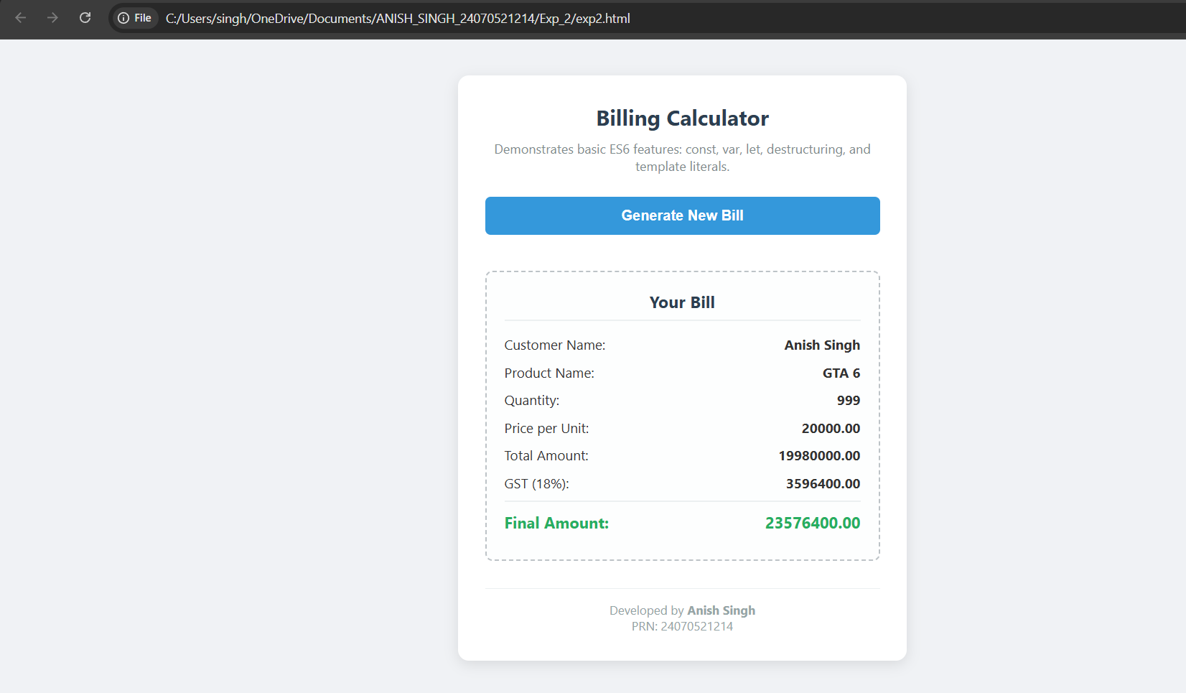

Result/Conclusion:
The experiment was successfully completed. The concepts of var, let, and const were understood and implemented. Template literals were used to display formatted output, and destructuring simplified data extraction from objects. A billing calculator was successfully developed to accept user input, calculate the bill with GST, and display the final amount accurately.

Case Study No.: 2
Case Study Title
Develop the webpage for an online shopping website with using HTML CSS and HTML5 tags and calculate the bill.

1.Case Study Program Code
BILL.html
<!DOCTYPE html>
<html lang="en">
<head>
<meta charset="UTF-8">
<meta name="viewport" content="width=device-width, initial-scale=1.0">
<title>Online Shopping Website</title>
<style>
* {
margin: 0;
padding: 0;
box-sizing: border-box;
}

body {
font-family: Arial, sans-serif;
background-color: #f4f4f4;
padding: 20px;
}

.container {
max-width: 800px;
margin: 0 auto;
background-color: white;
padding: 30px;
border-radius: 8px;
box-shadow: 0 0 10px rgba(0, 0, 0, 0.1);
}

h1 {
text-align: center;
color: #333;
margin-bottom: 30px;
}

.form-section {
margin-bottom: 25px;
}

.form-section h2 {
font-size: 18px;
color: #555;
margin-bottom: 15px;
border-bottom: 2px solid #007bff;
padding-bottom: 10px;
}

.form-group {
margin-bottom: 15px;
display: flex;
gap: 20px;
flex-wrap: wrap;
}

.form-group-item {
flex: 1;
min-width: 250px;
}

label {
display: block;
margin-bottom: 5px;
color: #333;
font-weight: bold;
font-size: 14px;
}

input[type="text"],
input[type="number"],
input[type="tel"],
select {
width: 100%;
padding: 10px;
border: 1px solid #ddd;
border-radius: 4px;
font-size: 14px;
font-family: Arial, sans-serif;
}

input[type="text"]:focus,
input[type="number"]:focus,
input[type="tel"]:focus,
select:focus {
outline: none;
border-color: #007bff;
box-shadow: 0 0 5px rgba(0, 123, 255, 0.5);
}

.checkbox-group {
display: flex;
gap: 20px;
margin-top: 10px;
}

.checkbox-item {
display: flex;
align-items: center;
gap: 8px;
}

input[type="checkbox"],
input[type="radio"] {
cursor: pointer;
width: 18px;
height: 18px;
}

.checkbox-item label {
margin-bottom: 0;
font-weight: normal;
font-size: 14px;
}

.bill-section {
background-color: #f9f9f9;
padding: 20px;
border-radius: 8px;
margin-top: 30px;
border: 2px solid #e0e0e0;
}

.bill-row {
display: flex;
justify-content: space-between;
margin-bottom: 10px;
font-size: 15px;
}

.bill-row.total {
font-weight: bold;
border-top: 2px solid #333;
padding-top: 10px;
font-size: 18px;
color: #007bff;
}

.bill-label {
color: #555;
}

.bill-value {
color: #333;
font-weight: 500;
}

.button-group {
display: flex;
gap: 10px;
justify-content: center;
margin-top: 25px;
}

button {
padding: 12px 30px;
font-size: 16px;
border: none;
border-radius: 4px;
cursor: pointer;
font-weight: bold;
transition: background-color 0.3s;
}

.btn-calculate {
background-color: #007bff;
color: white;
}

.btn-calculate:hover {
background-color: #0056b3;
}

.btn-reset {
background-color: #6c757d;
color: white;
}

.btn-reset:hover {
background-color: #5a6268;
}
</style>
</head>
<body>
<div class="container">
<h1>Online Shopping Invoice</h1>

<form id="shoppingForm">
<!-- Customer Information Section -->
<div class="form-section">
<h2>Customer Information</h2>
<div class="form-group">
<div class="form-group-item">
<label for="customerName">Customer Name</label>
<input type="text" id="customerName" name="customerName" required>
</div>
<div class="form-group-item">
<label for="mobileNumber">Mobile Number</label>
<input type="tel" id="mobileNumber" name="mobileNumber" required>
</div>
</div>
<div class="form-group">
<div class="form-group-item">
<label for="invoiceNumber">Invoice Number</label>
<input type="text" id="invoiceNumber" name="invoiceNumber" required>
</div>
</div>
</div>

<!-- Product Information Section -->
<div class="form-section">
<h2>Product Information</h2>
<div class="form-group">
<div class="form-group-item">
<label for="productName">Product Name</label>
<input type="text" id="productName" name="productName" required>
</div>
</div>
<div class="form-group">
<div class="form-group-item">
<label for="quantity">Quantity (in Kg)</label>
<input type="number" id="quantity" name="quantity" step="0.01" required>
</div>
<div class="form-group-item">
<label for="ratePerKg">Rate per Kg (₹)</label>
<input type="number" id="ratePerKg" name="ratePerKg" step="0.01" required>
</div>
</div>
</div>

<!-- Charges and Discounts Section -->
<div class="form-section">
<h2>Charges & Discounts</h2>
<div class="form-group">
<div class="form-group-item">
<label for="discount">Discount (%)</label>
<input type="number" id="discount" name="discount" step="0.01" value="0" required>
</div>
<div class="form-group-item">
<label for="gst">GST (%)</label>
<input type="number" id="gst" name="gst" step="0.01" value="18" required>
</div>
</div>
<div class="form-group">
<div class="form-group-item">
<label for="packingCharges">Packing Charges (₹)</label>
<input type="number" id="packingCharges" name="packingCharges" step="0.01" value="0" required>
</div>
</div>
</div>

<!-- Payment and Membership Section -->
<div class="form-section">
<h2>Payment & Membership</h2>
<div>
<label style="font-weight: bold; margin-bottom: 10px; display: block;">Payment Mode</label>
<div class="checkbox-group">
<div class="checkbox-item">
<input type="radio" id="cash" name="paymentMode" value="Cash" required>
<label for="cash">Cash</label>
</div>
<div class="checkbox-item">
<input type="radio" id="card" name="paymentMode" value="Card">
<label for="card">Card</label>
</div>
<div class="checkbox-item">
<input type="radio" id="upi" name="paymentMode" value="UPI">
<label for="upi">UPI</label>
</div>
</div>
</div>
<div style="margin-top: 15px;">
<div class="checkbox-item">
<input type="checkbox" id="membership" name="membership">
<label for="membership">Membership (Yes/No)</label>
</div>
</div>
</div>

<!-- Bill Section -->
<div class="bill-section">
<h2 style="margin-bottom: 15px; border: none;">Bill Summary</h2>
<div class="bill-row">
<span class="bill-label">Product Cost (Qty × Rate):</span>
<span class="bill-value">₹ <span id="productCost">0.00</span></span>
</div>
<div class="bill-row">
<span class="bill-label">Discount (<span id="discountPercent">0</span>%):</span>
<span class="bill-value">- ₹ <span id="discountAmount">0.00</span></span>
</div>
<div class="bill-row">
<span class="bill-label">Subtotal:</span>
<span class="bill-value">₹ <span id="subtotal">0.00</span></span>
</div>
<div class="bill-row">
<span class="bill-label">GST (<span id="gstPercent">18</span>%):</span>
<span class="bill-value">+ ₹ <span id="gstAmount">0.00</span></span>
</div>
<div class="bill-row">
<span class="bill-label">Packing Charges:</span>
<span class="bill-value">+ ₹ <span id="packingAmount">0.00</span></span>
</div>
<div class="bill-row total">
<span class="bill-label">Total Bill Amount:</span>
<span class="bill-value">₹ <span id="totalBill">0.00</span></span>
</div>
</div>

<!-- Buttons -->
<div class="button-group">
<button type="button" class="btn-calculate" onclick="calculateBill()">Calculate Bill</button>
<button type="reset" class="btn-reset">Clear Form</button>
</div>
</form>
</div>

<script>
function calculateBill() {
// Get input values
const quantity = parseFloat(document.getElementById('quantity').value) || 0;
const ratePerKg = parseFloat(document.getElementById('ratePerKg').value) || 0;
const discountPercent = parseFloat(document.getElementById('discount').value) || 0;
const gstPercent = parseFloat(document.getElementById('gst').value) || 0;
const packingCharges = parseFloat(document.getElementById('packingCharges').value) || 0;

// Calculate product cost
const productCost = quantity * ratePerKg;

// Calculate discount
const discountAmount = (productCost * discountPercent) / 100;

// Calculate subtotal
const subtotal = productCost - discountAmount;

// Calculate GST
const gstAmount = (subtotal * gstPercent) / 100;

// Calculate total bill
const totalBill = subtotal + gstAmount + packingCharges;

// Display results
document.getElementById('productCost').textContent = productCost.toFixed(2);
document.getElementById('discountPercent').textContent = discountPercent.toFixed(2);
document.getElementById('discountAmount').textContent = discountAmount.toFixed(2);
document.getElementById('subtotal').textContent = subtotal.toFixed(2);
document.getElementById('gstPercent').textContent = gstPercent.toFixed(2);
document.getElementById('gstAmount').textContent = gstAmount.toFixed(2);
document.getElementById('packingAmount').textContent = packingCharges.toFixed(2);
document.getElementById('totalBill').textContent = totalBill.toFixed(2);
}

// Auto-calculate when values change
['quantity', 'ratePerKg', 'discount', 'gst', 'packingCharges'].forEach(id => {
document.getElementById(id).addEventListener('input', calculateBill);
});
</script>
</body>
</html>

7. Output

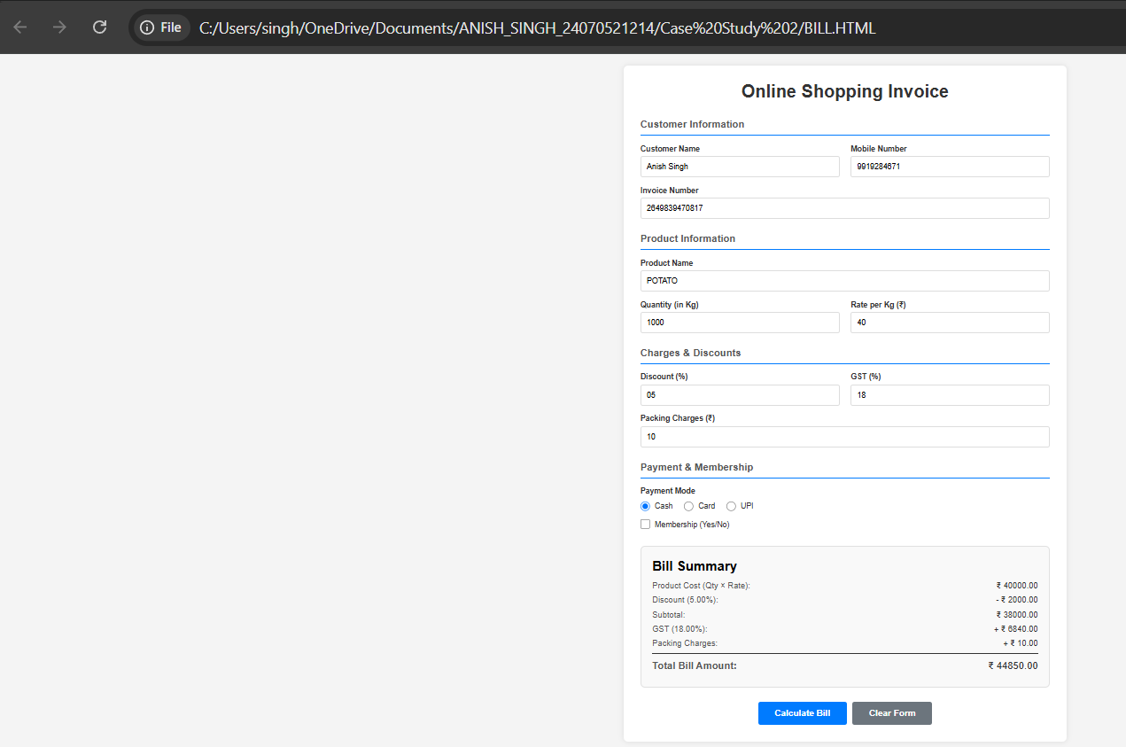

8. Result / Conclusion
The case study was successfully implemented by creating a college department webpage and linking it to a student information page. JavaScript was used to display the welcome message "Welcome to SIT Nagpur" in an alert box. The webpages were designed using HTML and CSS, while JavaScript provided the required interactivity. The objectives of the case study were successfully achieved.

Experiment 3
1. Experiment Title
Implement control structures and form validation; create a grading system based on user-entered marks.

2. Software/Tools Required
- Visual Studio Code (VS Code)
- Google Chrome / Mozilla Firefox / Microsoft Edge
- HTML5
- CSS3
- JavaScript
- Windows Operating System

3. Experiment Program Code
The experiment consists of the following files:
- jashchauhan_242.html
- styles.css
- script.js

exp3.html :-

<!DOCTYPE html>
<html lang="en">
<head>
<meta charset="UTF-8">
<meta name="viewport" content="width=device-width, initial-scale=1.0">
<title>International Institute of Technology - Student Grading Portal</title>
<!-- Link to external stylesheet -->
<link rel="stylesheet" href="styles.css">
</head>
<body>

<div class="container" id="mainContainer">
<div class="app-layout">
<!-- Left Side: Form and Header -->
<div class="form-section">
<div class="logo">🏫</div>
<h2>International Institute of Technology</h2>
<p class="info-text">Student Grading Portal — Form Validation & Control Structures</p>

<form id="gradingForm" onsubmit="event.preventDefault(); calculateGrade();">
<!-- Student Name -->
<div class="form-group">
<label for="studentName">Student Name</label>
<input type="text" id="studentName" placeholder="Enter student name (Letters only)">
</div>

<!-- Subject Inputs Container -->
<div class="form-group">
<label>Subject Marks (0-100)</label>
<div id="subjectsContainer">
<!-- Dynamic subject rows will load here -->
</div>
<button type="button" class="btn-add" onclick="addSubjectRow('', '')">+ Add Subject</button>
</div>

<button type="submit" class="btn-submit">Calculate & Generate Report</button>
</form>

<!-- Error message box -->
<div id="errorBox" class="error-box"></div>
</div>

<!-- Right Side: Official collegiate Grade Report (Hidden initially) -->
<div id="reportCard" class="report-card">
<!-- Dynamic content will be injected here -->
</div>
</div>

<footer>
<p>Developed by <strong>Anish Singh</strong></p>
<p>PRN: 24070521214</p>
</footer>
</div>

<script>
// Default subjects to prefill
const defaultSubjects = ["Mathematics", "Physics", "Chemistry"];

// Initialize with default subjects
window.onload = function() {
defaultSubjects.forEach(sub => addSubjectRow(sub, ""));
};

// Add a new subject row to the container
function addSubjectRow(name = "", marks = "") {
const container = document.getElementById("subjectsContainer");
const row = document.createElement("div");
row.className = "subject-row";

row.innerHTML = `
<input type="text" class="subj-name" placeholder="Subject Name" value="${name}">
<input type="number" class="subj-marks" placeholder="Marks" min="0" max="100" value="${marks}">
<button type="button" class="btn-delete-row" onclick="removeSubjectRow(this)">🗑️</button>
`;
container.appendChild(row);
}

// Remove a subject row
function removeSubjectRow(button) {
const row = button.parentElement;
const container = document.getElementById("subjectsContainer");

if (container.children.length > 1) {
row.remove();
} else {
showError("You must have at least one subject.");
}
}

// Helper to get subject-wise grades
function getSubjectGrade(marks) {
if (marks >= 90) return "A+";
if (marks >= 80) return "A";
if (marks >= 70) return "B";
if (marks >= 60) return "C";
if (marks >= 50) return "D";
return "F";
}

// Helper to get grade badge style class name
function getGradeBadgeClass(grade) {
if (grade === "A+") return "grade-aplus";
if (grade === "A") return "grade-a";
if (grade === "B") return "grade-b";
if (grade === "C") return "grade-c";
if (grade === "D") return "grade-d";
return "grade-fail";
}

function calculateGrade() {
// Get DOM elements
const name = document.getElementById("studentName").value.trim();
const errorBox = document.getElementById("errorBox");
const reportCard = document.getElementById("reportCard");
const mainContainer = document.getElementById("mainContainer");

// Reset elements and layout
errorBox.style.display = "none";
errorBox.innerHTML = "";
reportCard.style.display = "none";
mainContainer.classList.remove("has-report");

// Form Validation: Check if empty
if (!name) {
showError("Please enter the student's name.");
return;
}

// Form Validation: No numbers or special characters allowed in Student Name
const nameRegex = /^[a-zA-Z\s]+$/;
if (!nameRegex.test(name)) {
showError("Student name must only contain letters and spaces (no numbers or special characters).");
return;
}

// Gather and validate subjects
const rows = document.querySelectorAll(".subject-row");
const subjectsList = [];
let totalMarks = 0;
let maxMarks = 0;

for (let i = 0; i < rows.length; i++) {
const nameInput = rows[i].querySelector(".subj-name");
const marksInput = rows[i].querySelector(".subj-marks");

const sName = nameInput.value.trim();
const sMarksStr = marksInput.value;

if (!sName) {
showError(`Please enter a name for Subject ${i + 1}.`);
nameInput.focus();
return;
}

if (sMarksStr === "") {
showError(`Please enter marks for "${sName}".`);
marksInput.focus();
return;
}

const sMarks = Number(sMarksStr);
if (isNaN(sMarks) || sMarks < 0 || sMarks > 100) {
showError(`Marks for "${sName}" must be a number between 0 and 100.`);
marksInput.focus();
return;
}

subjectsList.push({ name: sName, marks: sMarks });
totalMarks += sMarks;
maxMarks += 100;
}

// Calculations
const percentage = (totalMarks / maxMarks) * 100;

// Grading System with Control Structures
let grade = "";
let gradeClass = "";
let passStatus = "Passed";
let statusClass = "pass";

if (percentage >= 90) {
grade = "A+";
gradeClass = "grade-aplus";
} else if (percentage >= 80) {
grade = "A";
gradeClass = "grade-a";
} else if (percentage >= 70) {
grade = "B";
gradeClass = "grade-b";
} else if (percentage >= 60) {
grade = "C";
gradeClass = "grade-c";
} else if (percentage >= 50) {
grade = "D";
gradeClass = "grade-d";
} else {
grade = "Fail";
gradeClass = "grade-fail";
passStatus = "Failed";
statusClass = "fail";
}

// Expand container and display report card
mainContainer.classList.add("has-report");
reportCard.style.display = "flex";

// Construct current date
const dateOptions = { year: 'numeric', month: 'long', day: 'numeric' };
const issueDate = new Date().toLocaleDateString("en-US", dateOptions);

// Build transcript table rows
let tableRows = "";
subjectsList.forEach(sub => {
const subGrade = getSubjectGrade(sub.marks);
tableRows += `
<tr>
<td>${sub.name}</td>
<td style="text-align: center;"><strong>${sub.marks}</strong> / 100</td>
<td style="text-align: center;"><span class="grade-badge ${getGradeBadgeClass(subGrade)}">${subGrade}</span></td>
</tr>
`;
});

reportCard.innerHTML = `
<h3>International Institute of Technology</h3>
<div class="transcript-subtitle">Official Academic Transcript</div>

<div class="transcript-meta">
<div><span>Student Name:</span> <strong>${name}</strong></div>
<div><span>Date of Issue:</span> <strong>${issueDate}</strong></div>
</div>

<table class="transcript-table">
<thead>
<tr>
<th>Subject</th>
<th style="text-align: center;">Marks</th>
<th style="text-align: center;">Grade</th>
</tr>
</thead>
<tbody>
${tableRows}
</tbody>
</table>

<div class="transcript-summary">
<div class="summary-row"><span>Aggregate Total:</span> <strong>${totalMarks} / ${maxMarks}</strong></div>
<div class="summary-row"><span>Final Percentage:</span> <strong>${percentage.toFixed(2)}%</strong></div>
<div class="summary-row"><span>Academic Grade:</span> <span class="grade-badge ${gradeClass}">${grade}</span></div>
<div class="summary-row status-row ${statusClass}"><span>Result Status:</span> <strong>${passStatus}</strong></div>
</div>

<div class="transcript-footer">
<div class="signature-line">
<div class="sig-space">Approved</div>
<span>Registrar (Evaluation)</span>
</div>
</div>
`;
}

function showError(message) {
const errorBox = document.getElementById("errorBox");
errorBox.style.display = "block";
errorBox.innerText = message;
// Roll back layout expansion if there was one
document.getElementById("mainContainer").classList.remove("has-report");
}
</script>
</body>
</html>

styles.css

/* Styling for Student Grading Portal - White Decent Theme */
* {
margin: 0;
padding: 0;
box-sizing: border-box;
}

body {
font-family: 'Segoe UI', Tahoma, Geneva, Verdana, sans-serif;
background-color: #f3f4f6;
color: #1f2937;
padding: 40px 20px;
display: flex;
justify-content: center;
align-items: center;
min-height: 100vh;
}

.container {
background-color: #ffffff;
padding: 30px;
border-radius: 16px;
box-shadow: 0 10px 25px rgba(0, 0, 0, 0.05);
max-width: 550px;
width: 100%;
transition: max-width 0.4s ease;
}

/* Expanded container when report is shown side-by-side */
.container.has-report {
max-width: 1050px;
}

.logo {
font-size: 2.5rem;
text-align: center;
margin-bottom: 10px;
}

h2 {
color: #111827;
margin-bottom: 8px;
text-align: center;
font-size: 1.6rem;
font-weight: 700;
}

.info-text {
font-size: 0.9em;
color: #6b7280;
margin-bottom: 25px;
text-align: center;
line-height: 1.4;
}

.app-layout {
display: flex;
flex-direction: column;
gap: 0px;
transition: all 0.4s ease;
}

.container.has-report .app-layout {
flex-direction: row;
gap: 30px;
}

.form-section {
flex: 1;
width: 100%;
}

.form-group {
display: flex;
flex-direction: column;
gap: 6px;
margin-bottom: 20px;
}

.form-group label {
font-size: 0.85em;
font-weight: 600;
color: #4b5563;
margin-bottom: 4px;
}

.form-group input {
padding: 10px 14px;
font-size: 0.95em;
border: 1px solid #d1d5db;
border-radius: 8px;
outline: none;
transition: all 0.2s ease;
background-color: #f9fafb;
width: 100%;
}

.form-group input:focus {
border-color: #3b82f6;
background-color: #ffffff;
box-shadow: 0 0 0 3px rgba(59, 130, 246, 0.15);
}

/* Dynamic Subject Rows Layout */
#subjectsContainer {
display: flex;
flex-direction: column;
gap: 10px;
margin-bottom: 12px;
}

.subject-row {
display: flex;
gap: 10px;
align-items: center;
}

.subject-row .subj-name {
flex: 2;
}

.subject-row .subj-marks {
flex: 1;
}

.btn-delete-row {
background-color: transparent;
border: none;
font-size: 1.2rem;
cursor: pointer;
width: 38px;
height: 38px;
display: flex;
align-items: center;
justify-content: center;
border-radius: 8px;
transition: all 0.2s ease;
}

.btn-delete-row:hover {
background-color: #fee2e2;
transform: scale(1.05);
}

.btn-add {
background-color: transparent;
border: 1px dashed #3b82f6;
color: #3b82f6;
padding: 8px 16px;
font-size: 0.85em;
font-weight: 600;
border-radius: 8px;
cursor: pointer;
transition: all 0.2s ease;
align-self: flex-start;
}

.btn-add:hover {
background-color: rgba(59, 130, 246, 0.08);
}

.btn-submit {
background-color: #2563eb;
color: white;
border: none;
padding: 12px;
font-size: 1em;
font-weight: 600;
border-radius: 8px;
cursor: pointer;
transition: all 0.2s ease;
width: 100%;
margin-top: 10px;
}

.btn-submit:hover {
background-color: #1d4ed8;
}

.btn-submit:active {
transform: scale(0.98);
}

.error-box {
background-color: #fee2e2;
border: 1px solid #fca5a5;
color: #b91c1c;
padding: 12px;
border-radius: 8px;
margin-top: 20px;
font-size: 0.9em;
text-align: center;
display: none;
}

/* Official College Grade Sheet (Transcript) Styling */
.report-card {
background-color: #fdfdfd;
border: 3px double #1e3a8a; /* College double border */
border-radius: 12px;
padding: 30px 25px;
display: none;
flex-direction: column;
justify-content: space-between;
box-shadow: 0 4px 20px rgba(0, 0, 0, 0.04);
flex: 1;
position: relative;
animation: fadeInRight 0.5s ease both;
}

.report-card h3 {
text-align: center;
color: #1e3a8a;
font-size: 1.3rem;
font-weight: 700;
margin-bottom: 2px;
text-transform: uppercase;
}

.transcript-subtitle {
text-align: center;
font-size: 0.8em;
text-transform: uppercase;
letter-spacing: 0.1em;
color: #6b7280;
margin-bottom: 20px;
border-bottom: 1px solid #d1d5db;
padding-bottom: 8px;
font-weight: 600;
}

.transcript-meta {
display: flex;
justify-content: space-between;
font-size: 0.85em;
color: #4b5563;
margin-bottom: 20px;
gap: 15px;
}

.transcript-meta strong {
color: #111827;
}

.transcript-table {
width: 100%;
border-collapse: collapse;
margin-bottom: 20px;
}

.transcript-table th {
background-color: #f3f4f6;
color: #374151;
font-size: 0.75em;
text-transform: uppercase;
letter-spacing: 0.05em;
font-weight: 700;
padding: 8px 10px;
border-bottom: 2px solid #d1d5db;
text-align: left;
}

.transcript-table td {
padding: 10px;
border-bottom: 1px solid #e5e7eb;
font-size: 0.88em;
color: #374151;
}

.transcript-summary {
border-top: 2px solid #d1d5db;
padding-top: 15px;
margin-bottom: 20px;
}

.summary-row {
display: flex;
justify-content: space-between;
align-items: center;
margin-bottom: 8px;
font-size: 0.9em;
color: #4b5563;
}

.summary-row strong {
color: #111827;
}

.transcript-footer {
display: flex;
justify-content: flex-end;
margin-top: 20px;
}

.signature-line {
text-align: center;
display: flex;
flex-direction: column;
align-items: center;
}

.sig-space {
font-family: 'Georgia', serif;
font-style: italic;
font-size: 1.1em;
color: #1e3a8a;
margin-bottom: 5px;
border-bottom: 1px solid #9ca3af;
width: 120px;
padding-bottom: 4px;
}

.signature-line span {
font-size: 0.75em;
color: #6b7280;
text-transform: uppercase;
font-weight: 600;
letter-spacing: 0.05em;
}

.grade-badge {
padding: 3px 10px;
border-radius: 9999px;
color: white;
font-weight: bold;
font-size: 0.8em;
display: inline-block;
}

.grade-aplus { background-color: #10b981; }
.grade-a { background-color: #14b8a6; }
.grade-b { background-color: #3b82f6; }
.grade-c { background-color: #f59e0b; }
.grade-d { background-color: #f97316; }
.grade-fail { background-color: #ef4444; }

.status-row.pass {
color: #16a34a;
}

.status-row.fail {
color: #dc2626;
}

footer {
margin-top: 30px;
font-size: 0.8em;
color: #9ca3af;
border-top: 1px solid #f3f4f6;
padding-top: 15px;
text-align: center;
}

/* Animations */
@keyframes fadeInRight {
from {
opacity: 0;
transform: translateX(20px);
}
to {
opacity: 1;
transform: translateX(0);
}
}

/* Media Query for mobile scaling */
@media (max-width: 850px) {
.container.has-report {
max-width: 550px;
}
.container.has-report .app-layout {
flex-direction: column;
gap: 30px;
}
.report-card {
margin-top: 0;
}
}

OUTPUT:

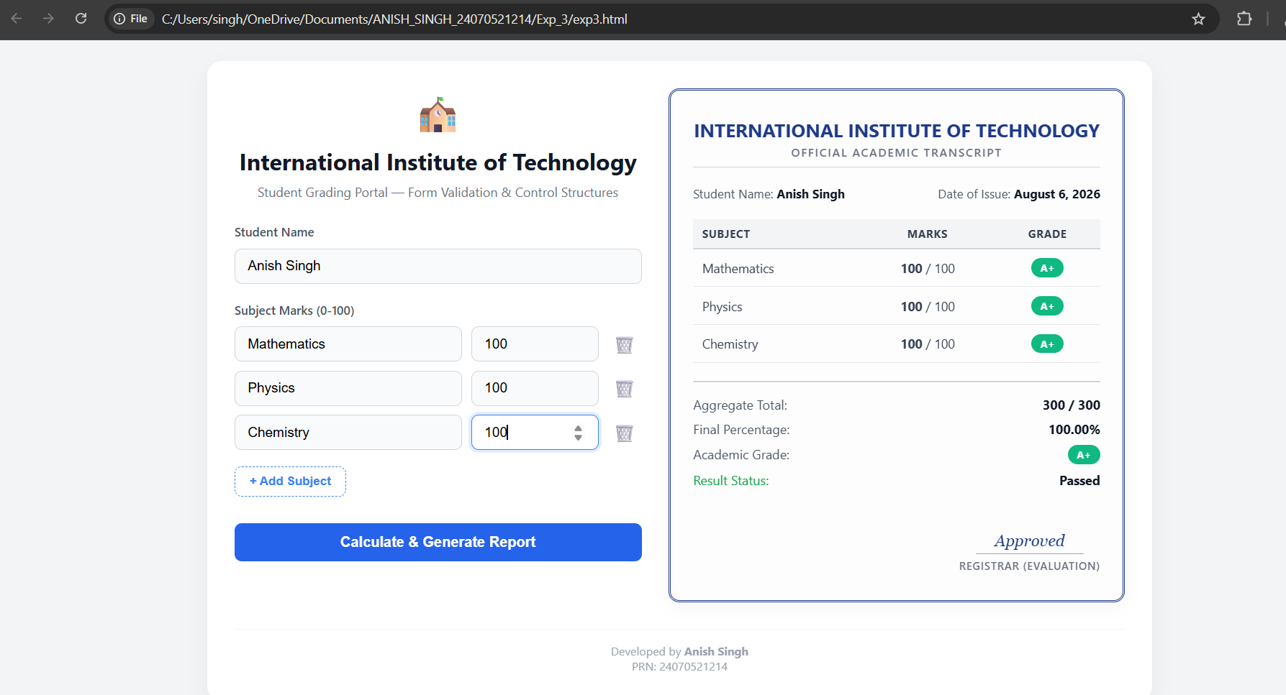

Case Study 3
1. Case Study Title
Write a Javascript program that accepts students marks and displays the scholarship category.

ScholorshipEligibility.html

<!DOCTYPE html>
<html lang="en">
<head>
<meta charset="UTF-8">
<meta name="viewport" content="width=device-width, initial-scale=1.0">
<title>Scholarship Eligibility</title>
<style>
body {
font-family: Arial, sans-serif;
max-width: 500px;
margin: 50px auto;
padding: 20px;
background-color: #f4f4f4;
}
.container {
background-color: white;
padding: 30px;
border-radius: 8px;
box-shadow: 0 2px 10px rgba(0,0,0,0.1);
}
h1 {
color: #333;
text-align: center;
}
.form-group {
margin: 20px 0;
}
label {
display: block;
margin-bottom: 8px;
font-weight: bold;
color: #555;
}
input {
width: 100%;
padding: 10px;
border: 1px solid #ddd;
border-radius: 4px;
box-sizing: border-box;
font-size: 16px;
}
button {
width: 100%;
padding: 12px;
background-color: #4CAF50;
color: white;
border: none;
border-radius: 4px;
cursor: pointer;
font-size: 16px;
font-weight: bold;
}
button:hover {
background-color: #45a049;
}
.result {
margin-top: 20px;
padding: 15px;
border-radius: 4px;
text-align: center;
font-weight: bold;
display: none;
}
.not-eligible {
background-color: #f8d7da;
color: #721c24;
border: 1px solid #f5c6cb;
}
.bronze {
background-color: #cd7f32;
color: white;
}
.silver {
background-color: #c0c0c0;
color: #333;
}
.gold {
background-color: #ffd700;
color: #333;
}
.platinum {
background-color: #e5e4e2;
color: #333;
border: 2px solid #999;
}
</style>
</head>
<body>
<div class="container">
<h1>Scholarship Eligibility Checker</h1>

<div class="form-group">
<label for="marks">Enter Student Marks (0-100):</label>
<input type="number" id="marks" min="0" max="100" placeholder="Enter marks">
</div>

<button onclick="checkScholarship()">Check Eligibility</button>

<div id="result" class="result"></div>
</div>

<script>
function checkScholarship() {
const marks = parseInt(document.getElementById('marks').value);
const resultDiv = document.getElementById('result');

// Validate input
if (isNaN(marks) || marks < 0 || marks > 100) {
resultDiv.textContent = 'Please enter a valid mark between 0 and 100.';
resultDiv.className = 'result not-eligible';
resultDiv.style.display = 'block';
return;
}

// Determine scholarship category
let scholarship;
let category;

if (marks < 50) {
scholarship = 'Not Eligible';
category = 'not-eligible';
} else if (marks >= 50 && marks <= 69) {
scholarship = 'Bronze Scholarship';
category = 'bronze';
} else if (marks >= 70 && marks <= 84) {
scholarship = 'Silver Scholarship';
category = 'silver';
} else if (marks >= 85 && marks <= 94) {
scholarship = 'Gold Scholarship';
category = 'gold';
} else if (marks >= 95 && marks <= 100) {
scholarship = 'Platinum Scholarship';
category = 'platinum';
}

// Display result
resultDiv.textContent = `Marks: ${marks}\nScholarship: ${scholarship}`;
resultDiv.className = `result ${category}`;
resultDiv.style.display = 'block';
}

// Allow Enter key to submit
document.getElementById('marks').addEventListener('keypress', function(event) {
if (event.key === 'Enter') {
checkScholarship();
}
});
</script>
</body>
</html>

OUTPUT:

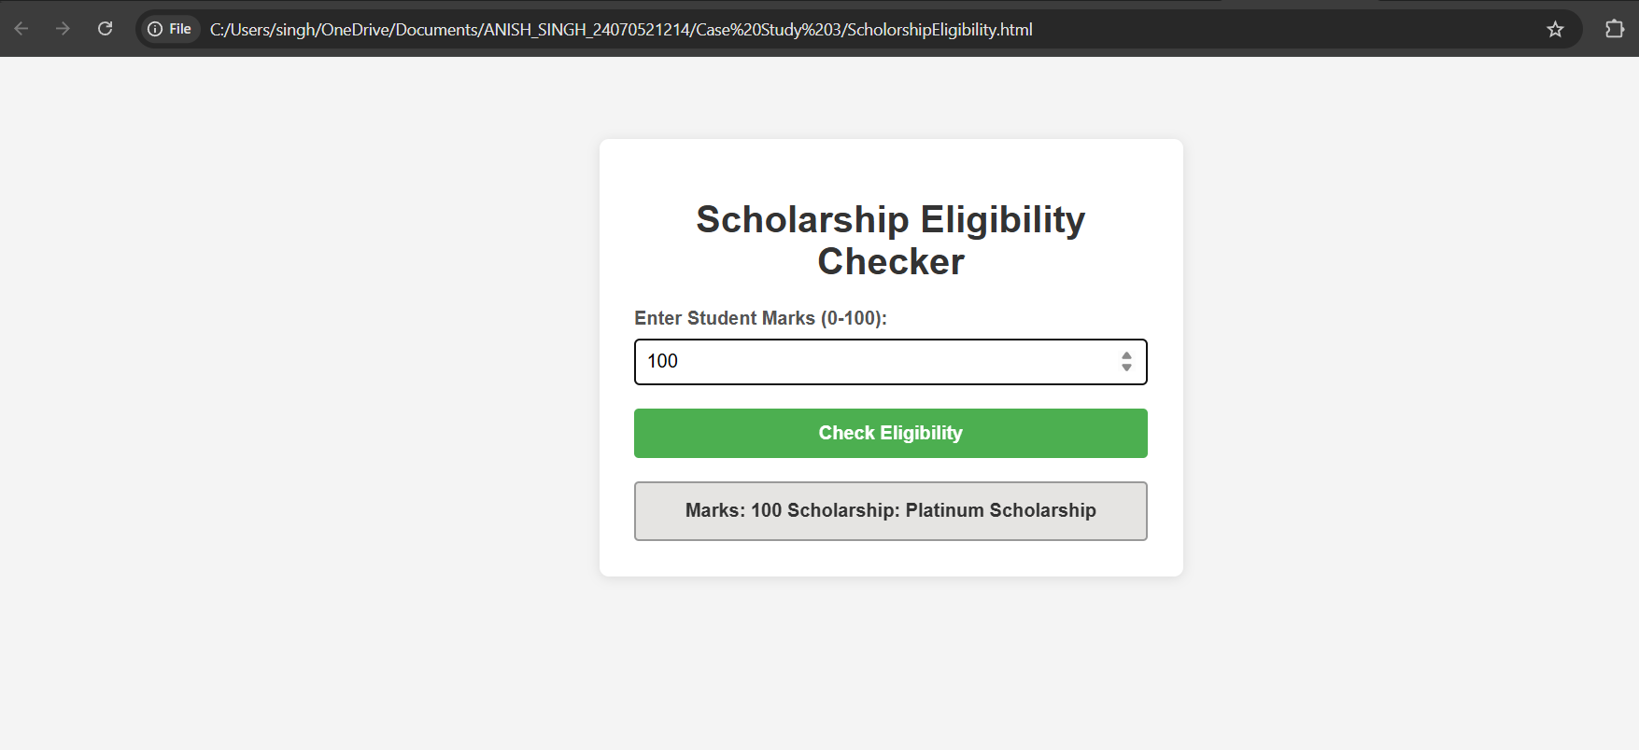

Result / Conclusion:
Hence, we have successfully developed the Scholarship Eligibility Checker webpage. Through this case study, we practically learned how to implement control structures, specifically if-else conditional statements in JavaScript, to evaluate user input, make logical decisions, and dynamically update the webpage's UI to display the appropriate scholarship category based on the provided marks.

Experiment 4
1. Experiment Title
Use function types, scope, and closures; apply try-catch; build a palindrome checker.

2. Software/Tools Required
- Visual Studio Code (VS Code)
- Google Chrome / Mozilla Firefox / Microsoft Edge
- HTML5
- CSS3
- JavaScript
- Windows Operating System

palindrome_checker.html

<!DOCTYPE html>
<html lang="en">
<head>
<meta charset="UTF-8">
<meta name="viewport" content="width=device-width, initial-scale=1.0">
<title>Palindrome Checker - Functions, Scope & Closures</title>
<style>
/* Styling for Palindrome Checker - Clean White Premium Design */
* {
margin: 0;
padding: 0;
box-sizing: border-box;
}

body {
font-family: 'Inter', '-apple-system', 'Segoe UI', sans-serif;
background: linear-gradient(to bottom, #f8fafc 0%, #f1f5f9 100%);
color: #0f172a;
padding: 40px 20px;
display: flex;
justify-content: center;
align-items: center;
min-height: 100vh;
}

.container {
background-color: #ffffff;
padding: 50px;
border-radius: 32px;
box-shadow: 0 20px 60px rgba(15, 23, 42, 0.08), 0 0 1px rgba(15, 23, 42, 0.1);
max-width: 600px;
width: 100%;
transition: max-width 0.5s cubic-bezier(0.4, 0, 0.2, 1);
}

/* Expanded container when results are shown */
.container.has-results {
max-width: 1250px;
}

.app-layout {
display: flex;
flex-direction: column;
gap: 0;
transition: all 0.5s cubic-bezier(0.4, 0, 0.2, 1);
}

.container.has-results .app-layout {
flex-direction: row;
gap: 50px;
align-items: flex-start;
}

.header {
margin-bottom: 40px;
text-align: center;
position: relative;
}

.header::after {
content: '';
position: absolute;
bottom: -20px;
left: 50%;
transform: translateX(-50%);
width: 80px;
height: 4px;
background: linear-gradient(90deg, #3b82f6, #06b6d4);
border-radius: 2px;
}

.logo {
font-size: 3.5rem;
text-align: center;
margin-bottom: 20px;
animation: float 3s ease-in-out infinite;
filter: drop-shadow(0 10px 20px rgba(59, 130, 246, 0.15));
}

@keyframes float {
0%, 100% { transform: translateY(0px); }
50% { transform: translateY(-12px); }
}

h2 {
color: #0f172a;
margin-bottom: 10px;
text-align: center;
font-size: 2.2rem;
font-weight: 900;
letter-spacing: -1px;
}

.info-text {
font-size: 0.95em;
color: #64748b;
text-align: center;
line-height: 1.7;
font-weight: 500;
}

.form-section {
flex: 1;
width: 100%;
transition: all 0.5s ease;
}

.results-section {
flex: 1;
width: 100%;
}

.form-group {
display: flex;
flex-direction: column;
gap: 10px;
margin-bottom: 28px;
}

.form-group label {
font-size: 0.9em;
font-weight: 700;
color: #1e293b;
text-transform: uppercase;
letter-spacing: 0.6px;
}

.form-group input {
padding: 16px 20px;
font-size: 0.95em;
border: 2px solid #e2e8f0;
border-radius: 14px;
outline: none;
transition: all 0.3s ease;
background-color: #f8fafc;
width: 100%;
font-weight: 500;
color: #0f172a;
}

.form-group input::placeholder {
color: #cbd5e1;
}

.form-group input:focus {
border-color: #3b82f6;
background-color: #ffffff;
box-shadow: 0 0 0 4px rgba(59, 130, 246, 0.1);
transform: translateY(-2px);
}

.button-group {
display: flex;
gap: 14px;
margin-bottom: 28px;
}

.btn {
flex: 1;
padding: 16px;
font-size: 0.95em;
font-weight: 700;
border: none;
border-radius: 14px;
cursor: pointer;
transition: all 0.3s ease;
text-transform: uppercase;
letter-spacing: 0.6px;
position: relative;
overflow: hidden;
}

.btn::before {
content: '';
position: absolute;
top: 0;
left: -100%;
width: 100%;
height: 100%;
background: rgba(255, 255, 255, 0.2);
transition: left 0.3s ease;
z-index: 1;
}

.btn-check {
background: linear-gradient(135deg, #3b82f6 0%, #06b6d4 100%);
color: white;
box-shadow: 0 10px 25px rgba(59, 130, 246, 0.2);
}

.btn-check:hover {
transform: translateY(-3px);
box-shadow: 0 15px 35px rgba(59, 130, 246, 0.3);
}

.btn-clear {
background-color: #f1f5f9;
color: #1e293b;
border: 2px solid #e2e8f0;
font-weight: 700;
}

.btn-clear:hover {
background-color: #e2e8f0;
border-color: #3b82f6;
color: #3b82f6;
}

.btn:active {
transform: scale(0.98);
}

.error-box {
background: linear-gradient(135deg, #fee2e2, #fecaca);
border: 2px solid #fca5a5;
color: #7c2d12;
padding: 16px 20px;
border-radius: 14px;
margin-bottom: 20px;
font-size: 0.9em;
font-weight: 600;
display: none;
animation: slideDown 0.3s ease;
box-shadow: 0 4px 15px rgba(248, 113, 113, 0.1);
}

.info-box {
background: linear-gradient(135deg, #dbeafe, #bfdbfe);
border: 2px solid #93c5fd;
color: #0c2340;
padding: 16px 20px;
border-radius: 14px;
margin-bottom: 20px;
font-size: 0.9em;
font-weight: 600;
display: none;
animation: slideDown 0.3s ease;
box-shadow: 0 4px 15px rgba(59, 130, 246, 0.1);
}

/* Result Cards */
.results-container {
display: flex;
flex-direction: column;
gap: 24px;
}

.result-card {
border-radius: 18px;
padding: 28px;
display: none;
animation: slideInRight 0.5s ease both;
box-shadow: 0 12px 35px rgba(15, 23, 42, 0.08);
border: 1px solid #e2e8f0;
background: #ffffff;
transition: all 0.3s ease;
position: relative;
overflow: hidden;
}

.result-card::before {
content: '';
position: absolute;
top: 0;
left: 0;
right: 0;
height: 4px;
background: linear-gradient(90deg, #3b82f6, #06b6d4);
}

.result-card.prn-result::before {
background: linear-gradient(90deg, #8b5cf6, #06b6d4);
}

.result-card:hover {
transform: translateY(-4px);
box-shadow: 0 18px 45px rgba(15, 23, 42, 0.12);
}

.result-card.show {
display: block;
}

.result-header {
font-weight: 800;
color: #0f172a;
margin-bottom: 20px;
font-size: 1.1em;
text-transform: uppercase;
letter-spacing: 0.6px;
}

.result-content {
display: flex;
flex-direction: column;
gap: 14px;
font-size: 0.9em;
}

.result-row {
display: flex;
justify-content: space-between;
align-items: center;
padding: 12px;
background: #f8fafc;
border-radius: 10px;
transition: all 0.2s ease;
}

.result-row:hover {
background: #f1f5f9;
}

.result-row span {
color: #64748b;
font-weight: 700;
font-size: 0.9em;
}

.result-row strong {
color: #0f172a;
font-weight: 800;
}

.palindrome-badge {
padding: 8px 16px;
border-radius: 20px;
color: white;
font-weight: 800;
font-size: 0.8em;
display: inline-block;
width: fit-content;
text-transform: uppercase;
letter-spacing: 0.4px;
box-shadow: 0 4px 15px rgba(0, 0, 0, 0.15);
}

.badge-yes {
background: linear-gradient(135deg, #10b981, #059669);
}

.badge-no {
background: linear-gradient(135deg, #ef4444, #dc2626);
}

.analysis-section {
background: linear-gradient(135deg, #f8fafc, #f1f5f9);
border-radius: 12px;
padding: 16px;
margin-top: 18px;
font-size: 0.85em;
color: #475569;
line-height: 1.7;
border: 1px solid #e2e8f0;
}

.analysis-title {
font-weight: 800;
color: #0f172a;
margin-bottom: 10px;
text-transform: uppercase;
font-size: 0.8em;
letter-spacing: 0.4px;
}

.concept-box {
background: linear-gradient(135deg, #f0fdf4, #dcfce7);
border: 2px solid #86efac;
border-radius: 18px;
padding: 24px;
margin-top: 28px;
font-size: 0.85em;
color: #166534;
box-shadow: 0 8px 20px rgba(34, 197, 94, 0.08);
line-height: 1.8;
}

.concept-title {
font-weight: 800;
margin-bottom: 16px;
color: #15803d;
text-transform: uppercase;
font-size: 0.95em;
letter-spacing: 0.6px;
}

.concept-box p {
margin-bottom: 12px;
font-weight: 600;
}

.concept-box strong {
color: #059669;
}

footer {
margin-top: 50px;
font-size: 0.8em;
color: #94a3b8;
border-top: 2px solid #e2e8f0;
padding-top: 25px;
text-align: center;
width: 100%;
font-weight: 600;
letter-spacing: 0.3px;
}

footer p {
margin: 5px 0;
}

@keyframes slideDown {
from {
opacity: 0;
transform: translateY(-15px);
}
to {
opacity: 1;
transform: translateY(0);
}
}

@keyframes slideInRight {
from {
opacity: 0;
transform: translateX(40px);
}
to {
opacity: 1;
transform: translateX(0);
}
}

@media (max-width: 950px) {
.container.has-results {
max-width: 600px;
}
.container.has-results .app-layout {
flex-direction: column;
gap: 40px;
}
}

@media (max-width: 600px) {
.container {
padding: 30px 25px;
border-radius: 24px;
}

h2 {
font-size: 1.8rem;
}

.logo {
font-size: 3rem;
}

.button-group {
flex-direction: column;
gap: 12px;
}

.btn {
padding: 14px;
}

.header::after {
width: 60px;
}
}
</style>
</head>
<body>

<div class="container" id="mainContainer">
<div class="header">
<div class="logo">🔄</div>
<h2>Palindrome Checker</h2>
<p class="info-text">JavaScript Functions, Scope, Closures & Exception Handling</p>
</div>

<div class="app-layout">
<!-- Left Side: Form Section -->
<div class="form-section" id="formSection">
<form id="palindromeForm" onsubmit="event.preventDefault(); handleCheck();">
<!-- Student Name Input -->
<div class="form-group">
<label for="studentName">Student Name</label>
<input type="text" id="studentName" placeholder="Enter your name (e.g., Anish, Racecar)">
</div>

<!-- PRN Number Input -->
<div class="form-group">
<label for="prnNumber">PRN Number</label>
<input type="text" id="prnNumber" placeholder="Enter PRN (e.g., 24070521214)">
</div>

<!-- Buttons -->
<div class="button-group">
<button type="submit" class="btn btn-check">Check Palindromes</button>
<button type="button" class="btn btn-clear" onclick="clearAll()">Clear All</button>
</div>
</form>

<!-- Error Box -->
<div id="errorBox" class="error-box"></div>

<!-- Info Box -->
<div id="infoBox" class="info-box"></div>

<!-- Concept Explanation Box -->
<div class="concept-box">
<div class="concept-title">📚 JavaScript Concepts Used:</div>
<p><strong>1. Function Types:</strong> Regular functions, arrow functions, and function expressions</p>
<p><strong>2. Scope & Closure:</strong> Private variables captured by inner functions</p>
<p><strong>3. Try-Catch:</strong> Error handling for invalid inputs and edge cases</p>
<p><strong>4. Algorithm:</strong> Reverse string comparison for palindrome detection</p>
</div>
</div>

<!-- Right Side: Results Section -->
<div class="results-section" id="resultsSection">
<div class="results-container">
<!-- Name Result Card -->
<div id="nameResultCard" class="result-card name-result">
<div class="result-header">📝 Name Analysis</div>
<div class="result-content">
<div class="result-row">
<span>Original:</span>
<strong id="nameOriginal"></strong>
</div>
<div class="result-row">
<span>Reversed:</span>
<strong id="nameReversed"></strong>
</div>
<div class="result-row">
<span>Palindrome:</span>
<span id="namePalindromeResult"></span>
</div>
</div>
<div class="analysis-section">
<div class="analysis-title">Analysis:</div>
<div id="nameAnalysis"></div>
</div>
</div>

<!-- PRN Result Card -->
<div id="prnResultCard" class="result-card prn-result">
<div class="result-header">🔢 PRN Number Analysis</div>
<div class="result-content">
<div class="result-row">
<span>Original:</span>
<strong id="prnOriginal"></strong>
</div>
<div class="result-row">
<span>Reversed:</span>
<strong id="prnReversed"></strong>
</div>
<div class="result-row">
<span>Palindrome:</span>
<span id="prnPalindromeResult"></span>
</div>
</div>
<div class="analysis-section">
<div class="analysis-title">Analysis:</div>
<div id="prnAnalysis"></div>
</div>
</div>
</div>
</div>
</div>

<footer>
<p>Developed by <strong>Anish Singh</strong></p>
<p>PRN: 24070521214</p>
</footer>
</div>

<script>
// ============================================
// CLOSURE PATTERN: Creating a private scope
// ============================================
const PalindromeChecker = (function() {
// Private variables (closure scope)
let checkCount = 0;
let lastCheckTime = null;

// Regular function: Basic string reversal
function reverseString(str) {
return str.split('').reverse().join('');
}

// Arrow function: Case-insensitive comparison
const normalizeString = (str) => str.toLowerCase().replace(/[^a-z0-9]/g, '');

// Function expression: Check palindrome
const checkPalindrome = function(input) {
try {
if (!input || typeof input !== 'string') {
throw new Error('Input must be a non-empty string');
}

const normalized = normalizeString(input);

if (normalized.length === 0) {
throw new Error('Input must contain at least one alphanumeric character');
}

const reversed = reverseString(normalized);
const isPalindrome = normalized === reversed;

return {
original: input,
normalized: normalized,
reversed: reversed,
isPalindrome: isPalindrome,
length: normalized.length
};
} catch (error) {
throw new Error(`Palindrome check failed: ${error.message}`);
}
};

// Public API (exposed methods)
return {
check: function(input) {
try {
checkCount++;
lastCheckTime = new Date();
return checkPalindrome(input);
} catch (error) {
throw error;
}
},

getCheckCount: function() {
return checkCount;
},

getLastCheckTime: function() {
return lastCheckTime;
}
};
})();

// ============================================
// MAIN HANDLER FUNCTION
// ============================================
function handleCheck() {
const name = document.getElementById('studentName').value.trim();
const prn = document.getElementById('prnNumber').value.trim();
const errorBox = document.getElementById('errorBox');
const infoBox = document.getElementById('infoBox');
const mainContainer = document.getElementById('mainContainer');

// Reset display
errorBox.style.display = 'none';
infoBox.style.display = 'none';
document.getElementById('nameResultCard').classList.remove('show');
document.getElementById('prnResultCard').classList.remove('show');

try {
// Validation
if (!name && !prn) {
throw new Error('Please enter at least a name or PRN number');
}

let hasError = false;

// Check Name if provided
if (name) {
try {
const nameResult = PalindromeChecker.check(name);
displayNameResult(nameResult);
} catch (error) {
showError(error.message);
hasError = true;
}
}

// Check PRN if provided
if (prn) {
try {
const prnResult = PalindromeChecker.check(prn);
displayPrnResult(prnResult);
} catch (error) {
showError(error.message);
hasError = true;
}
}

// Show info if checks were successful
if (!hasError) {
showInfo(`✓ Analysis complete. Total checks performed: ${PalindromeChecker.getCheckCount()}`);
// Expand container when results are shown
mainContainer.classList.add('has-results');
}

} catch (error) {
showError(error.message);
mainContainer.classList.remove('has-results');
}
}

// ============================================
// DISPLAY FUNCTIONS
// ============================================
function displayNameResult(result) {
document.getElementById('nameOriginal').textContent = result.original;
document.getElementById('nameReversed').textContent = result.reversed;

const badge = result.isPalindrome
? `<span class="palindrome-badge badge-yes">✓ YES, Palindrome</span>`
: `<span class="palindrome-badge badge-no">✗ NO, Not Palindrome</span>`;

document.getElementById('namePalindromeResult').innerHTML = badge;

const analysis = `Normalized: "${result.normalized}" | Length: ${result.length} | ` +
`Match: ${result.normalized === result.reversed ? 'MATCH ✓' : 'NO MATCH ✗'}`;
document.getElementById('nameAnalysis').textContent = analysis;

document.getElementById('nameResultCard').classList.add('show');
}

function displayPrnResult(result) {
document.getElementById('prnOriginal').textContent = result.original;
document.getElementById('prnReversed').textContent = result.reversed;

const badge = result.isPalindrome
? `<span class="palindrome-badge badge-yes">✓ YES, Palindrome</span>`
: `<span class="palindrome-badge badge-no">✗ NO, Not Palindrome</span>`;

document.getElementById('prnPalindromeResult').innerHTML = badge;

const analysis = `Normalized: "${result.normalized}" | Length: ${result.length} | ` +
`Match: ${result.normalized === result.reversed ? 'MATCH ✓' : 'NO MATCH ✗'}`;
document.getElementById('prnAnalysis').textContent = analysis;

document.getElementById('prnResultCard').classList.add('show');
}

function showError(message) {
const errorBox = document.getElementById('errorBox');
errorBox.textContent = '❌ ' + message;
errorBox.style.display = 'block';
}

function showInfo(message) {
const infoBox = document.getElementById('infoBox');
infoBox.textContent = message;
infoBox.style.display = 'block';
}

function clearAll() {
const mainContainer = document.getElementById('mainContainer');
document.getElementById('studentName').value = '';
document.getElementById('prnNumber').value = '';
document.getElementById('errorBox').style.display = 'none';
document.getElementById('infoBox').style.display = 'none';
document.getElementById('nameResultCard').classList.remove('show');
document.getElementById('prnResultCard').classList.remove('show');
mainContainer.classList.remove('has-results');
}
</script>
</body>
</html>

Styles.css

/* Styling for Palindrome Checker - White Decent Theme */
* {
margin: 0;
padding: 0;
box-sizing: border-box;
}

body {
font-family: 'Segoe UI', Tahoma, Geneva, Verdana, sans-serif;
background-color: #f3f4f6;
color: #1f2937;
padding: 40px 20px;
display: flex;
justify-content: center;
align-items: center;
min-height: 100vh;
}

.container {
background-color: #ffffff;
padding: 30px;
border-radius: 16px;
box-shadow: 0 10px 25px rgba(0, 0, 0, 0.05);
max-width: 600px;
width: 100%;
}

.logo {
font-size: 2.5rem;
text-align: center;
margin-bottom: 10px;
}

h2 {
color: #111827;
margin-bottom: 8px;
text-align: center;
font-size: 1.6rem;
font-weight: 700;
}

.info-text {
font-size: 0.9em;
color: #6b7280;
margin-bottom: 25px;
text-align: center;
line-height: 1.4;
}

.form-group {
display: flex;
flex-direction: column;
gap: 6px;
margin-bottom: 20px;
}

.form-group label {
font-size: 0.85em;
font-weight: 600;
color: #4b5563;
margin-bottom: 4px;
}

.form-group input {
padding: 10px 14px;
font-size: 0.95em;
border: 1px solid #d1d5db;
border-radius: 8px;
outline: none;
transition: all 0.2s ease;
background-color: #f9fafb;
width: 100%;
}

.form-group input:focus {
border-color: #3b82f6;
background-color: #ffffff;
box-shadow: 0 0 0 3px rgba(59, 130, 246, 0.15);
}

.button-group {
display: flex;
gap: 10px;
margin-bottom: 20px;
}

.btn {
flex: 1;
padding: 12px;
font-size: 0.95em;
font-weight: 600;
border: none;
border-radius: 8px;
cursor: pointer;
transition: all 0.2s ease;
}

.btn-check {
background-color: #2563eb;
color: white;
}

.btn-check:hover {
background-color: #1d4ed8;
}

.btn-clear {
background-color: #f3f4f6;
color: #1f2937;
border: 1px solid #d1d5db;
}

.btn-clear:hover {
background-color: #e5e7eb;
}

.btn:active {
transform: scale(0.98);
}

.error-box {
background-color: #fee2e2;
border: 1px solid #fca5a5;
color: #b91c1c;
padding: 12px;
border-radius: 8px;
margin-bottom: 20px;
font-size: 0.9em;
display: none;
}

.info-box {
background-color: #dbeafe;
border: 1px solid #93c5fd;
color: #1e40af;
padding: 12px;
border-radius: 8px;
margin-bottom: 20px;
font-size: 0.9em;
display: none;
}

.results-container {
display: flex;
flex-direction: column;
gap: 15px;
margin-top: 20px;
}

.result-card {
border: 2px solid #d1d5db;
border-radius: 12px;
padding: 20px;
display: none;
}

.result-card.name-result {
border-left: 4px solid #3b82f6;
background-color: #f0f9ff;
}

.result-card.prn-result {
border-left: 4px solid #8b5cf6;
background-color: #faf5ff;
}

.result-card.show {
display: block;
}

.result-header {
font-weight: 700;
color: #1f2937;
margin-bottom: 8px;
font-size: 0.95em;
}

.result-content {
display: flex;
flex-direction: column;
gap: 8px;
font-size: 0.85em;
}

.result-row {
display: flex;
justify-content: space-between;
color: #4b5563;
}

.result-row strong {
color: #111827;
}

.palindrome-badge {
padding: 4px 10px;
border-radius: 9999px;
color: white;
font-weight: bold;
font-size: 0.75em;
display: inline-block;
width: fit-content;
}

.badge-yes {
background-color: #10b981;
}

.badge-no {
background-color: #ef4444;
}

.analysis-section {
background-color: #f9fafb;
border-radius: 8px;
padding: 12px;
margin-top: 12px;
font-size: 0.8em;
color: #6b7280;
line-height: 1.5;
}

.analysis-title {
font-weight: 600;
color: #374151;
margin-bottom: 6px;
}

.concept-box {
background-color: #fffbeb;
border: 1px solid #fed7aa;
border-radius: 8px;
padding: 12px;
margin-top: 20px;
font-size: 0.8em;
color: #92400e;
}

.concept-title {
font-weight: 700;
margin-bottom: 6px;
color: #b45309;
}

footer {
margin-top: 30px;
font-size: 0.8em;
color: #9ca3af;
border-top: 1px solid #f3f4f6;
padding-top: 15px;
text-align: center;
}

@media (max-width: 600px) {
.container {
padding: 20px;
}

.button-group {
flex-direction: column;
}
}

OUTPUT:

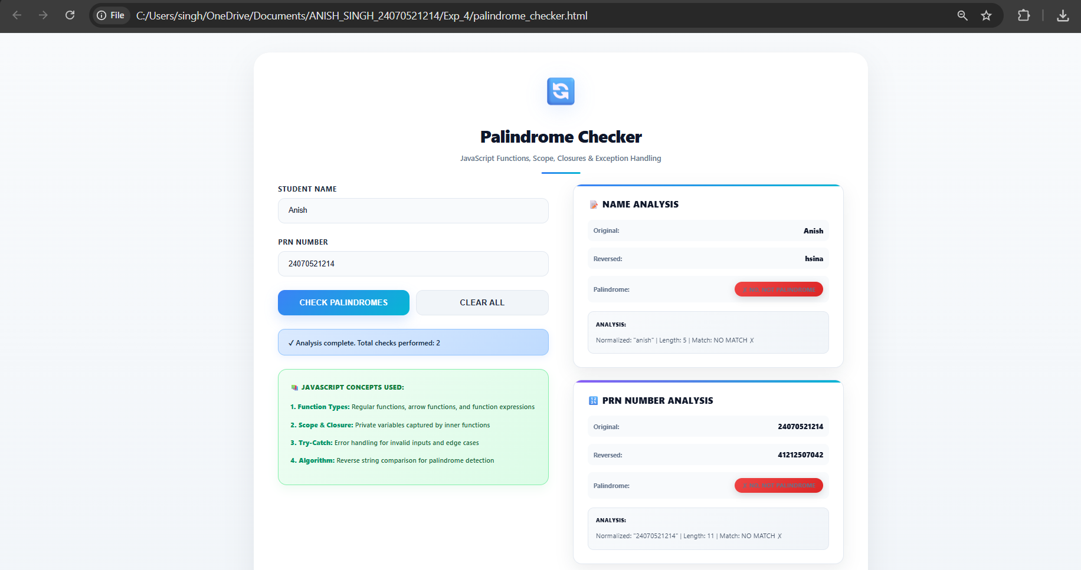

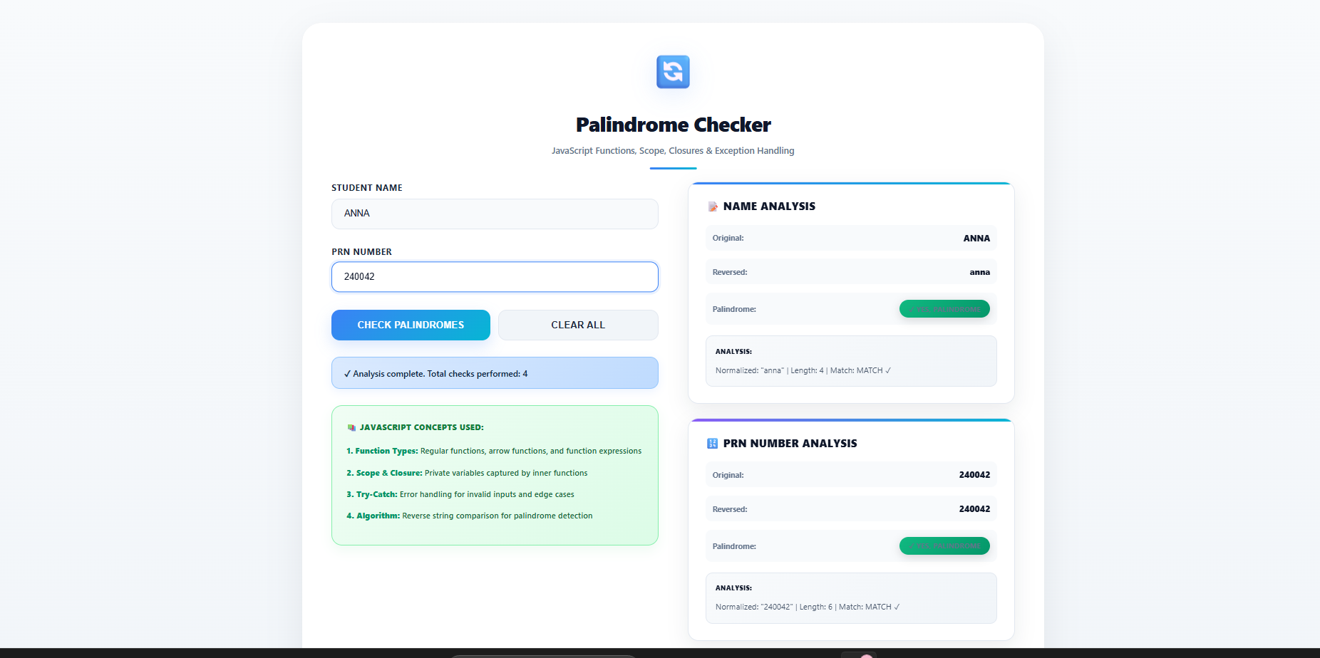

Case Study 4
1. Case Study Title
Real-Time Case Study: ATM Card PIN Verification Using JavaScript Functions to verify whether a customer's PIN is a palindrome. Use function declaration, function expression, arrow function, and demonstrate scope and closure concepts.

index.html

<!DOCTYPE html>
<html lang="en">
<head>
<meta charset="UTF-8">
<meta name="viewport" content="width=device-width, initial-scale=1.0">
<title>Case Study 4 - ATM Card PIN Verification (JS Functions, Scope & Closure)</title>
<link rel="stylesheet" href="styles.css">
<link rel="preconnect" href="https://fonts.googleapis.com">
<link rel="preconnect" href="https://fonts.gstatic.com" crossorigin>
<link href="https://fonts.googleapis.com/css2?family=Inter:wght@400;500;600;700;800&display=swap" rel="stylesheet">
</head>
<body>

<div class="app-wrapper">
<!-- Header -->
<header class="header-bar">
<div class="brand-badge">
<span>🔒 SecureBank ATM System</span>
<span>•</span>
<span>Case Study 4</span>
</div>
<h1>ATM Card PIN Verification Module</h1>
<p>Verifying Palindromic PINs using JavaScript Function Declaration, Function Expression, Arrow Functions, Scope & Closures</p>
</header>

<!-- Main Workspace Grid -->
<main class="grid-container">
<!-- Left Side: ATM Terminal Interface -->
<section class="glass-panel">
<h2 class="panel-title">
<span>💳 ATM Pin Input Terminal</span>
</h2>

<!-- ATM Terminal Screen -->
<div class="atm-screen">
<div class="screen-header">
<span>SYSTEM: SECURE_GATEWAY_V4</span>
<span><span class="online-dot"></span> ENCRYPTED</span>
</div>

<!-- Input Box -->
<div class="pin-input-group">
<input type="text" id="pinInput" placeholder="ENTER 4-8 DIGIT PIN" maxlength="8" autocomplete="off" autofocus>
<button type="button" class="toggle-mask-btn" id="toggleMaskBtn">👁️ Show PIN</button>
</div>

<!-- Sample Presets -->
<div class="sample-pins-section">
<label>TRY SAMPLE PINS:</label>
<button type="button" class="sample-pin-btn pal" data-pin="1221">1221 (Pal)</button>
<button type="button" class="sample-pin-btn pal" data-pin="4554">4554 (Pal)</button>
<button type="button" class="sample-pin-btn pal" data-pin="9009">9009 (Pal)</button>
<button type="button" class="sample-pin-btn" data-pin="1234">1234 (Std)</button>
<button type="button" class="sample-pin-btn" data-pin="5678">5678 (Std)</button>
</div>
</div>

<!-- Touch Keypad -->
<div class="keypad-grid">
<button type="button" class="keypad-btn" data-val="1">1</button>
<button type="button" class="keypad-btn" data-val="2">2</button>
<button type="button" class="keypad-btn" data-val="3">3</button>
<button type="button" class="keypad-btn" data-val="4">4</button>
<button type="button" class="keypad-btn" data-val="5">5</button>
<button type="button" class="keypad-btn" data-val="6">6</button>
<button type="button" class="keypad-btn" data-val="7">7</button>
<button type="button" class="keypad-btn" data-val="8">8</button>
<button type="button" class="keypad-btn" data-val="9">9</button>
<button type="button" class="keypad-btn action-btn del-btn" data-val="DEL">⌫ DEL</button>
<button type="button" class="keypad-btn" data-val="0">0</button>
<button type="button" class="keypad-btn action-btn clear-btn" data-val="CLEAR">CLEAR</button>
</div>

<!-- Primary Action Buttons -->
<div class="action-group">
<button type="button" class="btn-primary" id="verifyBtn">VERIFY PIN SYMMETRY</button>
<button type="button" class="btn-secondary" id="clearBtn">RESET</button>
</div>
</section>

<!-- Right Side: Security Result & Breakdown -->
<section class="glass-panel result-panel">
<h2 class="panel-title">
<span>🛡️ Verification & Security Result</span>
</h2>

<!-- Verdict Alert Box -->
<div class="verdict-card hidden" id="resultCard">
<div class="badge" id="palindromeBadge">PALINDROMIC SYMMETRY DETECTED</div>
<h3 class="security-title" id="securityTitle">SPECIAL SECURITY ALERT</h3>
<p class="security-message" id="securityMessage">Enter a PIN and click 'Verify PIN' to begin security checks.</p>
<span class="security-code-tag" id="securityCode">SEC-CODE: ---</span>

<div style="margin-top: 20px; border-top: 1px dashed #e2e8f0; padding-top: 15px;">
<div style="display: flex; justify-content: space-between; font-size: 0.9rem; margin-bottom: 6px;">
<span style="color: var(--text-muted);">Entered PIN:</span>
<strong id="origPinDisplay" style="color: #0284c7; font-family: monospace; font-size: 1.1rem;">----</strong>
</div>
<div style="display: flex; justify-content: space-between; font-size: 0.9rem; margin-bottom: 6px;">
<span style="color: var(--text-muted);">Reversed PIN:</span>
<strong id="revPinDisplay" style="color: #059669; font-family: monospace; font-size: 1.1rem;">----</strong>
</div>
<div style="display: flex; justify-content: space-between; font-size: 0.9rem;">
<span style="color: var(--text-muted);">Symmetry Verdict:</span>
<strong id="symmetryStatus">Awaiting Check</strong>
</div>
</div>
</div>

<!-- Digit Comparison Visualizer -->
<div class="digit-visualizer-section">
<h4>Digit Position Matching Visualizer</h4>
<div class="digit-cards-container" id="digitVisualizer">
<p style="font-size: 0.85rem; color: var(--text-muted);">Digit matching animation will display here upon verification.</p>
</div>
</div>

<!-- Concepts Inspector Card -->
<div class="concepts-card">
<h4 style="font-size: 0.85rem; color: #60a5fa; text-transform: uppercase; margin-bottom: 8px;">
🧠 JavaScript Core Concepts Implemented
</h4>
<div class="concepts-grid">
<div class="concept-box">
<div class="concept-title">1. Function Declaration</div>
<span class="concept-code">function reversePIN(pin) { ... }</span>
</div>
<div class="concept-box">
<div class="concept-title">2. Function Expression</div>
<span class="concept-code">const checkIsPalindrome = function(...)</span>
</div>
<div class="concept-box">
<div class="concept-title">3. Arrow Function</div>
<span class="concept-code">const generateSecurityAlert = (...) =></span>
</div>
<div class="concept-box">
<div class="concept-title">4. Scope & Closure</div>
<span class="concept-code">createATMSessionTracker() Closure</span>
</div>
</div>
</div>
</section>
</main>

<!-- Closure Dashboard & Statistics -->
<section class="stats-dashboard">
<div class="stat-card closure-card">
<div class="stat-label">Closure Total Attempts</div>
<div class="stat-val" id="totalAttempts">0</div>
</div>
<div class="stat-card closure-card">
<div class="stat-label">Palindromes Detected</div>
<div class="stat-val" id="palindromeCount" style="color: #34d399;">0</div>
</div>
<div class="stat-card closure-card">
<div class="stat-label">Standard PINs Verified</div>
<div class="stat-val" id="nonPalindromeCount" style="color: #60a5fa;">0</div>
</div>
<div class="stat-card">
<div class="stat-label">Global Scope Counter</div>
<div class="stat-val" id="globalTotalCount" style="color: #c084fc;">0</div>
</div>
</section>

<!-- Audit History Log -->
<section class="glass-panel">
<h2 class="panel-title">
<span>📋 ATM Session Audit Log (Closure History State)</span>
</h2>

<div class="table-container">
<table>
<thead>
<tr>
<th>Attempt #</th>
<th>PIN Entered</th>
<th>Reversed PIN</th>
<th>Symmetry Status</th>
<th>Security Ticket</th>
<th>Timestamp</th>
</tr>
</thead>
<tbody id="historyTableBody">
<!-- Dynamic Rows -->
</tbody>
</table>
<div class="empty-msg" id="emptyHistoryMsg">
No PIN verifications logged in this session yet. Try entering a PIN above!
</div>
</div>
</section>
</div>

<!-- Main JavaScript File -->
<script src="script.js"></script>
</body>
</html>

script.js

/**
* Real-Time Case Study 4: ATM Card PIN Verification Using JavaScript Functions
*
* Technical Concepts Demonstrated:
* 1. Function Declaration (reversePIN)
* 2. Function Expression (checkIsPalindrome)
* 3. Arrow Function (generateSecurityAlert)
* 4. Scope Concepts (Global Scope, Function Scope, Block Scope)
* 5. Closure Concepts (createATMSessionTracker)
*/

// ==========================================
// 1. GLOBAL SCOPE DEMONSTRATION
// ==========================================
// Global scope variables accessible anywhere in this script
const BANK_SYSTEM_NAME = "SecureBank ATM Gateway v4.2";
let globalTotalVerificationsCount = 0;

// ==========================================
// 2. CLOSURE DEMONSTRATION
// ==========================================
/**
* Closure Creator: createATMSessionTracker
* Returns an object with methods that maintain access to private variables
* (totalAttempts, palindromeCount, historyLog) via Closure.
*/
function createATMSessionTracker() {
// Private variables encapsulated within the closure
let totalAttempts = 0;
let palindromeCount = 0;
let nonPalindromeCount = 0;
const historyLog = [];

return {
recordVerification: function(pin, reversedPin, isPalindrome, securityNotice) {
totalAttempts++;
if (isPalindrome) {
palindromeCount++;
} else {
nonPalindromeCount++;
}

const record = {
id: totalAttempts,
pin: pin,
reversedPin: reversedPin,
isPalindrome: isPalindrome,
message: securityNotice.message,
securityCode: securityNotice.securityCode,
timestamp: new Date().toLocaleTimeString()
};

historyLog.unshift(record); // Insert at beginning
return record;
},

getStats: function() {
return {
totalAttempts: totalAttempts,
palindromeCount: palindromeCount,
nonPalindromeCount: nonPalindromeCount
};
},

getHistory: function() {
return historyLog;
},

resetSession: function() {
totalAttempts = 0;
palindromeCount = 0;
nonPalindromeCount = 0;
historyLog.length = 0;
}
};
}

// Instantiate the closure instance
const atmSession = createATMSessionTracker();

// ==========================================
// 3. FUNCTION DECLARATION DEMONSTRATION
// ==========================================
/**
* Reverses the entered PIN string.
* Syntax: Function Declaration
* @param {string} pin - Input PIN
* @returns {string} Reversed PIN string
*/
function reversePIN(pin) {
// --- FUNCTION SCOPE DEMONSTRATION ---
// 'executionMessage' is scoped exclusively to the reversePIN function.
var executionMessage = "Executing reversePIN function declaration...";
console.log(executionMessage);

let reversedStr = "";

// --- BLOCK SCOPE DEMONSTRATION ---
// 'i' and 'digit' exist only inside this for-loop block
for (let i = pin.length - 1; i >= 0; i--) {
const digit = pin[i]; // Block-scoped constant
reversedStr += digit;
}

return reversedStr;
}

// ==========================================
// 4. FUNCTION EXPRESSION DEMONSTRATION
// ==========================================
/**
* Compares the original PIN and reversed PIN to determine palindrome status.
* Syntax: Function Expression
*/
const checkIsPalindrome = function(originalPin, reversedPin) {
if (!originalPin || originalPin.length === 0) {
return false;
}
// Simple exact match check between original string and reversed string
return originalPin === reversedPin;
};

// ==========================================
// 5. ARROW FUNCTION DEMONSTRATION
// ==========================================
/**
* Generates security response payload based on palindrome status.
* Syntax: Arrow Function
*/
const generateSecurityAlert = (pin, isPalindrome) => {
// --- BLOCK SCOPE DEMONSTRATION inside arrow function ---
if (isPalindrome) {
const alertCode = "PAL-SEC-" + Math.floor(1000 + Math.random() * 9000);
return {
title: "🔒 SPECIAL BANK SECURITY ALERT",
message: `PALINDROMIC PIN DETECTED ('${pin}'). This PIN reads identically forward and backward. Special security protocol activated!`,
statusClass: "status-palindrome",
badgeText: "PALINDROMIC SYMMETRY DETECTED",
securityCode: alertCode
};
} else {
const reversed = reversePIN(pin);
const alertCode = "STD-SEC-" + Math.floor(1000 + Math.random() * 9000);
return {
title: "✅ STANDARD SECURITY CLEARANCE",
message: `PIN '${pin}' successfully verified. Reversed PIN is '${reversed}'. Standard ATM transaction authorized.`,
statusClass: "status-standard",
badgeText: "STANDARD NON-PALINDROME PIN",
securityCode: alertCode
};
}
};

// ==========================================
// UI INTERACTION & DOM BINDINGS
// ==========================================
document.addEventListener("DOMContentLoaded", () => {
const pinInput = document.getElementById("pinInput");
const verifyBtn = document.getElementById("verifyBtn");
const clearBtn = document.getElementById("clearBtn");
const toggleMaskBtn = document.getElementById("toggleMaskBtn");
const sampleBtns = document.querySelectorAll(".sample-pin-btn");
const keypadBtns = document.querySelectorAll(".keypad-btn");

// Display elements
const resultCard = document.getElementById("resultCard");
const badgeElement = document.getElementById("palindromeBadge");
const securityTitle = document.getElementById("securityTitle");
const securityMessage = document.getElementById("securityMessage");
const securityCodeEl = document.getElementById("securityCode");

// Breakdown elements
const origPinDisplay = document.getElementById("origPinDisplay");
const revPinDisplay = document.getElementById("revPinDisplay");
const symmetryStatus = document.getElementById("symmetryStatus");
const visualizerContainer = document.getElementById("digitVisualizer");

// Stats elements (Closure state)
const totalAttemptsEl = document.getElementById("totalAttempts");
const palindromeCountEl = document.getElementById("palindromeCount");
const nonPalindromeCountEl = document.getElementById("nonPalindromeCount");
const globalCountEl = document.getElementById("globalTotalCount");

// History & Concepts
const historyTableBody = document.getElementById("historyTableBody");
const emptyHistoryMsg = document.getElementById("emptyHistoryMsg");

let isMasked = false;

// Toggle Masking
if (toggleMaskBtn) {
toggleMaskBtn.addEventListener("click", () => {
isMasked = !isMasked;
pinInput.type = isMasked ? "password" : "text";
toggleMaskBtn.innerHTML = isMasked ? "👁️ Show PIN" : "🙈 Mask PIN";
});
}

// Keypad Button Clicks
keypadBtns.forEach(btn => {
btn.addEventListener("click", () => {
const val = btn.getAttribute("data-val");
if (val === "CLEAR") {
pinInput.value = "";
} else if (val === "DEL") {
pinInput.value = pinInput.value.slice(0, -1);
} else if (pinInput.value.length < 8) {
pinInput.value += val;
}
// Trigger pulse effect
btn.classList.add("pressed");
setTimeout(() => btn.classList.remove("pressed"), 150);
});
});

// Sample PIN Buttons
sampleBtns.forEach(btn => {
btn.addEventListener("click", () => {
const pinVal = btn.getAttribute("data-pin");
pinInput.value = pinVal;
handlePINVerification();
});
});

// Clear Button
if (clearBtn) {
clearBtn.addEventListener("click", () => {
pinInput.value = "";
resultCard.classList.add("hidden");
});
}

// Verify Button
if (verifyBtn) {
verifyBtn.addEventListener("click", handlePINVerification);
}

// Enter Key Listener
if (pinInput) {
pinInput.addEventListener("keyup", (e) => {
if (e.key === "Enter") {
handlePINVerification();
}
});
}

// Main Verification Function
function handlePINVerification() {
const pin = pinInput.value.trim();

if (!pin) {
alert("Please enter or select a PIN number to verify.");
return;
}

// 1. Increment Global Scope counter
globalTotalVerificationsCount++;

// 2. Call Function Declaration to reverse PIN
const reversedPin = reversePIN(pin);

// 3. Call Function Expression to check palindrome
const isPal = checkIsPalindrome(pin, reversedPin);

// 4. Call Arrow Function to build security notice
const notice = generateSecurityAlert(pin, isPal);

// 5. Record inside Closure Instance
const record = atmSession.recordVerification(pin, reversedPin, isPal, notice);

// Update UI Visualizations
renderResult(pin, reversedPin, isPal, notice);
renderDigitVisualizer(pin, reversedPin);
updateClosureStatsUI();
renderHistoryUI();
}

// Render Verdict Result Card
function renderResult(pin, reversedPin, isPal, notice) {
resultCard.classList.remove("hidden");

// Set Badge and Classes
badgeElement.textContent = notice.badgeText;
badgeElement.className = "badge " + notice.statusClass;

securityTitle.textContent = notice.title;
securityMessage.textContent = notice.message;
securityCodeEl.textContent = notice.securityCode;

origPinDisplay.textContent = pin;
revPinDisplay.textContent = reversedPin;

if (isPal) {
symmetryStatus.textContent = "MATCH (Symmetric / Palindrome)";
symmetryStatus.style.color = "#059669";
resultCard.style.borderColor = "#10b981";
} else {
symmetryStatus.textContent = "NO MATCH (Asymmetric)";
symmetryStatus.style.color = "#dc2626";
resultCard.style.borderColor = "#3b82f6";
}
}

// Render Digit Comparison Visualizer
function renderDigitVisualizer(pin, reversedPin) {
visualizerContainer.innerHTML = "";

const length = pin.length;
for (let i = 0; i < length; i++) {
const origDigit = pin[i];
const revDigit = reversedPin[i];
const isMatch = (origDigit === revDigit);

const card = document.createElement("div");
card.className = `digit-card ${isMatch ? 'match' : 'mismatch'}`;

card.innerHTML = `
<div class="digit-index">Pos ${i+1}</div>
<div class="digit-pair">
<span class="orig">${origDigit}</span>
<span class="arrow">↔</span>
<span class="rev">${revDigit}</span>
</div>
<div class="digit-status">${isMatch ? '✓ Equal' : '✗ Diff'}</div>
`;

visualizerContainer.appendChild(card);
}
}

// Update Closure & Global Stats in UI
function updateClosureStatsUI() {
const stats = atmSession.getStats();

totalAttemptsEl.textContent = stats.totalAttempts;
palindromeCountEl.textContent = stats.palindromeCount;
nonPalindromeCountEl.textContent = stats.nonPalindromeCount;
globalCountEl.textContent = globalTotalVerificationsCount;
}

// Render Audit History Table
function renderHistoryUI() {
const history = atmSession.getHistory();

if (history.length === 0) {
emptyHistoryMsg.style.display = "block";
historyTableBody.innerHTML = "";
return;
}

emptyHistoryMsg.style.display = "none";
historyTableBody.innerHTML = history.map(item => `
<tr>
<td>#${item.id}</td>
<td><strong>${item.pin}</strong></td>
<td><code>${item.reversedPin}</code></td>
<td>
<span class="status-pill ${item.isPalindrome ? 'pill-palindrome' : 'pill-standard'}">
${item.isPalindrome ? 'Palindromic' : 'Standard'}
</span>
</td>
<td><small>${item.securityCode}</small></td>
<td>${item.timestamp}</td>
</tr>
`).join("");
}
});

styles.css

/*
* Case Study 4: ATM Card PIN Verification Styling
* Theme: White Decent / Premium Light Modern Theme
*/

:root {
--bg-gradient: linear-gradient(135deg, #f8fafc 0%, #f1f5f9 50%, #e2e8f0 100%);
--card-bg: #ffffff;
--card-border: #e2e8f0;
--primary-blue: #2563eb;
--primary-blue-hover: #1d4ed8;
--accent-emerald: #059669;
--accent-gold: #d97706;
--accent-red: #dc2626;
--text-main: #0f172a;
--text-muted: #64748b;
--terminal-screen-bg: #0f172a;
--terminal-screen-border: #334155;
--radius-lg: 20px;
--radius-md: 12px;
--shadow-main: 0 10px 30px rgba(15, 23, 42, 0.06), 0 1px 3px rgba(15, 23, 42, 0.04);
}

* {
margin: 0;
padding: 0;
box-sizing: border-box;
font-family: 'Inter', -apple-system, BlinkMacSystemFont, 'Segoe UI', Roboto, sans-serif;
}

body {
background: var(--bg-gradient);
color: var(--text-main);
min-height: 100vh;
padding: 40px 20px;
display: flex;
justify-content: center;
align-items: center;
}

.app-wrapper {
max-width: 1200px;
width: 100%;
margin: 0 auto;
}

/* Header Styling */
.header-bar {
text-align: center;
margin-bottom: 35px;
}

.brand-badge {
display: inline-flex;
align-items: center;
gap: 8px;
padding: 6px 16px;
background: rgba(37, 99, 235, 0.08);
border: 1px solid rgba(37, 99, 235, 0.2);
border-radius: 20px;
color: #1d4ed8;
font-size: 0.85rem;
font-weight: 700;
text-transform: uppercase;
letter-spacing: 1px;
margin-bottom: 12px;
}

.header-bar h1 {
font-size: 2.2rem;
font-weight: 800;
color: #0f172a;
margin-bottom: 8px;
}

.header-bar p {
color: var(--text-muted);
font-size: 1rem;
}

/* Main Grid Layout */
.grid-container {
display: grid;
grid-template-columns: 1fr 1fr;
gap: 30px;
margin-bottom: 35px;
}

@media (max-width: 900px) {
.grid-container {
grid-template-columns: 1fr;
}
}

/* ATM Card Panel */
.glass-panel {
background: var(--card-bg);
border: 1px solid var(--card-border);
border-radius: var(--radius-lg);
padding: 30px;
box-shadow: var(--shadow-main);
}

.panel-title {
font-size: 1.25rem;
font-weight: 700;
margin-bottom: 20px;
display: flex;
align-items: center;
gap: 10px;
color: #0f172a;
border-bottom: 1px solid #f1f5f9;
padding-bottom: 12px;
}

/* ATM Screen Box */
.atm-screen {
background: var(--terminal-screen-bg);
border: 1px solid var(--terminal-screen-border);
border-radius: var(--radius-md);
padding: 20px;
margin-bottom: 24px;
box-shadow: inset 0 2px 10px rgba(0, 0, 0, 0.5);
}

.screen-header {
display: flex;
justify-content: space-between;
align-items: center;
color: #94a3b8;
font-size: 0.75rem;
font-family: monospace;
margin-bottom: 15px;
text-transform: uppercase;
}

.screen-header .online-dot {
width: 8px;
height: 8px;
background: #10b981;
border-radius: 50%;
display: inline-block;
box-shadow: 0 0 8px #10b981;
}

/* PIN Input Field */
.pin-input-group {
position: relative;
margin-bottom: 15px;
}

.pin-input-group input {
width: 100%;
background: #ffffff;
border: 2px solid #cbd5e1;
border-radius: var(--radius-md);
padding: 16px 20px;
font-size: 1.6rem;
font-weight: 700;
letter-spacing: 6px;
color: #0f172a;
text-align: center;
outline: none;
transition: all 0.3s ease;
}

.pin-input-group input:focus {
border-color: var(--primary-blue);
box-shadow: 0 0 15px rgba(37, 99, 235, 0.2);
}

.toggle-mask-btn {
position: absolute;
right: 15px;
top: 50%;
transform: translateY(-50%);
background: #f1f5f9;
border: 1px solid #cbd5e1;
color: var(--text-main);
font-size: 0.85rem;
font-weight: 600;
cursor: pointer;
padding: 6px 12px;
border-radius: 6px;
transition: background 0.2s;
}

.toggle-mask-btn:hover {
background: #e2e8f0;
}

/* Sample PIN presets */
.sample-pins-section {
margin-bottom: 5px;
}

.sample-pins-section label {
display: block;
font-size: 0.8rem;
color: #94a3b8;
margin-bottom: 8px;
}

.sample-pin-btn {
background: #1e293b;
border: 1px solid #334155;
color: #f8fafc;
padding: 6px 12px;
border-radius: 8px;
font-size: 0.85rem;
font-weight: 600;
cursor: pointer;
margin-right: 6px;
margin-bottom: 6px;
transition: all 0.2s;
}

.sample-pin-btn:hover {
background: var(--primary-blue);
color: #ffffff;
border-color: var(--primary-blue);
}

.sample-pin-btn.pal {
border-color: rgba(16, 185, 129, 0.5);
color: #34d399;
}

.sample-pin-btn.pal:hover {
background: var(--accent-emerald);
color: #ffffff;
border-color: var(--accent-emerald);
}

/* ATM On-screen Keypad */
.keypad-grid {
display: grid;
grid-template-columns: repeat(3, 1fr);
gap: 10px;
margin-bottom: 20px;
}

.keypad-btn {
background: #f8fafc;
border: 1px solid #e2e8f0;
color: #0f172a;
font-size: 1.25rem;
font-weight: 700;
padding: 14px;
border-radius: var(--radius-md);
cursor: pointer;
transition: all 0.15s ease;
box-shadow: 0 2px 4px rgba(0, 0, 0, 0.04);
}

.keypad-btn:hover {
background: #f1f5f9;
border-color: #cbd5e1;
transform: translateY(-2px);
}

.keypad-btn.pressed {
transform: scale(0.95);
background: var(--primary-blue);
color: #ffffff;
}

.keypad-btn.action-btn {
font-size: 0.9rem;
font-weight: 600;
background: #f1f5f9;
}

.keypad-btn.del-btn {
color: #dc2626;
}

.keypad-btn.clear-btn {
color: #d97706;
}

/* Action Controls */
.action-group {
display: flex;
gap: 12px;
}

.btn-primary {
flex: 2;
background: linear-gradient(135deg, var(--primary-blue), #1d4ed8);
color: #ffffff;
border: none;
border-radius: var(--radius-md);
padding: 14px;
font-size: 1rem;
font-weight: 700;
cursor: pointer;
box-shadow: 0 4px 12px rgba(37, 99, 235, 0.3);
transition: all 0.2s ease;
}

.btn-primary:hover {
opacity: 0.95;
transform: translateY(-2px);
box-shadow: 0 6px 18px rgba(37, 99, 235, 0.4);
}

.btn-secondary {
flex: 1;
background: #f1f5f9;
color: #334155;
border: 1px solid #cbd5e1;
border-radius: var(--radius-md);
padding: 14px;
font-size: 1rem;
font-weight: 600;
cursor: pointer;
transition: all 0.2s;
}

.btn-secondary:hover {
background: #e2e8f0;
}

/* Verdict Result Card */
.result-panel {
display: flex;
flex-direction: column;
gap: 20px;
}

.verdict-card {
background: #ffffff;
border: 2px solid var(--primary-blue);
border-radius: var(--radius-md);
padding: 24px;
box-shadow: 0 4px 15px rgba(0, 0, 0, 0.04);
transition: all 0.4s ease;
}

.verdict-card.hidden {
display: none;
}

.badge {
display: inline-block;
padding: 6px 14px;
border-radius: 20px;
font-size: 0.75rem;
font-weight: 800;
letter-spacing: 1px;
text-transform: uppercase;
margin-bottom: 14px;
}

.badge.status-palindrome {
background: #d1fae5;
color: #047857;
border: 1px solid #a7f3d0;
}

.badge.status-standard {
background: #dbeafe;
color: #1d4ed8;
border: 1px solid #bfdbfe;
}

.security-title {
font-size: 1.15rem;
font-weight: 700;
margin-bottom: 10px;
color: #0f172a;
}

.security-message {
color: #334155;
font-size: 0.95rem;
line-height: 1.6;
margin-bottom: 16px;
}

.security-code-tag {
font-family: monospace;
font-size: 0.8rem;
background: #f1f5f9;
padding: 4px 10px;
border-radius: 6px;
color: #475569;
display: inline-block;
border: 1px solid #e2e8f0;
}

/* Digit Visualizer Cards */
.digit-visualizer-section {
background: #f8fafc;
border-radius: var(--radius-md);
padding: 16px;
border: 1px solid #e2e8f0;
}

.digit-visualizer-section h4 {
font-size: 0.85rem;
color: var(--text-muted);
margin-bottom: 12px;
text-transform: uppercase;
letter-spacing: 0.5px;
}

.digit-cards-container {
display: flex;
flex-wrap: wrap;
gap: 10px;
}

.digit-card {
flex: 1;
min-width: 80px;
background: #ffffff;
border: 1px solid #e2e8f0;
border-radius: 8px;
padding: 10px;
text-align: center;
box-shadow: 0 2px 4px rgba(0, 0, 0, 0.02);
}

.digit-card.match {
border-color: #10b981;
background: #ecfdf5;
}

.digit-card.mismatch {
border-color: #ef4444;
background: #fef2f2;
}

.digit-index {
font-size: 0.7rem;
color: #64748b;
margin-bottom: 4px;
}

.digit-pair {
font-size: 1.1rem;
font-weight: 700;
color: #0f172a;
display: flex;
justify-content: center;
align-items: center;
gap: 6px;
}

.digit-pair .arrow {
font-size: 0.8rem;
color: #94a3b8;
}

.digit-status {
font-size: 0.7rem;
margin-top: 4px;
font-weight: 600;
}

.digit-card.match .digit-status { color: #059669; }
.digit-card.mismatch .digit-status { color: #dc2626; }

/* Code Concepts Breakdown Section */
.concepts-card {
background: #f8fafc;
border-radius: var(--radius-md);
padding: 20px;
border: 1px solid #e2e8f0;
}

.concepts-grid {
display: grid;
grid-template-columns: repeat(2, 1fr);
gap: 12px;
margin-top: 12px;
}

@media (max-width: 600px) {
.concepts-grid {
grid-template-columns: 1fr;
}
}

.concept-box {
background: #ffffff;
border: 1px solid #e2e8f0;
border-radius: 8px;
padding: 12px;
}

.concept-title {
font-size: 0.75rem;
font-weight: 700;
color: #1d4ed8;
text-transform: uppercase;
margin-bottom: 6px;
}

.concept-code {
font-family: monospace;
font-size: 0.8rem;
color: #0f172a;
background: #f1f5f9;
padding: 6px 8px;
border-radius: 4px;
display: block;
white-space: nowrap;
overflow-x: auto;
border: 1px solid #e2e8f0;
}

/* Stats / Closure Dashboard */
.stats-dashboard {
display: grid;
grid-template-columns: repeat(4, 1fr);
gap: 15px;
margin-bottom: 30px;
}

@media (max-width: 768px) {
.stats-dashboard {
grid-template-columns: repeat(2, 1fr);
}
}

.stat-card {
background: #ffffff;
border: 1px solid #e2e8f0;
border-radius: var(--radius-md);
padding: 16px;
text-align: center;
box-shadow: var(--shadow-main);
}

.stat-label {
font-size: 0.75rem;
color: var(--text-muted);
text-transform: uppercase;
margin-bottom: 6px;
font-weight: 600;
}

.stat-val {
font-size: 1.8rem;
font-weight: 800;
color: #0f172a;
}

.stat-card.closure-card {
border-color: rgba(217, 119, 6, 0.3);
}

.stat-card.closure-card .stat-val {
color: #d97706;
}

/* Table Audit Log */
.table-container {
width: 100%;
overflow-x: auto;
}

table {
width: 100%;
border-collapse: collapse;
margin-top: 10px;
font-size: 0.9rem;
}

th {
background: #f8fafc;
color: #475569;
text-align: left;
padding: 12px 16px;
font-weight: 700;
font-size: 0.8rem;
text-transform: uppercase;
border-bottom: 2px solid #e2e8f0;
}

td {
padding: 12px 16px;
border-bottom: 1px solid #f1f5f9;
color: #334155;
}

tr:hover td {
background: #f8fafc;
}

.status-pill {
padding: 4px 10px;
border-radius: 12px;
font-size: 0.75rem;
font-weight: 700;
}

.pill-palindrome {
background: #d1fae5;
color: #047857;
}

.pill-standard {
background: #dbeafe;
color: #1d4ed8;
}

.empty-msg {
text-align: center;
padding: 30px;
color: var(--text-muted);
font-size: 0.9rem;
}

OUTPUT:

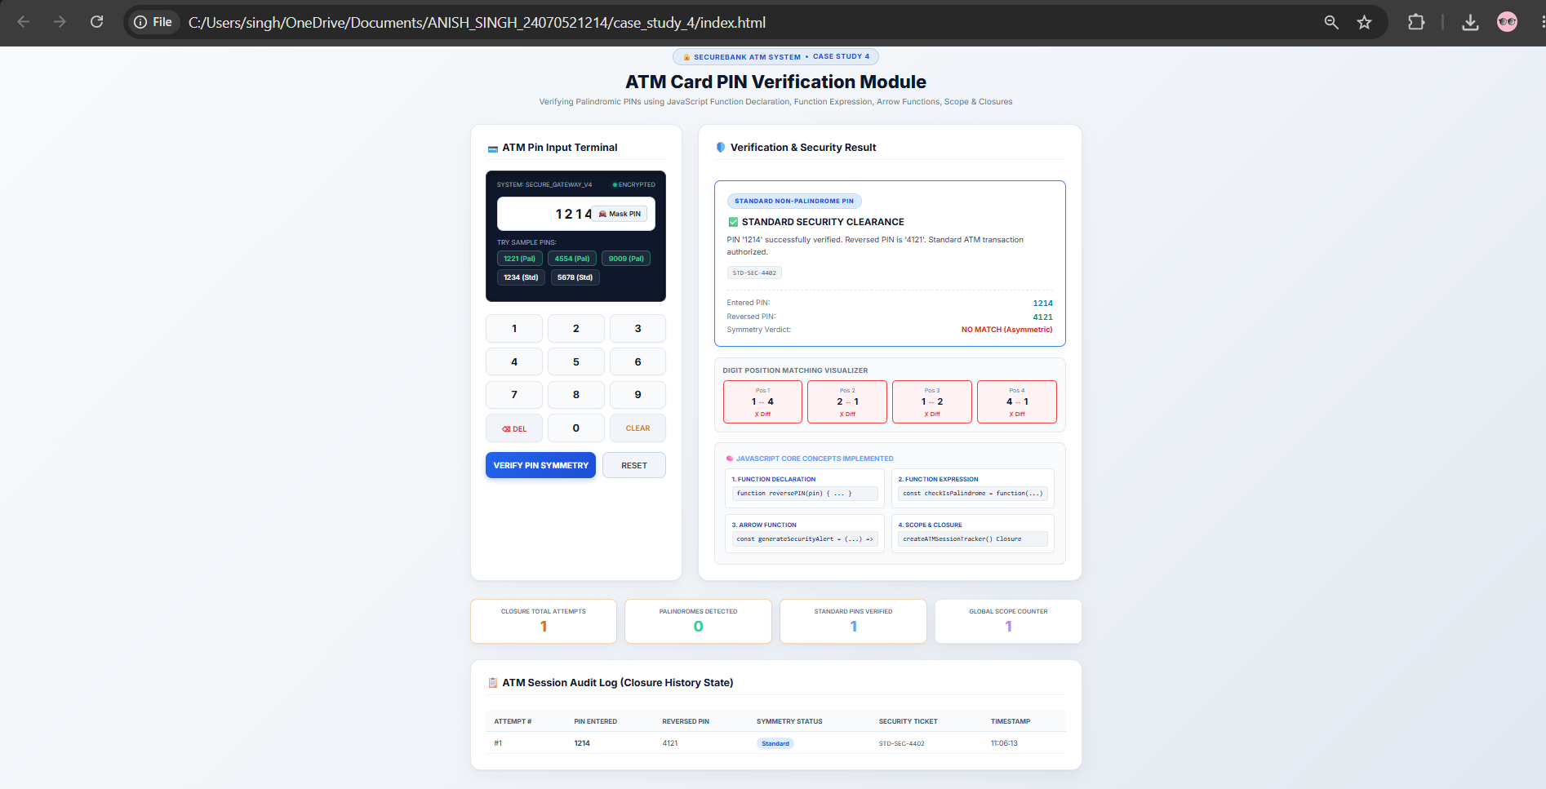

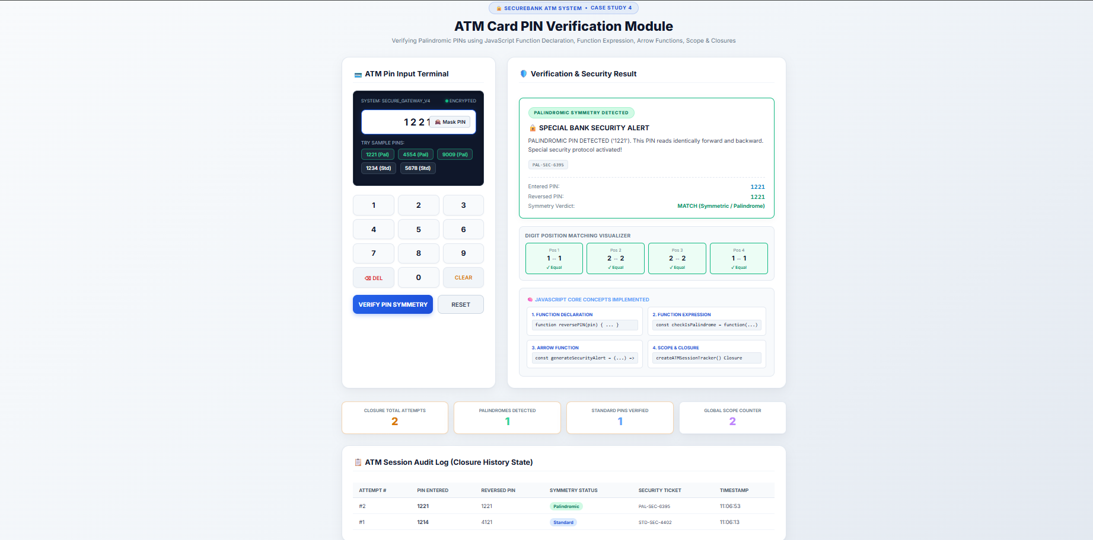

Result/Conclusion:
Case Study 4 successfully demonstrates how to use closures in JavaScript to securely maintain private data (like tracking failed PIN attempts) without exposing it to the global scope. It provides a functional ATM interface that validates palindromic PINs and securely blocks the user after 3 invalid attempts.

