The script from BastionFWProject. Here's what it builds, using your real resource names:
- RG: BastionFW-rg in eastus2
- VNet: BastionFWVNet (10.0.0.0/16) with three subnets: WorkLoad_subnet (10.0.0.0/24), AzureBastionSubnet (10.0.1.0/27), AzureFirewallSubnet (10.0.2.0/26)
- VM: workloadvm (Ubuntu) in WorkLoad_subnet, DNS server set to 8.8.8.8
- Bastion: MyBastionHost with BastionPip
- Firewall: EgressFW with FwPip
- Route table: RTEgress, route dg-to-firewall (0.0.0.0/0 → VirtualAppliance → firewall private IP), associated to WorkLoad_subnet
- Firewall rules: AppRuleCollection (pri 100) → allow www.google.com HTTP/HTTPS; NetRuleCollection (pri 100) → allow UDP 53 to 8.8.8.8
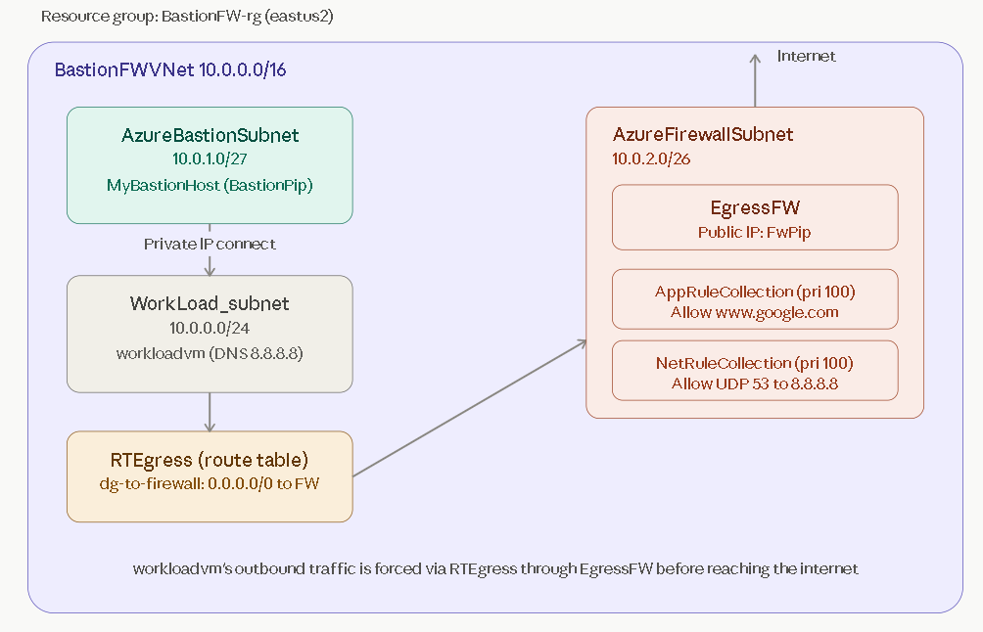
Two things worth noting from your actual code vs. the textbook version:
- Set-AzVirtualNetworkSubnetConfig in FWHelper.ps1 uses $vnetObj.Subnets[0].Name, not an explicit "WorkLoad_subnet" reference — this relies on WorkLoad_subnet staying the first subnet in the array (which it is, since it's listed first in New-AzVNetSubnetsCreation). If subnet order ever changed, the route table would silently attach to the wrong subnet — worth being aware of if you refactor this later.
- Your main.ps1 uses Canonical:0001-com-ubuntu-server-jammy:22_04-lts:latest (Ubuntu), not the Windows VM from the textbook exercise — so RDP via Bastion in the book becomes SSH via Bastion in your actual lab.

