Babu Banarasi Das University, Lucknow
Uttar Pradesh
Descriptive Analytics Report
Amul Product Sales Performance, 2019–2025
Name – Anish Yadav
Roll no. – 1250258088
Course – BCA D&AI
Date – 15-10-2026

Content
Cover page
Content page
Objective
Real-world scale table
Best-selling products
Annual sales trend
Regional demand
Revenue and profit
Rating distribution
Summary of key metrics
Key findings
Recommendations
Appendix

Descriptive Analytics Report: Daily Purchase Behaviour at Scale

Objective
- What are the best-selling Amul products by volume?
- How are the products rated, and has any rating slipped over time?
- In which year were the most products sold?
- Which region generates the highest total unit sales, and has that ranking shifted year over year?
- What is the average retail price by region, and how does the gap vary?
- Which region is most profitable per unit sold, and which is least?
- Is there a growing or declining trend in total sales volume from 2019 to 2025?
- Which products have the highest and lowest average ratings?
- Which product–region combination is the single biggest revenue driver?

How This Would Work at Real Scale
Processing millions of dairy purchases every day is an engineering problem before it is an analytics one. A realistic architecture:
Layer | Purpose | Typical tools
Investigation | Explore the raw dataset: shape, column types, missing values, ranges | df.info(), df.describe(), df.head()
Storage | Hold the dataset for repeated query and sharing | Amul_Sales_Dataset_2019_2025.csv / Excel workbook
Batch aggregation | Compute summary metrics: yearly sales, average rating, profit by region | pandas groupby, pivot_table, .mean(), .sum()
Serving / BI | Present aggregated results as charts and tables | matplotlib charts, Excel / PDF export

The dataset used here is a synthetic monthly sales table of 6,720 rows (20 products × 4 regions × 7 years × 12 months) covering units sold, retail price, discount, revenue, cost, profit and customer rating.

Best-Selling Products
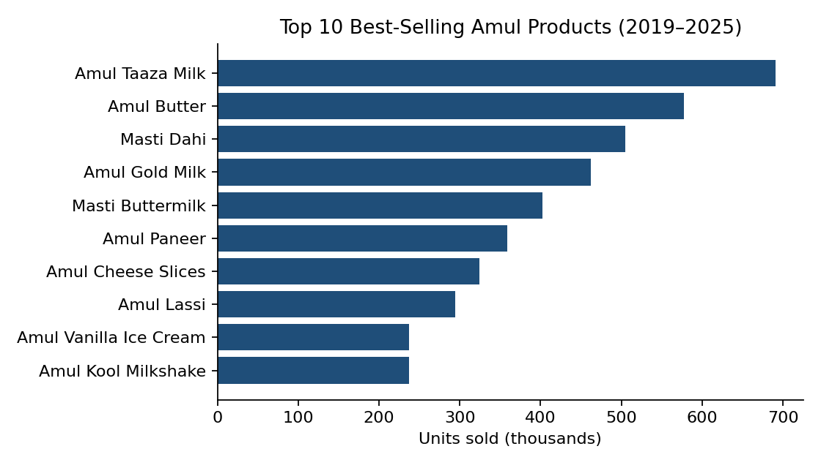
Amul Taaza Milk is the clear best-selling Amul product with approximately 6,90,819 units sold, followed by Amul Butter (5,77,135 units) and Masti Dahi (5,04,643 units). Amul Gold Milk and Masti Buttermilk round out the top five with roughly 4,62,186 and 4,01,959 units. The top five products together account for about 50% of all units, showing strong concentration of demand in everyday milk, butter and curd.
After the top tier, volumes decline steadily: Amul Paneer (~3,58,667), Amul Cheese Slices (~3,24,278) and Amul Lassi (~2,94,555). At the lower end, Amul Protein Shake records the lowest volume at about 31,823 units, with Amul Peda and Mithai Mate also in the long tail. Amul's volume leadership rests on low-priced daily-use products, while premium items such as ghee and cheese contribute far more through unit value than sheer quantity.

Annual Sales Trend
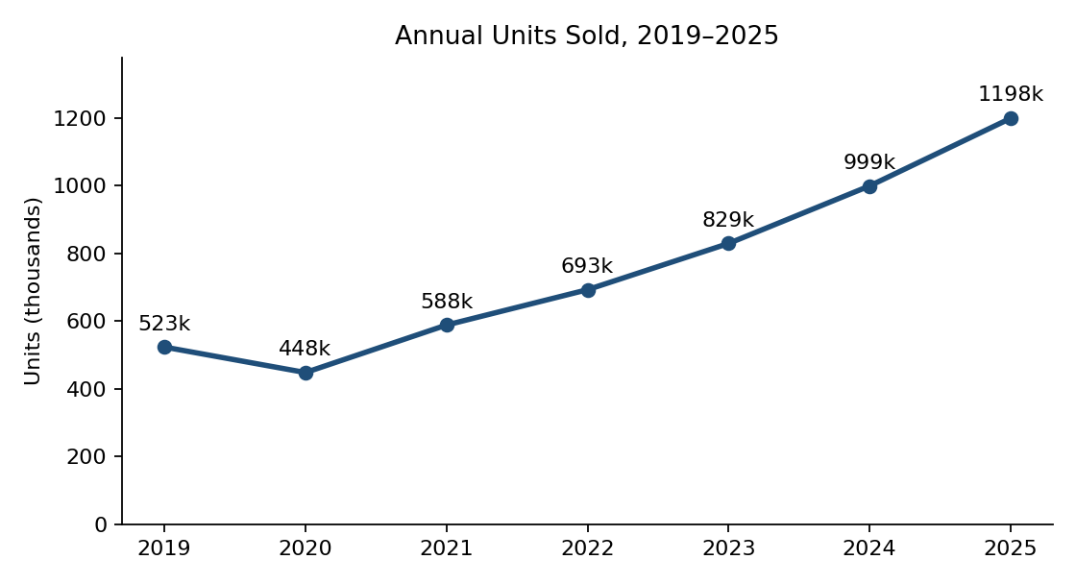
Sales show a broadly upward trend from 2019 to 2025 with a single dip in 2020. In 2019 approximately 5,23,433 units were sold; this fell to around 4,48,249 units in 2020 (-14.4%). Volume recovered in 2021 to 5,88,351 units (+31.3%), then rose through 2022 (6,92,626), 2023 (8,28,970) and 2024 (9,98,729), peaking at 11,98,203 units in 2025.
Across the full period, annual volume rose by about 6,74,770 units, roughly 2.3× the 2019 level (overall growth of ~129%). 2025 is the single highest-selling year in the dataset.

Regional Demand
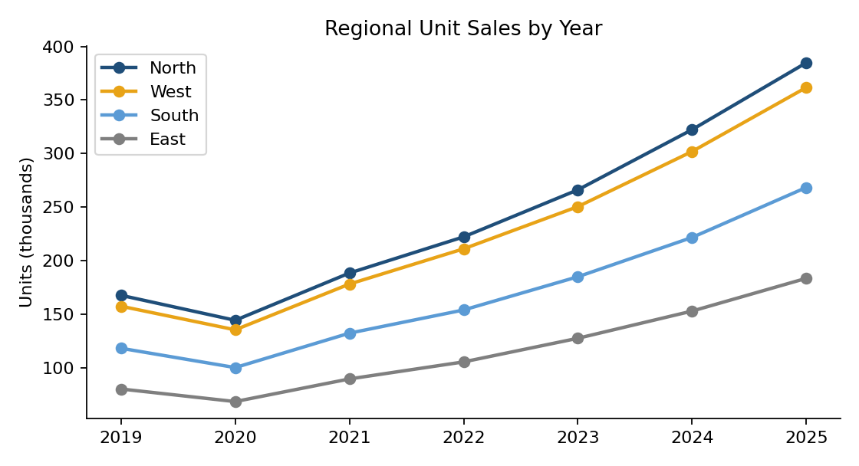
North India is the leading market in every year, growing from roughly 1,67,626 units in 2019 to about 3,84,744 units in 2025. West India follows closely, South India is a clear third, and East India is the smallest of the four regions. The ranking (North > West > South > East) has not shifted in any year.
North India accounts for approximately 32.1% of total volume across the seven years, West 30.2%, South 22.3% and East 15.3%.
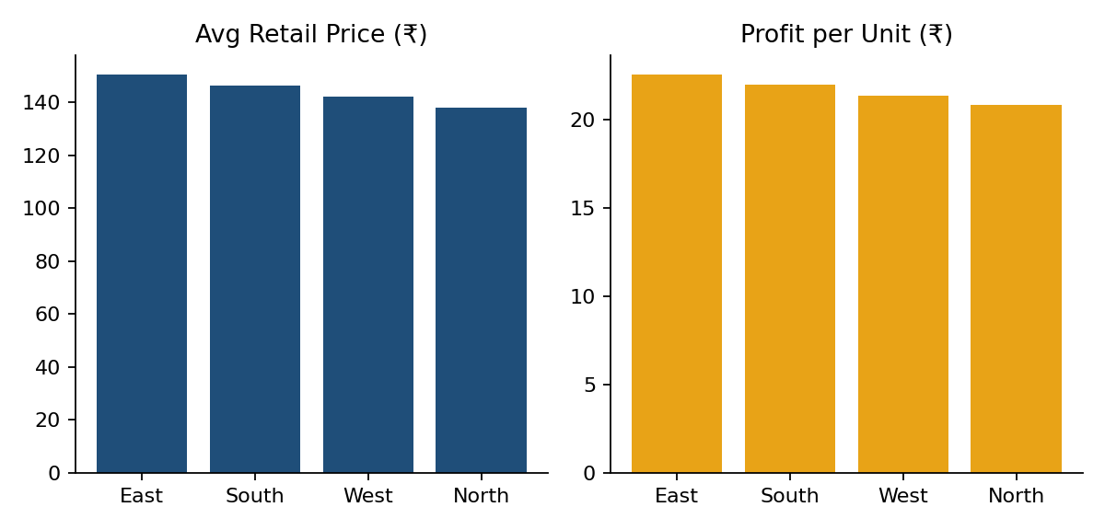
East India has the highest average retail price (≈ ₹150.27), followed by South (≈ ₹146.11), West (≈ ₹141.97) and North (≈ ₹137.92). East India also records the highest profit per unit (≈ ₹22.55), followed by South (≈ ₹21.98), West (≈ ₹21.35) and North (≈ ₹20.86). Although North leads on volume, higher prices in the East give it a modest edge on unit profitability. The gap between the most and least profitable regions is about ₹1.69 per unit, which is fairly tight across the network.

Top Product–Region Revenue Drivers
The strongest product–region combination is Amul Ghee – North India, generating about ₹4.99 crore. It is followed by Amul Ghee – West India (≈ ₹4.83 crore) and Amul Ghee – South India (≈ ₹3.67 crore). Amul Vanilla Ice Cream – North India also ranks in the top five. High-value products dominate the revenue leaderboard even though low-priced milk and butter lead on volume.

Revenue and Profit
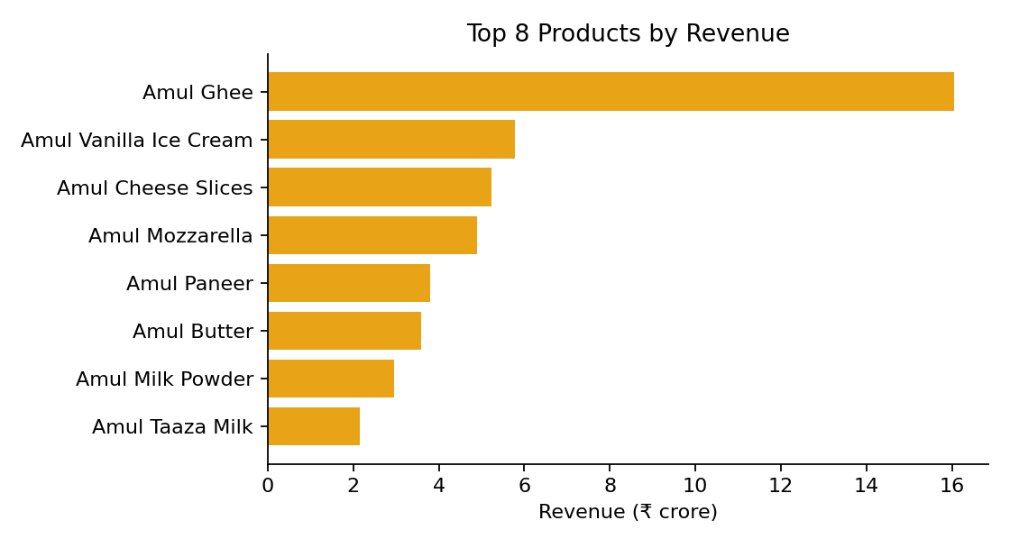
Amul Ghee is by far the largest revenue contributor at approximately ₹16.04 crore, followed by Amul Vanilla Ice Cream (≈ ₹5.79 crore) and Amul Cheese Slices (≈ ₹5.22 crore). The highest-revenue and highest-volume products are therefore not the same item, a classic value-versus-volume pattern. Across seven years total revenue is about ₹57.04 crore and total profit about ₹11.36 crore, an overall margin of 19.9%.
KPI | Value (simulated)
Total units (7 years) | ~5.28 million
Total revenue | ~₹57.04 crore
Total profit | ~₹11.36 crore
Highest revenue product | Amul Ghee (~₹16.04 Cr)
Highest volume product | Amul Taaza Milk (~6,90,819 units)
Highest revenue year | 2025

Rating Distribution
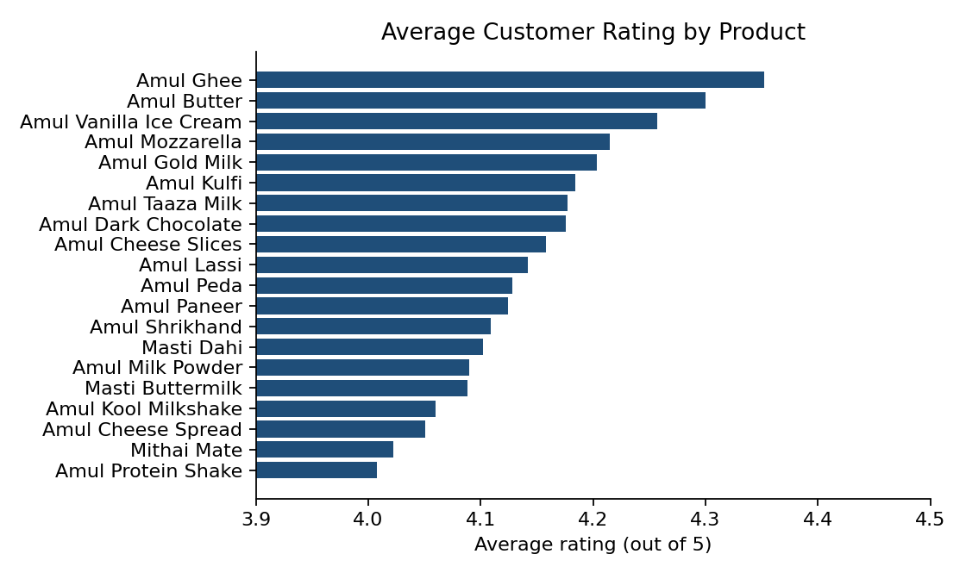
Average ratings are clustered in a narrow band. Amul Ghee (≈ 4.352) and Amul Butter (≈ 4.3) sit at the top, while Amul Protein Shake (≈ 4.008) and Mithai Mate (≈ 4.022) sit at the bottom. The difference between the highest- and lowest-rated products is about 0.34 points, so customer satisfaction is consistently high across the lineup and no product shows a serious quality problem.
Year-level average ratings stay between 4.14 and 4.15 across 2019–2025, with movements well within ordinary noise. There is no sustained downward or upward trend.
KPI | Value
Average Product Rating | 4.15 / 5
Highest Product Rating | ~4.35 / 5
Lowest Product Rating | ~4.01 / 5
Rating Range | ~0.34
Rating Scale | 5

Summary of Key Metrics
Metric | Value (simulated)
Total units sold (7 years) | ~5.28 million
Total revenue | ~₹57.04 crore
Average product rating | 4.15 / 5
Top volume seller | Amul Taaza Milk
Top revenue seller | Amul Ghee
Leading region (volume) | North India
Highest profit/unit region | East India
Regions tracked | 4
Products tracked | 20

Next Steps: Descriptive → Predictive
This report explains what happened in the Amul sales data from 2019 to 2025. The natural next step is predictive analytics:
- Sales forecasting by product, region and year
- Regional growth-rate prediction to identify the fastest-growing market
- Revenue prediction using volume, price and discount history
- Seasonal demand models for ice cream, lassi and festival sweets
- Early-warning models for any future rating deterioration

Key Findings
Volume vs. Revenue Leadership
- Amul Taaza Milk (~6,90,819 units) is the volume leader, yet Amul Ghee is the clear revenue leader (~₹16.04 Cr). Highest-volume and highest-revenue products are not the same.
Growth With One Interruption
- Total unit sales dipped in 2020 then rose every year through 2025. 2025 is the best year in the dataset; overall growth from 2019 is ~129%.
Stable Customer Satisfaction
- Average rating (4.15/5) stayed essentially flat over time; the gap between best- and worst-rated products is only ~0.34 points.
North India Leads on Volume
- North India is #1 by units every year (~32.1% of total volume). East India shows the highest average retail price and a slight edge on profit per unit.
One Combination Dominates Revenue
- Amul Ghee × North India is the single largest product–region revenue driver, followed by the same product in West, South and East India.

Recommendations
Consistent with the descriptive scope of this report, the following are brief, evidence-based observations drawn directly from the findings:
- Protect ghee supply and distribution in North and West India, since this one product–region group drives a disproportionate share of revenue.
- Keep milk, butter and curd as the volume backbone while using ghee, cheese and ice cream as the margin and revenue engines.
- Monitor rating trends annually even though the current pattern is flat; a rolling year-over-year dashboard will surface any genuine downturn early.
- Use East India's higher realised prices and unit profitability as a reference when reviewing pricing and logistics cost in other regions.
- Review the long-tail products (Amul Protein Shake, Amul Peda, Mithai Mate) for either targeted growth or rationalisation, given their low volumes and lower ratings.

Appendix

Full Units-Sold-by-Product Table
Product | Units Sold
Amul Taaza Milk | 6,90,819
Amul Butter | 5,77,135
Masti Dahi | 5,04,643
Amul Gold Milk | 4,62,186
Masti Buttermilk | 4,01,959
Amul Paneer | 3,58,667
Amul Cheese Slices | 3,24,278
Amul Lassi | 2,94,555
Amul Vanilla Ice Cream | 2,36,937
Amul Kool Milkshake | 2,36,863
Amul Ghee | 2,25,541
Amul Kulfi | 1,85,111
Amul Cheese Spread | 1,51,150
Amul Mozzarella | 1,37,486
Amul Shrikhand | 1,29,706
Amul Dark Chocolate | 1,09,924
Amul Milk Powder | 91,457
Mithai Mate | 74,089
Amul Peda | 54,232
Amul Protein Shake | 31,823

Full Average-Rating-by-Product Table
Product | Avg. Rating
Amul Ghee | 4.352
Amul Butter | 4.300
Amul Vanilla Ice Cream | 4.257
Amul Mozzarella | 4.215
Amul Gold Milk | 4.203
Amul Kulfi | 4.184
Amul Taaza Milk | 4.177
Amul Dark Chocolate | 4.176
Amul Cheese Slices | 4.158
Amul Lassi | 4.142
Amul Peda | 4.128
Amul Paneer | 4.124
Amul Shrikhand | 4.109
Masti Dahi | 4.102
Amul Milk Powder | 4.090
Masti Buttermilk | 4.088
Amul Kool Milkshake | 4.060
Amul Cheese Spread | 4.051
Mithai Mate | 4.022
Amul Protein Shake | 4.008

Revenue by Category
Category | Revenue (₹ crore)
Dairy Staples | 22.79
Cheese | 11.97
Ice Cream | 6.61
Milk | 3.90
Dairy Spreads | 3.59
Curd & Drinks | 3.29
Sweets | 2.53
Chocolates | 1.34
Flavoured Milk | 1.02

— End of Report —
Synthetic dataset & charts generated for academic descriptive-analytics demonstration. Dataset file: Amul_Sales_Dataset_2019_2025.csv

