Cognitive Robotics and Autonomous Systems Center (CRAS Center)
MedRoboAI Unit: Translational Research in Medical Robotics & AI in Healthcare
From Lab Bench to Clinical Use
CRAS Center Director | Prof. Anis Koubaa
CRAS Center Deputy Director | Prof. Driss Benhaddou
Unit Lead | Dr. Mohamed Bahloul
Initial launch horizon | 12 months (with scalable multi‑year roadmap)

Executive summary
This proposal establishes a dedicated unit within the Cognitive Robotics and Autonomous Systems Center to accelerate clinically relevant innovation in medical robotics, robotic surgery copilots, medical simulators, and AI in healthcare.
The unit is designed as a translation engine that connects CRAS robotics/autonomy capabilities with clinical needs, academic talent pipelines, and engineering validation capacity to produce demonstrable prototypes and translation-ready packages.

Vision and mission

Vision:

Build a nationally visible, clinically grounded hub delivering safe, validated, and transferable medical robotics and AI solutions.

Mission (Year 1)
- Deliver two pilot prototypes (simulation/bench validated) and at least one translation-ready package (evaluation + documentation + adoption plan).
- Establish a repeatable translation pipeline (needs finding → prototype → verification/validation → translation).
- Strengthen CRAS Center collaboration through shared infrastructure, joint proposals, co-supervision, and ecosystem engagement.

Scope and thematic pillars
- Medical Robotics (assistive/rehabilitation, image-guided robotics, safe human–robot interaction)
- Surgical Robotics Copilots (workflow intelligence, perception, skill assessment, safety monitoring)
- Medical Simulation & Training (VR/AR/haptics simulation, competency metrics, procedure rehearsal)
- AI in Healthcare (biomedical imaging/radiology, clinical AI, physiologic AI, decision support)
- Translation & Ecosystem Engagement (evaluation, documentation, partnerships, technology transfer)

Synergy model and collaboration
MedRoboAI is designed to integrate tightly with CRAS Center programs and infrastructure, while leveraging complementary strengths across the Colleges and the healthcare ecosystem:
- CRAS Center of Excellence: Robotics/autonomy platforms, shared testbeds, center governance, and cross-lab engineering integration.
- Alfa‑HI: Clinical needs finding, healthcare ecosystem partnerships, innovation pipeline, and translational program alignment.
- Translational Biomedical Engineering Research Lab: Rapid prototyping, verification/validation, publications, and IP support.
- Biomedical Engineering Department: BME curriculum alignment, capstones, clinical engineering pipeline, and co-supervision.
- Electrical Engineering Department: Controls, embedded systems, sensing, signals/AI, and systems engineering co-supervision.
- Software Engineering Department: Software architecture, MLOps, safety-by-design software practices, and productization support.
- Advanced Computing Division: High-performance compute, data infrastructure, scalable AI training/inference, and advanced computing expertise.

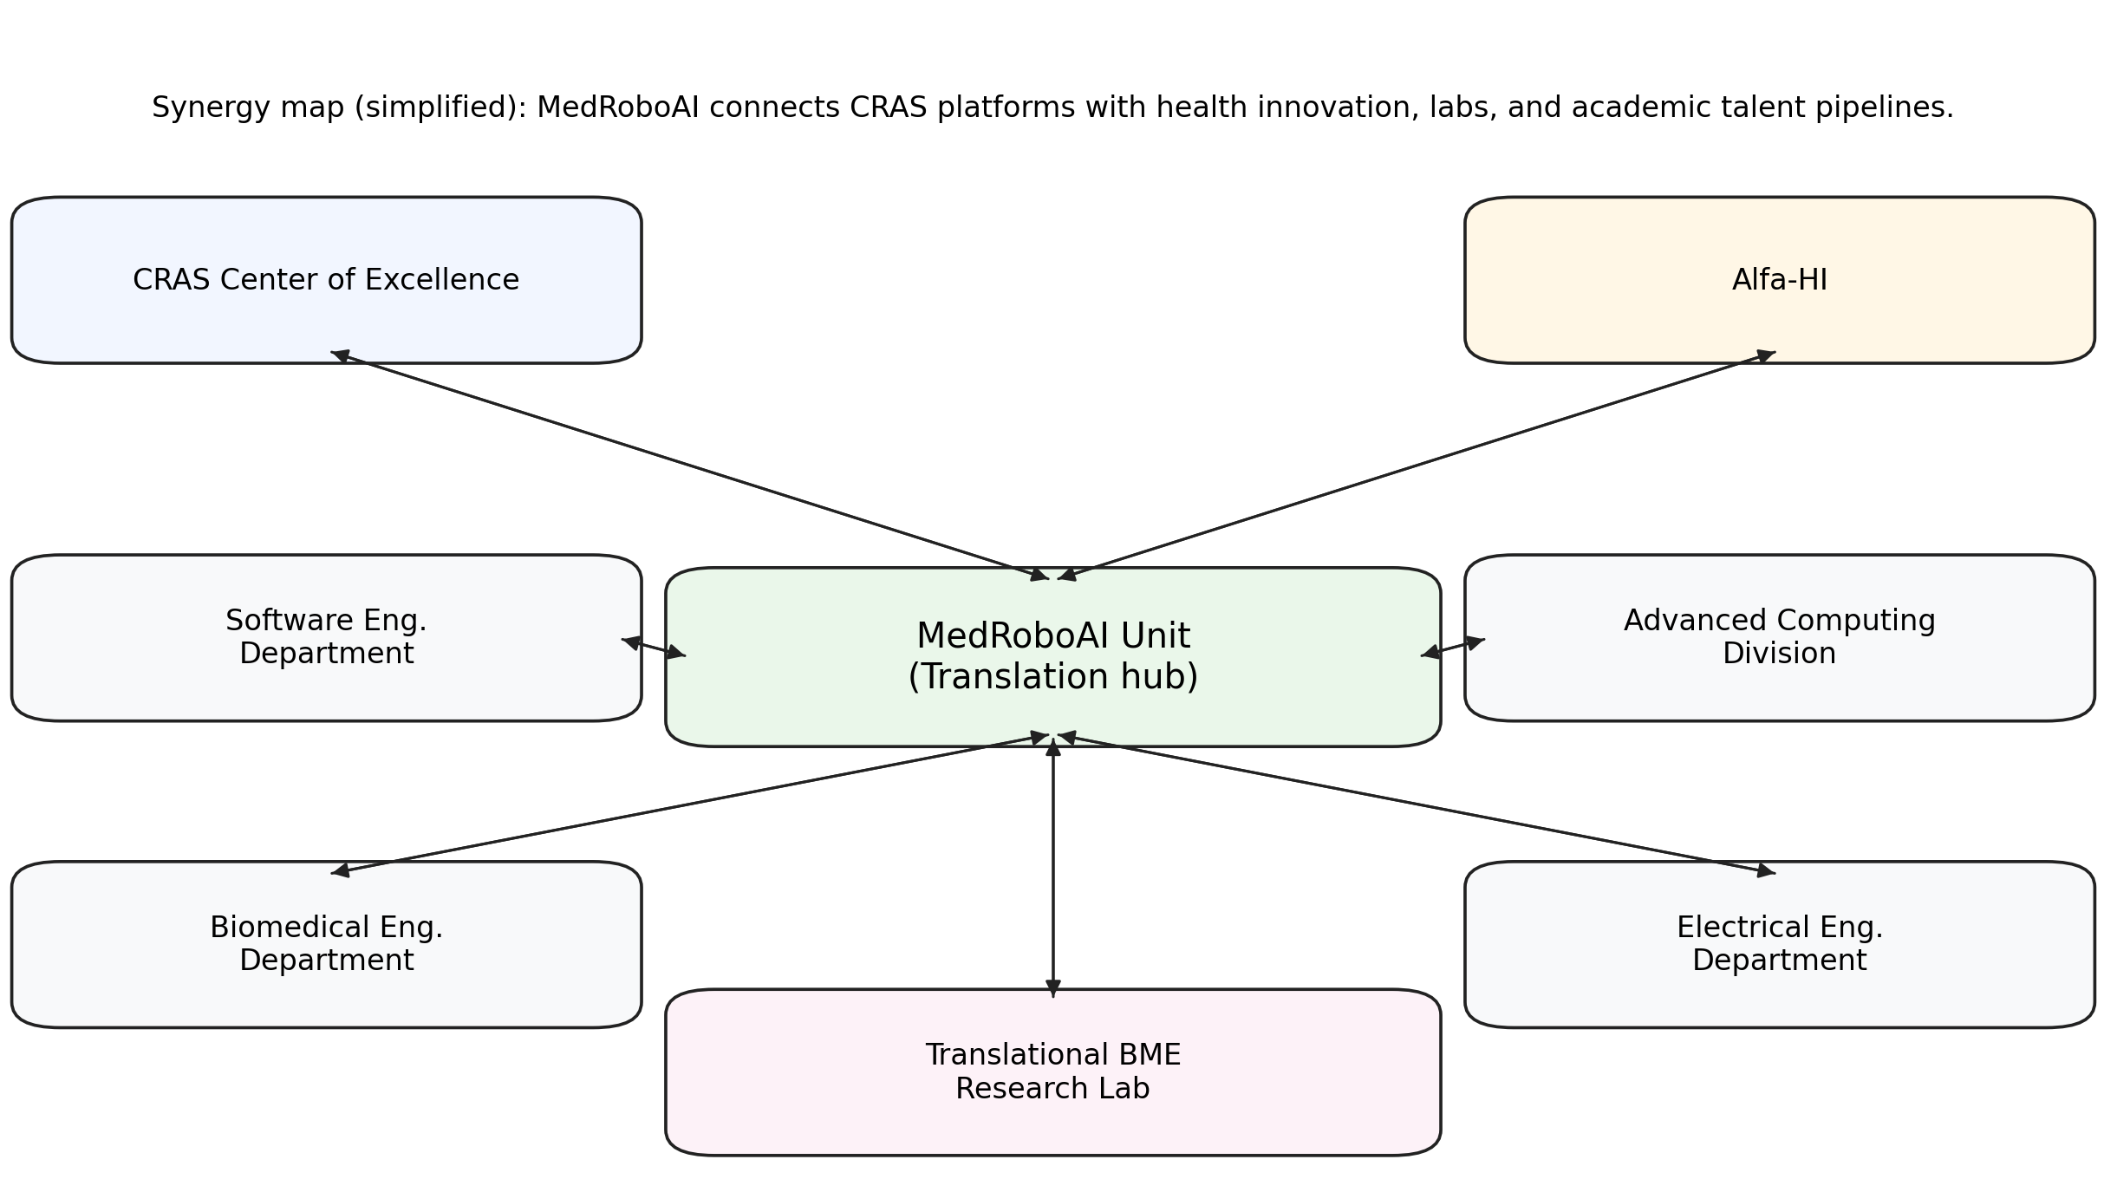

Operating model (recommended personnel hierarchy)
A simple, delivery-focused hierarchy is recommended to ensure both governance and execution speed:
- CRAS Center Director and Deputy Director (oversight and alignment)
- MedRoboAI Unit Lead (strategy, delivery accountability, stakeholder alignment)
- Unit Executive Committee (pillar leads + operations lead; monthly delivery review)
- Pillar Leads (technical roadmaps and deliverables)
- Core Team (program/ops, robotics/software engineering, data/ML, clinical coordination)
- Researchers and trainees (postdocs, MSc/PhD, capstones, interns)
- Clinical and industry advisory groups (periodic review for relevance, safety, and transfer readiness)

5. Year‑1 plan (high-level)
The unit will deliver two pilots and a translation playbook within 12 months:
- Pilot 1: Surgical Robotics Copilot (simulation-first MVP). Workflow recognition + safety prompts + measurable performance metrics in a simulator environment.
- Pilot 2: Medical Simulator Module. One procedure-focused simulator with objective skill scoring and feedback.
- Translational Playbook. Templates for data readiness, evaluation, documentation, and project gating (prototype → V&V → translation).

12‑month roadmap (quarterly milestones)
- Q1: Clinical needs-finding; select 2 use-cases; define success metrics; establish governance templates.
- Q2: Prototype v1 for both pilots; bench/simulation verification; first joint proposal submission.
- Q3: Prototype v2; usability/workflow studies; demo day; clinician-facing workshop delivery (part 1).
- Q4: Translation package for at least one pilot; publications/IP; workshops (part 2); SmartTech 2026 track execution; Year‑2 roadmap.

Clinician-facing workshops (healthcare ecosystem engagement)
An approved four-workshop program will run during mid‑January to February 2026, co-led by Dr. Mohamed Bahloul and Prof. Anis Koubaa, targeting clinicians and the wider healthcare ecosystem.
- الذكاء الاصطناعي في التصوير الطبي (AI in Medical Imaging)
- الذكاء الاصطناعي لتحسين نتائج المرضى (AI for Improving Patient Outcomes)
- تخصص الذكاء الاصطناعي في الرعاية الصحية (AI in Healthcare Specialization Track)
- تعلّم الآلة بلغة بايثون لمتخصصي الرعاية الصحية (Machine Learning with Python for Healthcare Professionals)
Each workshop will combine fundamentals and advanced applications with hands-on components (coding, case studies, and implementation templates) to seed pilot projects and strengthen the ecosystem pipeline.

7. SmartTech 2026 dedicated track
MedRoboAI will curate and lead a dedicated SmartTech 2026 track on Medical Robotics and AI in Healthcare, including keynotes/panels, technical sessions, tutorials (coding for the medical sector), and demo/poster showcases.

8. KPIs (12‑month targets)
- Two pilots launched; at least one demo-ready validated prototype
- Two or more joint funding submissions (center + external/industry)
- Two or more publications; at least one IP disclosure/patent filing
- Four workshops delivered (Jan–Feb 2026) and active engagement of clinicians and ecosystem partners
- At least two active clinical/industry collaborations with documented milestones
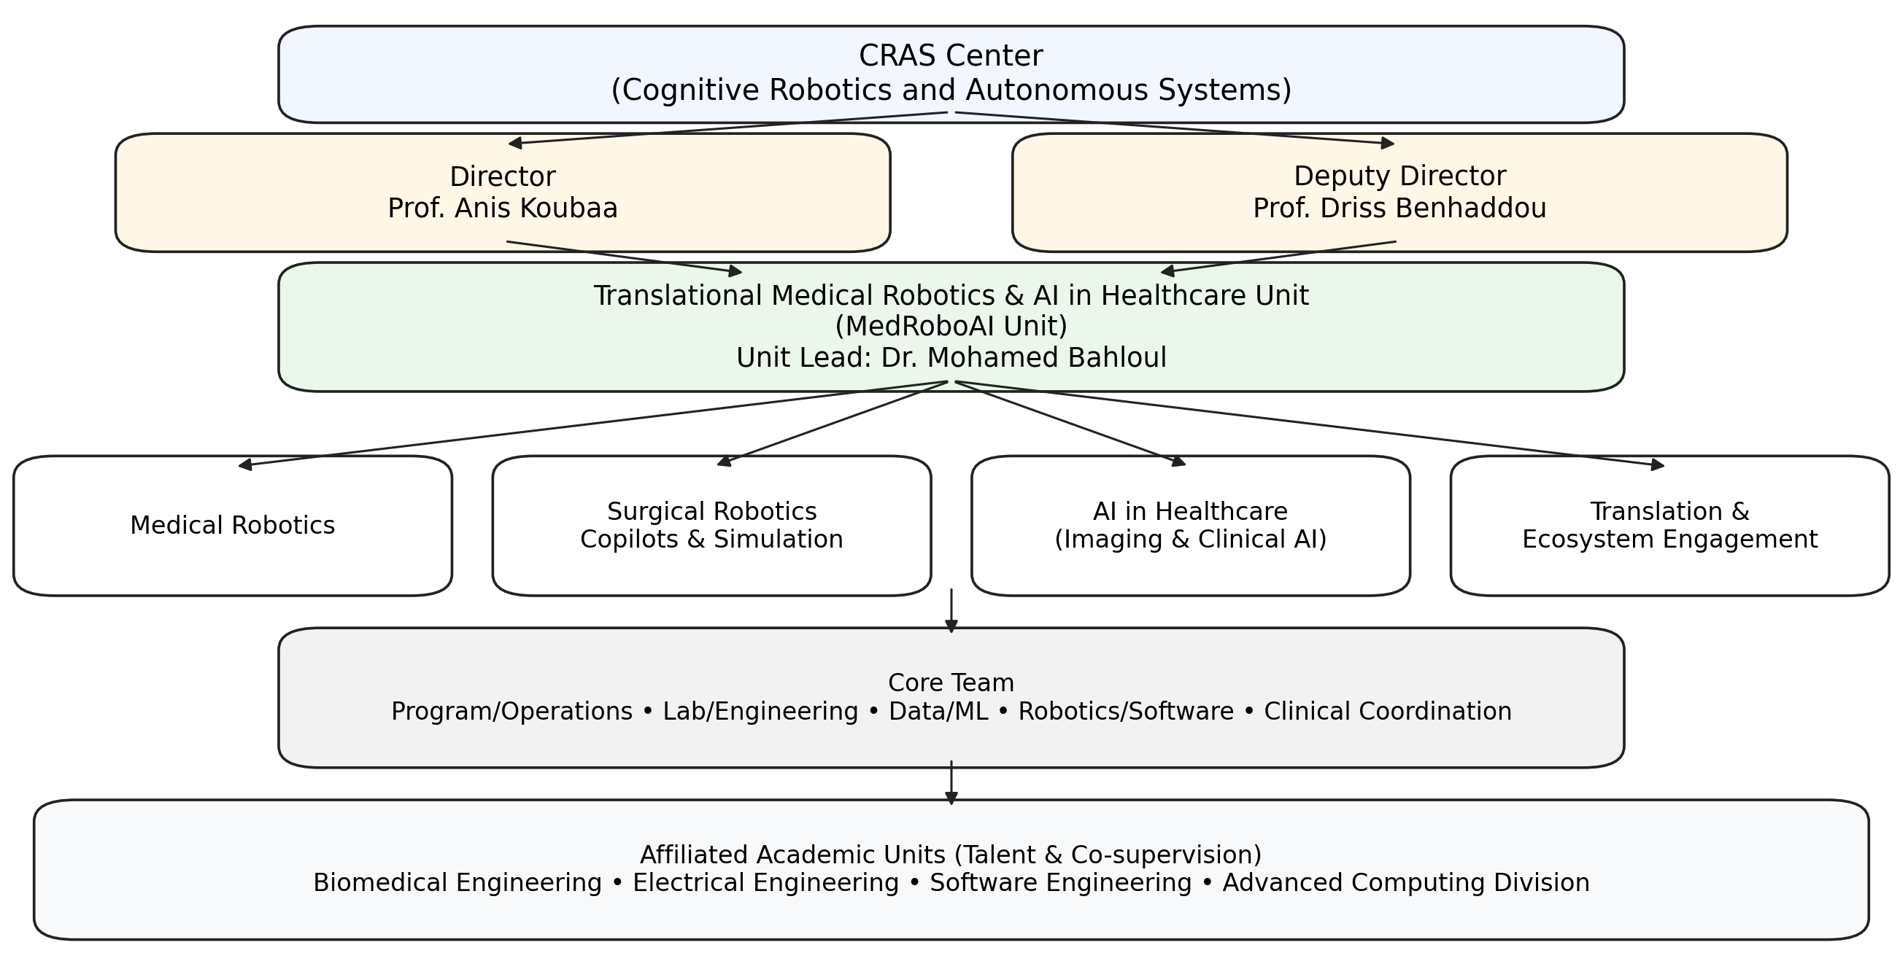
Figure 2. Simplified synergy map (CRAS + Alfa‑HI + departments + lab).

References (links)
- WHO Global Strategy on Digital Health 2020–2025: https://www.who.int/publications/i/item/9789240020924
- NIST AI Risk Management Framework (AI RMF 1.0):
https://www.nist.gov/itl/ai-risk-management-framework
- Saudi Vision 2030 – Health Sector Transformation Program: https://www.vision2030.gov.sa/en/explore/programs/health-sector-transformation-program
- SFDA (Saudi Food & Drug Authority) – Medical Devices portal: https://www.sfda.gov.sa/en/medicaldevices

