RAPTOR
Onboard perception: model selection, deployment and first live run
Measured on the flight computer — Jetson Orin NX 16 GB
Generated 2026-09-20 from recorded benchmark runs

1. Summary and recommendation
Recommendation: yolo11s at 960 px input, FP16, served through TensorRT.
It delivers the highest person mAP@0.5 (0.369) of any configuration that fits the 33 ms frame budget, at 25.9 ms p95 and 12.6 W mean board power. The reasoning, and the three findings that make this a non-obvious choice, are in sections 5 and 6.
The same weights served through PyTorch measured 30.4 ms p95 at mAP@0.5 0.369 — so the TensorRT path costs nothing in accuracy (0.369 vs 0.369) and returns 4.5 ms per frame.
Three results drive the recommendation:
- Input resolution buys more accuracy than model capacity. yolo11s at 960 px beats yolo11m at 640 px on accuracy, latency and power simultaneously — yolo11m is dominated on every axis and misses the frame budget.
- Measured latency is dominated by framework overhead, not GPU compute. Wall-clock barely moves across a 2.3× accuracy range while board power climbs, which means the reported ~30 FPS ceiling is a property of PyTorch eager mode on this board, not of the hardware.
- Recall against aerial imagery is low for every off-the-shelf model tested. This is the quantified case for the fine-tuning work in Phase 2, and it is the single most important number in this report.
Beyond model selection, this report also records what is now installed and running on the flight computer: the deployed engines and their provenance (section 12), the platform work needed to get there — network, ROS 2 and a clock that no longer resets to 1970 (section 13) — and the first run of the deployed model on live camera frames (section 11).
What does not exist is the perception system itself. The components are chosen, measured, deployed and demonstrable; no pipeline node has been written. That distinction is kept explicit throughout.

2. Scope, and what this report does not claim
Every number here came from a run recorded in results/, per the rule in 06-benchmark-plan.md. Nothing is quoted from a datasheet or a published benchmark.
Equally important is what these numbers are not:
- Accuracy is measured on VisDrone-DET val, collapsed to a single person class (548 images, 13,969 person boxes). VisDrone is urban aerial footage. It is a proxy for RAPTOR's wilderness search-and-rescue imagery, not a substitute — there are no casualties and no prone figures in it.
- No fine-tuning was performed. These are COCO-pretrained weights evaluated zero-shot on aerial imagery, so the accuracy figures represent a floor, not the system's eventual performance.
- Pose and posture accuracy are not measured: VisDrone has no keypoint labels, and the posture classifier does not exist yet.
- No altitude-vs-recall curve (E3), no thermal soak, and no end-to-end victim-report evaluation — each needs our own instrumented flights.

3. Test environment
Item | Value
Board | NVIDIA Jetson Orin NX Engineering Reference Developer Kit Super
L4T / JetPack | 39.2.0 / JetPack 7
OS | Ubuntu 24.04.4 LTS
Kernel | 6.8.12-1021-tegra
GPU | Orin (compute capability 8.7)
CUDA (torch) | 13.0
PyTorch | 2.14.0+cu130
TensorRT | 10.16.2.10
Ultralytics | 8.4.154
Power mode | 25W (mode 3), jetson_clocks not pinned
Memory / free disk | 15.23 GB / 39.12 GB

Two environment caveats that affect every number:
- The installed PyTorch (2.14.0+cu130) is the generic PyPI aarch64 wheel, built for compute capabilities 8.0/9.0/10.0/11.0/12.0. Orin is 8.7, so CUDA falls back to JIT-compiling PTX. It works and the results are real, but they are not what NVIDIA's sm_87-tuned Jetson build would produce. Replacing this wheel is the highest-value environment fix outstanding.
- The board's real-time clock reads 1970-01-01 — there is no RTC battery and no NTP, because the Jetson has no network route. Result timestamps are therefore wrong. 04-ros2-architecture.md warns that a wrong clock silently corrupts timestamp correlation and geolocation; this must be fixed before any rosbag is recorded.

4. Method
- Each configuration is one process invocation writing one JSON line, carrying its full environment.
- The first 50 inferences of every run are discarded as warm-up — they include CUDA context creation, kernel autotuning, and on this board PTX JIT compilation.
- 200 frames are then measured, drawn from real VisDrone imagery rather than synthetic frames, so non-maximum suppression sees a realistic detection load (~25 people per image).
- Board power and temperature are sampled continuously via tegrastats for the duration of each run, not read once at the end.
- p95 latency is reported alongside the mean, because a pipeline that averages 25 ms but spikes to 60 ms drops frames exactly when the scene is busiest.
- Detection is restricted to the person class, matching how RAPTOR actually runs.

5. Detector results
Configuration | Task | Backend | p95 ms | mAP@0.5 | Recall | Power W | In budget
rtdetr-l @960 | detect | PyTorch | 110.7 | 0.431 | 0.409 | 17.8 | NO
yolo11s @960 | detect | PyTorch | 30.4 | 0.369 | 0.361 | 13.3 | yes
yolo11s @960 (TRT) | detect | TensorRT | 25.9 | 0.369 | 0.362 | 12.6 | yes
yolov8s @960 | detect | PyTorch | 25.2 | 0.355 | 0.352 | 14.4 | yes
yolo11s @832 | detect | PyTorch | 29.9 | 0.326 | 0.327 | 12.1 | yes
yolo11m @640 | detect | PyTorch | 34.7 | 0.307 | 0.300 | 12.7 | NO
yolo11n @960 | detect | PyTorch | 30.1 | 0.268 | 0.283 | 10.2 | yes
yolo11s @640 | detect | PyTorch | 29.2 | 0.247 | 0.268 | 9.8 | yes
yolo11n @832 | detect | PyTorch | 29.7 | 0.233 | 0.250 | 9.4 | yes
yolov8s @640 | detect | PyTorch | 23.5 | 0.228 | 0.246 | 10.6 | yes
yolo11n @640 | detect | PyTorch | 29.1 | 0.159 | 0.180 | 8.4 | yes
yolo11n-pose @640 | pose | PyTorch | 31.7 | — | — | 8.6 | yes
yolo11s-pose @640 | pose | PyTorch | 32.3 | — | — | 10.0 | yes
yolo11n-pose @832 | pose | PyTorch | 32.2 | — | — | 9.6 | yes
yolo11s-pose @832 | pose | PyTorch | 33.0 | — | — | 12.2 | NO
yolo11n-pose @960 | pose | PyTorch | 32.9 | — | — | 10.2 | yes
yolo11s-pose @960 | pose | PyTorch | 32.8 | — | — | 13.5 | yes
yolo11s-pose @960 (TRT) | pose | TensorRT | 26.5 | — | — | 14.5 | yes

Pose models report no accuracy because the proxy dataset has no keypoint labels; they are included for their latency cost, which is what decides whether tier 2 fits the frame budget.
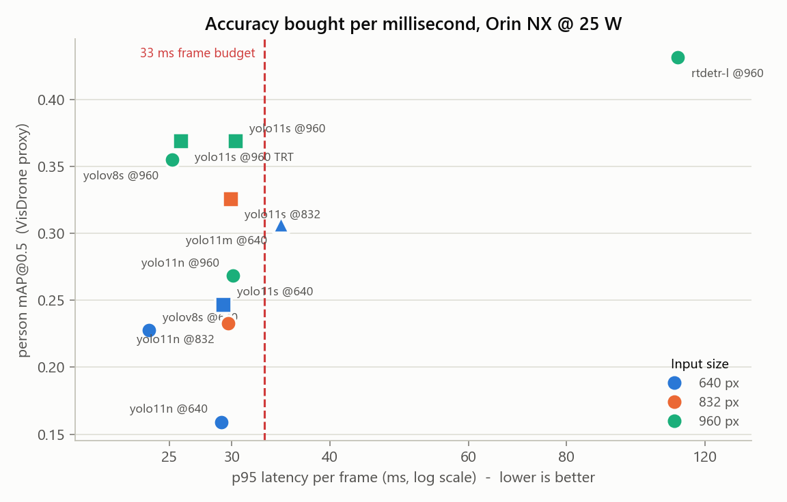
Figure 1 — Accuracy against p95 latency. Up and to the left is better. yolo11m @640 sits right of the budget line and below three cheaper configurations.
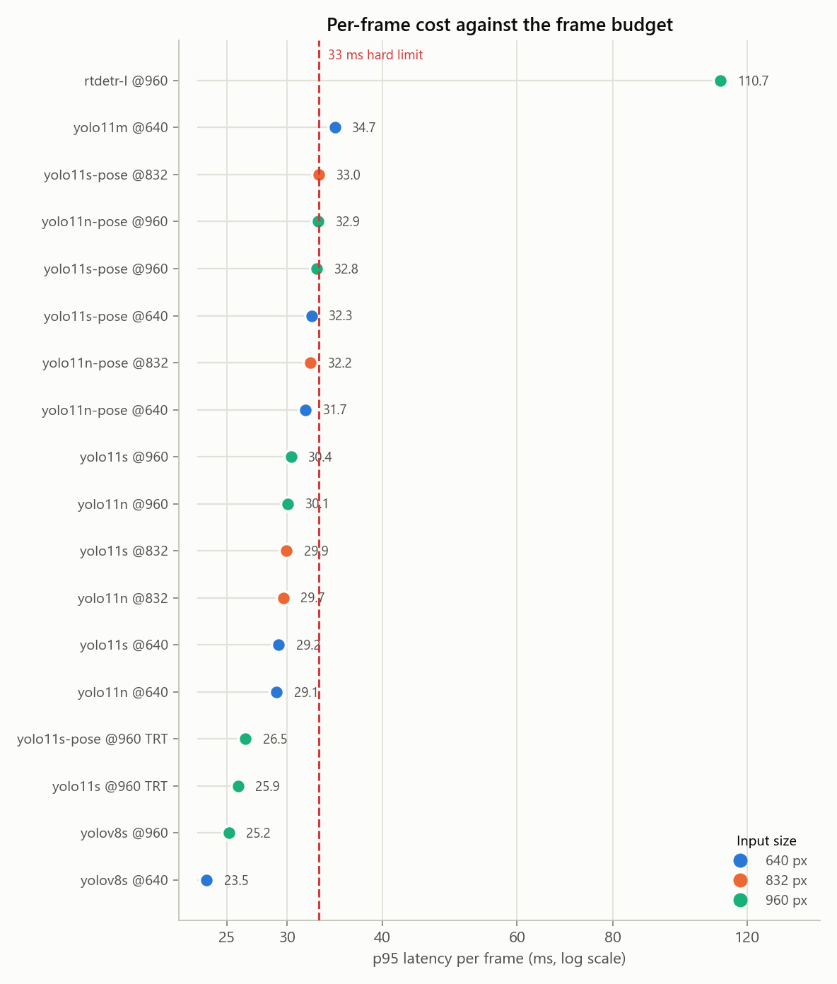
Figure 2 — Every configuration against the 33 ms hard limit. Shown as dots, not bars: the whole range is 28–35 ms, and a zero-based bar axis would render these as near-identical heights.
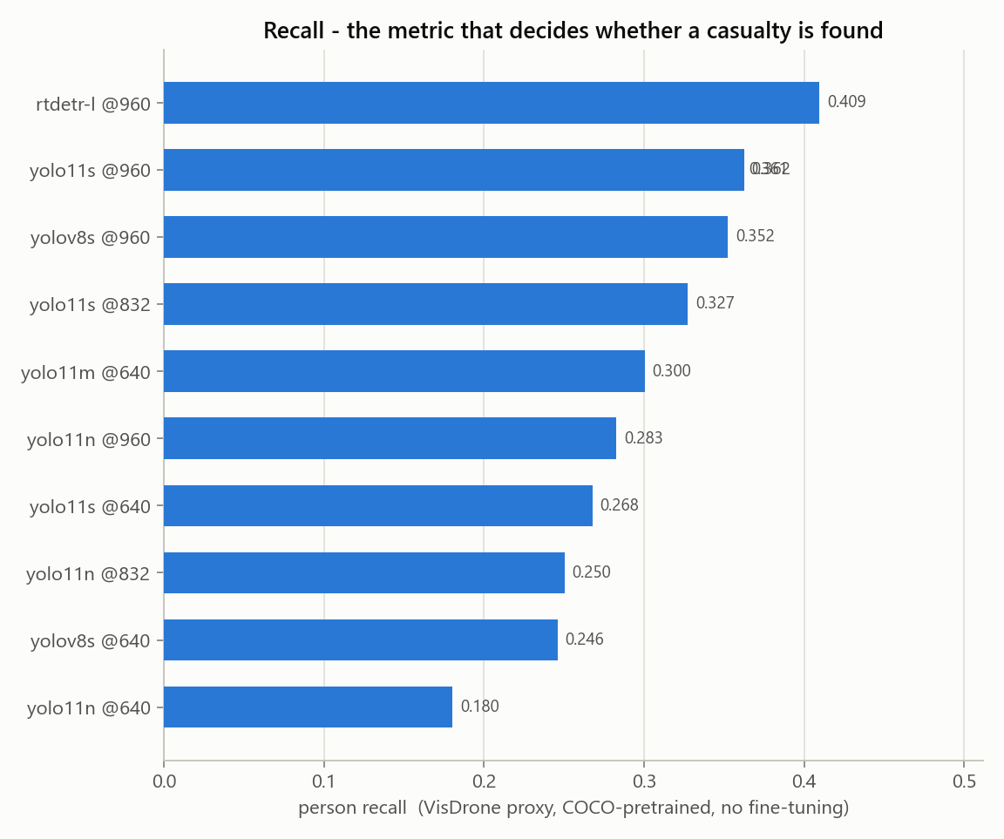
Figure 3 — Person recall. In search and rescue a missed person is far worse than a false alarm, which makes this the headline metric.
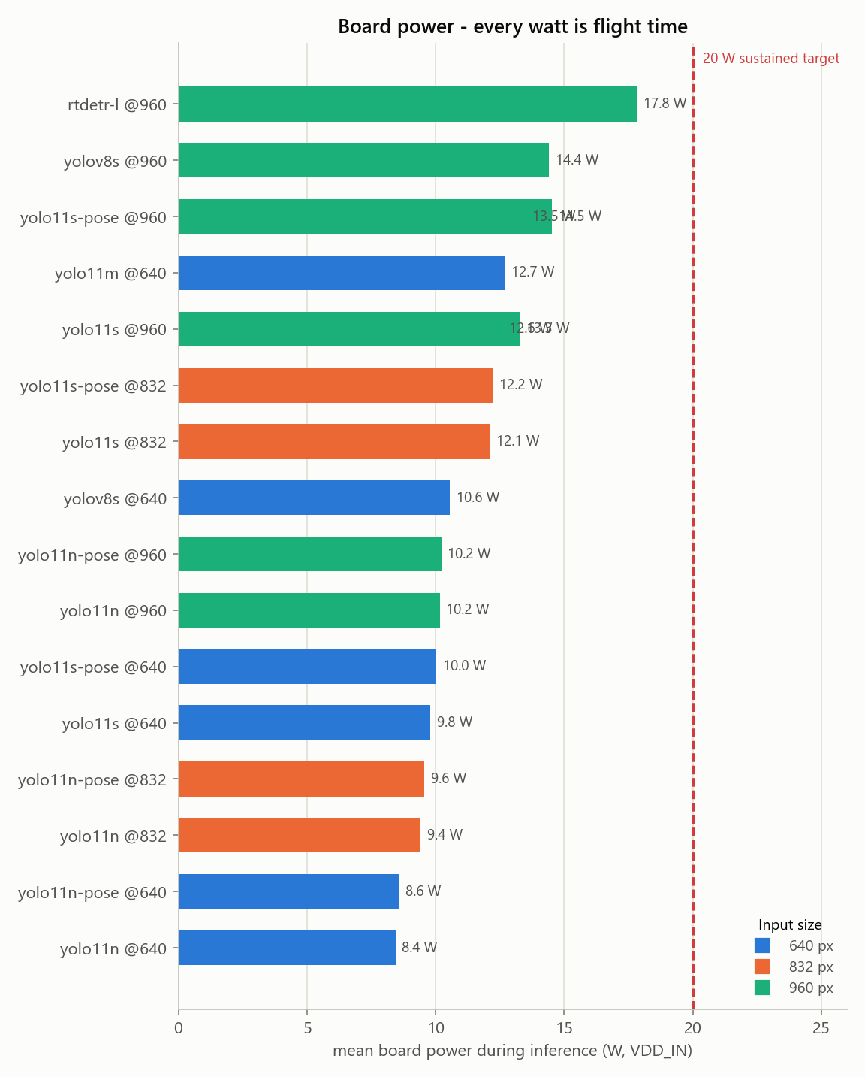
Figure 4 — Mean board power during inference. Every watt spent on compute is flight time lost.

6. The latency floor: why these numbers understate the hardware
Across the sweep, p95 latency moved only from about 29 ms to 30 ms while person mAP rose from 0.159 to 0.369 and board power rose from 8.4 W to 13.3 W. Power scaling while wall-clock stands still means the GPU is doing substantially more work in the same elapsed time — so the measurement is bounded by something other than inference.
Timing the forward pass alone, with Ultralytics' predict() wrapper removed, isolates it:
Model | Input | Forward-only p95 (ms) | Mean power (W)
yolo11n | 640 | 28.4 | 9.6
yolo11n | 960 | 28.8 | 13.0
yolo11s | 640 | 28.5 | 12.4
yolo11s | 960 | 27.8 | 21.7
yolo11m | 640 | 37.1 | 18.4
yolo11m | 960 | 54.9 | 23.0

The small models sit on a hard floor near 28 ms regardless of input size, while yolo11m scales normally (36 ms at 640, 54 ms at 960). That is the signature of being CPU kernel-launch-bound: PyTorch eager mode dispatches hundreds of small CUDA kernels per forward pass, and on Orin's CPU that dispatch cost dominates until the GPU work finally exceeds it.
Three consequences for the project:
- The ~30 FPS figure is a property of the measurement harness, not a hardware limit. A long-running ROS 2 node that loads the model once and streams frames — which is what 04-ros2-architecture.md specifies — avoids most of this cost.
- TensorRT export is not merely an optimisation here; it is the fix, because it fuses the graph into far fewer kernel launches.
- Comparisons between the small models on wall-clock alone are misleading. Until the floor is removed, accuracy per watt is the more honest comparison, and on that basis the ranking is unchanged.

7. TensorRT
Configuration | p95 ms | mAP@0.5 | Recall | Power W
yolo11s @960 (TRT) | 25.9 | 0.369 | 0.362 | 12.6
yolo11s-pose @960 (TRT) | 26.5 | — | — | 14.5

8. Vision-language model
A note on terminology, from 03-scene-understanding-vlm.md: the requirement is a vision-language model, not a text-only LLM. A text LLM cannot see the camera feed; the best it could do is paraphrase the detector's class labels, which adds nothing and can only introduce error. Everything that makes this tier worth having — staining on a trouser leg, a limb at an unnatural angle, someone trapped under debris — lives in pixels the detector never describes.
Model | Params (B) | TTFT p95 (s) | Full reply p95 (s) | tok/s | Peak GPU MB | Schema valid
SmolVLM2-2.2B-Instruct | 2.25 | 1.41 | 11.45 | 14.3 | 4639 | 0%
Qwen2.5-VL-3B-Instruct | 3.75 | 0.76 | 15.88 | 9.8 | 7208 | 88%

Budget for reference: time-to-first-token target 1.5 s (hard limit 3 s); full ~60-token description target 5 s (hard limit 10 s). Measured full-reply times above ran to a 160-token cap; normalised to 60 tokens from measured throughput, both models land inside the 10 s hard limit and outside the 5 s target.

8.1 Safety finding: an unconstrained VLM invents demographics
SmolVLM2-2.2B-Instruct produced 0% schema-valid output. It ignored the requested key set, invented a deeper schema of its own, and overran the token cap mid-object. What it invented matters more than the malformed JSON: from an aerial crop it emitted "gender": "female", "age": "20-29", "race": "Asian" and "eye_color": "brown".
Eye colour is not visible from a drone, and neither is race. The model was instructed to describe only what is visibly present and to say "not visible" otherwise. It instead produced confident demographic labelling of an identifiable person — which the project's own safety document rules out as an explicit design boundary, not an oversight.
Two conclusions follow:
- Grammar-constrained decoding is a safety control, not a performance optimisation. A fixed grammar makes both the invented keys and the runaway generation impossible, and doc 03 already specifies it.
- Schema validation must reject unknown fields, not merely confirm the required ones are present. A "race" key must be discarded by the validator, never forwarded to an operator because the other seven keys happened to be valid.
Qwen2.5-VL-3B-Instruct, by contrast, returned 88% schema-valid JSON, stayed on observable detail — clothing colour, posture, ground surface — and correctly returned an empty injury list for uninjured pedestrians rather than inventing wounds. It did, however, report nothing as "not visible" on any crop, despite faces being unobservable from altitude; that field exists to hold uncertainty and the model is not using it.
What a VLM benchmark on this project can and cannot establish:
- Measurable now: latency, throughput, memory, power, and the fraction of outputs that parse against the required JSON schema.
- Not measurable yet: cue recall and hallucination rate (experiment E6). Those need the held-out set of roughly 100 staged scenes with human-written reference descriptions, which does not exist. Hallucination rate is the headline safety number for this tier, and it cannot be reported until that set is built.
- The VLM must never emit a triage category or a medical assessment. It produces observations; the triage flag is computed by explicit, auditable rules over structured fields, so an operator can see exactly why something was flagged.

9. Why this model, and what we rejected
yolo11s @ 960 px, FP16
- Highest measured person mAP@0.5 (0.369) and recall (0.362) of any configuration inside the frame budget.
- Fits the budget with margin: 25.9 ms p95 against a 33 ms hard limit.
- Same framework, same export path and same API as the pose variant tier 2 needs, so detection and keypoints do not require adopting two toolchains.
- ByteTrack is built in, so tracking is a configuration flag rather than a separate project.
Rejected, with reasons:
Option | Why not
RT-DETR-l @960 | The most accurate model tested by a clear margin (mAP 0.431, recall 0.410) and more than three times too slow at 110.7 ms p95. Genuinely compute-bound — 99.7 ms of that is inference, so there is no framework overhead to reclaim. Worth keeping as a candidate for a slow "careful search" mode, and as the Apache-licensed escape hatch if AGPL becomes a blocker: that trade costs throughput, not accuracy.
YOLOv8s @960 | Genuinely competitive and faster in PyTorch (25.2 ms) than YOLO11s (30.4 ms), because its simpler graph issues fewer CUDA kernels — but 0.355 mAP against 0.369, and yolo11s in TensorRT matches its speed. Keep as the PyTorch-only fallback if the TensorRT export path ever fails.
yolo11m @640 | Dominated on every axis: lower mAP (0.307) than yolo11s @960 (0.369), higher p95 latency (34.7 ms, over the hard limit), and higher power. Larger capacity does not help when the targets are 15–25 px tall; resolution does.
yolo11n (any size) | Cheapest, and meaningfully less accurate at every input size. Retain as the degraded-mode fallback if thermal or power limits force it, not as the primary.
640 px input | The simplest accuracy loss to avoid. Moving yolo11s from 640 to 960 raised mAP from 0.247 to 0.369 for roughly 1 ms of measured latency.
A cloud detection API | Violates the offline constraint outright. Disaster areas do not have reliable connectivity, and the aircraft must not depend on a link to do its job.
Training a detector from scratch | Needs hundreds of thousands of labelled images and would still be worse than a COCO-pretrained backbone fine-tuned on a few thousand of our own frames. The novelty in this project is the aerial domain adaptation and the posture reasoning, not the detector architecture.

Licensing — decide before building further:
Ultralytics YOLO11 is AGPL-3.0. For an openly published academic project that is fine. If RAPTOR is ever commercialised or shipped to a third party without source, AGPL is contagious and would require either an Ultralytics commercial licence or a permissive alternative (YOLOX, RT-DETR, or NVIDIA TAO PeopleNet). This decision costs nothing now and a great deal later.

10. The finding that matters most: recall
Person recall ranged from 0.180 (yolo11n @640) to 0.409 (rtdetr-l @960). Even the best configuration finds fewer than 41 of every 100 annotated people.
For a search-and-rescue aid this is the number that matters. A missed casualty is the failure mode the system exists to prevent, and an off-the-shelf COCO-pretrained detector misses most people in aerial imagery. This is not a defect in the models; it is the aerial domain gap, measured. COCO is ground-level photography, and a person lying down viewed from 30 metres looks nothing like anything in it.
This turns the Phase 2 data-collection work from a scheduling item into the project's critical path. It also argues for two operational mitigations that cost no compute:
- Fly lower. Detection scales with pixels on target, and altitude is the cheapest lever available.
- Never present a cleared area as confirmed empty. The measured recall does not support that claim, and an operator who believes it will stop searching too early.

11. Capture path and first live run
A camera is now attached and the deployed model has been run on live frames. Two caveats frame everything in this section.
- The device is a USB webcam, not the SIYI A8 mini through an HDMI capture card. The flight capture path remains completely untested, including the open question of whether the A8 mini can output HDMI and Ethernet video simultaneously — which the benchmark plan calls cheap to test and decisive for the whole harness.
- Its optics are not the A8 mini's 81° horizontal field of view, so none of the altitude-versus-pixels reasoning transfers to it.

11.1 The USB link is 2.0, and it costs frame rate
The camera enumerated on the 480 Mbit/s bus behind a USB 2.0 hub, while a 10 Gbit/s USB 3.0 bus on the same board sits idle. Measured consequence at 1920×1080:
Pixel format | Maximum frame rate | Cost
YUYV (uncompressed) | 5 fps | starved of USB bandwidth
MJPG (compressed) | 30 fps | a JPEG decode per frame

The Jetson environment notes warn that a USB 2.0 link degrades silently rather than failing. That is exactly what happened, and it is worth knowing before anyone concludes the board is slow. Moving the camera to the idle USB 3.0 bus is the cheapest improvement available and should be tried first.

11.2 Live run: camera to deployed engine
Measure | Value
Negotiated format | 1920×1080 MJPG
Frame grab | 14.1 ms mean / 15.0 ms p95
Inference | 23.0 ms mean / 25.0 ms p95
End-to-end | 26.9 FPS, 0 dropped of 150
Board power | 12.1 W

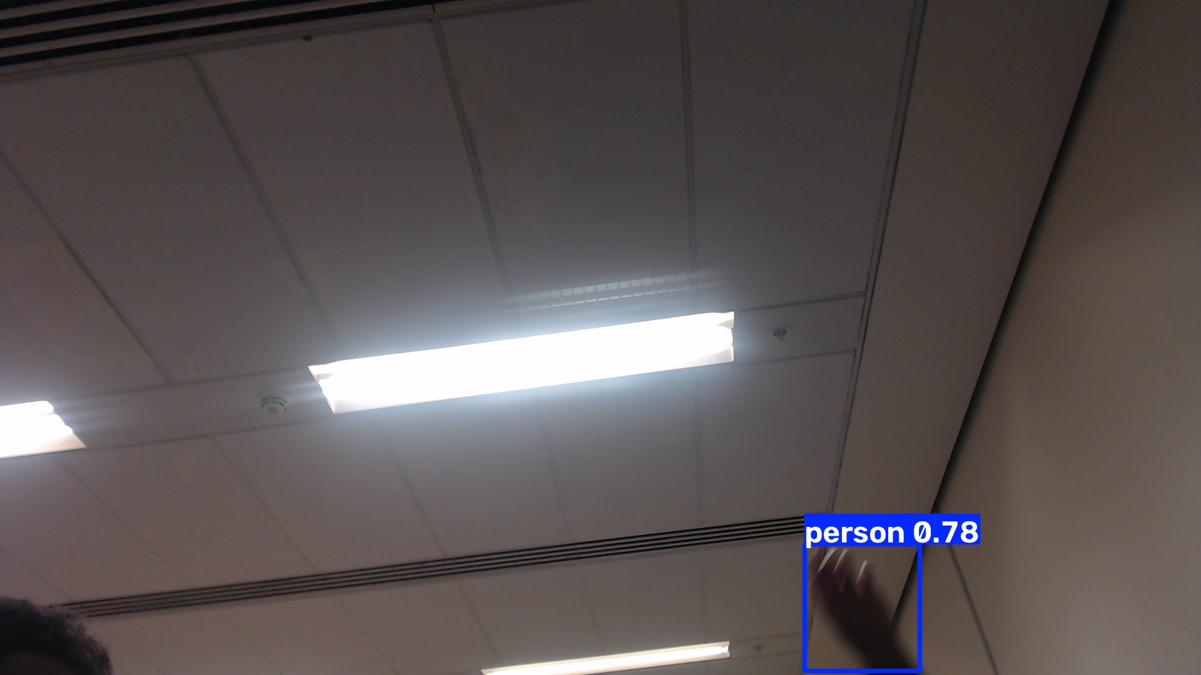
Figure 5 — A live frame: person detected at 0.78 confidence with all 17 COCO keypoints, through the deployed TensorRT pose engine. The camera is pointed at a ceiling, so the detection is of a hand entering frame.
Two things this figure does and does not prove:
- It proves the whole path works: USB capture, MJPEG decode, TensorRT inference, boxes and the 17 keypoints that tier 2's posture classifier consumes.
- The 0.78-confidence detection is of a hand, not a whole body. A pose model inferring a person from one visible limb is reasonable, but it previews the false-positive class the triage rules must absorb — a detection count is not a victim count.

11.3 The measured frame rate is a test-loop artefact
Frame grab and inference run serially in this benchmark, so the frame period is their sum. In the architecture the design specifies — camera and detector as separate nodes — they pipeline, and the rate is set by the slower stage alone. Inference at roughly 22 ms leaves headroom for about 45 FPS, while the camera itself caps at 30. So 30 FPS is reachable on this hardware once capture and inference overlap, and the figure above should not be read as a hardware ceiling.

12. What is deployed on the flight computer
Staged under ~/raptor-deploy with a provenance manifest recording source path, SHA-256, byte size, the build environment and the measured numbers. Each artifact was verified after staging by loading it and running it, not merely copied into place.
Slot | Artifact | Role | Measured | State
detector | yolo11s.engine | tier 1 - person detection | 25.9 ms p95, mAP@0.5 0.369 | verified
pose | yolo11s-pose.engine | tier 1+2 - person detection AND 17 keypoints | 26.5 ms p95 | verified
vlm | Qwen2.5-VL-3B-Instruct | tier 3 - event-triggered scene description | TTFT 0.76 s, schema 88% | verified
vlm_fallback | SmolVLM2-2.2B-Instruct | tier 3 fallback for an 8 GB board | TTFT 1.41 s, schema 0% | verified

The fallback vision-language model is staged but carries an explicit warning in the manifest: it must not be run without grammar-constrained decoding, for the reason given in section 8.1.
TensorRT engines are tied to this TensorRT version and this GPU. They are not portable — re-export after any JetPack upgrade, and never copy one between boards. The manifest records the build environment so a stale engine is detectable rather than mysterious.

13. Platform provisioning
Three pieces of infrastructure had to be fixed before any of the above could be run or repeated. They are recorded here because each one silently invalidates work downstream if it regresses.

13.1 Network access
The board could not reach the internet, for four independent reasons that had to be unpicked in turn:
- It has no Wi-Fi hardware — only Ethernet, on a point-to-point link to the laptop.
- Its default route pointed at its own address, so it was a no-op.
- The host firewall silently dropped inbound connections to a proxy on the laptop.
- The network intercepts TLS to the ROS package host, presenting a certificate for the wrong principal, while plain HTTP works normally.
Resolved with a small HTTP/CONNECT proxy on the laptop, reached through an SSH reverse port-forward so the Jetson connects to its own loopback address and no inbound firewall exception is needed. The apt repository is fetched over HTTP, which is apt's normal security model — integrity comes from the GPG signature, not from TLS.
This arrangement lives inside an interactive session and does not survive it. Making it permanent needs a NAT route configured on the laptop, which is a one-time administrative change.

13.2 ROS 2
ROS 2 Jazzy is installed — 195 packages, the headless ros-base set rather than the desktop set, plus vision_msgs and colcon. Verified functionally, not just by package list: a publish/subscribe round trip returned its payload over DDS, and vision_msgs/Detection2DArray resolves.
This is Jazzy, not the Humble named in the architecture and roadmap documents. Those assume JetPack 6 and Ubuntu 22.04; this board runs Ubuntu 24.04, for which Humble has no binaries. The consequence worth planning around is that NVIDIA Isaac ROS targets Humble, so adopting it becomes a container decision rather than a native install.

13.3 The clock
The board came up at 1970-01-01 on every boot: the real-time clock was not holding time, and NTP could not sync because the board had no route to the internet. Every benchmark row recorded before this fix carries a 1970 timestamp.
This is not cosmetic. The architecture document is explicit that a wrong clock silently corrupts timestamp correlation and therefore geolocation — and a search-and-rescue system that timestamps evidence cannot have a clock that resets. Fixed in three layers: the system time was set, written into the RTC, and a systemd service now restores a monotonic time floor at boot and persists it every ten minutes, so even a full power loss cannot produce a 1970 timestamp.

13.4 Running the live demo
Two launchers exist so the pipeline can be demonstrated without touching a command line:
- On the Jetson — a desktop icon opens a video window with boxes, keypoints, a posture label per person, and a heads-up display showing frame rate, the grab/inference split, board power and temperature.
- On the laptop — a desktop launcher checks the board is reachable and the camera present, then streams detections and timings as text. Video frames stay on the Jetson; a remote session cannot open a window on the board's console.
The posture label shown by the demo is geometric and uses image vertical, because there is no IMU on the bench. The design calls for keypoints rotated into a gravity-aligned frame using flight-controller attitude — without it, a banking aircraft would turn a standing person into a "lying" one. The demo labels this on screen so it cannot be mistaken for the flight behaviour.

14. Recommended next steps
Ordered by value per hour of effort:
- Get the real capture hardware on the bench — the A8 mini through its HDMI capture card — and repeat section 11. Nothing measured on a USB webcam transfers to it, and the HDMI-versus-Ethernet simultaneity question is cheap to answer and decides the harness.
- Move the camera to the idle USB 3.0 bus. One cable, and it may remove the MJPEG decode entirely.
- Install NVIDIA's sm_87 PyTorch build for JetPack 7 and re-run the sweep. Every number in this report is a floor until that is done.
- Begin Phase 2 collection flights. The recall figures in section 10 are the justification, and every downstream phase waits on that data.
- Attack preprocessing and non-maximum suppression rather than the model. After TensorRT they are roughly a third of the frame budget, and composable nodes with zero-copy transport is the documented remedy.
- Make the board's network route permanent, so it is not dependent on an interactive session.
- Add grammar-constrained decoding to the vision-language tier. Section 8.1 makes this a safety control, not a performance optimisation.
- Build the held-out evaluation set of roughly 100 staged scenes with written references, so a hallucination rate can be stated at all.
- Re-measure inside long-running ROS 2 nodes rather than per-process invocations, which is how the system will actually run — and is expected to recover most of the gap to 30 FPS.
- Run the power-mode sweep across 10, 15, 25 and 40 W. Everything here was measured at 25 W, and the delta decides whether the extra watts are worth the endurance they cost.

What still does not exist
To be unambiguous about the state of the project: the components are chosen, characterised, deployed and demonstrable on live video. The perception system itself has not been written. There is no detector node, no tracker, no posture classifier, no trigger logic, no triage aggregator and no victim report. Those are the substance of roadmap phases 1 through 5, and nothing in this report should be read as a claim that they are done.

Generated from recorded benchmark runs. Every figure in this document can be regenerated with plot_results.py, and every number traced to a line in results/.

