RAPTOR
Progress Report — Onboard Compute (Jetson Orin NX)
28 September 2026 · covers 17–28 September · follows the 16 September work report
This report combines the two progress reports written on 28 September — the afternoon edition (16:24) and the evening edition (21:08) — into one document. Where they differ, the evening edition is current: it adds the model re-evaluation, which changed both model choices.
Postscript: the new models were deployed and verified on the Jetson on 29 September — see the 29 September report.

1. Summary
Where we are
The onboard computer is provisioned, benchmarked and demonstrable: models run on a live camera, ROS 2 is installed, and the board is reachable by SSH, VNC and RDP. Today both model choices were re-examined against newer candidates and replaced on measured grounds. What does not exist yet is the perception system itself — no ROS 2 node, tracker, posture classifier, trigger logic or victim report has been written (roadmap phases 1 to 5).
Headlines
- New detector — YOLO26s trained on aerial imagery (VisDrone), as a 736×1280 engine: it finds 42 % of people on held-out aerial images, against 20 % for the previous choice, and is the lightest network at that accuracy (11.5 ms of GPU compute). RT-DETRv4-S (43 %, Apache-2.0) is the measured alternative if AGPL is ruled out.
- New vision-language model — Qwen3-VL-2B: 100 % valid JSON and no invented injuries on 16 test crops, where the previous choice (Qwen2.5-VL-3B) reported injuries for 7 of 16 uninjured people. Half the memory (4.1 GB) and a first token in 0.21 s.
- 16 vision-language model configurations (7 models) and 9 detector configurations measured today, on the board, with a new held-out test set (VisDrone test-dev) and a new truthfulness check on every VLM answer.
- Two earlier statements corrected: the 20 September review missed injuries Qwen2.5-VL had invented (in an answer that failed to parse), and a scoring bug in Ultralytics' validation had to be worked around. Both are documented, not hidden.
- Not yet deployed: the board still runs the previous models; swapping them in is the first next step.
Next steps: deploy the new models, then build the operator dashboard (section 9).

2. Progress since the last report
The 2026-09-16 report ended with the environment blocked (ultralytics would not install) and nothing measured. Since then:
Date | What happened
17–20 Sep | Environment unblocked and verified. First measurements on the flight computer: a 14-configuration detector sweep, TensorRT exports, a forward-pass study that found a ~28 ms framework floor, YOLOv8 and RT-DETR comparisons, two vision-language models.
20 Sep | Board given internet through the laptop; ROS 2 Jazzy installed; clock fixed; models deployed with a provenance manifest; camera attached and the model run on live frames; live-demo launchers; model-selection Word report.
22 Sep | Remote access: VNC mirroring the console and RDP with its own session; headless display raised to 1024×768.
28 Sep, day | Clock fix hardened after a cold-boot failure. Repository reorganised and renamed, all code from the Jetson brought in, documentation rewritten, "Orin Nano" references to this board corrected. Two security issues and four setup-script bugs fixed.
28 Sep, evening | Model re-evaluation. A research survey of newer detectors and VLMs; 16 VLM configurations (7 models) and 9 detector configurations measured on the board; a held-out test set and a truthfulness check added to the method; a scoring bug found and fixed; both model choices replaced; model-selection report rebuilt with the re-evaluation as Part A.

3. Key results — the model re-evaluation
Recorded on the Jetson at 25 W. Accuracy is on VisDrone, a public aerial dataset used as a proxy: RAPTOR has no flight footage yet, and VisDrone contains no casualties and nobody lying down.

3.1 Detectors (TensorRT FP16, latency on real frames)
Configuration | p95 | test-dev recall | test-dev mAP@0.5 | val recall | Verdict
YOLO26s VisDrone @1280 | 39.1 ms | 0.436 | 0.462 | 0.622 | over budget
RT-DETRv4-S VisDrone @960 | 24.3 ms | 0.428 | 0.439 | 0.622 | Apache alternative
YOLO26s VisDrone @736x1280 | 31.0 ms | 0.425 | 0.452 | 0.619 | chosen
YOLO26s VisDrone @960 | 26.0 ms | 0.375 | 0.392 | 0.554
YOLO26n VisDrone @1280 | 32.4 ms | 0.375 | 0.391 | 0.546
aerial-person 11n @1280 | 32.4 ms | 0.312 | 0.312 | 0.463
yolo11s COCO @1280 | 39.1 ms | 0.247 | 0.242 | 0.426 | over budget
YOLO26s COCO @960 | 26.7 ms | 0.218 | 0.210 | 0.386
yolo11s COCO @960 | 26.1 ms | 0.200 | 0.186 | 0.362 | previous choice
Correction made on 29 September: the 736×1280 row now shows accuracy measured directly on that engine (42.5 % recall on test-dev). The evening edition had carried over the square 1280 engine’s 43.6 %, on the reasoning that both see the same pixels of a 16:9 frame; measured, the rectangular engine is level with RT-DETRv4-S rather than ahead of it.
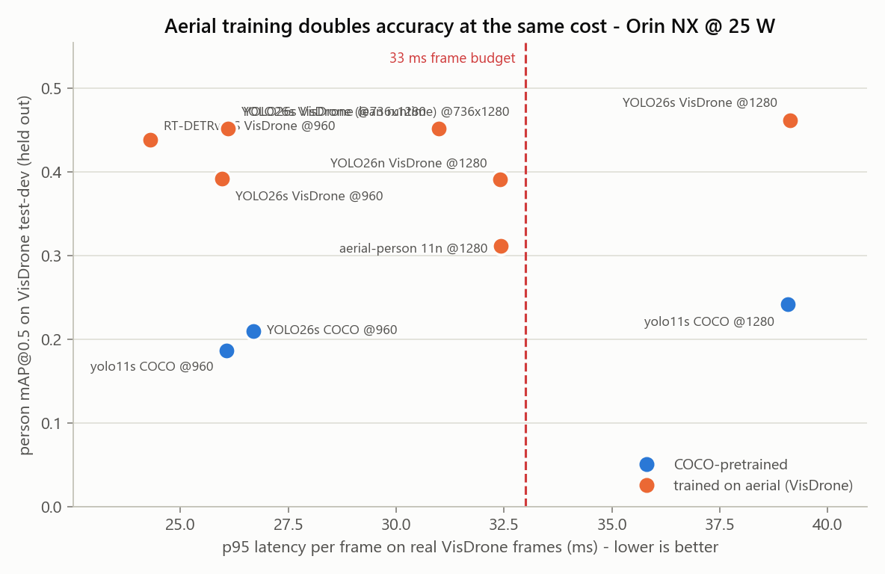
Held-out accuracy against real-frame latency. Orange: trained on aerial imagery. Dashed: the 33 ms frame budget.
- Training on aerial imagery is what matters: it roughly doubles the people found at the same cost. A newer architecture adds about 2 points, 1280 px about 5 — and only fits the budget as a rectangular 736×1280 engine.
- Measured as networks alone (GPU compute, trtexec), YOLO26s is the lightest at this accuracy; RT-DETRv4-S is heavier but is the only Apache-2.0 option, within a point on recall. Through Ultralytics’ Python pipeline the YOLO takes 31 ms, most of it pipeline rather than network, so the production node should run the engine directly. Both sets of weights inherit VisDrone’s non-commercial licence until we fine-tune our own.
- Pose: YOLO26s-pose runs at 22.7 ms against 26.5 ms for the current yolo11s-pose. No aerial pose model exists, so posture moves to a second stage on crops of each detected person.

3.2 Vision-language models (16 person crops; nobody injured, nobody lying)
Model (decoding) | Valid JSON | Injury reported | Said "lying" | Flags unseen | First token p95 | Peak GPU
Qwen3.5-2B (shipped = greedy) | 100 % | 0/16 | 0/16 | 0/16 | 0.30 s | 4.3 GB
Qwen3.5-2B (greedy+rep) | 100 % | 0/16 | 0/16 | 0/16 | 0.30 s | 4.3 GB
Qwen3-VL-2B (greedy+rep) | 100 % | 0/16 | 2/16 | 16/16 | 0.21 s | 4.1 GB
InternVL3.5-2B (greedy) | 100 % | 0/16 | 2/16 | 16/16 | 2.08 s | 5.1 GB
Qwen3-VL-4B (greedy+rep) | 100 % | 0/16 | 4/16 | 7/16 | 0.33 s | 8.5 GB
LFM2.5-VL-3B (shipped) | 100 % | 0/16 | 5/16 | 12/16 | 0.30 s | 6.0 GB
Qwen3-VL-4B (shipped) | 100 % | 0/16 | 5/16 | 6/16 | 0.33 s | 8.5 GB
InternVL3.5-2B (greedy+rep) | 88 % | 0/16 | 7/16 | 15/16 | 2.10 s | 5.1 GB
Qwen3-VL-2B (shipped) | 50 % | 0/16 | 0/16 | 15/16 | 0.20 s | 4.1 GB
Qwen3-VL-2B (greedy) | 31 % | 0/16 | 1/16 | 16/16 | 0.21 s | 4.1 GB
MiniCPM-V-4.6 (greedy+rep 4x) | 25 % | 0/16 | 0/16 | 0/16 | 0.70 s | 2.7 GB
MiniCPM-V-4.6 (greedy+rep) | 19 % | 0/16 | 0/16 | 0/16 | 0.50 s | 2.6 GB
MiniCPM-V-4.6 (shipped) | 6 % | 0/16 | 0/16 | 1/16 | 0.50 s | 2.6 GB
LFM2.5-VL-3B (greedy+rep) | 100 % | 1/16 | 5/16 | 8/16 | 0.30 s | 6.0 GB
Qwen2.5-VL-3B (shipped) | 88 % | 6/16 | 2/16 | 2/16 | 0.76 s | 7.2 GB
Qwen2.5-VL-3B (greedy) | 94 % | 7/16 | 2/16 | 1/16 | 0.75 s | 7.2 GB
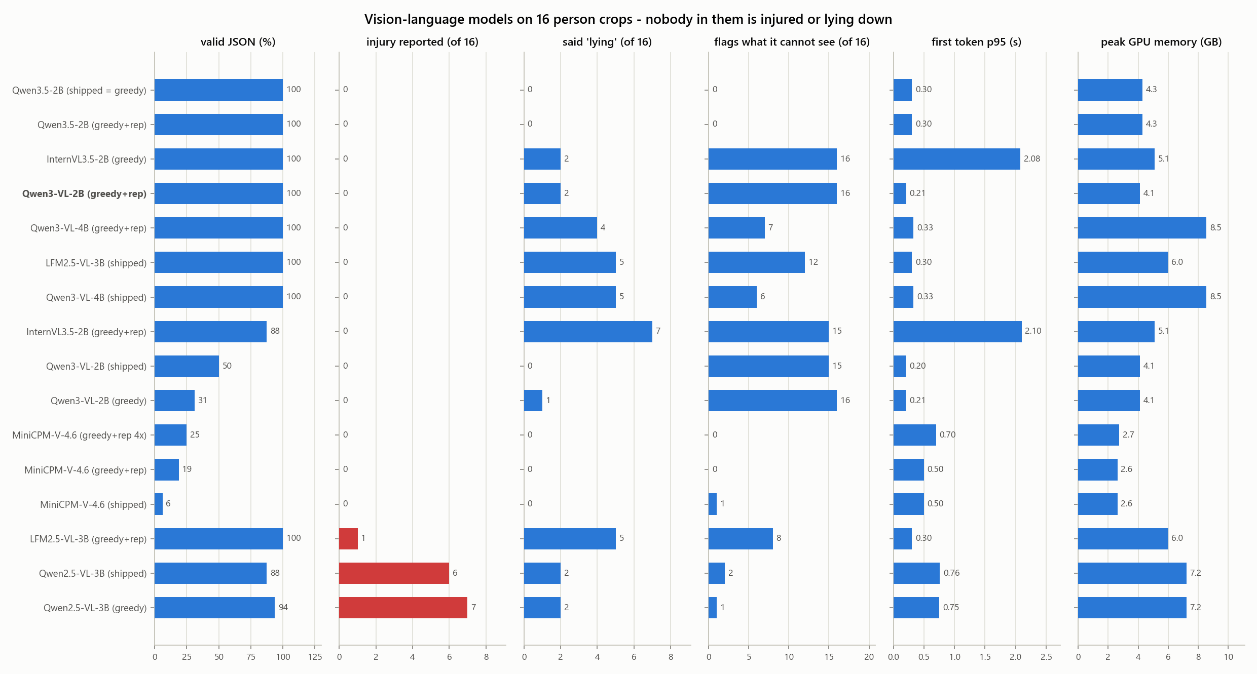
The VLM comparison. Red: answers reporting an injury for people who have none.
- Qwen3-VL-2B with greedy decoding and a 1.05 repetition penalty is the only configuration that is truthful, fully schema-valid, honest about what it cannot see, quick to start and small at once.
- Qwen3.5-2B is a close second — equally truthful on injuries and never fooled by the prompt’s posture, but it never admits what it cannot see and is slower. Both get a larger re-test after the prompt fix.
- Rejected: LFM2.5-VL-3B (fast, but asserted ethnicity, invented a bruise, and called 5 of 16 upright people "lying"); MiniCPM-V-4.6 (accurate but malformed JSON); Qwen3-VL-4B (slower and larger than the 2B, and fooled more often); InternVL3.5-2B (honest, but 2.1 s to its first token).
- Decoding settings decide whether a model works: under plain greedy decoding Qwen3-VL loops and a third of its replies parse.
- Most models sometimes repeat the posture the prompt asserts rather than the one they see, and most copy the prompt’s 0.91 as their own confidence. Both are prompt-design faults with known fixes (docs/12).
- A full description still takes about 12 s against a 5 s target. Quantising to 4 bits in llama.cpp, with a JSON grammar, is the next lever.

3.3 First-round results (20 September), kept for the record
The first round compared COCO-trained detectors on VisDrone val and two vision-language models. Its choices are superseded by 3.1 and 3.2; its findings on resolution and framework overhead still hold.
Configuration (960 px unless stated) | p95 latency | mAP@0.5 | Recall | Power | Verdict then
yolo11s — TensorRT | 25.9 ms | 0.369 | 0.362 | 12.6 W | chosen then
yolo11s — PyTorch | 30.4 ms | 0.369 | 0.361 | 13.3 W | same accuracy, slower
yolov8s — PyTorch | 25.2 ms | 0.355 | 0.352 | 14.4 W | fallback if TensorRT fails
rtdetr-l — PyTorch | 110.7 ms | 0.431 | 0.409 | 17.8 W | most accurate, 3× too slow
yolo11m @640 — PyTorch | 34.7 ms | 0.307 | 0.300 | 12.7 W | over budget, less accurate
yolo11n @640 — PyTorch | 29.1 ms | 0.159 | 0.180 | 8.4 W | too inaccurate
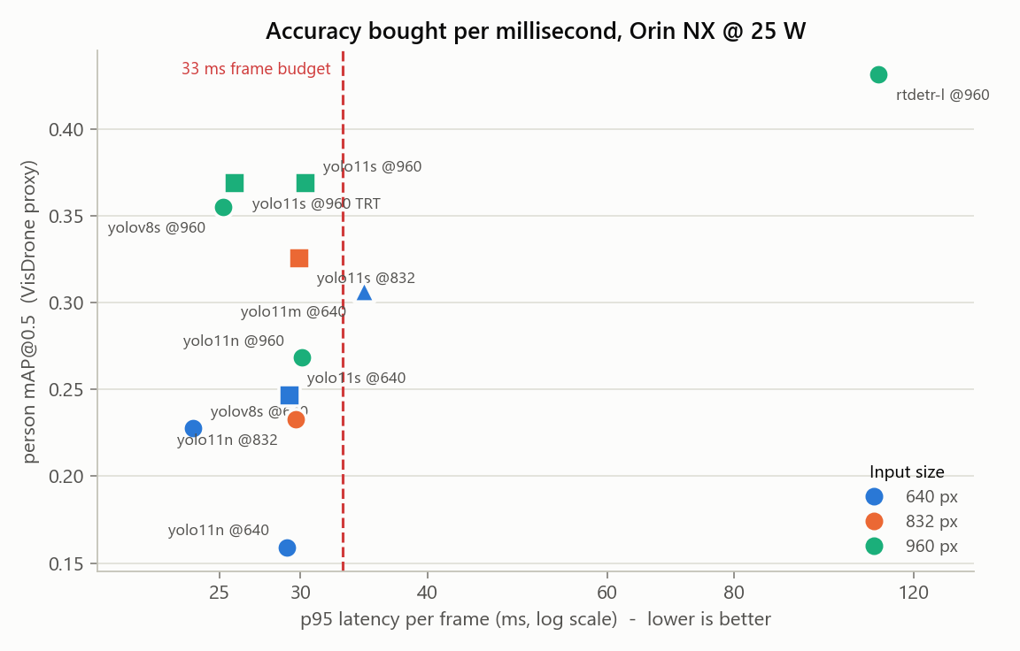
First round: accuracy against p95 latency on VisDrone val. The dashed line is the 33 ms frame budget.
- Input resolution bought more accuracy than model size: yolo11s at 960 px beat yolo11m at 640 px on accuracy, latency and power at once.
- At small model sizes the time was spent in the framework, not the GPU — a ~28 ms floor regardless of model. TensorRT broke it; after that, image handling and non-maximum suppression were about a third of the frame. The second round confirmed this with GPU-only timing.
- Pose: yolo11s-pose went from 32.8 ms to 26.5 ms p95 with TensorRT.
Model (first round, 8 crops) | First token p95 | Tokens/s | Schema-valid | Peak GPU | Verdict then
Qwen2.5-VL-3B | 0.76 s | 9.8 | 88 % | 7.2 GB | chosen then; replaced
SmolVLM2-2.2B | 1.41 s | 14.3 | 0 % | 4.6 GB | rejected: invented demographics

Correction: the first round said Qwen2.5-VL-3B invented no injuries. It had — in an answer that failed to parse and so went unread. The re-evaluation (3.2) found it, and the documentation now says so.

4. What is on the Jetson
Inventory taken live from the board at 2026-09-28 21:08 (end of 28 September).

4.1 Hardware and operating system
Item | Value
Module | NVIDIA Jetson Orin NX 16 GB ("Engineering Reference Developer Kit Super")
Carrier board | Seeed reComputer J401
JetPack / L4T | JetPack 7.2 / L4T R39.2.0
Operating system | Ubuntu 24.04.4 LTS, kernel 6.8.12-tegra
Storage | 79 GB NVMe - 67G used, 7.9G free (90%)
Power mode | 25 W (nvpmodel mode 3). Also available: 10 W, 15 W, 40 W, MAXN_SUPER.
Hostname / user | alfaisal-x-nx / alfaisal-x-nx

4.2 Software
Component | Version / location
Python environment | ~/raptor-venv, created with --system-site-packages
NumPy / SciPy / OpenCV / ONNX | 2.5.3 / 1.18.1 / 5.0.0 / 1.23.0
PyTorch / torchvision | 2.14.0 / 0.29.0 (CUDA 13) — the generic wheel, see Risks
TensorRT | 10.16.2 (trtexec at /usr/src/tensorrt/bin)
Ultralytics | 8.4.154 (supports YOLO26)
Transformers | 5.17.0 — loads every VLM tested today without remote code
ROS 2 | Jazzy, ros-base, 195 packages, with vision_msgs and colcon. Publish/subscribe verified.
VNC / RDP servers | x11vnc 0.9.16 / GNOME Remote Desktop 46.3
RT-DETRv4 source | ~/raptor-ext/RT-DETRv4, used only to build the model; training-only imports are stubbed

4.3 Deployed models (~/raptor-deploy) — unchanged today
Each artifact was loaded and run after staging; MANIFEST.json on the board records its source, checksum, build environment and measured performance.
Slot | Artifact | Role | Size | Measured
detector | yolo11s.engine | tier 1 - person detection | 22 MB | 25.9 ms p95, mAP@0.5 0.369
pose | yolo11s-pose.engine | tier 1+2 - person detection AND 17 keypoints | 23 MB | 26.5 ms p95
vlm | Qwen2.5-VL-3B-Instruct | tier 3 - event-triggered scene description | 7.5 GB | first token 0.76 s
vlm_fallback | SmolVLM2-2.2B-Instruct | tier 3 fallback for an 8 GB board | 9.0 GB | first token 1.41 s

These are the first-round choices. The recommended models are on disk (below) but not yet in the deployed set. The vlm_fallback slot (SmolVLM2) now points at a model archived off the board to free disk space; replacing the deployed set repairs it.
TensorRT engines are tied to this TensorRT version and this GPU. They must be rebuilt after any JetPack upgrade and cannot be copied to another board.

4.4 Models and data on disk (not in git)
Folder | Size | Contents
~/raptor-vlm | 28G | InternVL3_5-2B-HF, LFM2.5-VL-3B, MiniCPM-V-4.6, Qwen2.5-VL-3B-Instruct, Qwen3-VL-2B-Instruct, Qwen3.5-2B
~/raptor-models | 995M | COCO weights and engines (yolo11 n/s/m, -pose, yolov8s, rtdetr-l, YOLO26s/n, YOLO26s-pose) and, in aerial/, the VisDrone-trained YOLO26s/n, RT-DETRv4-S and aerial-person models with their TensorRT engines
~/raptor-data | 765M | VisDrone person val (548 images) and test-dev (1,610 images) sets, 16 person crops
~/raptor-ext | 40M | RT-DETRv4 source, for building the model
~/raptor-deploy | 28K | The deployed set (first-round models) and MANIFEST.json
~/raptor-results | 1.3M | Raw results and logs as first written on the board

Archived to the laptop to free disk space (C:\Users\majda\raptor-downloads\vlm): SmolVLM2-2.2B and Qwen3-VL-4B. Every downloaded model is also kept there, checksum-verified, so none needs downloading again.

4.5 Code
- ~/raptor/src — a mirror of RAPTOR/src from the repository, copied by src/deploy/sync_to_jetson.sh. The repository is the source of truth; edits made on the board are overwritten by the next sync.
- Desktop icon "RAPTOR Live Demo" — runs ~/raptor/src/demo/launch_demo.sh and opens the video window.
- On the laptop, "RAPTOR Live Demo.bat" — on the Windows desktop: checks the board and camera, then runs the demo over SSH and shows its detections and timings as text.
- Superseded, safe to delete: ~/raptor-bench-scripts and the loose scripts in the home folder (setup_*.sh, raptor-live-demo.sh, catch_person.py, and the clock-keeper and x11vnc files there).

4.6 Services and system changes
Every change made to the board’s operating system, so none of it is a surprise later. The installed files are kept in the repository under src/system/ at their real paths.
Change | What it does | State
raptor-clock-keeper (+ timer, udev rule) | Stops the board booting into 1970 — it has no clock battery. Restores a saved time at boot and again when the RTC driver loads; saves every 10 minutes. | enabled, active
x11vnc.service | VNC server mirroring the console, port 5900. | enabled, active
gnome-remote-desktop | RDP, port 3389, TLS, self-signed certificate. | enabled, active
/etc/X11/xorg.conf | Headless display at 1024×768. Stock file kept at xorg.conf.pre-headless. | installed
/etc/apt/apt.conf.d/99proxy | Sends apt through the laptop proxy. While present, apt only works with the tunnel running. | present
/etc/sudoers.d/99-nopasswd | Passwordless sudo for alfaisal-x-nx, so scripts can install without a prompt. | present
SSH key "claude-code" | Key-based login from the laptop (in ~/.ssh/authorized_keys). | present

4.7 Access
Method | Address | Notes
SSH | alfaisal-x-nx@100.100.100.1, port 22 | Key-based from the laptop.
VNC | 100.100.100.1, port 5900 | Shows the physical console at 1024×768. Not encrypted. Password is 8 characters maximum.
RDP | 100.100.100.1, port 3389 | Its own session, TLS-encrypted. Credentials are separate from the Linux login.
Internet | through the laptop | Only while src/tools/jetson_internet.sh is running on the laptop. The board’s Ethernet is a fixed address with no DHCP, so plugging it into a router does not give it internet (open question 5).

The VNC and RDP passwords are deliberately not written in this report, which lives in a shared repository. They were given to the operator directly. To reset them on the board: "sudo x11vnc -storepasswd <new> /etc/x11vnc.pass" for VNC, and "sudo grdctl --system rdp set-credentials <user> <password>" for RDP.
Do not use ping to decide whether the board is connected. Its address, 100.100.100.1, falls inside the carrier-grade NAT range (100.64.0.0/10) that this ISP places the laptop’s Wi-Fi in, so with the Ethernet cable unplugged an unrelated host on the internet can answer the ping. Use SSH instead, or check the reply’s TTL: 64 is the board, around 54 is not.

4.8 Camera and display
- Camera: a Logitech C922 USB webcam on /dev/video0 — not the SIYI A8 mini flight camera, which has still never been tested.
- It sits on a USB 2.0 port (a USB 3.0 bus is free). At 1080p that caps uncompressed video at 5 fps; MJPEG reaches 30. Live run: 26.9 FPS end to end, inference 23.0 ms.
- In dim light the webcam lowers its own frame rate to expose longer; a frame grab rose from 14 ms to 39 ms with inference unchanged.
- Display: no monitor attached; the console runs headless at 1024×768.
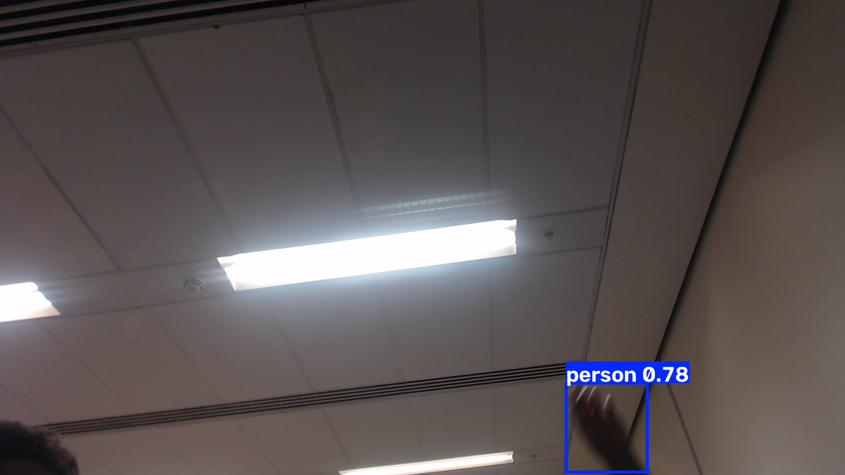
First live detection through the deployed engine: a person (a hand entering the frame) at 0.78 confidence with 17 keypoints.

5. Repository
RAPTOR/ was reorganised on 28 September, with every move made by git mv so file history is kept:
Folder | Contents
docs/ | Design documents 01–09, measured results 10, 12 and 14, platform setup 11, bill of materials 13, and the interactive HTML pages.
src/ | All code, grouped by purpose, with a code map in src/README.md: benchmarks, analysis, demo, deploy, setup, system (OS files at their installed paths), tools (laptop helpers), common.
benchmarks/ | Recorded results and figures — the scientific output.
reports/ | The model-selection Word report, generated from benchmarks/.
assets/photos/ | The build photos, named for what they show (previously imgs/img1–img5).

Files whose names said nothing were renamed for what they are: the live-demo launcher is now launch_demo.sh, the detector sweep run_detector_sweep.sh, the laptop proxy laptop_proxy.py, the raw VLM answers vlm_outputs_<model>.json, and docs 11 and 14 are now "Jetson platform setup" and "Camera, live demo and remote access". Every link and path in the repository was updated to match and checked.

Added during the evening re-evaluation:
Where | What
docs/10, docs/12 | A second-round section on top of each, with the first round kept below as the record; docs/12 carries an explicit correction.
docs/02, docs/03 | Decision tables updated to the new detector and VLM, with the originals kept.
src/benchmarks/bench_rtdetrv4.py | Harness for RT-DETRv4, which Ultralytics cannot load.
src/common/person_scoring.py | Person mAP and recall for any detector; works around Ultralytics val() ignoring its classes argument.
src/analysis/score_vlm_generations.py | Checks every VLM answer for invented injuries, false "lying", ethnicity and copied prompt numbers.
src/analysis/plot_reeval.py, report_part_a.js | The re-evaluation figures (5–7) and Part A of the model-selection report.
bench_detector.py, bench_vlm.py | Rectangular input sizes, VisDrone class merging, decoding settings, model-specific options, links from each result row to its raw answers.
benchmarks/results | 30 detector and 16 VLM result rows from today, the raw answers of every VLM run, and the truthfulness scores.
reports/RAPTOR-model-selection-report.docx | Rebuilt: Part A is the re-evaluation, Part B the original evaluation.

None of this is committed yet. It sits in the shared course repository on main, alongside other uncommitted work, so committing is a deliberate decision for the team.

6. Problems found and fixed
Problem | Fix
Ultralytics val() ignores its classes argument, so VisDrone-trained models were scored with cars counted as people (precision 0.25 instead of 0.73) | person_scoring.py scores the person classes explicitly; validated against val() within 0.5 points. The three wrong rows are kept, flagged, and never plotted.
Synthetic benchmark frames under-timed the 1280 px engines by a third (28 ms against 39 ms) | All latencies re-measured on the same real frames as the first round; the plotting script already refused synthetic rows.
Qwen3 models loop under greedy decoding, so only a third of their answers parsed | Decoding settings are now a benchmark parameter; greedy with a 1.05 repetition penalty gives 100 % valid JSON and stays deterministic.
A failed-to-parse VLM answer hid an invented injury in the 20 September review | Every answer is now scored from its raw text, parsed or not; the earlier claim is corrected in docs/12 and the report.
Model downloads stalled on the laptop Wi-Fi (0.1–0.4 MB/s per connection) | A parallel, resumable, checksum-verified downloader: up to 12 MB/s.
The Jetson became unreachable after the laptop's Ethernet was switched to DHCP (the USB hub has one Ethernet adapter, and the second adapter is not seen) | Fixed address restored; the board kept running throughout. See section 7.
Board booted into 1970 after a cold start, even with the first clock fix | The RTC driver loads 11 s into boot and resets the clock after the fix ran; the periodic save then recorded the bad time. Added a restore triggered by the RTC itself, and made saving monotonic. Tested by forcing the clock to 2020.
No internet on the board | Laptop proxy reached over an SSH reverse tunnel. The network intercepts TLS to the ROS package host, so the ROS repository is used over HTTP (packages are still GPG-verified).
VNC login always refused | VNC passwords are limited to 8 characters; the setup script now enforces it.
VNC service running but not listening | x11vnc could not find the X authority under systemd; a wrapper now reads it from the running X server.
RDP connections reset | System RDP needs its own credentials, which were never set; the setup script now sets them.
640×480 remote desktop | Headless display configuration giving 1024×768, with automatic rollback if X fails.
Security: laptop proxy reachable from the ISP network | It listened on all interfaces behind an address check that the ISP’s range could satisfy. It now listens on loopback only.
Security: a test script contained a password | Removed before it reached the repository; passwords are now arguments only.
Scripts broken by Windows line endings on the board | .gitattributes pins Linux-bound files to LF; the sync script also normalises them.

7. Open questions
# | Question | Blocks
1 | Can the A8 mini output HDMI and Ethernet video at the same time? | The split-video harness — test first, it is cheap
2 | ArduPilot or PX4 on the Pixhawk 6C? | Optional gimbal UART parameters
3 | What does the HDMI capture card negotiate? | Detector input sizing
4 | Swap the deployed models to the aerial YOLO26s (or RT-DETRv4-S) and Qwen3-VL-2B now? This also repairs the vlm_fallback slot, which points at a model archived off the board. | Everything downstream — the live demo, the dashboard
5 | Give the Jetson its own internet? Needs a small network switch (the USB hub cannot bridge) and a DHCP profile with fixed-address fallback on the board. | Faster installs and downloads; the laptop proxy retires
6 | Should the board run at 25 W or 40 W in flight? | Endurance against speed
7 | Is there a separate Orin Nano? | The failed factory reset in General Tasks may have been this board
— | Answered today: does Qwen3-VL beat Qwen2.5-VL? Yes — and the smaller one wins. Is AGPL a blocker? Still the team’s decision, but no longer blocking: RT-DETRv4-S is a measured Apache-2.0 alternative within a point of the chosen detector. | —

8. Risks and caveats
- Proxy data. VisDrone is urban, with no casualties and nobody lying down, and the new detectors were trained on it. Their 43 % is a ceiling for this data, not a prediction for a search over desert or rubble. Evaluating on aerial images of lying people is the next test to build.
- Licences. The chosen detector is AGPL-3.0, and both aerial detectors’ weights inherit VisDrone’s non-commercial licence; they must be replaced by our own fine-tune before any commercial use.
- The VLM believes the prompt. Most models sometimes report the posture the prompt asserts. The prompt must stop stating it as fact.
- Recall. Even the best detector misses more than half the people on the held-out set. The system must never present a searched area as confirmed clear.
- PyTorch has no kernels built for this GPU. Every PyTorch and transformers number is a floor; NVIDIA's Jetson build is the highest-value environment fix.
- Disk. The board's disk is 90% full. Rejected models can move to the laptop archive.
- Security posture is lab-grade. Passwordless sudo, unencrypted VNC, one SSH key that reaches root. Fine on a cable to one laptop; not on a shared network.
- Internet depends on a laptop window. And while the apt proxy file is present, apt fails whenever that window is closed.
- Timestamps. Result rows recorded before 20 September carry 1970 timestamps. Their order is still correct.

9. Next steps

9.1 Deploy the new models
- Build a lean TensorRT runtime for the YOLO26s VisDrone engine (736×1280) and measure it end to end, then stage it and Qwen3-VL-2B in ~/raptor-deploy with a provenance manifest, as the first-round models were. RT-DETRv4-S is the drop-in if AGPL is ruled out.
- Switch the live demo to the aerial detector, with YOLO26s-pose on crops of each person.
- Serve Qwen3-VL-2B through llama.cpp at 4 bits with a JSON grammar, and re-measure speed and truthfulness.
- Change the VLM prompt so it no longer asserts the posture, and drop its confidence field.

9.2 Then: an operator dashboard
Today, what the Jetson sees is only visible to someone logged in to it over SSH or VNC. The next step is a dashboard, hosted on a server, that shows everything the Jetson has logged: for every event, the image it captured and a full written description of what is in it.
This is an early, working version of the ground-station view planned for Phase 5 in docs/04 and docs/07, brought forward on purpose. Every later phase — the posture classifier, the trigger logic, the geolocation — becomes visible and testable the moment it has somewhere to appear.
What the dashboard shows
- An event feed — every time the Jetson logs something, a row with a thumbnail, the time, how many people, and their postures. Newest first, filterable (for example: lying only, or injury indicators present).
- An event page — the full image with the person boxes and keypoints drawn on it; a crop of each person; their posture; and the vision-language model’s description of each one: appearance, body position, surroundings, visible injury indicators, signalling, and — as important — what could not be seen.
- The Jetson’s health — online or not, frame rate, inference time, board power, temperature and free disk, so a failing board is noticed before its data goes missing.
- Later, as the rest of the system arrives — a map with a pin per person once GPS comes from the flight controller, the rule-based triage flag, and a one-click "this is wrong" button whose clicks become training data.
How it fits together
On the Jetson | Link | On the server
Event logger: when a trigger fires (a new person, a posture change, or a regular interval), save the frame, the annotated frame, the detections and postures. | — | —
Describe: run Qwen3-VL-2B on each person crop and store its structured description with the event. | — | —
Keep every event on local disk first, so nothing depends on the link. | Push each event over HTTP when the server is reachable; queue and retry when it is not. | Receive events into a database, with the images in file storage.
— | — | Serve the dashboard web pages, behind a login.

The rule that shapes the design: the aircraft must never wait on the server. The Jetson logs locally and sends when it can — the offline constraint in docs/01 applies to the dashboard exactly as it applies to everything else.
Build plan
Step | What gets built | Done when
1 | Event logger on the Jetson, extending the live demo: each event becomes a folder with the frame, the annotated frame and a JSON record. | Walking past the camera produces an event folder with the right image, boxes and posture.
2 | Descriptions: Qwen3-VL-2B on each person crop, grammar-constrained, with any demographic field rejected before it is stored. | Every event carries a description that matches the schema.
3 | Server: a small web service with a database and image storage that accepts events from the Jetson. | Events sent from the Jetson are stored and can be listed.
4 | Dashboard pages: the feed, the event page and the health panel. | A person in front of the camera appears on the dashboard, with image and description, within about 15 seconds.
5 | Reliable delivery: local queue, retry, no duplicates. | Unplugging the network for ten minutes loses nothing, and everything arrives once it is back.
Decisions needed before starting
- Which server hosts it. The simplest start is the laptop, which is already cabled to the board; packaging the server so it can move later to a university machine keeps that choice open.
- Who may see it. The dashboard holds images of real people. It needs a login, must not be public, and needs a retention period — docs/08 already sets these expectations for flight footage.
- How fast descriptions must be. Qwen3-VL-2B currently takes about 12 seconds for a full description. That is workable for a dashboard, but 4-bit serving (already planned) is what brings events close to real time.
Rules it must follow
- Always show the image beside the text. A description is a machine’s observation about pixels; the operator must be able to check it at a glance.
- Label descriptions as machine-generated observations, never as findings or diagnoses (docs/08).
- Never store or display identity or demographic attributes. Two of the models tested asserted a person’s race or ethnicity from an aerial crop; the logger must drop such fields, not just hide them.
- Never make the aircraft depend on the dashboard, or on any network.

10. Changes made on the laptop
- Sleep disabled (plugged in and on battery) so long runs survive the lock screen. To restore: powercfg /change standby-timeout-ac 30. Closing the lid is a separate setting (Power Options → "Choose what closing the lid does").
- Installed into the user Python: transformers 5.17.0 (to check VLM processors offline) and onnx 1.23.0 (to export RT-DETRv4). Both removable with pip uninstall.
- Downloads kept in C:\Users\majda\raptor-downloads (41 GB): every VLM tested, the detector weights and VisDrone test-dev. Outside git; safe to delete, but slow to re-download on this Wi-Fi.
- Ethernet 4 (the USB hub's adapter to the Jetson) was briefly switched to DHCP and has been restored to its fixed address, 100.100.100.2; an old gateway entry pointing at the Jetson was removed in the process.

11. Standing caveat
Every figure in this report came from a run recorded in RAPTOR/benchmarks/results; none is quoted from a datasheet. Accuracy is on a public proxy dataset and describes downloaded models, not RAPTOR's own performance.

