RAPTOR
Progress Summary — Onboard Compute (Jetson Orin NX)
2026-09-29 · covers 17–29 September 2026 · two-page summary of RAPTOR_Work_Report_2026-09-28_2108.docx

1. Where we are
The Jetson Orin NX flight computer is provisioned, benchmarked and reachable remotely (SSH, VNC, RDP), with ROS 2 Jazzy installed and a live camera demo on its desktop. This week both model choices were re-tested on the board against newer candidates and replaced on measured grounds; the new models are being deployed now. The perception pipeline itself (ROS 2 nodes, tracker, posture classifier, victim report) has not been written yet.

2. Model re-evaluation

Person detector — held-out aerial images (VisDrone test-dev), TensorRT FP16, 25 W
Model | People found | mAP@0.5 | Per frame (p95) | GPU compute | Licence | Verdict
YOLO26s, aerial-trained, 736×1280 | 44 % | 0.46 | 31.0 ms | 11.5 ms | AGPL-3.0 | chosen
RT-DETRv4-S, aerial-trained, 960 | 43 % | 0.44 | 24.3 ms | 17.1 ms | Apache-2.0 | licence alternative
YOLO26s, aerial-trained, 960 | 37 % | 0.39 | 26.0 ms | 11.4 ms | AGPL-3.0 | more headroom, less accurate
yolo11s, COCO, 960 (previous choice) | 20 % | 0.19 | 26.1 ms | 11.4 ms | AGPL-3.0 | replaced
- Training on aerial imagery is what matters: it roughly doubles the people found at the same cost. A newer architecture or a higher resolution alone adds only 2–5 points.
- The chosen model's 31 ms is measured through Ultralytics' Python code, which costs more than the network itself (11.5 ms). The deployed version runs the engine directly. Frame budget: 33 ms.
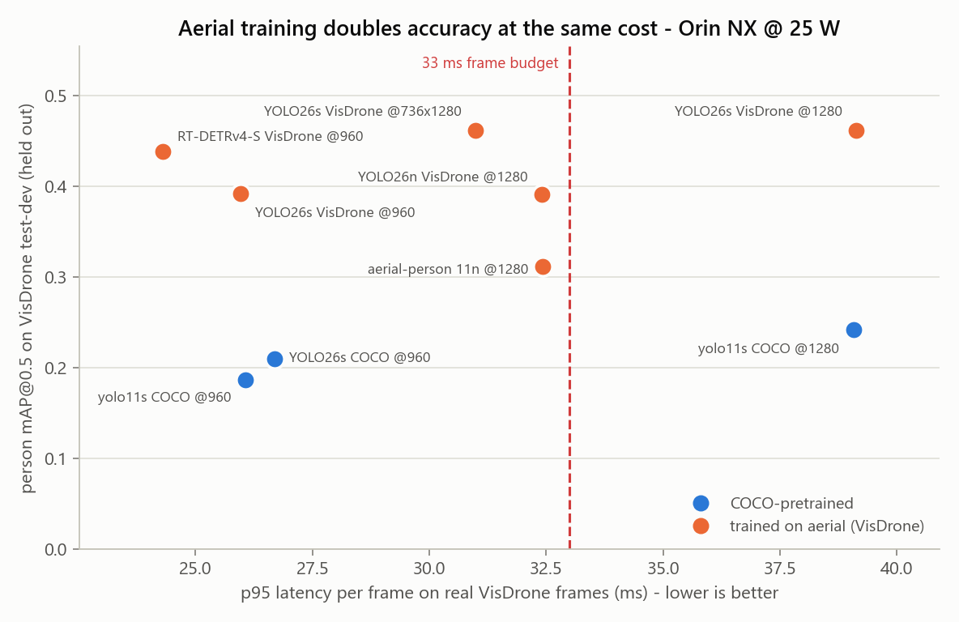
Held-out accuracy against time per frame. Orange: trained on aerial imagery. Dashed line: the 33 ms frame budget.

Vision-language model — 16 crops of people who are neither injured nor lying down
Model | Valid JSON | Injury invented | Said "lying" | Admits unseen | First word | GPU memory
Qwen3-VL-2B (chosen) | 100 % | 0/16 | 2/16 | 16/16 | 0.21 s | 4.1 GB
Qwen3.5-2B | 100 % | 0/16 | 0/16 | 0/16 | 0.30 s | 4.3 GB
InternVL3.5-2B | 100 % | 0/16 | 2/16 | 16/16 | 2.08 s | 5.1 GB
Qwen3-VL-4B | 100 % | 0/16 | 4/16 | 7/16 | 0.33 s | 8.5 GB
LFM2.5-VL-3B | 100 % | 1/16 | 5/16 | 8/16 | 0.30 s | 6.0 GB
MiniCPM-V-4.6 | 25 % | 0/16 | 0/16 | 0/16 | 0.70 s | 2.7 GB
Qwen2.5-VL-3B (previous choice) | 94 % | 7/16 | 2/16 | 1/16 | 0.75 s | 7.2 GB
- Qwen3-VL-2B is the only model that is at once truthful, fully schema-valid, honest about what it cannot see, fast to start and small. The previous choice reported injuries for 7 of 16 uninjured people — an error our first review missed, now corrected in the documentation.
- Rejected: LFM2.5-VL-3B asserted a person's ethnicity and invented a bruise; MiniCPM-V-4.6 writes malformed JSON; Qwen3-VL-4B is larger, slower and more often fooled by the prompt.
- A full description still takes about 12 s against a 5 s target. Serving the model at 4 bits (llama.cpp, with a JSON grammar) is the next step.

3. Progress since the last report (16 September)
- 17–20 Sep: environment unblocked; first benchmarks (detectors, TensorRT, two VLMs); ROS 2 Jazzy installed; clock fixed; first models deployed; live camera demo.
- 22 Sep: remote access by VNC and RDP; headless display at 1024×768.
- 28 Sep: repository reorganised with all Jetson code; documentation rewritten; model re-evaluation (9 detector and 16 VLM configurations); model-selection report rebuilt.
- 29 Sep: new models being deployed on the Jetson.

4. What is on the Jetson
- Orin NX 16 GB on a Seeed reComputer J401; JetPack 7.2, Ubuntu 24.04; run at 25 W.
- TensorRT 10.16, PyTorch 2.14, Ultralytics 8.4, transformers 5.17, ROS 2 Jazzy.
- The aerial detectors and six vision-language models are on disk; the deployed set is being switched to the new choices. Disk is 90 % full (7.9 GB free).
- Access over the laptop cable: SSH, VNC (port 5900), RDP (port 3389). Internet only through the laptop.

5. Problems found and fixed
- Ultralytics' validation ignores its class filter, so aerial models were first scored with cars counted as people. Replaced by our own scorer, validated within 0.5 points.
- Synthetic test frames under-timed the engines by about a third. All timings are now on real frames.
- A VLM answer that failed to parse hid an invented injury in the first review. Every answer is now checked, parsed or not.
- Earlier: the clock resetting on boot, VNC and RDP set-up, the laptop proxy exposed to the ISP network, Windows line endings on the board.

6. Decisions needed
- Is Ultralytics' AGPL licence acceptable, or should the detector be RT-DETRv4-S (Apache-2.0)?
- Dashboard requirements — hosting, access, what each event shows, how long images are kept — to be confirmed with the professor.
- Give the Jetson its own internet connection (needs a small network switch)?
- Hardware: power and test the SIYI A8 mini flight camera (never powered yet); decide where the Jetson mounts on the airframe.

7. Next steps
- Finish deployment: the aerial detector in the live demo, Qwen3-VL-2B as the description model.
- Faster, safer descriptions: 4-bit serving with a JSON grammar; stop the prompt asserting the person's posture.
- Test on aerial images of people lying down — the case that matters most, and not in our current data.
- Build the operator dashboard: an event logger on the Jetson feeding a server that shows each image with its description.
Accuracy figures are on VisDrone, a public urban aerial dataset with no casualties and nobody lying down: a proxy, not RAPTOR's own performance. Full details: RAPTOR_Work_Report_2026-09-28_2108.docx and docs 10 and 12 in the repository.

