RAPTOR
Progress Report — Onboard Compute (Jetson Orin NX)
2026-09-28, evening edition · covers 2026-09-17 to 2026-09-28 · follows the 2026-09-16 work report
This edition supersedes the one written at 16:24 today. It adds the evening's model re-evaluation, which changed both model choices.

1. Summary
Where we are
The onboard computer is provisioned, benchmarked and demonstrable: models run on a live camera, ROS 2 is installed, and the board is reachable by SSH, VNC and RDP. Today both model choices were re-examined against newer candidates and replaced on measured grounds. What does not exist yet is the perception system itself — no ROS 2 node, tracker, posture classifier, trigger logic or victim report has been written (roadmap phases 1 to 5).
Headlines
- New detector — YOLO26s trained on aerial imagery (VisDrone), as a 736×1280 engine: it finds 44 % of people on held-out aerial images, against 20 % for the previous choice, and is the lightest network at that accuracy (11.5 ms of GPU compute). RT-DETRv4-S (43 %, Apache-2.0) is the measured alternative if AGPL is ruled out.
- New vision-language model — Qwen3-VL-2B: 100 % valid JSON and no invented injuries on 16 test crops, where the previous choice (Qwen2.5-VL-3B) reported injuries for 7 of 16 uninjured people. Half the memory (4.1 GB) and a first token in 0.21 s.
- 16 vision-language model configurations (7 models) and 9 detector configurations measured today, on the board, with a new held-out test set (VisDrone test-dev) and a new truthfulness check on every VLM answer.
- Two earlier statements corrected: the 20 September review missed injuries Qwen2.5-VL had invented (in an answer that failed to parse), and a scoring bug in Ultralytics' validation had to be worked around. Both are documented, not hidden.
- Not yet deployed: the board still runs the previous models; swapping them in is the first next step.
Next steps: deploy the new models, then build the operator dashboard (section 9).

2. Progress since the last report
The 2026-09-16 report ended with the environment blocked (ultralytics would not install) and nothing measured. Since then:
Date | What happened
17–20 Sep | Environment unblocked and verified. First measurements on the flight computer: a 14-configuration detector sweep, TensorRT exports, a forward-pass study that found a ~28 ms framework floor, YOLOv8 and RT-DETR comparisons, two vision-language models.
20 Sep | Board given internet through the laptop; ROS 2 Jazzy installed; clock fixed; models deployed with a provenance manifest; camera attached and the model run on live frames; live-demo launchers; model-selection Word report.
22 Sep | Remote access: VNC mirroring the console and RDP with its own session; headless display raised to 1024×768.
28 Sep, day | Clock fix hardened after a cold-boot failure. Repository reorganised and renamed, all code from the Jetson brought in, documentation rewritten, "Orin Nano" references to this board corrected. Two security issues and four setup-script bugs fixed.
28 Sep, evening | Model re-evaluation. A research survey of newer detectors and VLMs; 16 VLM configurations (7 models) and 9 detector configurations measured on the board; a held-out test set and a truthfulness check added to the method; a scoring bug found and fixed; both model choices replaced; model-selection report rebuilt with the re-evaluation as Part A.

3. Key results — the model re-evaluation
Recorded on the Jetson at 25 W. Accuracy is on VisDrone, a public aerial dataset used as a proxy: RAPTOR has no flight footage yet, and VisDrone contains no casualties and nobody lying down.

3.1 Detectors (TensorRT FP16, latency on real frames)
Configuration | p95 | test-dev recall | test-dev mAP@0.5 | val recall | Verdict
YOLO26s VisDrone @736x1280 | 31.0 ms | 0.436 | 0.462 | 0.622 | chosen
YOLO26s VisDrone @1280 | 39.1 ms | 0.436 | 0.462 | 0.622 | over budget
RT-DETRv4-S VisDrone @960 | 24.3 ms | 0.428 | 0.439 | 0.622 | Apache alternative
YOLO26s VisDrone @960 | 26.0 ms | 0.375 | 0.392 | 0.554
YOLO26n VisDrone @1280 | 32.4 ms | 0.375 | 0.391 | 0.546
aerial-person 11n @1280 | 32.4 ms | 0.312 | 0.312 | 0.463
yolo11s COCO @1280 | 39.1 ms | 0.247 | 0.242 | 0.426 | over budget
YOLO26s COCO @960 | 26.7 ms | 0.218 | 0.210 | 0.386
yolo11s COCO @960 | 26.1 ms | 0.200 | 0.186 | 0.362 | previous choice
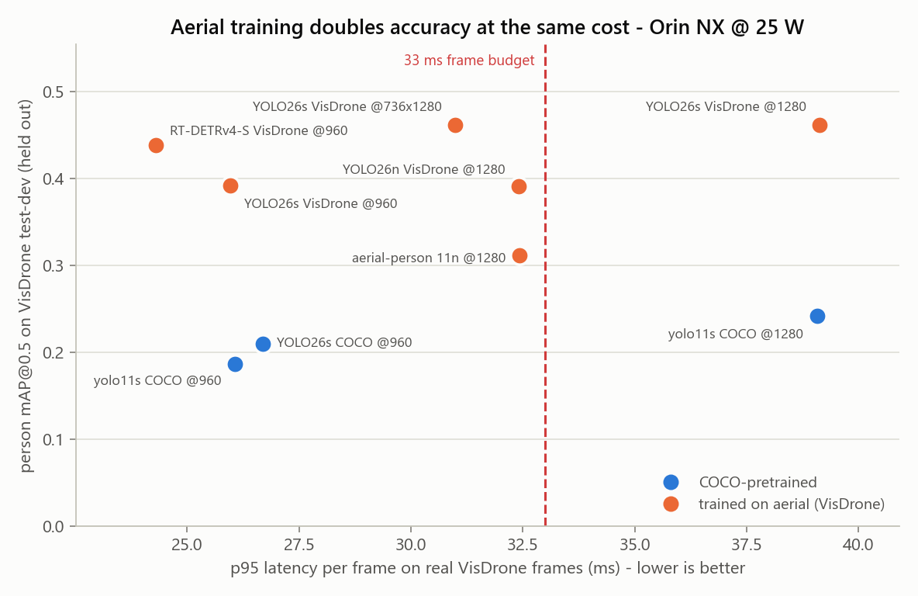
Held-out accuracy against real-frame latency. Orange: trained on aerial imagery. Dashed: the 33 ms frame budget.
- Training on aerial imagery is what matters: it roughly doubles the people found at the same cost. A newer architecture adds about 2 points, 1280 px about 5 — and only fits the budget as a rectangular 736×1280 engine.
- Measured as networks alone (GPU compute, trtexec), YOLO26s is the lightest at this accuracy; RT-DETRv4-S is heavier but is the only Apache-2.0 option, within a point on recall. Through Ultralytics’ Python pipeline the YOLO takes 31 ms, most of it pipeline rather than network, so the production node should run the engine directly. Both sets of weights inherit VisDrone’s non-commercial licence until we fine-tune our own.
- Pose: YOLO26s-pose runs at 22.7 ms against 26.5 ms for the current yolo11s-pose. No aerial pose model exists, so posture moves to a second stage on crops of each detected person.

3.2 Vision-language models (16 person crops; nobody injured, nobody lying)
Model (decoding) | Valid JSON | Injury reported | Said "lying" | Flags unseen | First token p95 | Peak GPU
Qwen3.5-2B (shipped = greedy) | 100 % | 0/16 | 0/16 | 0/16 | 0.30 s | 4.3 GB
Qwen3.5-2B (greedy+rep) | 100 % | 0/16 | 0/16 | 0/16 | 0.30 s | 4.3 GB
Qwen3-VL-2B (greedy+rep) | 100 % | 0/16 | 2/16 | 16/16 | 0.21 s | 4.1 GB
InternVL3.5-2B (greedy) | 100 % | 0/16 | 2/16 | 16/16 | 2.08 s | 5.1 GB
Qwen3-VL-4B (greedy+rep) | 100 % | 0/16 | 4/16 | 7/16 | 0.33 s | 8.5 GB
LFM2.5-VL-3B (shipped) | 100 % | 0/16 | 5/16 | 12/16 | 0.30 s | 6.0 GB
Qwen3-VL-4B (shipped) | 100 % | 0/16 | 5/16 | 6/16 | 0.33 s | 8.5 GB
InternVL3.5-2B (greedy+rep) | 88 % | 0/16 | 7/16 | 15/16 | 2.10 s | 5.1 GB
Qwen3-VL-2B (shipped) | 50 % | 0/16 | 0/16 | 15/16 | 0.20 s | 4.1 GB
Qwen3-VL-2B (greedy) | 31 % | 0/16 | 1/16 | 16/16 | 0.21 s | 4.1 GB
MiniCPM-V-4.6 (greedy+rep 4x) | 25 % | 0/16 | 0/16 | 0/16 | 0.70 s | 2.7 GB
MiniCPM-V-4.6 (greedy+rep) | 19 % | 0/16 | 0/16 | 0/16 | 0.50 s | 2.6 GB
MiniCPM-V-4.6 (shipped) | 6 % | 0/16 | 0/16 | 1/16 | 0.50 s | 2.6 GB
LFM2.5-VL-3B (greedy+rep) | 100 % | 1/16 | 5/16 | 8/16 | 0.30 s | 6.0 GB
Qwen2.5-VL-3B (shipped) | 88 % | 6/16 | 2/16 | 2/16 | 0.76 s | 7.2 GB
Qwen2.5-VL-3B (greedy) | 94 % | 7/16 | 2/16 | 1/16 | 0.75 s | 7.2 GB
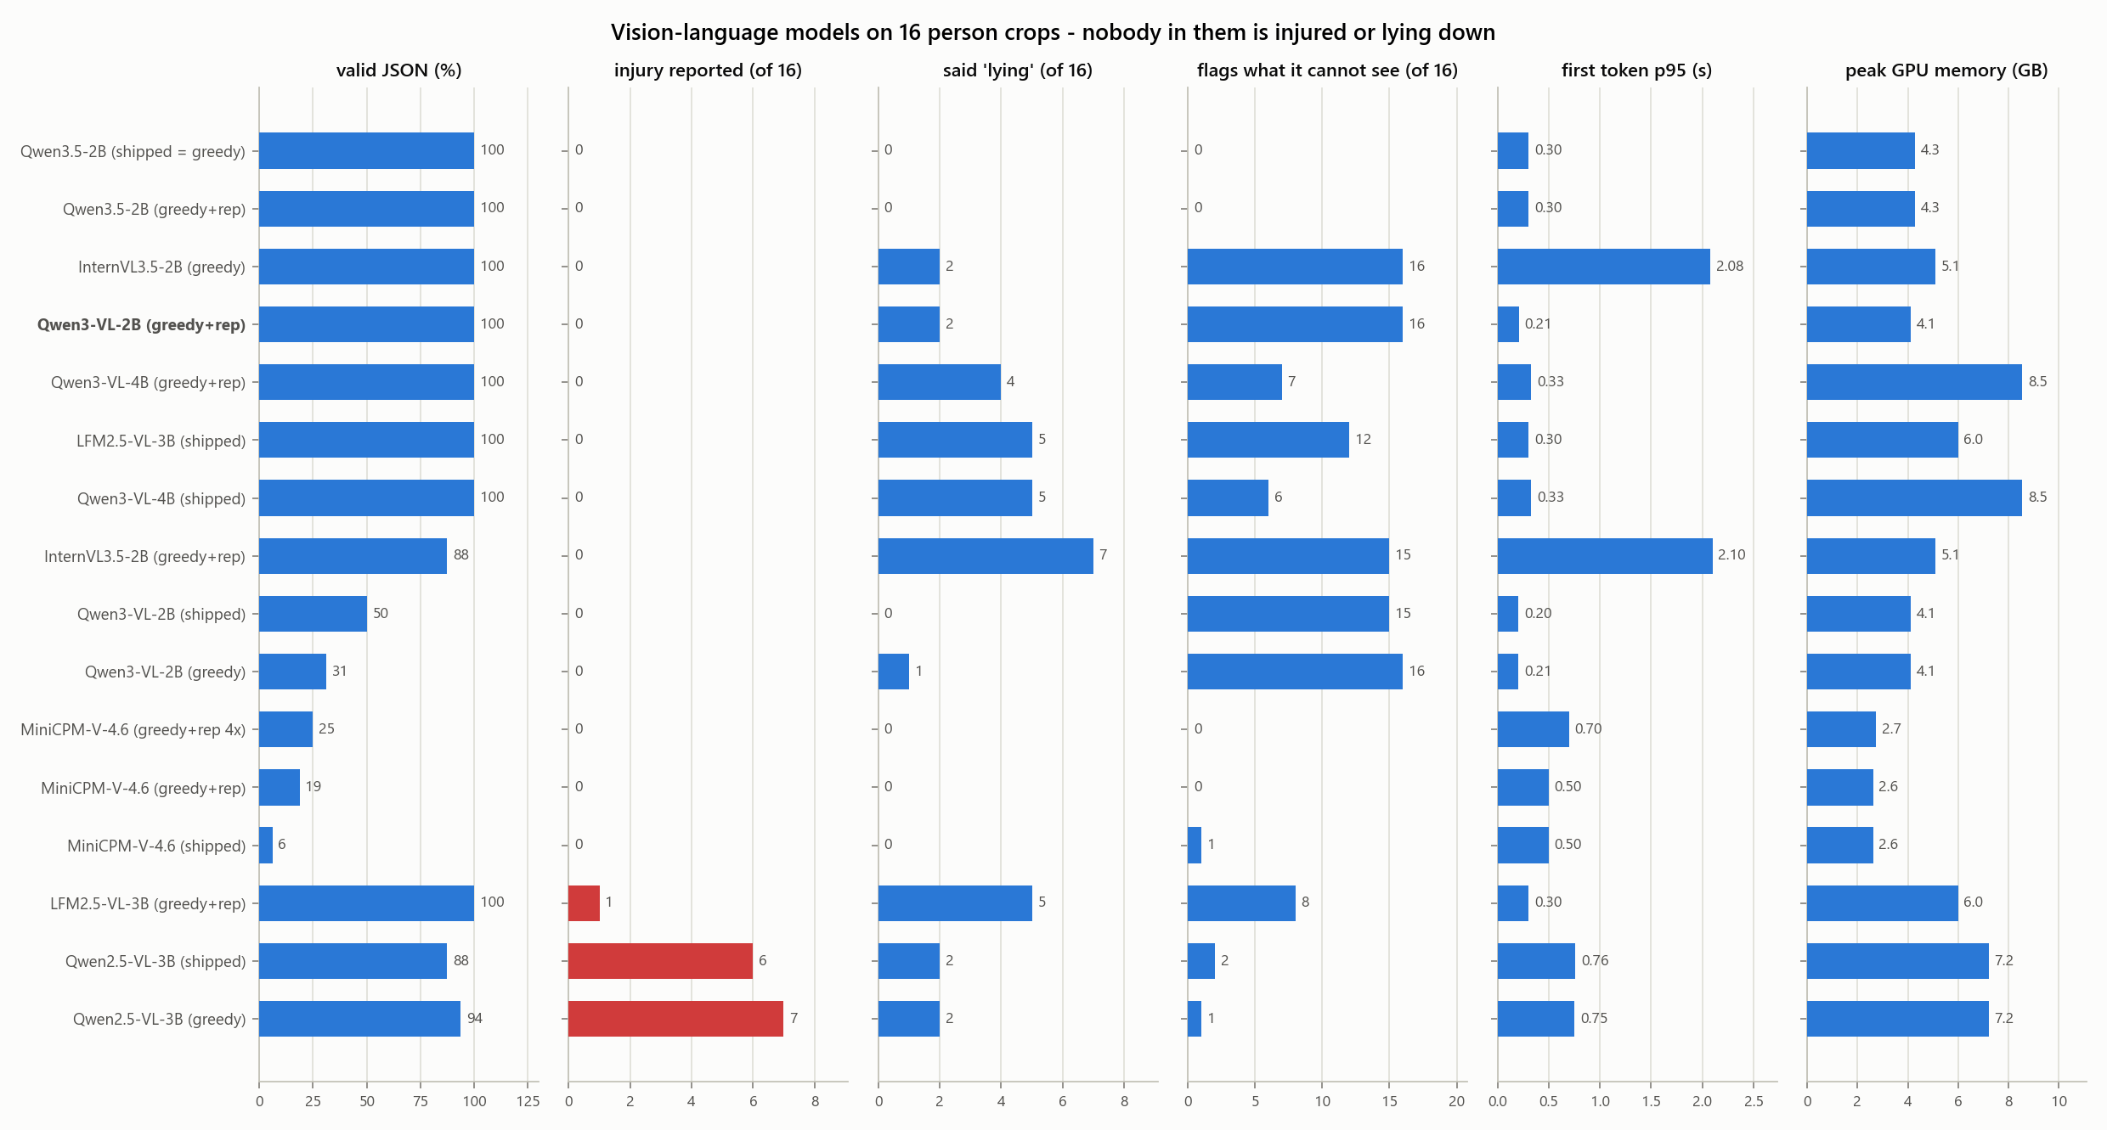
The VLM comparison. Red: answers reporting an injury for people who have none.
- Qwen3-VL-2B with greedy decoding and a 1.05 repetition penalty is the only configuration that is truthful, fully schema-valid, honest about what it cannot see, quick to start and small at once.
- Qwen3.5-2B is a close second — equally truthful on injuries and never fooled by the prompt’s posture, but it never admits what it cannot see and is slower. Both get a larger re-test after the prompt fix.
- Rejected: LFM2.5-VL-3B (fast, but asserted ethnicity, invented a bruise, and called 5 of 16 upright people "lying"); MiniCPM-V-4.6 (accurate but malformed JSON); Qwen3-VL-4B (slower and larger than the 2B, and fooled more often); InternVL3.5-2B (honest, but 2.1 s to its first token).
- Decoding settings decide whether a model works: under plain greedy decoding Qwen3-VL loops and a third of its replies parse.
- Most models sometimes repeat the posture the prompt asserts rather than the one they see, and most copy the prompt’s 0.91 as their own confidence. Both are prompt-design faults with known fixes (docs/12).
- A full description still takes about 12 s against a 5 s target. Quantising to 4 bits in llama.cpp, with a JSON grammar, is the next lever.

4. What is on the Jetson
Inventory taken live from the board at 2026-09-28 21:08.

4.1 Hardware and operating system
Item | Value
Module | NVIDIA Jetson Orin NX 16 GB ("Engineering Reference Developer Kit Super")
Carrier board | Seeed reComputer J401
JetPack / L4T | JetPack 7.2 / L4T R39.2.0
Operating system | Ubuntu 24.04.4 LTS, kernel 6.8.12-tegra
Storage | 79 GB NVMe - 67G used, 7.9G free (90%)
Power mode | 25 W (nvpmodel mode 3). Also available: 10 W, 15 W, 40 W, MAXN_SUPER.
Hostname / user | alfaisal-x-nx / alfaisal-x-nx

4.2 Software
Component | Version / location
Python environment | ~/raptor-venv, created with --system-site-packages
PyTorch / torchvision | 2.14.0 / 0.29.0 (CUDA 13) — the generic wheel, see Risks
TensorRT | 10.16.2 (trtexec at /usr/src/tensorrt/bin)
Ultralytics | 8.4.154 (supports YOLO26)
Transformers | 5.17.0 — loads every VLM tested today without remote code
ROS 2 | Jazzy, ros-base, with vision_msgs and colcon
RT-DETRv4 source | ~/raptor-ext/RT-DETRv4, used only to build the model; training-only imports are stubbed

4.3 Deployed models (~/raptor-deploy) — unchanged today
Slot | Artifact | Role | Measured
detector | yolo11s.engine | tier 1 - person detection | 25.9 ms p95, mAP@0.5 0.369
pose | yolo11s-pose.engine | tier 1+2 - person detection AND 17 keypoints | 26.5 ms p95
vlm | Qwen2.5-VL-3B-Instruct | tier 3 - event-triggered scene description | first token 0.76 s
vlm_fallback | SmolVLM2-2.2B-Instruct | tier 3 fallback for an 8 GB board | first token 1.41 s

These are the previous choices. The recommended models are on disk (below) but not yet in the deployed set.

4.4 Models and data on disk (not in git)
Folder | Size | Contents
~/raptor-vlm | 28G | InternVL3_5-2B-HF, LFM2.5-VL-3B, MiniCPM-V-4.6, Qwen2.5-VL-3B-Instruct, Qwen3-VL-2B-Instruct, Qwen3.5-2B
~/raptor-models | 995M | COCO weights and engines (yolo11 n/s/m, -pose, yolov8s, rtdetr-l, YOLO26s/n, YOLO26s-pose) and, in aerial/, the VisDrone-trained YOLO26s/n, RT-DETRv4-S and aerial-person models with their TensorRT engines
~/raptor-data | 765M | VisDrone person val (548 images) and test-dev (1,610 images) sets, 16 person crops
~/raptor-ext | 40M | RT-DETRv4 source, for building the model
~/raptor-deploy | 28K | The deployed set (first-round models) and MANIFEST.json
~/raptor-results | 1.3M | Raw results and logs as first written on the board

Archived to the laptop to free disk space (C:\Users\majda\raptor-downloads\vlm): SmolVLM2-2.2B and Qwen3-VL-4B. Every downloaded model is also kept there, checksum-verified, so none needs downloading again.

4.5 Access, services and camera
- SSH alfaisal-x-nx@100.100.100.1 (key-based); VNC port 5900 (console, 1024×768, unencrypted); RDP port 3389 (own session, TLS). Passwords are not written in this report; they were given to the operator directly.
- Services installed by us: raptor-clock-keeper (stops booting into 1970), x11vnc, GNOME Remote Desktop, a headless display configuration, an apt proxy file, passwordless sudo, one SSH key. The installed files are in the repository under src/system/.
- Internet: only through the laptop (src/tools/jetson_internet.sh). The board's Ethernet is a fixed address with no DHCP, so plugging it into a router does not give it internet; a DHCP fallback profile is proposed in section 7.
- Camera: a Logitech C922 webcam on USB 2.0 (the A8 mini flight camera is still untested). Live run: 26.9 FPS end to end.
- Do not use ping to check the board: 100.100.100.1 lies in the carrier-grade NAT range, so an unrelated host can answer. Use SSH.

5. Repository
Everything from today is in RAPTOR/, uncommitted (the repository is the shared course repository on main, so committing is a team decision). New today:
Where | What
docs/10, docs/12 | A second-round section on top of each, with the first round kept below as the record; docs/12 carries an explicit correction.
docs/02, docs/03 | Decision tables updated to the new detector and VLM, with the originals kept.
src/benchmarks/bench_rtdetrv4.py | Harness for RT-DETRv4, which Ultralytics cannot load.
src/common/person_scoring.py | Person mAP and recall for any detector; works around Ultralytics val() ignoring its classes argument.
src/analysis/score_vlm_generations.py | Checks every VLM answer for invented injuries, false "lying", ethnicity and copied prompt numbers.
src/analysis/plot_reeval.py, report_part_a.js | The re-evaluation figures (5–7) and Part A of the model-selection report.
bench_detector.py, bench_vlm.py | Rectangular input sizes, VisDrone class merging, decoding settings, model-specific options, links from each result row to its raw answers.
benchmarks/results | 30 detector and 16 VLM result rows from today, the raw answers of every VLM run, and the truthfulness scores.
reports/RAPTOR-model-selection-report.docx | Rebuilt: Part A is the re-evaluation, Part B the original evaluation.

6. Problems found and fixed
Problem | Fix
Ultralytics val() ignores its classes argument, so VisDrone-trained models were scored with cars counted as people (precision 0.25 instead of 0.73) | person_scoring.py scores the person classes explicitly; validated against val() within 0.5 points. The three wrong rows are kept, flagged, and never plotted.
Synthetic benchmark frames under-timed the 1280 px engines by a third (28 ms against 39 ms) | All latencies re-measured on the same real frames as the first round; the plotting script already refused synthetic rows.
Qwen3 models loop under greedy decoding, so only a third of their answers parsed | Decoding settings are now a benchmark parameter; greedy with a 1.05 repetition penalty gives 100 % valid JSON and stays deterministic.
A failed-to-parse VLM answer hid an invented injury in the 20 September review | Every answer is now scored from its raw text, parsed or not; the earlier claim is corrected in docs/12 and the report.
Model downloads stalled on the laptop Wi-Fi (0.1–0.4 MB/s per connection) | A parallel, resumable, checksum-verified downloader: up to 12 MB/s.
The Jetson became unreachable after the laptop's Ethernet was switched to DHCP (the USB hub has one Ethernet adapter, and the second adapter is not seen) | Fixed address restored; the board kept running throughout. See section 7.
Earlier today: the clock reset on cold boot; VNC, RDP and display issues; the laptop proxy exposed to the ISP network; Windows line endings on the board | Fixed, as in the 16:24 edition.

7. Open questions
# | Question | Blocks
1 | Can the A8 mini output HDMI and Ethernet video at the same time? | The split-video harness — test first, it is cheap
2 | ArduPilot or PX4 on the Pixhawk 6C? | Optional gimbal UART parameters
3 | What does the HDMI capture card negotiate? | Detector input sizing
4 | Swap the deployed models to the aerial YOLO26s (or RT-DETRv4-S) and Qwen3-VL-2B now? This also repairs the vlm_fallback slot, which points at a model archived off the board. | Everything downstream — the live demo, the dashboard
5 | Give the Jetson its own internet? Needs a small network switch (the USB hub cannot bridge) and a DHCP profile with fixed-address fallback on the board. | Faster installs and downloads; the laptop proxy retires
6 | Should the board run at 25 W or 40 W in flight? | Endurance against speed
7 | Is there a separate Orin Nano? | The failed factory reset in General Tasks may have been this board
— | Answered today: does Qwen3-VL beat Qwen2.5-VL? Yes — and the smaller one wins. Is AGPL a blocker? Still the team’s decision, but no longer blocking: RT-DETRv4-S is a measured Apache-2.0 alternative within a point of the chosen detector. | —

8. Risks and caveats
- Proxy data. VisDrone is urban, with no casualties and nobody lying down, and the new detectors were trained on it. Their 43 % is a ceiling for this data, not a prediction for a search over desert or rubble. Evaluating on aerial images of lying people is the next test to build.
- Licences. The chosen detector is AGPL-3.0, and both aerial detectors’ weights inherit VisDrone’s non-commercial licence; they must be replaced by our own fine-tune before any commercial use.
- The VLM believes the prompt. Most models sometimes report the posture the prompt asserts. The prompt must stop stating it as fact.
- Recall. Even the best detector misses more than half the people on the held-out set. The system must never present a searched area as confirmed clear.
- PyTorch has no kernels built for this GPU. Every PyTorch and transformers number is a floor; NVIDIA's Jetson build is the highest-value environment fix.
- Disk. The board's disk is 90% full. Rejected models can move to the laptop archive.
- Security posture is lab-grade. Passwordless sudo, unencrypted VNC, one SSH key that reaches root. Fine on a cable to one laptop; not on a shared network.

9. Next steps

9.1 Deploy the new models
- Build a lean TensorRT runtime for the YOLO26s VisDrone engine (736×1280) and measure it end to end, then stage it and Qwen3-VL-2B in ~/raptor-deploy with a provenance manifest, as the first-round models were. RT-DETRv4-S is the drop-in if AGPL is ruled out.
- Switch the live demo to the aerial detector, with YOLO26s-pose on crops of each person.
- Serve Qwen3-VL-2B through llama.cpp at 4 bits with a JSON grammar, and re-measure speed and truthfulness.
- Change the VLM prompt so it no longer asserts the posture, and drop its confidence field.

9.2 Then: an operator dashboard
A dashboard, hosted on a server, that shows everything the Jetson has logged: for every event, the image it captured and a full written description of what is in it — an early, working version of the Phase 5 ground-station view in docs/04 and docs/07, brought forward on purpose.
Step | What gets built | Done when
1 | Event logger on the Jetson: each trigger (new person, posture change, interval) becomes a folder with the frame, the annotated frame and a JSON record. | Walking past the camera produces an event folder.
2 | Descriptions: Qwen3-VL-2B on each person crop, grammar-constrained, with any demographic field rejected before it is stored. | Every event carries a schema-valid description.
3 | Server: a small web service with a database and image storage that accepts events from the Jetson. | Events from the Jetson are stored and listed.
4 | Dashboard pages: event feed, event page (image beside text), board health. | A person in front of the camera appears on the dashboard within about 15 s.
5 | Reliable delivery: local queue, retry, no duplicates. | Ten minutes offline loses nothing.

Rules: the aircraft never waits on the server; descriptions are labelled as machine observations, never diagnoses; identity and demographic attributes are never stored or shown; the image is always beside the text.

10. Changes made on the laptop today
- Sleep disabled (plugged in and on battery) so long runs survive the lock screen. To restore: powercfg /change standby-timeout-ac 30. Closing the lid is a separate setting (Power Options → "Choose what closing the lid does").
- Installed into the user Python: transformers 5.17.0 (to check VLM processors offline) and onnx 1.23.0 (to export RT-DETRv4). Both removable with pip uninstall.
- Downloads kept in C:\Users\majda\raptor-downloads (41 GB): every VLM tested, the detector weights and VisDrone test-dev. Outside git; safe to delete, but slow to re-download on this Wi-Fi.
- Ethernet 4 (the USB hub's adapter to the Jetson) was briefly switched to DHCP and has been restored to its fixed address, 100.100.100.2; an old gateway entry pointing at the Jetson was removed in the process.

11. Standing caveat
Every figure in this report came from a run recorded in RAPTOR/benchmarks/results; none is quoted from a datasheet. Accuracy is on a public proxy dataset and describes downloaded models, not RAPTOR's own performance.

