RAPTOR
Onboard perception: model selection and re-evaluation, deployment, first live run
Measured on the flight computer — Jetson Orin NX 16 GB
Generated 2026-09-29 from recorded benchmark runs
Part A is the re-evaluation of 28 September 2026 and holds the current recommendations. Part B is the original evaluation of 20 September, kept as the record.

Part A — Re-evaluation, 28 September 2026
This part replaces the recommendations of Part B. Part B, the original evaluation of 20 September, follows it unchanged except for one marked correction, because its method and most of its findings still hold.

A1. Summary and recommendation
Detector: YOLO26s trained on VisDrone aerial imagery, as a 736×1280 TensorRT FP16 engine, served through a lean TensorRT runtime.
On held-out aerial images (VisDrone test-dev) it finds 42 % of people, against 20 % for the first-round pick (COCO yolo11s), and it is the lightest network at that accuracy: 11.5 ms of GPU compute per frame (p95). Served by the lean TensorRT runner it takes 26.1 ms p95 end to end on real frames, against 31.0 ms through Ultralytics' Python pipeline. RT-DETRv4-S trained on VisDrone ties it on accuracy (43 % of people) and is 24.3 ms end to end, but needs 17.1 ms of GPU compute — a third more, on a GPU the VLM shares. It is Apache-2.0, and deployed alongside as the alternative if AGPL is ruled out.
Vision-language model: Qwen3-VL-2B-Instruct, greedy decoding with repetition penalty 1.05.
On 16 crops of people who are neither injured nor lying down, it returned valid JSON on 100 % and reported an injury for 0 of the 16. The first-round pick, Qwen2.5-VL-3B, reported injury indicators for 7 of them — four outright inventions (a bruise, bruising, a "foot injury", bloodstains) and three non-injuries filed as injuries. It starts answering in 0.21 s (p95) against 0.75 s, uses 4.1 GB against 7.2 GB, and is Apache-2.0.
What changed the answer:
- Detectors trained on aerial imagery now exist as downloads. Training data mattered far more than architecture or resolution: it roughly doubles the people found at the same cost.
- A truthfulness check, not just a schema check. Scoring what each VLM actually said against what the crops show exposed invented injuries that a parse-rate table cannot see.
- Decoding settings decide whether a model works. Under plain greedy decoding Qwen3-VL loops and only a third of its replies parse; with a 1.05 repetition penalty, all of them do.
Two statements in Part B were wrong, and are corrected in section A5. The new models were deployed on the board on 29 September (section A7).

A2. Why a re-evaluation
- Part B compared COCO-trained detectors only, and found that they miss most people seen from the air. The question was whether something better exists now, without training anything ourselves.
- Part B took its VLM shortlist from a design document written before the current generation (Qwen3-VL and others) was released. Qwen3 had never been tested.
- Both were answered with the same harness, the same board (Orin NX 16 GB at 25 W) and the same data as Part B, plus a held-out test set Part B did not have.

A3. Detectors
- Latency: TensorRT FP16 engines timed on the same 200 real VisDrone frames as Part B. The Part B baseline re-measures at 26.1 ms against 25.9 ms, so the two parts compare.
- Accuracy on VisDrone val (as in Part B) and on VisDrone test-dev: 1,610 images, 27,382 people, 343 images with nobody, which no one involved used for training or model selection. The VisDrone-trained checkpoints were selected on val by their authors, so test-dev is the fair column.
- Models trained on VisDrone split people into "pedestrian" and "people"; both count as a person, scored with person_scoring.py (see "A scoring bug" below).
Configuration | p95 ms | test-dev recall | test-dev mAP@0.5 | val recall | Licence
YOLO26s VisDrone @1280 | 39.1 | 0.436 | 0.462 | 0.622 | AGPL-3.0 (weights: VisDrone NC)
RT-DETRv4-S VisDrone @960 | 24.3 | 0.428 | 0.439 | 0.622 | Apache-2.0 (weights: VisDrone NC)
YOLO26s VisDrone (lean runtime) @736x1280 | 26.1 | 0.425 | 0.452 | 0.619 | AGPL-3.0 (weights: VisDrone NC)
YOLO26s VisDrone @736x1280 | 31.0 | 0.425 | 0.452 | 0.619 | AGPL-3.0 (weights: VisDrone NC)
YOLO26s VisDrone @960 | 26.0 | 0.375 | 0.392 | 0.554 | AGPL-3.0 (weights: VisDrone NC)
YOLO26n VisDrone @1280 | 32.4 | 0.375 | 0.391 | 0.546 | AGPL-3.0 (weights: VisDrone NC)
aerial-person 11n @1280 | 32.4 | 0.312 | 0.312 | 0.463 | AGPL-3.0
yolo11s COCO @1280 | 39.1 | 0.247 | 0.242 | 0.426 | AGPL-3.0
YOLO26s COCO @960 | 26.7 | 0.218 | 0.210 | 0.386 | AGPL-3.0
yolo11s COCO @960 | 26.1 | 0.200 | 0.186 | 0.362 | AGPL-3.0
Budget: 33 ms per frame. Rows above 33 ms p95 miss it. The 736×1280 engine carries the 1280 rows' accuracy (the same pixels on a 16:9 frame).
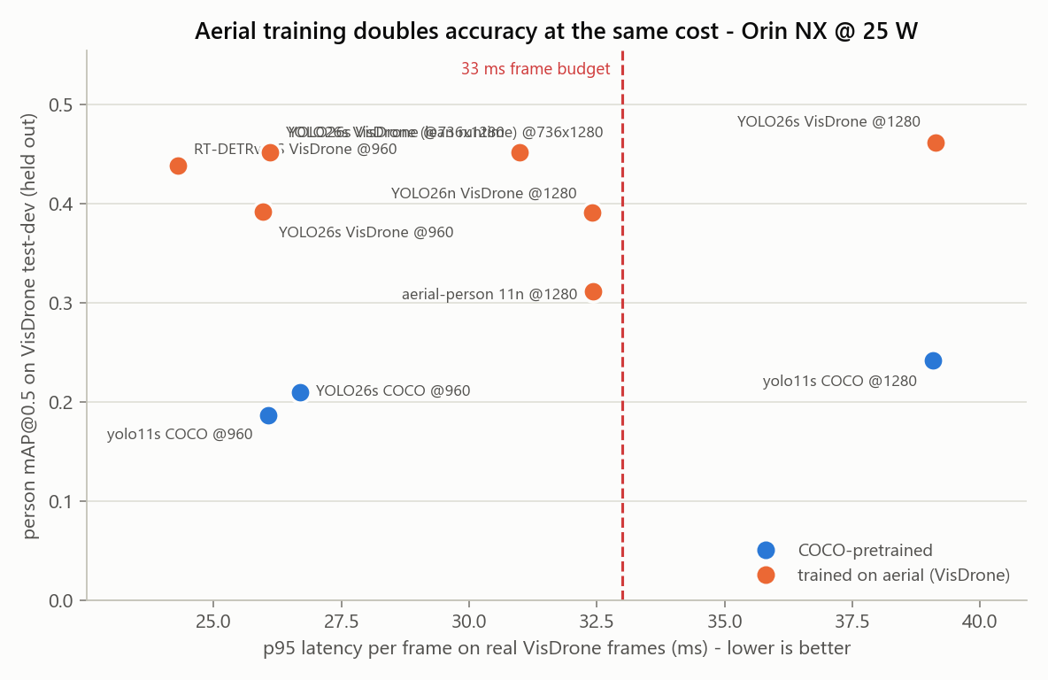
Figure 5. Held-out accuracy against real-frame latency. Orange: trained on aerial imagery.
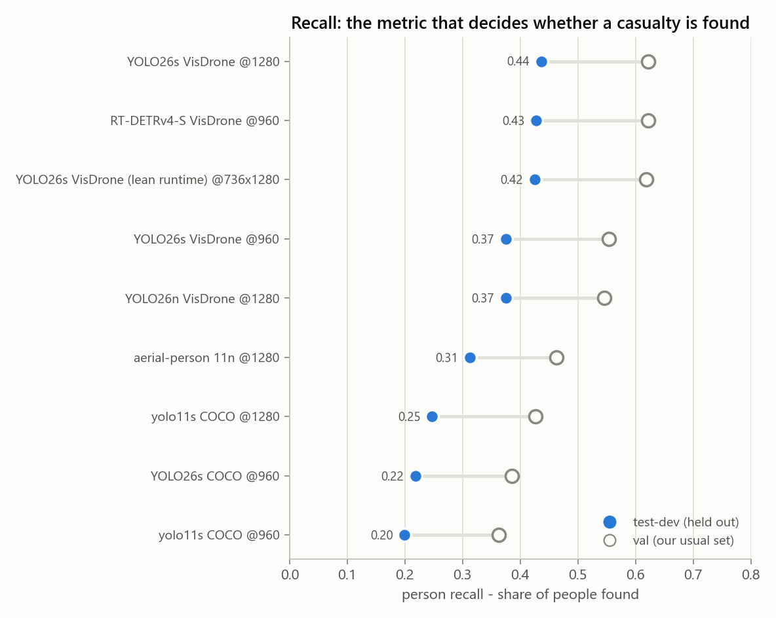
Figure 6. Recall on VisDrone val (hollow) and held-out test-dev (solid). The gap is how much our usual set flatters each model.
Findings:
- Aerial training is the lever. Inside the budget, COCO detectors find about a fifth of the people on test-dev; the VisDrone-trained ones find 37–44 %.
- Higher resolution only pays with a rectangular engine. A 1080p frame letterboxed into a 1280 square is 44 % padding: 39 ms, over budget. Built as 736×1280, the same model takes 31 ms.
- Synthetic frames under-time real work by about a third (28 ms against 39 ms for the square engines). Every latency here is on real frames.
- At 1280 px the nano model is no faster than the small one in a rectangular engine, and less accurate: pre- and post-processing, not the network, set the cost there.
- VisDrone val overstates every model by 15–25 points of mAP, most for models tuned on it. Decisions are made on test-dev.
- Measured as networks alone (trtexec, GPU compute only), the YOLO26s engines need 11.5 ms and RT-DETRv4-S 17.1 ms per frame. RT-DETRv4-S looked faster end to end only because its harness is leaner: Ultralytics’ Python pipeline adds 15–20 ms per frame to the YOLOs, more than the network itself. The production detector node should run the engine directly.
A scoring bug, found and fixed
Ultralytics' val() ignores its classes argument. That is harmless for COCO models against a one-class dataset, but with single_cls it scored every car and van as a person for the VisDrone-trained models: YOLO26s showed precision 0.25 instead of 0.73 and would have been rejected. person_scoring.py now keeps only the person classes, merges them, and scores with Ultralytics' own matching and ap_per_class; on the COCO baseline it agrees with val() within half a point. The three wrongly scored rows stay in the results, flagged, so they cannot be plotted by accident.
Pose (latency only; VisDrone has no keypoints): YOLO26s-pose runs at 22.7 ms p95 against 26.5 ms for yolo11s-pose.

A4. Vision-language models
- 7 models in 16 configurations: each with its shipped decoding settings and, where different, deterministic greedy decoding with a 1.05 repetition penalty. Same prompt and JSON schema as Part B, bf16, transformers 5.17, 160-token cap.
- Sixteen person crops from VisDrone. Checked by eye: 13 people standing or walking, 3 sitting, nobody lying down and nobody visibly injured — while the prompt tells every model the person is lying and immobile. So any injury reported is invented, and any "lying" means the model believed the prompt over the image.
- Schema validity says a reply parses. The truthfulness columns (score_vlm_generations.py) say whether it is true. Neither measures whether a model notices a real injury: there are none in this set.
Model (decoding) | Valid JSON | Injury reported | Said "lying" | Flags unseen | First token p95 s | Full reply s | Peak GB
Qwen3.5-2B (shipped = greedy) | 100 % | 0 / 16 | 0 / 16 | 0 / 16 | 0.30 | 15.0 | 4.3
Qwen3.5-2B (greedy+rep) | 100 % | 0 / 16 | 0 / 16 | 0 / 16 | 0.30 | 13.9 | 4.3
Qwen3-VL-2B (greedy+rep) | 100 % | 0 / 16 | 2 / 16 | 16 / 16 | 0.21 | 12.4 | 4.1
InternVL3.5-2B (greedy) | 100 % | 0 / 16 | 2 / 16 | 16 / 16 | 2.08 | 13.0 | 5.1
Qwen3-VL-4B (greedy+rep) | 100 % | 0 / 16 | 4 / 16 | 7 / 16 | 0.33 | 11.9 | 8.5
LFM2.5-VL-3B (shipped) | 100 % | 0 / 16 | 5 / 16 | 12 / 16 | 0.30 | 8.7 | 6.0
Qwen3-VL-4B (shipped) | 100 % | 0 / 16 | 5 / 16 | 6 / 16 | 0.33 | 12.4 | 8.5
InternVL3.5-2B (greedy+rep) | 88 % | 0 / 16 | 7 / 16 | 15 / 16 | 2.10 | 13.7 | 5.1
Qwen3-VL-2B (shipped) | 50 % | 0 / 16 | 0 / 16 | 15 / 16 | 0.20 | 14.7 | 4.1
Qwen3-VL-2B (greedy) | 31 % | 0 / 16 | 1 / 16 | 16 / 16 | 0.21 | 15.2 | 4.1
MiniCPM-V-4.6 (greedy+rep 4x) | 25 % | 0 / 16 | 0 / 16 | 0 / 16 | 0.70 | 10.9 | 2.7
MiniCPM-V-4.6 (greedy+rep) | 19 % | 0 / 16 | 0 / 16 | 0 / 16 | 0.50 | 10.3 | 2.6
MiniCPM-V-4.6 (shipped) | 6 % | 0 / 16 | 0 / 16 | 1 / 16 | 0.50 | 10.2 | 2.6
LFM2.5-VL-3B (greedy+rep) | 100 % | 1 / 16 | 5 / 16 | 8 / 16 | 0.30 | 7.4 | 6.0
Qwen2.5-VL-3B (shipped) | 88 % | 6 / 16 | 2 / 16 | 2 / 16 | 0.76 | 13.3 | 7.2
Qwen2.5-VL-3B (greedy) | 94 % | 7 / 16 | 2 / 16 | 1 / 16 | 0.75 | 12.6 | 7.2
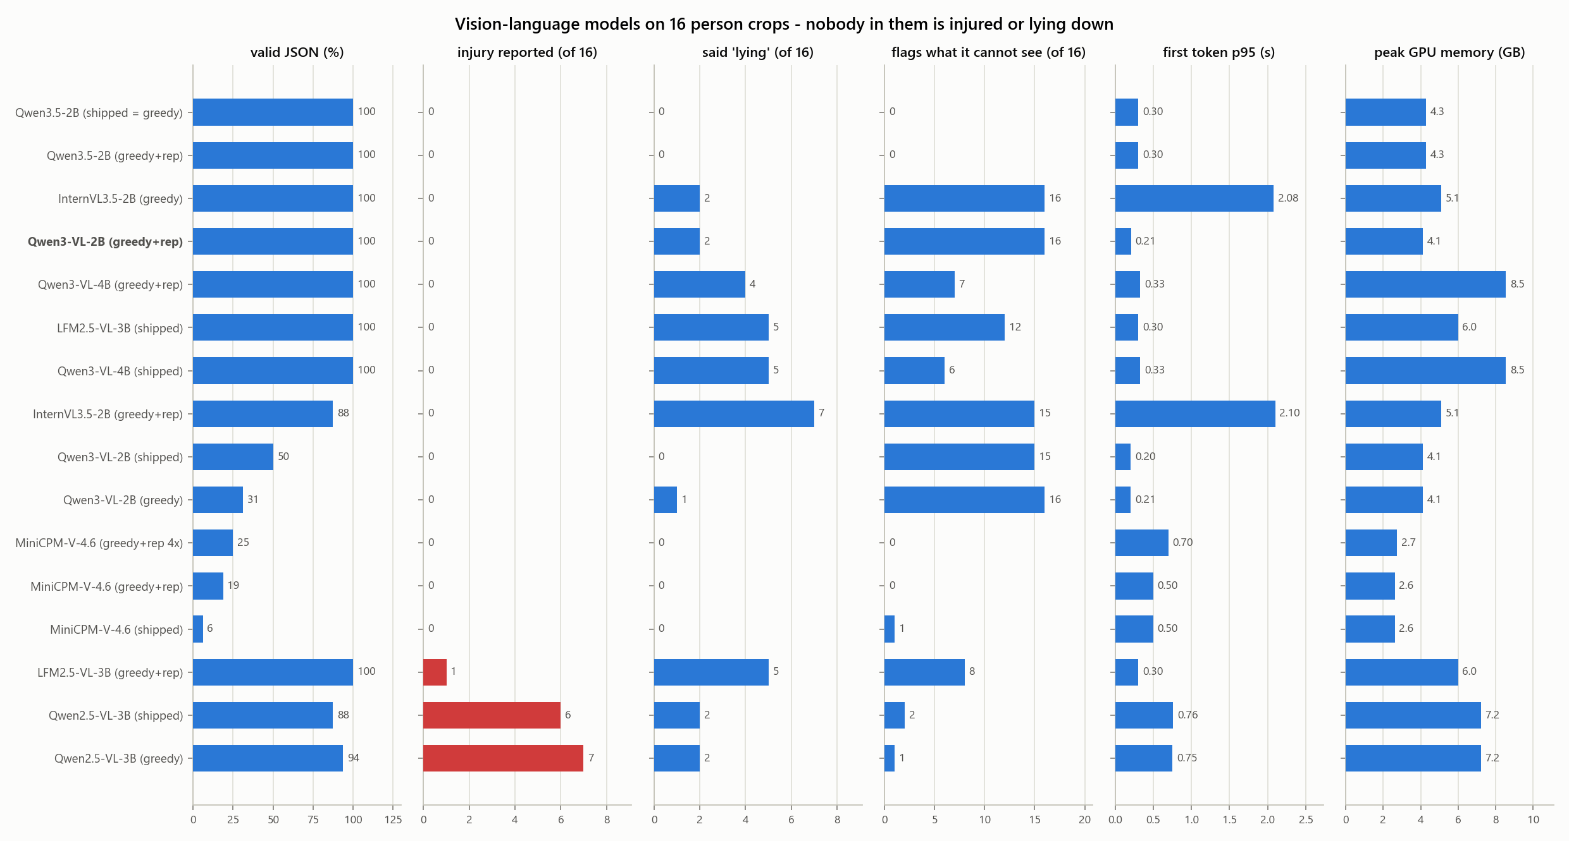
Figure 7. The VLM comparison. Red: answers reporting an injury for people who have none.
One crop, two models. A man sitting on a kerb, looking at his phone:
 | Qwen2.5-VL-3B (Part B pick) | Qwen3-VL-2B (new pick)
body_position | posture: sitting, location: on the ground | Sitting on the ground with his legs bent and knees close to his chest.
injury_indicators | bloodstains on the ground near the person's feet | (none)
surroundings | floor: concrete, background: indoor setting with tiled floor | The scene appears to be outdoors on a paved surface, possibly a sidewalk or street, with a white vehicle partially visible in the foreground.

Findings:
- Qwen3-VL-2B is the only configuration that is at once truthful (no invented injuries), fully schema-valid, honest about what it cannot see (it fills not_visible in 16 of 16 answers), quick to start and small.
- Qwen3.5-2B is a close second: equally free of invented injuries, and the only model that never repeated the prompt's "lying". But it never fills not_visible (0 of 16) — it presents everything as observed — it speculates ("possibly eating or drinking" of a man looking at his phone), and it is slower. Two posture errors against none in 16 crops is not a meaningful difference; both should be re-run on a larger set once the prompt is fixed.
- Rejected: LFM2.5-VL-3B is the fastest, but called 5 of 16 upright people "lying", invented a bruise, and wrote "East Asian male" — a demographic claim docs/08 rules out — at 0.95 confidence. MiniCPM-V-4.6 describes accurately but writes malformed JSON (6–25 % parse). Qwen3-VL-4B is slower, twice the size, and believes the prompt more often than the 2B. InternVL3.5-2B is honest but takes 2.1 s to its first token.
- Decoding is part of the model choice. Qwen3 models loop under plain greedy decoding — their own documentation says not to use it — and sampling makes the output non-deterministic, which a safety system should avoid. Greedy with a 1.05 repetition penalty fixes both.
- Most models sometimes report the posture the prompt asserted rather than the one they see, and most copy the prompt's 0.91 into their own "confidence". Both are design faults of the prompt, not of a model: the prompt must stop stating the posture as fact, and the VLM's confidence field cannot be used for anything.
- Still too slow for the 5 s target: about 12 s for a full description in bf16 transformers. That is a serving problem. A 4-bit llama.cpp build of the same model is expected to be several times faster (published Orin Nano figures for a Qwen3-VL-2B derivative: 38 tokens/s) and adds grammar-constrained JSON, which docs 03 and 12 already require as a safety control.

A5. Corrections to Part B
- Part B, section 8, says Qwen2.5-VL-3B "correctly returned an empty injury list for uninjured pedestrians rather than inventing wounds". That was wrong at the time. Its answers are deterministic, and the 20 September run is byte-identical to today's on the same eight crops: on a man sitting on a railing it reported "lying, face up" and "visible bruise on left arm", and on another crop it listed "slippery shoes" as an injury. The first answer was missed because it failed to parse, and unparsed answers were not read. The same claim in docs/12 is corrected there.
- Part B's recommendations (yolo11s-pose as detector and pose model; Qwen2.5-VL-3B) are superseded by A1. What is deployed on the board is still the Part B set until the swap is made.
- Lesson kept in the harness: every answer is now scored, whether it parses or not.

A6. What changes in the design
- Tier 1 and tier 2 separate. No aerial-trained pose model exists, and the COCO pose model finds about a fifth of the people from the air. Detection comes from the aerial detector on every frame; posture comes from crops of each track at a lower rate (people do not change posture thirty times a second), with YOLO26s-pose above about 32 px and a direct posture classifier below.
- The VLM prompt must not assert the posture. Pass the geometric posture as a hypothesis to confirm or reject, or not at all, and compare.
- The VLM's "confidence" field should be removed from the schema or ignored.
- Serving: run the detector engine directly (TensorRT runtime or NITROS), not through Ultralytics’ Python pipeline, which adds more time per frame than the network itself.
- Licensing: the VLM is Apache-2.0. The recommended detector is AGPL-3.0 (as YOLO11 was); the AGPL decision is still the team’s, but no longer blocking, because RT-DETRv4-S is a measured Apache-2.0 alternative. Both detectors’ weights are trained on VisDrone (non-commercial); they must be replaced by our own fine-tune before any commercial use — which Phase 2 plans anyway.

A7. Deployed on the flight computer, 29 September
Staged in ~/raptor-deploy by src/deploy/deploy_models.py. Each artifact was loaded and run on the board after staging; MANIFEST.json records its source, licence, checksum and measured performance. The previous set is kept at ~/raptor-deploy.2026-09-20.
Slot | Artifact | Measured | Verified
detector | visdrone-yolo26s-736x1280.engine | 26.1 ms p95, test-dev recall 0.425 | yes
detector_alt | visdrone-rtdetrv4-s.engine | 24.3 ms p95, test-dev recall 0.428 | yes
pose | yolo26s-pose-960.engine | 22.7 ms p95 | yes
vlm | Qwen3-VL-2B-Instruct | first token 0.21 s, 100 % valid JSON | yes
vlm_fallback | Qwen3.5-2B | first token 0.30 s, 100 % valid JSON | yes

- The live demo now runs the two-stage pipeline: the aerial detector on every frame through the lean runner, and pose on crops of each person every fifth frame. On the live camera the detector took 20.8 ms per 1080p frame (the webcam caps the demo at ~24 FPS).
- The aerial detector did not see a person sitting right next to the desk webcam, where the COCO pose model did: it is trained on small people seen from above. That is expected; a second desktop icon, RAPTOR Live Demo (bench), runs the pose model alone for close-up demos, and --source plays aerial images or footage through the real pipeline.
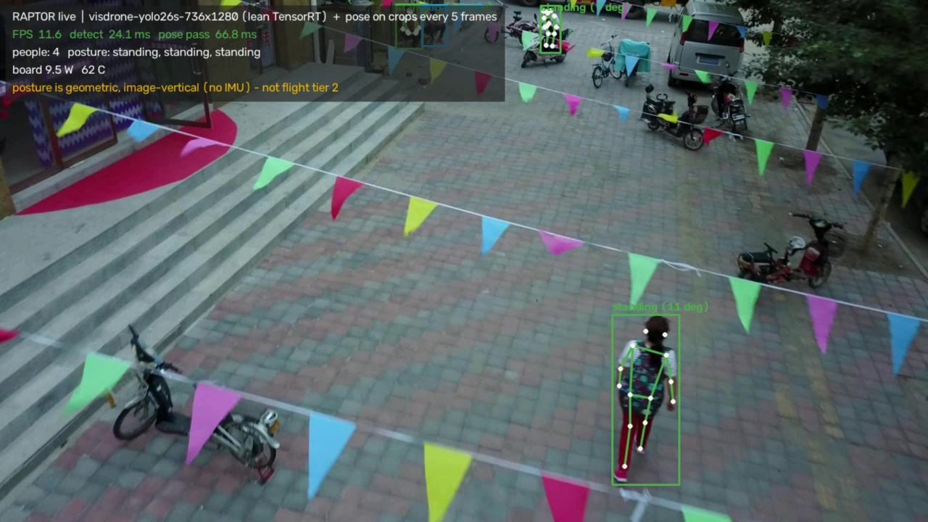
The deployed two-stage pipeline on a VisDrone frame: the aerial detector finds four people; pose on the crop gives the nearest one a skeleton and a posture.

A8. Next steps
- Speed up the lean detector runner: it still resizes on the CPU, so it takes 26.1 ms end to end against 11.5 ms of GPU compute. Resizing on the GPU should recover most of the gap.
- Serve the VLM through llama.cpp at 4 bits with a JSON grammar, and re-measure speed and truthfulness.
- Build the evaluation that matters most and does not exist yet: aerial images of people lying down (Okutama-Action, NOMAD, SARD, HERIDAL), for both the detector and the posture step.
- Run the detector and the VLM together (experiment E7) — they have never shared the GPU.

Part B — Original evaluation, 20 September 2026
Kept as the record. Its recommendations are superseded by Part A; its one factual error is marked where it occurs (section 8) and corrected in A5.

1. Summary and recommendation
Recommendation: yolo11s at 960 px input, FP16, served through TensorRT.
It delivers the highest person mAP@0.5 (0.369) of any configuration that fits the 33 ms frame budget, at 25.9 ms p95 and 12.6 W mean board power. The reasoning, and the three findings that make this a non-obvious choice, are in sections 5 and 6.
The same weights served through PyTorch measured 30.4 ms p95 at mAP@0.5 0.369 — so the TensorRT path costs nothing in accuracy (0.369 vs 0.369) and returns 4.5 ms per frame.
Three results drive the recommendation:
- Input resolution buys more accuracy than model capacity. yolo11s at 960 px beats yolo11m at 640 px on accuracy, latency and power simultaneously — yolo11m is dominated on every axis and misses the frame budget.
- Measured latency is dominated by framework overhead, not GPU compute. Wall-clock barely moves across a 2.3× accuracy range while board power climbs, which means the reported ~30 FPS ceiling is a property of PyTorch eager mode on this board, not of the hardware.
- Recall against aerial imagery is low for every off-the-shelf model tested. This is the quantified case for the fine-tuning work in Phase 2, and it is the single most important number in this report.
Beyond model selection, this report also records what is now installed and running on the flight computer: the deployed engines and their provenance (section 12), the platform work needed to get there — network, ROS 2 and a clock that no longer resets to 1970 (section 13) — and the first run of the deployed model on live camera frames (section 11).
What does not exist is the perception system itself. The components are chosen, measured, deployed and demonstrable; no pipeline node has been written. That distinction is kept explicit throughout.

2. Scope, and what this report does not claim
Every number here came from a run recorded in results/, per the rule in 06-benchmark-plan.md. Nothing is quoted from a datasheet or a published benchmark.
Equally important is what these numbers are not:
- Accuracy is measured on VisDrone-DET val, collapsed to a single person class (548 images, 13,969 person boxes). VisDrone is urban aerial footage. It is a proxy for RAPTOR's wilderness search-and-rescue imagery, not a substitute — there are no casualties and no prone figures in it.
- No fine-tuning was performed. These are COCO-pretrained weights evaluated zero-shot on aerial imagery, so the accuracy figures represent a floor, not the system's eventual performance.
- Pose and posture accuracy are not measured: VisDrone has no keypoint labels, and the posture classifier does not exist yet.
- No altitude-vs-recall curve (E3), no thermal soak, and no end-to-end victim-report evaluation — each needs our own instrumented flights.

3. Test environment
Item | Value
Board | NVIDIA Jetson Orin NX Engineering Reference Developer Kit Super
L4T / JetPack | 39.2.0 / JetPack 7
OS | Ubuntu 24.04.4 LTS
Kernel | 6.8.12-1021-tegra
GPU | Orin (compute capability 8.7)
CUDA (torch) | 13.0
PyTorch | 2.14.0+cu130
TensorRT | 10.16.2.10
Ultralytics | 8.4.154
Power mode | 25W (mode 3), jetson_clocks not pinned
Memory / free disk | 15.23 GB / 39.12 GB

Two environment caveats that affect every number:
- The installed PyTorch (2.14.0+cu130) is the generic PyPI aarch64 wheel, built for compute capabilities 8.0/9.0/10.0/11.0/12.0. Orin is 8.7, so CUDA falls back to JIT-compiling PTX. It works and the results are real, but they are not what NVIDIA's sm_87-tuned Jetson build would produce. Replacing this wheel is the highest-value environment fix outstanding.
- The board's real-time clock reads 1970-01-01 — there is no RTC battery and no NTP, because the Jetson has no network route. Result timestamps are therefore wrong. 04-ros2-architecture.md warns that a wrong clock silently corrupts timestamp correlation and geolocation; this must be fixed before any rosbag is recorded.

4. Method
- Each configuration is one process invocation writing one JSON line, carrying its full environment.
- The first 50 inferences of every run are discarded as warm-up — they include CUDA context creation, kernel autotuning, and on this board PTX JIT compilation.
- 200 frames are then measured, drawn from real VisDrone imagery rather than synthetic frames, so non-maximum suppression sees a realistic detection load (~25 people per image).
- Board power and temperature are sampled continuously via tegrastats for the duration of each run, not read once at the end.
- p95 latency is reported alongside the mean, because a pipeline that averages 25 ms but spikes to 60 ms drops frames exactly when the scene is busiest.
- Detection is restricted to the person class, matching how RAPTOR actually runs.

5. Detector results
Configuration | Task | Backend | p95 ms | mAP@0.5 | Recall | Power W | In budget
rtdetr-l @960 | detect | PyTorch | 110.7 | 0.431 | 0.409 | 17.8 | NO
yolo11s @960 | detect | PyTorch | 30.4 | 0.369 | 0.361 | 13.3 | yes
yolo11s @960 (TRT) | detect | TensorRT | 25.9 | 0.369 | 0.362 | 12.6 | yes
yolov8s @960 | detect | PyTorch | 25.2 | 0.355 | 0.352 | 14.4 | yes
yolo11s @832 | detect | PyTorch | 29.9 | 0.326 | 0.327 | 12.1 | yes
yolo11m @640 | detect | PyTorch | 34.7 | 0.307 | 0.300 | 12.7 | NO
yolo11n @960 | detect | PyTorch | 30.1 | 0.268 | 0.283 | 10.2 | yes
yolo11s @640 | detect | PyTorch | 29.2 | 0.247 | 0.268 | 9.8 | yes
yolo11n @832 | detect | PyTorch | 29.7 | 0.233 | 0.250 | 9.4 | yes
yolov8s @640 | detect | PyTorch | 23.5 | 0.228 | 0.246 | 10.6 | yes
yolo11n @640 | detect | PyTorch | 29.1 | 0.159 | 0.180 | 8.4 | yes
yolo11n-pose @640 | pose | PyTorch | 31.7 | — | — | 8.6 | yes
yolo11s-pose @640 | pose | PyTorch | 32.3 | — | — | 10.0 | yes
yolo11n-pose @832 | pose | PyTorch | 32.2 | — | — | 9.6 | yes
yolo11s-pose @832 | pose | PyTorch | 33.0 | — | — | 12.2 | NO
yolo11n-pose @960 | pose | PyTorch | 32.9 | — | — | 10.2 | yes
yolo11s-pose @960 | pose | PyTorch | 32.8 | — | — | 13.5 | yes
yolo11s-pose @960 (TRT) | pose | TensorRT | 26.5 | — | — | 14.5 | yes

Pose models report no accuracy because the proxy dataset has no keypoint labels; they are included for their latency cost, which is what decides whether tier 2 fits the frame budget.
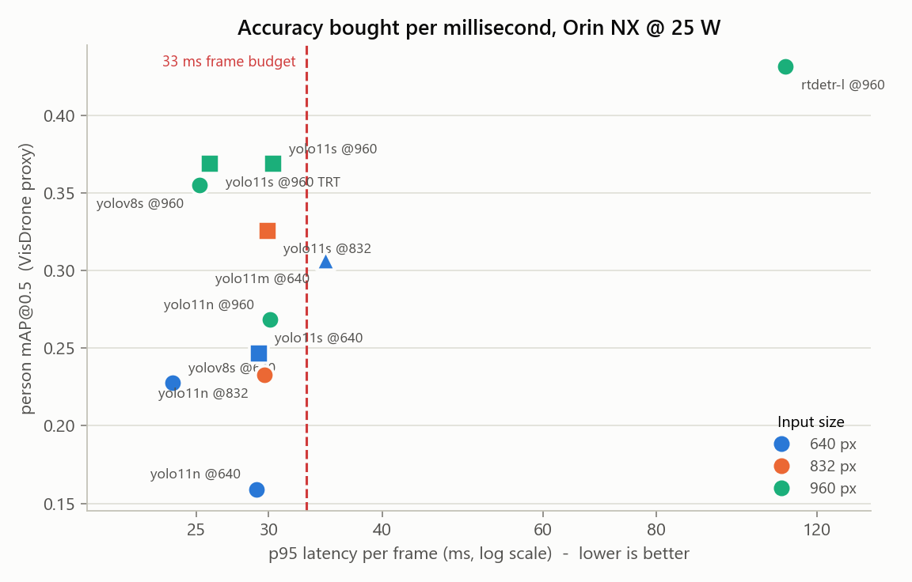
Figure 1 — Accuracy against p95 latency. Up and to the left is better. yolo11m @640 sits right of the budget line and below three cheaper configurations.
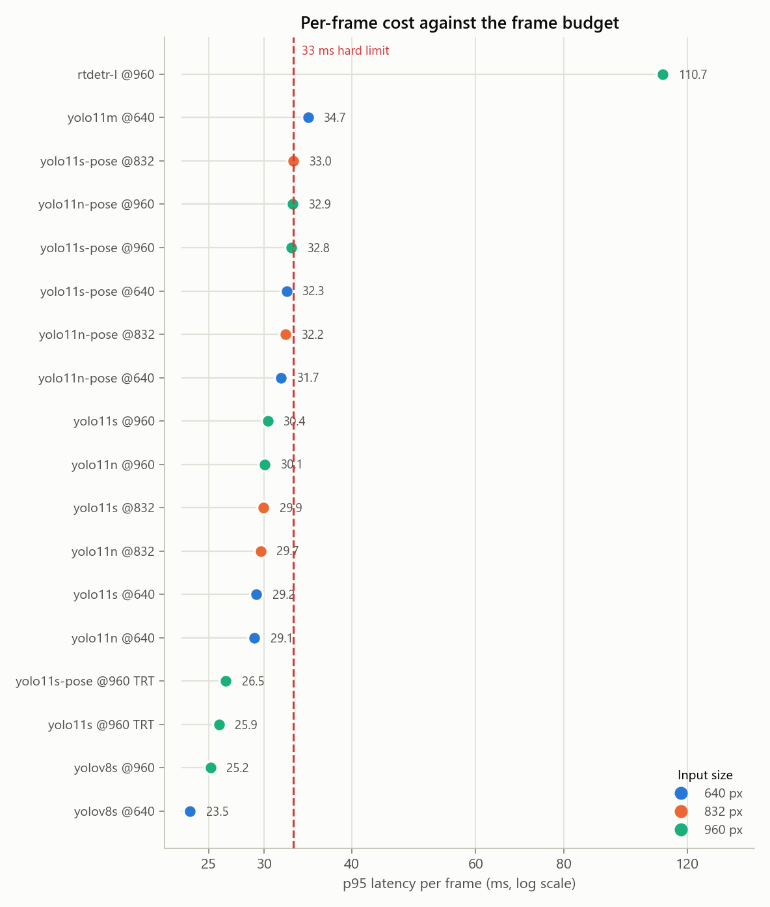
Figure 2 — Every configuration against the 33 ms hard limit. Shown as dots, not bars: the whole range is 28–35 ms, and a zero-based bar axis would render these as near-identical heights.
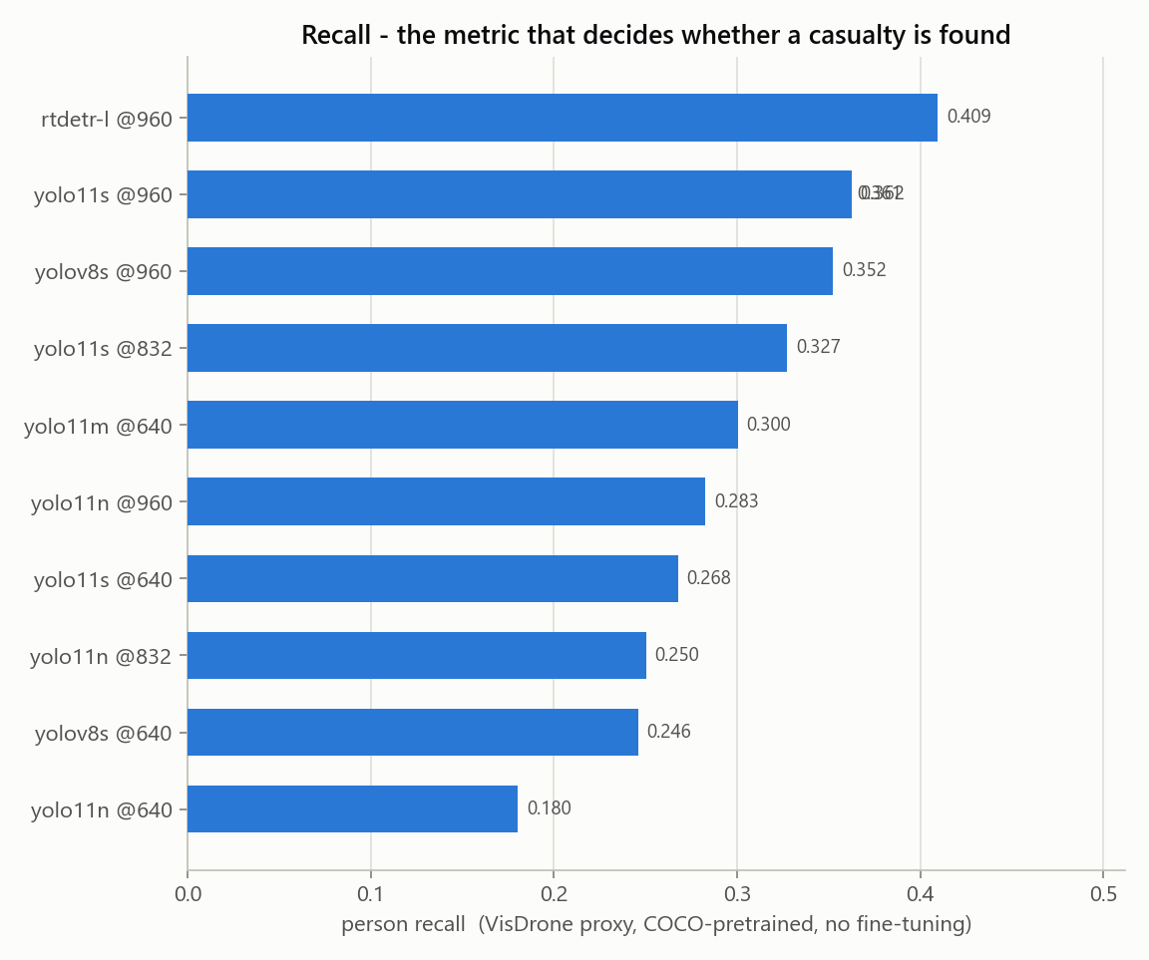
Figure 3 — Person recall. In search and rescue a missed person is far worse than a false alarm, which makes this the headline metric.
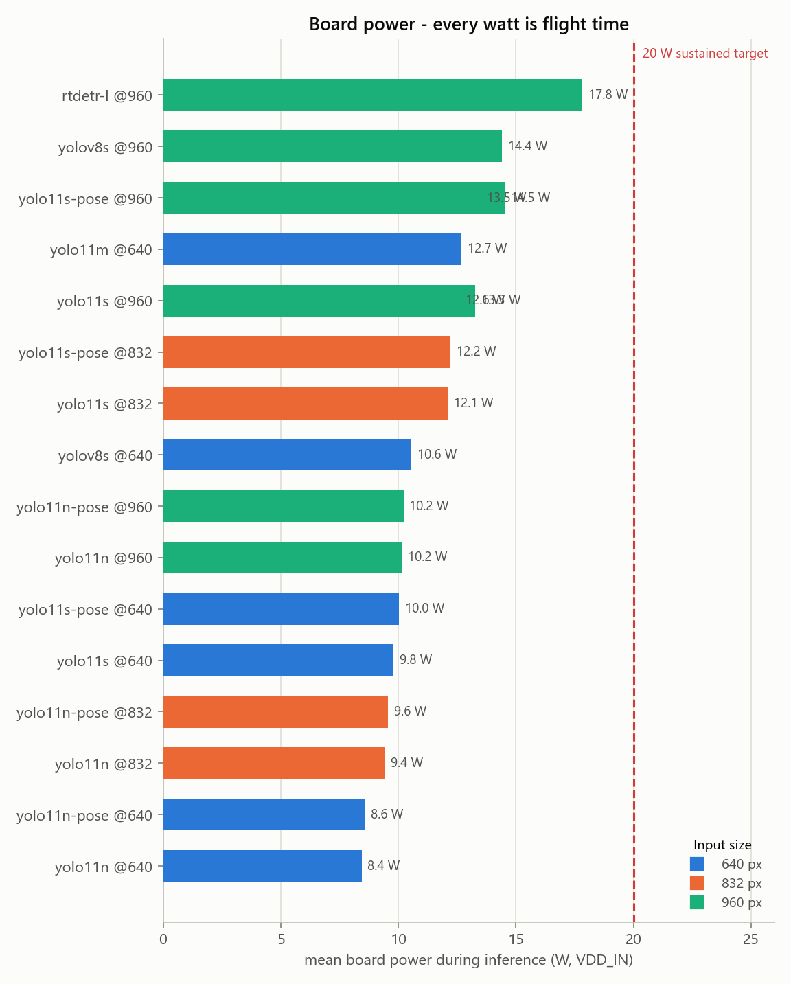
Figure 4 — Mean board power during inference. Every watt spent on compute is flight time lost.

6. The latency floor: why these numbers understate the hardware
Across the sweep, p95 latency moved only from about 29 ms to 30 ms while person mAP rose from 0.159 to 0.369 and board power rose from 8.4 W to 13.3 W. Power scaling while wall-clock stands still means the GPU is doing substantially more work in the same elapsed time — so the measurement is bounded by something other than inference.
Timing the forward pass alone, with Ultralytics' predict() wrapper removed, isolates it:
Model | Input | Forward-only p95 (ms) | Mean power (W)
yolo11n | 640 | 28.4 | 9.6
yolo11n | 960 | 28.8 | 13.0
yolo11s | 640 | 28.5 | 12.4
yolo11s | 960 | 27.8 | 21.7
yolo11m | 640 | 37.1 | 18.4
yolo11m | 960 | 54.9 | 23.0

The small models sit on a hard floor near 28 ms regardless of input size, while yolo11m scales normally (36 ms at 640, 54 ms at 960). That is the signature of being CPU kernel-launch-bound: PyTorch eager mode dispatches hundreds of small CUDA kernels per forward pass, and on Orin's CPU that dispatch cost dominates until the GPU work finally exceeds it.
Three consequences for the project:
- The ~30 FPS figure is a property of the measurement harness, not a hardware limit. A long-running ROS 2 node that loads the model once and streams frames — which is what 04-ros2-architecture.md specifies — avoids most of this cost.
- TensorRT export is not merely an optimisation here; it is the fix, because it fuses the graph into far fewer kernel launches.
- Comparisons between the small models on wall-clock alone are misleading. Until the floor is removed, accuracy per watt is the more honest comparison, and on that basis the ranking is unchanged.

7. TensorRT
Configuration | p95 ms | mAP@0.5 | Recall | Power W
yolo11s @960 (TRT) | 25.9 | 0.369 | 0.362 | 12.6
yolo11s-pose @960 (TRT) | 26.5 | — | — | 14.5

8. Vision-language model
A note on terminology, from 03-scene-understanding-vlm.md: the requirement is a vision-language model, not a text-only LLM. A text LLM cannot see the camera feed; the best it could do is paraphrase the detector's class labels, which adds nothing and can only introduce error. Everything that makes this tier worth having — staining on a trouser leg, a limb at an unnatural angle, someone trapped under debris — lives in pixels the detector never describes.
Model | Params (B) | TTFT p95 (s) | Full reply p95 (s) | tok/s | Peak GPU MB | Schema valid
SmolVLM2-2.2B-Instruct | 2.25 | 1.41 | 11.45 | 14.3 | 4639 | 0%
Qwen2.5-VL-3B-Instruct | 3.75 | 0.76 | 15.88 | 9.8 | 7208 | 88%

Budget for reference: time-to-first-token target 1.5 s (hard limit 3 s); full ~60-token description target 5 s (hard limit 10 s). Measured full-reply times above ran to a 160-token cap; normalised to 60 tokens from measured throughput, both models land inside the 10 s hard limit and outside the 5 s target.

8.1 Safety finding: an unconstrained VLM invents demographics
SmolVLM2-2.2B-Instruct produced 0% schema-valid output. It ignored the requested key set, invented a deeper schema of its own, and overran the token cap mid-object. What it invented matters more than the malformed JSON: from an aerial crop it emitted "gender": "female", "age": "20-29", "race": "Asian" and "eye_color": "brown".
Eye colour is not visible from a drone, and neither is race. The model was instructed to describe only what is visibly present and to say "not visible" otherwise. It instead produced confident demographic labelling of an identifiable person — which the project's own safety document rules out as an explicit design boundary, not an oversight.
Two conclusions follow:
- Grammar-constrained decoding is a safety control, not a performance optimisation. A fixed grammar makes both the invented keys and the runaway generation impossible, and doc 03 already specifies it.
- Schema validation must reject unknown fields, not merely confirm the required ones are present. A "race" key must be discarded by the validator, never forwarded to an operator because the other seven keys happened to be valid.
Qwen2.5-VL-3B-Instruct, by contrast, returned 88% schema-valid JSON, stayed on observable detail — clothing colour, posture, ground surface. [Corrected 28 September: this review said it returned an empty injury list rather than inventing wounds. It did not — on one crop it reported a bruise and a lying posture that are not there, in an answer that failed to parse and so went unread. See section A5.] It also reported nothing as "not visible" on any crop, despite faces being unobservable from altitude; that field exists to hold uncertainty and the model is not using it.
What a VLM benchmark on this project can and cannot establish:
- Measurable now: latency, throughput, memory, power, and the fraction of outputs that parse against the required JSON schema.
- Not measurable yet: cue recall and hallucination rate (experiment E6). Those need the held-out set of roughly 100 staged scenes with human-written reference descriptions, which does not exist. Hallucination rate is the headline safety number for this tier, and it cannot be reported until that set is built.
- The VLM must never emit a triage category or a medical assessment. It produces observations; the triage flag is computed by explicit, auditable rules over structured fields, so an operator can see exactly why something was flagged.

9. Why this model, and what we rejected
yolo11s @ 960 px, FP16
- Highest measured person mAP@0.5 (0.369) and recall (0.362) of any configuration inside the frame budget.
- Fits the budget with margin: 25.9 ms p95 against a 33 ms hard limit.
- Same framework, same export path and same API as the pose variant tier 2 needs, so detection and keypoints do not require adopting two toolchains.
- ByteTrack is built in, so tracking is a configuration flag rather than a separate project.
Rejected, with reasons:
Option | Why not
RT-DETR-l @960 | The most accurate model tested by a clear margin (mAP 0.431, recall 0.410) and more than three times too slow at 110.7 ms p95. Genuinely compute-bound — 99.7 ms of that is inference, so there is no framework overhead to reclaim. Worth keeping as a candidate for a slow "careful search" mode, and as the Apache-licensed escape hatch if AGPL becomes a blocker: that trade costs throughput, not accuracy.
YOLOv8s @960 | Genuinely competitive and faster in PyTorch (25.2 ms) than YOLO11s (30.4 ms), because its simpler graph issues fewer CUDA kernels — but 0.355 mAP against 0.369, and yolo11s in TensorRT matches its speed. Keep as the PyTorch-only fallback if the TensorRT export path ever fails.
yolo11m @640 | Dominated on every axis: lower mAP (0.307) than yolo11s @960 (0.369), higher p95 latency (34.7 ms, over the hard limit), and higher power. Larger capacity does not help when the targets are 15–25 px tall; resolution does.
yolo11n (any size) | Cheapest, and meaningfully less accurate at every input size. Retain as the degraded-mode fallback if thermal or power limits force it, not as the primary.
640 px input | The simplest accuracy loss to avoid. Moving yolo11s from 640 to 960 raised mAP from 0.247 to 0.369 for roughly 1 ms of measured latency.
A cloud detection API | Violates the offline constraint outright. Disaster areas do not have reliable connectivity, and the aircraft must not depend on a link to do its job.
Training a detector from scratch | Needs hundreds of thousands of labelled images and would still be worse than a COCO-pretrained backbone fine-tuned on a few thousand of our own frames. The novelty in this project is the aerial domain adaptation and the posture reasoning, not the detector architecture.

Licensing — decide before building further:
Ultralytics YOLO11 is AGPL-3.0. For an openly published academic project that is fine. If RAPTOR is ever commercialised or shipped to a third party without source, AGPL is contagious and would require either an Ultralytics commercial licence or a permissive alternative (YOLOX, RT-DETR, or NVIDIA TAO PeopleNet). This decision costs nothing now and a great deal later.

10. The finding that matters most: recall
Person recall ranged from 0.180 (yolo11n @640) to 0.409 (rtdetr-l @960). Even the best configuration finds fewer than 41 of every 100 annotated people.
For a search-and-rescue aid this is the number that matters. A missed casualty is the failure mode the system exists to prevent, and an off-the-shelf COCO-pretrained detector misses most people in aerial imagery. This is not a defect in the models; it is the aerial domain gap, measured. COCO is ground-level photography, and a person lying down viewed from 30 metres looks nothing like anything in it.
This turns the Phase 2 data-collection work from a scheduling item into the project's critical path. It also argues for two operational mitigations that cost no compute:
- Fly lower. Detection scales with pixels on target, and altitude is the cheapest lever available.
- Never present a cleared area as confirmed empty. The measured recall does not support that claim, and an operator who believes it will stop searching too early.

11. Capture path and first live run
A camera is now attached and the deployed model has been run on live frames. Two caveats frame everything in this section.
- The device is a USB webcam, not the SIYI A8 mini through an HDMI capture card. The flight capture path remains completely untested, including the open question of whether the A8 mini can output HDMI and Ethernet video simultaneously — which the benchmark plan calls cheap to test and decisive for the whole harness.
- Its optics are not the A8 mini's 81° horizontal field of view, so none of the altitude-versus-pixels reasoning transfers to it.

11.1 The USB link is 2.0, and it costs frame rate
The camera enumerated on the 480 Mbit/s bus behind a USB 2.0 hub, while a 10 Gbit/s USB 3.0 bus on the same board sits idle. Measured consequence at 1920×1080:
Pixel format | Maximum frame rate | Cost
YUYV (uncompressed) | 5 fps | starved of USB bandwidth
MJPG (compressed) | 30 fps | a JPEG decode per frame

The Jetson environment notes warn that a USB 2.0 link degrades silently rather than failing. That is exactly what happened, and it is worth knowing before anyone concludes the board is slow. Moving the camera to the idle USB 3.0 bus is the cheapest improvement available and should be tried first.

11.2 Live run: camera to deployed engine
Measure | Value
Negotiated format | 1920×1080 MJPG
Frame grab | 14.1 ms mean / 15.0 ms p95
Inference | 23.0 ms mean / 25.0 ms p95
End-to-end | 26.9 FPS, 0 dropped of 150
Board power | 12.1 W

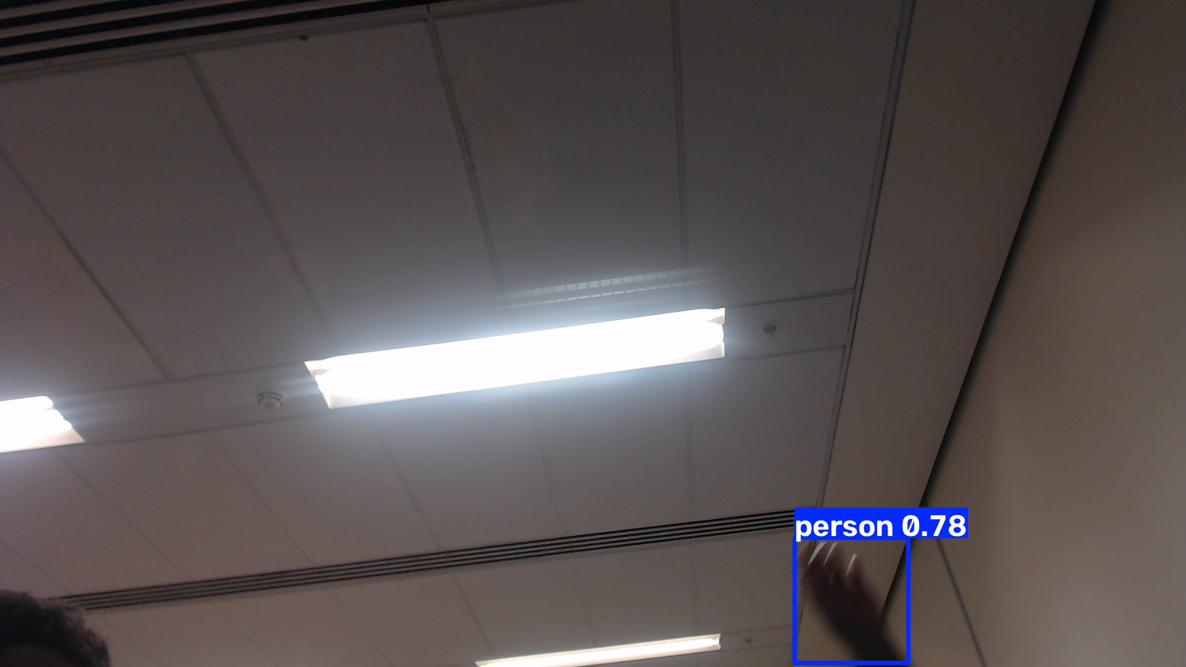
Figure 5 — A live frame: person detected at 0.78 confidence with all 17 COCO keypoints, through the deployed TensorRT pose engine. The camera is pointed at a ceiling, so the detection is of a hand entering frame.
Two things this figure does and does not prove:
- It proves the whole path works: USB capture, MJPEG decode, TensorRT inference, boxes and the 17 keypoints that tier 2's posture classifier consumes.
- The 0.78-confidence detection is of a hand, not a whole body. A pose model inferring a person from one visible limb is reasonable, but it previews the false-positive class the triage rules must absorb — a detection count is not a victim count.

11.3 The measured frame rate is a test-loop artefact
Frame grab and inference run serially in this benchmark, so the frame period is their sum. In the architecture the design specifies — camera and detector as separate nodes — they pipeline, and the rate is set by the slower stage alone. Inference at roughly 22 ms leaves headroom for about 45 FPS, while the camera itself caps at 30. So 30 FPS is reachable on this hardware once capture and inference overlap, and the figure above should not be read as a hardware ceiling.

12. What is deployed on the flight computer
Staged under ~/raptor-deploy with a provenance manifest recording source path, SHA-256, byte size, the build environment and the measured numbers. Each artifact was verified after staging by loading it and running it, not merely copied into place.
Slot | Artifact | Role | Measured | State
detector | yolo11s.engine | tier 1 - person detection | 25.9 ms p95, mAP@0.5 0.369 | verified
pose | yolo11s-pose.engine | tier 1+2 - person detection AND 17 keypoints | 26.5 ms p95 | verified
vlm | Qwen2.5-VL-3B-Instruct | tier 3 - event-triggered scene description | TTFT 0.76 s, schema 88% | verified
vlm_fallback | SmolVLM2-2.2B-Instruct | tier 3 fallback for an 8 GB board | TTFT 1.41 s, schema 0% | verified

The fallback vision-language model is staged but carries an explicit warning in the manifest: it must not be run without grammar-constrained decoding, for the reason given in section 8.1.
TensorRT engines are tied to this TensorRT version and this GPU. They are not portable — re-export after any JetPack upgrade, and never copy one between boards. The manifest records the build environment so a stale engine is detectable rather than mysterious.

13. Platform provisioning
Three pieces of infrastructure had to be fixed before any of the above could be run or repeated. They are recorded here because each one silently invalidates work downstream if it regresses.

13.1 Network access
The board could not reach the internet, for four independent reasons that had to be unpicked in turn:
- It has no Wi-Fi hardware — only Ethernet, on a point-to-point link to the laptop.
- Its default route pointed at its own address, so it was a no-op.
- The host firewall silently dropped inbound connections to a proxy on the laptop.
- The network intercepts TLS to the ROS package host, presenting a certificate for the wrong principal, while plain HTTP works normally.
Resolved with a small HTTP/CONNECT proxy on the laptop, reached through an SSH reverse port-forward so the Jetson connects to its own loopback address and no inbound firewall exception is needed. The apt repository is fetched over HTTP, which is apt's normal security model — integrity comes from the GPG signature, not from TLS.
This arrangement lives inside an interactive session and does not survive it. Making it permanent needs a NAT route configured on the laptop, which is a one-time administrative change.

13.2 ROS 2
ROS 2 Jazzy is installed — 195 packages, the headless ros-base set rather than the desktop set, plus vision_msgs and colcon. Verified functionally, not just by package list: a publish/subscribe round trip returned its payload over DDS, and vision_msgs/Detection2DArray resolves.
This is Jazzy, not the Humble named in the architecture and roadmap documents. Those assume JetPack 6 and Ubuntu 22.04; this board runs Ubuntu 24.04, for which Humble has no binaries. The consequence worth planning around is that NVIDIA Isaac ROS targets Humble, so adopting it becomes a container decision rather than a native install.

13.3 The clock
The board came up at 1970-01-01 on every boot: the real-time clock was not holding time, and NTP could not sync because the board had no route to the internet. Every benchmark row recorded before this fix carries a 1970 timestamp.
This is not cosmetic. The architecture document is explicit that a wrong clock silently corrupts timestamp correlation and therefore geolocation — and a search-and-rescue system that timestamps evidence cannot have a clock that resets. Fixed in three layers: the system time was set, written into the RTC, and a systemd service now restores a monotonic time floor at boot and persists it every ten minutes, so even a full power loss cannot produce a 1970 timestamp.

13.4 Running the live demo
Two launchers exist so the pipeline can be demonstrated without touching a command line:
- On the Jetson — a desktop icon opens a video window with boxes, keypoints, a posture label per person, and a heads-up display showing frame rate, the grab/inference split, board power and temperature.
- On the laptop — a desktop launcher checks the board is reachable and the camera present, then streams detections and timings as text. Video frames stay on the Jetson; a remote session cannot open a window on the board's console.
The posture label shown by the demo is geometric and uses image vertical, because there is no IMU on the bench. The design calls for keypoints rotated into a gravity-aligned frame using flight-controller attitude — without it, a banking aircraft would turn a standing person into a "lying" one. The demo labels this on screen so it cannot be mistaken for the flight behaviour.

14. Recommended next steps
Ordered by value per hour of effort:
- Get the real capture hardware on the bench — the A8 mini through its HDMI capture card — and repeat section 11. Nothing measured on a USB webcam transfers to it, and the HDMI-versus-Ethernet simultaneity question is cheap to answer and decides the harness.
- Move the camera to the idle USB 3.0 bus. One cable, and it may remove the MJPEG decode entirely.
- Install NVIDIA's sm_87 PyTorch build for JetPack 7 and re-run the sweep. Every number in this report is a floor until that is done.
- Begin Phase 2 collection flights. The recall figures in section 10 are the justification, and every downstream phase waits on that data.
- Attack preprocessing and non-maximum suppression rather than the model. After TensorRT they are roughly a third of the frame budget, and composable nodes with zero-copy transport is the documented remedy.
- Make the board's network route permanent, so it is not dependent on an interactive session.
- Add grammar-constrained decoding to the vision-language tier. Section 8.1 makes this a safety control, not a performance optimisation.
- Build the held-out evaluation set of roughly 100 staged scenes with written references, so a hallucination rate can be stated at all.
- Re-measure inside long-running ROS 2 nodes rather than per-process invocations, which is how the system will actually run — and is expected to recover most of the gap to 30 FPS.
- Run the power-mode sweep across 10, 15, 25 and 40 W. Everything here was measured at 25 W, and the delta decides whether the extra watts are worth the endurance they cost.

What still does not exist
To be unambiguous about the state of the project: the components are chosen, characterised, deployed and demonstrable on live video. The perception system itself has not been written. There is no detector node, no tracker, no posture classifier, no trigger logic, no triage aggregator and no victim report. Those are the substance of roadmap phases 1 through 5, and nothing in this report should be read as a claim that they are done.

Generated from recorded benchmark runs. Every figure in this document can be regenerated with plot_results.py, and every number traced to a line in results/.

