Carrier-
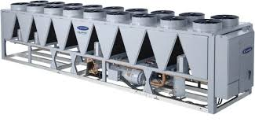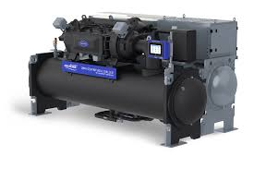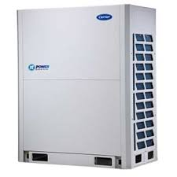

Product Lineup-
-Magnetic Bearing Chiller
-Water Cooled Chiller
-Air-cooled Chiller
Manufacturing Country From USA, France & China
-VRF-Model-XCT-8 From Thailand Up to 26 HP
-VRF-Model-X-Power from China Up to 32 HP

Geothermal HVAC Systems
Geothermal HVAC equipment use the earth’s stable underground temperature to heat and cool homes. Pipes are buried underground, circulating fluid that absorbs or dissipates heat. Geothermal heat pumps provide energy-efficient performance to give you comfortable indoor comfort within your home. Geothermal HVAC systems come in four different loop types (horizontal, vertical, pond, and open loop) which all work differently to extract water to heat and cool your home

Indoor Air Quality Products
A plethora of indoor air quality products can be added to your HVAC system to help manage humidity and ventilation, helping you breathe cleaner air.
- Air purifiers trap and reduce contaminants like pollen, dust, dander, select airborne viruses, and bacteria to keep your indoor air cleaner.
- Humidifiers and dehumidifiers work to control the humidity of your home.
- Ventilators bring fresh outdoor air into your home while removing stale air from your home.
- UV lamps can kill mold and bacteria on your cooling coil.
- Check out Carrier’s full line of indoor air quality solutions.
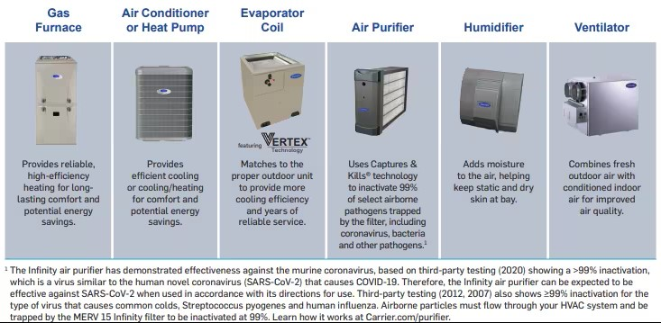

Toshiba
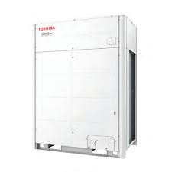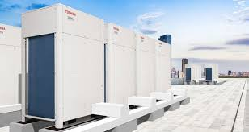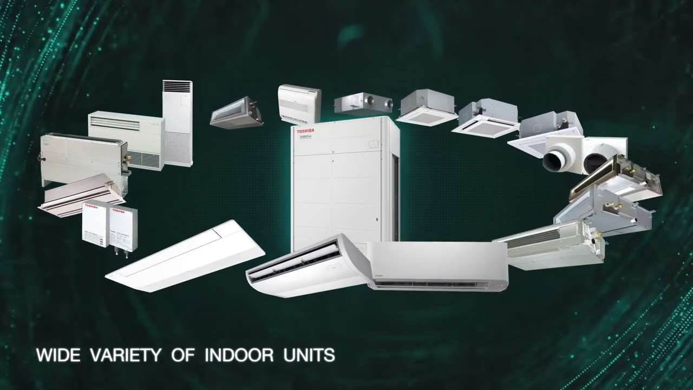
The Toshiba SMMS-Infinity (SMMS∞) is a next-generation Variable Refrigerant Flow (VRF) system engineered for superior energy efficiency, flexibility, and serviceability. It features advanced Japanese technology, including a compact, lightweight chassis and high-performance DC twin-rotary compressors.
Key Features Summary:
- Top-Class Efficiency & Performance:
  - Utilizes new, highly efficient core technologies and DC Twin-Rotary compressors, achieving a high EER.
  - Features intelligent, ultra-precise 0.1 Hz inverter control for optimized, smooth operation.
  - Designed for high ambient temperature operation (up to 46°C–54°C depending on model).
- Enhanced Flexibility & Capacity:
  - Allows up to 120 HP (horse power) combinations and supports up to 128 connectable indoor units.
  - Offers over 4,000 condensing unit combinations.
  - Supports long piping lengths (up to 1200m total) and high lift (110m), making it suitable for high-rise buildings.
  - Boasts up to 200% diversity, allowing for high-capacity indoor connections.
  - Heist Level of EER among all other VRF.in 50 % load it can reached 8.6- EER
- Compact & User-Friendly Design:
  - Features a smaller, lighter, and more compact chassis for easier installation.
  - Reduced refrigerant charge requirements.
- Advanced Controls & Serviceability:
  - Supports "Wave Tool Advance" for wireless, NFC-based data collection using a smartphone.
  - Offers advanced, remote diagnostic capabilities and self-recording functionality.
- Improved Air Quality & Comfort:
  - Includes PM2.5 filtration, plasma air purifiers, and optional UVC/HEPA filters to minimize airborne contaminants.
  - Advanced Pulse Motor Valve (PMV) control ensures precise, stable, and comfortable indoor temperatures.
- Reliability:
  - Utilizes a new, improved accumulator design for enhanced system reliability.
  - Includes resin-coated heat exchangers for better protection

TICA
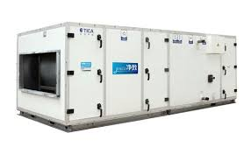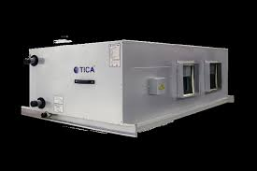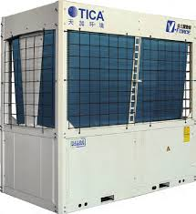
TICA HVAC Product Line Up Summary:
- Chillers (Water-Cooled & Air-Cooled):
  - Centrifugal Chillers: Water-cooled, including high-capacity flooded and falling film types (e.g., TWCF/TWSF series) with DC inverter technology.
  - Screw Chillers: Water-cooled flooded or F-series, and air-cooled screw chillers (TASF/TASD series).
  - Modular Chillers: Air-cooled modular chillers (TCA-XH, TCAV series), including heat pump options.
  - Magnetic Bearing Chillers: Specialized high-efficiency modular centrifugal chillers.
- VRF Systems (Variable Refrigerant Flow):
  - TIMS Series: Inverter VRF systems (independent and modular), focusing on strong heating, full inverter technology (TIMS-AS+, TIMS-AXA, TIMS-X).
  - Purifying VRF: TIMS Hyplus Health Type VRF, designed for air purification.
- Air-Side Units & AHUs:
  - Air Handling Units (AHU): Specialized in cleanroom applications, including modular AHUs.
  - Fan Coil Units (FCU): Various configurations for commercial and residential comfort.
  - Air-Cooled Ducted Units: Standard, purifying, and fresh-air-cooled ducted units.
- Commercial & Specialized AC:
  - Rooftop Units: Packaged rooftop air conditioners.
  - Water Source Heat Pumps: Various models for water-source applications.
  - Clean Environment Units: Specialized DX modular AHUs and purifying air conditioning units for operating rooms and laboratories.
- Household Products:
  - Residential VRF & Heat Pumps: Inverter-driven units for residential homes and luxury apartments, including CO2 heat pump hot water units.
  - Mini Chillers: Air-cooled mini chillers for light commercial/residential use.
- Thermal/Energy Products:
  - ORC Systems: Organic Rankine Cycle systems for low-temperature power generation, utilizing Exergy technology.
Key Features:
- Technology: Strong emphasis on inverter technology, EVI (Enhanced Vapor Injection), and magnetic bearings.
- Purification: Strong presence in health-care and cleanroom technology, with 4-layer filtering systems.
- Partnerships: Technical partnership with UTC (Carrier), giving them advanced centrifugal and screw compressor technology

DYN AIR-
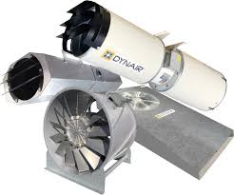

Key Features and Performance
- High Efficiency & Performance: Many models are designed with aerofoil profile blades to maximize air volume (up to 210,000 m³/h in some axial series) while reducing noise levels.
- Diverse Product Range: Includes axial fans (ring, plate-mounted, ducted), centrifugal fans (roof, in-line, box), jet fans, and heat recovery units.
- Temperature Handling: High-temperature versions are available for continuous service up to +200°C (AT series) and emergency smoke extraction up to 400°C (HT series).
- Regulation Compliance: Units are engineered to comply with the European Union's ErP Directive (327/2011) and EN 12101-3 standards for smoke extraction.
- Specialized Applications: Offers ATEX-certified fans for explosive atmospheres, corrosion-resistant plastic fans, and car park ventilation systems.
Structural and Technical Design
- Robust Construction: Casings are typically galvanized steel or treated with epoxy-polyester paint for durability against atmospheric agents.
- Adjustable Blades: Many axial fans feature variable pitch angles, allowing for adjustment when stationary to fine-tune performance.
- Motor Protection: Motors generally feature IP55 protection (with some exceptions) and Class F or H insulation.
- Noise Reduction: Options include insulated acoustic cabinets (MINI-BOX, AxB) for urban or noise-sensitive environments.
Key Series
- CC/CCB: Ducted axial fans for large airflows.
- QCL/AC/QC: Compact or ring axial fans.
- FC/FCV: Centrifugal roof fans (horizontal/vertical discharge).
- Box-T/Box-D: Belt or direct-driven box fans.
- Jet Fans (CC-JD): For car park ventilation and CO removal.

Trouble Shooting and Spare Parts
Genuine VRF & Chiller Spare Parts Supply with Professional Installation

We specialize in the supply of genuine spare parts for VRF systems and chillers, combined with professional installation, commissioning, and after-sales service. Our solutions support all major HVAC brands, ensuring reliability, efficiency, and long-term system performance for commercial and industrial projects.

⸻

Our Core Services

🔹 Genuine VRF & Chiller Spare Parts Supply

We supply 100% original OEM spare parts for VRF and chiller systems, including:
• Compressors
• Inverter drives & VFDs
• PCBs & control boards
• Expansion valves & solenoid valves
• Sensors, motors & fans
• Heat exchangers & accessories

All parts are authentic, tested, and warranty-supported, ensuring maximum system lifespan and efficiency.

⸻

🔹 Multi-Brand Expertise

We support all leading international HVAC brands, including but not limited to:
• Daikin
• LG
• Samsung
• Carrier
• Trane
• York
• Mitsubishi Electric
• Panasonic
• Midea
• Gree

Our engineers are experienced in handling brand-specific technologies and control systems.

⸻

🔹 Professional Installation & Commissioning

Our certified HVAC engineers ensure:
• Proper system design & load compliance
• Accurate refrigerant piping & insulation
• Electrical wiring & control integration
• Factory-standard installation procedures
• Complete testing, commissioning & performance verification

We follow international HVAC standards to ensure safe and efficient operation.

⸻

🔹 Repair, Retrofit & System Upgradation
• VRF system troubleshooting & fault diagnosis
• Chiller performance optimization
• Inverter & control system upgrades
• Replacement of obsolete or damaged components

We focus on cost-effective solutions without compromising quality.

⸻

🔹 After-Sales Service & AMC
• Preventive maintenance contracts (AMC)
• Emergency breakdown support
• Performance monitoring & reporting
• Genuine spare parts replacement with warranty

Our service team ensures minimum downtime and maximum reliability.

⸻

Why Choose Us

✔ Genuine OEM spare parts only
✔ All VRF & chiller brands supported
✔ Skilled & experienced HVAC engineers
✔ Proper installation with commissioning report
✔ Fast spare parts availability
✔ Competitive pricing with transparent quotations
✔ Strong after-sales & technical support

⸻

Industries We Serve
• Commercial buildings
• Corporate offices
• Hotels & resorts
• Hospitals & healthcare facilities
• Industrial plants
• Shopping malls & data centers

⸻

Our Commitment

We are committed to delivering reliable HVAC solutions, combining genuine spare parts, professional installation, and dependable service—helping our clients achieve energy efficiency, system longevity, and operational excellence.

Midea

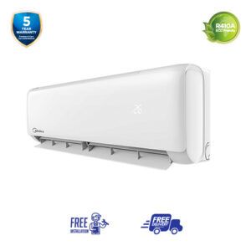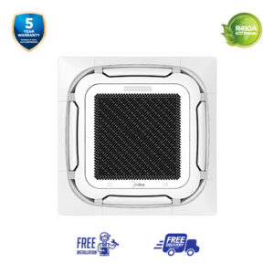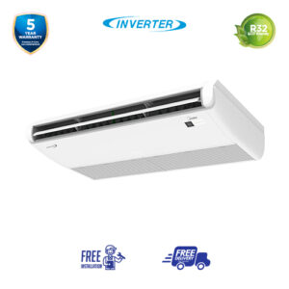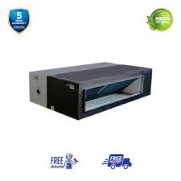
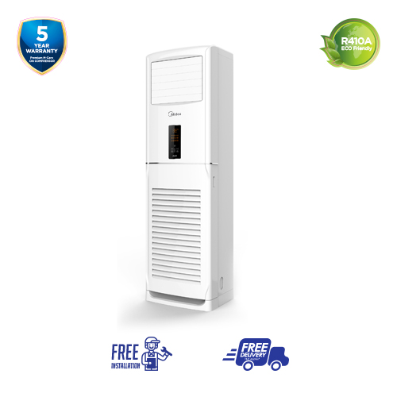
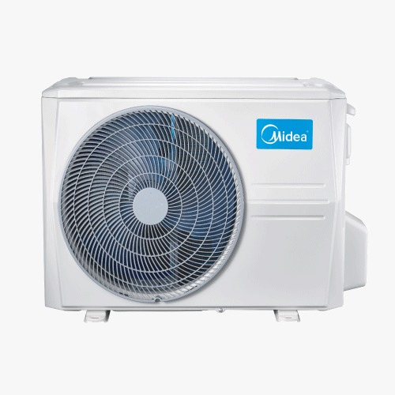
Need to collage all the pic .only product will take ..No sticker taken.

House of Authentic Midea Air-condition
Distributor Code-ED-1310

Midea Group is a world-leading, Fortune 500 Chinese appliance manufacturer founded in 1968, specializing in air treatment, refrigeration, laundry, and kitchen appliances. Renowned as the world's number one air conditioner manufacturer, they produce over 67 million units annually, focusing on affordable, inverter-based, and smart HVAC solutions.

Midea RAC (Residential Air Conditioners) – Key Features

These are the typical wall/window/floor-standing ACs you’d use in homes, small offices, or rooms. ￼

❄️ Cooling & Performance
• Fast & powerful cooling: Some models boast features like CoolFlash and Inverter Quattro™ technology that deliver rapid cooling even in high outdoor temperatures. ￼
• Turbo / IcyBlast modes: Quick chill options to lower room temperature faster than standard modes. ￼

🔋 Energy Efficiency
• Inverter technology: Helps adjust compressor speed instead of turning it fully on/off, saving electricity and keeping temperature stable. ￼
• Energy-saving modes: Intelligent modes like “nobody energy saving” that reduce energy use when a room is empty. ￼

📱 Smart & User-friendly
• Remote & app control: Many models support Wi-Fi and can be controlled via smartphone apps (SmartHome/LBS). ￼
• Self-diagnosis and protection: Some units can detect issues and auto-protect the system. ￼

👂 Comfort Enhancements
• Quieter operation: Designed for low noise indoors to keep bedrooms/offices peaceful. ￼
• Sleep mode / airflow control: More comfortable airflow settings for nighttime use. ￼

🛡️ Durability
• Anti-corrosion coatings (Prime Guard / Hyper Grapfins): Helps outdoor coils resist rust and corrosion especially in coastal or humid climates. ￼

⸻

🏢 Midea Light Commercial AC (LCAC) – Key Features

These units are designed for business, commercial buildings, small offices, and larger rooms where stronger, more robust cooling is needed than typical home units. ￼

💪 Performance & Capacity
• High cooling capacities: Light commercial ACs come in larger BTU ratings (often 18,000 BTU up to 60,000 BTU or more) suitable for bigger spaces. ￼
• Multi-split & CCU options: Allows one outdoor unit to run multiple indoor units — ideal for multiple rooms/offices. ￼

🔄 Advanced Features
• Built-in drain pumps: Helps remove condensate water efficiently — critical in commercial ceilings. ￼
• Econo+ Mode: Reduces energy usage by operating compressor at minimum speeds when full power isn’t needed. ￼

🌬️ Comfort & Airflow
• 360° even airflow (Cool Surround): Delivers cooling uniformly throughout larger spaces. ￼
• Super slim / compact designs: Easier installation in false ceilings and offices with limited space. ￼

🛡️ Durability & Protection
• Strong anti-corrosion & PrimeGuard coils: Commercial environments often involve dust and humidity, so enhanced protection helps prolong life. ￼
• Built for harsh environments: Some commercial models are tailored for high ambient temperatures, humidity, or heavy duty use. ￼

🔌 Installation & Support
• Designed for ceiling-embedded, ducted, cassette, and split layouts depending on space and aesthetic needs.

Total Tow page

