OBJECT ORIENTED PROGRAMMING

LAB Assignment 5



|  |  |
| --- | --- |
| Submitted by | MUHAMMAD ANIS SARWAR |
| Registration Number | CIIT/SP20-BSE-053/ISB |
| Class | SP20 - BSE - 3 - B |
| Submitted to | SIR MUKHTAR AZEEM |

**ASSIGNMENTS**:

Define a class called Fraction. This class is used to represent a ratio of two integers. Create two constructors, set, get and display function. Include an additional method, equals, that takes as input another Fraction and returns true if the two fractions are identical and false if they are not.

**package** cons_1;

**public** **class** Fraction {

**private** **int** first_num;

**private** **int** second_num;

**public** Fraction(){

first_num = 2;

second_num= 2;

}

**public** Fraction(**int** a, **int** b){

first_num = a;

second_num = b;

}

**public** **void** setfirstnum(**int** a){

first_num = a;

}

**public** **int** getfirstnum(){

**return** first_num;

}

**public** **void** setsecondnum(**int** b){

second_num = b;

}

**public** **int** getsecondnum(){

**return** second_num;

}

**public** **boolean** equals(Fraction f1,Fraction f2){

**if**(f1 == f2)

**return** **true**;

**else**

**return** **false**;

}

**public** **void** Display(){

System.***out***.println("Ratio: "+first_num/second_num);

}

}

**RUNNER:**

**package** cons_1;

**public** **class** Fraction_runner {

**public** **static** **void** main(String[] args) {

Fraction f1 = **new** Fraction();

f1.Display();

Fraction f2 = **new** Fraction();

f2.setfirstnum(36);

f2.setsecondnum(12)

f2.Display();

System.***out***.println("Identical Ratios: "+f1.equals(f1,f2));

}

}

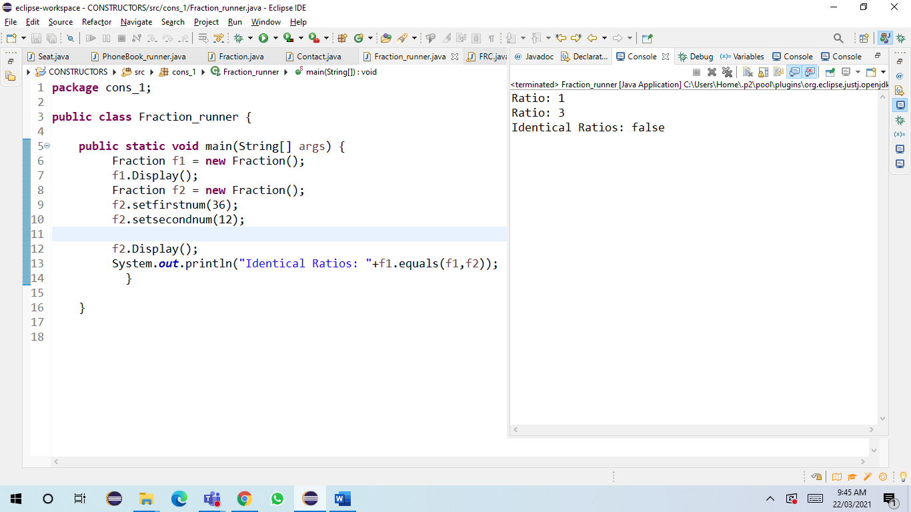

***GITHUB LINK***