Short-Term Load Forecasting based on Internet of Things (IoT)
Mahdi Uz Zaman 1, Anisul Islam Fahad¹, Nahid Sultana1,
Dr. Amitabha Chakrabarty¹

Department of Computer Science and Engineering, BRAC University, 66 Mohakhali,
Dhaka 1212, Bangladesh

{emahdi.zaman, kingfahad0802, nahid.sultana280}@gmail.com
Abstract. In the era of internet every device is getting connected to the internet. Devices that are connected to the internet are called Internet of Things (IoT). In this paper we have assumed that IoT devices can share their power consumption history. Based on data points collected from real world environment we have conducted experiments to show that IoT can used as a reliable backbone of short term load forecasting system. In the experiment four machine learning algorithms Long Short-term Memory (LSTM), Support Vector Machines Regression, Decision Forest Regression with AdaBoost and Nearest Neighbors Regression were used to analyze the performance of the load forecasting system. Result of the experiment have shown that short term load forecasting system based on LSTM will give more reliable result with root mean square error of 1.65
Keyword: IoT, Load Forecasting, Save electricity.
1 Introduction
If you are living in Dhaka city then probably you have faced problems or might have witnessed bargain with the conductor of the public bus over fare. This is a very common scenario of charging more in accordance to distance. Even though there is a fare chart provided by Dhaka Metro's Regional Transport Committee published on September 16, 2015 on the website of BRTA the bus owner does not pay a heed to the chart [7]. According to the chart fare for bus is Tk1.7 per kilometer and the many buses charges Tk10 from Gulshan-1 to Mohakhali though the distance is less than two kilometer. Meshkat and Gabtoli Link (sitting service) both charge Tk 20 per passenger on that route. The fare according to the BRTA website is Tk 15 for large buses [8]. According to the BRTA site, the fare should not be more than Tk 8 for the distance in large buses [9]. Again with giving extra fare people have to go through argument with the bus driver and the conductor which is very tiresome and sometime it turns into mayhem. The main reason is because of the conductors and drivers being uneducated and ill-mannered. After a hectic day or starting of the day no one want such an argument. To solve such unpleasant situation and disputes we came up with the project which using GPS which will track the distance covered by the passenger and the fare will be calculated according to the distance. Every passenger will have a pre-paid card which we can be recharged from the booth or from the counter. While punching the Radio Frequency Identification technology (RFID), the device will read the card’s validation and check the balance. As soon as the card is punched the GPS will be stored in database as the starting location. Reaching the destination the card will be punched again Global positioning system (GPS) coordinates will be stored in the database as ending location and the distance will be sent to server for calculation of fare and that amount will be deducted from the card account of the user. For our database we used CGI server and SQLite3 to commit and fetch the data from the server.
2 Related work
Over the years many works are carried out related to automated bus ticketing system using RFID and GPS. Few of them are mentioned here. Prasun Chowdhury et.al [1] proposes a system which calculates bus fare based on GPS taking bus stoppage name/no as input and performs credit transaction with the use of RFID based tickets. Their automated system does not include a panel for bus owners. Our proposal includes a panel for the authority. In the survey of Moumita Sen [2] it’s a common scenario in Bangladesh people doesn’t use bus stoppage more often. Our proposal calculates the distance traveled for fare taking real time GPS data from device. As a result calculation of fare is more precise for the case of the scenario mentioned earlier. Md Foisal Mahedi Hasan et.al [3] mentions the hassle of the commuters regarding existing ticketing services of the public transport in Dhaka (Bangladesh) which has severe malfunction in the system and corruption. Their proposed system emphasizes on conductor-less driving which solves the above defects. Our proposed model also solves the above effects with a much user friendly system and accurate distance based fare as well as credit transactions with the use of GPS and RFID tickets. Varun Krishna K.G et.al [4] primarily suggests the use of RFID technology to provide an efficient and enhanced automated ticketing system. Taking into consideration the capital and complexity, this paper suggests the implementation of the ticketing system by making use of a cyclometer that can be coupled to the wheel(s) of the bus to measure the accurate distance travelled by the user. But the use of cyclometer, which is coupled to the wheel(s) of the bus, is both complex and tedious. Arul Das [5] has proposed the same idea on automated public transport fare collection systems based on distance travelled by passenger using smart card instead of RFID, and GPS module. Some tracking systems for public bus transport have also been implemented using these technologies. Vijay Kumar and Dalip [6] have proposed a GPS and GSM based Passenger Tracking System. It tracks the passengers by using ticket number and displays location on Google map. After going through all these papers, we get the idea to propose an Automated Ticketing System for Public Transport Using RFID and GPS. The idea is to create a system capable of precise fare ticketing system and easier recharging though our web application which can be monitored by the authority in charge.
3 Proposed Model
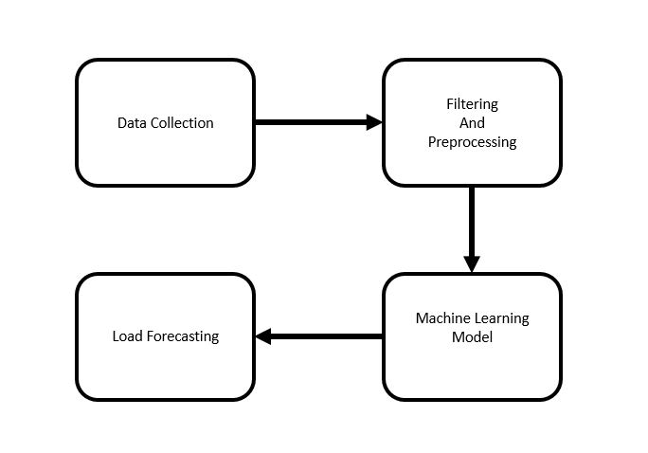
Figure 1. Proposed Model
The IoT based Short Term Load forecasting system is consist of IoT devices and a central processing unit. IoT devices are configured to upload power usage data to the server. The central processing unit is configured to do calculation based on a selected machine learning algorithm. Based on the calculation and learning process the unit will give prediction. In fig-1 the workflow is shown.
Main idea of this paper is to forecast total power consumption based on the data collected from the IoT devices. Due to limitations of time and resources we could not configure devices to upload power uses data to the internet.
To determine which prediction algorithm works best for our model we have implemented four machine learning algorithms and compared them.
In particular, the following numerical forecasting techniques were used:
- Nearest Neighbor Regression: KNN regression is used to calculate average
of targeted value of k nearest neighbors. Using inverse distance weighted average of the k nearest neighbors can also be calculated. KNN classification and KNN regression uses the same distance functions.
- Support Vector Regression: Support Vector Machine can also be used as a
method of regression, keeping all the fundamental elements intact that designate the algorithm (maximal margin). With scarcely trivial distinction, the Support Vector Regression utilizes the same postulates as the SVM for categorization.
- Decision Tree Regression with AdaBoost: Decision tree establishes
regression models in the form of a tree structure. It simultaneously jots down dataset onto smaller and smaller subsets and aligned decision is incrementally established. The end result is a tree with decision nodes and leaf nodes. A numerical target is illustrated by leaf node. The highest decision node in a tree which becomes equivalent to the leading predictor is called root node. Both categorical and numerical data can be conducted by decision trees.
- LSTM:

4 Experimental Setup and Results

4.1 Experimental Protocol
In this paper we have used “The UK-DALE dataset” created by Jack Kelly & William Knottenbelt [8]. This datasets contains appliance level disaggregated power consumption record as well as aggregated whole house power consumption record. In Fig. 2 whole house power consumption of last one year is given. We assumed that all the appliances in this datasets are IoT devices which records the power consumption of an appliances and uploads in the database. For training and testing we have used data of house_1 because it contains maximum number of appliances. Also they have given more emphasis on recording house_1 data. In Fig. 2 shows that house_1 data are more consistent than other houses.
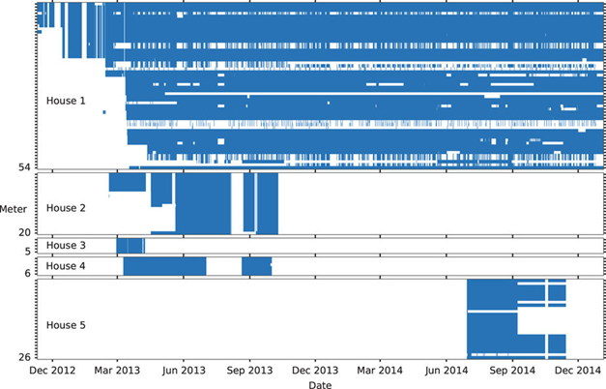
Fig. 2. Summary of The UK-DALE dataset
The main dataset contains five folder. Each folder correspond to each house. Under each house numbers of CSV files according to number of devices are given. Each CSV file contains records of power consumption with time. In each CSV file time is give in format of UNIX time epoch. Interval data recording is six seconds.
Noise and misleading data in any dataset are bad for any model to train on. A misleading dataset will eventually produce a hypothesis which will not do well in unseen data. Therefore noise cancellation has done with great care. The dataset contains UML configuration file for every houses. The file has details description of meter devices and appliances. Each appliance has upper bound and lower bound of power consumption. Any power consumption beyond that limit is considered as noise or bad reading. In Table 1 upper and lower bound of few devices recorded in house_1 is given.
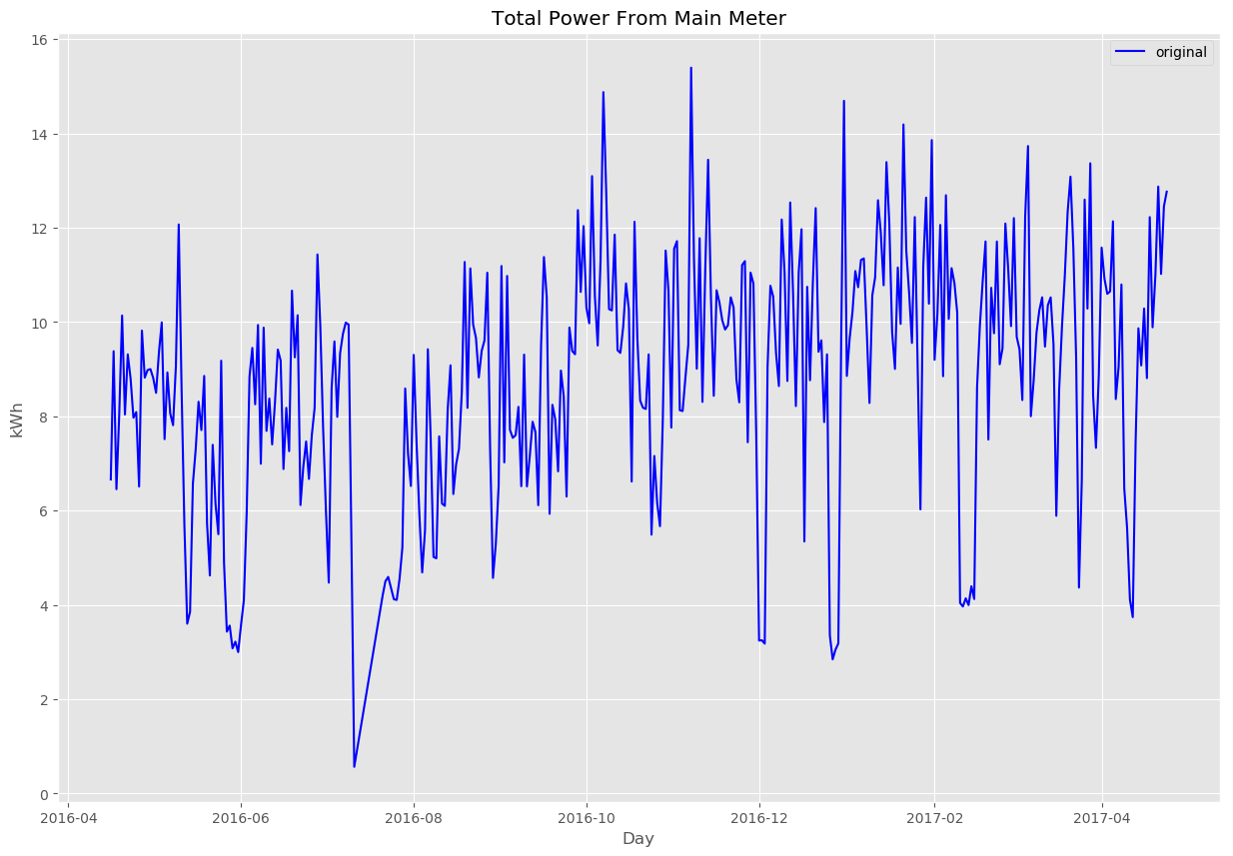
Figure 3. . Total Power Consumption of 1 year in KWh

Table-1. List of devices
Channel ID | Name | Min Power (Watt) | Max Power (Watt) | Type
2 | boiler | 70 | 4000 | Apparent
3 | solar_thermal_pump | 43 | 4000 | Apparent
4 | laptop | 70 | 4000 | Active
5 | washing_machine | 20 | 4000 | Active
The most frequently used measures of the differences between predicted values by an estimator and the actual values is the Root Mean Square Error (RMSE). The RMSE of predicted data for survey of , for variables is calculated for numbers of cases using the following formula:
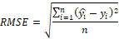
The parameters for building the predictive models of the algorithms are:
- Nearest Neighbors Regression: n_neighbors=15.
- Support Vector Regression: Penalty parameter C=1.0, epsilon=0.2 (specifies
the epsilon-tube within which no penalty is associated in the training loss
function with points predicted within a distance epsilon from the actual value).
- Decision Tree Regression with AdaBoost: max_depth=16, n_estimators=300.
- LSTM:
The algorithms Nearest Neighbors Regression, Support Vector Machine Regression, Decision Forest with AdaBoost is performed in using environment PyCharm IDE. Python v3.6.2 was used as coding language. The python library we used for building the above mentioned algorithms scikit-learn v0.19.1. It is an open source, commercially usable –BSD license. It has simple and efficient tools for data mining and data analysis.

4.2 Results

As our goal is to predict the power consumption of the house the next day depending on the power usage of the appliances of the present day. Model is evaluated on test set. The error result is obtained from test set. For preprocessing we scaled the data using the library function scale(). We used Kfold splits for splitting the dataset as it’s a time series dataset. Later we trained out model on train set and the error rate is acquired by evaluating the models against our test set. We used all the default settings of the library and few changes in parameters of few algorithms. We used an API out of 3 APIs of the library to measure our trained model’s performance. The API scoring parameter contains model-evaluating tools using cross-validation depends on an internal scoring strategy. We used this API to find the MSE of our models then used square root to find out RMSE and we compared the algorithms based on the result of the API.

Nearest Neighbors has RMSE of 1.9331727. As we are to predict the total power consumption of a house of the next day depending on the usage of the today’s power consumption of the appliances, for which we are getting this much higher RMSE value. In fig-4 the comparison of the real value and the predicted value of the trained model Nearest Neighbors Regression is given where x-axis is the date and y-axis is power consumption of the house in KWh. Using the kernel RBF performs better than other kernels in SVR. RBF kernel performs better in this context because of the data. The higher the degree, the performance of other kernels are worse than RBF. SVR using kernel polynomial and Gaussian Radial Basis function with degree of 3 has RMSE of 2.1229618 and 1.8341087 respectively. But kernel linear performs slightly lesser than RBF but better than the polynomial as it has a degree of 1. It has RMSE of 1.8474361. For having the lowest RMSE among the kernel function, we preferred the kernel function RBF for SVR. In fig-5 the performance of Support Vector regression (kernel RBF) is shown by comparing the true value with predicted value where x-axis is date and y-axis is the power consumption of the appliances in KWh. The predicted power consumption is the output of the model. The RMSE of Decision Tree Regression with AdaBoost algorithm based model is 1.9202281. As we restricted the depth to 16 and we selected all the features to train the model we are getting much high RMSE. The deeper the tree is the model tend to over fit. To avoid overfitting we specified the maximum depth of the tree. In fig-6 Evaluation of the model Decision Forest Regression with AdaBoost is shown by comparing predicted and real value. In fig-6 x-axis is the date and y-axis is power consumption of the house in KWh. In experiment we used single cell LSTM network. We have tested with LSTM network with up to 3 LSTM cell stacked top of one another. Stacking more than one LSTM cell made computation heavier but did not give better result. In some cases it went bad. We have also experimented with length of look back. Here look back is how many samples is given as an input in each time step. We have tested variable length of look back. Most significant were 7 for 7 days, 15 for 15 days, 30 for 1 month. Length of look back (between 7 and 15), have given better result than longer look back like 30. We have found best result in look back length 10. In table we can see LSTM has given lowest RMSE score. Reason of the lowest score is ability of a LSTM to process sequence of samples rather than a single sample. In fig-7 we can see that predicted data points by a LSTM almost catches the pattern of electricity usages. In fig-8 point by point comparison of 10 test and predicted data point is given.
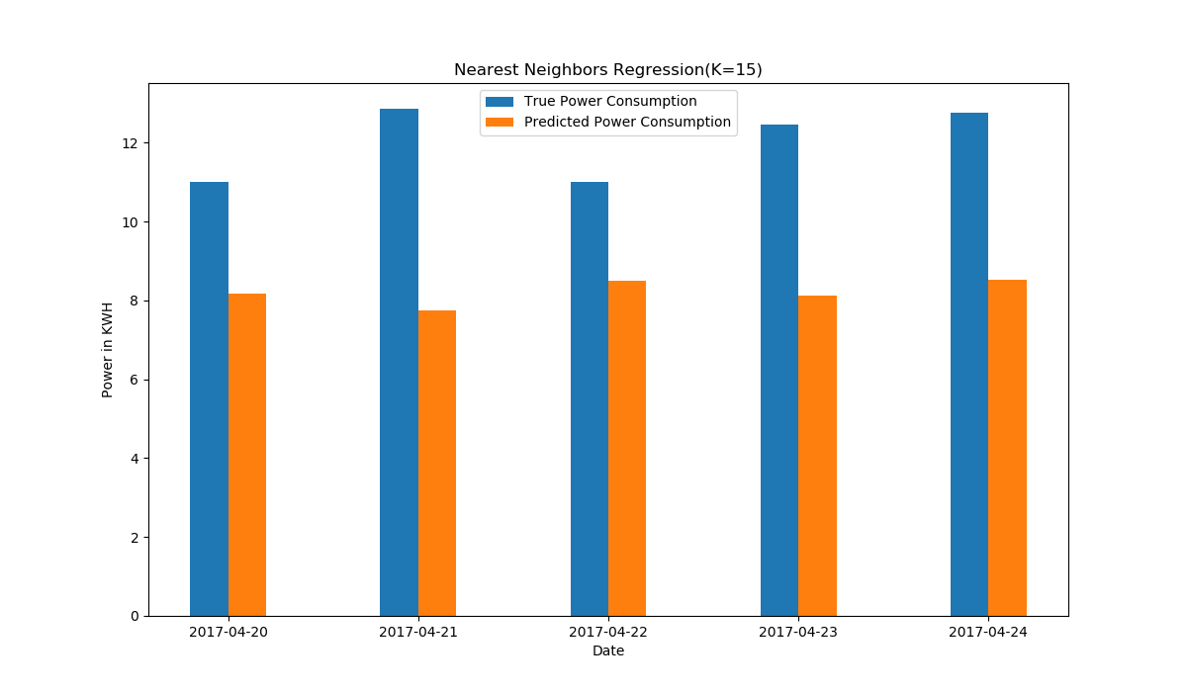
Fig. 1. Nearest Neighbors Regression, empirical comparison
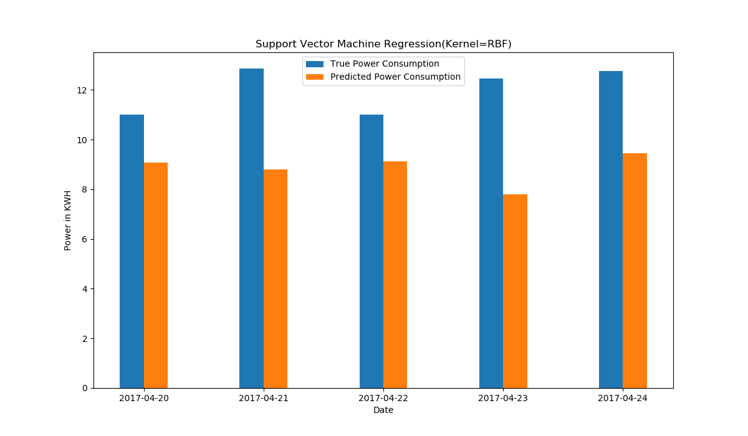
Fig. 2. Support Vector Machine Regression, empirical comparison

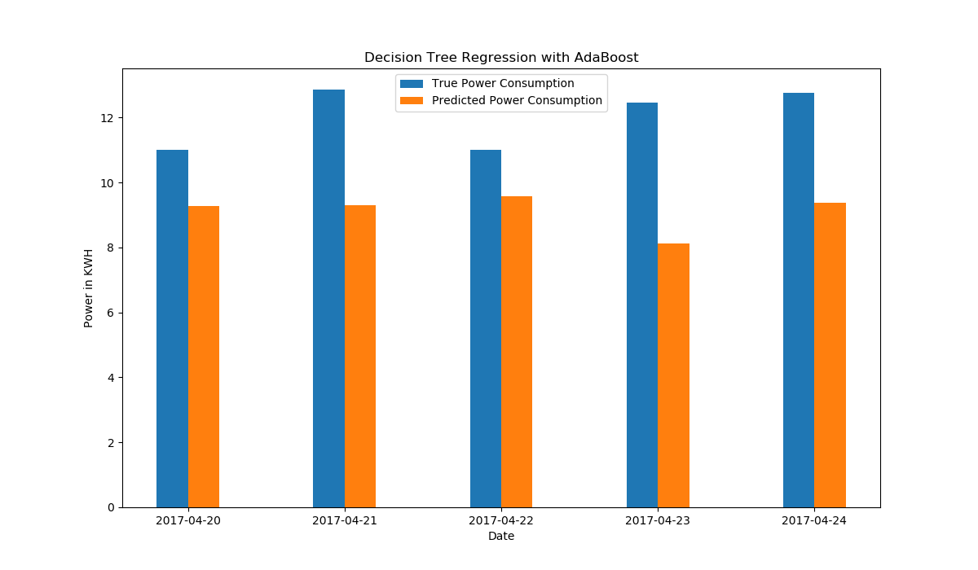
Fig. 3. Decision Tree Regression with AdaBoost, empirical comparison
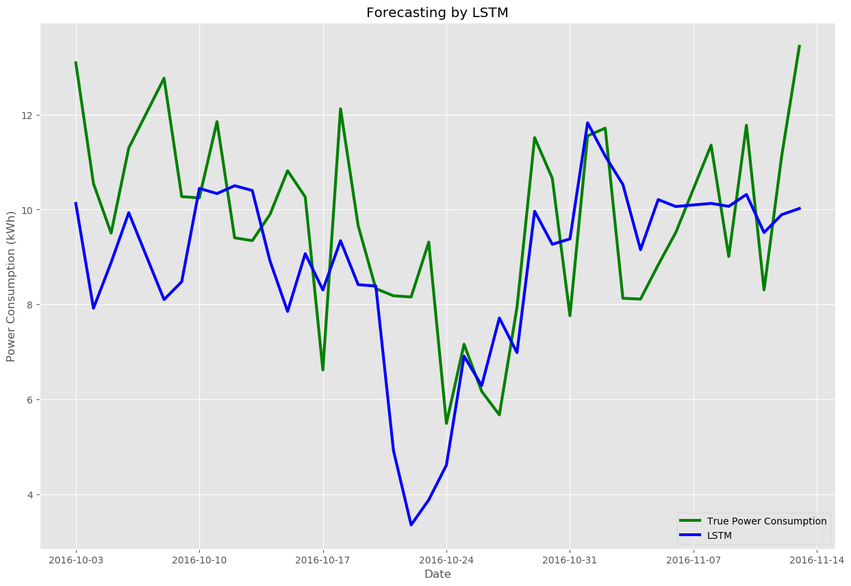
Fig. 4. Load forecasting by LSTM

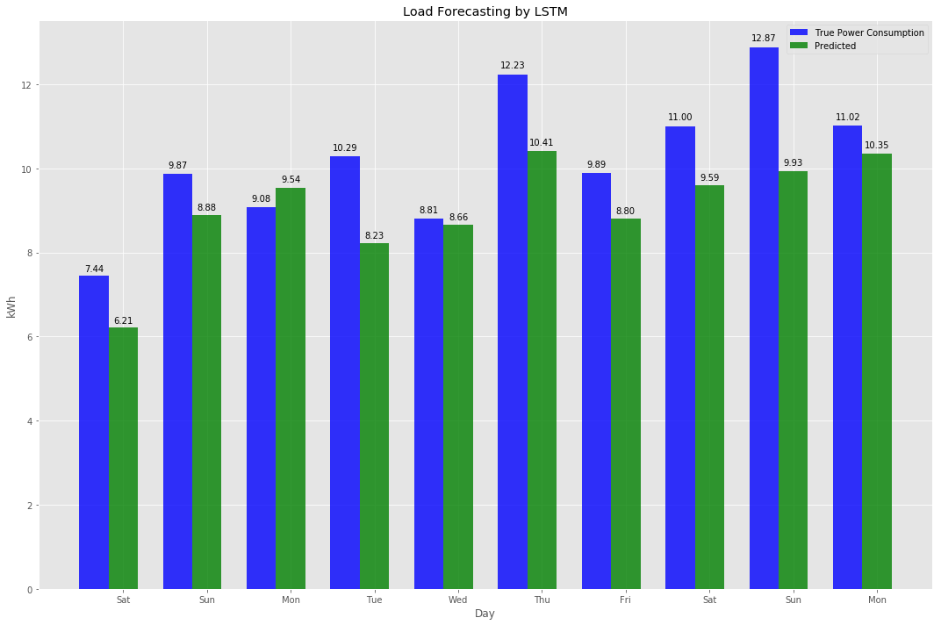
Fig. 5. Load forecasting of LSTM, empirical comparison

Table 2 RMSE of ML algorithms

Algorithms | Error
Algorithms | Root Mean Squared Error
Nearest Neighbors Regression | 1.93
Support Vector Machines  Regression | 1.83
Decision Forest Regression  With AdaBoost | 1.86
Long Short Term Memory | 1.65

In Fig.9 an overall summary of the outputs of four algorithm is given. Day by day our processors are getting stronger and less power hungry. Also in recent days processors are coming with dedicated core for neural net and artificial intelligence. As a result cost and computational power required for training a neural network will not be problem in the future. Neural networks like LSTM has the ability to adopt with a great variety of patterns and the ability of recognize those pattern. In our experiment LSTM has given better result with compared to Support Vector Machines Regression, Decision Forest Regression with AdaBoost and Nearest Neighbors Regression, Table 3.
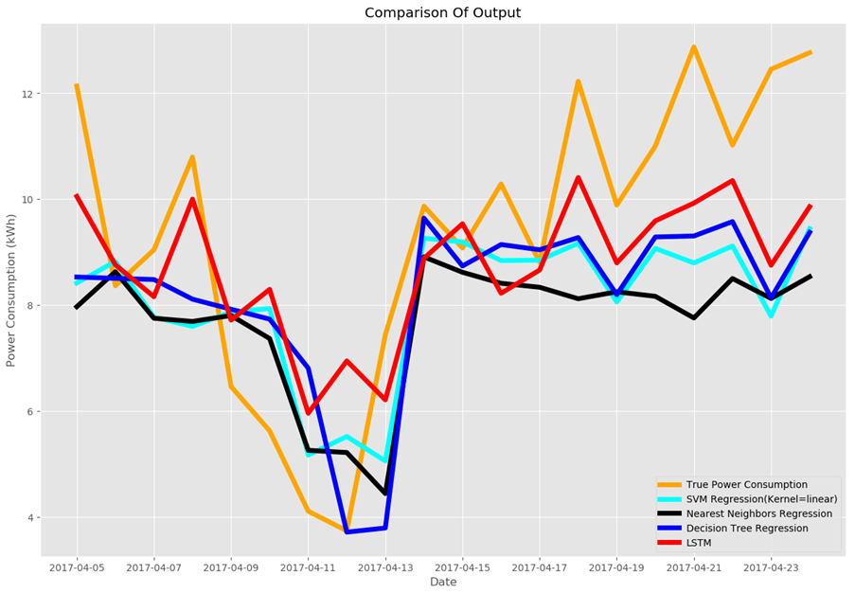
Fig. 9. Comparison of four ML Algorithms based on their outputs on same test set
5 Conclusion

In this paper we have presented a system which can give prediction based on data collected from IoT devices. To prove the reliability of the system we have tested the system with real world data sets. We have conducted several experiments to evaluate the performance of four machine learning algorithms and concluded the experiment with a comparison of RMSE loss score. Long Short Term Memory network has given lowest RMSE in the experiment. The system described in this paper worked on data collected from IoT devices. Therefore privacy is a big concern here. In future we want to work on the security side of this system. We will try to improve the accuracy of prediction

References

- Sarkar, K. (2014, 2nd August). Unmanned level crossing is a death trap. Dhaka Tribune. Retrieved from http://www.dhakatribune.com
- I. T. Young, Jan J. Gerbrands, L. J. van Vliet, "Fundamentals of Image Processing", version 2.2, pp 4,1997
- K. M. M. Rao, "OVERVIEW OF IMAGE PROCESSING".[On line]. Available: http://www.drkmm.com/resources/INTRODUCTION_TO_IMAGE_PROCESSING_29aug06.pdf. pp 1. 29th August, 2006
- A. K. Jain, P. Hall, " Fundamentals Of Digital Image Processing", 1989.
- R. C. G. Woods, A Wesley, "Digital Image Processing", 1992
- K.. Sunil, & M. Satish. (2014, June 12). "Optimal Gaussian Filter for Effective Noise Filtering". Retrieved from arxiv.org/pdf/1406.3172.pdf
- V. L. Lajish, V. K. Pandey, and S. K. Kopparapu, “Knotless spline noise removal technique for improved OHCR,” in Proceedings of the 2010 International Conference on Signal and Image Processing, 2010.
- Fernández-Caballero, A., López, M. T., Castillo, J. C., & Maldonado-Bascón, S. (2009). Real-Time Accumulative Computation Motion Detectors. Sensors, 9(12), 10044–10065. MDPI AG. Retrieved from http://dx.doi.org/10.3390/s91210044

