Project Specification

Flight Reservation System

MSSE670 Fall 2019 1W

Anit Adhikari

Regis University

Contents

1 Introduction 3

1.1 Intent 3

1.2 Issue 3

**2. ClassDiagram……………………………………………………………….4**

2.1 Description………………………………………………………… 4

2.2 Service Layer Class Diagram…………………………………….4

2.3 Domain Layer Class Diagram……………………………………..4

**3. Development Directory………………………………………………….5**

# Introduction

## Intent

Document details the design of the flight Reservation System

## Issue

This is for login service implementation which can validate only single customer.

**Issue**

In the above case, we have created own LoginException. AuthenticateCustomer method throws LoginException service implementation class.

**Summary**

# Class diagram

## Description

This section illustrates service layer of login service and flight service.

## Service Layer Class Diagram

Figure 2‑1 Service Layer Class Diagram

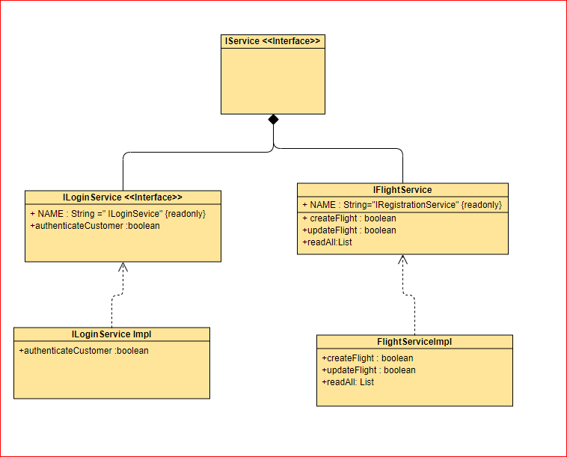

## Domain Layer Class Diagram

Figure 2‑2 Domain Layer Class Diagram

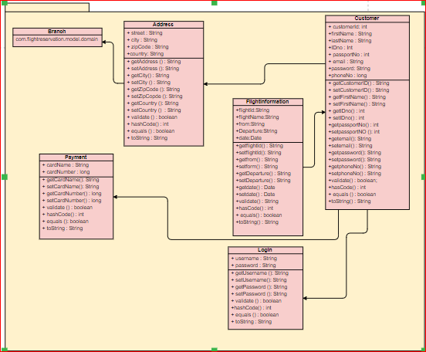

# Development Directory

## Description

This service showsv the directory structure of the source code located under the “src” folder and the correspoind test code under the “ test” folder. This week business layer has been created with correspondence with use case. Test of each layer has been created and tested the functionality which is plaed under “test” folder.

