Project Specification

Flight Reservation System

MSSE670 Fall 2019 1W

Anit Adhikari

Regis University

Contents

1 Introduction 3

1.1 Intent 3

1.2 Issue 3

**2. ClassDiagram……………………………………………………………….4**

2.1 Description…………………………………………………………. 4

2.2 Service Layer Class Diagram……………………………………...4

2.3 Domain Layer Class Diagram……………………………………....4

**3. Development Directory………………………………………………...5**

3.1 Description…………………………………………………………...6

3.2 Widget requirement for flight requirement system……………… 7

# Introduction

## Intent

Document details the design of the flight Reservation System

## Issue

This is for login service implementation which can validate only single customer.

**Issue**

In the above case, we have created own LoginException. AuthenticateCustomer method throws LoginException service implementation class.

**Summary**

# Class diagram

## Description

This section illustrates service layer of login service and flight service.

## Service Layer Class Diagram

Figure 2‑1 Service Layer Class Diagram

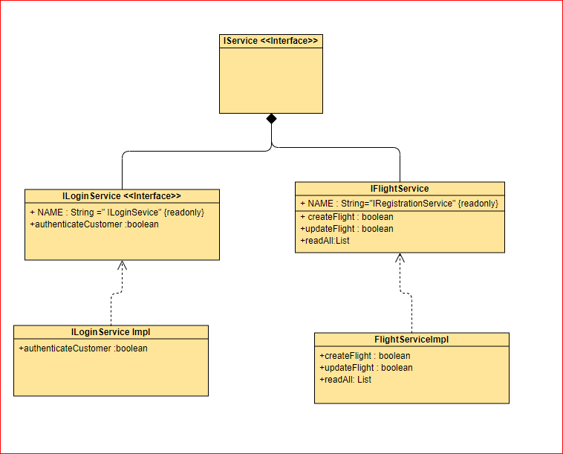

## Domain Layer Class Diagram

Figure 2‑2 Domain Layer Class Diagram

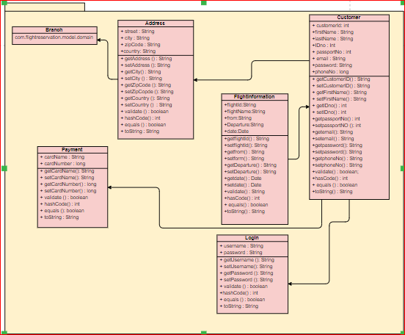

# Development Directory

## Description

This service showsv the directory structure of the source code located under the “src” folder . This week presentation layer has been created with correspondence with use case.

## Widget Requirement for Flight Registration System

For Customer Login :

* JMenuBar
* JMenu : 2
* JMenuItem :2
* JPanel
* JLabel:2
* JTextField:2
* JButton:2

For Customer Registration:

* JMenuBar
* JMenu : 2
* JMenuItem :2
* JPanel
* JLabel:7
* JTextField:7
* JButton:2

For Flight Reservation :

* JMenuBar
* JMenu : 2
* JMenuItem :2
* JPanel
* JLabel:5
* JTextField:5
* JButton:2

