**Project Plan, Team Charter**

**TAVRN Tabletop Gaming App**

|  |  |
| --- | --- |
| Industry Partner | N/A |
| Primary Instructor | Anjana Shah |
| Team Member | Matthew Geddes |
| Team Member | Matthew Shone |
| Team Member | Chris Hughes |
| Team Member | Avery Cieszynski |
| Team Member | Anita Russo |

Document Revision History

|  |  |
| --- | --- |
| Revision # | Date |
| 1.0 | 02/10/2019 |
| 2.0 | 07/01/2020 |

**Table of Contents**

**1. Executive Summary**

The following describes the project to be executed.

|  |  |
| --- | --- |
| Objective | Project goals and objectives:   * Accomplish business goals on budget and within the projected timeline * Produce an application that is worthy of being featured on the app store * Incorporate feedback from end users to improve application over iterations |
| Corporate Goals Addressed | This corporate goals of this product are to deliver an application which:   * Brings in new members to the tabletop gaming community * Creates opportunities with 3rd party businesses, allowing them to easily host tabletop gaming-themed promotions * Allows current players to connect with others seamlessly * Provides an easy-to-use platform for users * Creates a place for users to discuss games respectfully |
| Planned Start Date | September 23, 2019 |
| Planned End Date | March 27, 2020 |

**2. Project Approvers, Reviews and Distribution List**

Approvers, reviewers and distribution list

|  |  |  |
| --- | --- | --- |
| Project Role | Name | E-mail |
| Project Consultant | Anjana Shah | ashah@georgebrown.ca |
| Manager | Anita Russo | anita.russo@georgebrown.ca |
| Manager | Avery Cieszynski | avery.cieszynski@georgebrown.ca |
| Assistant to the Regional Manager | Matthew Shone | matthew.shone@georgebrown.ca |
| Manager | Matthew Geddes | matthew.geddes@georgebrown.ca |
| Manager | Chris Hughes | christopher.hughes@georgebrown.ca |

**3. Scope**

|  |  |
| --- | --- |
| In Scope | Out of Scope |
| Messaging - Users will be able to exchange messages as long as they comply with the Terms of Service | Transactions - Application will not support purchases or monetary transactions of any kind |
| Forums - Users can post online to find or join games as long as they comply with the Terms of Service | Forums - Users will not be allowed to make posts which are outside of the scope of the app (unrelated to tabletop games) |
| Location Services - Users will be able to post meetup locations | Location Services - Users will not be required to disclose location. Location Services will not be in-house (Google Maps) |
| Calendar - Users will be able to add ‘sessions’ to their phone calendar | Calendar - Users will not be able to edit their Calendar manually from the app (they can only update it with scheduled sessions) |

**4. Deliverables**

This project will deliver the following.

|  |  |
| --- | --- |
| Deliverable | Description |
| Forum (Tavern) | A place where users can take part in discussions as well as host and join groups with the intent to gather and play tabletop games by putting up postings. |
| Posting | Users can create postings either as a host or a player. These are displayed on the forum. |
| Group (Party) | Users in a group can use this page to chat, schedule game sessions, post session recaps (journal entries), etc. |
| Friend List | Users can add each other as friends. This allows users to find each other easily, as well as send messages (ravens). |
| Instant Messaging (Ravens) | Users can send messages (ravens) to people in their friends list. |

**5. Assumptions**

Hiring moderators/admins, acquiring appropriate server/database space, marketing campaign to attract initial user base, leasing office space to house developers and moderators, AGILE development process.

**6. Dependencies**

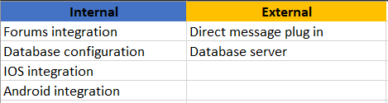

**7. Risk Management**

|  |  |  |  |
| --- | --- | --- | --- |
| Potential Risk | Severity (H/M/L) | Likelihood (H/M/L) | Management Strategy |
| Scope of project increasing | M | M | Clearly define scope at beginning of project and implement a client agreement |
| Cost overrun | H | L | Stay within project scope using project planning techniques |
| New technology | M | H | Give members ample time to learn new platforms and programming languages that will be implemented in the app |
| Missing due dates | H | H | Have weekly meetings with team members to ensure that all members are reaching their goals |

**8. Communication**

**Reporting**

The following reports will be produced;

|  |  |  |
| --- | --- | --- |
| Report | Audience | Frequency |
| Project Presentation | T127 Class | Monthly |
| Sprint Reports | Anjana Shah | Weekly (with some exceptions) |

**Meetings**

The following meetings/communication will be established;

|  |  |  |  |
| --- | --- | --- | --- |
| Meeting | Purpose | Attendees | Frequency |
| Group Sprint Session | Meet as a group to work on more difficult tasks together | TAVRN Group Members | Weekly |
| Sprint Check-in | Check in on sprint progress, delegate duties for the next sprint, schedule group work sessions | TAVRN Group Members | Weekly |

**9. Task Listing (WBS- Work Breakdown Structure)**

The following resource proposal template summarizes the resource hours committed to this project, upon final approval of this document.

|  |  |  |  |
| --- | --- | --- | --- |
| Reference | Tasks | Duration | Dependency |
| A | Create basic UI for app | January 24 - February 14 | Mobile app development environment |
| B | Update forums to web-based React platform | January 24 - February 14 | React and programming IDE |
| C | Create database for persistent storage | January 24 - February 14 | MongoDB |
| D | Implement medium-priority and low-priority features | February 14 - March 13 | Mobile app IDE |
| E | Debug app and run testing | March 13 - March 26 | IDE with debugger |
| F | Launch app | March 27 | None |

**10. Gantt Chart**

Create a detailed Gantt Chart from your Task Listing(Use any software tool and paste the image or upload as a separate file that can be opened as pdf/doc/xls):

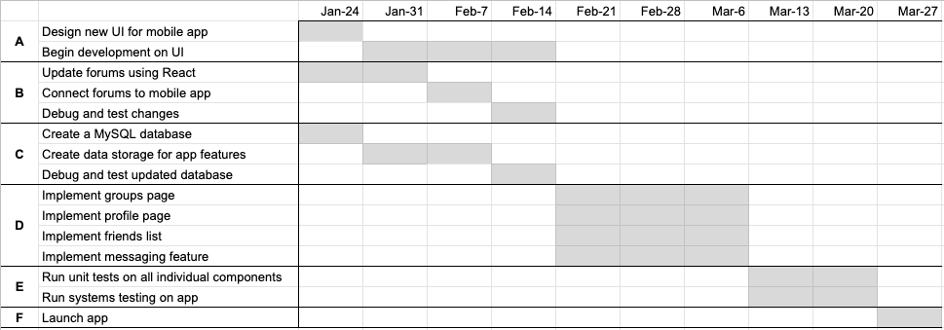

**11. Milestones**

|  |  |  |
| --- | --- | --- |
| Major Activity or Milestone | Estimated Milestone Target date | Owner/Reviewer Team Members |
| Sprint 1 | September 30th, 2019 | All Members |
| Sprint 2 | October 7th, 2019 | All Members |
| Sprint 3 | November 4th, 2019 | All Members |
| Sprint 4 | November 25th, 2019 | All Members |
| Presentation 1 | October 16th, 2019 | All Members |
| Presentation 2 | December 4th, 2019 | All Members |
| Prototype | December 5th | All Members |
| High Priority Features Implemented:   * User interface * Web forums | January 2020 | All Members |
| Medium Priority Features Implemented   * Messaging * Friends List | February 2020 | All Members |
| Low Priority Features Implemented   * Profile page * Groups | March 2020 | All Members |
| Product Launch | March 27 2020 | All Members |

**12. RAM – Responsibility Assignment Matrix**

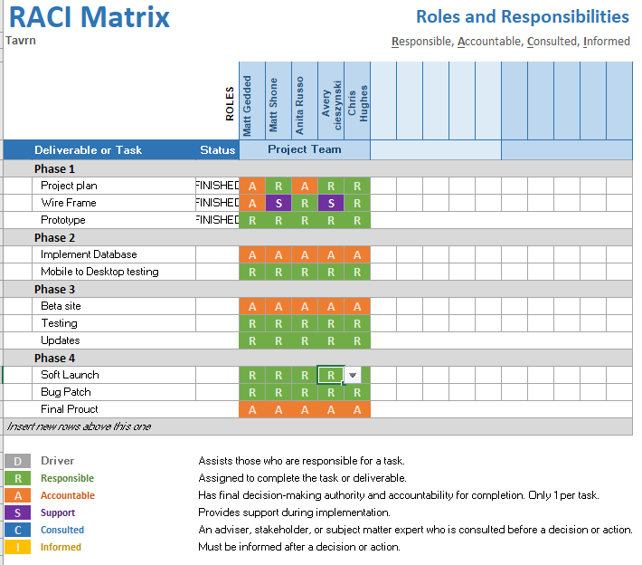

**13. Approval**

The signatures below indicate their approval of the contents of this document.

|  |  |  |  |
| --- | --- | --- | --- |
| Project Role | Name | Signature | Date |
| Primary Approver | Anjana Shah |  |  |

**TEAM CHARTER**

The team has been formed for the purpose of completing the capstone project of T127, with the intention of demonstrating competent understanding of the course materials as well as working as a team.

The charter includes the following sections:

1. **Purpose**

To develop a functioning mobile application as well as the skills necessary for future employment/careers.

2. **Background**

Create a mobile application for the use of finding players, creating games, and planning meetups for tabletop games (i.e. Dungeons and Dragons, Call of Cthulhu, Cyberpunk 2020). It is aimed at any user who has a difficult time either finding or hosting a game with likeminded people or users with an interest in these types of games/social settings.

3**. Scope**

A functioning app that has a forum and allows users to post to the forum, schedule games with built-in calendar support, and message and group up with other users.

4. **Team composition**

The team consists of Avery Ciesznyski, Matthew Geddes, Christopher Hughes, Anita Russo and Matthew Shone being overseen by Anjana Shah.

5. **Team empowerment**

Our company will offer a stock stake based on years worked for the company and/or as an incentive bonus for meeting targets and company goals.

6. **Team operations**

Team members will meet weekly for a standup meeting to discuss outcomes of the previous week and goals for the upcoming week. Any issues, concerns, or relative information will be discussed.

7. **Team Performance Assessment**

The team’s success in this project is dependent on communication and delegation. At weekly meetings, the team will discuss how they feel about their performance, and what more could be done if necessary.

8. **Signature Page**