- Dataflow Diagram
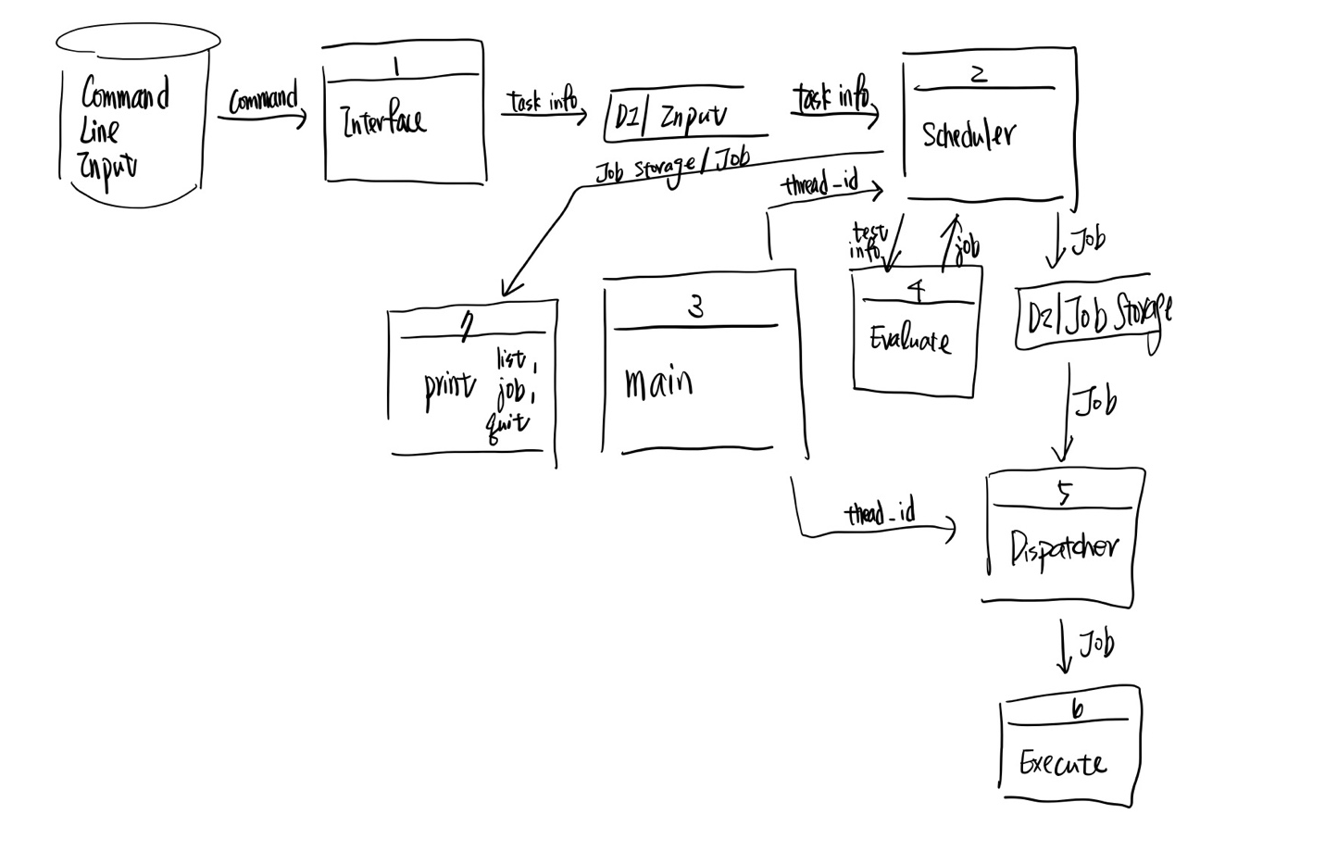
- Function Prototypes:
  - src/evaluate.c
    - void generate_job(struct Benchmark* benchmark, struct Job *job);
      - generate a job base on the given benchmark information including name, arrival_time, expected_execution_time, priority, is_benchmarkchar
    - void run_for_time(time_t seconds);
      - This function will run for seconds secondssrc/word_count.c
  - src/execute.c
    - char* intToCharArray(int num);
      - Convert the integer to a string and store it in the char array
    - void execute_job(struct Job* job);
      - This function will execute file with a child process according to job
  - src/job_storage.c
    - void setup_job_storage(struct JobStorage* job_storage);
      - initializing a job stoage
    - void setup_job(struct Job* job, char const* name, time_t arrival, int time, int priority, bool is_benchmark);
      - initializing a job
    - void use_policy(struct JobStorage* job_storage, struct Job* job);
      - append job to the queue in job_storage according to its policy
    - bool add_to_queue(struct JobStorage* job_storage, struct Job* job);
      - add a job to the queue in job_stoage.
      - If the queue was empty return true, otherwise return false
    - void reschedule(struct JobStorage* job_storage, int policy);
      - reschedule the queue in job_storage according to new policy
    - struct Job* pop_queue(struct JobStorage* job_storage);
      - pop the queue in job_storage and returns it
    - void job_done(struct JobStorage* job_storage, struct Job* job);
      - updates measurements of performance evaluation when a job is done
  - src/main.c
    - int main(int argc, char **argv)
      - This is the main function
    - void *scheduler(void *t);
      - Takes input from interface and schedule jobs into job_storage according to requirement
    - void *dispatcher(void *t);
      - takes jobs from job_storage and dispatch them to executer
  - src/user_interface.c
    - void print_main_menu();
      - prints out the initial main menu
    - void get_input(char * command);
      - gets input from command line
    - void print_help();
      - prints help message
    - void setup_input(struct Input* ptr_input, char const* command);
      - initializing struct input
    - void list_jobs(struct JobStorage* job_storage);
      - lists all jobs in the queue
    - void quit_listing(struct JobStorage* job_storage);
      - lists performance measurement (is used when quitting)
    - void print_reschedule(struct JobStorage* job_storage);
      - prints reschedule message
    - void print_submit_job(struct JobStorage* job_storage, struct Job* job);
      - prints job information
    - int get_policy(char const * policy);
      - transform policy char array into int
    - void interface(struct Input* ptr_input);
      - prints out the menu and get command line command
      - returns a input to caller
- Performance Comparison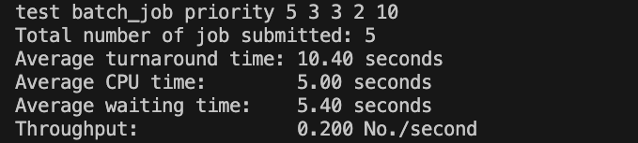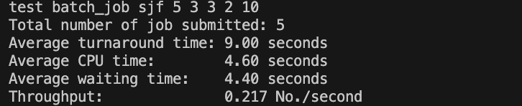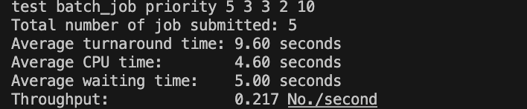
  - SJF has the least waiting time and turnaround time. Since turnaround time = waiting time+CPU time where as CPU time is constant for our fixed benchmark
  - FCFS and Priority has similar waiting time and turnaround time. Since command ‘test’ is build on top of rand(), it is by chance which of them will perform better.
- Lessons learnt
  - Since the 2 threads should be in charge of mutexes and condition variables, it is hard to follow clean architecture. In clean architecture the outer module should depends on the inner module. However, in this homework, I cannot get interface to depend on dispatcher, and it is not beautifully built.

