INFORMATION SHEET
UN No. 1075
Hazard No. 2(Y)E

LP Gas
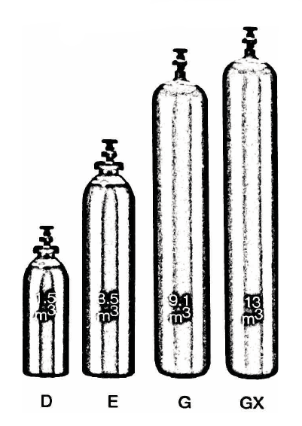

Container sizes may vary from state to state
SPECIFICATION |  | 9kg | 15kg | 45kg | 210kg
Cylinder contents (kg)  (101.325kPa @15ºC) |  | 9 | 15 | 45 | 210
Water Capacity per cylinder (L) |  | TBC | 36 | 110 | 500
Cylinder Pressure - kPa @15ºC |  | 638 or 91psi
Cylinder Colour |  | Silver
Outlet Connection |  | Type 21 |  |  | 1.75”Acme
Dimensions (mm) | Height  Width | TBC | 680  310 | 1264  374 | 1450  760
Cylinder dimensions are approximate – variations may occur due to manufacturing tolerances.
Height includes the valve.

Description
Propane is a flammable gas which is non-toxic and colourless. It is intentionally odourised with a special chemical agent (easy to detect a leak). Propane possess a high thermal capacity with clean burning properties.

Typical Uses
- Used as fuel in cooking on several BBQ’s and stoves
- Used as fuel for many motor vehicles
- Heaters for cafes and factories.

Main Hazards
LPG in gas form is heavier than air and may accumulate in confined spaces, particularly at or below ground level. LPG is extremely flammable.

Storage and handling
- Ensure all cylinders are correctly labelled in accordance with Australian Dangerous Goods Code (Transport).
- Protect cylinders and valves from physical damage whether empty or full.
- All cylinders must be stored or secured for transport in an upright position. They should be stored in a clean, well-ventilated area below 45°C.
- Keep cylinders away from ignition sources (including static discharges).

N.B. Only regulators, manifolds and ancillary equipment, rated for the appropriate pressure and compatible with the relevant gas, shall be connected to or downstream of these cylinders (if in doubt, contact Speed Gas).

In case of leaks
- No smoking or naked lights within 50 metres.
- Shut off engines, electrical equipment and all other sources of ignition.
- If possible and safe to do so, stop leak
- If the leak cannot be stopped and only if safe to do so, remove cylinder to safe outdoor area (ensure there are no underground drains).
- When the cylinder is empty return it to the supplier with faulty cylinder tag attached.
- Notify emergency services if required.

