INFORMATION SHEET
UN No. 1066
Hazard No. 2(T)

Nitrogen
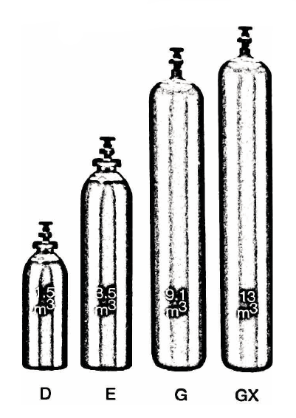

Container sizes may vary from state to state
SPECIFICATION |  | D Cyl. | E Cyl. | G Cyl. | GX Cyl.
Cylinder contents (m³)  (101.325 kPa at 15⁰C) |  | 1.5 | 3.5 | 9.1 | 13
Water Capacity per cylinder (L) |  | 10 | 23 | 50 | 50
Cylinder Pressure (kPa) |  | 14,300 | 15,000 | 20,000 | 30,000
Cylinder Colour |  | Pewter
Outlet Connection |  | Type 50 |  |  | Type 51
Dimensions (mm) | Height  Diameter | 645  180 | 1000  220 | 1580  230 | 1630  230
Cylinder dimensions are approximate – variations may occur due to manufacturing tolerances
Height includes the valve

Typical Analysis
PRODUCT NAME | N₂ | O₂ | Moisture | CxHy
UHP Nitrogen | 99.999% | < 3 ppm | < 2 ppm | -
HP Nitrogen | 99.99% | < 10 ppm | < 10 ppm | -
Industrial Nitrogen | 99.9% | < 1000 ppm | < 100 ppm | < 0.5 ppm

Description
Nitrogen is a non-flammable gas which does not support combustion. It is colourless, odourless and non-toxic; it is almost a totally inert gas (comprising approx. 79% volume of air).
IG, HP, UHP Nitrogen is produced with a food grade classification.

Typical Uses
- Purging
- Tyre inflation
- Inert atmospheres
- Food packaging
- Gauge calibration
- Metal degassing
- Aerosol propellent
- Hydraulic systems
- Photo processing
- Plastic forming
- Pipeline testing
- Air tools
- Wine making
- Fire fighting

Main Hazards
Nitrogen is non-toxic, inert and inflammable. It comprises 78.09vol% of air we breathe. However, high concentrations in confined spaces may result in unconsciousness without symptoms.

Storage and handling
- Protect the cylinders and valves from physical damage, whether empty or full.
- Secure cylinders in an upright position.
- Store in clean well ventilated areas below 45°C, away from combustible materials and heat sources.
- Ensure all devices, including fittings and regulators, are free from dust, oil and grease.
- Always open the valve which helps to prevent leakage.
- Close valves fully when not in use.
- Check regularly for leaks.
- Do not attempt to transfer contents from one cylinder to another.

N.B. Only regulators, manifolds and ancillary equipment, rated for the appropriate pressure and compatible with the relevant gas, shall be connected to or downstream of these cylinders.

In case of leaks
- Check for leaks by sound and locate with soapy water.
- Evacuate personnel from the area in which a very large quantity of gas is likely to move.
- Stop leak, if possible, and only if safe to do so.
- Do not approach major leaks without air supplied breathing equipment.
- If leak cannot be stopped, and only if safe to do so, remove cylinder to a safe area outdoors and allow to empty. Ensure people have been evacuated from the vicinity of the gas flow.
- Return empty cylinders and pack to supplier with a note to confirm the leak occurred
- Notify emergency services if required

