INFORMATION SHEET

UN No. 1001

Hazard No. 2(S)E

# Acetylene

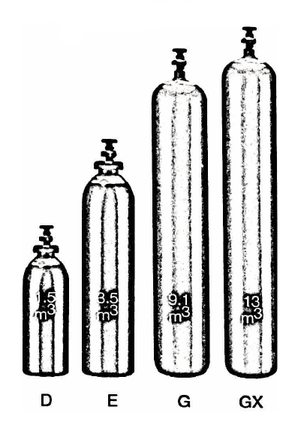

Container sizes may vary from state to state

|  |  |  |  |  |
| --- | --- | --- | --- | --- |
| SPECIFICATION | | **D** Cyl. | **E** Cyl. | **G** Cyl. |
| (1)Cylinder contents (m3) (101.325 kPa at 150C) | | 1.0 | 4.1 | 8.7 |
| Water Capacity per cylinder (L) | | 7 | 25 | 54.5 |
| (2)Cylinder Pressure (kPa) | | 1,850 | | |
| Cylinder Colour | | Claret | | |
| Outlet Connection | | Type 20 | | |
| Dimensions (mm) | Height  Diameter | 600  180 | 930  210 | 846  305 |

(1) Max withdraw rate for short term use is 10% of nominal capacity.

(2) This pressure can vary between 1300 and 2500 kPa depending upon the ambient temperature.

For special applications (flame, heating etc., please contact your Speed Gas fuel gas specialists.

To determine withdraw rates, refer to the charts of your equipment supplier.

Cylinder dimensions are approximate - variations may occur due to manufacturing tolerances.

Height includes the valve.

### Typical Analysis

|  |  |  |
| --- | --- | --- |
| PRODUCT NAME | Phosphene | PH3/AsH3 |
| Instrument Acetylene | ≥98.0% | < 1 ppm |
| Industrial Acetylene | ≥98.0% | 0 ppm |

### Description

Acetylene is a colourless, highly flammable gas which has a distinct odour.

### Typical Uses

* Oxy-Acetylene welding
* Cutting localised
* Heating
* Flame hardening
* Atomic absorption spectroscopy (AAS)

### Main hazards

Highly flammable and forms an explosive mixture with air. Leaks may catch fire without apparent source of ignition. High concentration of gas may cause dizziness, drowsiness and/or suffocation.

### Storage and handling

* Protect cylinders, particularly the valves, from physical damage whether full or empty.
* Always store and transport upright.
* Always store in a cool well ventilated area (max. 45°C)
* Store away from combustible materials (refer to appropriate regulations for segregation from other dangerous and combustible materials).
* If valve is damaged, do not operate. If valve does not operate by hand, notify supplier and return cylinder with “faulty” tag.

N.B. Only regulators, manifolds and ancillary equipment, rated for the appropriate pressure and compatible with the relevant gas, shall be connected to or downstream of these cylinders.

### In case of leaks

* No smoking or makes lights within 70 metres.
* Shut off engines, electrical equipment and all other sources of ignition.
* If possible, stop leak and remove cylinder to safe area.
* Notify emergency services if required.
* When cylinder has emptied, return to supplier with identification of problem.