INFORMATION SHEET

UN No. 1956

Hazard No. 2(S)E

Classification: As 4882-2003: SG-AC-2

# Argon 02

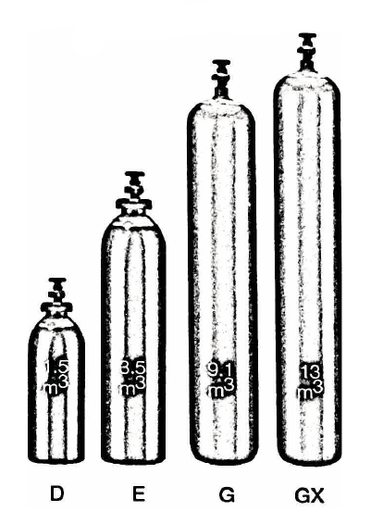

Container sizes may vary from state to state.

|  |  |  |  |  |
| --- | --- | --- | --- | --- |
| SPECIFICATION | |  | **E** Cyl. | **G** Cyl. |
| Cylinder contents (m3) (101.325 kPa at 150C) | |  | 4.3 | 8.4 |
| Water Capacity per cylinder (L) | |  | 23 | 50 |
| Cylinder Pressure (kPa) | |  | 18,500 | 18,000 |
| Cylinder Colour | |  | Peacock Blue Body/Black Shoulder | |
| Outlet Connection | |  | Type 10 | |
| Dimensions (mm) | Height  Diameter |  | 780  230 | 1510  230 |

Cylinder dimensions are approximate – variations may occur due to manufacturing tolerances

Height includes the valve

### Typical Analysis

|  |  |  |
| --- | --- | --- |
| PRODUCT NAME | Ar | O2 |
| Argon 02 | 98% | 2% |

### Description

Argon 02 is an oxygen, argon based gas mixture with a medium active gas content. The is inert, non-toxic, colourless and odourless. Supplied in high pressure metal cylinders and packs where available.

Argon 02 is offered to customers using GMAW for most high alloy for most high alloy and austenitic stainless steel across a wide range of material thickness. Argon 02 for these applications may be more economical than Ar / He/ CO₂ mixtures and fit for purpose.

### Physical Characteristics

Appearance/Odour:

* Colourless and Odourless

Relative Density (Air = 1): 1.4

Molecular Weight: 39.8

Density of gas @ 15°C,101.33kPa:

1.69Kg/m3

### Typical Uses

* MIG welding of stainless steel

### Main hazards

* Compressed high pressure gas in cylinders
* Asphyxiant in high concentrations.

### Storage and handling

Ensure adequate ventilation for all cylinders and packs. Secure single cylinders in upright position and protect valves and manifolds from accidental damage.

* Keep cylinders and packs in a cool area away from all sources of heat.
* Open cylinder valve slowly.
* Close all valves when not in use.
* Ensure all regulators and other devices attached to the cylinder outlets are free from oil and grease, and able to withstand contents pressures. Check for leaks regularly.
* Do not store cylinders in an area where any leaking gas could accumulate.
* If valve is damaged, do not attempt to operate.
* If valve does not operate by hand, return the cylinder to the supplier (attach a “faulty” tag).

N.B. Only regulators, manifolds and ancillary equipment, rated for the appropriate pressure and compatible with the relevant gas, shall be connected to or downstream of these cylinders.

### In case of leaks

* If cylinder or pack is suspected of leaking, evacuate personnel from the direction in which the gas is likely to flow. Stop leak if possible.
* Major leaks should only be approached with breathing apparatus.
* If possible and if safe to do so, remove leaking cylinder or pack to a safe area outdoors and allow contents to empty into atmosphere.
* Return empty cylinders and pack to supplier with a note to confirm the leak occurred
* Notify emergency services if required