INFORMATION SHEET

UN No. 1066

Hazard No. 2TE

Classification: As 4882-2003: SG-AC-10; SG-AC-18; SG-AC-23

# Argon 10/18/23

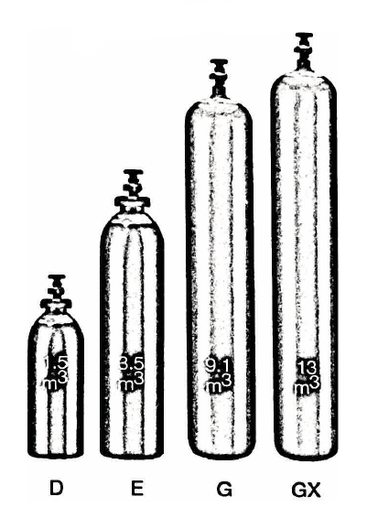

Container sizes may vary from state to state

|  |  |  |  |
| --- | --- | --- | --- |
| SPECIFICATION | | E Cyl. | G Cyl. |
| Cylinder contents (m3) (101.325 kPa at 150C) | | 4.3 | 10.0 |
| Water Capacity per cylinder (L) | | 23 | 50 |
| Cylinder Pressure (kPa) | | 16,500 | 17,000 |
| Cylinder Colour | | Peacock Blue/Green Grey Shoulder | |
| Outlet Connection | | Type 10 | |
| Dimensions (mm) | Height  Diameter | 780  230 | 1510  230 |

Cylinder dimensions are approximate – variations may occur due to manufacturing tolerances

Height includes the valve

### Typical Analysis

|  |  |  |
| --- | --- | --- |
| PRODUCT NAME | Ar | CO2 |
| Argon 10 | Balance | 10%±1% |
| Argon 18 | Balance | 18%±1% |
| Argon 23 | Balance | 23%±1% |

### Description

### ARGON 10

A true general purpose MIG Welding shielding gas designed to provide very low spatter levels whilst delivering high travel / welding speeds and reduced welding fume levels to help protect workers.

Additionally, resultant weld metal exhibits very low deposited silica levels and excellent weld penetration profiles that can help reduce over-welding.

### ARGON 18

A shielding gas mixture which provides weld of excellent appearance. Suitable for use on low alloy, high tensile, quenched and tempered steels. Suitable for solid wires and some flux core wires.

### ARGON 23

With a high CO₂ concentration, displays excellent dip transfer performance on steel over 10mm in vertical and overhead positions.

It is the ideal choice for fast out-of-position welding of heavy sections and offers excellent root penetration and side fusion. Argon 23 is particularly suited to the welding of heavy duty tubular sections.

### Typical Uses

Argon 10, 18 and 23 are used for:

* MIG Welding of Mild and Carbon Manganese Steels

### Advantages

ARGON 10 - general purpose, medium thickness, good penetration, very low spatter

ARGON 18 - heavy section, deep penetration, low to medium spatter

ARGON 23 - very heavy sections, deep penetration, low to medium spatter

The CO₂ content in these gases is ideal for welding galvanised metals.

### Main hazards

* Compressed high pressure gas in cylinders
* Asphyxiant in high concentrations.

### Storage and handling

Ensure adequate ventilation for all cylinders and packs. Secure single cylinders in upright position and protect valves and manifolds from accidental damage.

* Keep cylinders and packs in a cool area away from all sources of heat.
* Close all valves when not in use.
* Ensure all regulators and other devices attached to the cylinder outlets are free from oil and grease, and able to withstand contents pressures. Check for leaks regularly.
* Do not store cylinders in an area where in an area where any leaking gas could accumulate.
* If valve is damaged, do not attempt to operate.
* If valve does not operate by hand, return the cylinder to the supplier (attach a “faulty” tag).

N.B. Only regulators, manifolds and ancillary equipment, rated for the appropriate pressure and compatible with the relevant gas, shall be connected to or downstream of these cylinders.

### In case of leaks

* If cylinder or pack is suspected of leaking, evacuate personnel from the direction in which the gas is likely to flow. Stop leak if possible.
* Major leaks should only be approached with breathing apparatus.
* If possible and if safe to do so, remove leaking cylinder or pack to a safe area outdoors and allow contents to empty into atmosphere.
* Return empty cylinders and pack to supplier with a note to confirm the leak occurred
* Notify emergency services if required